**Waste Analysis Report for Bloom Restaurant**

Student’s Name

University

Course

Instructor

Date

**Waste Analysis Report for Bloom Restaurant**

**Purpose**

The objective of the waste audit at Bloom Restaurant is to review the best practices of waste handling and management in order to determine opportunities for improvements of sustainable practices. This audit contributes to meeting the goals and values of Bloom Restaurant’s sustainability by generating evidence-based recommendations for waste minimization and improved environmental responsibility.

The waste audit fits into Bloom Restaurant's sustainability initiatives by:

1. Improving waste management: this strategy provides a way to decrease the negative impacts on the environment.
2. Meets environmental regulations and certification requirements.
3. Increasing awareness and visibility of the restaurant as a sustainable eating option.

The three drivers or motivators for sustainability at Bloom Restaurant include:

* **Environmental Responsibility:** Waste management positively affects environmental conservation as it helps the restaurant cut down on wastage.
* **Cost Savings:** Effective waste management may help to reduce costs associated with waste disposal and possibly even offer an opportunity for revenue generation from the recyclables.
* **Customer Expectations:** Customers today also want to eat at restaurants that show that they care for the environment.

**Waste Collection Methodology**

Based on the provided Waste Audit data, the following methodology was likely employed:

**Types of Waste Collected:** Waste was classified into bio degradable, reusable and non reusable during the audit.

**Collection Process:** Waste was collected from different sections of the restaurant such as the kitchen, dining area and the bar.

**Sorting and Categorizing:** It involved placing waste materials in separate bins depending on their classification (for example, compost bin, recyclable bin, and landfill bin).

**Data Analysis:** The separated waste was also weighed and documented after which the amount and kind of waste being generated was calculated.

**Involvement of Personnel**

**Front of House:** servers and bussers collected and separated garbage from the dining area.

**Back of House:** The kitchen crew handled the food wastes and the recyclables, while Housekeeping took care of proper disposal and documentation.

**Cost Estimate:**

* Personnel Costs: $500 (for additional staff hours)
* Materials: Bin $130, gloves $50, scales $20
* Time: Two days of audit, which make 16 hours in total.
* Total Estimated Cost: $700

**Analysis and Observations**

**Data Analysis**

When evaluating the findings of the waste audit completed by the organization, we applied guidance from the EPA Waste Reduction Model (WARM). The data was categorized into three main types: biodegradable waste, recyclable waste, and non-recyclable waste. The weight and volume of total waste and each category were measured and documented in a bid to determine specific areas of focus in the waste management of Bloom Restaurant.

**Observations**

**1. The production of a large volume of organic wastes:** The audit found that organic waste was the largest waste stream with 60 percent of the generated waste. From the audit data, it was evident that the kitchen generated a lot of food wastage in form of food scraps and leftovers. This indicates the probability of composting and food waste reduction programs in this area is relatively high. The proposal to start composting could decrease the amount of waste that would be sent to the landfill and turn student generated organic waste to compost which could be used by local farmers or gardeners.

**2. Low Recycling Rate:** It was observed that only 25% of the waste generated was actually recyclable, which is below the expected rates. The audit data also showed that many of the items that could be repurposed where classified as ‘Non-Recyclable’, this might be as a result of contamination or mis-sorting. This points to the fact that there is a need for enhanced recycling measures, as well as creating awareness and training for the staff on how to sort waste correctly. Expanded recycling processes may reduce the amount of waste going to the landfill and contribute to greater sustainability.

**3. Consistent Waste Generation:** Another observation during the audit period was no sign of a reduction or increase in the amount of wastes produced. Daily waste retrieval records presented near equal daily accumulations of waste without much fluctuations. This means that consumption and waste are reasonable and consistent, which means that rational waste reduction strategies can be formulated without threatening the organization’s operations. This could be done through a process of normal or routine checks so that the organization retains this level of disposal while slowly working towards a general decrease in waste.

**Visual Representation**

In order to analyze the data graphically, a pie chart was used with the aim of representing the types of wastes that were generated. By making use of the chart, it becomes easier for one to understand the percentage of organic waste and recyclable and non-recyclable fractions.

Pie Chart: Types of wastes in the Restaurant

Explanation of Visual Representation: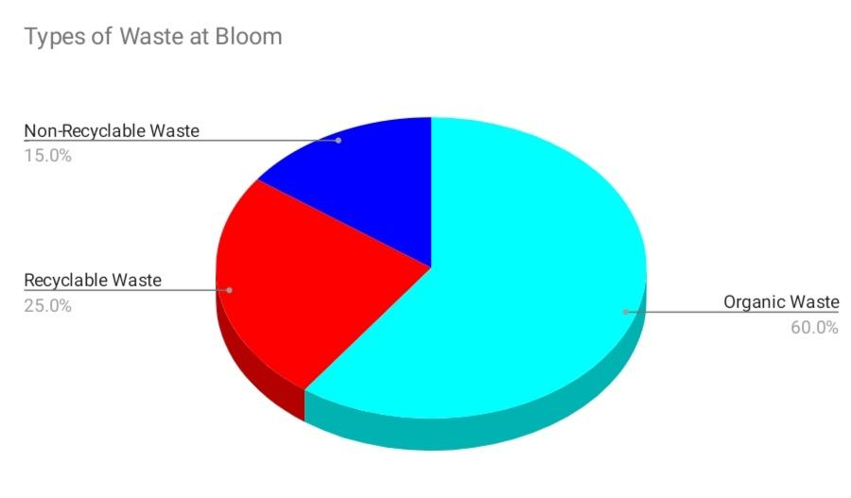

The pie chart shows that the amount of waste that is organically disposed by Bloom Restaurant is very high compared to recyclable and non-recyclable waste. This graphical display helps to pinpoint the areas of greatest potential for improvement, like raising the recycling rate and decreasing organic waste through the implementation of the composting process.

**Data Trends and Patterns**

1. Organic Waste Trends: The high percentage of the organic waste generated means that food waste is one of the significant sources. Measures that may aid in reducing the number of wasted meals include improved stock control and portion control (Pimentel et al., 2022).

2. Recycling Patterns: The low recycling rate gives an indication that the recyclables are not sorted appropriately, or the bins contain non-recyclable items. Educating the staff and applying enhanced sorting criteria can enhance the recycling metrics (Connors, 2019).

3. Waste Consistency: This indicates that waste generation is constant, thereby meaning that waste reduction strategies can also be implemented and evaluated regularly.

**Recommendations**

**Specific Activities for the next two years**

Based on the results of the Waste Audit, the following action plan is recommended for Bloom Restaurant to enhance its sustainability efforts over the next two years:

1. **Frequency of Waste Audits:** Carry out waste audits on regular bases preferably on the quarterly basis. Monitoring should be done frequently to assess changes, both positive and negative, and the efficiency of the applied waste management measures. A quarterly audit is sufficient enough to give time to implement changes and notice the consequences before the next audit (Laico, 2020)

**2. Frequency of the next Audit:** The next audit can be scheduled for October. Carrying out the audit in October when stores are not busy with the holiday rush will give an understanding on the wastes generated at what could be a steady state. This timing will also help the restaurant to adopt necessary change to different hardwares before the onset of the busy season (Laico, 2020)

**3. Duration of Each Audit:** Every audit should take three days of the specialist’s working time. The fact that audit is carried over 3 days minimises the chances of missing critical information due to difference in daily operations. This duration is reasonable and offers a proper view of the records that the restaurant produces or generates quantities of waste products (Laico, 2020)

**4. Data Collection Responsibilities:** The audits should be managed by a sustainability coordinator. This means that there will be a familiar face in the collection and analysis of data concerning the company’s sustainability. This role can also become responsible for teaching other staff members, monitoring the execution of the waste reduction initiatives as well as reporting their effectiveness to the management (Laico, 2020).

**More Data to be Recorded in Future Audits**

**1. Water Usage**: Collecting water use data with waste data can be used to establish the relationship between water use and waste generation. This can provide details on exactly where water and waste reduction measures can be combined for synergistic effect. This can be implemented by providing a certain number of water meters in areas of focus and document the daily consumption during assessments.

**2. Energy Consumption:** Measuring energy usage will assess areas concerning inefficiency in aspects like waste disposal, storage, and preparation through refrigerator and cooking appliances. Another strategy that can improve sustainability is the savings in energy consumption. These measurements can be recorded by installing energy meters in important sections to measure the energy used daily and compare the results to the amount of waste generated.

**Recommendations for the Next Waste Audit**

**1. Recycling Rate to be raised by 20%:** Enforce stricter sorting standards, educate all employees on sorting rules, and label recycling bins to clearly specify what is acceptable. Research has demonstrated that higher rates of recycling can be achieved through increased training and clearly outlined procedures (Connors, 2019).

**2. Reduce Organic Waste by 15%:** The restaurant can launch a composting program, improve the methods of ordering food supplies and introducing portion control. Composting programs have been effective in the reduction of organic waste in facilities such as the Starbucks Coffee Company (Snarr & Pezza, 2000; Policastro & and Cesaro, 2023).

**Benchmarking**

**Evaluation of Bloom’s Practices**

According to the benchmarking, Bloom Restaurant has adopted some of the best practices, but there is room for improvement in other fields.

**1. Waste Categories:** Bloom has clear organic waste, recyclable waste, and non-recyclable waste categories like other restaurants observed in Ontario. However, improving the quality of the signs and making people more aware of them could increase it (Slaven, 2020) .

**2. Standardized Sorting Bins:** In Bloom, labeled bins are used but the use of color-coded bins like the ones used in other facilities in Ontario such as Tim Hortons Restaurant can greatly enhance the efficiency of sorting (Tim Hortons, 2021; Connors, 2019).

**3. Staff Training:** Bloom involves the staff in waste sorting but it does not effectively train them. Holding periodical training sessions might increase the level of compliance and accuracy of sorting (Connors, 2019; Mensah, 2023).

**4. Regular Audits:** Bloom currently does not engage in the routine practice of audits. Other restaurants in Ontario have been using a quarterly audit schedule; this would be useful when it comes to tracking the progress and implementing any changes (Reinhard, 2019).

**5. Technology for Data Collection:** Bloom uses manual methods of data collection for most of its reports. Purchasing digital scales as used by other restaurants in Ontario will enhance the accuracy of data collected on waste as well as increasing operational efficiency of the waste tracking software (Ontario, 2021; Rajabalee, 2024).

**Contribution to Sustainability**

The waste audit conducted at Bloom Restaurant demonstrates that the restaurant respects the environment, and by analyzing the practices of other restaurants in Ontario, Bloom can learn not only their shortcomings and successes. This comparative analysis indicates that Bloom can move from weak to strong sustainability by:This comparative analysis indicates that Bloom can move from weak to strong sustainability by:

**1. Weak Sustainability**

Current practices reflect minimum compliance but there are areas that are not commonly or not adequately practiced, such as regular auditing, staff training, and incorporation of technology.

Improvements Needed: In this case, there are three proposals for increased activity: quarterly audits, training of employees, and embracing technologies.

**2. Strong Sustainability**

This paper identifies the sources of best practices in sustainability and how Bloom can systematically improve its score to ensure the firm meets its strategic goal of strong sustainability. The recommended strategies which can be implemented include; Conducting periodic auditing, extensive staff training, and integrating technology.

**References**

Connors, L. (2019, February 26). Hotel Waste Management: How to Make It More Efficient. Hospitality Net; Hospitality Net. <https://www.hospitalitynet.org/opinion/4092117.html>

Laico, S. (2020, June 17). Waste Data: Everything A Facility Manager Needs To Know About Waste Audits. Great Forest.

<https://greatforest.com/sustainability101/waste-data-everything-a-facility-manager-needs-to-know-about-waste-audits/>

Mensah, D., Ng, K. T. W., Hasan, M. M., Jeenat, R. E., & Hurlbert, M. (2023). Assessing non-hazardous solid waste business characteristics of Western Canadian provinces. Ecological Informatics, 75(2), 102030. <https://doi.org/10.1016/j.ecoinf.2023.102030>

Ontario. (2019). Food and Organic Waste Framework. Ontario.ca. <https://www.ontario.ca/page/food-and-organic-waste-framework>

Pimentel, B. F., Misopoulos, F., & Davies, J. (2022). A review of factors reducing waste in the food supply chain: The retailer perspective. Cleaner Waste Systems, 3(100028), 100028. <https://doi.org/10.1016/j.clwas.2022.100028>

Policastro, G., & Cesaro, A. (2022). Composting of Organic Solid Waste of Municipal Origin: The Role of Research in Enhancing Its Sustainability. International Journal of Environmental Research and Public Health, 20(1), 312–312. <https://doi.org/10.3390/ijerph20010312>

Rajabalee, A. (2024). Module 6: Bloom_Best Practices_Food Waste Mgt. *MGMT8421 - Sustainable Management.*

Reinhard, E. (2019, November 21). Food Waste Audits Help Restaurants Fight Waste and Hunger. QSR Magazine.

<https://www.qsrmagazine.com/food/food-safety/food-waste-audits-help-restaurants-fight-waste-and-hunger/>

Slaven, B. (2020, February 21). Sustainability and Waste Reduction in the Hospitality Industry: How the Right Policies can Increase Profitability | s.t.o.p. S.t.o.p Restaurant Supply.

<https://www.shopatstop.com/blogs/news/sustainability-and-waste-reduction-in-the-hospitality-industry-how-the-right-policies-can-increase-profitability>

Snarr, J., & Pezza, K. (2000). Recycling Guidebook for the Hospitality and Restaurant Industry. Metropolitan Washington Council of Governments Department of Environmental Programs.

<https://conestoga.desire2learn.com/d2l/le/content/1123431/viewContent/24241629/View>

Tim Hortons. (2021). Our Commitment to Sustainability. [Www.timhortons.ca](http://www.timhortons.ca). <https://www.timhortons.ca/sustainability>