**Cellphone Launch Plan**

Name

Department

Course

Date

**Product Launch Plan**

**Introduction**

To re-invent a business, it is essential that the new product is developed or outsourced with consideration for the target market. The success of the proposed launch depends on various factors such as an understanding of the market through research, collaboration, and effective communication. Good research helps one gain an understanding of the potential market while identifying problems and solving them. For instance, the organizational problem in this case is increasing UCP's growth by at least 20% through a product launch project. In as much as the product will solve the company's growth issue, It is imperative that the team explores what solutions the product offers its customer base. This report seeks to describe a plan that will turn UCP's fortunes around by introducing a tech-savvy cellphone that targets the youth with unique features that will guarantee its success and facilitate the company’s growth.

**Initiation**

**Problem Definition**

UCP experienced a low growth rate of 2%, something that indicated the company needs a breath of fresh air and a new product will improve results. Looking at the Canadian population, Heritage (2021), posits that there are over 7 million people, aged between 15-29, and make, presenting UPC with a demographic that would suit a smartphone. Syzmkowiak et al. (2021), posit that the said age group commonly referred to as Gen Z is more tech-savvy and adept at technology. With such information, UCP must leverage it and launch a product that will capture the population. Additionally, UCP has already established that electronics are popular with the Canadian population. Entering partnerships with cellphone manufacturing companies looking to enter the Canadian market could benefit either party. However, UCP has an array of options sourcing for the product.

**Project Charter**

**Goals**

Based on the findings presented in the conference room, the primary goal of this project is to improve the growth rate from 2%-20% in a year. Achieving this goal requires a sub-division of the goals to smaller attainable goals. Therefore, the following sub-goals will aid the attainment of the primary objective:

1. Collaborate with an entry-level cellphone manufacturer and launch a tech-savvy smartphone within six months.
2. Conduct thorough market research to understand market needs
3. Have the growth rate increase by at least 5% each quarter.
4. Create a marketing and promotion campaign for the new product.
5. Realign the supply chain, logistics, and inventory management to ensure adequate stocking for the new phone.

**Project Scope**

The project will cover a variety of areas including product development, processes, budget estimations, launch, and post-launch monitoring. Processes include marketing campaigns, supply chain management, supply and demand analytics, and product design. Below is a breakdown of the scope, including a shareholder analysis.

**Shareholder Analysis Matrix**

|  |  |
| --- | --- |
| Keep Satisfied: This refers to stakeholders interested in the project but are less invested in it hence the need to keep them reasonably updated. They include:   * The media * Human resource managers * Executive management * Alternative partners | Manage Closely: This refers to stakeholders with the highest interest, influence, and involvement. They include:   * Project development team * Project sponsors * Supervisors * UPC staff. * Customers |
| Monitor: This is the least involved group but should always be informed. It includes:   * Managers in other departments | Keep informed: These should be kept updated all the time as they could influence the project’s success. They include:   * Consumer rights advocacy groups * Law enforcement and policymakers |

**Stakeholder Needs Concerns and Expectations**

Based on the stakeholder analysis matrix, various stakeholders will have varying expectations, concerns, roles, and needs. In this case, the most important shareholders are the project development team, project sponsors, department supervisors, staff, and customers. Each team member will play well-defined roles to avoid confusion and conflict of interest.

**Planning**

In this section, team and shareholder roles are defined, and budget development, tasks, communication strategies, and initial project schedules are developed.

|  |  |
| --- | --- |
| Group Member/Stakeholder | Roles, Expectation, Needs |
| Project Manager | Provide leadership to stakeholders and team members.  Oversee the development and implementation of the project plan.  Manage resources including financial and labor.  Will ensure quality processes and outcomes.  Risk management.  Communicate to all stakeholders in a clear and consistent manner. |
| Team Members | Deliver any assigned task in a timely and professional manner.  Remain committed to the primary objective by completing their tasks as required.  Collaborate and communicate effectively with other team members and stakeholders. |
| Project Sponsor | Provide resources for project development  Offer support to the team and collaborate with other stakeholders. |
| Executive Management | Offer guidance on the project with respect to UCP's vision and mission. |
| UCP Staff | Provide designated support to the team in the project development process. |
| Consumer Rights Advocacy Groups | Provide consultation on the product's compliance with consumer rights and ethical requirements. |
| Policymakers and Law Enforcement | Offer consultation on potential policy-induced risks and offer insight on how to manage them. |

Budget

The project will involve various budgeted processes as indicated below:

|  |  |
| --- | --- |
| Expense | Cost and Detail |
| Product Outsourcing | $ 500000: this will include the development supplier sourcing and initial inventory cost. |
| Project Development | $ 50000: Travel expenses and other personalized expenses for the group. |
| Marketing Campaign | $ 200000 |
| Total | $750000 |

**Tasks, Milestones, and Deliverables**

For this product launch project, these are the tasks developed for each team member:

|  |  |
| --- | --- |
| Team Member | Task |
| Team Member 1(Project Manager) | Provide leadership to stakeholders and team members.  Oversee the development and implementation of the project plan.  Manage resources including financial and labor.  Will ensure quality processes and outcomes.  Risk management.  Communicate to all stakeholders in a clear and consistent manner.  Launch the product. |
| Team Member 2 (Secretary) | Record team meeting minutes for future reference.  Document processes and outcomes. |
| Team Member 3 (Marketing Manager) | Develop a marketing campaign strategy for the new phone. |
| Team Member 4 (Finance strategist) | Facilitate the development and implementation of the budget.  Oversee procurement. |
| Team Member 5 (Relations Manager) | Interact and look for product suppliers.  Keep all stakeholders informed. |

**Work Break Down Structure (WBS)**

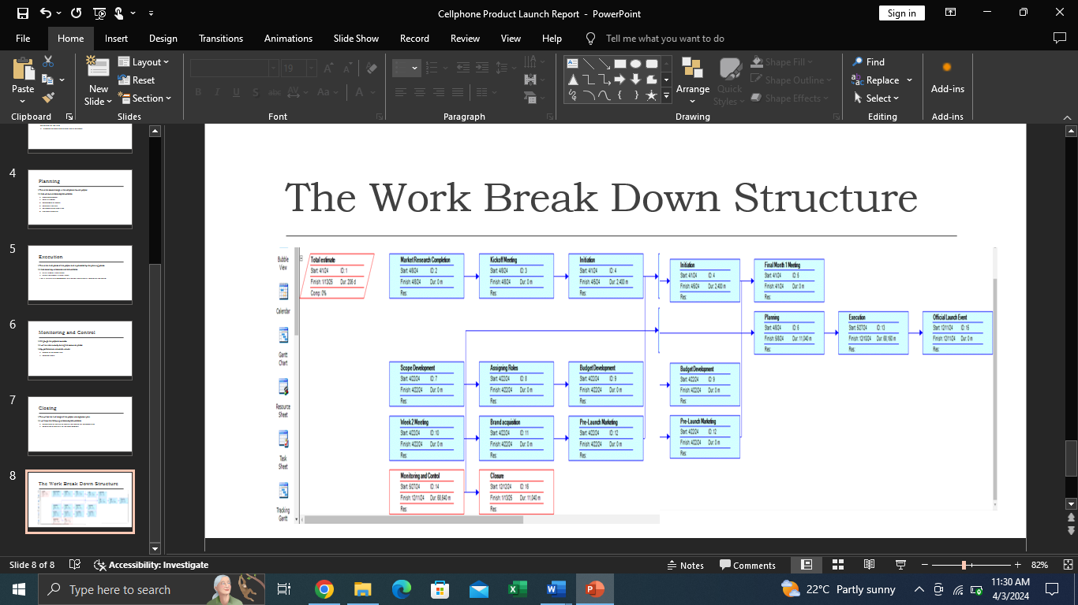

**Key Milestones**

The team will focus on achieving the following milestones in different phases

1. Market research
2. Scope development
3. Role assignment
4. Development of budget
5. Resource allocation
6. Cellphone Brand Acquisition
7. Prelaunch campaign
8. Launch event
9. Closing
10. Handing over

**Execution**

As indicated in the plan above, the project will be implemented within the defined budget. In this phase, the team will enter into a contractual agreement with the cellphone manufacturer. Also, adjustments will made to the supply chain to ensure an adequate supply of the phones. The marketing manager will lead the marketing campaign, mainly focusing on social media marketing. Once the cell phone is launched, the team will define its key performance indicators and assessment criteria before handing over the project to the operations department.

**Control and Monitoring**

The purpose of this section is to determine the product's success. Here, some of the key performance indicators include cellphone sales, return on investment, and revenue growth over time. To effectively accomplish control and monitoring, the team will leverage technology that allows the continuous collection and analysis of data. If the project does not meet the primary requirement of a 20% growth rate, the team will either improve, replace or halt the product.

**Closing**

In this phase, the project manager will document the process, hire external parties to terminate contracts, and aid with any legal requirements. Also, the project manager will give a detailed report to the stakeholders. Finally, the team will hand over the product's supply chain and logistics management to the concerned team.

**References**

Heritage, C. (2021, August 11). *Canada's first State of Youth report: for youth, with youth, by youth*. Canada.ca. https://www.canada.ca/en/canadian-heritage/campaigns/state-youth/report.html

Szymkowiak, A., Melović, B., Dabić, M., Jeganathan, K., & Kundi, G. S. (2021). Information technology and Gen Z: The role of teachers, the internet, and technology in the education of young people. *Technology in Society*, *65*, 101565.