**The Nehiyawak (Cree)**

Student’s Name

Institution

Course

Instructor

Date

**The Nehiyawak (Cree)**

**Introduction**

The Nehiyawak, commonly called the Cree, are among the largest Indigenous groups in Canada, the Lac La Biche area. They are subdivided into multiple dialects; however, the two main groups in Canada are the Woods Cree, which inhabit the northern regions, and the Plains Cree, which mostly occupy the south. Historical accounts reveal that the Cree were not the original occupants of this region and that they displaced other Indigenous groups, like Blackfoot and Dene-zaa. However, pottery found on Black Fox Island shows that the Cree have inhabited the subarctic region since at least the 1500s. This paper examines the culture, history, and contemporary issues facing the Nehiyawak. It explores their traditional way of life, the nature of their contact with Europeans, the impact of colonial policies on their way of life, and ongoing efforts towards decolonization. It effectually highlights the resilience and adaptability of the Nehiyawak people.

**Steady State – Pre-Contact**

The Nehiyawak inhabit the Plains and Subarctic regions from Quebec to Alberta. They occupy the most extensive area compared to other Indigenous groups in Canada. Before contact with the Europeans, they lived a semi-nomadic lifestyle, following animal migrations to get food and make a living (Harp, 2024). The Cree were socially organized into hunting groups; however, during summer, these groups would come together to socialize, participate in ceremonies, and exchange resources. While the Nehiyawak aimed to maintain an egalitarian and communal society, there were power differences as some individuals held more influence than others in group hunts, spiritual matters, and trading. In terms of language, the Cree had multiple dialects that belong to the Algonquian language family (Harp, 2024). The dialects differ based on the region, and the closer the communities are, the more likely they are to understand each other.

The Nehiyawak took part in multiple cultural ceremonies. Examples of these ceremonies include the Sun Dance, sweat lodges, pipe ceremonies, vision quests, and others. The "walking out ceremony" was done to welcome children officially into the community. It was a ritual for children who were beginning to stand or walk independently. The Cree culture valued art and music (Hallowell, 2017). It was renowned for its excellent craft in beadwork and ability to create functional bags, clothing, and furniture out of them. Spiritually, the Cree believed in the close connection between humanity and nature. Therefore, it was necessary to be in balance with nature to achieve happiness and health. Their worldview incorporated the Trickster mythology, with Wisakedjak as the familiar trickster figure.

**First Encounter – Contact**

The Cree made their first contact with Europeans in the early 1600s. Based on the Cree oral tradition, it happened when a man from the community went to Henry Hudson, who was trading on the Eastern coast of James Bay, and attempted to exchange goods with him. With time, a trading relationship grew between them, as the Europeans would offer them clothes and take animal furs in exchange. Because of their lifestyle as hunters, the Cree community along Hudson Bay and Lake Superior regions had plenty of fur to trade with the Europeans (The Museum, 2017). The Europeans understood the area's economic potential, so they explored the region further to create and expand their trading networks in the Great Lakes region. As the fur trade grew, the Creek became more dependent on European goods, significantly altering their social structures and economic practices. Besides, there were conflicts between the Creek and other Indigenous groups in the region due to competition for trade.

Although the Cree did not trust the Europeans fully, the fur trade altered their perception of the animals they hunted and how they maintained order in their community. With time, the Europeans started selling their culture to the Cree, and Residential Schools and missionary work began to gain traction. These had a negative impact on the community as issues related to the separation of children from their families and mandatory Christian upbringing of children gained prevalence. However, the effect on their political structure was positive as the Cree learned to form administrative self-government. The Europeans began to enter treaties with the Cree, who later participated in the UN (United Nations) negotiations and had to deal with the *'United Nations Declaration on the Rights of Indigenous Peoples'* (Fogarty, 2024). The impact of contact went further, with Europeans intruding into the Cree culture. For instance, they discouraged them from performing certain rituals and ceremonies. They also taught them English, causing their children to forget their original dialects.

**Colonial Relations**

The colonial relations between the Cree people and the Europeans were complex, with the avenues of interaction being trade, warfare, and diplomacy. Besides the fur trade, the Cree formed trade alliances with the Europeans that ultimately profited various colonial projects. In terms of diplomacy, the Cree entered treaties and developed diplomatic relations with the Europeans for several centuries. Treaties became a standard way of relating with the Europeans. For instance, the aim of the 1876 Treaty 6 was to create an understanding between the two communities on how land was to be shared (The Museum, 2017). However, this was not the case as Indigenous communities were forcefully relocated from the mainland to the reserves and ended up losing their land alongside their rights. The treaty further undermined their livelihoods as the Canadian government implemented policies that limited their fishing and hunting activities.

The colonial period was associated with a change in spirituality as the Europeans undermined the religious practices of the Cree. The missionaries spread Christianity in an attempt to undo the traditional Cree beliefs. They discouraged ceremonies like the Sun Dance and Sweat Lodge, which held great spiritual significance in the community (Belshaw et al., 2022). Additionally, they insisted on using Western medicine, discouraging the Cree from engaging in traditional medicine practices like consulting herbalists and traditional healers. There were changes in the Cree social structures as government-controlled band councils replaced traditional leadership. The colonialists created laws that limited the independence of the Cree people. They did not have the right to self-governance for several millennia and were excluded from voting.

The Cree lived in constant opposition to the government and colonialists. They felt oppressed by the policies and practices introduced by the Europeans. As a result, they fought for their rights under the leadership of people like Poundmaker and Big Bear. The issue of residential schools was one of the most devastating experiences for the Cree community (Belshaw et al., 2022). Their children were forcefully taken away and put in state-funded schools that were run by missionaries. They could not speak their language or practice their culture in the residential schools and were punished for doing so. This caused the children intergenerational trauma, whose lasting effects were felt on the community structures and the victims' mental health. Residential schools are also to blame for the erosion of the Algonquian language. Over time, only a few people who remained faithful to the culture spoke fluent Algonquian; however, efforts are underway to ensure its revival.

**Internalized Colonialism**

The Nehiyawak has a long history of systemic marginalization, dating back to the 19th century. For instance, the Indian Act, which took effect in 1876, controlled multiple aspects of Indigenous life. In the attempt to assimilate the Cree people into the non-indigenous society, the Act forbade them from expressing their identities through culture and governance (Thompson & Suzuki, 2022) . Traditional governance structures were replaced with band councils, and hereditary chiefs were stripped of their powers under the Indian Act. Indigenous women were disproportionately affected because they could not participate in band council politics until the Act was revised in 1951. Colonial policies resulted in the Cree being dispossessed from their lands, translating into intense economic struggles. Their relationship with nature changed as the Europeans continuously destroyed their environment while extracting resources like minerals and harvesting timber. These practices completely altered how the Nehiyawak made their living and obtained food. Since the Cree people could no longer hunt and fish, they began to take up jobs in urban areas to fend for themselves and their families. The Cree culture has also been eroded by the heavier emphasis placed on Western education than their traditional education systems.

**Decolonization**

The colonial period exposed the Nehiyawak to multiple social injustices that the community is still trying to undo to date. For instance, they were forced out of the territorial land and till now discussions are underway with the Canadian government to restore their rights to their land and cultural identity. Decolonization efforts are made through organizations like the Assembly of First Nations which advocates for indigenous rights (Thompson & Suzuki, 2022). Local leaders have also taken a front seat in the negotiations between the Indigenous people and the government. Some of the most famous leaders from the Nehiyawak who have relentlessly fought for decolonization include pîhtokahânapiwiyin, mistahi-maskwa, and payipwât (University of Saskatchewan, n.d.). These three men are remembered for their extraordinary effort to shape the history of the Cree people.

Decolonization efforts have also focused on reviving the once-eroded Nehiyawak culture. The community is putting measures in place to ensure the renewal of the cultural practices that had been banned by the missionaries. The community leaders are also doing all they can to educate new generations on the Cree culture and teach them the language which is at risk of becoming extinct. It is evident from literature that the Cree people have adapted to the new way of life and are consequently advancing themselves economically by starting businesses and investing in different economic sectors. A good number of them are also well educated and this has earned them political positions and spots as faculty in various academic institutions. This representation in the scholarly and political fields gives them a stronger voice to advocate for their rights and make their claims.

**Conclusion**

The Nehiyawak have a complex history that begins from the pre-contact period to the present. The value of resilience is evident from their history as they have managed to navigate significant challenges in society. The Nehiyawak were a self-sufficient society that valued nature and cultural practices but this changed with colonization. They were exposed to a new way of life and forced to adopt elements of the Western culture through policies, treaties, and initiatives like residential schools. The impact of colonialism is still evident among the Cree people; however, local leaders have taken it upon themselves to restore their lost land and identity. This research shows how important it is to acknowledge a community’s historical injustices while showing support for contemporary initiatives for cultural preservation and self-determination.

**References**

Belshaw, J., Nickel, S., & Horton, C. (2022). Chapter 9: Cultural Genocide—Belief Systems, Residential Schools, Potlatch Laws, “Sixties Scoop.” *Histindigenouspeoples.pressbooks.tru.ca*. Retrieved from <https://histindigenouspeoples.pressbooks.tru.ca/chapter/chapter-9-cultural-genocide-belief-systems-residential-schools-potlatch-laws-sixties-scoop/>

Fogarty, I. (2024). The World Heritage Convention, human rights and Indigenous peoples: a critical review. *Hunter Gatherer Research*, 1-26.

Hallowell, R. (2017). Dancing Together: The Lakota Sun Dance and Ethical Intercultural Exchange. *IK: Other Ways of Knowing*, 30-52.

Harp, S. mîkiwin. (2024, June 20). Nêhiyawak – Library and Archives Canada. Retrieved February 16, 2025, from Library and Archives Canada Blog website: https://thediscoverblog.com/tag/nehiyawak/

The_Museum. (2017, April 6). Regional Cultures: Cree. Retrieved from Laclabichemuseum.com website: https://laclabichemuseum.com/tag/nehiyawak/

Thompson, S., & Suzuki, K. (2022). Displacement of Indigenous People in Canada under the Indian Act: Participatory Video with Lake St. Martin and Little Saskatchewan First Nations on Flood Impacts. *Journal of Geoscience and Environment Protection*, *10*(11), 242–264. https://doi.org/10.4236/gep.2022.1011017

University of Saskatchewan. (n.d.). Nehiyawak (Plains Cree) Leadership on the Plains | Our Legacy. Retrieved from digital.scaa.sk.ca website<https://digital.scaa.sk.ca/ourlegacy/exhibit_nehiyawak_leadership>

**Appendix**

**Harp (2024)**

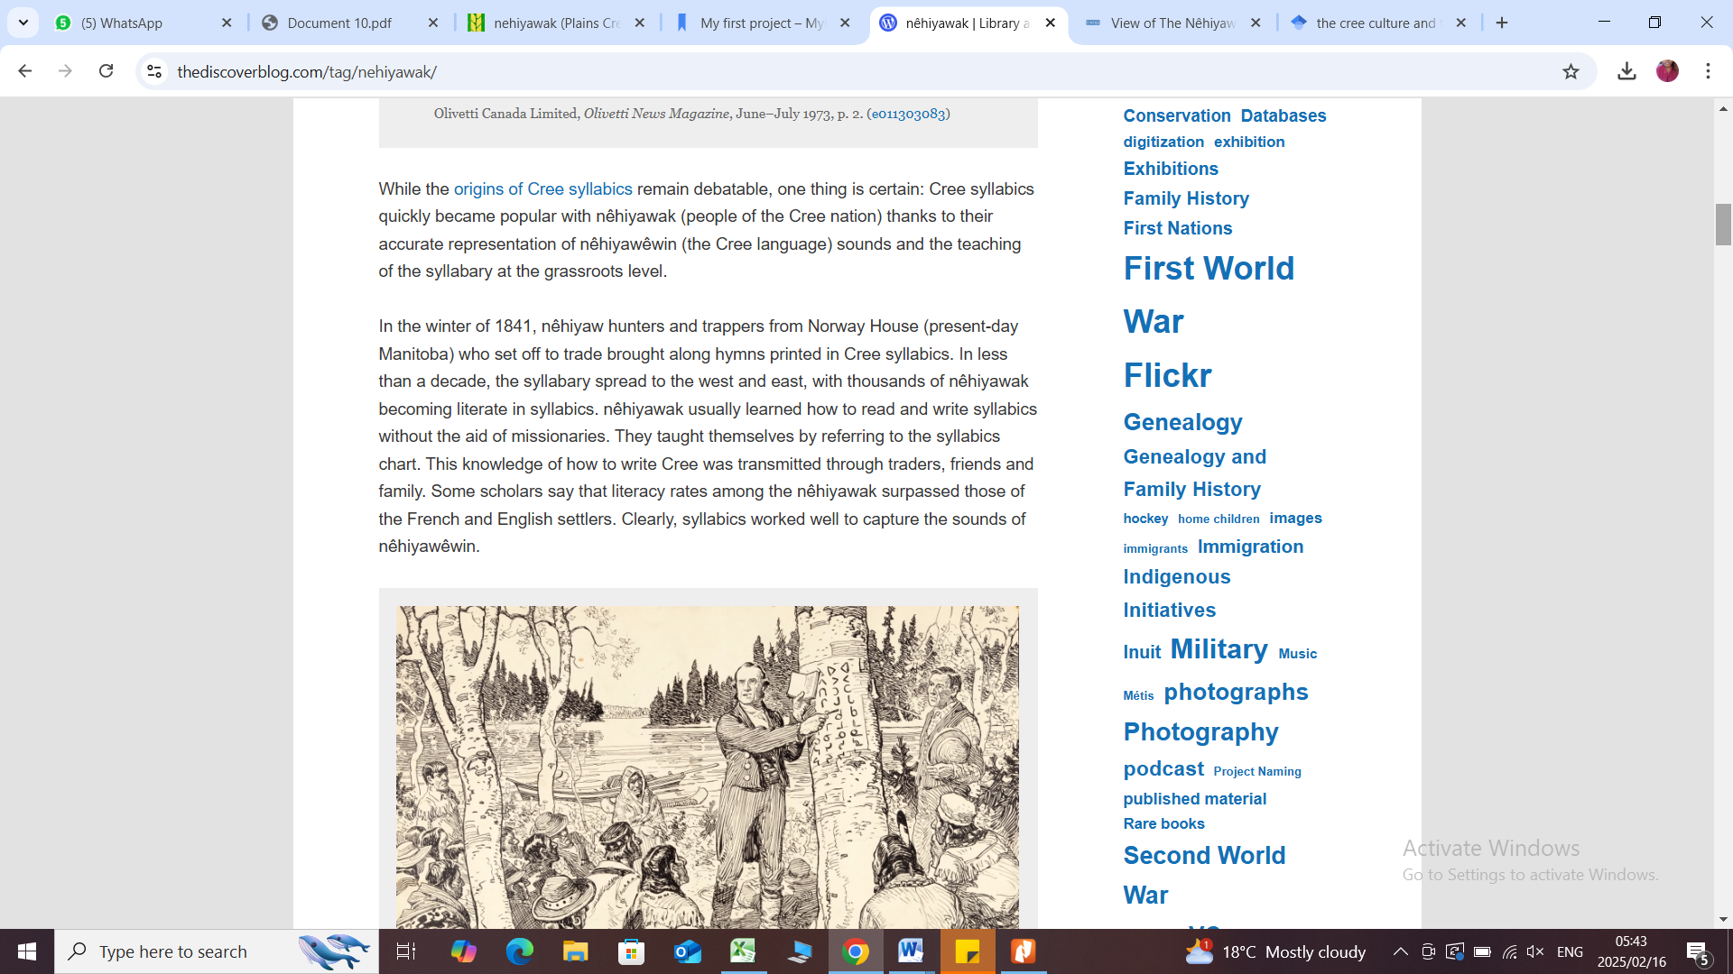

Hallowell (2017)

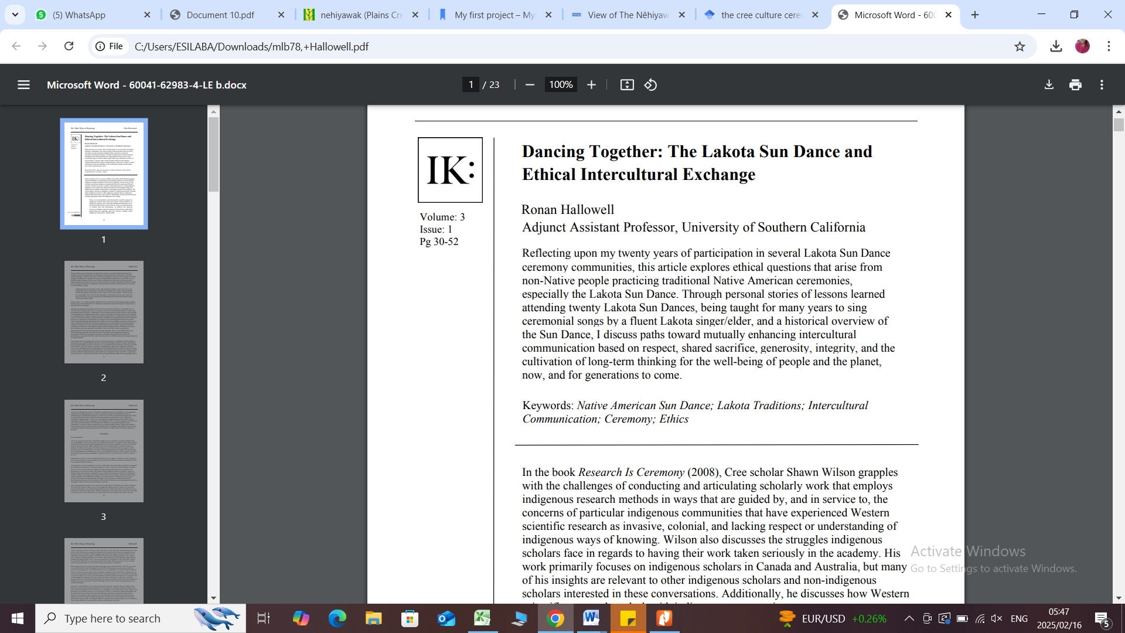

Fogarty (2024)

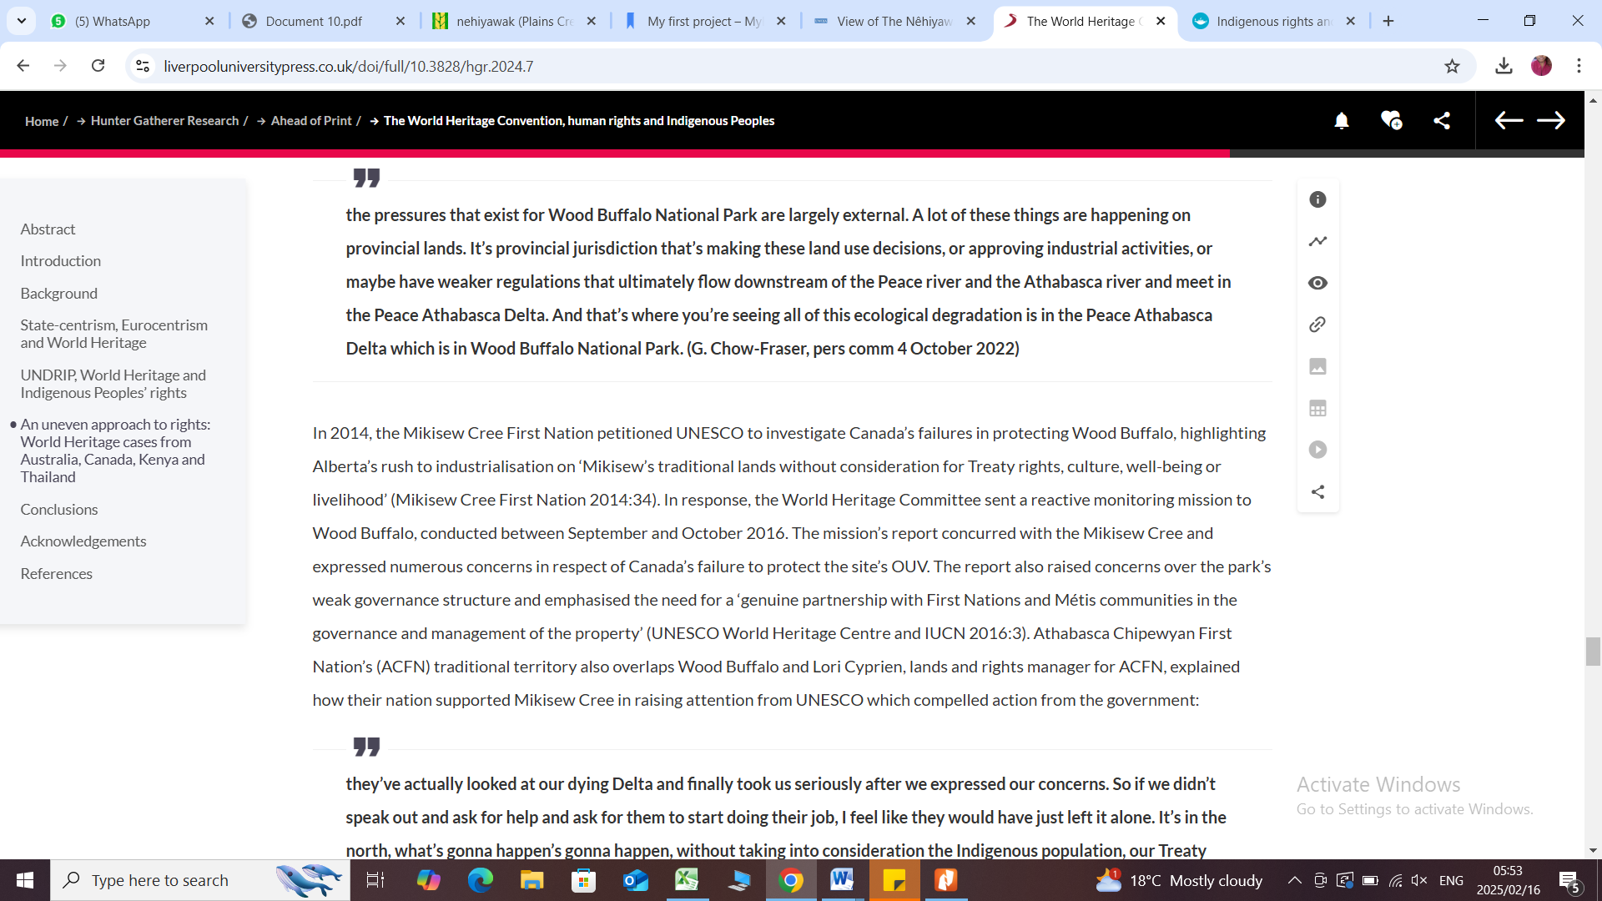

The Museum (2017)

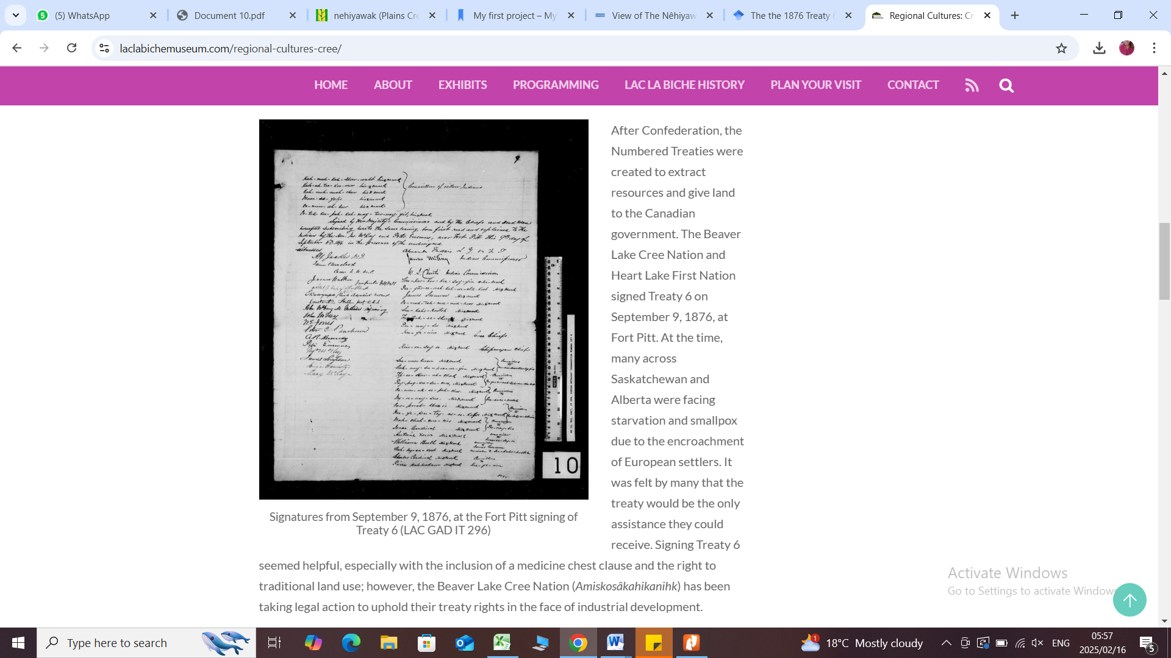

Belshaw et al. (2022)

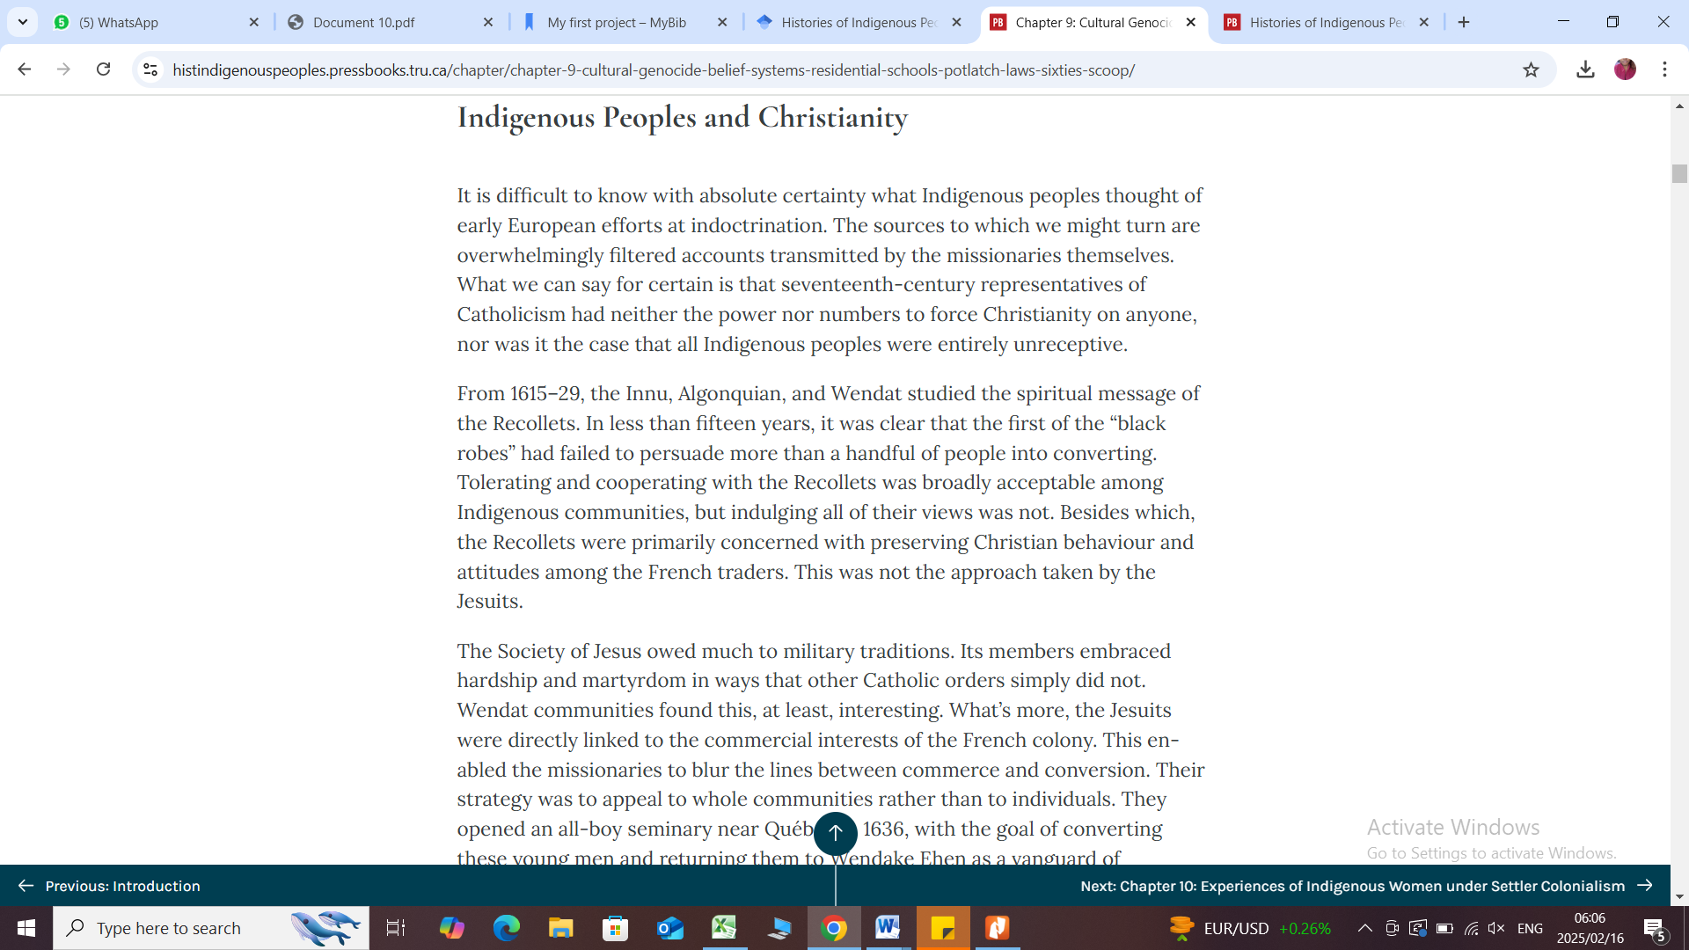

Thompson & Suzuki, 2022

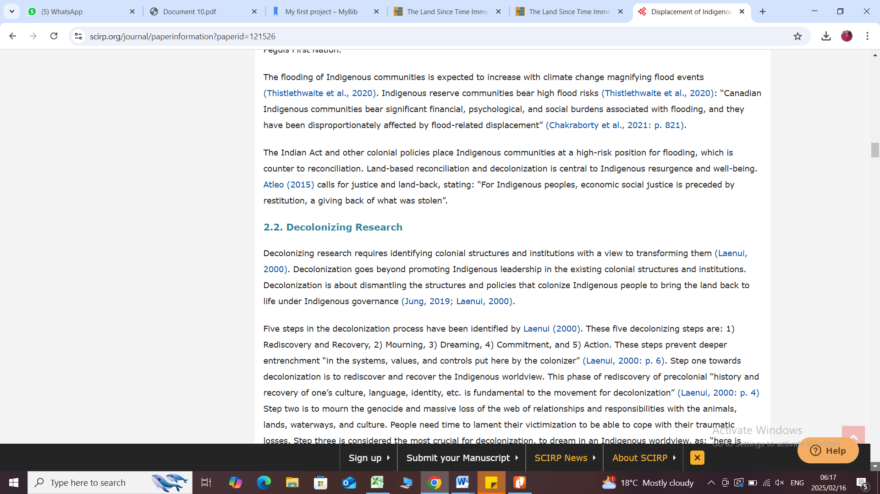

University of Saskatchewan (n.d.)

