### 作业2：（需提交，注意：作业提交均需要转成pdf格式）

脚本见教学资源 “作业2脚本”

1. **课本第三章习题：**

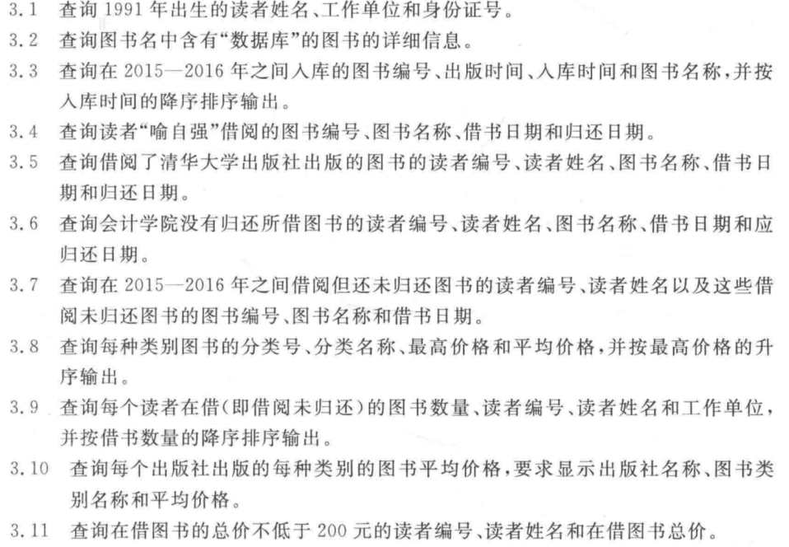

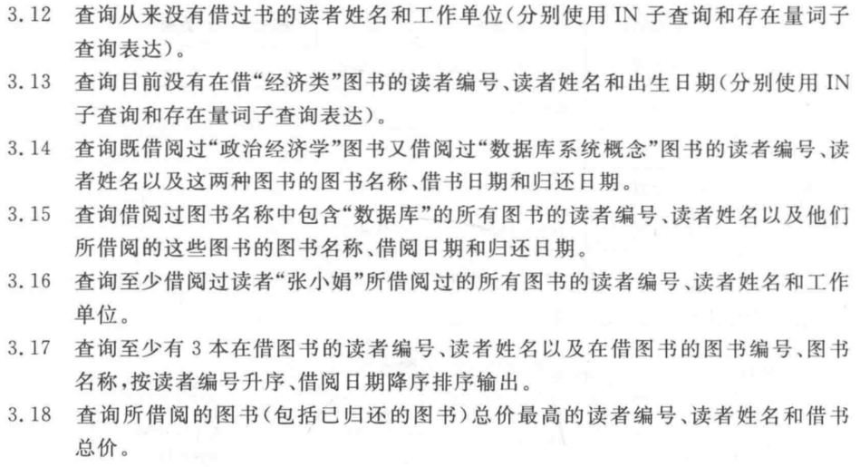

3.1

SELECT readerName, workUnit, identifycard

FROM Reader

3.2

SELECT *

FROM book

WHERE bookName LIKE '%数据库%';

3.3

SELECT bookNo,publishingDate,shopDate,bookName

FROM book

WHERE year(shopDate) IN (2015,2016)

ORDER BY shopDate DESC;

3.4

SELECT a.bookNo,bookName,borrowDate,returnDate

FROM borrow a,book b,reader c

WHERE a.bookNo=b.bookNo AND a.readerNo=c.readerNo AND readerName='喻自强'

3.5

SELECT a.readerNo,readerName,bookName,borrowDate,returnDate

FROM reader a,borrow b,book c,publisher d

WHERE a.readerNo=b.readerNo AND b.bookNo=c.bookNo

AND c.publisherNo=d.publisherNo

AND publisherName='清华大学出版社'

3.6

SELECT a.readerNo,readerName,bookName,borrowDate,shouldDate

FROM reader a,borrow b,book c

WHERE a.readerNo=b.readerNo AND b.bookNo=c.bookNo AND returnDate IS NULL

3.7

SELECT a.readerNo,readerName,c.bookNo,bookName,borrowDate

FROM reader a,borrow b,book c

WHERE a.readerNo=b.readerNo AND b.bookNo=c.bookNo AND year(borrowDate) IN (2015,2016) AND returnDate IS NULL

3.8

SELECT a.classNo,b.className,max(price),avg(price)

FROM Book a,BookClass b

WHERE a.classNo=b.classNo

GROUP BY a.classNo, b.className

ORDER BY max(price)

3.9

SELECT count(bookNo),a.readerNo,readerName,workUnit

FROM reader a,borrow b

WHERE a.readerNo=b.readerNo

GROUP BY bookNo, a.readerNo, readerName, workUnit

ORDER BY count(bookNo) DESC

3.10

SELECT publisherName,className,avg(price)

FROM book a,bookclass b,publisher c

WHERE a.classNo=b.classNo AND a.publisherNo=c.publisherNo

GROUP BY publisherName,className

3.11

SELECT a.readerNo,readerName,sum(price)

FROM reader a,borrow b,book c

WHERE a.readerNo=b.readerNo AND b.bookNo=c.bookNo AND returnDate IS NULL

GROUP BY a.readerNo, readerName

HAVING sum(price)>=200

3.12

SELECT readerName,workUnit

FROM reader

WHERE readerNo NOT IN (SELECT readerNo

FROM borrow)

3.13

SELECT readerNo,readerName 出生日期

FROM reader

WHERE readerNo NOT IN

(SELECT readerNo

FROM borrow

WHERE bookNo IN

(SELECT bookNo

FROM book

WHERE classNo IN

(SELECT classNo

FROM bookclass

WHERE className LIKE '%经济类%')))

3.14

SELECT a.readerNo,readerName,bookName,borrowDate,returnDate

FROM reader a,borrow b,book c

WHERE a.readerNo=b.readerNo AND b.bookNo=c.bookNo AND bookName IN ('政治经济学','数据库系统概念')

AND a.readerNo IN

(SELECT readerNo FROM borrow,book

WHERE borrow.bookNo=book.bookNo AND bookName='政治经济学' AND readerNo IN

(SELECT readerNo FROM borrow,book WHERE borrow.bookNo=book.bookNo AND bookName='数据库系统概念'))

3.15

SELECT a.readerNo,readerName,bookName,borrowDate,returnDate

FROM reader a,borrow b,book c

WHERE a.readerNo=b.readerNo AND b.bookNo=c.bookNo AND bookName LIKE '%数据库%'

3.16

SELECT a.readerNo,readerName,workUnit FROM reader a RIGHT JOIN borrow b ON a.readerNo=b.readerNo

WHERE bookNo IN

(SELECT bookNo FROM reader a,borrow b WHERE a.readerNo=b.readerNo AND readerName='张小娟')

GROUP BY a.readerNo, readerName,workUnit

HAVING count(DISTINCT bookNo)>=3

3.17

SELECT a.readerNo,readerName,c.bookNo,bookName

FROM reader a,borrow b,book c

WHERE a.readerNo=b.readerNo AND b.bookNo=c.bookNo AND returnDate IS NULL

GROUP BY a.readerNo , readerName, c.bookNo, bookName

HAVING count(b.bookNo)>=3

3.18

SELECT sum(price),readerNo, a.bookNo num

FROM Book a, Borrow b

WHERE a.bookNo=b.bookNo

GROUP BY readerNo, a.bookNo, a.price

ORDER BY sum(price) DESC