Open Geospatial Consortium Inc.
Date: 2007-04-03
Reference number of this OpenGIS© document: OGC 07-002r1
Version: 0.1.2
Category: OpenGIS© Discussion Paper
Editor: Simon Cox
Observations and Measurements –
Part 2: Sampling Features

Copyright notice
To obtain additional rights of use, visit http://www.opengeospatial.org/legal/.

Warning
This is an OGC Best Practices document, which represents an official position of the OGC membership. This document is not an OGC Standard.
Recipients of this document are invited to submit, with their comments, notification of any relevant patent rights of which they are aware and to provide supporting documentation.

Document type: OpenGIS© Best Pratices Document
Document subtype: if applicable
Document stage: Draft
Document language: English
Contents
i. Preface v
ii. Submitting organizations v
iii. Document contributor contact points vi
iv. Revision history vi
v. Changes to the OpenGIS® Specification vi
vi. Future work vii
Introduction ix
1 Scope 1
2 Conformance 1
2.1 Overview 1
2.2 Conformance classes related to Application Schemas including Sampling Features 2
3 Normative references 2
4 Terms and definitions 3
5 Conventions 6
5.1 Symbols (and abbreviated terms) 6
5.2 UML notation 6
5.3 Document terms and definitions 7
6 Observations and sampling 8
6.1 Overview of observation model 8
6.2 Requirement for Sampling Features 9
6.2.1 General 9
6.2.2 Observable property is not of ultimate interest 9
6.2.3 Proximate feature embodies a sample design 9
6.2.4 Combination 9
6.3 Cross-domain application 9
7 Sampling features 11
7.1 Basic Sampling Feature 11
7.2 Sampling manifolds 13
7.3 Specimen 14
7.4 XML Implementation 15
8 Discussion 16
ANNEX A (normative) Abstract test suite for Sampling Features schemas 17
ANNEX B (informative) XML Schema implementation 18
1 GML Application Schema 18
2 Sampling features schema 18
2.1 Namespace 18
2.2 samplingBase.xsd 18
2.3 samplingManifold.xsd 21
2.4 specimen.xsd 24
2.5 surveyProcedure.xsd 25
2.6 sampling.xsd 27
ANNEX C (informative) XML implementation - examples 28
1 Introduction 28
2 Sampling station 28
3 Sampling profile 29
4 Specimen 30
Bibliography 32

Figures
Figure 1. Summary of O&M model, taken from OGC 07-022 8
Figure 2. Basic model for sampling features 12
Figure 3. (Informative) Basic model for Survey Procedure 13
Figure 4. A hierarchy of types used for observation sampling. 14
Figure 5. Specimen model 15

Code Listings
Listing 1. samplingBase.xsd 18
Listing 2. samplingManifold.xsd 21
Listing 3. specimen.xsd 24
Listing 4. surveyProcedure.xsd 26
Listing 5. Sampling.xsd 27
Listing 6. Station1.xml 28
Listing 7. Station2.xml 29
Listing 8. Profile1.xml 29
Listing 9. Specimen1.xml 30

- Preface
This Discussion Paper was produced as part of the OGC’s Sensor Web Enablement (SWE) activity.
Suggested additions, changes, and comments on this report are welcome and encouraged. Such suggestions may be submitted by OGC portal message, email message, or by making suggested changes in an edited copy of this document.
The changes made in this document version, relative to the previous version, are tracked by Microsoft Word, and can be viewed if desired. If you choose to submit suggested changes by editing this document, please first accept all the current changes, and then make your suggested changes with change tracking on.
- Submitting organizations
The following organizations submitted this document to the Open GIS Consortium Inc.
Commonwealth Scientific and Industrial Research Organisation (Australia) (CSIRO)
Council of the Central Laboratories of the Resarch Councils (UK)
Geoscience Australia
- Document contributor contact points
All questions regarding this document should be directed to the editor or the contributors:
Contact | Company | Address | Phone | Email
Simon Cox (Editor) | CSIRO Exploration and Mining | ARRC  PO Box 1130  Bentley  WA 6102  Australia | +61 8 6436 8639 | Simon.Cox@csiro.au
Andrew Woolf | Data Management Group, e-Science Centre, | Rutherford-Appleton Laboratory, Chilton, Didcot, Oxon. OX11 0QX, United Kingdom | +441235778027 | A.Woolf@rl.ac.uk
- Revision history
Date | Release | Editor | Primary clauses modified | Description
2007-01-15 | 0.1.0 | Simon Cox | Baseline version | OGC Discussion Paper produced by refactoring 05-087r4 and revising
2007-01-24 | 0.1.1 | Simon Cox | Annex B, Annex C | Added examples; updated schemas to match SWE 1.0 candidate
2007-02-06 | 0.1.2 | Simon Cox, Andrew Woolf | 6.2, 6.3, 6.4, 7 | Clarifications in text of clause 6; rename extensive sampling features to neutral terms (SamplingPoint, etc); add clause 7 (discussion)
- Changes to the OpenGIS® Specification
The OpenGIS© Specification requires changes to accommodate the technical contents of this document. The following is a list of the required changes:
- O&M describes a property-value provider model, linked to the ISO 19109 GFM, under which features are the generic carriers of properties. However, ISO 19123 provides a model for describing properties that vary with spatio-temporal location. For consistency between the GFM and the Coverage model, it appears that every coverage must be related to one or more “features” of some type that may logically carry the property whose variation is described. This may be trivial – e.g. the “medium” whose extent matches the domain-extent of the coverage (e.g. atmosphere, ocean, earth) – and may merely be described in the coverage “metadata”. But it is nonetheless required to add a notion of “the feature carrying the coverage” to ISO 19123 in order to make it consistent with the GFM.
- Introduce new stereotype <<estimatedProperty>> to the UML profile, to be used on attributes and association-roles to mark those properties whose value is amenable to determination by application of an observation procedure and is there for an estimate, in contrast to those properties whose value is assigned by an authority and therefore exact. This may flow through in implementation to a mechanism to resolve the “Observation” that provided the value-estimate (i.e. a property-metadata syntax).

- Future work
Improvements in this document are desirable to

Foreword
Attention is drawn to the possibility that some of the elements of this document may be the subject of patent rights. Open Geospatial Consortium Inc. shall not be held responsible for identifying any or all such patent rights. However, to date, no such rights have been claimed or identified.
Observations and Measurements consists of the following parts:
-  Part 1: Observation schema (OGC 07-022)
-  Part 2: Sampling features (OGC 07-002) (this document)
Part 2 replaces the OGC Recommendation Paper 05-087r4 Observations and Measurements clauses 1-5, 7 and Annexes. The following changes have been made to the model presented earlier:

The cardinality of the sampledFeature association role has been changed from [0..1] to [1..*]. (a) it is considered important to require at least one sampled feature, to recognise the intention of the sampling strategy, and (b) it is possible for a sampling feature to relate to more than one domain feature, often referring to a range of scales.
- Additional labels have been added to some class associations
- Formal constraints have been added to some classes, to complement normative directions provided in the text of the specification
A set of XML schemas implementing the model as a GML Application Schema is provided in ANNEX B.

Introduction
OGC’s Sensor Web Enablement (SWE) activity, which is being executed through the OGC Web Services (OWS) initiatives (under the Interoperability Program) and the SWE Working Group (under the Specification Program), is establishing the interfaces and protocols that will enable a “Sensor Web” through which applications and services will be able to access sensors of all types over the Web. These initiatives have defined, prototyped and tested several foundational components needed for a Sensor Web.
This document specifies Sampling Features. This report is part of a refactoring of a number of elements originally all described as part of the Observations and Measurements specification.
This work was supported by OGC through the OWS-4 Interoperability project, by the Water Resources Observation Network activity based at CSIRO Australia, and by Geoscience Australia.

OGC Abstract Specification — Observations and Measurements –
Part 2: Sampling Features

Scope
We describe a conceptual model and encoding for sampling features. These feature-types are typically associated with making observations producing estimates of property values that are in some way representative of a domain feature. Sampling features embody a sampling strategy that is suitable for the observation procedure and the observed property. Hence, sampling features are artefacts of the observation process rather than the inherent domain semantics. Similar sampling strategies are used across a wide range of application domains so a common sampling features schema may be described.
Instances of sampling features may act as the proximate feature-of-interest for observations [O&M-1], particularly early in the value-adding chain.

Conformance

Overview
Clause 6 of this Specification uses the Unified Modeling Language (UML) to present conceptual schemas for describing Sampling Features. These schemas define conceptual classes that (i) may be considered to comprise a cross-domain application schema, or (ii) may be used in application schemas, profiles and implementation specifications. The document concerns ONLY externally visible interfaces and places no restriction on the underlying implementations other than what is needed to satisfy the interface specifications in the actual situation.
ANNEX B of this Specification specifies XML Schema components, in the form of GML Application Schemas that implement the conceptual model in accordance with ISO 19136.
This clause defines a set of conformance classes that will support applications whose requirements range from the minimum necessary to define data structures to full object implementation.
This flexibility is controlled by a set of UML types that can be implemented in a variety of manners. Common names for “metaphorically identical” but technically different entities are acceptable. The UML model in this Specification defines conceptual classes, various software systems define implementation classes or data structures, and the XML following the encoding standard (ISO 19136) defines entity tags. All of these reference the same information content. There is no difficulty in allowing the use of the same name to represent the same information content even though at a deeper level there are significant technical differences in the digital entities being implemented. This allows types defined in the UML model to be used directly in application schemas.

Conformance classes related to Application Schemas including Sampling Features
The conformance rules for Application Schemas in general are described in ISO 19109. Application Schemas also claiming conformance to this Specification shall also pass all relevant test cases of the Abstract Test Suite in ANNEX A. Depending on the characteristics of an Application Schema, NN conformance classes are distinguished. Table 1 lists these classes and the corresponding Subclause of the AbstractTest Suite.
Table 1 — Conformance classes related to Application Schemas including Sampling Features
Conformance class | Subclause of the Abstract Test Suite

TBC

Normative references
The following normative documents contain provisions which, through reference in this text, constitute provisions of this document. For dated references, subsequent amendments to, or revisions of, any of these publications do not apply. For undated references, the latest edition of the normative document referred to applies.
IETF RFC 2396, Uniform Resource Identifiers (URI): Generic Syntax. (August 1998)
ISO 1000:1994, SI units and recommendations for the use of their multiples and of certain other units.
ISO 8601:2004, Data elements and interchange formats — Information interchange Representation of dates and times
ISO/IEC 11404:1996, Information technology — Programming languages, their environments and system software interfaces – Language-independent datatypes
ISO 19101:2003, Geographic Information--ReferenceModel
ISO/TS 19103:2006, Geographic Information — Conceptual schema language
ISO 19107:2003, Geographic Information — Spatial schema
ISO 19109:2006, Geographic Information — Rules for application schemas
ISO 19110:2006, Geographic Information – Feature cataloguing methodology
ISO 19115:2003, Geographic Information — Metadata
ISO 19118:2005, Geographic Information — Encoding
ISO 19123:2005, Geographic Information — Coverages
ISO DIS 19136:2006, Geographic Information — Geography Markup Language
ISO/FDTS 19139:2006, Geographic Information — Metadata — XML schema implementation
ISO/IEC 19757-3:2006, Information technology -- Document Schema Definition Language (DSDL) -- Part 3: Rule-based validation -- Schematron

OpenGIS® Discussion Paper GML Encoding of Discrete Coverages (interleaved pattern), OGC document 06-188.
OpenGIS® Engineering Specification Observations and Measurements – Part1: Observation Schema. OGC Document 07-022 http://www.opengeospatial.org/
UCUM, Unified Code for Units of Measure, Schadow, G. and McDonald, C. J. (eds.), <http://aurora.rg.iupui.edu/UCUM>
W3C XLink, XML Linking Language (XLink) Version 1.0. W3C Recommendation (27 June 2001)
W3C XML, Extensible Markup Language (XML) 1.0 (Second Edition), W3C Recommendation (6 October 2000)
W3C XML Namespaces, Namespaces in XML. W3C Recommendation (14 January 1999)
W3C XML Schema Part 1, XML Schema Part 1: Structures. W3C Recommendation (2 May 2001)
W3C XML Schema Part 2, XML Schema Part 2: Datatypes. W3C Recommendation (2 May 2001)

Terms and definitions
For the purposes of this document, the following terms and definitions apply.

application schema
conceptual schema for data required by one or more applications
[ISO 19101]

coverage
feature that acts as a function to return values from its range for any direct position within its spatiotemporal domain
[ISO 19123]

data type
specification of a value domain with operations allowed on values in this domain
[ISO/TS 19103]
EXAMPLE Integer, Real, Boolean, String, Date (conversion of a data into a series of codes).
Data types include primitive predefined types and user-definable types. All instances of a data types lack identity.

feature
abstraction of real world phenomena
[ISO 19101]
A feature may occur as a type or an instance. Feature type or feature instance should be used when only one is meant.

GML application schema
application schema implemented according to ISO 19136

namespace <XML>
collection of names, identified by a URI reference, which are used in XML documents as element names and attribute names [W3C XML Namespaces]

observation (noun)
an act of observing a property or phenomenon, with the goal of producing an estimate of the value of the property. A specialized event whose result is a data value.
[OGC O&M]

phenomenon
concept that is a characteristic of one or more feature types, the value for which may be estimated by application of some procedure in an observation. Synonym for property-type in this specification.

procedure
method, algorithm or instrument
[OGC O&M]

property <General Feature Model>
characteristic of a feature type, including attribute, association role, defined behaviour, feature association, specialization and generalization relationship, constraints
[ISO 19109]

property-type
concept that is a characteristic of one or more feature types, the value for which may be estimated by application of some procedure in an observation. Synonym for phenomenon in this specification.

result
an estimate of the value of some property generated by a known procedure
[OGC O&M]

sampling
a process whereby subelements of a feature are used to represent the whole

schema
formal description of a model
[ISO 19101]
In general, a schema is an abstract representation of an object's characteristics and relationship to other objects. An XML schema represents the relationship between the attributes and elements of an XML object (for example, a document or a portion of a document)

value
member of the value-space of a datatype. A value may use one of a variety of scales including nominal, ordinal, ratio and interval, spatial and temporal. Primitive datatypes may be combined to form aggregate datatypes with aggregate values, including vectors, tensors and images [ISO11404].

Conventions

Symbols (and abbreviated terms)
GFM General Feature Model
GML Geography Markup Language
ISO International Organization for Standardization
O&M Observations and Measurements [OGC]
OGC Open Geospatial Consortium
OWS OGC Web Services
SensorML Sensor Model Language
SAS Sensor Alert Service
SOS Sensor Observation Service
SPS Sensor Planning Service
SWE Sensor Web Enablement
UML Unified Modeling Language
WXS W3C XML Schema Definition Language
XML Extensible Markup Language
1D One Dimensional
2D Two Dimensional
3D Three Dimensional

UML notation
Most diagrams that appear in this specification are presented using the Unified Modeling Language (UML) static structure diagram, as described in Subclause 5.2 of the OGC Web Services Common Implementation Specification [OGC 04-016r2].
Many of the models refer to classes from various models in the ISO 19100 series of international standards. In this document these components have been imported from the ISO Harmonized Model as of 2004-05-11.
The UML is conformant with the profile described in ISO 19103 and ISO 19136 (GML) Annex E. Use of this restricted idiom supports direct transformation into a GML Application Schema.
The prose explanation of the model uses the term “property” to refer to both class attributes and association roles. This is consistent with the General Feature Model described in ISO 19109. In the context of properties, the term “value” refers to either a literal (for attributes whose type is simple), or to an instance of the class providing the type of the attribute or target of the association. Within the explanation, the property names are sometimes used as natural language words where this assists in constructing a readable text.

Document terms and definitions
This document uses the specification terms defined in Subclause 5.3 of [OGC 04-016r2].

Observations and sampling

Overview of observation model
A model for Observations and Measurements (O&M), based on patterns described by Fowler [1999] is formalized in O&M Part 1. The core model is summarized in Figure 1.
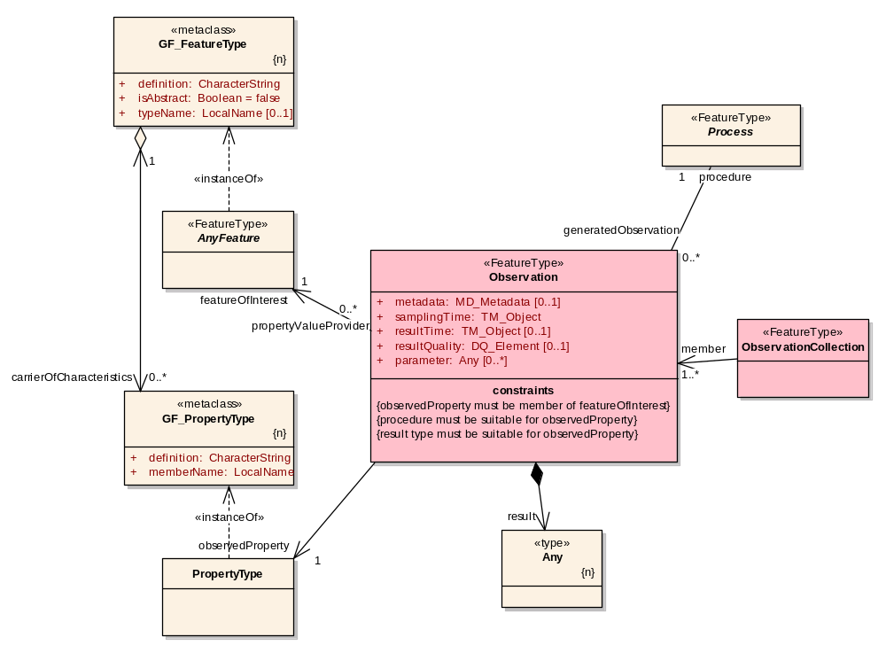
- Summary of O&M model, taken from OGC 07-022
The class named “AnyFeature” represents the set of all classes with the stereotype <<FeatureType>>. In an implementation this abstract class will be substituted by a concrete class representing a feature type from a domain of discourse. This class is implemented in GML by the element gml:AbstractFeature.
A key to the model is the relationship between an Observation and its feature-of-interest. The Observation acts as property-value-provider for the feature of interest. There is a related constraint that the observed-property of the Observation must be a member property of the feature-of-interest, i.e. it must be a valid property in the definition for the target class of the association end having the roleName featureOfInterest.
The feature of interest may be any feature having properties whose values are discovered by observation. In general, this will be of a type from catalogue representing the application domain for an investigation [ISO 19109, ISO 19110].

Requirement for Sampling Features

General
The proximate feature of interest of the initial observation may not be the ultimate domain-specific feature, whose properties are of interest in the investigation of which the observation is a part. There are two circumstances that can lead to this: (i) the observation procedure obtains values for properties that are not characteristic of the type of the ultimate feature; (ii) the observation does not directly sample the whole of a domain feature. Furthermore, in some practical situations, both differences apply.

Observable property is not of ultimate interest
The procedure for obtaining values of the property of interest may be indirect, relying on direct observation of primitive parameters, to which an algorithm or processing chain is applied to obtain an estimate of the ultimate property of interest. For coherence with the propertyValueProvider-featureOfInterest association, a feature of a type that carries the observed property must be identified as the feature of interest of the initial observation.
Example: A remote sensing observation may obtain the reflectance colour, when the investigation is actually interested in vegetation type and quality. The feature which contains reflectance colour is a scene or swath, while the feature carrying vegetation properties is a field or tract.

Proximate feature embodies a sample design
For various reasons, the domain feature may not be fully accessible. In such circumstances, the procedure for estimating the value of a property of the domain feature involves sampling in a representative location(s). Then the procedure for transforming a property value observed on the proximate feature to an estimate of the property on the ultimate feature of interest depends on knowledge of the relationship of the sampling feature with the domain feature.
Example: The chemistry of water in underground aquifer is sampled at one or more positions in a well or bore.
Example: The magnetic field of the earth is sampled at positions along a flight-line.
Example: The structure of a rock mass is observed on a cross-section exposed on a road-cut.

Combination
In some situations, these two variations are combined, if (i) direct observation of the domain feature is impractical, and (ii) it is more convenient to make direct measurement of a property only related to the one of interest.
Example: For certain styles of mineralization, the average gold concentration of rocks in a region may be estimated through measurement of a related element (e.g. copper), in a specimen of gravel collected in a the stream at a convenient position downstream of the outlet of a catchment covering a proportion of the region. The gravel is assumed to sample the rocks in the stream bed and upslope.

Cross-domain application
A small number of sampling patterns are common in observational science. These are the basis of processing and portrayal tools which are similar across domains and depend primarily on the geometry of the sample design. This specification is concerned with describing such generic feature types to support description of sample design.
Sampling features are artefacts of an observational strategy, and have no significant function outside of their role in the observation process. The physical characteristics of the features themselves are of little interest, except perhaps to managers of a sampling campaign.
Example: A “station” is essentially an identifiable locality where a sensor system or procedure may be deployed and an observation made. In the context of the observation model, it connotes the “world in the vicinity of the station”, so the observed properties relate to the physical medium at the station, and not to an artefact such as a mooring, benchmark, monument, well, etc.
Common names for sampling features include specimen, station, profile, swath, scene, and specializations of these. Most of these may be classified by their spatio-temporal dimensionality, corresponding to a small number of patterns, as shown in sub-clause 8.2.

Sampling features

Basic Sampling Feature
The base model for sampling features is shown in Figure 2.
A SamplingFeature must be associated with one or more other features through an association role sampledFeature. This association records the intention of the sample design. The target of this association will often be a domain feature.
Examples: a profile typically samples a water- or atmospheric-column; a well samples an aquifer; a tissue specimen samples a part of an organism
A SamplingFeature is distinguished from typical domain feature types in that it has a set of [0..*] navigable associations with Observations, given the rolename relatedObservation. This complements the association role “featureOfInterest” which is constrained to point back from the Observation to the SamplingFeature.
The usual requirement of a feature-of-interest is that its type has a property matching the value of the observedProperty on an Observation. However, in the case of Sampling-features, the topology of the model and navigability of the relatedObservation role means that this requirement is relaxed: the value of any observed property is given by traversing the relatedObservation association role to the Observation result.
Sampling features are frequently related to each other, as parts of complexes, networks, through sub-sampling, etc. This is supported by the relatedSamplingFeature association with a SamplingFeatureRelation association class, which carries a source, target and role.
Examples:
A SamplingFeatureCollection is a concrete specialization which has the specialized relation member. The sampledFeature property is required, and provides the only homogeneity constraint on collections.
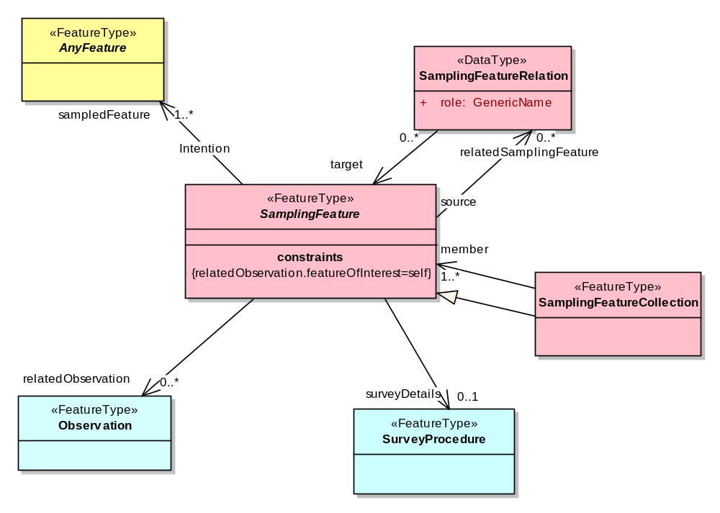
- Basic model for sampling features
The class named “AnyFeature” represents the set of all classes with the stereotype <<FeatureType>>. In an implementation this abstract class will be substituted by a concrete class representing a feature type from a domain of discourse, including SamplingFeature.

A common requirement for sampling features is an indication of the SurveyProcedure that provides the surveyDetails related to determination of its location and shape. A simple model for a SurveyProcedure class is shown in Figure 3.
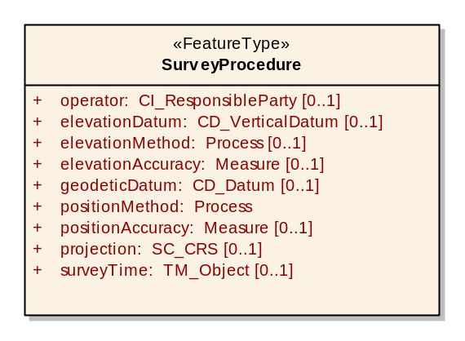
- (Informative) Basic model for Survey Procedure

Sampling manifolds
A hierarchy of concrete sampling feature types may be organized on the basis of the dimensionality of their shape (Figure 4). A SamplingPoint samples its target at a point (0-manifold); a SamplingCurve along a curve (1-manifold); a SamplingSurface on a surface (2-manifold); a SamplingSolid in an enclosed solid region (3-manifold).
In ISO 19109 sub-clause 8.6 Figure 17 shows a model of a Station and its associated Measurements as an example application schema.
SpatiallyExtensiveSamplingFeatures may have properties whose values vary over their extent, and which may also vary with time and with other parameters. Where the variation is only with time or space, the value of the property may be described as a coverage [ISO 19123].
The shape of a sampling feature defines a manifold within which the varying property may be characterized and within which further subsampling may be undertaken. The shape provides a complete sampling domain, but does not specify the domain elements of the discrete coverage representation of the variation of a property within the sampling feature. The shape of the sampling feature is the context for domain decomposition.
Example: Logs of different properties along a well or borehole may use different intervals, and sub-samples may be either spatially instantaneous, or averaged in some way over an interval. The position of the samples may be conveniently described in terms of offsets in a linear coordinate reference system that is defined by the shape of the well axis.
Some additional properties for the different sampling features relate to the geometry (length, area, volume). While these properties are computable from a description of the feature geometry, in practice they are often recorded separately so are included in the model here.
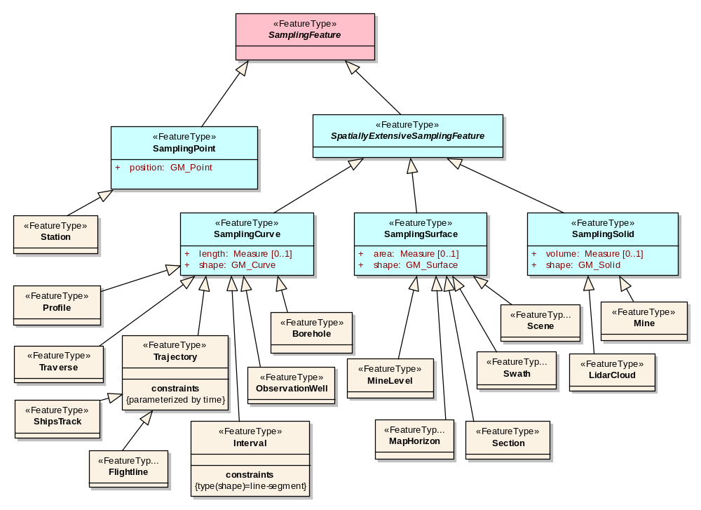
- A hierarchy of types used for observation sampling.
Some common names used in application domains to denote sampling features include Flightline, Interval, LidarCloud, ObservationWell, Profile, Scene, Section, ShipsTrack, Station, Swath, Trajectory, Traverse, etc. These are shown non-normatively as specialized feature types, for illustration only.
Time dependent properties arise if a sampling feature is time-persistent, with properties whose values vary with time. Hence, the value of the timeDependentProperty is a Coverage [ISO 19123] whose domain decomposition is primarily on the time axis. The value of the timeDependentProperty is a Function.
Example: The elevation of the collar of an observation-well is fixed.
Example: The temperature of the atmosphere at a weather station varies as a function of time.
Example: The density of a specimen varies as a function of temperature.

Specimen
A Specimen (Figure 5) is a physical sample, obtained for observation(s) usually carried out ex situ, often in an analytical laboratory.
A specimen is characterized by having a currentLocation (e.g. its storage location) and a measure of its currentSize (e.g. mass) and gross materialClass (e.g. soil, water, rock, tissue, etc). The samplingMethod may also be recorded. In many applications a specimen preparation procedure is applied to the material prior to its use in an observation. This may be recorded as part of the observation procedure, or may be associated with the specimen. The optional processingDetails property supports the latter pattern.
The sampling-location and -time may be determined by reference to a relatedSamplingFeature (e.g. a SamplingPoint) or to its sampledFeature (typically a domain feature) and to the samplingMethod. Alternatively, LocatedSpecimen is a specialization that carries this information directly.
Several of the properties characteristic of specimens are normally obtained by observation, so these are stereotyped <<estimatedProperty>>.

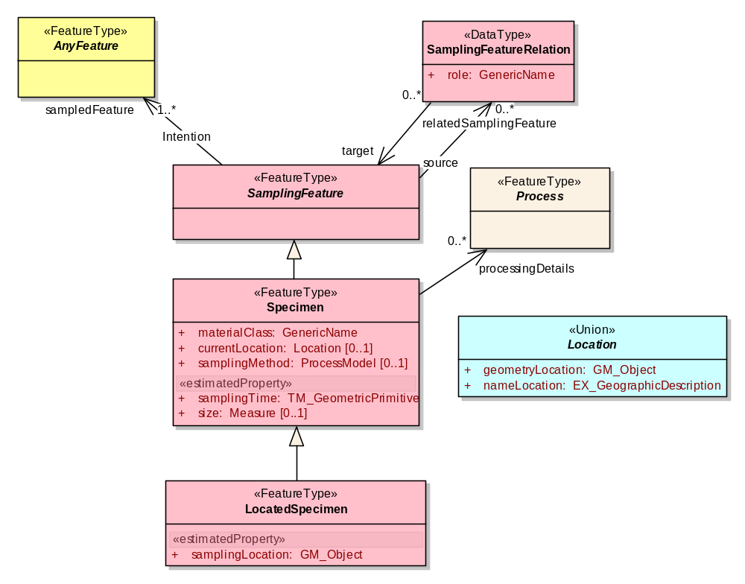
- Specimen model

XML Implementation
An explicit XML implementation of the sampling features model as a GML Application Schema is presented in ANNEX B clause 2.

Discussion

Observation feature of interest
Application of the Observations and Measurements model requires careful attention to identify the feature of interest correctly. This may be straightforward if the observation is clearly concerned with an easily identified concrete feature type from a domain model. However, in some cases the ultimate feature of interest to the investigator may not be the proximate feature of interest for the observation. And in some cases a careful analysis reveals that the type of the feature of interest is something that had not previously been identified in the application domain.
The key is that the proximate feature of interest must be capable of carrying this result as the value of a relevant property. So a useful approach in analysis is to consider what the result of the observation is, and then the feature of interest may be deduced since it must have a property with this result as its value. If an observation produces a result with several components, or if there are a series of related observations with different results, then this may help further refine the understanding the type of the true feature of interest.
In monitoring situations, the feature of interest is often a typed event or “occurrence”. The observation procedure(s) provides an estimate of (i) time, (ii) location, and (iii) type (e.g. species, identity) of the party involved.

Processing chains and intermediate features of interest
The Observation model implies a direct relationship between the observed property and the type of the feature of interest (e.g. a specimen type has a property ‘mass’ & observation observed property is ‘mass’). However, as discussed in sub-clause Error: Reference source not found, the relationship between the observed property and property(ies) of the ultimate feature-of-interest is often more complex.
One motivation for the Sampling Feature model is to provide a mechanism for preserving this strict association – by introducing a Sampling Feature with a (soft-typed) property appropriate to the observation. The path from the sensed property of the sampling feature, to the interesting property on the ultimate feature-of-interest is then modelled as a processing chain.
If intermediate values are made available, then application of the processing chain may be modelled as a sequence of “observations”, with intermediate features of interest carrying the intermediate property-types. Each intermediate value must apply to a feature-of-interest that bears this property. Note that the types of these features may not be conventional or immediately recognisable, but the coherence of the Observations and Measurements model does imply their existence. Hence, if any intermediate result is made explicit, then a suitable intermediate feature must also be identified.

- (normative)
Abstract test suite for Sampling Features schemas
TBC
- (informative)
XML Schema implementation

GML Application Schema
The models presented in this specification use the UML profile described in ISO 19103 and ISO DIS 19136. This allows a GML Application Schema to be generated by following the encoding rules in ISO DIS 19136. This implementation provides an explicit representation of the model, with XML elements carrying the literal names that appear in the model.

Sampling features schema

Namespace
The Sampling Features schema is in the namespace http://www.opengis.net/sampling/0.0

samplingBase.xsd
This document implements the basic SamplingFeature and SamplingFeatureRelation classes described in sub-clause 8.1 and shown in Figure 2, together with Station described in sub-clause 8.2 and shown in Figure 4.
- samplingBase.xsd
<?xml version="1.0" encoding="UTF-8"?>
<schema xmlns:gml="http://www.opengis.net/gml" xmlns:cv="http://www.opengis.net/cv/0.0" xmlns:gmd="http://www.isotc211.org/2005/gmd" xmlns:swe="http://www.opengis.net/swe/0.0" xmlns:om="http://www.opengis.net/om/0.0" xmlns="http://www.w3.org/2001/XMLSchema"
xmlns:sa="http://www.opengis.net/sampling/0.0" targetNamespace="http://www.opengis.net/sampling/0.0" elementFormDefault="qualified" attributeFormDefault="unqualified" version="0.0">
<annotation>
<documentation>samplingBase.xsd
Sampling features are feature types that are used primarily for making observations:
Station (0-D), SamplingFeature, and collections are described in this schema document
Profile, Interval, Traverse, Flightline, Borehole (1-D)
SurfaceOfInterest, Swath (2-D)
SolidOfInterest (3-D) are described in extensiveSite.xsd
Copyright (c) 2007 Open Geospatial Consortium - see http://www.opengeospatial.org/about/?page=ipr</documentation>
</annotation>
<!-- ====================================================================== -->
<!-- bring in other schemas -->
<import namespace="http://www.opengis.net/gml" schemaLocation="http://schemas.opengis.net/gml/3.1.1/base/gml.xsd"/>
<import namespace="http://www.isotc211.org/2005/gmd" schemaLocation="../../../../gml/trunk/gml/3.1.1/gmd/gmd.xsd"/>
<import namespace="http://www.opengis.net/cv/0.0" schemaLocation="../../cv/0.0.0/cv.xsd"/>
<import namespace="http://www.opengis.net/swe/0.0" schemaLocation="../../sweCommon/current/swe.xsd"/>
<import namespace="http://www.opengis.net/om/0.0" schemaLocation="../../om/current/om.xsd"/>
<include schemaLocation="./surveyProcedure.xsd"/>
<!-- ====================================================================== -->
<!-- ====================================================================== -->
<!-- ===== Feature types in Site hierarchy ====== -->
<!-- ====================================================================== -->
<complexType name="SamplingFeatureType">
<annotation>
<documentation>A "SamplingFeature" is a feature used primarily for taking observations.</documentation>
</annotation>
<complexContent>
<extension base="gml:AbstractFeatureType">
<sequence>
<element name="sampledFeature" type="gml:FeaturePropertyType" maxOccurs="unbounded">
<annotation>
<documentation>Pointer to the feature(s) being sampled, indicating the intention of the samplingFeature</documentation>
</annotation>
</element>
<element name="relatedObservation" type="om:AbstractObservationPropertyType" minOccurs="0" maxOccurs="unbounded"/>
<element name="relatedSamplingFeature" type="sa:SamplingFeatureRelationPropertyType" minOccurs="0" maxOccurs="unbounded">
<annotation>
<documentation>A samplingFeature is often associated with a set of member samplingFeatures: e.g. stations on a traverse, intervals in a borehole or section, boreholes within an area of interest.</documentation>
</annotation>
</element>
<element name="surveyDetails" type="sa:SurveyProcedurePropertyType" minOccurs="0">
<annotation>
<documentation>Link to description of the procedure used in determining the position of the samplingFeature.
For complex procedures, such as when elevation and position are determined separately, may be disaggregated.</documentation>
</annotation>
</element>
<element name="property" type="swe:TypedValuePropertyType" minOccurs="0" maxOccurs="unbounded"/>
<element name="timeDependentProperty" type="sa:CV_Coverage_PropertyType" minOccurs="0" maxOccurs="unbounded"/>
<element name="parameterDependentProperty" type="sa:CV_Coverage_PropertyType" minOccurs="0" maxOccurs="unbounded">
<annotation><documentation>There is no convenient "Function" implementation available, so re-use Coverage for the moment.
Generalize Coverage/domain or Coverage/element/GeometryValuePair/geometry to hold the independent variable, by defining a non-spatio-temporal CRS axis</documentation></annotation>
</element>
</sequence>
</extension>
</complexContent>
</complexType>
<!-- .................. -->
<element name="SamplingFeature" abstract="true" type="sa:SamplingFeatureType" substitutionGroup="gml:_Feature"/>
<!-- .................. -->
<complexType name="SamplingFeaturePropertyType">
<sequence minOccurs="0">
<element ref="sa:SamplingFeature"/>
</sequence>
<attributeGroup ref="gml:AssociationAttributeGroup"/>
</complexType>
<!-- ====================================================================== -->
<complexType name="SamplingFeatureRelationType">
<annotation>
<documentation>A "SamplingFeatureRelation" is used to describe relationships between sampling features, including part-whole, siblings, etc.</documentation>
</annotation>
<sequence>
<element name="role" type="gml:CodeType"/>
<element name="target" type="sa:SamplingFeaturePropertyType"/>
</sequence>
</complexType>
<!-- .................. -->
<element name="SamplingFeatureRelation" type="sa:SamplingFeatureRelationType"/>
<!-- .................. -->
<complexType name="SamplingFeatureRelationPropertyType">
<sequence>
<element ref="sa:SamplingFeatureRelation"/>
</sequence>
</complexType>
<!-- ====================================================================== -->
<!-- ====================================================================== -->
<!-- Collection -->
<!-- ====================================================================== -->
<complexType name="SamplingFeatureCollectionType">
<annotation>
<documentation>A Sampling Feature Collection is a simple collection of sampling features.
The relationship of members to the collection is equivalent to a part-whole relation.
A collection is a sampling feature so must still carry the sampledFeature association to indicate intention. </documentation>
</annotation>
<complexContent>
<extension base="sa:SamplingFeatureType">
<sequence>
<element name="member" type="sa:SamplingFeaturePropertyType" maxOccurs="unbounded"/>
</sequence>
</extension>
</complexContent>
</complexType>
<!-- .................. -->
<element name="SamplingFeatureCollection" type="sa:SamplingFeatureCollectionType" substitutionGroup="sa:SamplingFeature"/>
<!-- .................. -->
<complexType name="SamplingFeatureCollectionPropertyType">
<sequence minOccurs="0">
<element ref="sa:SamplingFeatureCollection"/>
</sequence>
<attributeGroup ref="gml:AssociationAttributeGroup"/>
</complexType>
<!-- ====================================================================== -->
<!-- ====================================================================== -->
<complexType name="CV_Coverage_PropertyType">
<annotation>
<documentation>Convenience property type to support selection of either a Discrete Coverage or a GML coverage</documentation>
</annotation>
<sequence minOccurs="0">
<choice>
<element ref="cv:CV_AbstractDiscreteCoverage"/>
<!--
<element ref="gml:AbstractCoverage"/>
-->
</choice>
</sequence>
<attributeGroup ref="gml:AssociationAttributeGroup"/>
<attribute name="unionSemantics">
<simpleType>
<restriction base="string">
<enumeration value="interleavedCoverage"/>
<enumeration value="domainRangeCoverage"/>
</restriction>
</simpleType>
</attribute>
</complexType>
<!-- ====================================================================== -->
</schema>

samplingManifold.xsd
This document implements the specialized SamplingFeature classes described in sub-clause 8.2 and shown in Figure 4.
- samplingManifold.xsd
<?xml version="1.0" encoding="UTF-8"?>
<schema xmlns:gml="http://www.opengis.net/gml"
xmlns:cv="http://www.opengis.net/cv/0.0"
xmlns:om="http://www.opengis.net/om/0.0"
xmlns="http://www.w3.org/2001/XMLSchema" xmlns:sa="http://www.opengis.net/sampling/0.0"
targetNamespace="http://www.opengis.net/sampling/0.0" elementFormDefault="qualified"
attributeFormDefault="unqualified" version="0.0.0">
<annotation>
<documentation>samplingManifold.xsd
SamplingFeatures are feature types that are used primarily for making observations:
SamplingFeature, and collections are described in samplingBase.xsd
SamplingPoint (0-D)
SamplingCurve (1-D)
SamplingSurface (2-D)
SamplingSolid (3-D) are described in this schema document
In many cases the properties of interest vary within the site, so may be represented as a coverage associated with the SamplingFeature.
Copyright (c) 2007 Open Geospatial Consortium - see http://www.opengeospatial.org/about/?page=ipr</documentation>
</annotation>
<!-- ====================================================================== -->
<!-- bring in other schemas -->
<import namespace="http://www.opengis.net/gml" schemaLocation="http://schemas.opengis.net/gml/3.1.1/base/gml.xsd"/>
<import namespace="http://www.opengis.net/cv/0.0" schemaLocation="../../cv/0.0.0/cv.xsd"/>
<include schemaLocation="./samplingBase.xsd"/>
<!-- ====================================================================== -->
<!-- ====================================================================== -->
<!-- 0-D sampling regimes -->
<!-- ====================================================================== -->
<complexType name="SamplingPointType">
<annotation>
<documentation>A "SamplingPoint" is an identified position (0-D geospatial feature).
It may be revisited for various purposes, in particular to retrieve multiple specimens or make repeated or complementary observations.
The position property of the SamplingPoint provides the value of the position property of observations an specimens associated with the SamplingPoint.
By using the SamplingPoint feature, this position information and any metadata associated with it may be encoded in one place, i.e. normalised, and then re-used _by reference_ on other feature instances associated with it.
SamplingPoints are often known as Stations</documentation>
</annotation>
<complexContent>
<extension base="sa:SamplingFeatureType">
<sequence>
<element name="position" type="gml:PointPropertyType"/>
<element name="elevation" type="gml:DirectPositionType" minOccurs="0">
<annotation>
<documentation>Use the srsName attribute to record the elevation datum</documentation>
</annotation>
</element>
</sequence>
</extension>
</complexContent>
</complexType>
<!-- .................. -->
<element name="SamplingPoint" type="sa:SamplingPointType" substitutionGroup="sa:SamplingFeature"/>
<!-- .................. -->
<complexType name="SamplingPointPropertyType">
<sequence minOccurs="0">
<element ref="sa:SamplingPoint"/>
</sequence>
<attributeGroup ref="gml:AssociationAttributeGroup"/>
</complexType>
<!-- ====================================================================== -->
<!-- Extensive sampling regimes -->
<!-- ====================================================================== -->
<complexType name="SpatiallyExtensiveSamplingFeatureType">
<annotation>
<documentation>SpatiallyExtensiveSamplingFeature is the root class for sampling manifolds that are extensive in 1- 2- or 3-D.</documentation>
</annotation>
<complexContent>
<extension base="sa:SamplingFeatureType">
<sequence>
<element name="spaceDependentProperty" type="sa:CV_Coverage_PropertyType" minOccurs="0" maxOccurs="unbounded"/>
<element name="spaceTimeDependentProperty" type="sa:CV_Coverage_PropertyType" minOccurs="0" maxOccurs="unbounded"/>
</sequence>
</extension>
</complexContent>
</complexType>
<!-- .................. -->
<element name="SpatiallyExtensiveSamplingFeature" abstract="true" type="sa:SpatiallyExtensiveSamplingFeatureType" substitutionGroup="sa:SamplingFeature"/>
<!-- .................. -->
<complexType name="SpatiallyExtensiveSamplingFeaturePropertyType">
<sequence minOccurs="0">
<element ref="sa:SpatiallyExtensiveSamplingFeature"/>
</sequence>
<attributeGroup ref="gml:AssociationAttributeGroup"/>
</complexType>
<!-- ====================================================================== -->
<!-- 1-D sites and sampling regimes -->
<!-- ====================================================================== -->
<complexType name="SamplingCurveType">
<annotation>
<documentation>A "SamplingCurve" is an identified 1-D spatial feature.
It may be revisited for various purposes, in particular to retrieve multiple specimens or make repeated or complementary observations.
Specialized names for SamplingCurve include Sounding, ObservationWell, FlightLine, Transect.</documentation>
</annotation>
<complexContent>
<extension base="sa:SamplingFeatureType">
<sequence>
<element name="shape" type="gml:CurvePropertyType"/>
<element name="begin" type="gml:PointPropertyType"><annotation><documentation>Often used for discovery and simple portrayal</documentation></annotation></element>
<element name="end" type="gml:PointPropertyType" minOccurs="0"/>
<element name="length" type="gml:MeasureType" minOccurs="0"/>
</sequence>
</extension>
</complexContent>
</complexType>
<!-- .................. -->
<element name="SamplingCurve" type="sa:SamplingCurveType" substitutionGroup="sa:SamplingFeature">
<annotation>
<documentation>A "SamplingCurve" is an identified 1-D spatial feature.
It may be revisited for various purposes, in particular to retrieve multiple specimens or make repeated or complementary observations.
Specialized names for SamplingCurve include Profile, ObservationWell, FlightLine, Transect.</documentation>
</annotation>
</element>
<!-- .................. -->
<complexType name="SamplingCurvePropertyType">
<sequence minOccurs="0">
<element ref="sa:SamplingCurve"/>
</sequence>
<attributeGroup ref="gml:AssociationAttributeGroup"/>
</complexType>
<!-- ====================================================================== -->
<!-- 2-D sites and sampling regimes -->
<!-- ====================================================================== -->
<complexType name="SamplingSurfaceType">
<annotation>
<documentation>A "SamplingSurface" is an identified 2-D spatial feature.
It may be used for various purposes, in particular for observations of cross sections through features.
Specialized names for SamplingSurface include CrossSection, Section, Flitch, Swath, Scene, MapHorizon.</documentation>
</annotation>
<complexContent>
<extension base="sa:SamplingFeatureType">
<sequence>
<element name="shape" type="gml:SurfacePropertyType"/>
<element name="area" type="gml:MeasureType" minOccurs="0"/>
</sequence>
</extension>
</complexContent>
</complexType>
<!-- .................. -->
<element name="SamplingSurface" type="sa:SamplingSurfaceType" substitutionGroup="sa:SamplingFeature">
<annotation>
<documentation>A "SamplingSurface" is an identified 2-D spatial feature.
It may be used for various purposes, in particular for observations of cross sections through features.
Specialized names for SamplingSurface include CrossSection, Section, Flitch, Swath, Scene, MapHorizon.</documentation>
</annotation>
</element>
<!-- .................. -->
<complexType name="SamplingSurfacePropertyType">
<sequence minOccurs="0">
<element ref="sa:SamplingSurface"/>
</sequence>
<attributeGroup ref="gml:AssociationAttributeGroup"/>
</complexType>
<!-- ====================================================================== -->
<!-- 3-D sites and sampling regimes -->
<!-- ====================================================================== -->
<complexType name="SamplingSolidType">
<annotation>
<documentation>A "SamplingSolid" is an identified 3-D spatial feature used in sampling.</documentation>
</annotation>
<complexContent>
<extension base="sa:SamplingFeatureType">
<sequence>
<element name="shape" type="gml:SolidPropertyType"/>
<element name="volume" type="gml:MeasureType" minOccurs="0"/>
</sequence>
</extension>
</complexContent>
</complexType>
<!-- .................. -->
<element name="SamplingSolid" type="sa:SamplingSolidType" substitutionGroup="sa:SamplingFeature">
<annotation>
<documentation>A "SamplingSolid" is an identified 3-D spatial feature used in sampling.</documentation>
</annotation>
</element>
<!-- .................. -->
<complexType name="SamplingSolidPropertyType">
<sequence minOccurs="0">
<element ref="sa:SamplingSolid"/>
</sequence>
<attributeGroup ref="gml:AssociationAttributeGroup"/>
</complexType>
<!-- ====================================================================== -->
<!-- ====================================================================== -->
</schema>

specimen.xsd
This document implements the Specimen classes described in sub-clause NOTE: and shown in Figure 5.
- specimen.xsd
<?xml version="1.0" encoding="UTF-8"?>
<schema xmlns:gml="http://www.opengis.net/gml" xmlns:gmd="http://www.isotc211.org/2005/gmd" xmlns:om="http://www.opengis.net/om/0.0" xmlns="http://www.w3.org/2001/XMLSchema" xmlns:sa="http://www.opengis.net/sampling/0.0"
targetNamespace="http://www.opengis.net/sampling/0.0" elementFormDefault="qualified" attributeFormDefault="unqualified" version="pre-release">
<annotation>
<documentation>specimen.xsd
Copyright (c) 2006 Open Geospatial Consortium - see http://www.opengeospatial.org/about/?page=ipr</documentation>
</annotation>
<!-- ====================================================================== -->
<!-- bring in other schemas -->
<import namespace="http://www.opengis.net/gml" schemaLocation="http://schemas.opengis.net/gml/3.1.1/base/gml.xsd"/>
<import namespace="http://www.isotc211.org/2005/gmd" schemaLocation="../../../../gml/trunk/gml/3.1.1/gmd/gmd.xsd"/>
<include schemaLocation="./samplingBase.xsd"/>
<!-- ====================================================================== -->
<!-- ====================================================================== -->
<complexType name="SpecimenType">
<annotation>
<documentation>A located object on which measurements may be made.
A basic material classification is provided using the "material" property.
Its value may be relatively generic (rock, pulp) or may reflect a detailed classification (calcrete, adamellite, biotite-schist).
In the latter case it is wise to use the codeSpace attribute to provide a link to the classification scheme/vocabulary used.
Note that if this specimen is a "processed" version of another (e.g. by grinding, sieving, etc) then
the predecessor (if known) may be recorded as a relatedSamplingFeature</documentation>
</annotation>
<complexContent>
<extension base="sa:SamplingFeatureType">
<sequence>
<element name="materialClass" type="gml:CodeType">
<annotation>
<documentation>Material type, usually taken from a controlled vocabulary
Specialised domains may choose to fix the vocabulary to be used</documentation>
</annotation>
</element>
<element name="currentLocation" type="sa:LocationPropertyType" minOccurs="0">
<annotation>
<documentation>Shelf location of specimen</documentation>
</annotation>
</element>
<element name="size" type="gml:MeasureType" minOccurs="0">
<annotation>
<documentation>The size of the specimen</documentation>
</annotation>
</element>
<element name="samplingMethod" type="gml:ReferenceType" minOccurs="0">
<annotation>
<documentation>Method used when retrieving specimen from host feature</documentation>
</annotation>
</element>
<element name="processingDetails" type="gml:ReferenceType" minOccurs="0" maxOccurs="unbounded">
<annotation>
<documentation>One or more procedures may have been applied to a specimen.
May contain collection, sampling and preparation procedures</documentation>
</annotation>
</element>
</sequence>
</extension>
</complexContent>
</complexType>
<!-- .................. -->
<element name="Specimen" type="sa:SpecimenType" substitutionGroup="sa:SamplingFeature"/>
<!-- .................. -->
<complexType name="SpecimenPropertyType">
<sequence minOccurs="0">
<element ref="sa:Specimen"/>
</sequence>
<attributeGroup ref="gml:AssociationAttributeGroup"/>
</complexType>
<!-- ====================================================================== -->
<complexType name="LocatedSpecimenType">
<annotation>
<documentation/>
</annotation>
<complexContent>
<extension base="sa:SpecimenType">
<sequence>
<element name="samplingLocation" type="gml:GeometryPropertyType"/>
<element name="samplingTime" type="gml:TimePrimitivePropertyType">
<annotation>
<documentation>Time and date when the specimen was initially retrieved</documentation>
</annotation>
</element>
</sequence>
</extension>
</complexContent>
</complexType>
<!-- .................. -->
<element name="LocatedSpecimen" type="sa:LocatedSpecimenType" substitutionGroup="sa:Specimen"/>
<!-- .................. -->
<complexType name="LocatedSpecimenPropertyType">
<sequence minOccurs="0">
<element ref="sa:LocatedSpecimen"/>
</sequence>
<attributeGroup ref="gml:AssociationAttributeGroup"/>
</complexType>
<!-- ====================================================================== -->
<complexType name="LocationPropertyType">
<sequence minOccurs="0">
<choice>
<element ref="gml:_Geometry"/>
<element ref="gmd:EX_GeographicDescription"/>
</choice>
</sequence>
<attributeGroup ref="gml:AssociationAttributeGroup"/>
<attribute name="unionSemantics">
<simpleType>
<restriction base="string">
<enumeration value="geometryLocation"/>
<enumeration value="nameLocation"/>
</restriction>
</simpleType>
</attribute>
</complexType>
<!-- ====================================================================== -->
</schema>

surveyProcedure.xsd
This document implements the specialized Survey Procedure class introduced in sub-clause 8.1, and shown in Figure 3.
- surveyProcedure.xsd
<?xml version="1.0" encoding="UTF-8"?>
<schema xmlns:sa="http://www.opengis.net/sampling/0.0" xmlns="http://www.w3.org/2001/XMLSchema"
xmlns:gml="http://www.opengis.net/gml" xmlns:gmd="http://www.isotc211.org/2005/gmd"
xmlns:om="http://www.opengis.net/om/0.0" targetNamespace="http://www.opengis.net/sampling/0.0"
elementFormDefault="qualified" attributeFormDefault="unqualified" version="pre-release">
<annotation>
<documentation>surveyProcedure.xsd
Components to describe procedures used in sampling.
Copyright (c) 2007 Open Geospatial Consortium - see http://www.opengeospatial.org/about/?page=ipr</documentation>
</annotation>
<!-- ====================================================================== -->
<!-- bring in other schemas -->
<import namespace="http://www.opengis.net/gml" schemaLocation="http://schemas.opengis.net/gml/3.1.1/base/gml.xsd"/>
<import namespace="http://www.isotc211.org/2005/gmd" schemaLocation="../../../../gml/trunk/gml/3.1.1/gmd/gmd.xsd"/>
<!-- ====================================================================== -->
<!-- ====================================================================== -->
<complexType name="SurveyProcedureType">
<annotation>
<documentation>Specialized procedure related to surveying positions and locations.</documentation>
</annotation>
<complexContent>
<extension base="gml:AbstractFeatureType">
<sequence>
<element name="positionMethod" type="gml:ReferenceType"/>
<element name="surveyTime" type="gml:TimePrimitivePropertyType" minOccurs="0"/>
<element name="instanceIdentifier" type="gml:CodeType" minOccurs="0">
<annotation>
<documentation>Identifier or serial number of specific instance of system.
If not present, then the system is a description of a generic re-usable procedure type.</documentation>
</annotation>
</element>
<element name="positionAccuracy" type="gml:MeasureType" minOccurs="0"/>
<element name="elevationMethod" type="gml:ReferenceType" minOccurs="0"/>
<element name="elevationAccuracy" type="gml:MeasureType" minOccurs="0"/>
<element name="projection" type="gml:ReferenceType" minOccurs="0"/>
<element name="geodeticDatum" type="gml:ReferenceType" minOccurs="0"/>
<element name="elevationDatum" type="gml:ReferenceType" minOccurs="0"/>
<element name="operator" type="gmd:CI_ResponsibleParty_PropertyType" minOccurs="0">
<annotation>
<documentation>Note than in other contexts the "operator" is not embedded in the procedure description. Maybe needs a tweak later?</documentation>
</annotation>
</element>
</sequence>
</extension>
</complexContent>
</complexType>
<!-- ...................... -->
<element name="SurveyProcedure" type="sa:SurveyProcedureType" substitutionGroup="gml:_Feature">
<annotation>
<documentation>Specialized procedure related to surveying positions and locations.</documentation>
</annotation>
</element>
<!-- ...................... -->
<complexType name="SurveyProcedurePropertyType">
<sequence minOccurs="0">
<element ref="sa:SurveyProcedure"/>
</sequence>
<attributeGroup ref="gml:AssociationAttributeGroup"/>
</complexType>
<!-- ====================================================================== -->
</schema>

sampling.xsd
This stub schema document collects all the Sampling Features components. Use of this document in for external references to the Sampling Features package ensures that all components are included, and reduces the risk of conflicting <import> statements.
- Sampling.xsd
<?xml version="1.0" encoding="UTF-8"?>
<schema xmlns="http://www.w3.org/2001/XMLSchema"
xmlns:sa="http://www.opengis.net/sampling/0.0"
targetNamespace="http://www.opengis.net/sampling/0.0"
elementFormDefault="qualified" attributeFormDefault="unqualified" version="pre-release">
<annotation>
<documentation>sampling.xsd

The complete sampling schema

Copyright (c) 2007 Open Geospatial Consortium - see http://www.opengeospatial.org/about/?page=ipr</documentation>
</annotation>
<!-- ====================================================================== -->
<include schemaLocation="./samplingManifold.xsd"/>

<include schemaLocation="./specimen.xsd"/>
<!-- ====================================================================== -->
</schema>

- (informative)
XML implementation - examples

Introduction
The details of the GML implementation are easily explored using instance examples. The GML implementation is an explicit mapping from the model, using names from the model as element and attribute names, so inspection of sample data is an effective way to assess the effectiveness of the model in capturing the required information. In this clause we present a graduated series of examples to illustrate the model and encoding.

Sampling station
Listing 6 and Listing 7 describe two sampling stations.
Listing 6 shows the minimal valid information, comprising only an indication of the sampled feature (in this case a domain feature), and the position of the station. Note that the coordinate reference system for the station position is indicated using the OGC URN scheme.
- Station1.xml
<?xml version="1.0"?>
<sa:SamplingPoint gml:id="st1" xmlns:sa="http://www.opengis.net/sampling/0.0" xmlns:xsi="http://www.w3.org/2001/XMLSchema-instance" xmlns:xlink="http://www.w3.org/1999/xlink" xmlns:gml="http://www.opengis.net/gml"
xsi:schemaLocation="http://www.opengis.net/sampling/0.0 ../sampling.xsd">
<sa:sampledFeature xlink:href="http://my.hydrology.custodian.org/storages/aquifer/abc345"/>
<sa:position>
<gml:Point gml:id="st1p">
<gml:pos srsName="urn:ogc:def:crs:EPSG:6.8:4283">-30.702 134.199</gml:pos>
</gml:Point>
</sa:position>
</sa:SamplingPoint>

Listing 7 also includes several optional items, including
- a description and name, using elements imported from GML
- links to two related observations
- a second sampled feature which this station relates to
- a link to the description of the survey.
- Station2.xml
<?xml version="1.0"?>
<sa:SamplingPoint gml:id="st2" xmlns:sa="http://www.opengis.net/sampling/0.0" xmlns:xsi="http://www.w3.org/2001/XMLSchema-instance" xmlns:xlink="http://www.w3.org/1999/xlink" xmlns:gml="http://www.opengis.net/gml"
xsi:schemaLocation="http://www.opengis.net/sampling/0.0 ../sampling.xsd">
<gml:description>Hydrology sampling station</gml:description>
<gml:name codeSpace="http://my.hydrology.custodian.org/catchments/Potamos">st2</gml:name>
<sa:sampledFeature xlink:href="http://my.hydrology.custodian.org/catchments/Potamos"/>
<sa:relatedObservation xlink:href="http://my.hydrology.custodian.org/chemistry/2007/rtg78n"/>
<sa:relatedObservation xlink:href="http://my.hydrology.custodian.org/chemistry/2007/rtg108q"/>
<sa:relatedSamplingFeature>
<sa:SamplingFeatureRelation>
<sa:role>member</sa:role>
<sa:target xlink:href="http://my.flakey.org/wfs?request=getFeature;featureid=coll32" xlink:role="urn:x-ogc:def:featureType:SWE:SamplingFeatureCollection"/>
</sa:SamplingFeatureRelation>
</sa:relatedSamplingFeature>
<sa:surveyDetails xlink:href="http://my.hydrology.custodian.org/procedures/survey/g682fgh"/>
<sa:position>
<gml:Point gml:id="st2p">
<gml:pos srsName="urn:ogc:def:crs:EPSG:6.8:4283">-30.711 134.205</gml:pos>
</gml:Point>
</sa:position>
</sa:SamplingPoint>

Sampling profile
Listing 8 describes a sampling profile. This example includes the required properties sampledFeature, begin, end and shape, and also many of the optional properties, including some described in the previous example, and also
- a reference to the person responsible for the profile
- a measure of the length of the profile
Note that in this example
- the survey procedure is described inline, instead of by reference
- while the bounding box and begin and end points are provided in a 2-D CRS, the detailed shape of the traverse is given in 3-D
- Profile1.xml
<?xml version="1.0"?>
<sa:SamplingCurve gml:id="pr1" xmlns:sa="http://www.opengis.net/sampling/0.0" xmlns:xsi="http://www.w3.org/2001/XMLSchema-instance" xmlns:xlink="http://www.w3.org/1999/xlink" xmlns:gml="http://www.opengis.net/gml"
xsi:schemaLocation="http://www.opengis.net/sampling/0.0 ../sampling.xsd">
<gml:description>Geology traverse</gml:description>
<gml:name codeSpace="http://my.geology.custodian.org/projects/2007">pr1</gml:name>
<gml:boundedBy>
<gml:Envelope srsName="urn:ogc:def:crs:EPSG:6.8:4283">
<gml:lowerCorner>-30.711 134.196</gml:lowerCorner>
<gml:upperCorner>-30.702 134.205</gml:upperCorner>
</gml:Envelope>
</gml:boundedBy>
<sa:sampledFeature xlink:href="http://my.geology.custodian.org/unit/g345"/>
<sa:sampledFeature xlink:href="http://my.geology.custodian.org/unit/g347"/>
<sa:surveyDetails>
<sa:SurveyProcedure gml:id="sp3">
<gml:name>field survey class B</gml:name>
<sa:positionMethod xlink:href="http://my.geology.custodian.org/procedures/survey/position/GPS4"/>
<sa:positionAccuracy uom="m">3.</sa:positionAccuracy>
<sa:elevationMethod xlink:href="http://my.geology.custodian.org/procedures/survey/position/GPS4"/>
<sa:elevationAccuracy uom="m">10.</sa:elevationAccuracy>
<sa:operator xlink:href="http://my.geology.custodian.org/staff/cox075"/>
</sa:SurveyProcedure>
</sa:surveyDetails>
<sa:spaceDependentProperty xlink:href="http://my.geology.custodian.org/observations/logs/2007/pr1_lxc4"/>
<sa:shape>
<gml:LineString gml:id="pr1_ls1" srsName="urn:ogc:def:crs:EPSG:6.8:4347">
<gml:pos>-30.711 134.205 321.</gml:pos>
<gml:pos>-30.710 134.204 315.</gml:pos>
<gml:pos>-30.709 134.203 303.</gml:pos>
<gml:pos>-30.708 134.201 296.</gml:pos>
<gml:pos>-30.706 134.196 272.</gml:pos>
<gml:pos>-30.703 134.197 271.</gml:pos>
<gml:pos>-30.702 134.199 280.</gml:pos>
</gml:LineString>
</sa:shape>
<sa:begin>
<gml:Point gml:id="pr1_0">
<gml:pos>-30.711 134.205</gml:pos>
</gml:Point>
</sa:begin>
<sa:end>
<gml:Point gml:id="pr1_7">
<gml:pos>-30.702 134.199</gml:pos>
</gml:Point>
</sa:end>
<sa:length uom="m">750.</sa:length>
</sa:SamplingCurve>

Specimen
Listing 9 describes a rock sample using the LocatedSpecimen structure. In addition to the required properties sampledFeature, materialClass, samplingLocation and samplingTime, the description also includes
- A reference to the related sampling feature on which the specimen was collected
- A link to the current (storage) location of the specimen.
- Specimen1.xml
<?xml version="1.0"?>
<sa:LocatedSpecimen gml:id="pr1_s1" xmlns:sa="http://www.opengis.net/sampling/0.0" xmlns:xsi="http://www.w3.org/2001/XMLSchema-instance" xmlns:xlink="http://www.w3.org/1999/xlink" xmlns:gml="http://www.opengis.net/gml"
xsi:schemaLocation="http://www.opengis.net/sampling/0.0 ../sampling.xsd">
<gml:description>Rock sample collected on traverse</gml:description>
<gml:name codeSpace="http://my.geology.custodian.org/samples/2007">pr1_s1</gml:name>
<sa:sampledFeature xlink:href="http://my.geology.custodian.org/unit/g345"/>
<sa:relatedSamplingFeature>
<sa:SamplingFeatureRelation>
<sa:role>parent survey</sa:role>
<sa:target xlink:href="http://my.geology.custodian.org/projects/2007/pr1"/>
</sa:SamplingFeatureRelation>
</sa:relatedSamplingFeature>
<sa:surveyDetails xlink:href="http://my.geology.custodian.org/procedures/survey/sp3"/>
<sa:materialClass>rock</sa:materialClass>
<sa:currentLocation xlink:href="http://my.geology.custodian.org/storage/shelf/s234_8"/>
<sa:size uom="kg">2.16</sa:size>
<sa:samplingLocation>
<gml:Point gml:id="pr1_s1_p">
<gml:pos srsName="urn:ogc:def:crs:EPSG:6.8:4347">-30.706 134.196 272.</gml:pos>
</gml:Point>
</sa:samplingLocation>
<sa:samplingTime>
<gml:TimeInstant gml:id="pr1_s1_t">
<gml:timePosition>2007-01-24T12:14:50.00+09:00</gml:timePosition>
</gml:TimeInstant>
</sa:samplingTime>
</sa:LocatedSpecimen>

Bibliography
[FOW1998] Fowler, M. Analysis Patterns: reusable object models. Addison Wesley Longman, Menlo Park, CA. 1998.
[PAT1995] Gamma, E., Helm, R., Johnson, R., Vlissides, J. Design Patterns: Elements of Reusable Object-Oriented Software. 395pp. Addison Wesley, 1995.
[SAR1995] Sarle, W.S., Measurement theory: frequently asked questions. Originally published in the Disseminations of the International Statistical Applications Institute, 4th edition, 1995, Wichita: ACG Press, pp. 61-66. Revised 1996, 1997. Available at ftp://ftp.sas.com/pub/neural/measurement.html
[VIM] International Vocabulary of Basic and General Terms in Metrology. BIPM/ISO 1993.
[YOD] Yoder, J. W., Balaguer, F. and Johnson, R. From analysis to design of the observation pattern. http://www.joeyoder.com/Research/metadata/Observation/ObservationModel.pdf

