OpenGIS Project Document 07-044r1
TITLE: Observations & Measurements RFC Comments and Responses
AUTHOR: Name: Simon Cox
Address: CSIRO Exploration & Mining, PO Box 1130, Bentley, WA 6102, Australia
Phone: +61 8 6436 8639
Email: Simon.Cox@csiro.au
DATE: Julember 32, 2007
CATEGORY: Informational

Background
This document is for reference only. It was produced by the O&M RFC Submission team following the 30 day comment period for the O&M Request for Comments (RFC) (OGC RFC 37). The responses were added after consideration by the O&M RWG and issued together with the revised documents.
References
The content in this document was extracted from (a) the minutes of the OGC Architecture Board meeting, 2007-01-25 (b) the O&M RFC email list archive [1], and (c) an email sent directly to the editor:
- https://mail.opengeospatial.org/mailman/private/requests/

Direction from OGC Architecture Board
The OGC Architecture board, in considering the progress of the O&M specification, provided some specific guidance concerning the harmonization of O&M and GML.
O&M "approve with guidance" Motion:
- Approve OGC 05-087r4 retaining the "informative" annotation on Annex D.
- Direct the formation of a task team to develop a GML application schema to replace Clause 18.1 of GML 3.2 consistent with the abstract specification in the O&M document 05-087r4. Task team shall include members of GML and O&M development teams.
- Concurrently begin a change request for Clause 18.1 of GML 3.2 (ISO 19136:2007-anticipated) – this is an action to TC211/OGC Joint Advisory Group.

Comments

Comment

Submitter
Simon Cox
Simon.Cox@csiro.au

Requirement: [Refactor document]
Refactor specification, remove Sampling Features, SWE Common, Discrete Coverage, Geometry Extensions into separate documents

Implementation Specification Section number: [7, Annex C, Annex D]

Criticality: [Major]

Comments/justifications for changes: [Comments]
The specification could be usefully refactored, removing some non-core sections into separate documents. This would allow focus on the observation model, removing clauses which might draw essentially irrelevant criticism, and would enforce some useful discipline in clarifying the relationships between the core model and supporting components. Suggest removing
- Sampling Features (clause 7; Annex C sub-clause 2; Annex D sub-clause 3),
- SWE Common (Annex D subclause 5),
- Discrete Coverage (Annex D subclause 5,
- Geometry Extensions (Annex D sub-clause 4)
into separate documents
OGC pending documents 07-002, 07-003, 06-188 and 07-001 cover the scope proposed for the refactored material so the work for this change is already well in hand.

Response
Agree. Sampling Features is not required to use Observations, and is of more specialized interest, so this material may be usefully decoupled to remove distraction in the primary spec. However, as the Sampling Features model is intrinsically related to O&M, the titles of the refactored specs should reflect this. The other material is not directly related so should be removed.

Action taken
Accept. Refactor main document as
- O&M Part 1 – Observation schema
  - Containing Clauses 1-6 & 8, Annexes A, B, D.1, D.2, E (part)
- O&M Part 2 – Sampling Features
  - Containing Clauses 1-5 & 7, Annexes A, C.2, D.1, D.3, E (part)

Comment

Submitter
Simon Cox
Simon.Cox@csiro.au

Requirement: [Link to GF classes]
Link Observation/Feature model with relevant "GF_" classes from ISO 19109

Implementation Specification Section number: [Clause 6, Figure 1]

Criticality: [Minor]

Comments/justifications for changes: [Comments]
The "AnyFeature" and "Phenomenon" classes are dependent on the GF_FeatureType and GF_PropertyType meta-classes from ISO 19109.
This should be indicated in the model.

Response
Agree.

Action taken
Accept. Associations with GF_FeatureType and GF_PropertyType made explicit.

Comment

Submitter
Simon Cox
Simon.Cox@csiro.au

Requirement: [Name of Phenomenon/PropertyType]
Change class name "Phenomenon" to "PropertyType"

Implementation Specification Section number: [Clause 6, Annex C]

Criticality: [Minor]

Comments/justifications for changes: [Comments]
As noted in comment [2], the Phenomenon class is an implementation of the GF_PropertyType metaclass. The term Phenomenon was originally selected as a "neutral" term that did not risk a clash with GML's narrow use of the term "property" for XML patterns. However, the GML usage is also clearly consistent with the ISO 19101 and ISO 19109 terminology so there is no need for coyness.
It is most important to focus on getting the terminology correct at the model level. The term "phenomenon" is not widely used for this purpose in the relevant communities: "property" is more common. Furthermore, since the class is intended to support links to concepts (definition) not data instances, the "Type" suffix is an appropriate indication of the higher meta-level.

Response
Agree. This would be a useful generalization which makes the relationship of O&M to the GFM explicit.

Action taken
Accept. Change Phenomenon to PropertyType
Ensure that commentary is gdoog …

Comment

Submitter
Simon Cox
Simon.Cox@csiro.au

Requirement: [Event class and –time properties]
Remove "Event" class; clarify "time" attributes

Implementation Specification Section number: [Clause 6.3]

Criticality: [Major]

Comments/justifications for changes: [Comments]
The Event superclass may not be a useful abstraction.
- the notion of Event is more general and should be managed in a separate specification. If this happens, then an amendment to O&M at that time could be considered.
- the notion that an Event can occur at a time more generic than a time instant is inconsistent with the use of the word event in other ISO 19100 specifications (e.g. ISO 19109)
- the generic "time" attribute becomes ambiguous when inherited by a more specialised class like Observation and divorced from its original Event context
- various "time" properties are of interest in the context of observations, and disambiguation of these is important to enable the model to be generally comprehensible and useful
We suggest
- removing the Event class and the specialization relationship with Observation,
- adding two attributes to the Observation class, viz. procedureTime, samplingTime,
- add procedureParameter in place of eventParameter.
These property names more explicitly convey the intended semantics.
However, it should also be made clear in the text of the specification that such specialized time properties may simply "copy-up" (denormalize) values that can be found associated with the feature-of-interest or procedure.

Response
Agree. 1. Event is defined in ISO 19108, and is a change of state, associated with a TM_Instant or TM_Node only. This is a narrower definition than required here. 2. Making some specific times explicit properties of Observation rather than inherited from a more generic class will remove potential ambiguity.

Action taken
Accept. Remove Event class. Add procedureTime and samplingTime properties to Observation class. Change eventParameter to procedureParameter to keep terminology consistent and to clarify intention. Use the word “action” or “act” in the text in preference to “event” when referring to the Observation feature.
Do we like losing topology?

Comment

Submitter
Simon Cox
Simon.Cox@csiro.au

Requirement: [Align procedure with SensorML]
Improve alignment between "Procedure" class and SensorML terminology

Implementation Specification Section number: [6.3, 6.6, Annex C 4]

Criticality: [Minor]

Comments/justifications for changes: [Comments]
The high-level model for procedure types provided in clause 6.6 and Annex C differs in some small ways from the "process" model described in SensorML. The model should be modified to provide a better match, so that the SensorML model can be easily seen to be conformant.

Response
In SML the taxonomy is designed around non-physical vs physical, atomic vs composite processes. Discussion with the SML editors has uncovered that the SML ProcessChain applies to both parallel and serial combinations, so it has been suggested that it be renamed ProcessGraph. A class with the name ProcessGraph is shown in O&M.
In O&M, following requirements gleaned from the laboratory world, an additional factor is introduced: ProcessModel (i.e. multi-use) vs ProcessEvent (i.e. single application, with event-related parameters). This has been left in the O&M model, and we plan to consider introduction of this aspect into SML at a later stage.

Action taken
Move figure from Annex C.3 to main clause 6.6. Rename top level class from Procedure to Process, and simplify model to just ProcessModel (was ProcedureSystem) and ProcessGraph (was ProcedureSequence, ProcedurePackage) and ProcessEvent (was ProcedureEvent). Simplify class attributes and refer reader to SensorML for detail. Work with SensorML team to reconcile or enrich both models.

?? Is there an ISO class corresponding to sml:Process??

Comment

Submitter
Simon Cox
Simon.Cox@csiro.au

1. Requirement: [New stereotype]
Introduce a stereotype <<observedProperty>> or <<estimatedProperty>> to characterize those feature properties whose values are determined by observation, in contrast to those assigned by an authority ("by assertion").

Implementation Specification Section number: [General, #]

Criticality: [Minor]

Comments/justifications for changes: [Comments]
The Observation model concerns the determination of property values through some estimation procedure. This implies a classification of feature properties into those whose values are amenable to an observation process and which will have some associated error. This contrasts with those properties whose value is assigned by some authority (e.g. name, owner) for which the value is exact. Essentially this marks those feature properties against which observations may be made.
In due course this would be a potential addition to the suite of stereotypes defined in ISO 19109.

Response
Agree. However, the stereotype would only appear on the feature types of Observation.featureOfInterest classes, so will likely only appear in a limited way in the SamplingFeatures document.

Action taken
Accept. Add comment to “Changes to the OpenGIS Specification”.

Comment

Submitter
Simon Cox
Simon.Cox@csiro.au

Requirement: [Specialization using constraints]
Implement specialised Observation types using constraints instead of property-type override.

Implementation Specification Section number: [Clause 6.5; Annex D - XML Schema implementation]

Criticality: [Major]

Comments/justifications for changes: [Comments]
The (informative) UML model and XML Schema implementation include concrete elements for both generic (Observation) and specialized observation types (Measurement, CategoryObservation, etc). In the UML this requires use of the "override" pattern, and in XML Schema this requires insertion of an additional "abstract" layer to avoid difficulties with derivation by restriction. The ISO recommendation in implementation models is to use constraints, rather than override/type derivation.
It is suggested that the XML Schema implementation be revised to use a constraint language (ISO Schematron) instead of XML Schema derivation, for specialized Observation types.

Response
Agree. The specialized Observation types should be labelled informative. XML encodings showing the various approaches to specialization should be included.

Action taken
Accept.
1. implement Observation.result as an association role (instead of class attribute);
2. mark the relevant sections “Informative” in the sub-clause “Result type and observation specializations”
3. Show XML implementations of specialized observations using
(i) Schematron constraints
(ii) XML Schema “restriction”
(iii) XML Schema “redefine”

Comment

Submitter
Geoscience Australia
chris.body@ga.gov.au

Requirement: [ComplexObservation result type]
Consider alternatives to the use of Record and RecordDefinition within ComplexObservation.
Namely, alternatives that don’t specify a content model in instance documents/objects.

Implementation Specification Section number: [6.5.2 – Page 15 & XML examples Page 119]

Criticality: [Major]

Comments/justifications for changes: [Comments]
Whilst the ComplexObservation appears useful as a way to support Observations on multiple properties of a feature, its use of Record and RecordDefinition is complex and hinders application and tool support. Although Record and RecordType appear ratified as part of ISO 19103, strong justification would seem necessary to offset the complexity of a nested mechanism to define a content model. The disadvantages of this approach are apparent in the XML encoding layer, namely sacrifice of the ability to validate Record instances or otherwise use XML “schema aware” technologies. i.e. Tools need to be developed from scratch to support this content model.
We suggest consideration of alternative ways to achieve this binding. For instance, use of domain schema components/classes that redefine a “view” of the feature of interest (essentially a restriction pattern).

Response
Agree.

Action taken
Accept. See also response to comment 7 above. Description of specialized observations now marked “Informative” and derivation changed to use constraints instead of override. In an implementation this puts it into a different layer.

Comment

Submitter
Geoscience Australia
chris.body@ga.gov.au

Requirement: [Calculation procedure]
Possible need to support more strongly typed CalulationProcedure/algorithm type for machine readability.

Implementation Specification Section number: [4.2 – Page 39]

Criticality: [Minor]

Comments/justifications for changes: [Comments]
Within O&M, Procedure information is primarily descriptive, with some effort made to support a more complex model for accuracy or error. SensorML allows for more complex, strongly typed Processes/Detectors but appears not to be a suitable model for general mathematical algorithms/functions/processes. The “CalculationProcedure” <<ObjectType>> on Page 38-39 models the algorithm property as a CharacterString which limits its usefulness to description or identification only. Having stated this, it is also apparent that Procedure serves a primarily descriptive role, and typically identifies canonical or out-of-band entities via reference mechanisms.

Response
The description of complex Observation procedures is out of scope for O&M. An informative discussion with examples is useful, but details should be deferred to SensorML.

Action taken
Changes to sub-clause 4.4 “Observation Procedures” make it clear that the description of processes is managed by SensorML.

Comment

Submitter
Geoscience Australia
chris.body@ga.gov.au

Requirement: [Schema inconsistencies]
Update XML Schema in ANNEX D to correct minor inconsistencies with UML Class Model.

Implementation Specification Section number: [Figure 1 & Figure 5]

Criticality: [Minor]

Comments/justifications for changes: [Comments]
Perhaps just a result of an update to the UML model without an updated ShapeChange generated schema. For example is the listing for observation.xsd appears to model the quality property with different multiplicity and type than is shown in Figure 5.

Response
Agree.

Action taken
Accept – correct the schema as mentioned.

Comment

Submitter
Geoscience Australia
chris.body@ga.gov.au

Requirement: [Remove determinand]
Remove the use of the term 'determinant' as a synonym for observable

Implementation Specification Section number: [4.12, 4.23 Def. Page 6-7 and used on Pages 1,4,6,7,25]

Criticality: [Minor]

Comments/justifications for changes: [Comments]
If the terms are truly synonymous then using only one should improve the readability of the specification. It is really only used in its own right on Page 25.

Response
Agree (presume comment referred to “determinand”).

Action taken
Determinand left in table of definitions (some readers may like to understand its relationship to other terms) and in one place in the text (where it is specifically identified as a synonym).

Comment

Submitter
Geoscience Australia
chris.body@ga.gov.au

Requirement: [Link to procedure implementation]
Add document reference from Clause 6.6 on Observation procedures to Annex C, Clause 4.

Implementation Specification Section number: [6.6 – Page 18]

Criticality: [Minor]

Comments/justifications for changes: [Comments]
Clause 6.6 on Observation procedures might benefit from clarifying the implication of Procedure being of type <<Union>>, namely that one or other of ProcedureSystem or ProcedureEvent can be specified but not both. Alternatively, just reference Annex C, Clause 4 from Clause 6.6 (where the relationship is described as such in the last sentence of the clause).

Response
A link to the procedures taxonomy was provided in one of the NOTEs in sub-clause 6.6.

Action taken
Description of procedures/process has been streamlined, and largely harmonized with SensorML, as described in 3.5 and 3.9 above.

Comment

Submitter
Geoscience Australia
chris.body@ga.gov.au

Requirement: [Ultimate vs proximate FoI]
Confirm the correct order of the words ‘ultimate’ and ‘proximate’ as used in Clause 8.1, Paragraph 1, Sentence 5.

Implementation Specification Section number: [8.1 – Page 25]

Criticality: [Minor]

Comments/justifications for changes: [Comments]
The order of these terms appears back-to-front in this sentence?

Response
I can see the problem.

Action taken
Sentence re-written to clarify.

Comment (sent direct to the Editor)

Submitter
Branko Djapic
bdjapic@ciesin.columbia.edu

Requirement [Location]
Location is not ambigous for me: it is property (dimension) of Observed Value (observation result). I agree that "location" is independent of
- sampling location
- location of proximate freature of interest,
- location of sensor and iv) current location of feature of interest.
Basic components of mode: featureOfInterest, ObservationEvent and Observation Result all have spatial and temporal location, but those are not equal. Location to which observation result is relevant, is of primary concern, while location of featureOfInterest or Observation event is secondary ('metadata'). Does O&M model assumes that temporal location of result coincide with temporal location of event, or that spatial location of result coincide with spatial location of featureOfInterest (for example: 6.5.3: domain of varying property is extent of the feature)?
Primary interest is location to which observation result is relevant, we call it ObservationPoint. To illustrate this following scenarious may be used:
- Observation is made on sample taken from location XY. In this case Observation Point coincide with original location of sample. Any displacement of instruments will be accounted for by calibration.
- Probes are placed around ocean bottom vent to measure temperature or tehr propeties. While featureOfInterest is clearly vent with its spatial location, Observation Point coincide with location of probes. Only modeling can give us temperature at vent (observation point changes during post-processing). Temporal Location of observed value coincide with observation event.
- Sedimentation rate is measured on samples taken around Greenland.
Both location (ocean floot) and time (present) of observation event are pretty clear in this case. This data are then processed to recretate surface temperature at some point in past. Obviously, time relavant to observation result is different than time when observation event took place. This is also true for spatial component (ocean sub-floor versus surface). It may be argued that featureOfInterest has changed, but ultimate feature of interest may be irrelevant or unknown: location to which observation is relevant, is constant no matter which featureOfInterest it is associated with.
For me ObservationPoint (tima and space) is independent component of model, on par with feature, property and observation event. I feel that location is somewhat neglected in model.

Response
One of the primary goals of the Observation and Measurements model is to provide a generic model that describes the relationship between various items of information related to observations to in a standard way regardless of the observation process. In particular, this allows remote-sensed, in-situ, and ex-situ observations to be described using a similar structure. In order to accomplish this, it is necessary to preserve the distinction between the location of the procedure and of the feature of interest, and also to recognise that the relationship of the feature of interest to the real world may be complex. This may add some additional levels of indirection relative to simplified models based on certain domain-specific practices.
The discussion provided by the commentator provides an interesting case-study of the complexity. The O&M model makes that complexity explicit, and provides a standard language that also allows users from other domains to access the details of observations that include such complexity. What may be obvious and unambiguous to experts in one domain may not be so obvious to legitimate users from another. The goal of a standard information model is to make all elements and the relationships between them explicit, and to provide a standard terminology for these.
N.B ObservationPoint appears to be essentially equivalent to observation Station, described in the Sampling Features description. The discussion of Sampling Features vs domain features has been strengthened in the new packaging of Sampling Features in a separate document.

Action taken
Editor will contact the commentator directly to explain the mapping of the cases discussed to the O&M model. The result might be published as an informative note in the future.

Comment (sent direct to the Editor)

Submitter
Branko Djapic
bdjapic@ciesin.columbia.edu

Requirement [Collections of observations]
My view of is that this is corect in scope you are reffering to, but for us collections are much more. They are logical grouping of values, and the are used primarily in two ways: to denote that set of values should be looked at as single grouping, and to group values which will be used together in post-processing (input for modelling or simmilar observation events). Age models or simmialr constructs will fall into this category, set of data use to produce those will also be collection.
Consequence is that there will be more tha one type of collection, with O&M Collection as defined being one of those ('homogenious' collection).

Response
O&M Observation Collection is not required to be homogeneous in any way. Sub-clause 8.6 discusses how collections with specific homogeneity constraints may be mapped to particular specialised Observations.
As the commentator indicates, Observations may be grouped in many ways, often related to domain-specific use-cases. This will normally be dealt with by profiles of O&M.
Note also that the Sampling Features (clause 7 in the RFC draft, O&M Part 2 in the revision) provide access to collections related to a specific sampling strategy.

Action taken
None required.

Comment (sent direct to the Editor)

Submitter
Branko Djapic
bdjapic@ciesin.columbia.edu

Requirement [Feature of interest]
Transient featues are mentioned here, which have no meaning but to obtain observation. I agree to that, but believe that observation is always made on some feature of interest even in case of weather sensors (valley, continent, athmosphere). However, feature of interest does not have ultimate meaning for me, and observation is not relevant only to one feature. This is where independence of ObservationPoint comes nicely in the picture, same observation point belongs to many features of interest through its location. Transition from proximate to ultimate feature of interest is natural, both share same space.

Response
“Transient” features (flightlines, profiles, cross-sections) are a key part of the sampling strategy in many domains. They are a primary access point for collections of observations particularly in the earth and atmospheric sciences. The relationship between a Sampling Feature and the domain feature which it samples is shown explicitly in the sampling feature model, with the role “sampledFeature”.

Action taken
The requirement for transient features is expanded in the preamble to O&M Part 2: Sampling Features, now packaged separately.

Comment (sent direct to the Editor)

Submitter
James Odell [email@jamesodell.com]

Requirement [Observation as an Event]
Since the intension (with an "s" not a "t") of Observation is based on the definition Event, understanding the O&M definition of Event is vital to me.
Event is not included in the glossary of Section 4. The next occurrence of the term is 6.2. Whilst the Fowler reference does not define Time, I can state his definition (which is the identical to mine): an event is a noteworthy change in state. It is the same as a physicist where, in any given spacetime, an event is a unique position at a unique time.
This definition, however, is only partially compatible with Section 6.2.
While Section 6.2 does not contain a definition of Event, it does contain a description: i.e., it is "characterised primarily by time." However, this description goes on to say that the time associated with an event "will often be an instant or period." The "instant" portion is consistent with physics (and ironically UML :-); however, the "period" portion is not.
With an event described as a period, this will cause alignment problems with with more than physics and UML. In the event calculus, one can specify the value of fluents at some given time points, the actions that took place at given time points, and the effects of actions. Abductive Event Calculus Planners and Discrete Event Calculus Reasoners will also suffer from this impedance mismatch.

Response
Agree. ISO 19108 defines Event as “action which occurs at an instant”, and in ISO 19109 GF_EventType is defined as “A temporal attribute that describes an action that takes place at an instant”.
“Instant” is clearly intended to be understood as “relative to the overall time frame of interest”. So an Observation, for which the primary outcome (change of state) is the generation of a “result” probably satisfies the definition, even if the application of the procedure does strictly have a finite extent. Nevertheless, there is potential for confusion, and the development of an Event feature-type and specializations thereof is beyond the scope of the current document. See 3.4 above.

Action taken
Accept. Simplify model, removing the Event class. Add two specialized time properties, corresponding to the sampling- and procedure-times. Change name of eventParameter to procedureParameter. See 3.4 above.

Comment (sent direct to the Editor)

Submitter
Mike Botts, Ingo Simonis

Requirement [Name of “Phenomenon”]
Mike and I spent the last two days with some folks heavily involved in Semantic Web and all the current research around Web 2.0. We found out that it would be extremely helpful to change Phenomenon to PhysicalProperty. Most of the current ontologies model it that way and it is in line with what I heart from several other sides. A phenomenon is a tornado or a thunderstorm but certainly not temperature or windspeed. I am not sure if this approach clashes with our FoI approach (Simon?).
IMHO it is important that we orient ourselves more towards the semantic web community. Changing phenomenon to PhysicalProperty would be a first an impotant step. It is important that we do this change for the 1.0 version that will raise a lot of attention.
Alex Robin added:
PhysicalProperty sounds good except that not everything is a physical property!! Simon's favorite example of species is not a physical property I believe. Also remember that a Category also has a definition that can actually be "stormType", which now is also considered a phenomenon. I believe that's why Simon picked that term. PhysicalProperty seems more restricted to things like temperature, pressure, radiation, etc.

Response
See 3.3 above.
Further study of the "General Feature Model" in ISO 19101 and ISO 19109 has uncovered the fact that the "Phenomenon" class is an implementation of GF_PropertyType. This might be called
- "PropertyType"
- "OM_PropertyType" (if we use the ISO prefixing convention)
- "ObservablePropertyType" (to pick up the distinction between those that are estimated through an observation process, compared with those properties that are "assigned" by an authority - e.g. "name").
The "Type" part of the name is taken from the parent ISO class, and recognises that this concept is up one metalevel, in the UML sense at least (though I know the ontologies guys don't necessarily like the distinction), and also partly overcomes the "confusion with GML property" issue.
There is the slight untidyness that "swe:PropertyTypeType" and "swe:PropertyTypePropertyType" will occur in the GML-conformant encoding. But this would only be seen by people who insist on looking at XML Schemas.
I think you are all aware that "Phenomenon" was only ever intended as a placeholder until we came up with a consensus. As Alex notes, PhysicalProperty is definitely problematic.

Action taken
Accept. Change “Phenomenon” to “PropertyType”.

Comment (sent direct to the Editor)

Submitter
Bryan Lawrence, Andrew Woolf (CCLRC), Ben Domenico, John Caron (NCAR), Jeremy Tandy (UK Met Office), Stefano Nativi (CNR)

Requirement [Names for Sampling Features; Coverage-valued properties]
A workshop concerning “scientific feature types” was convened by UK CCLRC and held in UK 7-9 March. A significant focus of the workshop was an examination of the proposed Sampling Features with the interest of aligning the model and terminology with practice in the “fluid earth” community, where there is a significant focus on observations and simulations of the oceans and atmospheres. The primary outcomes were recommendations to
(a) change the names of the concrete sampling features to more neutral terms that reflect the basis for the hierarchy (geometry) rather than names taken from particular communities (e.g. “Station”).
(b) generalize the properties that concern varying values.

Response
Agree

Action taken
Accept.
- rename Sampling Feature classes to SamplingPoint, SamplingCurve, SamplingSurface, SamplingVolume;
- add to SamplingFeature class timeDependentProperty and parameterDependentProperty;
- insert additional class ExtensiveSamplingFeatures, carrying properties spaceDependentProperty and spaceTimeDependentProperty.

Comment (sent direct to the Editor)

Submitter
Andrew Woolf (CCLRC)

Requirement [Clarify relationship between process-chains and intermediate feature-types]
There are careers and sophisticated science built on the relationships between observed values and properties of a feature-of-interest, and there might be value in being able to characterise (or at least label) the associations more explicitly, in the process removing the requirement that they be identical. Something like the following:
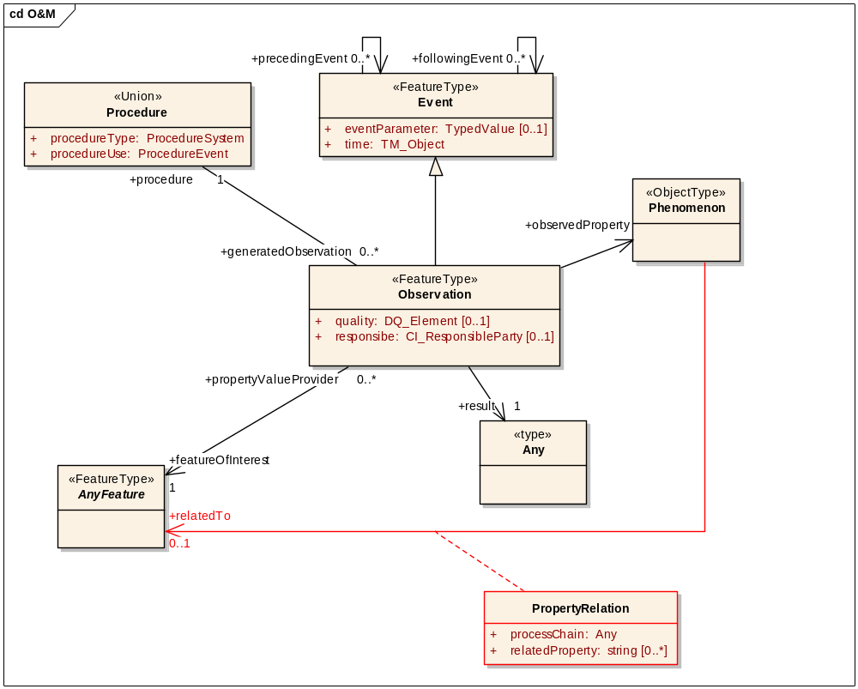
- Some aspects of this:
- in general, the association between observed properties and properties of the (ultimate) feature-of-interest is many-to-many
- the ‘sequence of observations of Sampling Features’ approach to modelling this captures explicitly the procedure at each step (nice, I grant); however, needing a new feature-of-interest as an artefact of each step of the processing chain feels artificial
- The proposed Sampling Feature has corresponding pairs of a relatedObservation and (soft-typed) property. The association can be preserved where needed, while not requiring this pairing, through the mechanism suggested earlier – i.e. allowing an explicit association between the observed property (of the related observation in this case) and a property of the feature-of-interest.
- The case of 6.1.2 (observed property not a property of the feature-of-interest) would be covered by modelling more explicitly the relationship between an observed property and property(ies) of the feature-of-interest, as suggested earlier. This would leave the Sampling Feature exclusively concerned with the case of 6.1.3 – a coverage-valued property of the feature-of-interest being discretely sampled. Moreover, I think that this case is so common that there is probably good reason: (a) to make it the exclusive concern of Sampling Features; and (b) thereby to include some additional patterns in the model.
- Essentially, it would eliminate the ‘extensive sampling feature’ specialisation. Each Sampling Feature property would be a discrete coverage. This coverage would provide the result of a related observation; and the coverage domain could be explicitly identified as the sampling regime. The model would look something like:
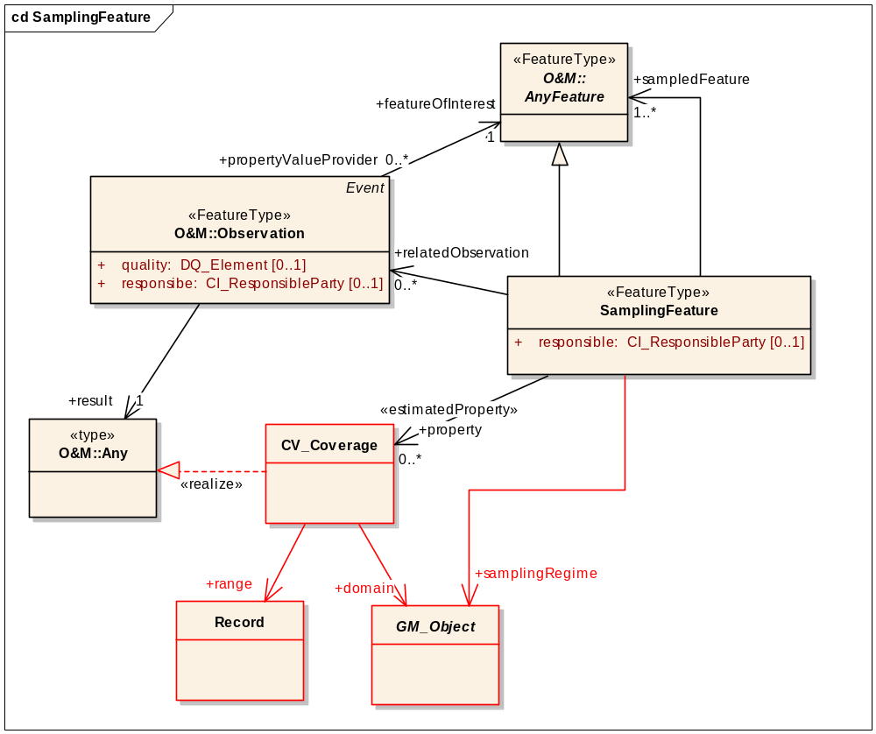

- [O&M] I think there needs to be a mechanism for modelling the chain of processes/observations that leads from an observed property of a proximate FoI to a (generally different) property of an ultimate FoI.
- [O&M] Modelling this explicitly would remove the requirement for an observedProperty to be so tightly bound to a particular property of the FoI (which feels artificial for all but the simplest cases). A variant on the first figure in section 8 is the kind of thing I imagined.
- [SF] If such a processing/observation chain could be modelled explicitly (including an explicit characterisation of the relationship between the proximate observedProperty and a property of the ultimate FoI), then one of the goals for SamplingFeatures (“6.2.2 Observable property is not of ultimate interest”) is removed thus allowing considerable clarification of purpose.
- [SF] SF would then be concerned just with the ‘sampling design’ case (“6.2.3 Proximate feature embodies a sample design”):
  - All SF soft-typed properties would be coverage-valued (simplifying Fig 2)
  - No need to introduce ‘SpatiallyExtensiveSamplingFeatures’ – by definition a SF is now concerned with sampling over some domain
  - The ‘sampling regime’ for a given relatedObservation could be identified as the domain of the (coverage-valued) result – a potentially useful new model relationship

Response
To be discussed

Action taken
.

