Hi Steve,
Grigory has forwarded to me your request to make some review of draft vocabularies for GeoSciML scheme. It’s a big pity that time remained was too short to prepare some more or less in-details comments on it (I was on vacations and just few days ago I have returned back at work). So, I could only have a very general look at the suggested vocabularies. What is given below is just some comments and questions on particular items that I’d like to clarify.

At very first glance, GeoSciML vocabularies look quite different as compared to the Russian ones. Some principal differences in geological concepts appear already in the categories of uppermost level.
-- Distinction between Rocks and Unconsolidated material is not typical for Russian geoscientific school (i.e., in common practice sand/gravel/clay is considered a rock, especially when it composes a part of some old-aged geological formation. For instance, so-called “Ordovician sands” which form a member within the old-aged formation in the region of Saint Petersburg is definitely a rock).
But we still have a category of Sediment, which is commonly applied in a more strict sense, namely: kinds of products that are accumulated as a result of physical, chemical, biological, etc. processes which take place in the areas of contemporary deposition, and that haven’t been turned (modified) into a rock by subsequent processes (e.g. diagenetic or metamorphic processes). Target communities for this category (sediment) are usually marine geologists and ‘quaternary’ (surficial/terrestrial) geologists.
Sediment is unconsolidated. Also have various unconsolidated fault rocks, also unconsolidated volcanic deposits. Unconsolidated material is general category for all of these sorts of things; not sure how you can do without it?
-- Acidic igneous material / Composite genesis material / Chemical sediment / Non-clastic siliceous sediment, etc. – are these terms really supposed for the use in entry forms of the data base, or these only are top nodes in the hierarchical structure of the language? (Russian geologists does not operate with terms like these in a case of any formal use)
-- Classification scheme for carbonate rocks is completely different from the Russian one. Such categories as grainstone, boundstone, carbonate wakestone, packstone, framestone, etc. are not used, since fabric-based classification for this type is just complementary but not a basic one. Basic division of carbonate rocks includes usually mineralogy-based types of limestones and dolomites (with a variety of intermediate types between these two based on ratio of carbonate minerals), and also marls (with the varieties, too).
-- Clastic sediment category (by its definition) is not fully compliant with Clastic sediment in Russian sense. It converges more closely with ‘russian’ Terrigenous sediment category, which implies, similarly, an essential transportation of clasts to the place of deposition. (in Russian understanding, Clastic sediment is mostly irrespective of this property, therefore this is a more general category in relation to Terrigenous sediment).
-- Do you intend to extend the content of the vocabularies afterwards? Seems like a current set of terms would not be sufficient to cover all the variety of lithologies in the US geological maps.
-- Clay and silt are pretty abundant terms that occur in the legends of maps. So, it is important to have them in the vocabulary and to distinguish these two subtypes of mud class.
-- Phaneritic igneous rock / Porphyry / Fine grained igneous rock, etc. – don’t you think it would be possible to split these compound terms in order to use fabric properties as qualifiers (adjectives) that you could use in the combinations with the main term (igneous rock) ? Reasons: a) rock names put under these topics may be assigned to another categories, as well, – for example, acidic igneous rock); b) same rock (e.g. granite) may have porphyry or fine-grained fabric in different occurrences.
This would probably allow to avoid constructing of complicated and tricky hierarchical structures of the language. Are the properties like fabric or granularity so important to install them into the hierarchical structure of the entire language? Genetic type of rock (igneous, sedimentary, etc.), silica contents-based types – definitely yes, but these…I’m not sure.
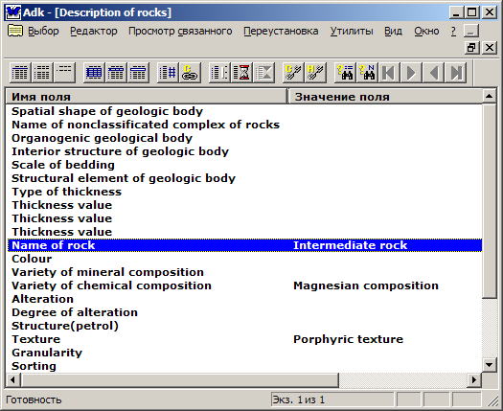
Below is snapshot picture illustrating how it may be combined (example taken from the Russian geologic map database).

Best wishes,
Yuri

