Table of Contents
Introduction : Center for Genetic Identification 2
Summary 3
Notes from 20180316 (Version 3.18) 3
Notes from 20180205 3
Our Workflow 4
How to import the excel-sheet, step-by-step 4
Next Release, additional feature ? 4
How to verify the excel import 5
Landing Page 6
'Help'-Headline and the links to documentation 6
Next release, additional feature ? 6
‘Genotypes’-page 6
Error when sorting the list 6
Export options 6
‘Genotype Details’-page 7
Next release, additional feature ? 7
Update records by using Export Specimen 8
Appendix A ; First Template-Importer 9
Appendix B ; Second Template-Importer 10
NRM Developers-Environment 11
Additional Questions 12
Questions from 2018-02-05 12
Questions from 2018-03-05 12
Questions from 2018-03-16 12

Introduction : Center for Genetic Identification
2018-03-16, Compiled by Ingimar Erlingsson
CGI , “Center for Genetic Identification”.
http://www.nrm.se/en/forskningochsamlingar/centrumforgenetiskidentifiering.18738.html
Staff: Niclas Gyllenstrand, Thomas Källman
This document describes the use-case ‘Niclas dream-importer’.
The excel-file has metadata (inlcudes position in the rack) + Genotypes, using the custom-importer ‘NRM Genotype’.
This document does NOT cover the use-case ‘DNA-LAB importer’ (imports 2 docs; Specimens + Samples)

Summary

Notes from 20180316 (Version 3.18)
- The importer works, Able to verify the importer with the new Template
  - Able to export from Specimen List ( ‘Specimen Records’) using ‘ Specimen Bulk Edit Export (.xlsx)’ → i.e output = export_specimens.xlsx
  - OK : changed the file ( added ‘country’=’Sweden’), Able to import export_specimens.xlsx using the ‘Specimen’-importer and checking the ‘Bulk Edit’
    - Verify the SeqDB after import , I can find ‘Sweden’ – OK
  - NOT-OK : changed the file (added ‘Common Name’ =’Björn’) ,Able to import export_specimens.xlsx using the ‘Specimen’-importer and checking the ‘Bulk Edit’
    - Verify the SeqDB after import , I can NOT find ‘Björn’ – NOT-OK

Comments on the 1-2-3-list from 20180205
1. You are now able to click on the column-names in ‘https://seqdb.nrm.se/seqdb.web-3.18/genotypes.html’
2 The ‘column-names’ are still missing in the CSV-export.
Comments on the Question-chapter

Notes from 20180205
- Minor error in ‘Genotypes’ - sorting The table with id=”genotypeList” , when clicking on one of the column-names. Java stack-trace.
- Q: ‘ Genotypes’ : Exporting to cvs does not give the column-names
- Q on a future feature : see ‘Genotypes Details’-page

Our Workflow

How to import the excel-sheet, step-by-step
- Landing Page → Storage/ ’Storage Containers’
  - ‘Add New Container’ (96wells) → container name = ‘rack-id’ (barcode on the rack)
    - container name = ‘3000142742’
- Landing Page → Import / ’Spreadsheet Import Page’
  - ‘Select importer’ → drop down, choose → ‘NRM Genotype’ (do not check checkbox)
  - ‘Container Type’ → drop down, choose →’96 Well 12*8 plate’
  - ‘Choose file’ → choose the excel-sheet you want to import → submit
    - our excel-sheet contains 96 records
  - If the import works → You should get the feedback the it works

Next Release, additional feature ?
Import the excel-sheet.
- That we are able to put in X-number of Alleles ( so instead of 16, we can choose an arbitrary length .....)
- Seeing all the metadata under 'Specimen Details' and 'Collection Details' . It would be great if we could just add a column to our Excel-sheet that matches a field from the Collections Details - like adding 'Country' and 'Continent' ..... and sof orth
- Help-page for the importers
- Error-messages when importing. To have better error-messages – for instance : state which record (row in the Excel-file) and which column is breaking the import.

How to verify the excel import
- Collections → Specimens
  - ‘Specimen Records’ → displays ‘102 specimens found’ → OK
  - The ‘Result’-table is sortable
- Genotyping → Genotypes
- Storage → Storage Containers
  - ‘Storage Container Records’
    - List : Choose the record ‘Admin Group | 3000142742’
    - New-Page : ‘Container Details’
      - The rack is displayed as a Matrix : [A-H] / [1-12]
      - Number on each cell is ‘NRM-CGI-<nr>’ + ‘A’
        - Click on Sample in the Matrix
        - New-Page: ‘Sample Details’
        - Details are there → OK

Landing Page

'Help'-Headline and the links to documentation
Today the links are ending up in the agr.gc.ca-redmine instance (redmine.biodiversity.agr.gc.c)

Next release, additional feature ?
- Could we create our own links and point them to our wiki ? Especially , the ‘User Documentation’.
- The language-toggle between English and Francais is not working
- A language-toggle between : ‘English’ and ‘Swedish’.
  - If possible, we could provide translation (‘bundle’_sv_SE.properties-file)

‘Genotypes’-page
The page : https://seqdb.nrm.se/seqdb.web-3.15/genotypes.html

Error when sorting the list
The table with id=”genotypeList” , when clicking on one of the column-names to sort we get a crash – java-stacktrace ( for instance : org.hibernate.QueryException: could not resolve property: allele6 of: ca.gc.aafc.seqdb.entities.Genotype)

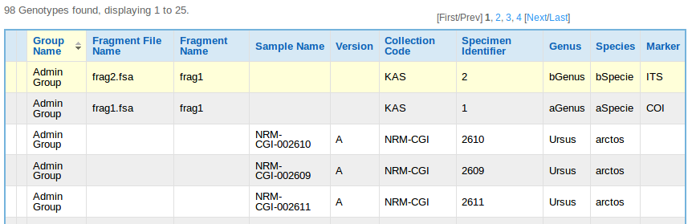

Export options
- OK ? Exporting to cvs does not give me the column-names, is that the default behavior ?
- OK! Exporting to excel, XML and PDF gives me the column-names

‘Genotype Details’-page
https://seqdb.nrm.se/seqdb.web-3.15/editGenotype.html?genotypeId=7

Current layout, see the ‘Alleles’-section

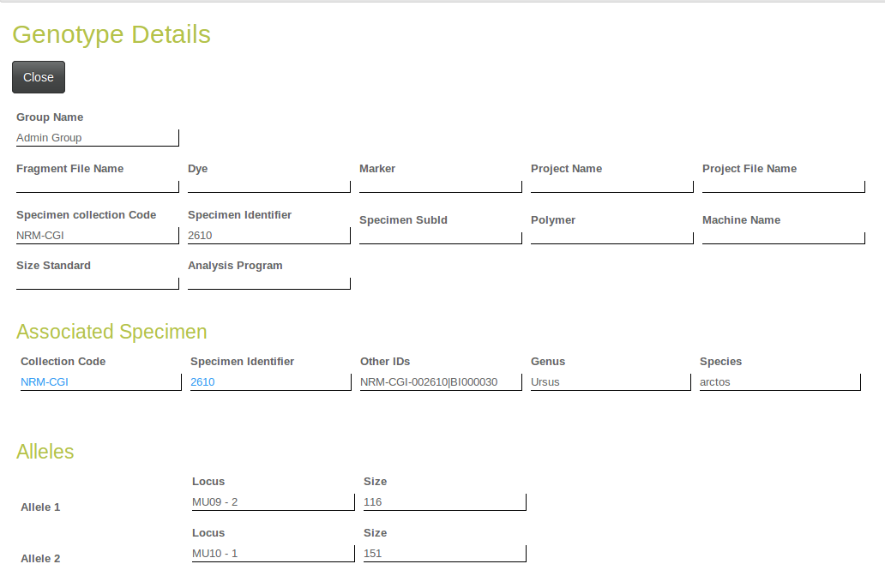

Next release, additional feature ?
Changing the layout for the ‘Alleles’-section

Either Example 1 or Example 2.

Example 1
Locus Size
MU23 173
Locus Size
MU23 176

Example 2
Locus Size
MU23 173
MU23 176

Update records by using Export Specimen

Appendix A ; First Template-Importer

Columns in the excel-file, the ‘Freezer’-column should be empty :
- Position,
- Tube,
- RackID,
- Freezer,
- NRMID,
- IndividID,
- Species,
- Sex,
- date,
- N_SWEREF99,
- E_SWEREF99,
- Municipal,
- County,
- MU09-1,MU09-2,
- MU10-1,MU10-2
- MU05-1,MU05 – 2,
- MU23 - 1,MU23 – 2,
- MU51 - 1,MU51 – 2,
- MU59 - 1 ,MU59 – 2,
- G10L - 1,G10L- 2,
- MU50 - 1,MU50 – 2

Appendix B ; Second Template-Importer
- Position
- Tube
- Container
- Name
- NRMID
- IndividID
- Species
- Sex
- date
- Latitude (WGS84)
- Longitude (WGS84)
- Municipal
- County
- MU09 - 1 MU09 - 2
- MU10 - 1 MU10 - 2
- MU05 - 1 MU05 - 2
- MU23 - 1 MU23 - 2
- MU51 - 1 MU51 - 2
- MU59 - 1 MU59 - 2
- G10L - 1 G10L- 2
- MU50 - 1 MU50 - 2

NRM Developers-Environment

Access to the source code from AAFC
Git clone https://inkimar@bitbucket.org/aafc-mbb/seqdb.git
Branch : ingimar_portal_and_dream_importer
build from ‘root’ : ~/seqdb/ : mvn clean install -e -Dmaven.test.skip=true

OS = Linux Mint 18 Sarah
java -version
openjdk version "1.8.0_151"
OpenJDK Runtime Environment (build 1.8.0_151-8u151-b12-0ubuntu0.16.04.2-b12)
OpenJDK 64-Bit Server VM (build 25.151-b12, mixed mode)
mvn -version
Apache Maven 3.3.9
Maven home: /usr/share/maven
Java version: 1.8.0_151, vendor: Oracle Corporation
Java home: /usr/lib/jvm/java-8-openjdk-amd64/jre
Default locale: en_US, platform encoding: UTF-8
OS name: "linux", version: "4.4.0-89-generic", arch: "amd64", family: "unix"

Docker project
Working with SeqDB version 3.18
$ git remote -v
origin https://github.com/DINA-Web/seqdb-docker.git
Summary Dockerfile:
- using Ubuntu 16.04 , java = , Tomcat = 7.0.76
Summary docker-compose.yml ( still version 0)
- db = image: mysql:5.6 , VIRTUAL_HOST=seqdb.nrm.se
TODO Docker-proj : Upgrade Tomcat to 8x . Upgrade mysql ?

Additional Questions

Questions from 2018-02-05
- Q: Is there a way to delete the Example Specimens ?
- Q: What is a ‘Specimen Identifier’ ?
- Q: Under the Headline 'Asscociated Samples'
  - Version, what is that related to ?
  - Would the version become 'B' if I do the same import again (with the same rack-id)?
  - The Well is 1A, Should it not be A1 ?
- Q: 'Container Details'-page
  - Is it possible to update the label 'Rack Number' and have 'Rack Number' as a link to a help-wiki-page (our page) that explains 'our' way of handling this ?
- Q: import and export DarwinCore Archive (DwC-A) ? (not knowing how well DwC-A supports the DNA-domain)
  - Do you have any plans on supporting import of DwC-A
  - Do you have any plans on supporting export of DwC-A

Questions from 2018-03-05
- Q: Are we able to delete all 96 records belonging to a rack (wanting to make the import once again).
- Q: To use OpenJDK instead of Oracle JDK (Question brought up during the Berlin-Meeting , 28th of February 2018)

Questions from 2018-03-16

See Appendix A for the required format.

