CGIAR Climate Data Hub - System-Wide Climate Data Asset Mapping
  - Internal review draft
2026-06-17
Table of contents

<IPython.core.display.HTML object>
<IPython.core.display.HTML object>
Version 1.0 (draft) — 123 assets in this build. Interactive data access: CDH interactive dashboard.
Generated programmatically from the data — no numbers are hand-typed. The figures and tables below are interactive (hover, sort, filter) in this HTML edition. See Data Access, Feedback and Reproducibility near the end for the source code, steps to reproduce, and how to suggest corrections or additions.

Who This Report Is For
This report turns the first system-wide mapping of CGIAR’s climate data assets into something the Hub can act on. It is written for three audiences:
- CDH leadership and the Core team — to see where the system is strong and where it is thin, and to steer Phase-1 priorities. (Start with the Executive Summary and Section 5.)
- The CDH development and data team — to decide what to federate or ingest now, what to queue for later, and where effort is being duplicated. (Section 6.)
- Contributing centres — to check how their assets are represented and flag corrections or additions. (Annex A and the feedback links in the Data Access section.)
The questions it answers
- Where is CGIAR strong, and where are the gaps — by centre, theme, and geography?
- Which assets should the Hub act on now, and which belong in the next cycle?
- What is openly reusable, foundational, or nationally important — and what is locked behind an access conversation?
- Where are centres independently reprocessing the same upstream climate inputs?
The needs it serves
The Hub exists to reduce fragmentation in CGIAR’s climate evidence base. This mapping is the evidence behind that effort: it prioritises a focused set of high-value assets for Phase-1 inclusion or federation, surfaces reusable and nationally-relevant datasets, flags duplicated preprocessing the Hub can do once instead of many times, and points to the gaps — and the centres — still to engage. It is deliberately strategic, not exhaustive (Section 1).

Executive Summary
CGIAR holds a wealth of climate data — but it is scattered across centres, programmes, and bilateral projects: hard to find, easy to duplicate, and difficult to reuse. The Climate Data Hub was created to change that, and this exercise is its first concrete step: a structured look at the strongest climate data assets the centres themselves put forward.
123 assets from 11 centres were catalogued, spanning hazard monitoring, adaptation analytics, exposure, mitigation accounting, and integrated multi-domain platforms; 70 (57%) come from the six Hub-funded centres. Coverage is deepest in Adaptation Analytics and Hazard, and concentrated in Africa and Global datasets.
Three messages stand out:
- There are clear quick wins. 28 assets are openly accessible, technically ready, and high-value — they can be federated or ingested with little friction (Section 6.5).
- The strategic shortlist is already defined by the centres. The 28 top-three nominations come with written justifications and are the natural candidates for immediate Hub inclusion (Section 6.2).
- The gaps are specific and actionable. Adaptive Capacity is essentially absent, Latin America & Caribbean and Asia are thin, and two major centres — CIMMYT and ICARDA — have yet to submit (Section 5; Section 7).
The rest of the report makes each of these concrete: where the strengths and gaps sit (Section 5), and exactly what to do now and next (Section 6).

1. Background and Objectives
The CGIAR Climate Data Hub (CDH) is a CGIAR initiative under Area of Work 1 (AoW1), designed to surface, standardise, and federate climate-relevant data assets held across the CGIAR system. The Hub operates under a federation model: it points to data where it already exists, rather than duplicating it, and only ingests data where cloud-optimised or API-accessible formats are not available.
This report summarises the first system-wide asset mapping exercise, conducted in early 2026. Centres were asked to nominate climate data assets through a structured submission template covering identity, structure, spatiotemporal scope, thematic domain, context of use, and a readiness/nomination assessment.
Consistent with the mapping strategy, the exercise is deliberately focused and strategic, not exhaustive: each centre nominated a limited set (up to ~20) of its strongest, most decision-relevant assets, prioritising quality and reuse over volume. It is not an audit of past outputs, and not a scientific evaluation of data quality, and it does not alter data ownership or impose hosting requirements. It is a coordination and governance step to inform Phase 1 of the Hub.
Objectives of the mapping:
- Surface a focused, strategic set of high-value climate data assets across CGIAR (not an exhaustive inventory).
- Identify gaps and priorities for Hub curation and integration.
- Provide a foundation for cross-centre collaboration and data-sharing.
- Inform the CDH technical roadmap for ingestion and federation.

2. Methods

2.1 Submission process
Each centre received a standardised Excel template with six thematic sheets. Nominators were asked to complete one row per asset, covering:
- Sheet A — Identity: asset name, nominator, organisation, asset type, short description.
- Sheet B — Structure: file format, storage location, licence, API/access details.
- Sheet C — SpatioTemp: spatial coverage, resolution, temporal type, update frequency.
- Sheet D — Thematic: climate domain, farming system, commodity, output variable type.
- Sheet E — Context & Use: decision relevance, reuse potential, existing use cases.
- Sheet F&G — Assess & Nominate: technical readiness, contemporary validity, sustainability, asset rank, and intended Hub role.
Submissions were received from 11 centres.
The blank template, full submission guidelines, and every centre’s completed Excel workbook are version-controlled in the project repository: the raw submissions are at [data/submissions/](https://github.com/CGIAR-Climate-Data-Hub/cdh-asset-mapping/blob/main/data/submissions/) and the mapping strategy and template instructions at [docs/CDH-Asset-Mapping-Strategy.docx](https://github.com/CGIAR-Climate-Data-Hub/cdh-asset-mapping/blob/main/docs/CDH-Asset-Mapping-Strategy.docx).

2.2 Normalisation
Free-text fields for climate domain, asset type, and spatial coverage were normalised to controlled vocabularies using keyword matching. The normalisation rules are documented in src/ingest.py and applied reproducibly by the pipeline documented in the Data Access, Feedback and Reproducibility section.

2.3 Consolidation of duplicate entries
4 consolidations were applied where multiple submitted entries represented sub-components of a single dataset (e.g. model inputs and outputs from the same pipeline). This reduced the raw submission count of 129 to 123 catalogued assets. The full merge log is in Annex C.

2.4 Optional composite priority score
The mapping strategy deliberately avoids reducing the five qualitative criteria to a single rank (Section 6.1). For navigation only — to help sort long lists in the report and dashboard — a transparent composite score (0–100) is nonetheless computed. It is defined once in src/ingest.py and shared verbatim with the dashboard, so the two never diverge. It is not an official ranking; the authoritative signal remains each centre’s own top-three nomination.
Each component is mapped to a 0–1 sub-score, then combined as a weighted average:
- Ordinal criteria (Decision Relevance, Technical Readiness, Reuse Potential, Contemporary Validity, Sustainability) map Very High = 1.0, High = 0.85, Medium-High = 0.75, Medium = 0.5, Medium-Low = 0.35, Low = 0.25.
- Submitted rank maps to a centre-relative sub-score (max_rank_in_centre − rank + 1) / max_rank_in_centre, so rank 1 scores highest within each centre regardless of how many assets that centre ranked.
- Intended Hub role maps Hub-native = 1.0, Derived = 0.8, Federation = 0.7, Reference/Operational = 0.6; unspecified is omitted.
Component | Weight
Decision relevance | 0.20
Technical readiness | 0.20
Reuse potential | 0.15
Submitted rank (within centre) | 0.15
Contemporary validity | 0.10
Sustainability | 0.10
Intended Hub role specified | 0.10
The score is the weighted mean of only the components that are present: a missing criterion is dropped from both numerator and denominator rather than scored as zero, so incomplete submissions are not unfairly penalised (they simply rest on less evidence). The portfolio mean is 73.

3. Domain Definitions
The following climate domain vocabulary is used throughout this report:
Domain | Definition
Hazard | Climate variables and indices that characterise physical hazard (e.g. rainfall, temperature, drought, flood extent).
Hazard / Climate Services | Operationally processed hazard products delivered as services (e.g. seasonal forecasts, advisories).
Exposure | Data on agricultural systems, land use, populations, and assets exposed to climate hazards.
Sensitivity | Data on how exposed systems respond to climate stressors (e.g. crop yield sensitivity, disease risk models).
Adaptive Capacity | Data on capacity of systems or communities to adjust to climate impacts.
Adaptation Analytics | Integrated datasets and model outputs that assess adaptation options, impacts, or trade-offs (combines hazard, exposure, and response).
Mitigation | GHG inventories, emission factors, and tools for quantifying emission reductions in agriculture.
Multi-domain | Assets that span two or more domains without clear primary classification.
Hybrid labels | Some assets are tagged with two adjacent domains (e.g. Sensitivity / Adaptation Analytics) where single label would be misleading.
These labels follow the mapping strategy’s domain vocabulary. The strategy lists Climate finance and Climate policy as separate domains; given the small number of assets in either, this report combines them under Climate Policy / Finance — they can be split if future submissions warrant.

4. Results
This section describes the portfolio as a whole — how much was submitted and by whom, which themes and geographies it covers, who owns the assets, and what they actually contain. Sections 5 and 6 then turn this into strengths, gaps, and actions.

4.1 Volume and coverage
A total of 123 assets were catalogued across 11 centres (Figure 1). All figures reported here reflect post-consolidation count (see Section 2.3 and Annex C).
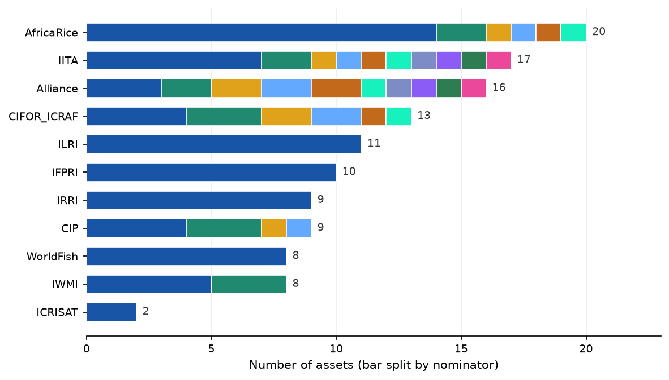
Figure 1. Assets submitted per centre. Total catalogued assets per centre after consolidation (Section 2.3), ordered largest to smallest. Each bar is split into one coloured segment per nominating individual — a longer run of colours means more contributors behind a centre’s portfolio (e.g. AfricaRice and IITA drew on many nominators, while ILRI, IFPRI, and IRRI came through a single nominator). Segment colour is arbitrary and carries no meaning (hence no legend); the number is the centre total. The interactive dashboard names each nominator and their count on hover.
Centre | Assets | Hub-funded
AfricaRice | 20 | No
IITA | 17 | Yes
Alliance | 16 | Yes
CIFOR-ICRAF | 13 | No
ILRI | 11 | Yes
IFPRI | 10 | Yes
CIP | 9 | No
IRRI | 9 | No
IWMI | 8 | Yes
WorldFish | 8 | Yes
ICRISAT | 2 | No
Total | 123
Hub-funded centres account for 70 assets (57%) of portfolio.
Coverage caveat — centres not yet represented. Submissions were received from 11 centres. CIMMYT and ICARDA had not submitted at the time of this build and are therefore absent from all totals and figures below; their inclusion will materially change domain and geographic coverage (CIMMYT in particular for South Asian wheat/maize systems and adaptation analytics — see the box in Section 5.4). Targeted follow-up with both centres is underway.

4.2 Domain distribution
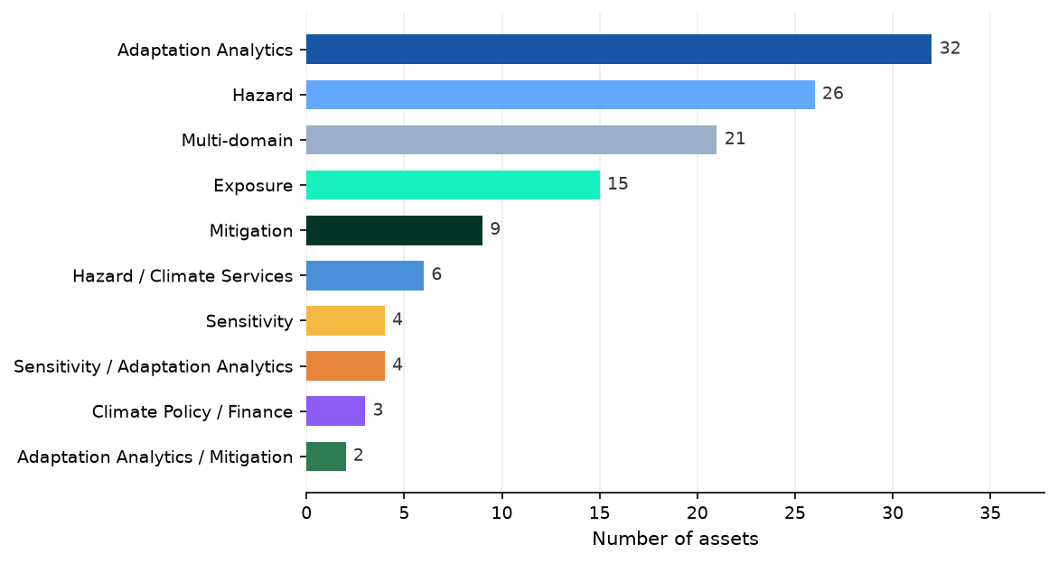
Figure 2. Distribution by climate domain. Number of assets in each normalised climate domain (definitions in Section 3); assets with no specified domain are excluded. Hover a bar for its share of the portfolio, the centres contributing it, and how much is openly accessible. Adaptation Analytics and Hazard are the largest domains; Adaptive Capacity and Climate Policy / Finance the thinnest.
Adaptation Analytics is most represented domain (32 assets, 26%), followed by Hazard (26 assets). Multi-domain assets (21 assets) reflect submissions where nominated asset spans two or more domains — common for integrated platforms and modelling frameworks.
High Multi-domain share from IITA reflects their submission labels (‘Agronomy and climate’, ‘Disease risk’) which span exposure, sensitivity, and adaptation. CIFOR-ICRAF’s multi-domain assets include food security and livelihoods datasets with indirect but significant climate relevance. See Figure 5 for centre-by-domain breakdown.

Cross-centre domain coverage
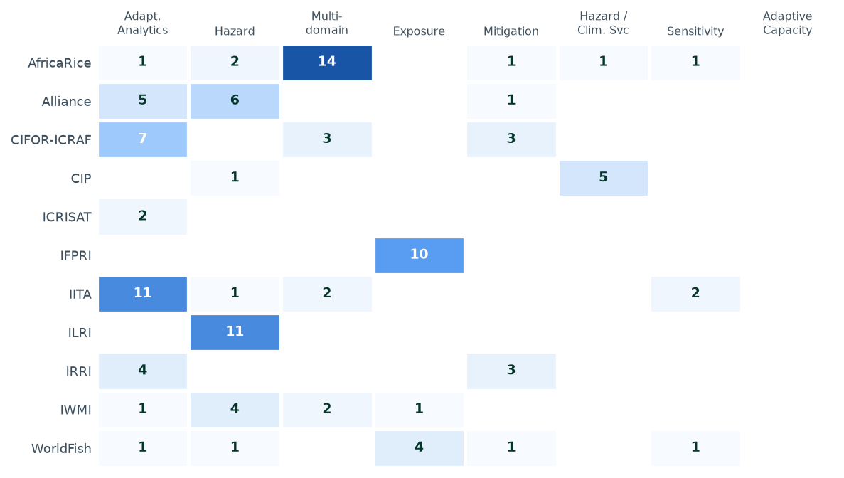
Figure 5. Centre × domain heatmap. Number of assets each centre holds in each single-label climate domain; darker cells hold more, blank cells none. Hover a cell for example assets and the open-access share of that centre–domain combination. Hybrid-domain assets are excluded here for readability but counted in Figure 2.
Heatmap shows number of assets per centre per domain. Hybrid domain labels (e.g. Sensitivity / Adaptation Analytics, Adaptation Analytics / Mitigation) are excluded from heatmap for readability; they are included in Figure 2.

4.3 Ownership and asset type
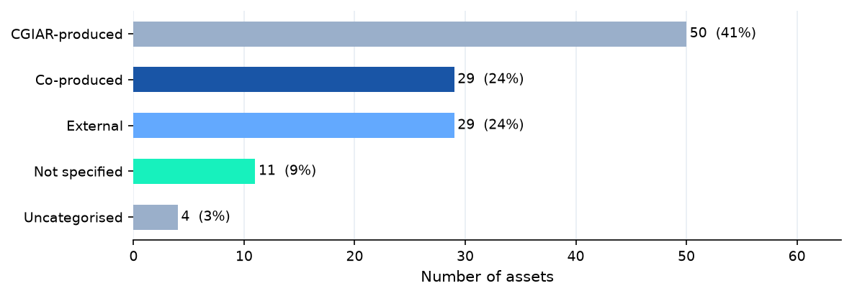
Figure 3. Asset type (ownership). Share of catalogued assets by ownership class — CGIAR-produced, co-produced with partners, or external datasets adopted into CGIAR workflows. Hover a bar for the centres behind it and its open-access share.
50 assets (41%) are CGIAR-produced; 29 (24%) are external datasets adopted into CGIAR workflows; and 29 (24%) are co-produced with external partners. External assets are included where centres have demonstrated active use in climate analytics and where Hub can add value through standardisation or linkage.

4.4 Geographic coverage
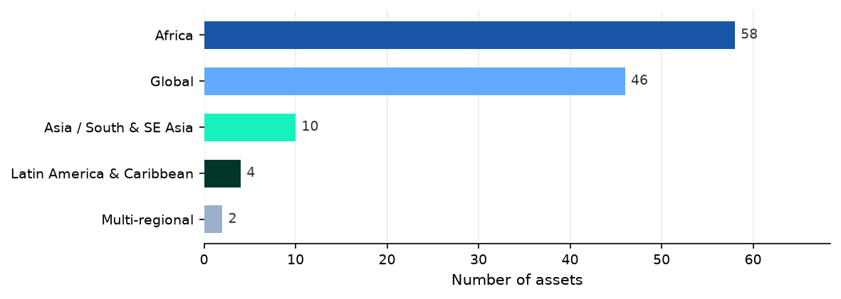
Figure 4. Geographic coverage. Number of assets per geographic grouping; assets with no specified coverage are excluded. Hover a bar for the dominant domains and centres in that region. Africa and Global dominate; Latin America & Caribbean, Asia, and Multi-regional are comparatively thin.
Africa (58 assets) and Global (46 assets) together represent 85% of portfolio. Asia and South/Southeast Asia (10 assets) is driven primarily by IRRI. Latin America & Caribbean (4 assets) is represented by Alliance and CIP submissions.
3 assets had no spatial coverage specified in submission and are excluded from Figure 4.

4.5 Priority nominations
Of 123 catalogued assets, 106 (86%) include Asset Rank (Section F&G of submission template) and 53 (43%) specify intended Hub Role.
Intended Hub Roles describe how asset should be integrated with Hub:
- Hub Native — asset will be ingested and hosted directly by Hub.
- Hub Reference — Hub will link to asset at its existing location, without ingesting copy.
- Hub Derived — Hub will produce derived or value-added product from asset.
Hub preference is federation over ingestion. Datasets in existing platforms that are not cloud-optimised or available by API may require ingestion to enable interoperability; in such cases Hub will work with data owner to agree on approach. Where permissions already allow it, Hub may proceed without delay; otherwise, formal agreement with data owner is required before ingestion.

4.6 What the assets measure, and who uses them
Counts alone understate what was captured. The submissions also describe what each asset actually produces (template Sheet D — Thematic) and how it is used in practice (Sheet E — Context & Use). That detail is what turns an inventory into a basis for reuse, and it sharpens the picture of where the portfolio’s real value sits.
What they measure. 123 of 123 assets specify an output variable type, spanning raw climate variables and hazard indices, biophysical outputs (crop yields, biomass, soil moisture), greenhouse-gas emissions, and suitability or classification layers. The commodity focus tracks CGIAR’s mandate crops — led by Rice (32), Potato/sweetpotato (11), Livestock (11) — while farming systems are dominated by Cropping (60), Rice-based (15), Mixed (13). The recurring upstream climate inputs in Section 6.7 show how many of these outputs are, in turn, built on a small shared set of sources, which is exactly where the Hub can remove duplicated effort.
How they are used. Submitters most often describe their assets serving Modelling (44), Research (44), Policy (43) purposes — confirming a portfolio that skews decisively toward decision support rather than purely academic output. The user communities named most frequently are Researchers (77), Governments (76), Donors (52). Most tellingly for the Hub’s reuse mandate, 114 assets already name the CGIAR programmes using them, 68 are rated high or very-high national relevance (the datasets that underpin country engagement and policy dialogue), and 78 are flagged as foundational to ongoing work — assets whose withdrawal would break existing pipelines.
Two implications follow. First, the portfolio’s value is concentrated in a relatively small core of foundational, multi-programme, nationally-relevant datasets; these are the natural anchors for Phase 1, ahead of more peripheral or single-use submissions. Second, the strong policy, advisory, and modelling orientation means the Hub’s task is less to surface new science than to make assets that are already relied upon discoverable, interoperable, and durable — reducing the risk that critical datasets remain locked to the teams that happen to maintain them today.

5. Strength and Gap Analysis
This section is written for the CDH Core team: where the system-wide portfolio is strong, where it is thin, and where coverage depends on a single centre.

5.1 Domain × geography coverage
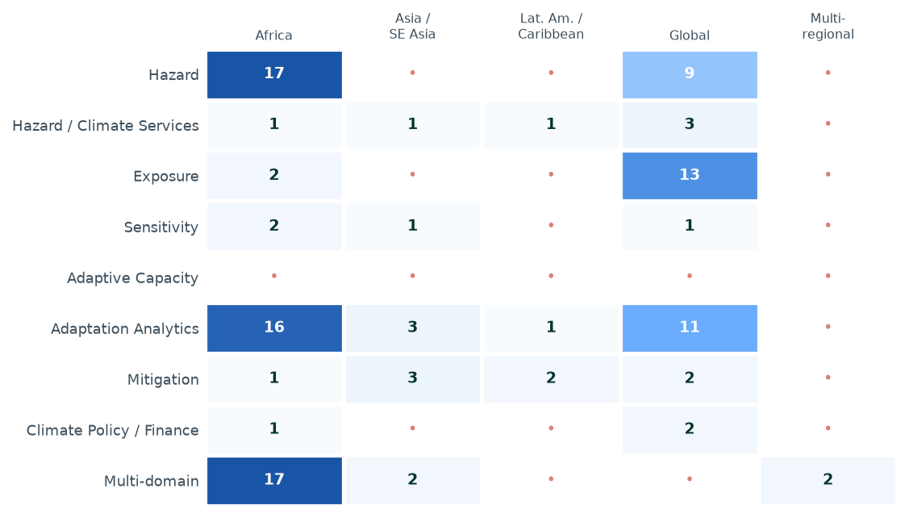
Figure 6. Where coverage is deep, thin, or absent (climate domain × geography). Each cell counts the assets in one domain (row) and geography (column); darker blue = more assets, a red dot = a true gap with none. Hover any cell for the exact count. Two patterns stand out: coverage concentrates heavily in Africa and Global, and Adaptive Capacity is empty across every region while Latin America & Caribbean and Multi-regional are thin throughout — the clearest targets for the next cycle. Hybrid-domain and unspecified-geography assets are excluded for legibility.
Coverage concentrates in two cells — Hazard × Africa (17 assets) and Adaptation Analytics × Africa (16 assets) — alongside a strong Global column. Of the 45 domain × geography combinations, 21 are empty.
The clearest thematic gap is Adaptive Capacity, with no catalogued assets in any region. Latin America & Caribbean and Multi-regional are the thinnest geographies across nearly every domain.

5.2 Concentration risk
2 domain(s) are currently represented by a single centre, making system-wide coverage dependent on one submitter:
Domain | Sole centre
Adaptation Analytics / Mitigation | IRRI
Climate Policy / Finance | Alliance
These are priorities for cross-centre outreach: a second submitter would reduce single-point dependency and validate the domain’s representation.

5.3 Per-centre strength profile
Mean priority score summarises each centre’s portfolio on the shared 0–100 scale (see Section 6.1). ‘Domains’ counts the distinct climate domains a centre covers.
Table — Per-centre strength profile (mean priority is the optional composite of Section 6.1).
Centre | Assets | Mean priority | Domains covered | Hub-funded
IWMI | 8 | 82 | 4 | Yes
IRRI | 9 | 81 | 3 | No
AfricaRice | 20 | 77 | 6 | No
Alliance | 16 | 74 | 5 | Yes
IITA | 17 | 73 | 4 | Yes
CIFOR-ICRAF | 13 | 72 | 3 | No
CIP | 9 | 70 | 3 | No
IFPRI | 10 | 69 | 1 | Yes
ILRI | 11 | 67 | 1 | Yes
WorldFish | 8 | 66 | 5 | Yes
ICRISAT | 2 | 63 | 1 | No

5.4 Notable assets outside this mapping
Two strategically important assets are intentionally not ranked in the analysis above, and should be read alongside it:
AAA Atlas (CGIAR Adaptation Atlas). Already planned for integration into the Climate Data Hub from the outset, the AAA Atlas has been deliberately excluded from the nomination ranking so that other centre assets can surface on their own merit. Its inclusion in the Hub is assumed, not contingent on this exercise.
South Asia Adaptation Atlas (ACASA). Developed by CIMMYT / BISA (https://acasa-bisa.org/), ACASA is a major adaptation-analytics resource for South Asian food systems. CIMMYT has not yet submitted to this mapping, so ACASA does not appear in any totals or figures; it is flagged here as a high-priority asset to capture once CIMMYT engages.

6. Priorities and Actions
This section is written for the CDH development and data team: which assets to act on now, which to queue for the next cycle, and the suggested integration pathway for each.

6.1 How to read priority here
The mapping strategy is deliberate that the five qualitative criteria are a comparison aid, not a formal score or ranked list — collapsing them into a single number would oversimplify. This report follows that intent: the authoritative signal is each centre’s own ranking, and the top three assets per centre are the strategic nominations for immediate Hub consideration (Section 6.2).
As a navigation convenience only, each asset additionally carries an optional composite score (0–100) — a weighted blend of the five criteria, submitted rank, and hub-role specification, computed reproducibly in src/ingest.py and shared with the dashboard so the two never diverge. Treat it strictly as a sorting aid for long lists, not as an official quality verdict; absent criteria are dropped from the blend rather than penalised. Portfolio mean 73.

6.2 Strategic nominations — each centre’s top three
The 28 assets below are each centre’s three best-ranked submissions. Under the mapping strategy these are the unit for immediate Hub inclusion or federation; lower-ranked assets are candidates for later cycles. Each carries a centre-written justification (summarised below; full text in the asset record).
Data-quality note: 4 centre(s) (AfricaRice, ICRISAT, IITA, ILRI) submitted tied/duplicate ranks, so their nominations are capped at the three lowest-ranked assets (ties broken by name); IRRI submitted no ranks and so contribute no nominations; a centre with fewer than three ranked assets shows fewer. To be corrected with centres next cycle.
Table 1 — Strategic nominations: each centre’s top-ranked assets (sortable / filterable in HTML; asset names link to the data source).
Centre | Rank | Asset | Domain | Access | Justification
AfricaRice | 1 | AfricaRice AgDataHub climate database (integrated agrometeorological datasets) | Hazard / Climate Services | Restricted | Backbone climate dataset enabling modelling, advisories, and risk analytics
AfricaRice | 1 | AfricaRice-processed ENACTS climate datasets (enhanced and quality-controlled) | Multi-domain | Restricted | Essential input for most climate applications and models
AfricaRice | 2 | AfricaRice Data Sharing Tool (DST) for climate services | Multi-domain | Restricted | Enables institutional climate data sharing and integration
Alliance | 1 | CGIAR Africa Agricultural Adaptation Atlas | Adaptation Analytics | Open | A comprehensive collection of data products specifically curated to support end-to-end policy and investment for adaptation in Africa. It includes not only data to support climate risk analysis (hazard, exposure, vulnerability), but also so
Alliance | 2 | CCAFS-Climate data portal (MarkSim, CMIP5/6 downscaling, bias correction) | Hazard | Open | An ecosystem of global, foundational climate data and associated tools widely used in adaptation analytics, climate and crop modelling. It strategically fills multiple gaps between direct GCM outputs and more ready-to-use data products for
Alliance | 3 | IPR Tool | Adaptation Analytics | Open | The IMPACT model is a multimarket economic model for the agriculture sector widely used for assessing climate impacts on global food price, production, trade, and demand. The IPR tool updates intrinsic productivity rate, a key input for the
CIFOR-ICRAF | 1 | The potential of Indonesian mangrove forests for global climate change mitigation | Mitigation | Open | Foundational mangrove carbon dataset supporting climate mitigation planning, carbon accounting, and restoration policy in Indonesia and globally
CIFOR-ICRAF | 2 | National Mountain Peatland Maps of Colombia | Mitigation | Open | Strategic peatland mapping asset supporting restoration, conservation planning, and emissions mitigation
CIFOR-ICRAF | 3 | Evaluating the restoration of the commons: LDSF field data | Adaptation Analytics | Open | Strong adaptation and restoration relevance with reusable LDSF methodology and operational restoration monitoring applicability
CIP | 1 | ILCYM – Insect Life Cycle Modeling Platform for Pest and Natural Enemy Risk Modeling | Hazard / Climate Services | Open | ILCYM is the highest-priority candidate in this submission because it is a CIP-developed climate-risk modelling platform that directly links temperature-driven insect biology with pest and natural enemy risk assessment. It supports developm
CIP | 2 | Lateblight Advisor / SIMCAST Digital Advisory Platform for Potato Late Blight | Hazard / Climate Services | Open | Lateblight Advisor / SIMCAST is a top strategic Climate Data Hub candidate because it directly connects climate data to real-world advisory decisions for potato late blight management. The platform converts observed and forecast weather int
CIP | 3 | SOLANUM / Spatial Solanum / SWEETPO Crop Growth Modeling Tools | Sensitivity / Adaptation Analytics | Open | SOLANUM / Spatial Solanum / SWEETPO is a top-three candidate because it represents a CIP-developed crop modelling asset that translates climate, crop physiology and management conditions into yield and crop-growth outputs. SOLANUM estimates
ICRISAT | 3 | Pest & disease risk distribution & hot spot mapping tool | Adaptation Analytics | Restricted | Simple tool understand the futute climate change in the selected regions, to plant the future breeding program, varietal deplyment, stress monitoring and adapating the integrated management stratergies. Ability to replicate to other crops
ICRISAT | 3 | Climate change impacts on crops yield and Nutrition | Adaptation Analytics | Open | Higly reliable data sets on simulated cliate variables on crop, plant for mudulation of crop repsonse, breaking of resistance, nutrient acqusation, changes in the benifical microbes. Simulate the other regions climatic condition, specifica
IFPRI | 1 | Global MapSPAM 2020 | Exposure | Open | Global spatial dataset of crop production, area, and yield at ~10 km resolution using data fusion methods
IFPRI | 2 | Global hamonized cropland | Exposure | Restricted | Advisory, Invesment, Decision making
IFPRI | 3 | High resolution national crop type maps | Exposure | Restricted | Research, Investment and policy
IITA | 1 | AKILIMO | Adaptation Analytics | Open | Akilimo translate data on climate–soil interactions into actionable insights for farmers and systems. Enables targeting, climate vulnerability assessment, and segmentation for scaling climate-smart interventions. Used by extension agents to
IITA | 2 | Predicted aflatoxin risk in maize | Sensitivity | Open | This asset provides strategic value as a data-driven tool for anticipating aflatoxin contamination risk in maize, a major food safety and public health concern in East and Southern Africa. By translating climate and environmental signals in
IITA | 3 | Carob | Adaptation Analytics | Open | This asset provides structured access to historical agricultural research, not only CGIAR, but also from other organizations on experimental and observational data from thousands of experiments. It serves as a foundational database for meta
ILRI | 1 | Bias-corrected climate dataset for East Africa | Hazard | Open | This asset is strategically important because it translates climate observations and seasonal forecast information into practical agriculture indicators: onset, cessation and length of growing season. These outputs are directly relevant to
ILRI | 1 | Operational Onset, Cessation and Length of Growing Season Forecast Dataset | Hazard | Open | This asset is strategically important because it translates climate observations and seasonal forecast information into practical agriculture indicators: onset, cessation and length of growing season. These outputs are directly relevant to
ILRI | 2 | Administrative Boundary Climate Extractor Outputs | Hazard | Open | Policy, Research, Modelling, Investment
IWMI | 1 | Africa Flood Hazard | Exposure | Open | The Africa flood hazard dataset utilizes Earth Observation (EO) data to deliver continent-wide flood monitoring at a 500 m spatial resolution. It is developed using moderate-resolution NASA MODIS data spanning 2001 to 2025 and is available
IWMI | 3 | Africa Multi-hazard risk maps | Adaptation Analytics | Open | Multi-Hazard Map integrates data on various natural disasters to assess risk exposure and support climate adaptation. This map visualizes hazard (floods, droughts, cyclones, landslides, epidemics, volcanic activity, earthquakes, extreme tem
WorldFish | 1 | FishBase | Sensitivity | Open | Foundational Climate Action enabler. FishBase underpins climate impact models, exposure assessments, and adaptation analyses by providing species‑level biological and ecological traits. Its interoperability and long‑term maintenance make it
WorldFish | 2 | Bio-Oracle | Hazard | Open | Bio‑ORACLE provides the biophysical climate drivers required to assess exposure and vulnerability of marine systems. Its direct use in climate modelling and adaptation analytics makes it a high‑priority asset for supporting Climate Action a
WorldFish | 3 | FishScores | Mitigation | Open | Useful for specific mitigation and industry decision contexts, but limited relevance for national or system‑level Climate Action analytics within a Hub framework.

6.3 Priority quadrant
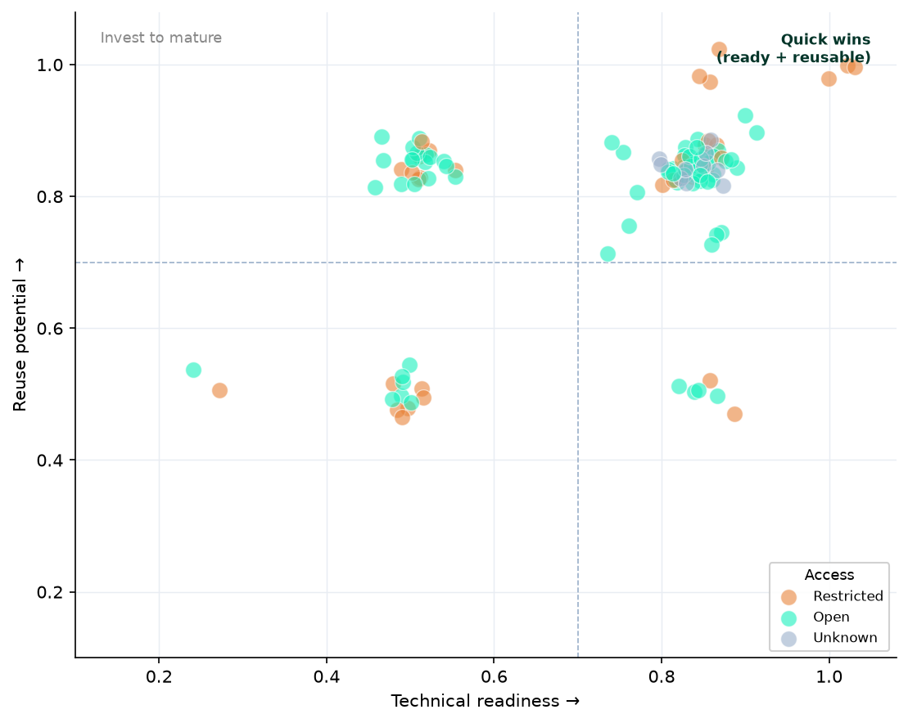
Figure 7. Priority quadrant. Each point is an asset placed by its submitter-rated technical readiness (x-axis) and reuse potential (y-axis); colour shows access status (green = Open, orange = Restricted, grey = Unknown). Hover any point for the asset’s name, centre, domain, access, and priority score. The shaded top-right zone holds the natural ‘quick wins’ — assets that are both ready and broadly reusable. Reuse potential and access are independent criteria, so high-reuse Restricted (orange, upper) points are not a contradiction — they are the prime candidates for an access negotiation to unlock that value.
Why are several Restricted assets rated high reuse? The two are measured independently. Reuse potential is the submitter’s judgement of how broadly the asset’s content could serve other programmes, countries, or analyses; access status is whether it can be obtained today under current licensing or permissions. A dataset can be scientifically reusable while still gated — these are exactly the assets where a short access conversation converts latent value into usable value (see Section 6.6).

6.4 Suggested integration pathway
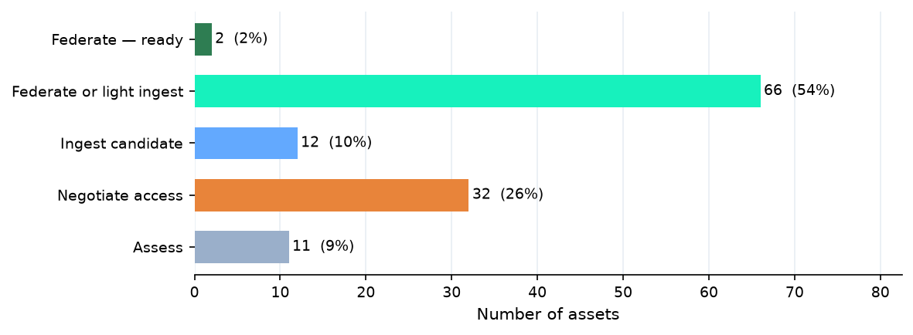
Figure 8. Suggested integration pathway. Each asset is classified by a heuristic combining its access status and file format into a starting pathway — federate (ready, or with light ingest), ingest candidate, negotiate access, or assess. Hover a bar for the file formats driving that pathway and example assets. The classification is advisory and should be verified per asset before committing.
A heuristic combining access status and file format suggests a starting integration pathway per asset. 68 assets look federation-ready or close to it; 32 are gated behind an access conversation; 12 are open but need ingestion to become interoperable. These labels are advisory — verify format and licence per asset before committing.
Of the 123 assets, 80 are Open access, 32 Restricted, and 11 unspecified. 78 are flagged foundational to ongoing CGIAR work and 80 are reported as actively maintained.

6.5 Act now — ready, open, high value
28 assets combine Open access, high technical readiness, and a priority score of 75+. These are the recommended near-term targets for federation or ingestion (all listed below; sort or filter the table in the HTML edition):
Table 2 — ‘Act now’ shortlist: Open-access, high-readiness assets (sortable / filterable in HTML; asset names link to the data source).
Centre | Asset | Domain | Score | Pathway | Rationale
IFPRI | Global MapSPAM 2020 | Exposure | 89 | Federate or light ingest | Global spatial dataset of crop production, area, and yield at ~10 km resolution using data fusion methods
IWMI | Africa Flood Hazard | Exposure | 89 | Federate or light ingest | The Africa flood hazard dataset utilizes Earth Observation (EO) data to deliver continent-wide flood monitoring at a 500 m spatial resolution. It is developed using moderate-resolution NASA MODIS data spanning 2001 to 2025 and is available
CIFOR-ICRAF | National Mountain Peatland Maps of Colombia | Mitigation | 86 | Federate or light ingest | Strategic peatland mapping asset supporting restoration, conservation planning, and emissions mitigation
WorldFish | FishBase | Sensitivity | 86 | Federate or light ingest | Foundational Climate Action enabler. FishBase underpins climate impact models, exposure assessments, and adaptation analyses by providing species‑level biological and ecological traits. Its interoperability and long‑term maintenance make it
CIFOR-ICRAF | The potential of Indonesian mangrove forests for global climate change mitigation | Mitigation | 85 | Federate or light ingest | Foundational mangrove carbon dataset supporting climate mitigation planning, carbon accounting, and restoration policy in Indonesia and globally
IITA | PlantVillage Nuru | Adaptation Analytics | 85 | Ingest candidate | Nuru: In-field Pest and Disease Diagnosis has strategic value as a digital agricultural support asset designed to assist with rapid field-level identification of crop pests and diseases. Its relevance remains high in the context of increasi
IWMI | Africa Drought Hazard | Hazard | 85 | Federate or light ingest | Advisory, Invesment, Decision making
IWMI | Irrigater Area Map | Multi-domain | 85 | Federate or light ingest | Research, Modelling
IWMI | River Discharge | Hazard | 85 | Federate or light ingest | Advisory, Invesment, Decision making, resaearch
IWMI | Population Impact on Flood | Multi-domain | 85 | Federate or light ingest | Research, Decision making
IWMI | South Asia Climate Risk Map | Hazard | 85 | Federate or light ingest | Research, Decision making
Alliance | CCAFS-Climate data portal (MarkSim, CMIP5/6 downscaling, bias correction) | Hazard | 84 | Federate or light ingest | An ecosystem of global, foundational climate data and associated tools widely used in adaptation analytics, climate and crop modelling. It strategically fills multiple gaps between direct GCM outputs and more ready-to-use data products for
CIP | ILCYM – Insect Life Cycle Modeling Platform for Pest and Natural Enemy Risk Modeling | Hazard / Climate Services | 84 | Ingest candidate | ILCYM is the highest-priority candidate in this submission because it is a CIP-developed climate-risk modelling platform that directly links temperature-driven insect biology with pest and natural enemy risk assessment. It supports developm
IITA | AKILIMO | Adaptation Analytics | 84 | Ingest candidate | Akilimo translate data on climate–soil interactions into actionable insights for farmers and systems. Enables targeting, climate vulnerability assessment, and segmentation for scaling climate-smart interventions. Used by extension agents to
CIP | Lateblight Advisor / SIMCAST Digital Advisory Platform for Potato Late Blight | Hazard / Climate Services | 82 | Federate — ready | Lateblight Advisor / SIMCAST is a top strategic Climate Data Hub candidate because it directly connects climate data to real-world advisory decisions for potato late blight management. The platform converts observed and forecast weather int
IITA | Predicted aflatoxin risk in maize | Sensitivity | 82 | Federate or light ingest | This asset provides strategic value as a data-driven tool for anticipating aflatoxin contamination risk in maize, a major food safety and public health concern in East and Southern Africa. By translating climate and environmental signals in
CIFOR-ICRAF | Evaluating the restoration of the commons: LDSF field data | Adaptation Analytics | 81 | Federate or light ingest | Strong adaptation and restoration relevance with reusable LDSF methodology and operational restoration monitoring applicability
IITA | Plant species of Drabo Gbo Forest Benin | Multi-domain | 80 | Federate or light ingest | This asset represents a detailed floristic dataset of plant species in a restored forest ecosystem in Benin, which may hold value for biodiversity monitoring and ecological restoration research. Its strategic value likely lies in documentin
IITA | SoySA10 | Adaptation Analytics | 80 | Federate or light ingest | SoySA10 provides national-scale 10 m soybean distribution maps for South Africa from 2018–2025, offering a recent and spatially detailed dataset for monitoring soybean cultivation dynamics. Its strategic value lies in supporting agricultura
IITA | Pan-African Soybean Variety Trials (PAT) | Adaptation Analytics | 80 | Federate or light ingest | Dataset is valuable for advancing research on genotype × environment × management interactions and adaptation of soybean germplasm, supporting genetic evaluation, environmental modeling, and informed decision-making for soybean expansion in
Alliance | Observed Climate Data - AgERA5 | Hazard | 79 | Federate or light ingest | Modelling, Advisory, Monitoring
CIFOR-ICRAF | REDD+ Country Profiles Indicators | Mitigation | 78 | Federate or light ingest | Supports comparative REDD+ policy analysis, governance assessment, and climate policy planning
CIP | PISCO SENAMHI Gridded Hydro-Meteorological Products for Peru | Hazard / Climate Services | 78 | Federate or light ingest | Strong foundational national hydro-meteorological dataset for Peru. It remains highly relevant because it provides precipitation, temperature, evapotranspiration and dew point-related variables used in GeoSIMCAST and other climate-risk work
ILRI | DEFRA Climate and Health Daily Projection Dataset for Kenya, Ghana and Zambia | Hazard | 78 | Federate or light ingest | This asset is strategically valuable because it provides harmonised, monthly, multi-variable climate projection data for Kenya, Ghana and Zambia under SSP245 and SSP585 for two future periods. It is directly relevant to climate-health and l
Alliance | MODIS NDVI | Climate Policy / Finance | 76 | Federate or light ingest | Policy, intervenion/decision-support, research
CIFOR-ICRAF | Wet chemistry data for a subset of AfSIS: Phase I archived soil samples | Adaptation Analytics | 76 | Federate or light ingest | Foundational African soil chemistry and spectroscopy dataset with broad reuse potential across land health and restoration analytics.
Alliance | Copernicus Global Flood Monitoring | Hazard | 75 | Federate or light ingest | Advisory, Research
IITA | Crop sowing date optimization | Adaptation Analytics | 75 | Federate or light ingest | Research, Modelling, Policy

6.6 Next cycle — high value, currently blocked
26 assets score 70+ but are held back by restricted access or sub-‘High’ technical readiness. These warrant an access conversation or a readiness investment before the next mapping cycle (top 12 shown):
Table 3 — ‘Next cycle’ queue: high-value assets blocked by access or readiness. Asset names link to the data source.
Centre | Asset | Domain | Blocker | Rationale
AfricaRice | AfricaRice-processed ENACTS climate datasets (enhanced and q | Multi-domain | Restricted access | Essential input for most climate applications and models
AfricaRice | Climate information service datasets used in digital advisor | Multi-domain | Restricted access | Direct farmer-facing climate services
AfricaRice | AfricaRice Data Sharing Tool (DST) for climate services | Multi-domain | Restricted access | Enables institutional climate data sharing and integration
AfricaRice | RiceAdvice | Multi-domain | Restricted access | Widely deployed agronomic advisory platform
Alliance | IPR Tool | Adaptation Analytics | Readiness below High | The IMPACT model is a multimarket economic model for the agriculture sector widely used for assessing climate impacts on global food price, production, trade, a
AfricaRice | AfricaRice AgDataHub climate database (integrated agrometeor | Hazard / Climate Services | Restricted access | Backbone climate dataset enabling modelling, advisories, and risk analytics
AfricaRice | Mali Disaster Risk Management (DRM) Maproom | Multi-domain | Restricted access | Supports drought/flood risk management and response
AfricaRice | Climate risk indicators datasets (drought, flood, heat stres | Hazard | Restricted access | Key for hazard monitoring and resilience planning
AfricaRice | RIICE satellite-derived rice monitoring and climate impact d | Multi-domain | Restricted access | Supports production monitoring and policy decisions
IFPRI | Global hamonized cropland | Exposure | Restricted access | Advisory, Invesment, Decision making
AfricaRice | Flood risk and submergence hazard datasets for inland valley | Hazard | Restricted access | Critical for flood risk management in inland valleys
IFPRI | High resolution national crop type maps | Exposure | Restricted access | Research, Investment and policy

6.7 Shared dependencies and reuse signals
Duplication of climate inputs. Of the 19 assets that reported their underlying climate inputs, several inputs recur across multiple submissions — CHIRPS (8), Station / observational (7), CMIP6 (4), ERA5 (4). Shared upstream inputs are prime candidates for once-only Hub preprocessing (a stated aim of the mapping: detecting duplication in climate inputs and pipelines) rather than each centre reprocessing the same source independently.
Climate input | Assets relying on it
CHIRPS | 8
Station / observational | 7
CMIP6 | 4
ERA5 | 4
WorldClim | 2
Only 19 of 123 assets recorded their climate inputs; enforcing this field next cycle would complete the dependency picture.
Cross-programme reuse. 114 assets name the CGIAR programmes already using them — direct evidence of reuse beyond the originating team, which the strategy treats as a core signal for Hub inclusion.
National relevance. 68 assets are rated High or Very High for national relevance — the datasets most important for country engagement, policy dialogue, and partner buy-in. The strategy flags these as priorities even where they are not globally standardised or openly accessible.

7. Discussion
Stepping back from the numbers: what does the portfolio tell us, how far can we trust it, and what should happen next?

7.1 Coverage and gaps
This mapping captures a substantial and decision-relevant slice of CGIAR’s climate data portfolio, but by design it is neither exhaustive nor a complete census. The picture it paints should be read as what the engaged centres consider their strongest assets, not the full universe of CGIAR climate data. Two coverage caveats matter most when interpreting the gaps below.
First, two centres are absent: CIMMYT and ICARDA had not submitted at the time of this build (Section 4.1). This is consequential, not cosmetic — CIMMYT anchors much of CGIAR’s South Asian wheat and maize adaptation analytics (including the ACASA atlas, Section 5.4), and ICARDA anchors dryland and West Asia / North Africa systems. Several apparent gaps below will narrow once they engage.
Second, within the assets that were submitted, three gaps are robust enough to act on. Adaptive Capacity is essentially absent (0 assets) — the portfolio is strong on hazard and adaptation analytics but weak on the social and institutional capacity to respond, a recognised blind spot for climate targeting. Latin America & Caribbean and Asia / South & SE Asia are thin relative to Africa and Global coverage, concentrating geographic risk. And 2 domain(s) currently rest on a single centre (Section 5.2), so the system-wide picture in those areas is one withdrawal away from a hole. Each of these is an outreach target rather than a finding about CGIAR’s true capability — the mapping surfaces where to look next, not a verdict on what exists.

7.2 Data quality observations
The submissions are usable and rich, but several recurring data-quality issues shape how far the analysis can be pushed, and each has a concrete fix for the next cycle.
Incomplete assessment fields. Asset rank, intended Hub role, and the qualitative ratings were left blank for a non-trivial share of assets, and only 19 of 123 recorded their underlying climate inputs — which limits the duplication analysis (Section 6.7) more than any other gap. Mandating the Hub-role and climate-input fields would sharply increase the analytical value of the next round.
Inconsistent ranking. The strategy intends a clean 1..N ordering per centre, but AfricaRice, ICRISAT, IITA, ILRI submitted tied or duplicate ranks (e.g. several assets all ranked ‘1’ or ‘2’), so their strategic nominations were capped at the three lowest-ranked assets; IRRI submitted no ranks at all. Ranking is the single most important field for prioritisation, so a brief validation step with each focal point before the next submission would pay off directly.
Free-text variability and AI-drafted fields. Domain, type, and access were submitted as free text and normalised to controlled vocabularies (Section 2.2); a handful of entries also carried template example text or GPT-drafted descriptions that required scrubbing or validation. This is expected given the strategy’s allowance for GPT drafting, but it reinforces that externally-researchable fields must be expert-checked, and that internal-use and strategic-importance fields should never be GPT-generated.
Finally, 1 asset(s) had no climate domain specified and could not be classified from context; they are retained in the inventory but excluded from the domain figures.

7.3 Hub integration approach
CDH operates federation-first model. Many CGIAR data products already reside in well-maintained platforms (CGIAR Library, data.cgiar.org, institutional repositories). Hub preference is to register and link these rather than duplicate them.
Where data is not cloud-optimised, not accessible by API, or not in standardised format compatible with other CDH datasets, Hub may work with data owner to improve format or — where necessary — ingest copy. In all cases, CDH will notify data owner and, where permissions do not already allow federation, agree approach before proceeding.
Many CDH data products will be open access. CDH intends to link back into existing portals and platforms so that Hub amplifies rather than duplicates those investments.
What the mapping implies for sequencing is concrete. Roughly 68 assets look federation-ready or close to it and can be registered with little engineering; 32 are gated behind an access conversation and should enter a parallel, relationship-led track rather than block the technical work; and the shared upstream inputs identified in Section 6.7 (CHIRPS, station data, CMIP6, ERA5) argue for the Hub preprocessing these once, centrally, rather than each centre repeating the work. Federation-first keeps stewardship with the originating centres while still delivering cross-CGIAR discovery — the central tension the Hub is designed to resolve.

7.4 In short
Returning to the questions this report set out to answer: CGIAR’s catalogued climate data is strong on hazard and adaptation analytics, deepest in Africa and at global scale, and anchored by a core of foundational, multi-programme, nationally-relevant datasets — but thin on adaptive capacity, in Latin America and Asia, and dependent on single centres in several domains. For the Hub, the immediate move is clear: act on the 28 open, ready, high-value assets and the centres’ 28 strategic nominations now; open access conversations for the high-value-but-restricted assets in parallel; preprocess shared climate inputs once; and bring CIMMYT and ICARDA into the next cycle to close the most visible gaps. The detail sits in Sections 5 and 6; this is the throughline.

8. Next Steps
- Complete outstanding submissions — follow up with ICARDA and centres with incomplete assessment fields.
- Prioritise assets for Hub integration — use asset rank and Hub role to sequence technical work.
- Agree federation vs ingestion for each priority asset — work with data owners to determine appropriate integration pathway.
- Publish asset catalogue — make inventory available to CGIAR partners via CDH portal.
- Iterate mapping annually — re-run pipeline as new submissions arrive.

Acknowledgments
This mapping exists only because colleagues across the centres took the time to nominate, describe, rank, and justify their strongest climate data assets — a substantial effort on top of busy research agendas. We are sincerely grateful to every contributor, and in particular to the centre focal points and nominators listed below.
Centre | Contributors
AfricaRice | Aboubacar Diallo; Ali Ibrahim; Elliott Dossou-Yovo; Geoffrey Onaga; Mohamed Diallo; Paul Iboko
Alliance | Alcade Segnon; Alejandro Ruden; Camilo Barrios; Carlos E. Navarro Racines; Carlos Gonzalez; Kaue De Sousa; Robert S. Andrade; Shalika Vyas; Tosin Akingbemisilu; Xiaojing Wei
CIFOR-ICRAF | Ardhani, Trialaksita; Brockhaus, M.; Ickowitz, A.; Tamba, Yvonne; Winowiecki, Leigh Ann; Winowiecki, Leigh Ann (ICRAF)
CIP | David Ramirez; Heidy Gamarra; Henry Juarez; Robert Hijmans
IFPRI | Zhe Guo
IITA | Eduardo Garcia Bendito; Francis Muthoni; Harun Murithi; James Legg; John Omondi; Julius Adewopo; Peter Neuenschwander; Rhys Manners; Siyabusa Mkuhlani; Thompson Ogunsanmi
ILRI | Teferi Demissie
IRRI | a.urfels@cgiar.org
IWMI | Giriraj Amarnath; Niranga Alahacoon
WorldFish | Michelle Tigchelaar
Coordination of the asset-mapping exercise is led by the Alliance of Bioversity International & CIAT under the Climate Action Program (Critical Capacity PoD2), in collaboration with the Climate Data Hub team and AoW1. Thanks also to the centre contacts who fielded follow-up questions on access, format, and provenance. Any errors of consolidation or normalisation are the compilers’, not the contributors’.

Data Access, Feedback and Reproducibility
This report is generated programmatically: every figure, table, and statistic is computed from the normalised data, with no hand-typed numbers. The data and the code that produces this document are version-controlled and open.
Data
- Normalised catalogue (one row per asset): data/normalized/assets.json
- Raw centre submissions (Excel, one per centre): data/submissions/
- Consolidation/merge log: data/merge_log.json
- Researched contact overrides: data/contact_overrides.json
Code that generates this report
- src/ingest.py — reads the Excel submissions, normalises fields, writes data/normalized/assets.json
- src/figures.py — generates the static figures
- src/report_common.py — computes all statistics and builds the narrative, tables, and figure captions
- report.qmd — the Quarto source for this document (the interactive figures and tables are defined here)
- Full repository: https://github.com/CGIAR-Climate-Data-Hub/cdh-asset-mapping
Reproduce this report
pip install -r requirements.txt
python src/ingest.py # Excel submissions -> data/normalized/assets.json
python src/figures.py # static figures -> outputs/figures/
quarto render report.qmd --to html # or: --to docx

Feedback — corrections, additions, and questions
Spotted an error, or know of an asset that should be included? Please open a short issue — it goes straight to the team and is tracked to resolution. The links below open a pre-filled template:
- Correct an asset record — wrong domain, access, contact, etc.
- Suggest a missing asset — e.g. from a centre not yet represented.
- General feedback on the report — on framing, figures, or analysis.
(Opening an issue requires a free GitHub account. For richer inline discussion the repository can later enable GitHub Discussions with a Giscus comment box; issue links are used here because they produce tracked, actionable items.)

Annex A — Full asset list
All 123 catalogued assets, sortable and filterable in the HTML edition. Use the search box to find a centre, domain, or asset.
Centre | Asset | Domain | Geography | Type | Score | Access | Pathway
AfricaRice | AfricaRice-processed ENACTS climate datasets (enhanced and quality-controlled) | Multi-domain | Africa | CGIAR-produced | 97 | Restricted | Negotiate access
AfricaRice | Climate information service datasets used in digital advisories | Multi-domain | Africa | CGIAR-produced | 95 | Restricted | Negotiate access
AfricaRice | AfricaRice Data Sharing Tool (DST) for climate services | Multi-domain | Africa | CGIAR-produced | 93 | Restricted | Negotiate access
AfricaRice | RiceAdvice | Multi-domain | Africa | CGIAR-produced | 93 | Restricted | Negotiate access
Alliance | IPR Tool | Adaptation Analytics | Global | CGIAR-produced | 92 | Open | Ingest candidate
AfricaRice | AfricaRice AgDataHub climate database (integrated agrometeorological datasets) | Hazard / Climate Services | Africa | CGIAR-produced | 90 | Restricted | Negotiate access
IFPRI | Global MapSPAM 2020 | Exposure | Global | CGIAR-produced | 89 | Open | Federate or light ingest
IWMI | Africa Flood Hazard | Exposure | Global | Co-produced | 89 | Open | Federate or light ingest
AfricaRice | Mali Disaster Risk Management (DRM) Maproom | Multi-domain | Africa | CGIAR-produced | 88 | Restricted | Negotiate access
AfricaRice | Climate risk indicators datasets (drought, flood, heat stress) for rice systems | Hazard | Africa | CGIAR-produced | 88 | Restricted | Negotiate access
AfricaRice | RIICE satellite-derived rice monitoring and climate impact dataset | Multi-domain | Multi-regional | CGIAR-produced | 88 | Restricted | Negotiate access
IFPRI | Global hamonized cropland | Exposure | Global | Co-produced | 87 | Restricted | Negotiate access
AfricaRice | Flood risk and submergence hazard datasets for inland valley landscapes | Hazard | Africa | CGIAR-produced | 86 | Restricted | Negotiate access
CIFOR-ICRAF | National Mountain Peatland Maps of Colombia | Mitigation | Latin America & Caribbean | Co-produced | 86 | Open | Federate or light ingest
IFPRI | High resolution national crop type maps | Exposure | Africa | CGIAR-produced | 86 | Restricted | Negotiate access
WorldFish | FishBase | Sensitivity | Global | External | 86 | Open | Federate or light ingest
CIFOR-ICRAF | The potential of Indonesian mangrove forests for global climate change mitigation | Mitigation | Asia / South & SE Asia | Co-produced | 85 | Open | Federate or light ingest
IITA | PlantVillage Nuru | Adaptation Analytics | Africa | CGIAR-produced | 85 | Open | Ingest candidate
IWMI | Surface Water Extent | Hazard | Africa | Co-produced | 85 | Unknown | Assess
IWMI | Africa Drought Hazard | Hazard | Africa | Co-produced | 85 | Open | Federate or light ingest
IWMI | Irrigater Area Map | Multi-domain | Asia / South & SE Asia | Co-produced | 85 | Open | Federate or light ingest
IWMI | River Discharge | Hazard | Africa | Co-produced | 85 | Open | Federate or light ingest
IWMI | Population Impact on Flood | Multi-domain | Multi-regional | Co-produced | 85 | Open | Federate or light ingest
IWMI | South Asia Climate Risk Map | Hazard | Africa | Co-produced | 85 | Open | Federate or light ingest
AfricaRice | Mali Climate Suitability for Crop Maproom | Multi-domain | Africa | CGIAR-produced | 84 | Restricted | Negotiate access
AfricaRice | Rice yield gap decomposition dataset with climate, resource and management components | Multi-domain | Africa | CGIAR-produced | 84 | Restricted | Negotiate access
Alliance | CCAFS-Climate data portal (MarkSim, CMIP5/6 downscaling, bias correction) | Hazard | Global | CGIAR-produced | 84 | Open | Federate or light ingest
CIP | ILCYM – Insect Life Cycle Modeling Platform for Pest and Natural Enemy Risk Modeling | Hazard / Climate Services | Global | Uncategorised | 84 | Open | Ingest candidate
IITA | AKILIMO | Adaptation Analytics | Africa | CGIAR-produced | 84 | Open | Ingest candidate
IITA | Soybean rust (SBR) risk hotspot | Sensitivity | Africa | CGIAR-produced | 83 | Unknown | Assess
IRRI | Temperature-Related Stress Maps | Adaptation Analytics | Global | Not specified | 83 | Unknown | Assess
IRRI | Country-level DSR Suitability Assessment Maps | Adaptation Analytics | Asia / South & SE Asia | Not specified | 83 | Unknown | Assess
IRRI | NDVI-Anomaly based Drought Maps | Adaptation Analytics | Asia / South & SE Asia | Not specified | 83 | Unknown | Assess
IRRI | AWD Suitability Maps | Adaptation Analytics / Mitigation | Global | Not specified | 83 | Unknown | Assess
IRRI | NDFI-based Flood Risk Assessment | Adaptation Analytics | Asia / South & SE Asia | Not specified | 83 | Unknown | Assess
IRRI | Rice Mitigation Hotspots and Mitigation Pathway Maps (currently being develop) | Mitigation | Not specified | Not specified | 83 | Unknown | Assess
Alliance | CGIAR Africa Agricultural Adaptation Atlas | Adaptation Analytics | Global | Co-produced | 82 | Open | Federate or light ingest
CIP | Lateblight Advisor / SIMCAST Digital Advisory Platform for Potato Late Blight | Hazard / Climate Services | Asia / South & SE Asia | Uncategorised | 82 | Open | Federate — ready
IITA | Predicted aflatoxin risk in maize | Sensitivity | Africa | CGIAR-produced | 82 | Open | Federate or light ingest
CIFOR-ICRAF | Evaluating the restoration of the commons: LDSF field data | Adaptation Analytics | Global | Co-produced | 81 | Open | Federate or light ingest
IITA | Plant species of Drabo Gbo Forest Benin | Multi-domain | Africa | CGIAR-produced | 80 | Open | Federate or light ingest
IITA | SoySA10 | Adaptation Analytics | Africa | CGIAR-produced | 80 | Open | Federate or light ingest
IITA | Pan-African Soybean Variety Trials (PAT) | Adaptation Analytics | Africa | CGIAR-produced | 80 | Open | Federate or light ingest
Alliance | Observed Climate Data - AgERA5 | Hazard | Global | CGIAR-produced | 79 | Open | Federate or light ingest
CIFOR-ICRAF | REDD+ Country Profiles Indicators | Mitigation | Global | External | 78 | Open | Federate or light ingest
CIP | PISCO SENAMHI Gridded Hydro-Meteorological Products for Peru | Hazard / Climate Services | Global | Uncategorised | 78 | Open | Federate or light ingest
ILRI | DEFRA Climate and Health Daily Projection Dataset for Kenya, Ghana and Zambia | Hazard | Africa | External | 78 | Open | Federate or light ingest
IRRI | Rice-GEM | Adaptation Analytics / Mitigation | Not specified | Not specified | 78 | Unknown | Assess
IRRI | IRRI’s LTCCE | Mitigation | Asia / South & SE Asia | Not specified | 78 | Unknown | Assess
IRRI | RCMAS | Mitigation | Asia / South & SE Asia | Not specified | 78 | Unknown | Assess
Alliance | MODIS NDVI | Climate Policy / Finance | Global | External | 76 | Open | Federate or light ingest
CIFOR-ICRAF | Wet chemistry data for a subset of AfSIS: Phase I archived soil samples | Adaptation Analytics | Africa | Co-produced | 76 | Open | Federate or light ingest
Alliance | Global multi-crop agricultural trial data (tricot data) | Adaptation Analytics | Global | Co-produced | 75 | Open | Ingest candidate
Alliance | Alliance Crop Observatories | Adaptation Analytics | Global | Co-produced | 75 | Open | Ingest candidate
Alliance | Copernicus Global Flood Monitoring | Hazard | Global | External | 75 | Open | Federate or light ingest
IITA | Crop sowing date optimization | Adaptation Analytics | Africa | CGIAR-produced | 75 | Open | Federate or light ingest
Alliance | World Bank Open Data | Climate Policy / Finance | Global | External | 74 | Open | Federate or light ingest
Alliance | Observed Climate Data - CHIRPS | Hazard | Global | CGIAR-produced | 74 | Open | Federate or light ingest
CIP | SOLANUM / Spatial Solanum / SWEETPO Crop Growth Modeling Tools | Sensitivity / Adaptation Analytics | Global | CGIAR-produced | 74 | Open | Ingest candidate
IITA | Citizen-H2D3 | Multi-domain | Africa | CGIAR-produced | 74 | Open | Federate or light ingest
ILRI | Bias-corrected climate dataset for East Africa | Hazard | Africa | External | 74 | Open | Federate or light ingest
ILRI | Operational Onset, Cessation and Length of Growing Season Forecast Dataset | Hazard | Africa | External | 74 | Open | Federate or light ingest
ILRI | District-Level Climate Projection Time-Series Dataset for Kenya, Ghana and Zambia | Hazard | Africa | External | 74 | Open | Federate or light ingest
WorldFish | Bio-Oracle | Hazard | Global | External | 74 | Open | Federate or light ingest
AfricaRice | Simulated rice yield datasets under current and future climates | Adaptation Analytics | Africa | CGIAR-produced | 73 | Restricted | Negotiate access
CIFOR-ICRAF | Improved Knowledge of the Role of the Forests for Food Security and Nutrition in Congo Basin Phase 2: Cameroon | Multi-domain | Africa | External | 73 | Open | Federate or light ingest
CIFOR-ICRAF | Biophysical baseline assessment within the KCEP-CRAL action areas in Kenya, using the LDSF | Adaptation Analytics | Africa | Co-produced | 73 | Open | Federate or light ingest
IITA | Carob | Adaptation Analytics | Global | CGIAR-produced | 73 | Open | Federate or light ingest
CIP | WorldClim v2.1 Global Climate Surfaces | Hazard | Global | External | 72 | Open | Federate or light ingest
IITA | Nutrient omission, planting window, crop arrangement, and management data in Chinyanja Triangle | Not specified | Africa | CGIAR-produced | 72 | Open | Federate or light ingest
CIFOR-ICRAF | Dataset for the evaluation of forest and landscape restoration in Northern Ethiopia | Adaptation Analytics | Africa | Co-produced | 71 | Open | Federate or light ingest
IFPRI | Seasonal Crop type map from Foundation model | Exposure | Africa | Co-produced | 71 | Restricted | Negotiate access
Alliance | Tortilla Platform Off the Griddle -TOR 2- | Adaptation Analytics | Latin America & Caribbean | Co-produced | 70 | Open | Federate or light ingest
ILRI | Extreme Climate Indices Dataset for Drought, Heat and Heavy Rainfall | Hazard | Africa | External | 70 | Open | Federate or light ingest
ILRI | Administrative Boundary Climate Extractor Outputs | Hazard | Africa | External | 70 | Open | Federate or light ingest
Alliance | climatrends | Sensitivity / Adaptation Analytics | Global | CGIAR-produced | 69 | Open | Ingest candidate
Alliance | FinAccess Household Survey (KNBS) | Climate Policy / Finance | Africa | External | 69 | Open | Federate or light ingest
IFPRI | Crop specific suitablity layers | Exposure | Global | Co-produced | 69 | Restricted | Negotiate access
IITA | HFCP Nigeria | Adaptation Analytics | Africa | CGIAR-produced | 69 | Open | Federate or light ingest
AfricaRice | Climatic water balance datasets for rice-based systems (derived: rainfall–ET–irrigation) | Multi-domain | Africa | CGIAR-produced | 68 | Restricted | Negotiate access
CIFOR-ICRAF | Spatial Assessments of Changes in Soil Health Indicators (Benin, Kenya) | Adaptation Analytics | Africa | Co-produced | 68 | Open | Federate or light ingest
CIP | WeatherAPI — Operational Real-Time and Forecast Weather Data Service for SIMCAST / Lateblight Advisor | Hazard / Climate Services | Global | External | 68 | Open | Federate or light ingest
IFPRI | Global subnational agricultural statistics | Exposure | Global | CGIAR-produced | 68 | Restricted | Negotiate access
AfricaRice | AquaCrop-ready climate datasets for rice and off-season crops (current and future yield and adaptation solutions) | Multi-domain | Africa | CGIAR-produced | 67 | Restricted | Negotiate access
CIFOR-ICRAF | Mitigating risks of disease transmission in the wild meat food chain from forest to fork in Cameroon | Multi-domain | Africa | External | 67 | Open | Federate or light ingest
IFPRI | Time series of global harmonized cropland extent from 2011 to 2020 | Exposure | Global | Co-produced | 67 | Restricted | Negotiate access
ILRI | C3S Multi-Model Seasonal Forecast Processing Dataset for Ethiopia | Hazard | Africa | External | 67 | Open | Federate or light ingest
WorldFish | FishStatJ | Exposure | Global | External | 67 | Open | Federate or light ingest
AfricaRice | Climate-induced agricultural land suitability change dataset | Multi-domain | Africa | CGIAR-produced | 66 | Restricted | Negotiate access
CIFOR-ICRAF | Biophysical Soil and Land Health Assessment in the Gambia | Adaptation Analytics | Africa | Co-produced | 66 | Open | Federate or light ingest
IITA | System dynamics model for exploring synergies, trade-offs, and resilience | Adaptation Analytics | Africa | CGIAR-produced | 66 | Open | Ingest candidate
WorldFish | FishScores | Mitigation | Global | Co-produced | 66 | Open | Federate or light ingest
Alliance | Climatologies at High resolution for the Earth’s Land Surface Areas (CHELSA) | Hazard | Global | External | 65 | Open | Federate or light ingest
CIP | TIPCIP – Thermal Image Processor for Crop Water Stress and Irrigation Management | Sensitivity / Adaptation Analytics | Global | CGIAR-produced | 65 | Open | Ingest candidate
ICRISAT | Climate change impacts on crops yield and Nutrition | Adaptation Analytics | Global | Not specified | 65 | Open | Federate or light ingest
IITA | HarvestStat Africa | Adaptation Analytics | Africa | External | 65 | Open | Federate or light ingest
ILRI | VECTRI Malaria Model Dataset (climate forcing inputs + model outputs, Ethiopia) | Hazard | Africa | External | 65 | Open | Federate or light ingest
WorldFish | Future fish biomass projections (DBEM / FishMIP) | Adaptation Analytics | Global | External | 65 | Restricted | Negotiate access
AfricaRice | Farmers’ climate risk perception and drought mitigation dataset (survey + climate linkage) | Multi-domain | Africa | CGIAR-produced | 64 | Restricted | Negotiate access
Alliance | CCAC Columbia livestock and agriculture sector GHG emission data for National DNC | Mitigation | Latin America & Caribbean | CGIAR-produced | 64 | Restricted | Negotiate access
IITA | Maize-Yield-in-Ghana-and-Malawi | Adaptation Analytics | Africa | CGIAR-produced | 64 | Open | Federate or light ingest
IITA | Extreme rainfall indices in Ghana | Hazard | Africa | CGIAR-produced | 64 | Open | Federate or light ingest
ILRI | S2S AI/ML Model-Ready Training Dataset for East Africa | Hazard | Africa | External | 64 | Open | Federate — ready
WorldFish | Sea Around Us | Exposure | Global | External | 62 | Open | Federate or light ingest
Alliance | JRC Global River Flood Hazard Maps (v2.1) | Hazard | Global | External | 61 | Open | Federate or light ingest
ICRISAT | Pest & disease risk distribution & hot spot mapping tool | Adaptation Analytics | Global | Not specified | 61 | Restricted | Negotiate access
WorldFish | Aquatic Food Composition Database | Exposure | Global | Co-produced | 61 | Open | Federate or light ingest
ILRI | Bias-Corrected SEAS5 Seasonal Forecast Dataset for Agricultural Onset Applications | Hazard | Africa | External | 60 | Open | Federate or light ingest
IFPRI | Global Irrigation map | Exposure | Global | Co-produced | 59 | Restricted | Negotiate access
CIFOR-ICRAF | Dataset for supporting the net agronomic assessment of yield limiting factors in maize production in Machakos county, Kenya | Adaptation Analytics | Africa | Co-produced | 56 | Open | Federate or light ingest
CIP | Image Canopy – Digital Canopy Cover Estimation Software | Sensitivity / Adaptation Analytics | Global | CGIAR-produced | 56 | Open | Ingest candidate
AfricaRice | Mid-season drainage × iron toxicity × water productivity dataset (irrigated rice) | Multi-domain | Africa | CGIAR-produced | 55 | Restricted | Negotiate access
AfricaRice | Alternate wetting and drying × weed infestation × water productivity dataset (irrigated rice) | Multi-domain | Africa | CGIAR-produced | 55 | Restricted | Negotiate access
IWMI | Africa Multi-hazard risk maps | Adaptation Analytics | Global | Co-produced | 55 | Open | Federate or light ingest
AfricaRice | Biochar × nitrogen × no-tillage greenhouse gas and yield dataset in rice systems | Mitigation | Africa | CGIAR-produced | 53 | Restricted | Negotiate access
CIFOR-ICRAF | Oil Palm and Diets in Indonesia: Papua | Multi-domain | Asia / South & SE Asia | External | 53 | Open | Federate or light ingest
CIP | CIP Peru Experimental Station Historical Meteorological Records — La Molina, La Victoria & San Ramón | Hazard / Climate Services | Latin America & Caribbean | Uncategorised | 51 | Open | Federate or light ingest
AfricaRice | Rice brown spot climate risk projection dataset under climate change scenarios | Sensitivity | Asia / South & SE Asia | CGIAR-produced | 48 | Restricted | Negotiate access
WorldFish | Illumating Hidden Harvests | Exposure | Global | Co-produced | 48 | Open | Federate or light ingest
IFPRI | Global Farming system data | Exposure | Global | CGIAR-produced | 46 | Restricted | Negotiate access
IFPRI | Global crop specific intensity data | Exposure | Global | CGIAR-produced | 45 | Restricted | Negotiate access
IITA | Sims | Adaptation Analytics | Not specified | CGIAR-produced | 40 | Open | Ingest candidate
ILRI | AI/ML Flood Forecasting Model-Ready Dataset and Outputs | Hazard | Global | External | 40 | Open | Federate or light ingest

Annex B — Submission completeness
Centre | Assets | Has Rank | Has Hub Role
AfricaRice | 20 | 20/20 | 2/20
Alliance | 16 | 16/16 | 3/16
CIFOR-ICRAF | 13 | 13/13 | 1/13
CIP | 9 | 9/9 | 1/9
ICRISAT | 2 | 2/2 | 0/2
IFPRI | 10 | 10/10 | 10/10
IITA | 17 | 15/17 | 6/17
ILRI | 11 | 11/11 | 11/11
IRRI | 9 | 0/9 | 9/9
IWMI | 8 | 2/8 | 2/8
WorldFish | 8 | 8/8 | 8/8

Annex C — Merge log

C.1 Applied consolidations
Centre | Original entries | Consolidated name | Entries removed | Rationale
Alliance | CCAFS-Climate data portal - statistical downscaling CIMP5; CCAFS-Climate data portal - statistical downscaling CIMP6; CCAFS-Climate data portal - MarkSim v2.0; CCAFS-Climate data portal -temporal bias correction of daily data | CCAFS-Climate data portal (MarkSim, CMIP5/6 downscaling, bias correction) | 3 | Four sub-products of the same CCAFS-Climate platform submitted as separate entries
WorldFish | Future fish biomass projections (DBEM); Future fish biomass projections (FishMIP) | Future fish biomass projections (DBEM / FishMIP) | 1 | Two model runs of the same product submitted as separate entries
CIFOR-ICRAF | Spatial Assessments of Changes in Soil Health Indicators in Benin; Spatial Assessments of Changes in Soil Health Indicators in Kenya | Spatial Assessments of Changes in Soil Health Indicators (Benin, Kenya) | 1 | Same dataset applied in two countries submitted as separate entries
ILRI | VECTRI Climate Forcing and Preprocessed Dataset; VECTRI Malaria Model Output Dataset for Ethiopia | VECTRI Malaria Model Dataset (climate forcing inputs + model outputs, Ethiopia) | 1 | Model inputs and outputs from same pipeline submitted as separate entries

C.2 Recommended for catalogue
The following additional consolidations are recommended when building public catalogue, but were not applied to analysis inventory:
- IWMI: Africa Flood Hazard and Africa Drought Hazard are component layers of Africa Multi-hazard Risk Maps — consider cataloguing as one entry with sub-layers (3 → 1)
- IFPRI: ‘Global harmonized cropland’ and ‘Time series of global harmonized cropland extent 2011-2020’ are static and temporal versions of the same product — consider one catalogue record (2 → 1)

