http://www.imd.gov.in

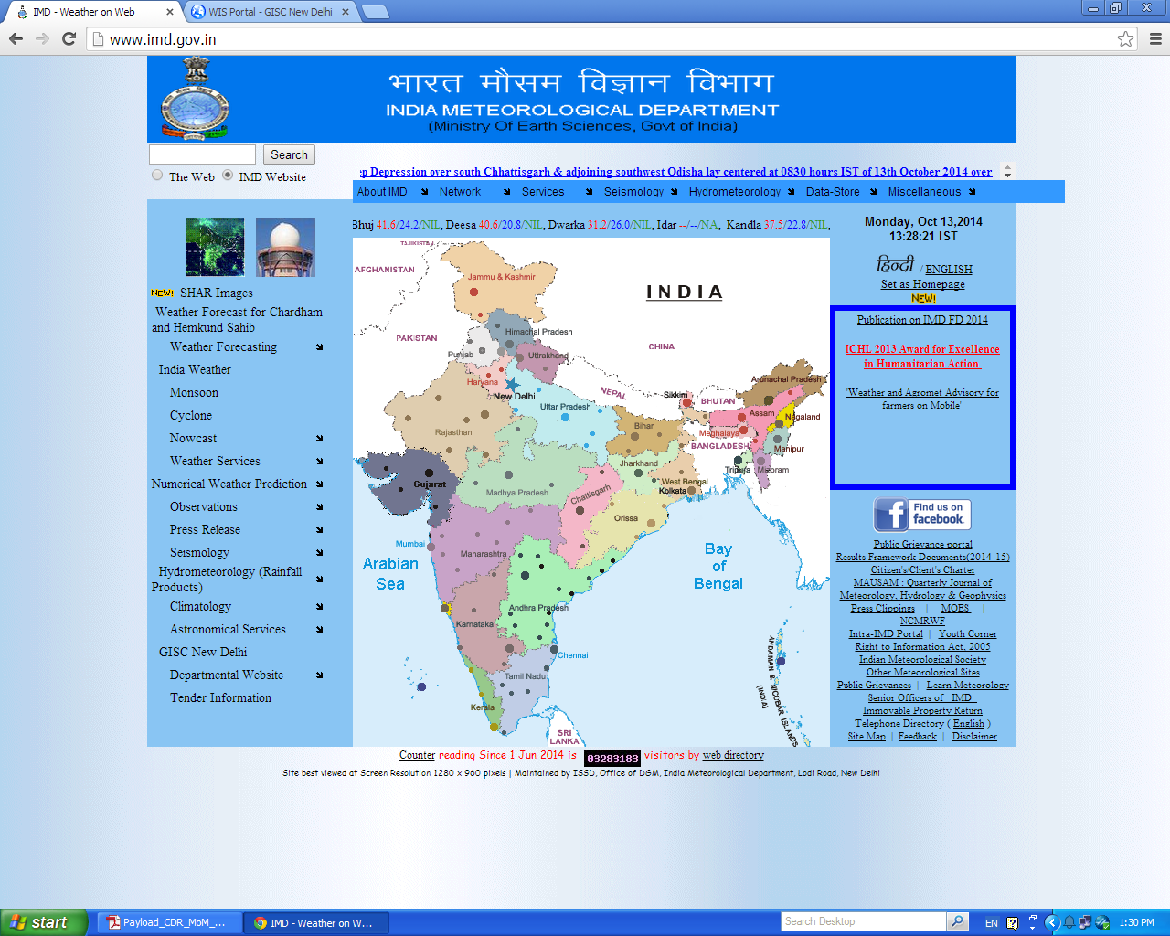

Then click on GISC New Delhi link

It will open a new window http://wis.imd.gov.in/MessirWIS/index.html

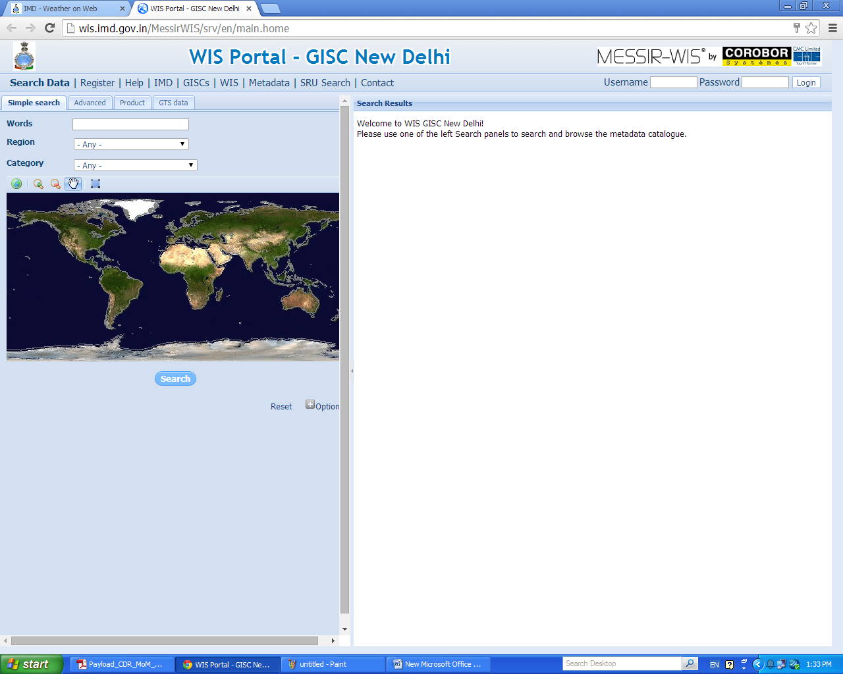

For login

Enter username and password

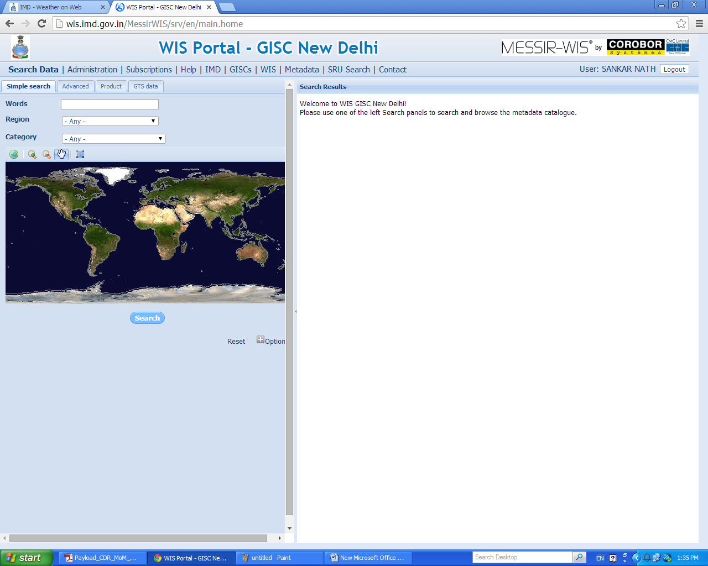

Click on Product tab

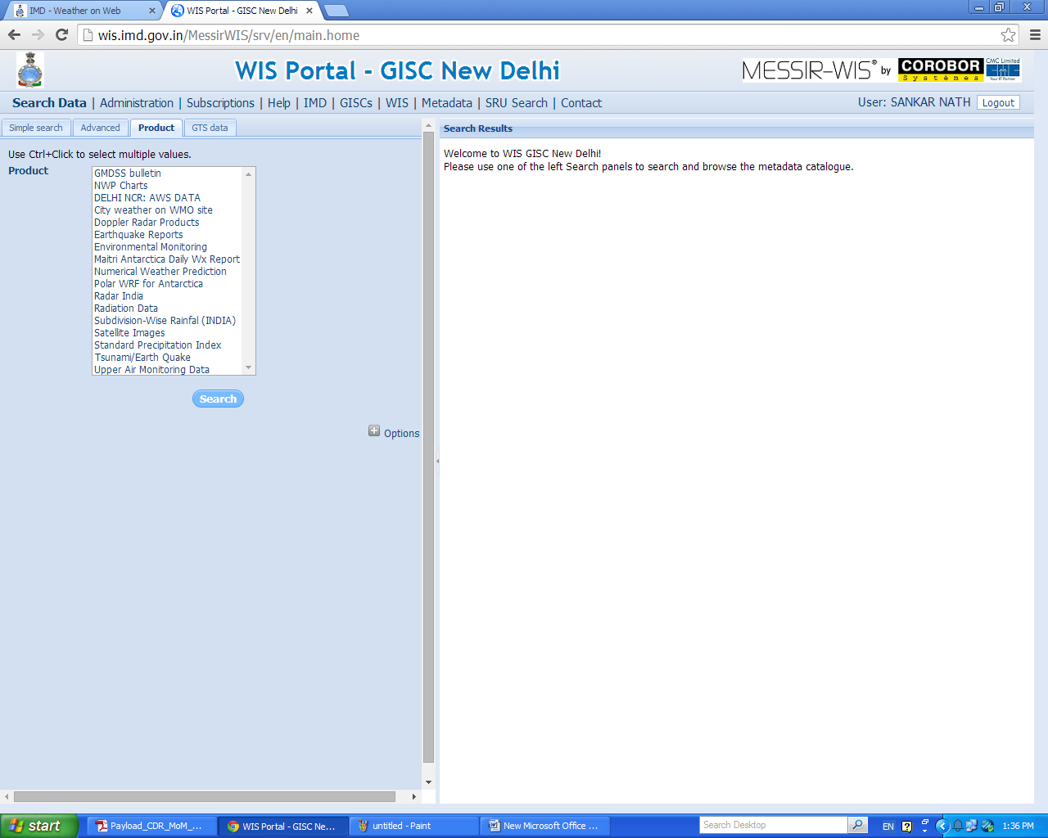

Click on GTS data

