.

CGMS-WMO Task Force on Metadata Implementation

Satellite Product Essential Information for WIS Discovery Metadata

# Introduction

The WIS infrastructure has been declared operational in 2012 and it has reached a stage where satellite data providers can use the WIS as a distribution platform for making available their products. In order to further increase the satellite data providers’ involvement and allow the distribution of more satellite data products through the WIS, it was decided to create a CGMS-WMO Task Force on Metadata Implementation (TF-MI) to ease the creation of satellite metadata describing products for the WIS discovery catalogues.

Prior to define documentation and templates for the creation of satellite products discovery metadata, the experts of the CGMS TF-MI have decide first to define a list of essential information that needs to be present in the discovery metadata to allow a WIS Portal user understanding what types of satellite products he has been discovering. The following chapters describe the information model that has been created by the CGMS-TF-MI to present the essential information that needs to be present in a discovery metadata record. The following information model will be then used in a second phase by the CGMS TF-MI team to create the documentation helping satellite data providers creating WIS discovery metadata for satellite products. This information model will for instance used as the basis for creating examples and templates for the most relevant satellite products which will be made available to the satellite data providers.

# Information Model

The information model presented below is organised around four big categories of information types:

* **Product Information**: Information related to the product definition and content. It contains for instance the product description, its temporal and spatial coverage, the fields of potential applications, data policies, etc.
* **Spacecraft Information**: Information related to the spacecraft and mission source of the product.
* **Instrument Information**: Information related to the instrument such as instrument type, resolution, coverage, channels, etc
* **Product Distribution**: Information related to the product distribution, e.g. how to access the product, in which formats, frequency, etc.

Because users come to those portals to discover products the information model focused on the product and is centred on the product information. For these reasons, the most important pieces of the information model are the **Product Information** and **Product Distribution**. Additional information such as **Spacecraft** and **Instrument Information** contribute to inform the user regarding the product.

The information model is represented below using UML in order to organise and express the relation between the different pieces of information.

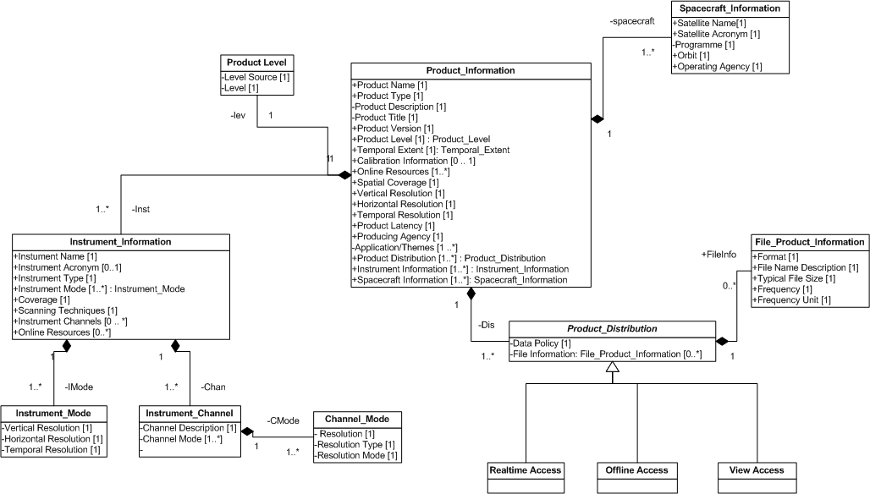***1. Discovery Metadata Information Model for Satellite Products***

# Information Categories

Below is described each different information categories and each individual attributes of the four different categories.

## Product information

The main information related to the product is described in this section. It is the core of the information model from which each additional set of information is associated. This part provides essential information to the user such as

|  |  |  |
| --- | --- | --- |
| **attribute** | **Example** | **Description** |
| Product Name |  | Name of the product |
| Product Type | Cloud, fire detection, … | Type of the product. Different classifications are being currently used in the meteorology community but there is no clear reference list.  The following reference have been identified:  Provide multiple pointers as reference (NOAA Measurements Category, Product Access Guide Domains, GEMET ontology, …) |
| Product Description | N/A | Descriptive paragraph to present the product. This information field is essential for the user as it describes what the data producer thinks is important to present the product |
| Product Version | Product version | Current version of the product. |
| Product Level | Such as  Level-0, 1A, 1B, 1C, 1D, 2 | Level of the product which indicate in the space community the level of product processing, e.g. level 0 is the original product as generated by the satellite without geo-location, calibration corrections, …  Different level definitions exist. The following referenced have been identified and will need to be provided when referencing level. |
| Product Level Source | Such as Nasa, NOAA | Provide the main definitions of the level in the documentation.  NOAA: <https://mmisw.org/orr/#http://mmisw.org/ont/noaa/noaadatalevels>  NASA: <https://mmisw.org/orr/#http://mmisw.org/ont/nasa/datalevel>Eumetsat: http://www.eumetsat.int/website/home/Data/GlobalDataService/index.html |
| Temporal extent | From: 20xx-xx-xx  Until: now | Time period(s) for which the product is available. Provide a Time Range. When it is still daily produced use Now. |
| Calibration Information | URL to the calibration information | URL Links to the Calibration information (calibration tables and product information). |
| Online resources | Information regarding the products | URL Links to additional technical and scientific information regarding the product. This will provide in-depth information regarding the product. |
| Spatial Coverage | Global, Specific region (lat, Lon), … | Description of the coverage area in lat/Lon |
| Horizontal Resolution |  | Resolution of product and observation is not necessarily same. Ask Anna  Gridded product 0.5x0.5 degree.  Point: 1 pixel is 5 km . |
| Vertical Resolution |  | Sounder product => layers, height, number of level => in kms |
| Temporal Resolution | Every 15 mins | Frequency of the product issues. |
| Product Latency | 15 minutes | The time from the end of observation to the start of product distribution/dissemination. |
| Producing agency | NOAA, JAXA | Organization that has created the product. It could be different from the organization in charge of operating the satellite. |
| Application/Themes | See 3.1.1 | Themes and domain under which the product can be categorized. See 3.1.1 from more information |
| Product Distribution | See 3.2 | Information describing how to access the data. This section 3.2 contains all information related to the distribution and access of the products |
| Spacecraft Information | See 3.3 | Information regarding the spacecraft from which the product has originated. The section 3.3 contains all information related to the spacecraft. |
| Instrument Information | See 3.4 | Information regarding the instrument from which the product has been measured. The section 3.4 contains all information related to the instrument |

### Application/Theme information

This section regroups categorization information helping to build more efficient discovery portals. The categorization information can be used to guide the user in its discovery experience when it hasn’t got a deep knowledge regarding the satellite data products.

Two thesaurus/ontology are recommend:

* The Domain categories defined in the WMO Product Access Guide (<http://www.wmo-sat.info/product-access-guide/advanced-search>) and also used in the EUMETSAT Product Navigator (http://navigator.eumetsat.int/)

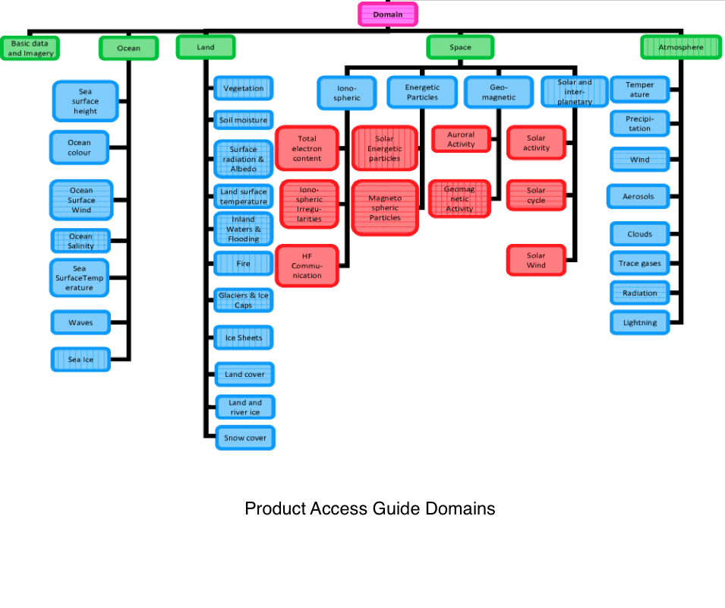

* The Different categories defined in the NOAA NGDC SPEEDS Catalogue <http://www.ngdc.noaa.gov/speeds/>

|  |  |
| --- | --- |
| **Categories** | **Categories** |
| Atmosphere > Aerosols | Land > Land Surface Temperature |
| Atmosphere > Air Quality | Land > Snow and Ice Cover |
| Atmosphere > Altitude | Land > Soils |
| Atmosphere > Atmospheric Chemistry | Land > Vegetation Index |
| Atmosphere > Atmospheric Moisture | Land Surface > Land Use/Land Cover |
| Atmosphere > Atmospheric Phenomena | Oceans > Ocean Color |
| Atmosphere > Atmospheric Pressure | Oceans > Ocean Currents |
| Atmosphere > Atmospheric Radiation | Oceans > Ocean Optics |
| Atmosphere > Atmospheric Temperature | Oceans > Ocean Temperature |
| Atmosphere > Atmospheric Water Vapor | Oceans > Ocean Waves |
| Atmosphere > Atmospheric Winds | Oceans > Ocean Winds |
| Atmosphere > Clouds | Oceans > Oil Spill Events |
| Atmosphere > Imagery | Oceans > Sea Surface Temperature |
| Atmosphere > Ozone | Oceans > Sea Surface Topography |
| Atmosphere > Precipitation | Services > Archive |
| Atmosphere > Stability | Services > DCS |
| Atmosphere > Turbulence | Services > SAR |
| Atmosphere > Volcanic Events | Solid Earth > Volcanoes |
| Atmosphere > Winds | Space > Space Products |
| Biosphere > Vegetation | Spectral/Engineering > Infrared Wavelengths |
| Cryosphere > Sea Ice | Spectral/Engineering > Microwaves |
| Cryosphere > Snow/Ice | Spectral/Engineering > Visible Wavelengths |
| Human Dimensions > Natural Hazards | Sun-Earth Interactions > Ionosphere/Magnetosphere Dynam |
| Human Dimensions > Natural Hazards, Land > Fire and Smoke Events | Sun-Earth Interactions > Solar Activity |
| Instrument Products > Brightness Temperatures | Sun-Earth Interactions > Solar Energetic Particle Flux |
| Instrument Products > Level 1a Products | Terrestrial Hydrosphere > Surface Water |
| Instrument Products > Level 1b Products |  |
| Land > Land Surface Emissivity |  |

## Product Distribution

The product distribution section indicates how the user can access the product. There can be multiple ways to get access to the products either in near-real-time, offline for past data stored in an archive or through a view service for visualizing the product.

|  |  |  |
| --- | --- | --- |
| **attribute** | **Example** | **Description** |
| Distribution Type | Near-real-time | Offline | View | Type of data access. For instance it can be near-real time, offline (archive) or a view access to visualize the products.  Note that it has been model using an inheritance relation in the information model. |
| Data Policy | Free of charge, available to WMO users,  Licensed data, .... | Information describing the licensing condition to comply to get access to the product. |
| Online Resources | Information related to the type of access | Additional information related to the product distribution. |
| File Product Information | See 3.2.1 | Information related to the different type of file formats (format, production frequency, size, …) available. |

### File Product Information

Each product can have multiple formats and distribution frequencies and for each different format files a File Product Information section is necessary.

|  |  |  |
| --- | --- | --- |
| **attribute** | **Example** | **Description** |
| Format | BUFR, GRIB, NECTDF. | Information related to the product file format. URL and links providing additional information can be provided in an Online Resources section. |
| File Name Description | MSG3-SEVI-MSGAMVE-0100-0100-20130214054500.000000000Z-1051616.bfr | Typical filename and file patterns for the different segment or granules files received during a distribution cycle (orbit, ….) |
| Typical File Size | 12.4 MBytes | Typical file size in Mbytes. |
| Frequency | 24 files per day | Number of files received per day or another unit. |
| Frequency unit | Per day | Frequency unit. |

## Spacecraft information

Information regarding the spacecraft from which the product has been created.

|  |  |  |
| --- | --- | --- |
| **attribute** | **Example** | **Description** |
| Satellite name  (Full name) | Meteorological operational satellite - A | Full Name of the Satellite. It is recommended to use the list of acronyms from OSCAR (<http://www.wmo-sat.info/oscar/satellites>). |
| Satellite name (Acronym) | Metop-A | Acronym of the satellite. It is recommend to use the list of acronyms from OSCAR (<http://www.wmo-sat.info/oscar/satellites>). |
| Programme | Meteosat 2nd Generation | Information regarding the space programme of the satellite. |
| Orbit | Sunsynchronous orbit | Orbit type. It is recommended to use the orbit types defined in the OSCAR database (see Orbit Controlled Vocabulary List). |
| Operating agency | EUMETSAT, ESA , NOAA | Agency operating the satellite. |

### Orbit Controlled Vocabulary List

|  |  |
| --- | --- |
| **Value** | **Description** |
| Geostationary orbit | 24-h period, equatorial, eastbound, stationary over a specified longitude (need longitude to fully qualify the Geostationary orbit) |
| Sunsynchronous orbit | Low Earth Orbit, quasi-polar, keeping constant Equatorial Crossing Time (need Equatorial Crossing Time to fully qualify the Sunsynchronous orbit) |
| Drifting orbit | Low Earth Orbit inclined over the equator, with changing Equatorial Crossing Time (need inclination) |
| Molniya orbit | Highly elliptical orbit, period 12-h, inclination 63.4°, argument of perigee -90°, quasi-geostationary around the apogee for about 8 hours. Two apogees each day. |
| Cross-magnetosphere orbit | Highly elliptical orbit cross the Magnetosphere volume |
| Three-Apogee orbit | Highly elliptical orbit, period 16-h, inclination 63.4°, argument of perigee -90°, quasi-geostationary around the apogee for about 12 hours. Three apogees every two days. |
| Geosynchronous orbit | 24-h period, inclined over the equator, eastbound, changing latitude over a constant longitude during the day. |
| Lagrange libration point | Stationary on a Lagrange libration point (e.g. L1, one hundredth of the distance Earth-Sun, closer to Earth) |
| Ecliptic orbit | Co-rotating with the Earth around the Sun. |
| Solar orbit | Orbit around the Sun |
| Lunar orbit | Orbit around the moon |

## Instrument information

|  |  |  |
| --- | --- | --- |
| **attribute** | **Example** | **Description** |
| Instrument name  (Full name) | Advanced Microwave Sounding Unit - A | Full Instrument Name. It is recommended to use the list of instrument names from the WMO OSCAR database (<http://www.wmo-sat.info/oscar/instruments>). |
| Instrument Acronym (Acronym) | AMSU-A | Instrument Acronym. It is recommend to use the list of instrument acronyms from the WMO OSCAR database (<http://www.wmo-sat.info/oscar/instruments>). |
| Instrument type | MW sounding radiometer, cross-track scanning | Instrument Type. It is recommend to use the list of instrument acronyms from the WMO OSCAR database (<http://www.wmo-sat.info/oscar/instruments>). |
| Mode | See 3.4.1 from more information. | Instruments can be operated in different modes and for each mode a different horizontal, vertical and temporal resolution can be used. See 3.4.1 from more information. |
| Coverage | Near-global coverage | Coverage type (near global, …) |
| Scanning technique | Cross-track , spinning E-W continuous and S-N stepping | Scanning technique information. It is recommended to use the WMO OSCAR database scanning information (e.g.: <http://www.wmo-sat.info/oscar/instruments/view/503>). |
| Instrument Channels | See 3.4.2 for more information. | See 3.4.2 Channel information description. |
| Online resources |  | Pointers and links to additional documents related to the instruments. |

### Instrument Mode

Instruments can be operated in different modes and this section describes the information specific to each individual modes. An instrument can have several modes.

|  |  |  |
| --- | --- | --- |
| **attribute** | **Example** | **Description** |
| Mode Name | Nominal |  |
| Mode Vertical resolution |  | One of the component of the spatial resolution. |
| Mode Horizontal resolution | 50 km at Nadir | Instrument Horizontal resolution |
| Mode Temporal resolution | hourly, every 15 mins | measurements frequency. |

### Channel Information

Instruments have multiples channels that can be operated in different modes.

|  |  |  |
| --- | --- | --- |
| **attribute** | **Example** | **Description** |
| Channel Name | IR10.8 | Name of the Channel |
| Channel Description | Infrared 10.8 | Channel description |
| Channel Mode | See 3.4.2.1 | A channel can have multiple modes which are described in the section (see 3.4.2.1) |

#### Channel Mode

This section describes the information relative to the different mode of a particular channel. A channel can have multiple modes with different resolutions.

|  |  |  |
| --- | --- | --- |
| **attribute** | **Example** | **Description** |
| Channel Mode Name | nominal | Name of the Channel mode. |
| Resolution Type | Spatial | The different types of resolution. It can be a spatial or temporal resolution |
| Resolution Information | 3.0 km | Resolution Information. For instance 1 pixel equal 3 km. |

### Instrument Type Controlled Vocabulary List

For the instrument type list, it is recommended to use the OSCAR Instrument types. For more information refer to <http://www.wmo-sat.info/oscar/instrumenttypes>

|  |  |
| --- | --- |
| **Value** | **Description** |
| Moderate-resolution optical imager | Wide range of instruments with the following general characteristics:   * Operating in the VIS, NIR, SWIR, MWIR and TIR spectral bands, i.e. from ~ 0.4 to ~15 μm. * Discrete channels, number from a few to a few tens, separated by dichroics, filters or spectrometers, with bandwidths from ~10 nm to ~1 μm. * Imaging capability, i.e. continuous and contiguous sampling, with spatial resolution in the order of 1 km, covering a swath of several 100 km to a few 1000 km. * Scanning law generally cross-track, sometimes multi-angle, sometimes under more polarisations. * Applicable in both LEO and GEO.   Depending on spectral bands, number and bandwidth of channels, and radiometric accuracy, the application fields may include: cloud observation, surface variables, ocean colour, aerosol, and cloud-motion winds. |
| High resolution optical imager | Instruments with the following general characteristics:   * Spatial resolution in the range of less than 1 m to a few 10 m. * Covered wavelengths in the VIS, NIR and SWIR bands, i.e. 0.4 to 3 μm, with possible extension to supporting MWIR and TIR. * Variable number or channels and bandwidths:   + single channel (panchromatic) with around 0.4 μm bandwidth (e.g., 500-900 nm)   + 3 to 10 (multispectral) channels with around 0.1 μm bandwidth   + continuous spectral range (hyperspectral) with typically100 channels of around 10 nm bandwidth; * Imaging capability, i.e. continuous and contiguous sampling, covering a swath ranging from a few 10 km to some 100 km, often addressable within a field-of-regard of several 100 km. * Applicable in LEO (GEO not excluded but not yet exploited).   Depending on the spectral bands, number and bandwidth of channels, and steerable pointing capability, the application fields may include:   * panchromatic: recognition, stereoscopy; * multispectral: land use/cover, vegetation classification, disaster monitoring; * hyperspectral: vegetation process study, carbon cycle. |
| Cross-nadir scanning SW sounder | Spectrometer with the following main characteristics:   * Covered wavelengths in the UV, VIS, NIR and SWIR bands, i.e. 0.2 to 3 μm. * Spectral resolution ranging from a fraction of nm to a few nm. * Spatial resolution in the order of 10 km. * Horizontal sampling not necessarily continuous and contiguous. * Scanning capability varying from none (nadir-only) to a swath of a few 1000 km. * Applicable both in LEO and in GEO.   Covered application fields depending on spectral bands and resolution:   * UV basic for ozone; * extension to VNIR includes some Cl compounds and several NOx; * extension to SWIR includes some green-house species, more accurately measured if supporting MWIR and/or TIR bands are associated. |
| Cross-nadir scanning IR sounder | Radiometer or spectrometer with the following main characteristics:   * Covered wavelengths in the MWIR and TIR bands, i.e. 3 to 15 μm, with possible extension to FIR up to 50 μm, and auxiliary channels in VIS/NIR. * Spectral resolution in the order of 0.1 cm-1 (very high) or 0.5 cm-1 (hyperspectral) or 10 cm-1 (radiometer). * Spatial resolution in the order of 10 km. * Horizontal sampling not necessarily continuous and contiguous. * Scanning capability varying from none (nadir-only) to a swath of a few 1000 km. * Applicable both in LEO and in GEO.   Covered application fields mostly depending on the spectral resolution, as follows:   * radiometers: coarse vertical resolution temperature and humidity profiles; * hyperspectral: high vertical resolution temperature and humidity profile, coarse ozone profile and total column or gross profile of few other species, mostly green-house; * very-high resolution spectrometers: profiles of several species of atmospheric chemistry interest, including CFC’s and other aggressive species. |
| SW and IR sounder | Spectrometer with the following main characteristics:   * Covered wavelengths in both short-wave (VIS/NIR/SWIR and long-wave (MWIR/TIR). * Spectral resolution in the order of 0.2 cm-1in both SW and LW bands. * Spatial resolution in the range of less than 1 km to a few 10 km. * Horizontal sampling not necessarily continuous and contiguous. * Scanning capability varying from none (nadir-only) to a swath of a several 100 km. * Applicable in LEO.   The purpose of this type of instrument is to observe greenhouse gases with signatures in both SW and LW to improve the profiling vertical resolution in the PBL. |
| MW imaging radiometer, conical scanning | Radiometer with the following main characteristics:   * Covered frequencies from 1 to 200 GHz (wavelengths 1.5 mm to 30 cm), operating in atmospheric window channels of bandwidths from some 100 MHz to some GHz. * Spatial resolution from a few kilometres to some 100 km, determined by antenna size and frequency. * Horizontal sampling continuous and contiguous, over a swath of some 1500 km. * Conical scanning, providing two or more polarisations. * Applicable only in LEO.   Covered application fields mostly depending on the frequency and the spatial resolution (i.e., the antenna size):   * sea-surface salinity and volumetric soil moisture from lowest frequencies; * sea-surface temperature, surface soil moisture, wind speed from low-medium frequencies (wind vector by full polarisation); * precipitation, snow, ice from higher frequencies. |
| MW sounding radiometer, cross-track scanning | Radiometer with the following main characteristics:   * Covered frequencies from 20 to 200 GHz (wavelengths 1.5 to 15 mm), operating in absorption bands split in several channels of bandwidths from a few MHz to some GHz. * Spatial resolution from some 10 to some 100 km, determined by antenna size and frequency. * Horizontal sampling not necessarily continuous and contiguous. * Cross-track scanning, providing single or dual polarisations over a swath of some 2000 km. * Applicable only in LEO (possibilities in GEO being studied).   Covered application fields depending on the exploited frequency bands:   * nearly-all-weather temperature profile from oxygen bands (e.g., 54 GHz, 118 GHz); * nearly-all-weather humidity profile from water vapour bands (e.g., 183 GHz); * precipitation also observed. |
| MW imaging/sounding radiometer, conical scanning | Radiometer with the following main characteristics:   * Covered frequencies from 10 to 1000 GHz (wavelengths 0.3 mm to 3 cm), operating in absorption bands split in several channels of bandwidths from a few MHz to several GHz; and a number of window channels of bandwidths from some 100 MHz to some GHz. * Spatial resolution from a few kilometres to some 100 km, determined by antenna size and frequency. * Horizontal sampling continuous and contiguous, over swath of some 1500 km. * Conical scanning, providing dual polarisation for window channels and single or dual polarisation for absoption-band channels. * Applicable only in LEO.   Covered application fields depending on the exploited frequency bands and channels:   * nearly-all-weather temperature profile from oxygen bands (e.g., 54 GHz, 118 GHz); * nearly-all weather humidity profile from water vapour bands (e.g., 183 GHz); * sea-surface temperature, surface soil moisture, wind speed from low-medium frequencies (wind vector by full polarisation); * precipitation, snow, ice from higher frequencies |
| Special scanning or non-scanning MW radiometer | Family of radiometers without mechanical scanning.  Several categories:   * Imaging, by synthetic aperture or real-aperture multi-beam antenna:   + operating in L-band (typically 1.4 GHz);   + spatial resolution in the order of 50 km with swath of a few 100 km (multi-beam) or some 1000 km (synthetic aperture);   + applicable only in LEO;   + for sea-surface salinity and volumetric soil moisture. * Imaging, by cross-track electronic scanning:   + operating in K-band (typically 19 GHz);   + spatial resolution in the order of 20 km with swath of some 3000 km;   + applicable only in LEO;   + for sea ice and heavy precipitation over the sea. * Nadir-pointing radiometers:   + operating on frequencies from 15 to 40 GHz (wavelengths 7.5 mm to 2 cm), across the water vapour absorption band around 23 GHz by two or three channels with a bandwidth of several 100 MHz;   + spatial resolution of some 20 km and near-continuous sampling along the track;   + applicable only in LEO;   + to provide information on total-column water vapour to correct for the atmospheric path delay induced on the signal of the radar altimeter. * Imaging from GEO by real or synthetic aperture antenna:   + operating in absorption bands of oxigen (e.g., 54, 118, 425 GHz) and water vapour (e.g., 183, 380 GHz);   + spatial resolution changing with frequency, e.g. 50 at 54 GHz;   + to provide sub-hourly sampling of nearly-all-weather temperature and humidity sounding, and liquid and solid precipitation. |
| Limb-scanning sounder | Family of spectrometers with the following main characteristics:   * Covered wavelengths in the ranges of short-wave (UV to SWIR), or infrared (MWIR and TIR) or millimetre-submillimetre (0.1 to 3 mm or 100 to 3000 GHz). * Spectral resolution in the range of 0.2 nm (SW) or 0.05 cm-1 (IR) or 100 MHz (Mm-submm). * Limb scanning, mechanically determining the vertical resolution (in the range of 1-3 km) and the observed atmospheric layer (in the range of 10 to 80 km); and the spatial resolution (about 300 km along-view). * In the SW range, scanning may be provided by solar occultation, as well as moon or stars occultation. * Applicable only in LEO.   Application: high-vertical resolution atmospheric chemistry in the stratosphere and mesosphere, to track species depending on the exploited spectral band |
| Broad-band radiometer | Instrument with the following main characteristics:   * Covered wavelengths in the bands of total radiation emerging from Earth and atmosphere (0.2-300 μm) and the fraction represented by reflected solar radiation (0.2-4.0 μm). * One broad-band channel integrating over each of the two bands, and optional narrow-bandwidth channels in VIS and/or TIR to collect information on clouds within the IFOV. * Cross-track scanning with continuous and contiguous sampling, to cover a swath of a few 1000 km with spatial resolution in the order of 10 km; or biaxial scanning or combination of a cross-track scanning and a wide-angle non-scanning unit to enable conversion of radiance into irradiance; or non-scanning, either with 2π view or along-track only. * Applicable both in LEO and in GEO.  Observation from the L1 Lagrange libration point also is possible.   Application: observation of upward long-wave and short-wave irradiance at TOA, associated to solar irradiance for the purpose of monitoring Earth radiation budget. |
| Solar irradiance monitor | Instrument with the following main characteristics:   * Covered wavelengths in the range of solar radiation (0.15-50 μm). * Integration over the full range (Total Solar Irradiance) and/or spectroscopy in the 0.15-3 μm range. * Total Solar Irradiance measured by absolute techniques, e.g. active cavity radiometers. * Applicable in LEO, in GEO, and in special high-orbits.   Application: observation of the solar irradiance:   * at TOA in association with upward long-wave and short-wave irradiance, for the purpose of monitoring Earth radiation budget; * at the Sun surface, particularly for variability, significant of Sun interior processes. |
| GNSS radio-occultation sounder | Instrument with the following main characteristics:   * GNSS receiver exploiting at least two L-band frequencies around 1.18, 1.25 and 1.58 GHz.(or 19, 24 and 25.4 cm). * Earth’s limb observation from surface to the satellite altitude during the occultation phase of satellites of the GNSS constellations (GPS, GLONASS, Galileo, Beidou). * Directional antennas looking aft- (for setting GNSS) and/or fore- (for rising GNSS), and toroidal antenna for navigation. * Spatial resolution around 300 km in the direction LEO-satellite to occulting GNSS-satellite, a few 10 km transverse. * Horizontal sampling limited by the daily number of occultation events, from 250 to 1500 depending on the number of tracked GNSS constellations and the aft- and/or fore- tracking capability. * Supported by a complex system of ground stations for clock error correction by double differentiation. * Applicable only in LEO.   Applications: very-high vertical resolution profiling of temperature, water vapour and air density; and electron total content and density in the ionosphere. |
| Lightning imager | Instrument with the following main characteristics:   * Detector matrix (CCD) all-time watching the earth in a very-narrow oxygen band at 777.4 nm. * Measurement: flash rate and intensity in the IFOV. * Spatial resolution 5-10 km; horizontal sampling continuous and contiguous, over a swath of several 100 km from LEO, full disk from GEO. * Applicable both in LEO and in GEO.   Applications: detection of convective cloud systems, thus proxy of precipitation; also proxy of earth’s electric field and of NOx generation. |
| Cloud and precipitation radar | Family of instruments with the following main characteristics:   * Operating frequencies in Ku (~14 GHz), or Ka (~35 GHz), or W (~94 GHz) bands.  Ku and Ka bands often flown together. * Pulse repetition rate such as to result in a vertical resolution of a few 100 m. * Spatial resolution 2 to 5 km; horizontal sampling continuous and contiguous, swath from only nadir (W-band) to several 100 km (Ku and Ka bands). * Applicable only in LEO.   Applications depending of the exploited frequency:   * Ku-band suitable for heavy rain (liquid, with droplets that may exceed 1 cm); * Ka-band: suitable for light rain (from stratiform clouds) and snowfall; * W-band: suitable for non-precipitating clouds (droplets < 0.1 mm). |
| Radar scatterometer | Instrument with the following main characteristics:   * Operating frequencies in C (~5 GHz), and/or Ku (~14 GHz) bands. * Very accurate calibration, to measure backscatter coefficients (σ0) from sea capillary waves. * Observation performed from at least 3 distinct directions; spatial resolution 10 to 50 km; horizontal sampling continuous and contiguous, swath some 1000 km. * Two scanning concepts: pushbroom, side-looking with azimuths 45°, 90° and 135*, on one side or both; and conical, with two beams to provide four distinct σ0 from each IFOV. * Applicable only in LEO.   Applications: sea-surface wind; also surface soil moisture. |
| Radar altimeter | Instrument with the following main characteristics:   * Operating frequencies in Ku-band (~14 GHz) or Ka-band (~36 GHz), with supporting C (~5 GHz) or S (~3 GHz) to correct for signal rotation in the ionosphere. * Very accurate ranging measurement, supported by co-flying MW radiometer in the 23 GHz water vapour band for path delay correction. * Observation essentially nadir (large-swath possibly to be performed by interferometry of signals from two parallel antennas); spatial resolution in the order of 20 km, possible to be improved to hundred metres along-track by SAR-like processing. * Applicable only in LEO.   Applications:   * sea-surface height (ocean topography), significant wave height, sea-surface wind speed, sea-ice thickness; * geoid (by analysis of measurement series and the support of precise orbitography). |
| Space lidar | Family of instruments with the following main characteristics:   * Operating wavelengths in the UV (e.g., 355 nm), or VIS (e.g., 532 nm), or NIR (e.g., 1064 nm), or SWIR (e.g., 1600 nm); possible dual-wavelength, two receivers (for Mie and Rayleigh scattering), polarimetry. * Spatial resolution in the range of 100 m, often degraded up to 50 km in order to collect enough de-correlated samples; vertical resolution in the range of 100 m (a few 10 cm for lidar altimeters). * Non-scanning; either nadir-viewing or oblique. * Several designs for different purposes:   + Doppler lidar generally operating in UV, for both Mie and Rayleigh scattering, to track aerosol and air molecules; oblique view for radial wind in clear-air and aerosol;   + Backscatter lidar operating at one (in UV) or two (VIS and NIR) wavelengths, often with more polarisations; nadir view for aerosol profile, cloud top height and atmospheric discontinuities;   + Lidar altimeter operating at two wavelengths, VIS and NIR; nadir view, very high vertical resolution (for sea-ice elevation) and horizontal resolution (for ice boundaries);   + Differential absorption lidar (DIAL), operating at one wavelength centred on the absorption peak of one trace gas (e.g., O3, H2O and CO2), and nearby windows; nadir-view. |
| Imaging radar (SAR) | Family of instruments with the following main characteristics:   * Operating frequencies in P (~0.4 GHz), L (~1.3 GHz), S (~2.7 GHz), C (~5.3 GHz), X (~9.6 GHz), or Ku (~17.2 GHz) band - the mostly used bands being L, C and X. * Several combinations of polarizations in transmission and reception possible to be implemented: HH, VV, VV/HH, HH/HV and VV/VH. * Spatial resolution can be traded-off with swath: from 1-30 m associated to swath of 30-100 km; and 100-1000 m associated to swath of 300-500 km. * Pushbroom, side-looking generally on one side, keeping high resolution within a field-of-regard of several 100 km. * Wide range of applications for every frequency band, with variable effectiveness:   + P-band most suited for biomass monitoring and hydrological mapping;   + S-band best suited for volumetric soil moisture;   + C-band covering the widest range (sea-ice, wave parameters by spectral analysis of image segments, surface soil moisture, snow parameters, glaciers, ground water, etc.);   + X-band providing the best spatial resolution, thus best suited for surveillance;   + Ka-band specifically suited for snow, that is semi-transparent at lower frequencies;   + interferometry of the signals from one SAR at different times or two SARs flying in tandem enables measuring the Digital Elevation Model (DEM) and detecting changes of contours and elevation. * Applicable only in LEO. |
| Positioning system | Family of instruments for precise orbitography:   * Laser retroreflector: mirrors (generally cube corners) to reflect laser beams sent to the satellite by ground laser-equipped sites during positioning sessions. * GNSS receiver: exploiting the differential phase of signals from a few satellites of the Global Navigation Satellite System. * Radio positioning system: transponders involving satellite and ground transmitting-receiving stations. * Star tracker: CCD imager that tracks bright stars, recognise the pattern and sends information to the satellite attitude control system.   Applications:   * satellite navigation and attitude control; * basic to provide the underlying geoid for the altimetry mission, in turn basic for geoid determination; * space geodesy: crustal plates positioning and motion; * concurring to the observation of the Earth’s gravity field. |
| Gravity sensing system | Family of instruments to measure the Earth’s gravity field:   * Accelerometer: to measure the variation of the gravity field along the satellite trajectory. * Gradiometer: network of accelerometers to measure the gravity-gradient tensor. * Satellite-to-satellite ranging: transmit-receiver systems in K-band (24 GHz) and Ka-band (32 GHz) to accurately measure the distance and its variations between satellites in coordinated orbits.  Also implemented by simultaneous reception of signals from tens of GNSS satellites for extremely accurate determination of positioning changes.   Applications closely connected with precise orbitography by positioning systems. |
| Solar processes monitor | Family of instruments for remote observation of solar phenomena, either as spectrally-analysed fluxes from the full sun disk, or by detailed imagery of the layers of the solar atmosphere and the heliosphere. Observations:   * Electromagnetic radiation at discrete wavelengths and total spectral irradiance: Gamma-ray, X-ray, EUV, UV, radio, etc.; * Coronal mass ejections and their propagation through interplanetary space; * Additional features of the sun and solar atmosphere, such as: magnetic field and the velocity of surface and sub-surface flows..   Observing positions include LEO, GEO, the L1 Lagrange libration point, but also any orbit around the Sun or Earth with constant viewing of the Sun. |
| Solar wind and cosmic radiation monitor | System of detectors for in-situ measurements of the plasma, energetic particles, and magnetic field in the heliosphere.  Specific observations:   * solar wind (electrons, protons, and heavy ions); * energetic electrons, protons, and heavy ions, including galactic cosmic rays; * solar wind magnetic field. |
| Magnetosphere/ionosphere sounder | System performing 3-D sounding of the Magnetosphere and Ionosphere by in-situ measurements on satellite fleets moving in coordinated orbits:   * across the magnetospheric volume and tail in highly elliptical orbits, often in appropriately shaped formation; * in relatively low orbits optimised for ionospheric coverage.   The measurements include plasma and energetic particles, magnetic fields, electric fields, scintillations, and electromagnetic waves and radiation |
| Aurora imager | Family of instruments to image auroral features:.   * FUV and UV imagers; * VIS and/or NIR imagers. |
| Platform environment monitor | System of detectors for in-situ measurements of the plasma, energetic particles, and magnetic and electric fields in the magnetosphere and ionosphere. These instruments provide in-situ monitoring of the environmental conditions around the satellite, both to detect Space Weather disturbances in the magnetosphere and ionosphere, and for the diagnoses of satellite anomalies.  Observations include:   * low-energy and high-energy electrons, protons, and heavy ions; * magnetic field; * electric field. |
| Data collection system | Transponder that relays to ground the data collected in situ by Data Collection Platforms (DCP).  Applicable in LEO and GEO.  Operating modes:   * random access to collect messages transmitted at fixed times (self-timed DCP) or in emergency (alert DCP); * message acquisition only after interrogation of the DCP; * location of the DCP if mobile (only from LEO). |
| Search & rescue system | Transponder that relays distress signals from ground users in difficulty to local user terminals that, in turn, relay the message to a mission control centre enabled to activate the most appropriate unit of the international search & rescue organisation. Applicable in LEO and GEO.  LEO enables location of the transmitting user.  For GEO, the information on location must be embedded in the message. |