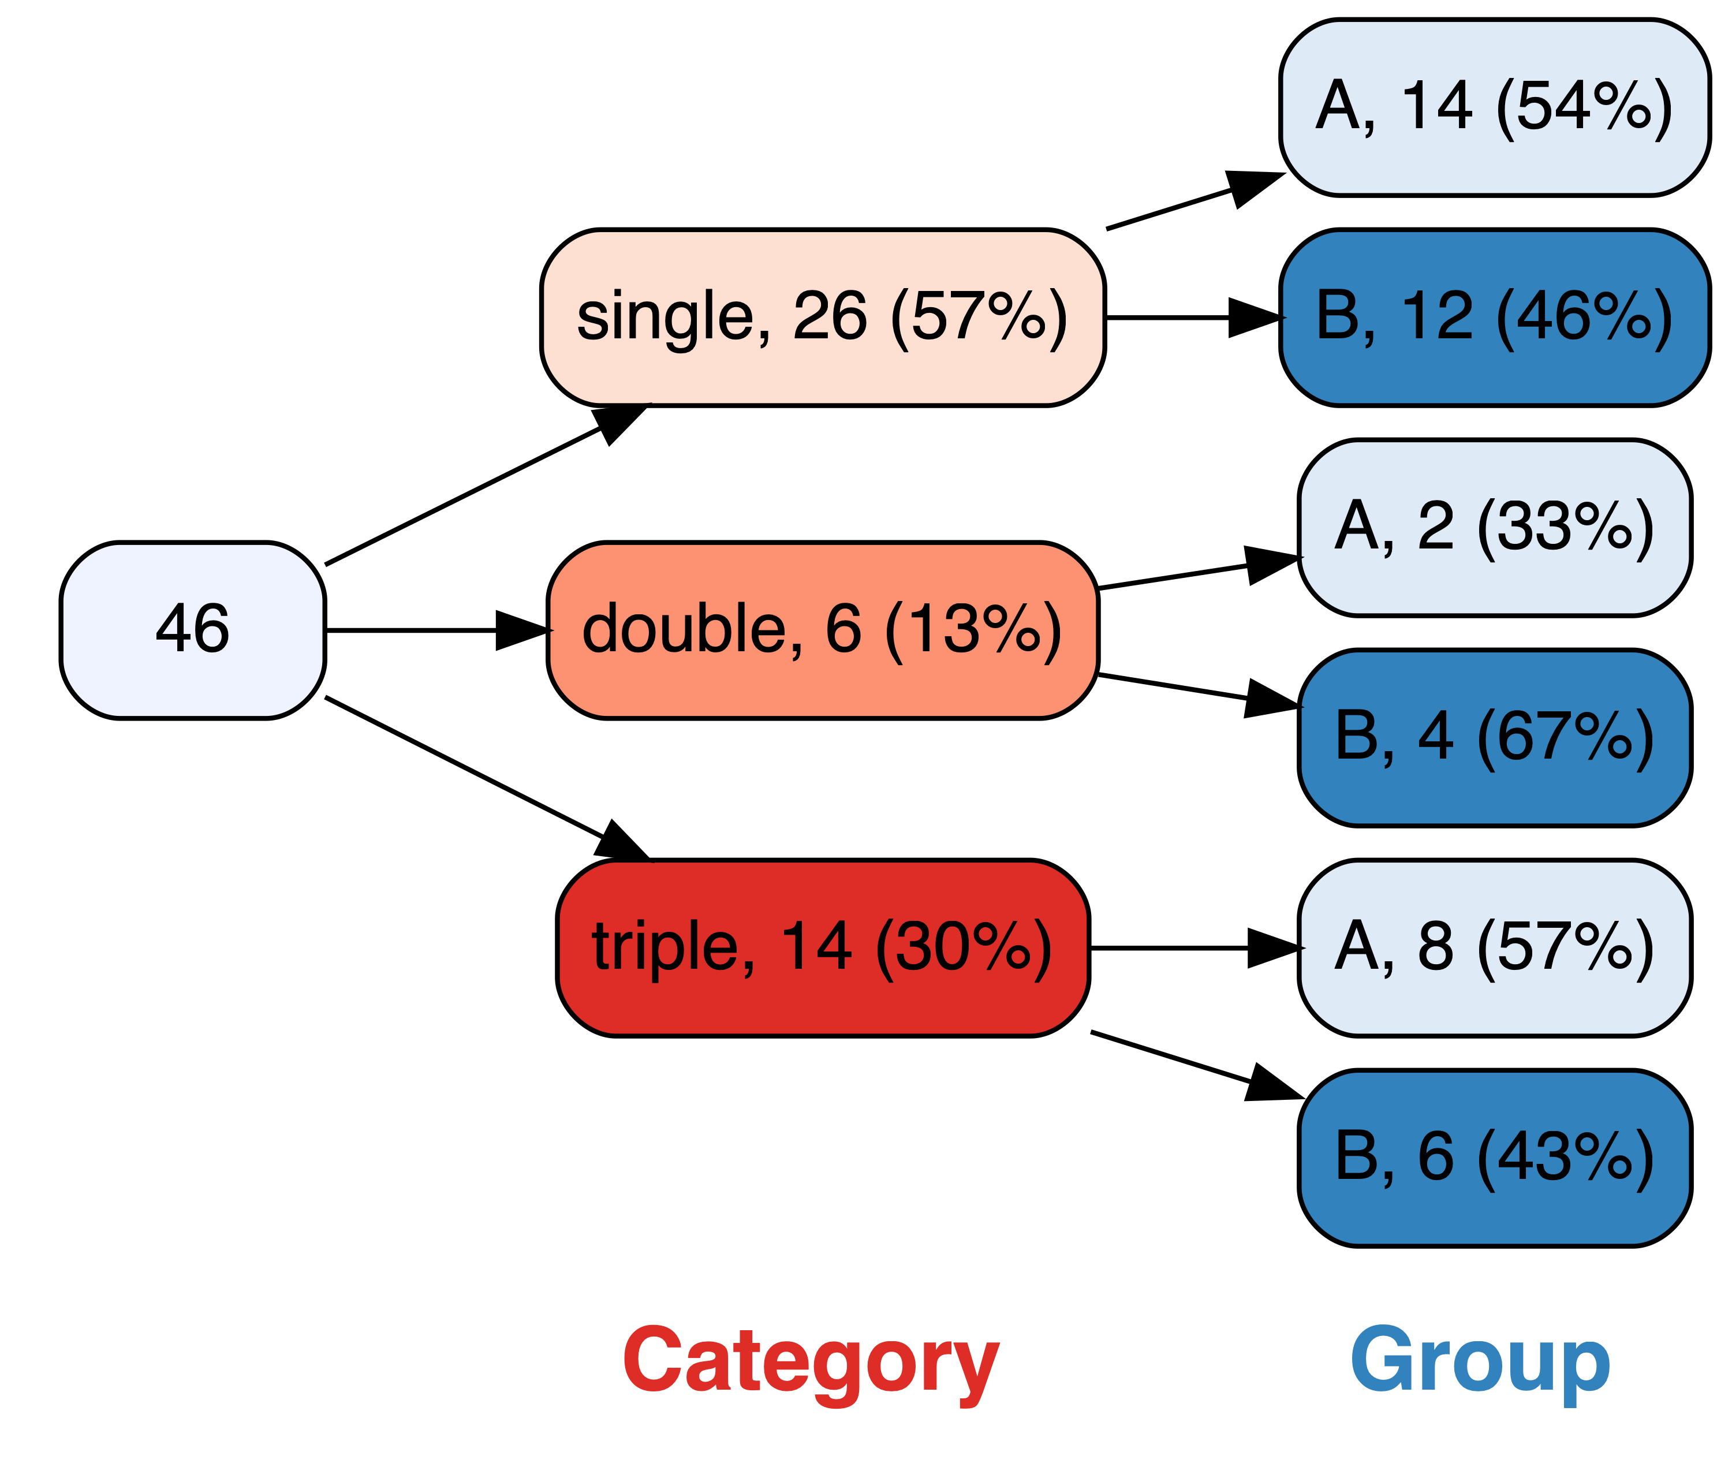**vtree** cheatsheet

vtree(FakeData,"Category Group",sameline=TRUE,

**prune**=list(Category=c("single","double")))

vtree(FakeData,"Category Group",sameline=TRUE,

**prunebelow**=list(Category=c("single","double")))

vtree(FakeData,"Category Group",sameline=TRUE,

**keep**=list(Category=c("single","double")))

vtree(FakeData,"Category Group",sameline=TRUE,

**follow**=list(Category=c("single","double")))

vtree(FakeData,"Severity",sameline=TRUE,

summary="Score , mean=%mean%")

|  |  |
| --- | --- |
| Code | Result |
| %mean% | mean |
| %SD% | standard deviation |
| %min% | minimum |
| %max% | maximum |
| %pX% | Xth percentile (e.g. p50 means the 50th percentile) |
| %median% | median, i.e. p50 |
| %IQR% | IQR, i.e. p25, p75 |
| %npct% | frequency and percentage |
| %pct% | just percentage |
| %list% | list of individual values, separated by commas |
| %listlines% | list of individual values, each on a separate line |
| %mv% | the number of missing values |

|  |  |
| --- | --- |
| Code | Summary information restricted to: |
| %noroot% | all nodes *except* the root |
| %leafonly% | leaf nodes |
| %var=*v*% | nodes of variable *v* |
| %node=*n*% | nodes named *n* |

Summary information

vtree(FakeData,"Severity Sex")

vtree(FakeData,"Group",horiz=FALSE)

vtree(FakeData,"Category Group",sameline=TRUE,

showlegend=TRUE)

Basics

vtree(FakeData,"Group Category",sameline=TRUE,

text=list(Category=c(triple="\n*not verified*")))

|  |  |
| --- | --- |
| Code | Meaning |
| \n | Line break |
| *...* | Italics |
| **...** | Bold |
| ^...^ | Superscript |
| ~...~ | Subscript |
| %%red ...%% | Make text red (or another color) |

|  |
| --- |
| Text in a specific node (“targeted text”) |
| ttext=list(Group="A",Severity="Moderate",text="hi") |

Text

Pruning

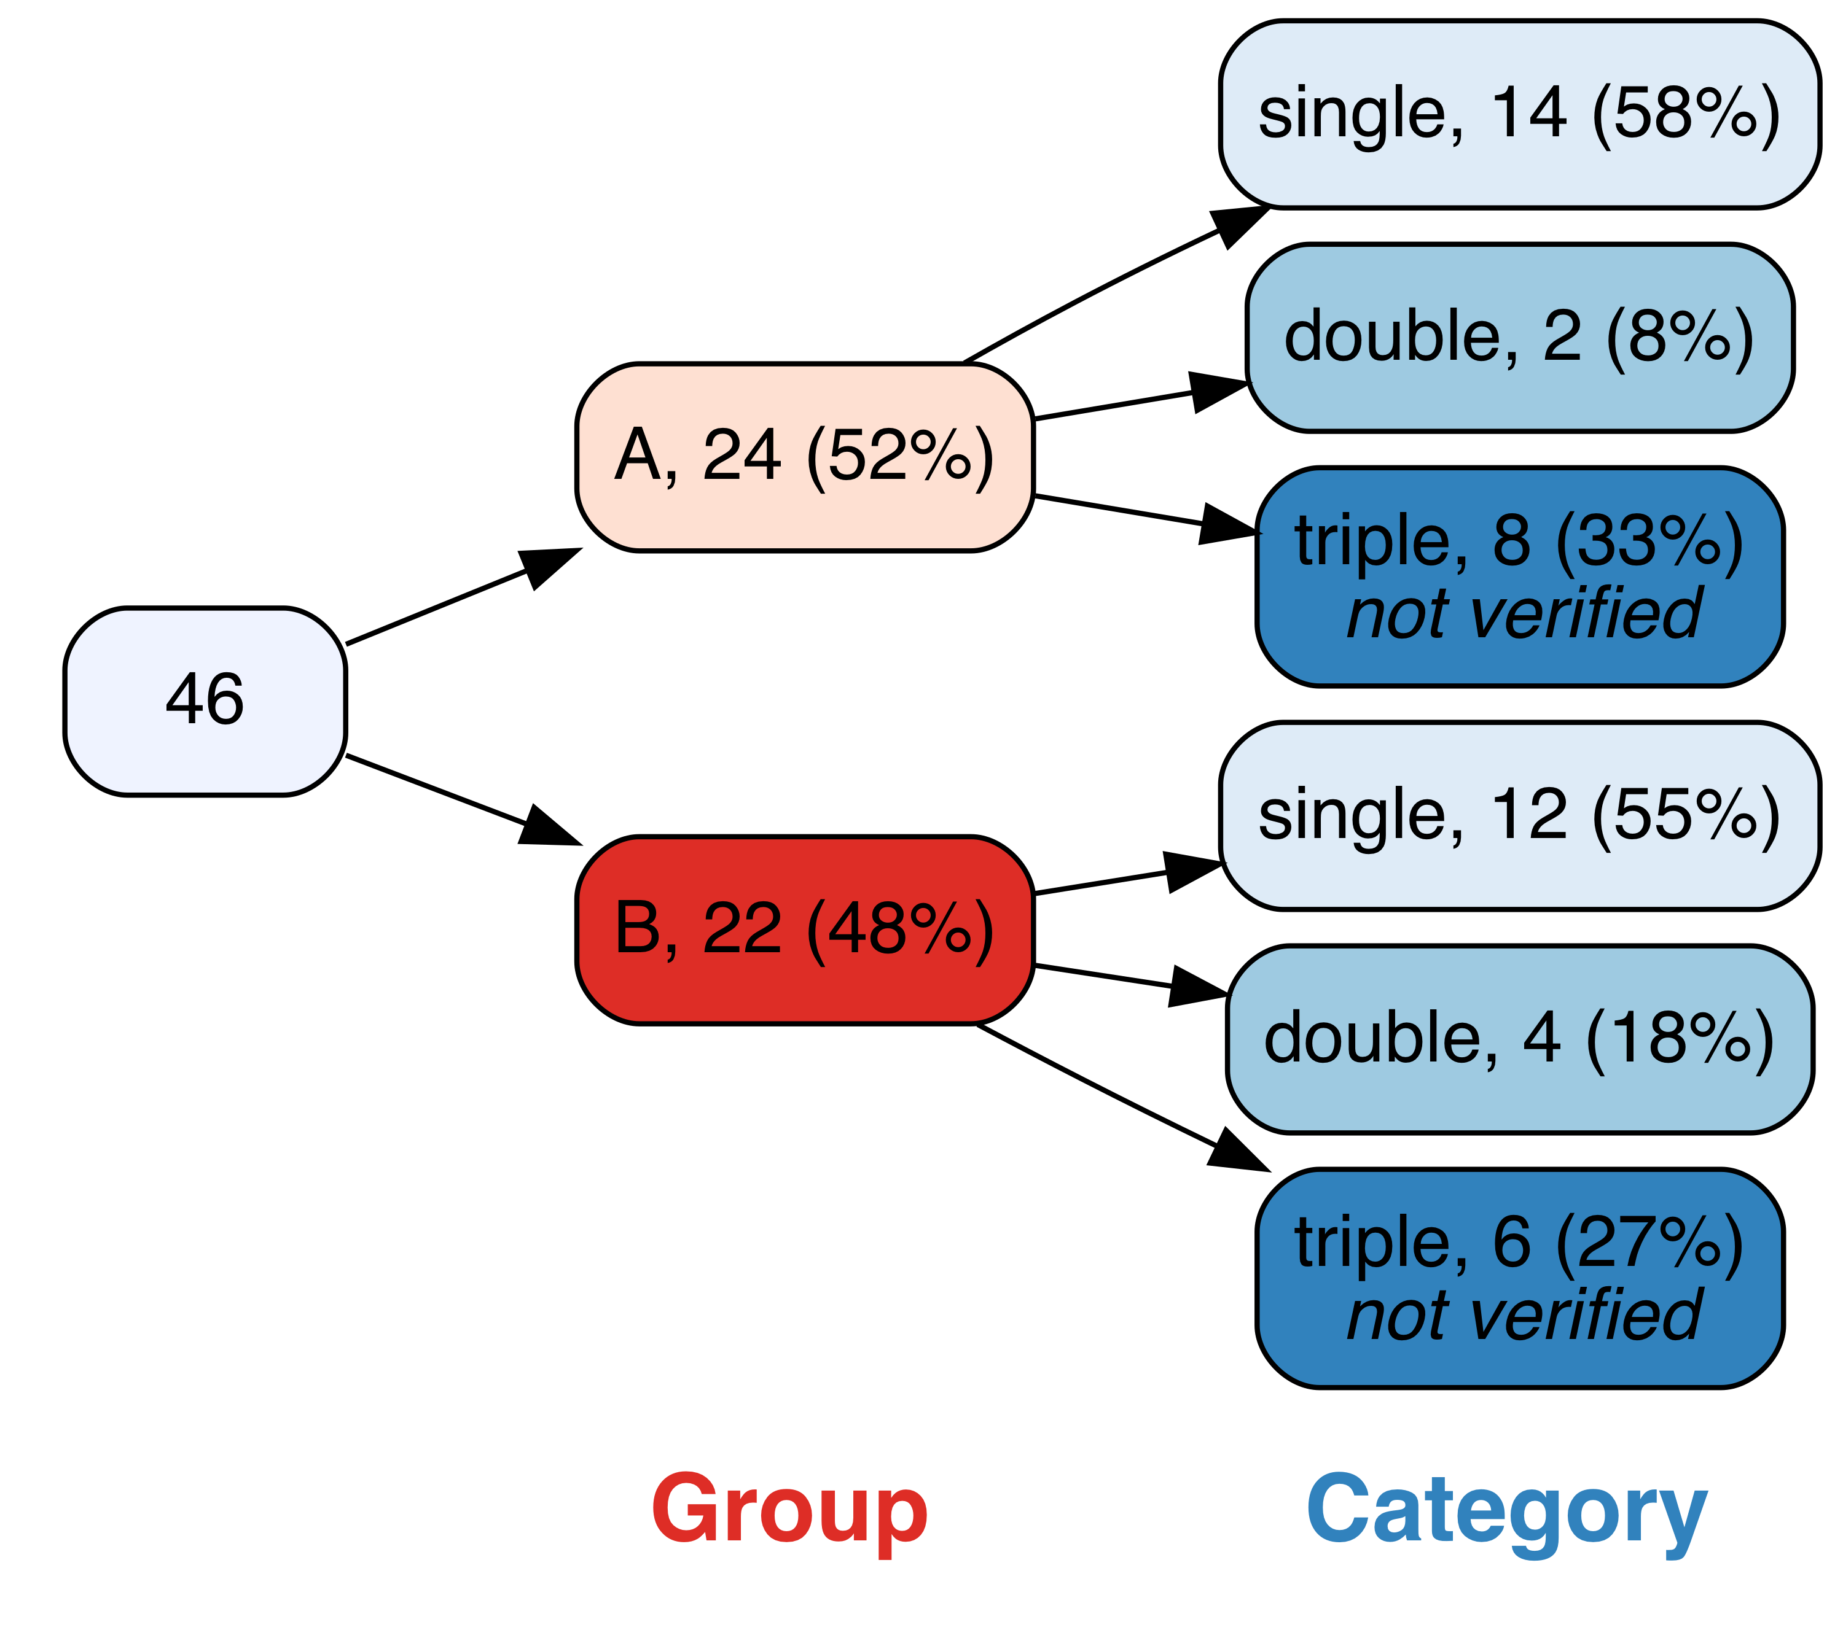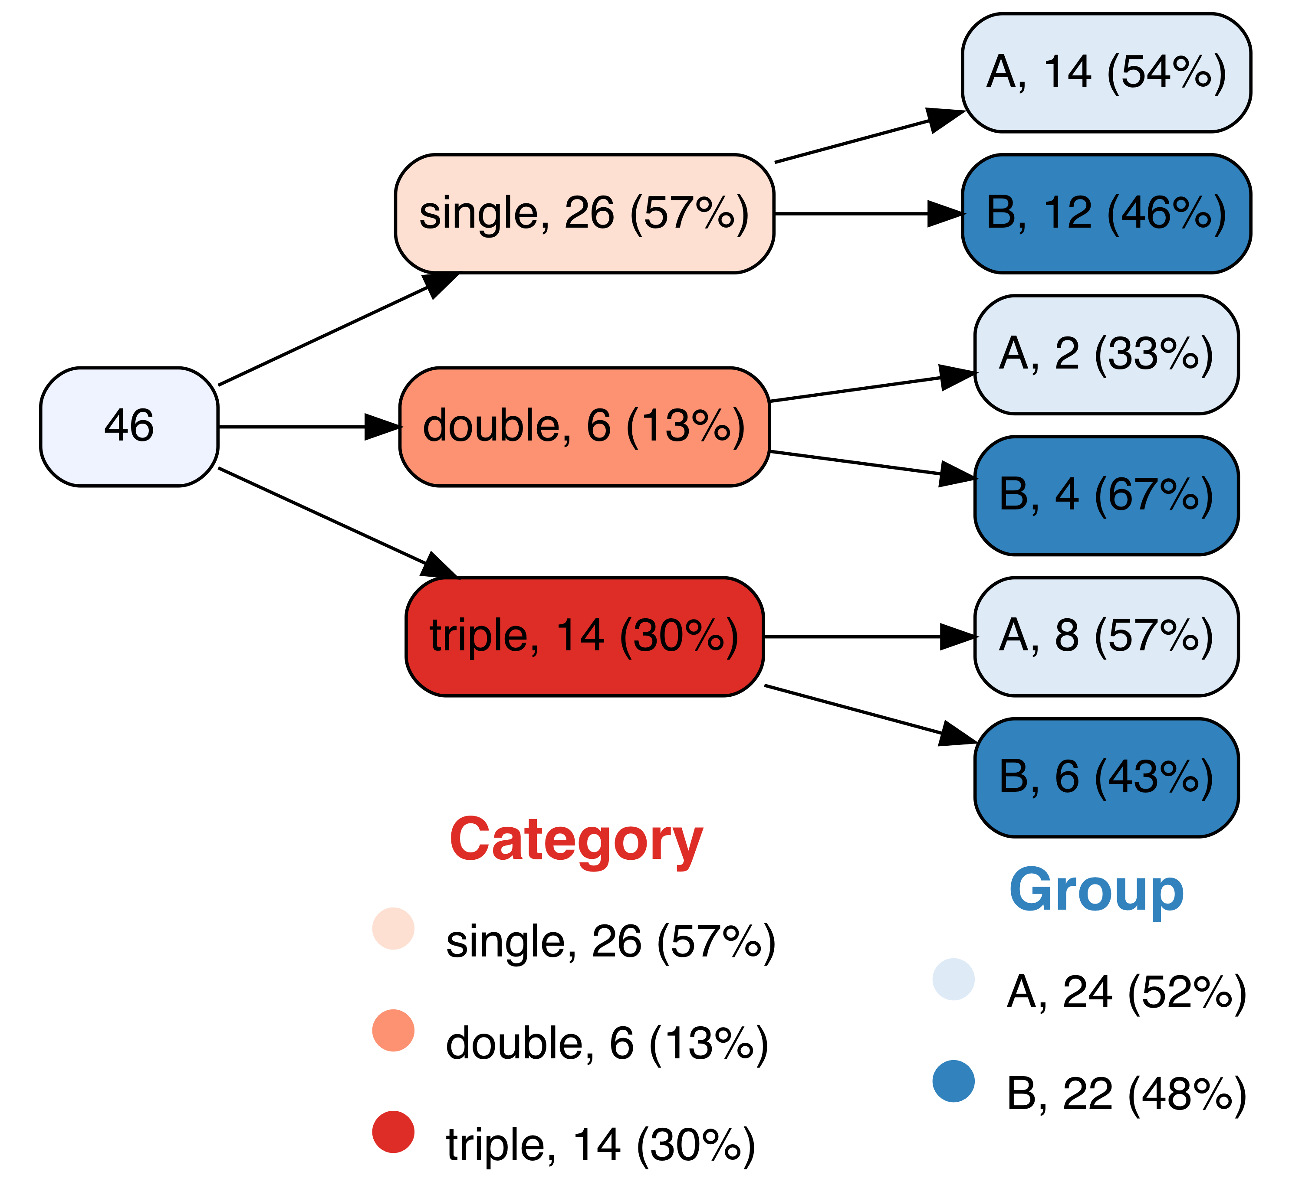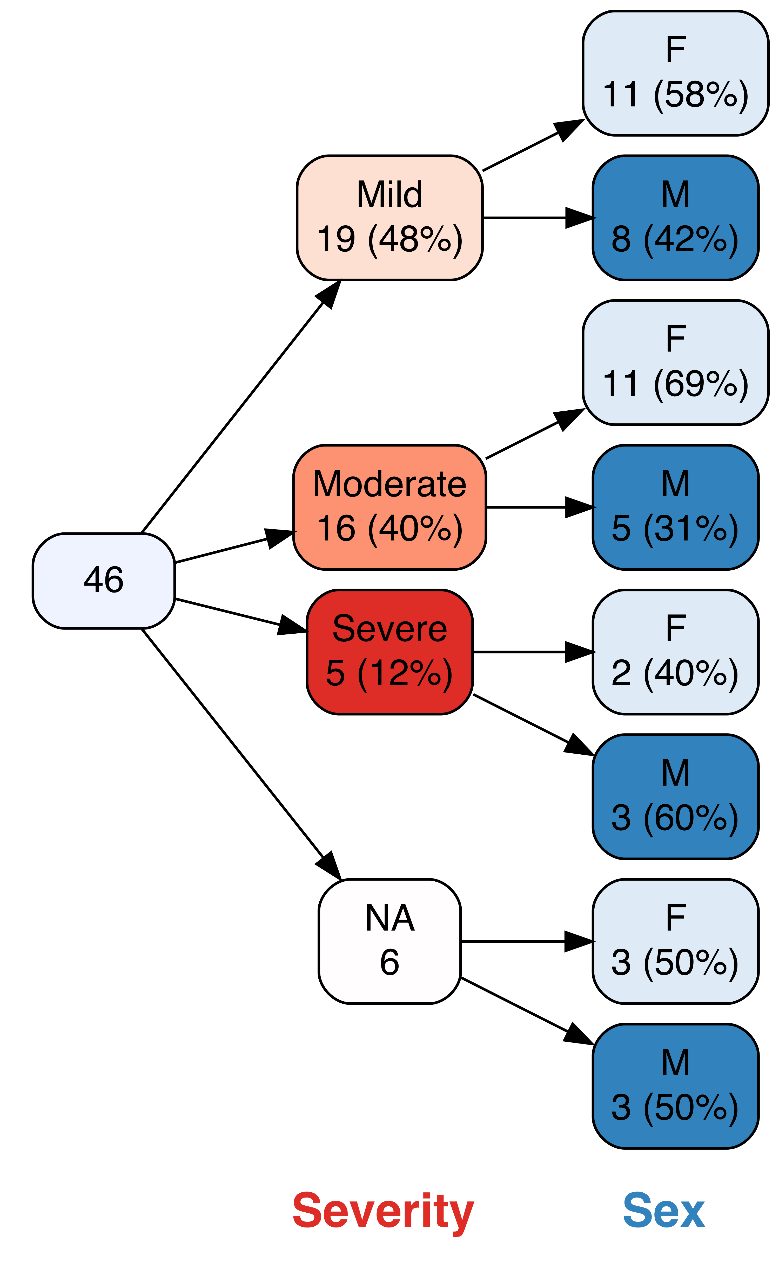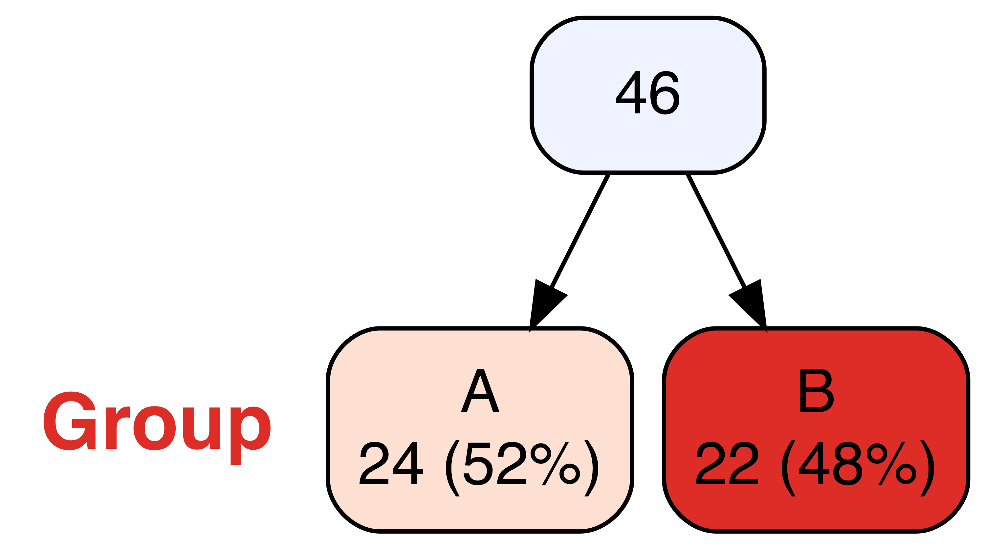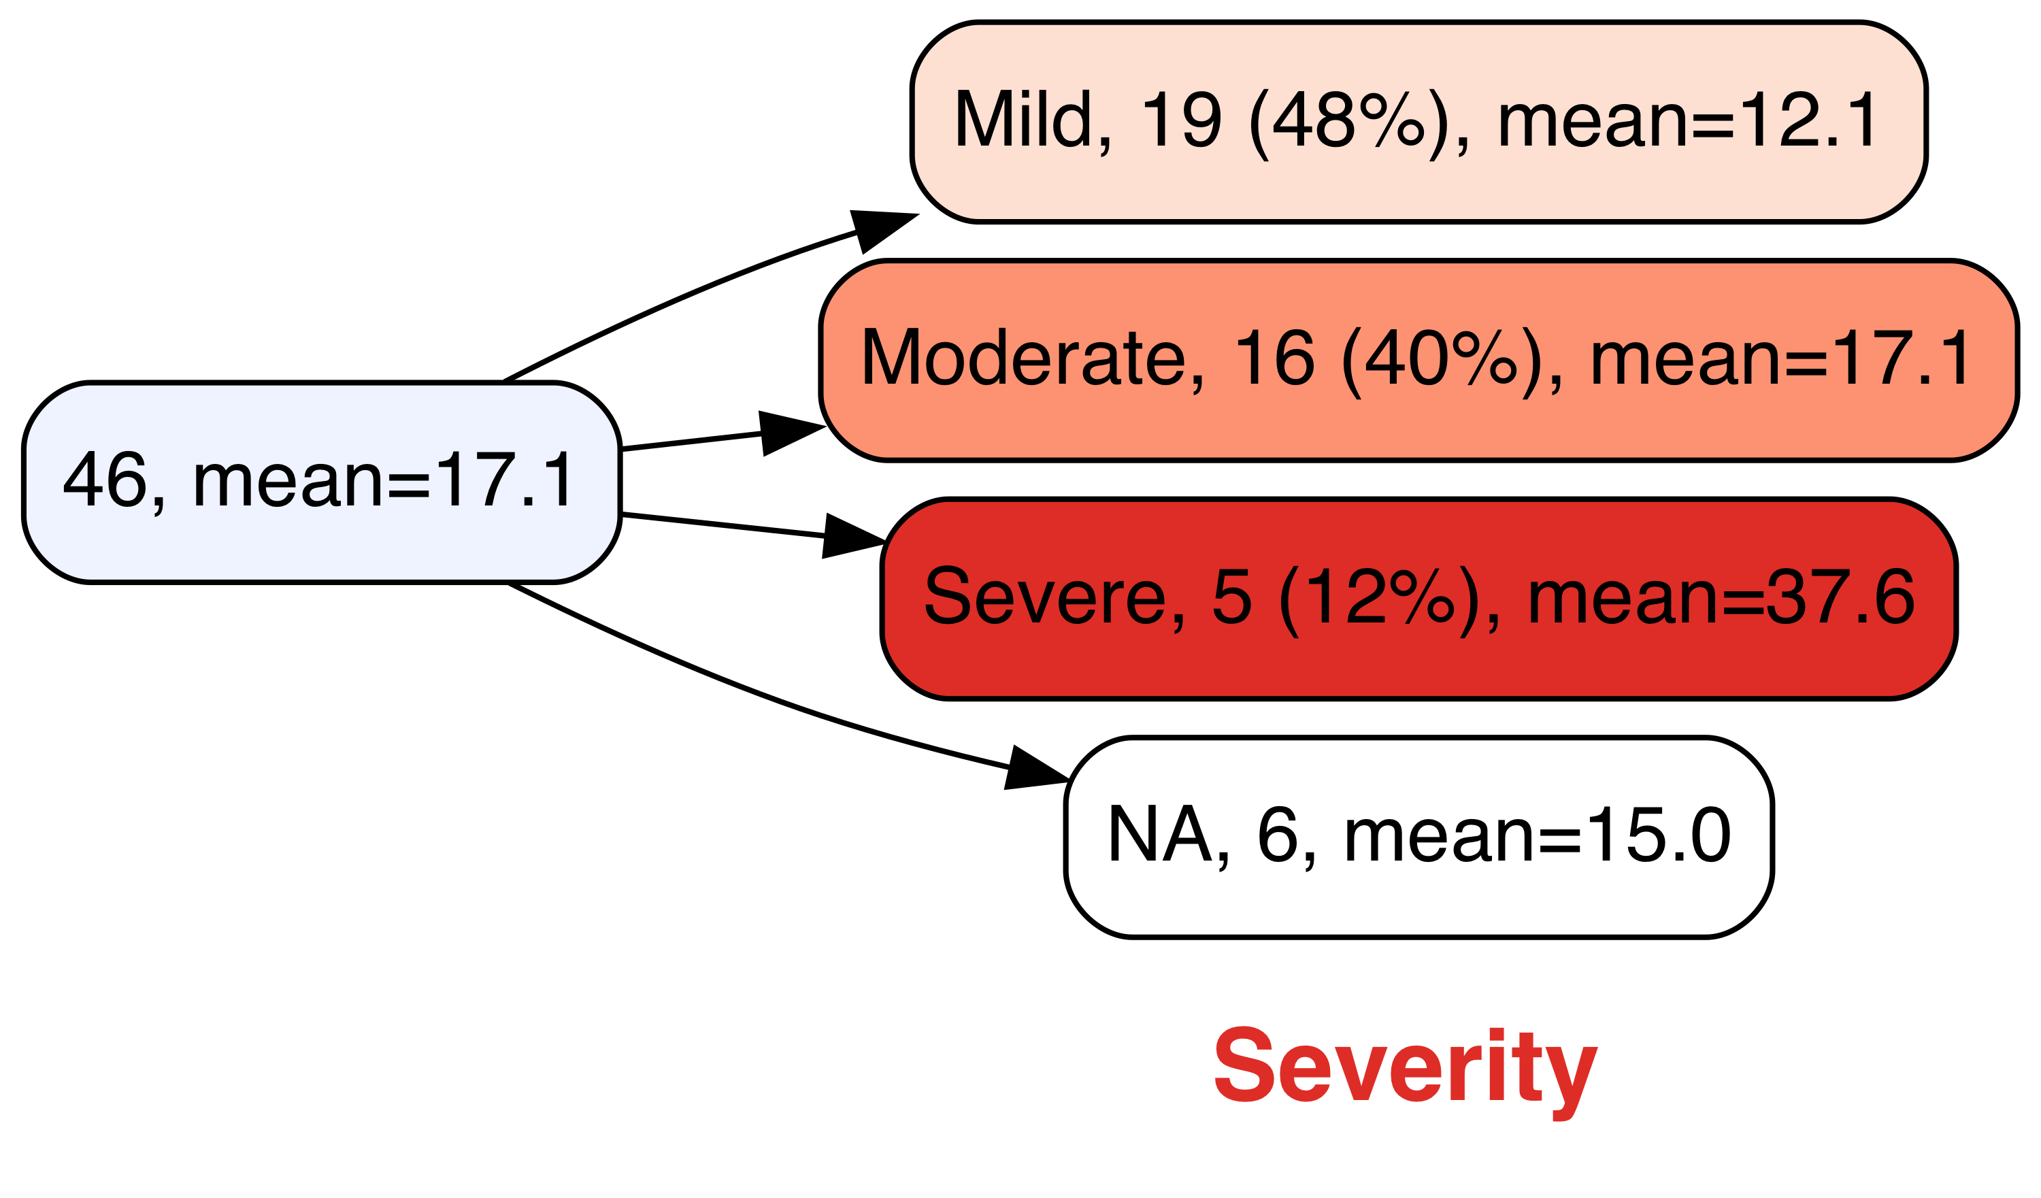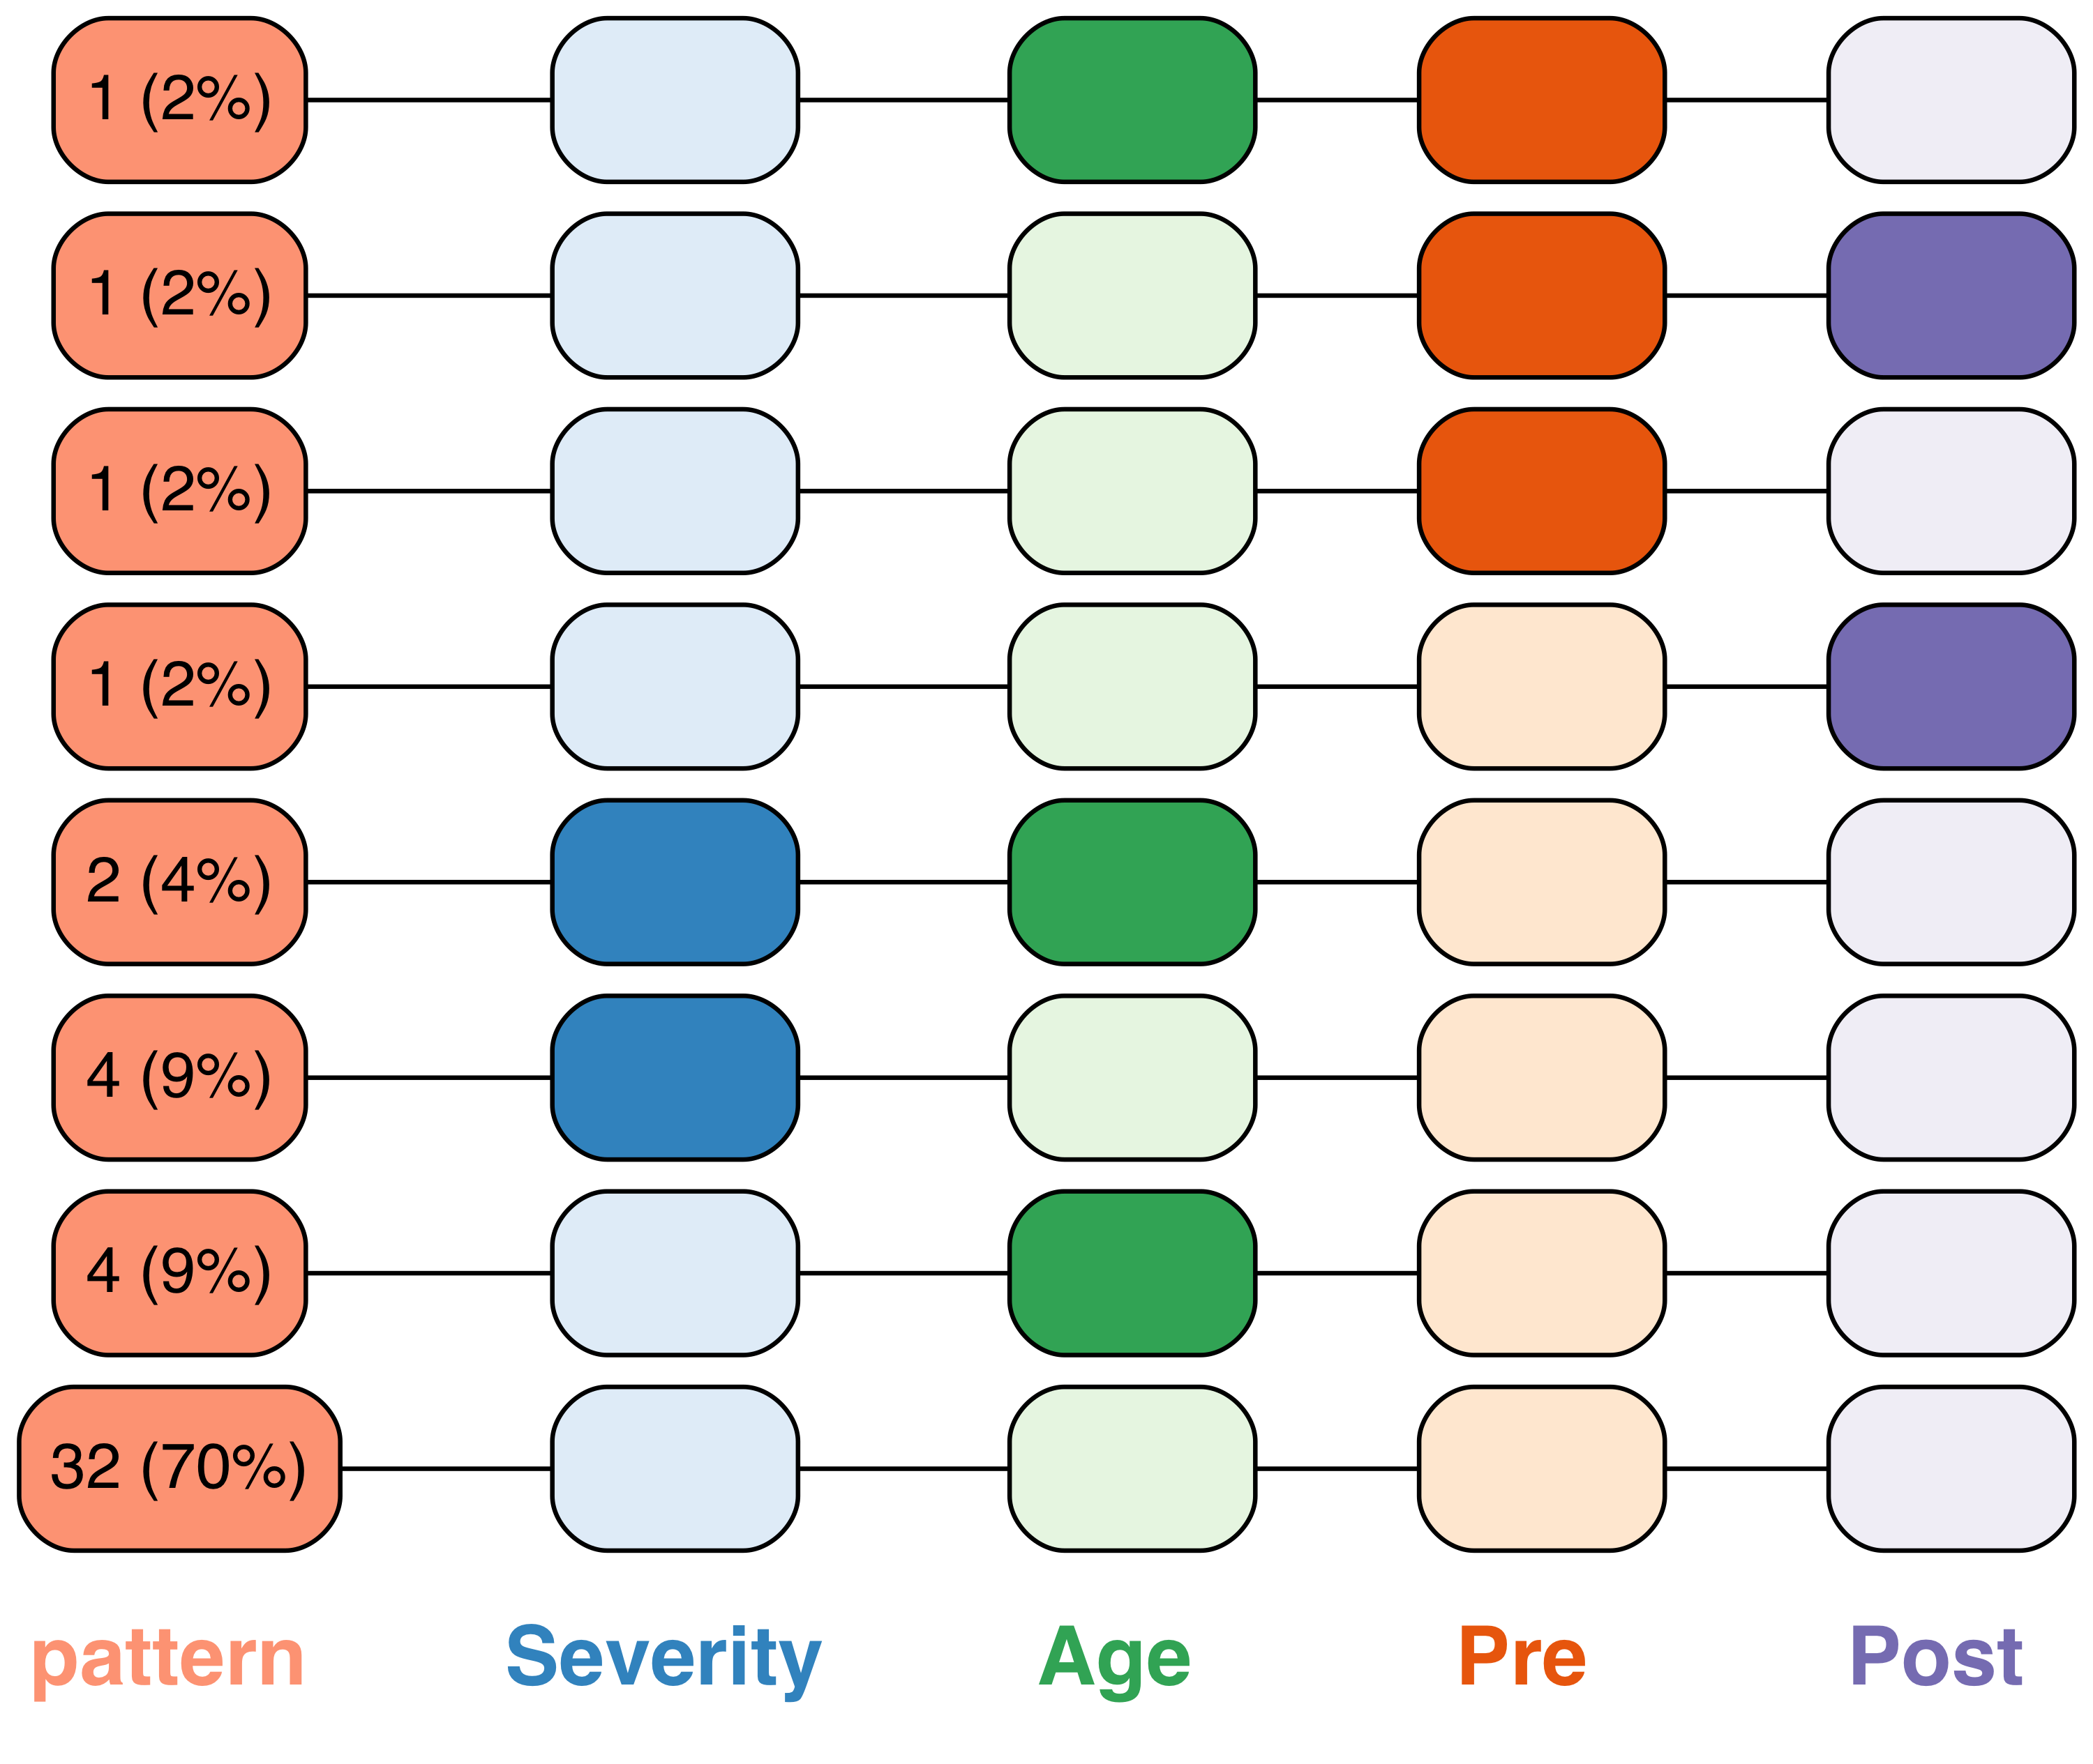

vtree(FakeData,"Severity Age Pre Post",check.is.na=TRUE)

Checking for missing values

|  |  |
| --- | --- |
| Modifier | Effect |
| prefix is.na: | is.na(variable) |
| prefix stem: | all REDCap variables with stem |
| prefix tri: | trichotomize in each node |
| variable=*x* | dichotomize at *x* |
| variable<*x* | dichotomize below x |
| variable>*x* | dichotomize above *x* |

|  |  |
| --- | --- |
| **Parameter** | **Effect** |
| prune | remove all specified nodes |
| prunebelow | remove all descendants of the specified nodes |
| keep | retain only the specified nodes |
| follow | retain descendants of only the specified nodes |

Variable specification

|  |
| --- |
| Parameter |
| Change variable labels |
| labelvar=c(  Severity="New label for Severity") |
| Change node labels for a variable |
| labelnode=list(MyVar=  c(New="Old",New2="Old2")) |
| Change a specific node label |
| tlabelnode=list(  c(Group="A",Sex="F",label="girl")) |
| Font size (points) for variable names |
| varnamepointsize=15 |
| Specify an optional label for the root node |
| title="All patients" |
| Show node labels? |
| shownodelabels=TRUE |
| Show variable names? |
| showvarnames=TRUE |

Labeling

Learn more at **github.com/nbarrowman/vtree •** package version 2.0.0 **•** updated May 15, 2019