**vtree** cheatsheet For more information, type: vignette(“vtree”)

**Add text to nodes**

vtree(FakeData,"Group Category",sameline=TRUE,

text=list(Category=c(triple="\n*not verified*")))

|  |  |
| --- | --- |
| Code | Effect |
| \n | Line break |
| *...* | Italics |
| **...** | Bold |
| ^...^ | Superscript |
| ~...~ | Subscript |
| %%red ...%% | Make text red (*or another color*) |

Text

**Syntax:** summary=" varspec format "

varspec variable specification format text and codes

|  |  |
| --- | --- |
| Variable specification | Effect |
| variable=*x* | *x* vs. all other values |
| variable>*x* | below *x* vs. all other values |
| variable<*x* | above *x* vs. all other values |

|  |  |
| --- | --- |
| Code | Produces |
| %mean% | mean |
| %SD% | standard deviation |
| %sum% | sum |
| %min% | minimum |
| %max% | maximum |
| %pX% | Xth percentile |
| %median% | median, i.e. p50 |
| %IQR% | IQR, i.e. p25, p75 |
| %npct% | frequency and percentage |
| %pct% | just percentage |
| %list% | comma-separated list of values |
| %listlines% | individual values on separate lines |
| %mv% | the number of missing values |
| %nonmv% | the number of non-missing values |

|  |  |
| --- | --- |
| Code | Restricts summary information to: |
| %noroot% | all nodes *except* the root |
| %leafonly% | leaf nodes |
| %var=*v*% | nodes of variable *v* |
| %node=*n*% | nodes named *n* |

summary parameter

|  |  |
| --- | --- |
| Parameter setting | Effect |
| pattern=TRUE | Generate a pattern tree |
| Venn=TRUE | Use Venn settings for indicator variables |
| ptable=TRUE | Generate a pattern table |
| check.is.na=TRUE | Generate a pattern table for missing values |

|  |
| --- |
| Format a pattern table for markdown |
| VennTable(vtree(FakeData,"Ind1 Ind2",ptable=T),markdown=T) |

Pattern trees and tables

**Draw a basic variable tree**

vtree(FakeData,"Severity Sex")

|  |  |
| --- | --- |
| Parameter setting | Effect |
| vp=FALSE | Use full denominator for % |
| horiz=FALSE | Vertical variable tree |
| sameline=TRUE | Node labels on same line as the counts and percentages |
| splitwidth=50 | Split text after 50 chars |
| getscript=TRUE | Get DOT script |
| plain=TRUE | Nodes in shades of blue |
| digits=1 | 1 decimal place in % |
| cdigits=2 | 2 dec. places in summary |
| showpct=FALSE | Do not show % |
| showcount=FALSE | Do not show counts |

**Prune single and double and their descendants**

vtree(FakeData,"Category Group",sameline=TRUE,

**prune**=list(Category=c("single","double")))

**Only keep single and double and their descendants**

vtree(FakeData,"Category Group",sameline=TRUE,

**keep**=list(Category=c("single","double")))

|  |  |
| --- | --- |
| Other ways to prune | Effect |
| prunebelow | Prune below nodes |
| follow | Only follow specified nodes |
| prunesmaller | Prune smaller nodes |

Basics

Pruning

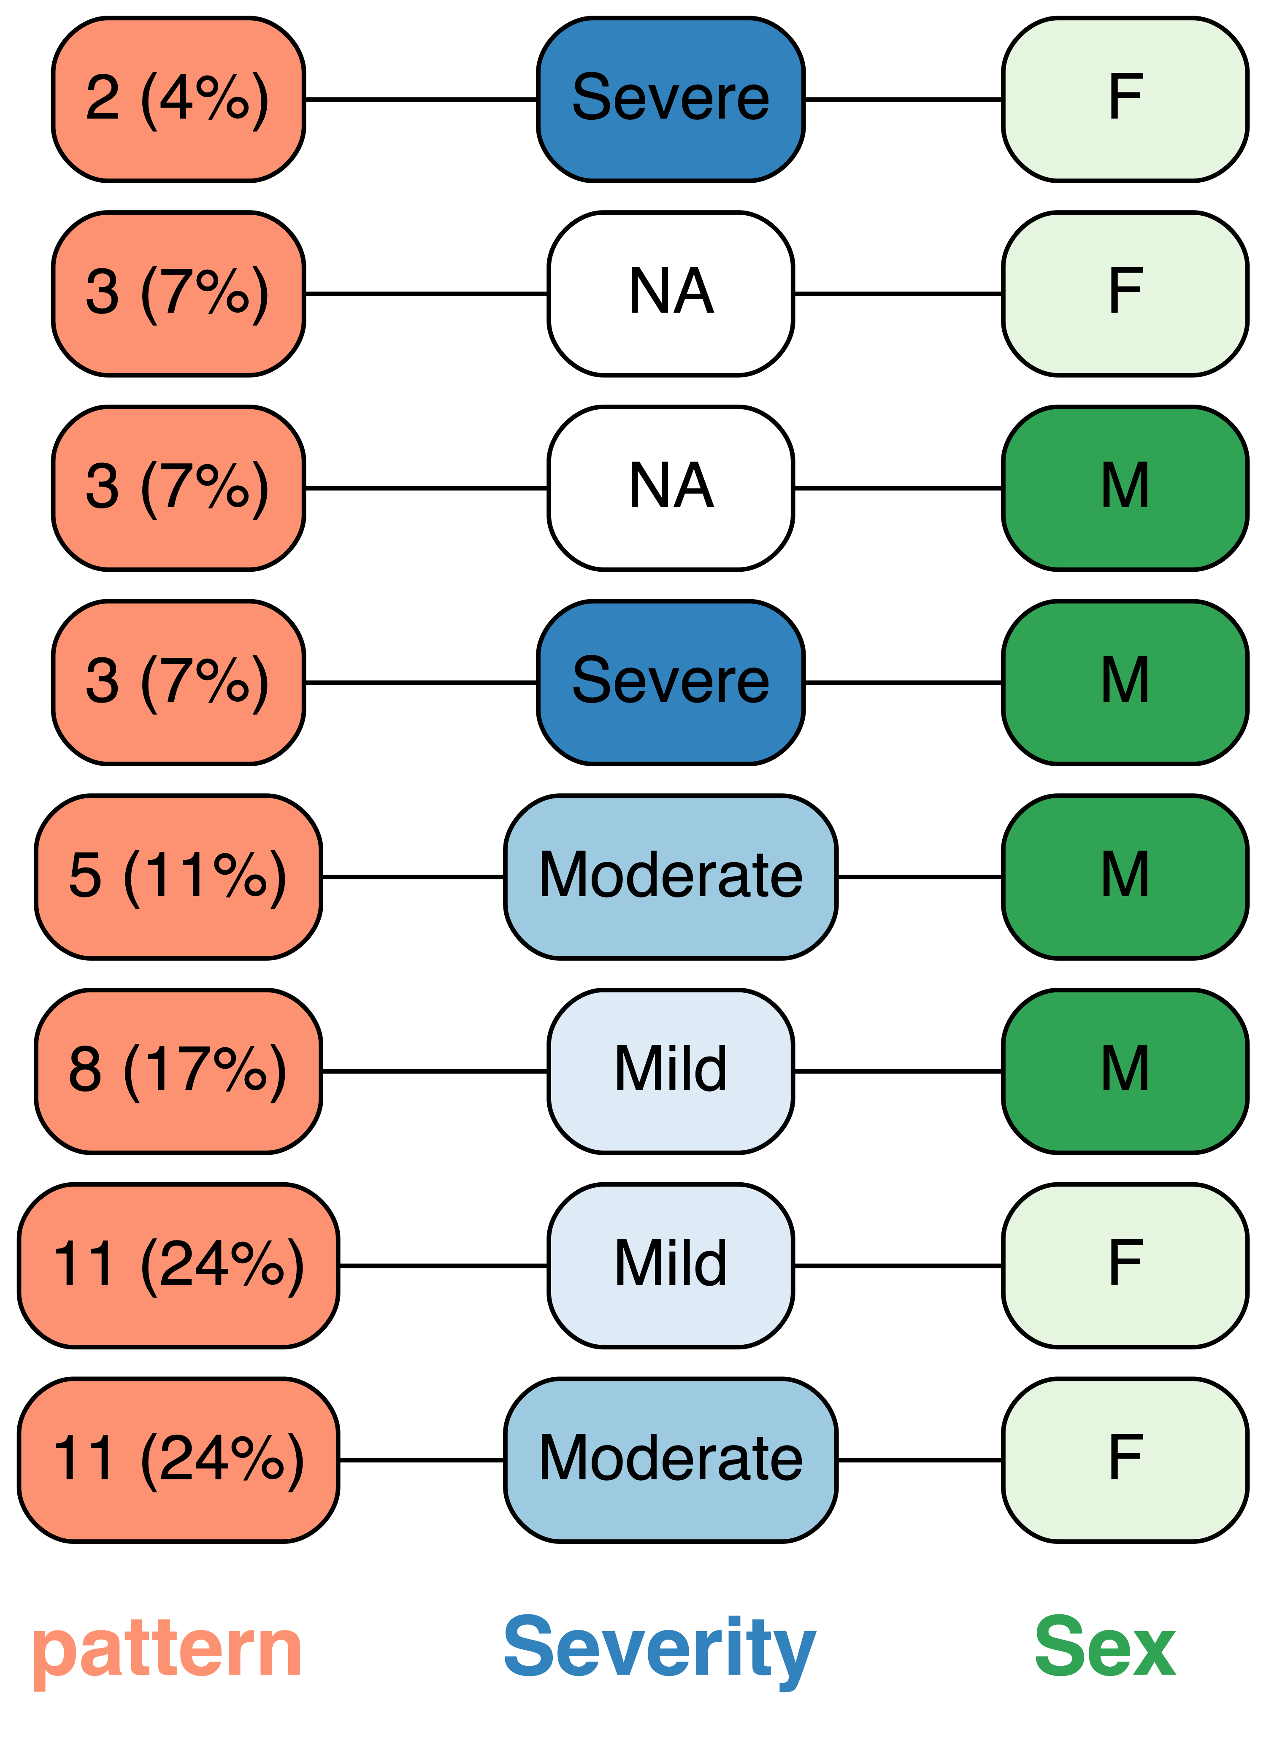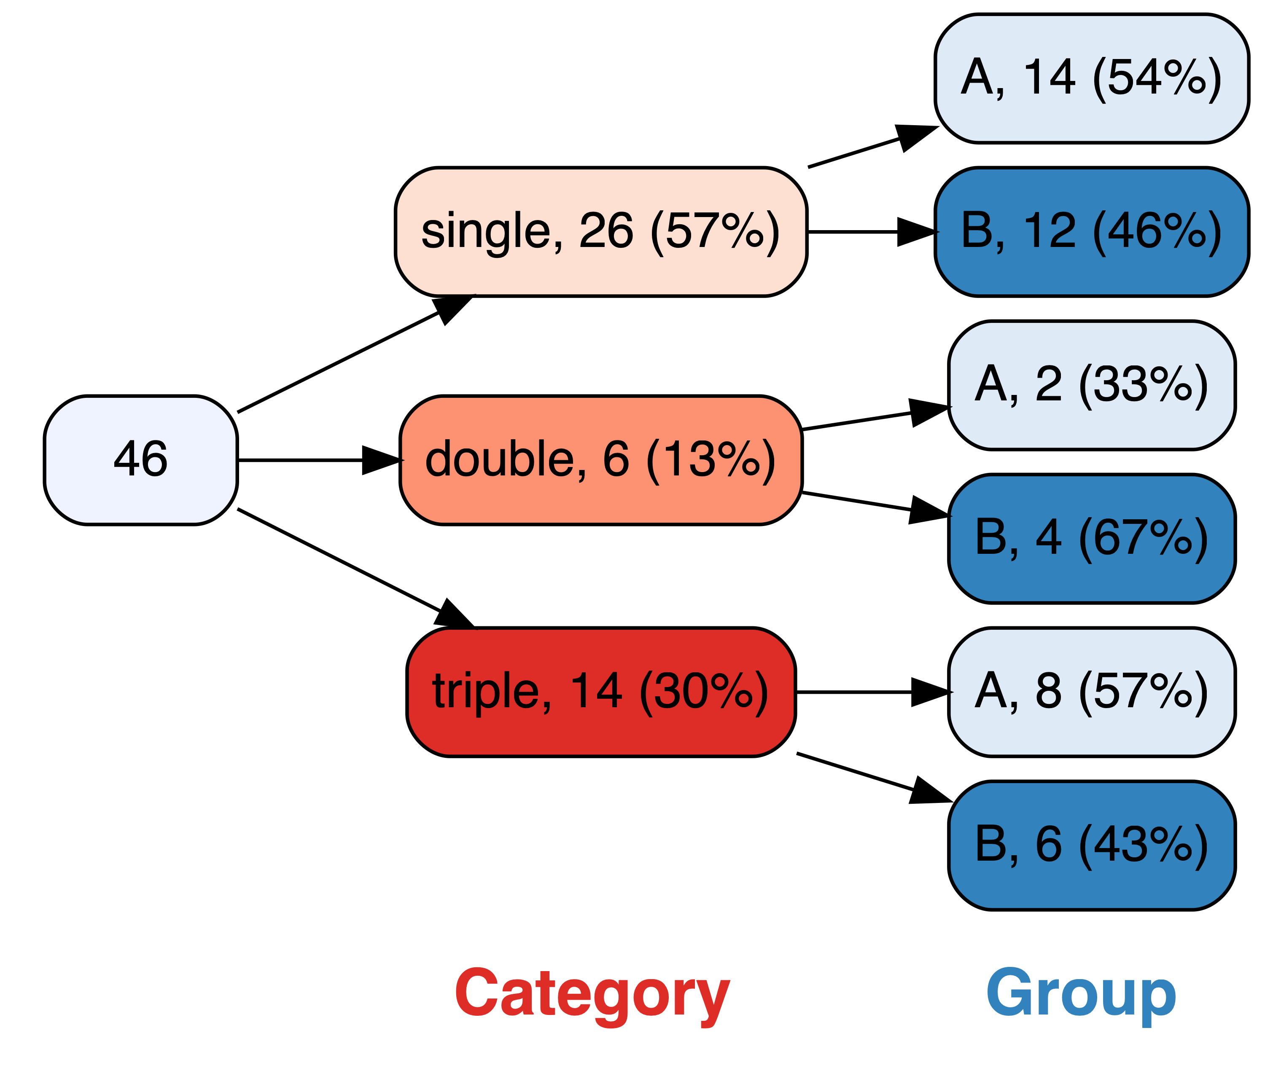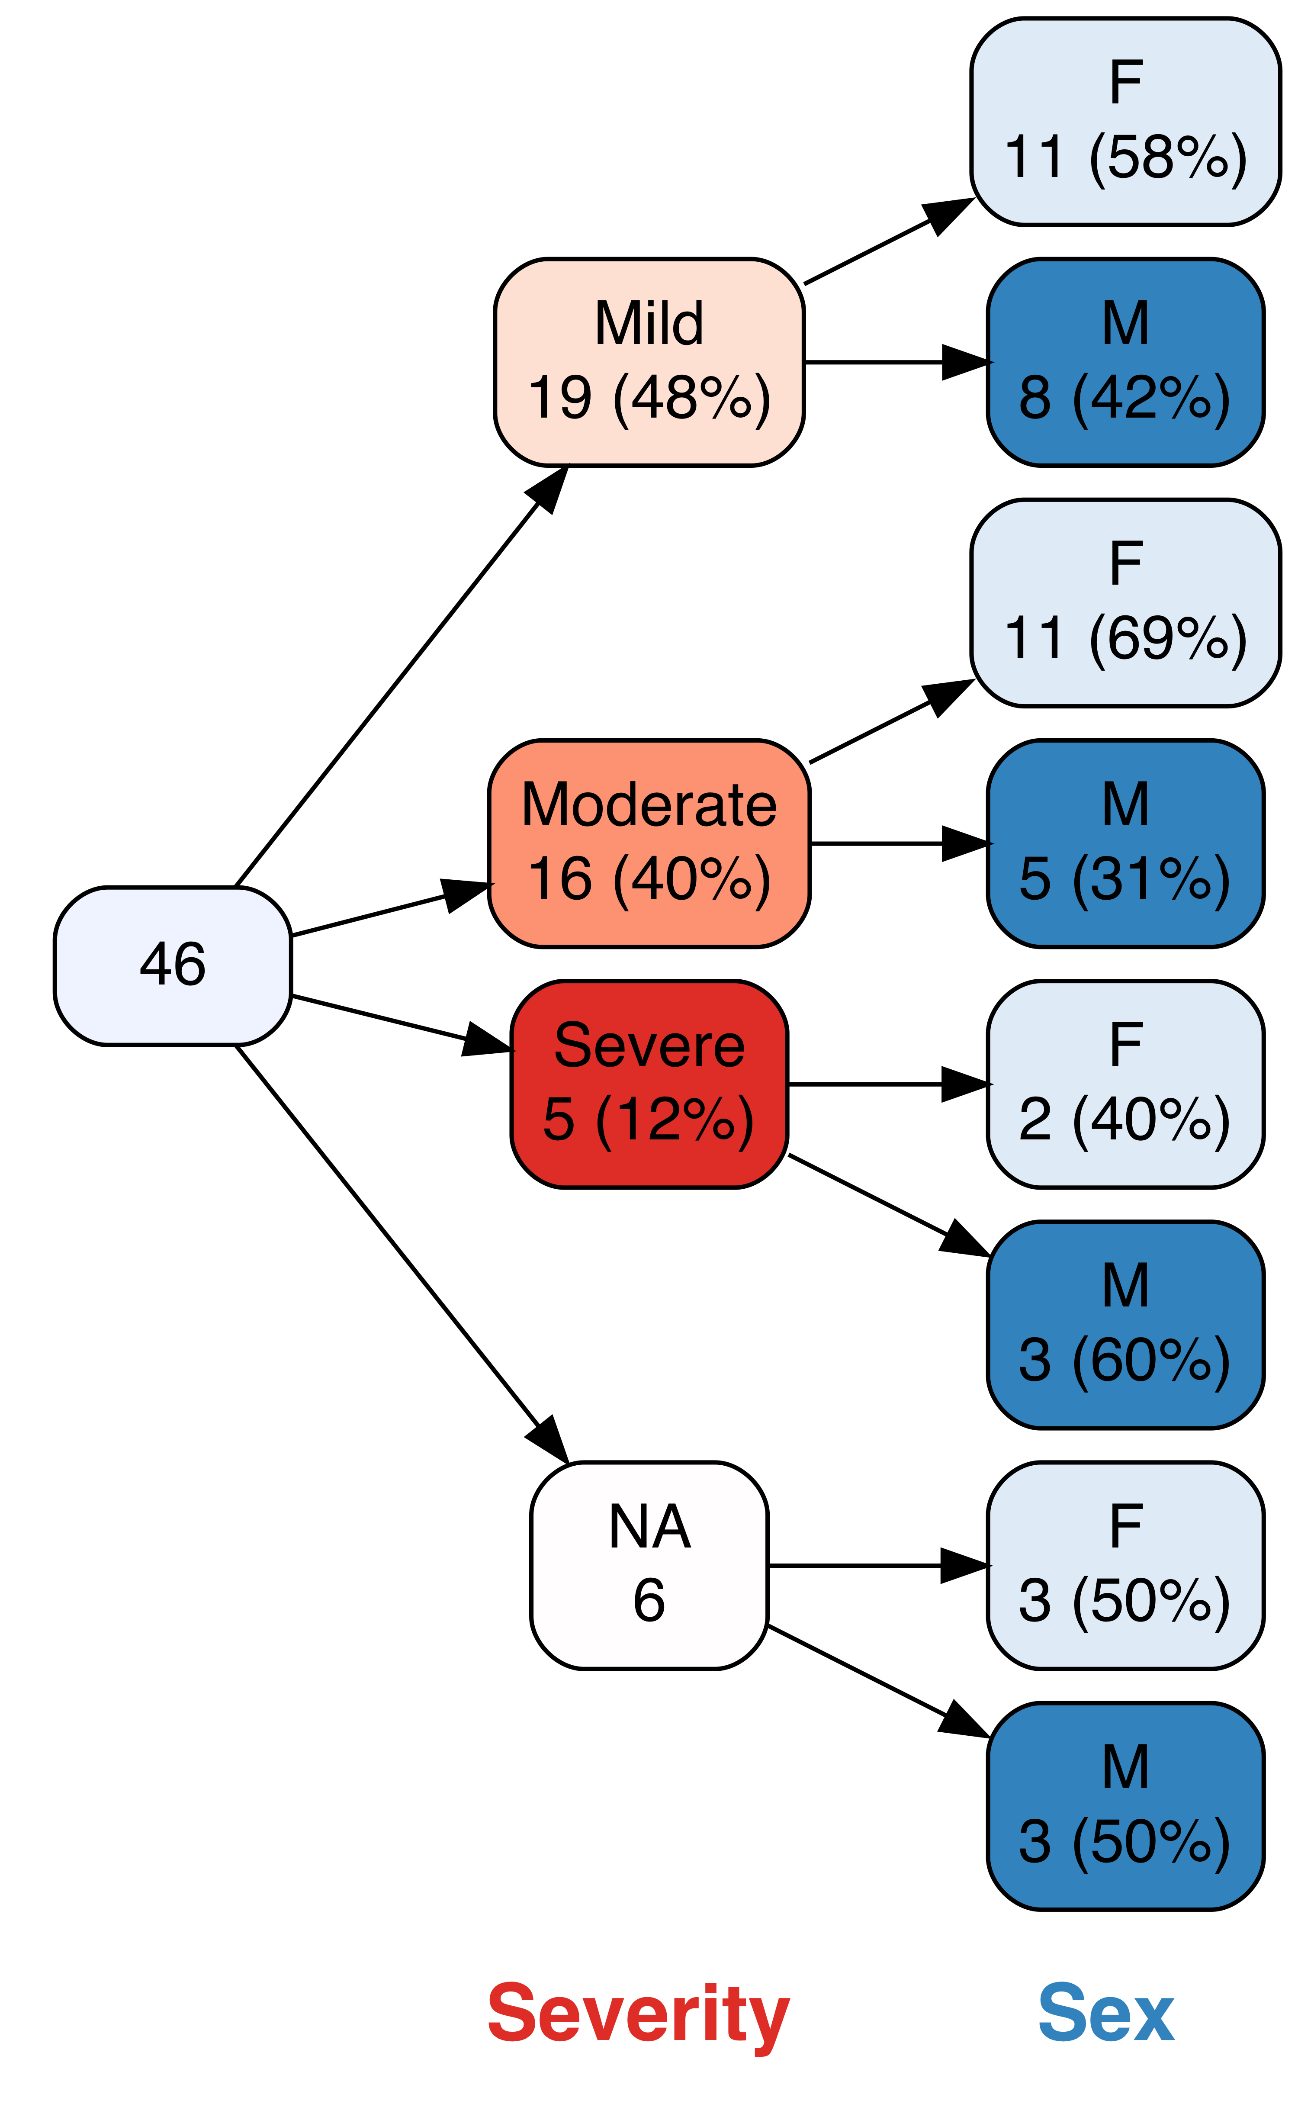

Additional functions

|  |  |
| --- | --- |
| Function | Purpose |
| VennTable | Format pattern table |
| crosstabToCases | Convert a crosstab array to cases |
| grVizToPNG | Generate a PNG file |
| build.data.frame | Generate data frame from specified counts |

|  |  |
| --- | --- |
| **Parameter** | **Effect** |
| prune | remove all specified nodes |
| prunebelow | remove all descendants of the specified nodes |
| keep | retain only the specified nodes |
| follow | retain descendants of only the specified nodes |

|  |  |
| --- | --- |
| Prefix | Effect |
| is.na: | is.na(variable) |
| stem: | all REDCap variables starting with stem |
| rc: | flag variable as a REDCap checkbox variable |
| tri: | trichotomize in each node of variable |

|  |  |
| --- | --- |
| Suffix | Effect |
| *this*\* | variable names starting with *this* |
| *this*# | variable names ending with numeric digits |

|  |  |
| --- | --- |
| Dichotomize | Effect |
| variable=*x* | *x* vs. all other values |
| variable<*x* | below *x* vs. all other values |
| variable>*x* | above *x* vs. all other values |

|  |  |
| --- | --- |
| **Parameter** | **Effect** |
| prune | remove all specified nodes |
| prunebelow | remove all descendants of the specified nodes |
| keep | retain only the specified nodes |
| follow | retain descendants of only the specified nodes |

|  |  |
| --- | --- |
| Parameter setting | Effect |
| labelvar=c(Ind1="Indicator1") | Relabel Ind1 |
| labelnode=list(MyVar=c(New="Old",New2="Old2")) | Change node labels |
| tlabelnode=list(c(Group="A",Sex="F",label="girl") | Change the label of a specific node |
| varnamepointsize=15 | Set font size (points) for variable names |
| shownodelabels=FALSE | Do not show node labels |
| showvarnames=FALSE | Do not show variable names |
| showlegend=TRUE | Show a legend |
| title="All businesses" | Show a title for the root node |

Variable specification

|  |  |
| --- | --- |
| Inline | Output |
| `r vtree(FakeData,"Group Category")` | PNG |
| `r vtree(FakeData,"Severity Sex",pngknit=FALSE)` | htmlwidget |

|  |  |
| --- | --- |
| Chunk | Output |
| ```{r, results="asis"}  vtree(FakeData,"Sex Severity",asis=TRUE)  ``` | PNG |
| ```{r}  vtree(FakeData,"Severity Sex",pngknit=FALSE)  ``` | htmlwidget |

|  |  |
| --- | --- |
| Parameter setting | Effect |
| imagewidth="3in" | Image 3 inches wide |
| imageheight="4in" | Image 4 inches tall |
| pxwidth=800 | Image 800 pixels wide |
| pxheight=2000 | Image 200 pixels high |

R Markdown

n pct Severity Sex

2 4 Severe F

3 7 <NA> F

3 7 <NA> M

3 7 Severe M

5 11 Moderate M

8 17 Mild M

11 24 Mild F

11 24 Moderate F

Labels

CC by Nick Barrowman <https://creativecommons.org/licenses/by/4.0/> **•** Learn more at <https://github.com/nbarrowman/vtree/>  **•** package version 3.0.8 available on CRAN **•** updated Oct 30, 2019