**vtree** cheatsheet For more information type: vignette("vtree") v2.0.0

vtree(FakeData,"Severity",sameline=TRUE,

summary="Score , mean=%mean%")

|  |  |
| --- | --- |
| **Code** | **Result** |
| %mean% | mean |
| %SD% | standard deviation |
| %min% | minimum |
| %max% | maximum |
| %pX% | Xth percentile (e.g. p50 means the 50th percentile) |
| %median% | median, i.e. p50 |
| %IQR% | IQR, i.e. p25, p75 |
| %npct% | frequency and percentage |
| %pct% | just percentage |
| %list% | list of individual values, separated by commas |
| %listlines% | list of individual values, each on a separate line |
| %mv% | the number of missing values |

|  |  |
| --- | --- |
| **Code** | **Summary information restricted to:** |
| %noroot% | all nodes *except* the root |
| %leafonly% | leaf nodes |
| %var=*v*% | nodes of variable *v* |
| %node=*n*% | nodes named *n* |

Summary

vtree(FakeData,"Group Severity",sameline=TRUE,

text=list(Severity=c(Mild="\n*or none*")))

|  |  |
| --- | --- |
| Code | Meaning |
| \n | Line break |
| *...* | Italics |
| **...** | Bold |
| ^...^ | Superscript |
| ~...~ | Subscript |
| %%red ...%% | Make text red (or whatever color specified) |

Text

vtree(FakeData,"Severity Sex")

vtree(FakeData,"Group",horiz=FALSE)

vtree(FakeData,"Severity Sex",

showlegend=TRUE,sameline=TRUE)

Basics

vtree(FakeData,"Severity Sex",

prune=list(Severity=c("Mild","Moderate")))

|  |  |
| --- | --- |
| **Parameter** | **Effect** |
| prune | remove all specified nodes |
| prunebelow | remove all descendants of the specified nodes |
| keep | retain only the specified nodes |
| follow | retain descendants of only the specified nodes |

Pruning

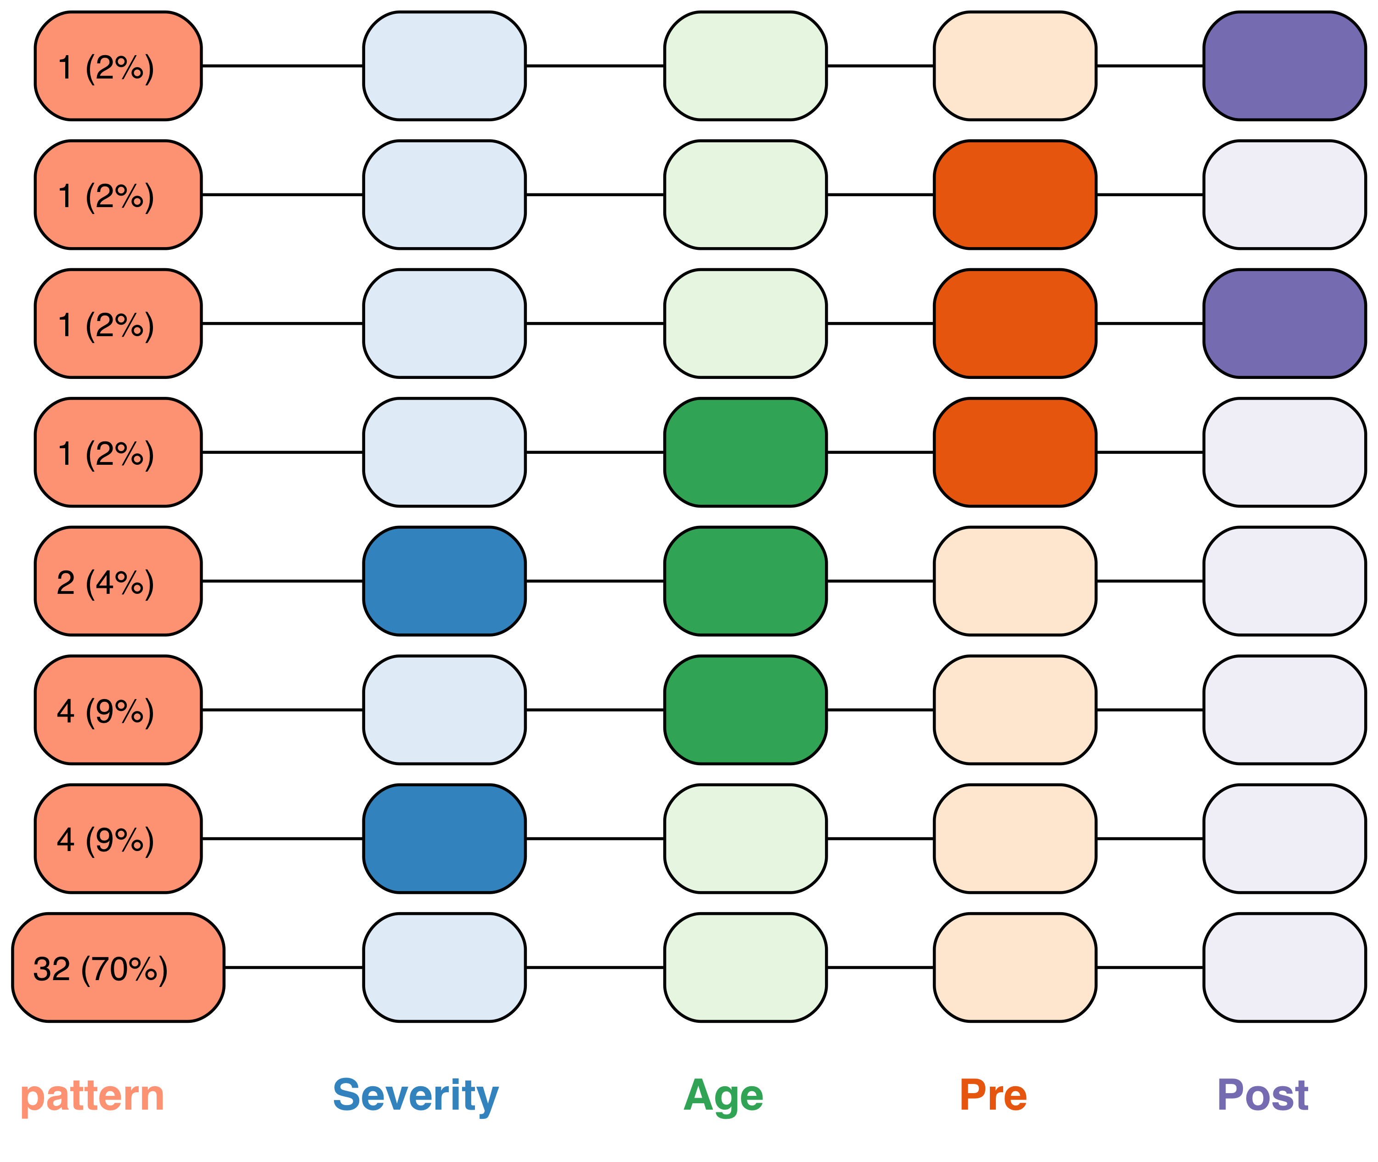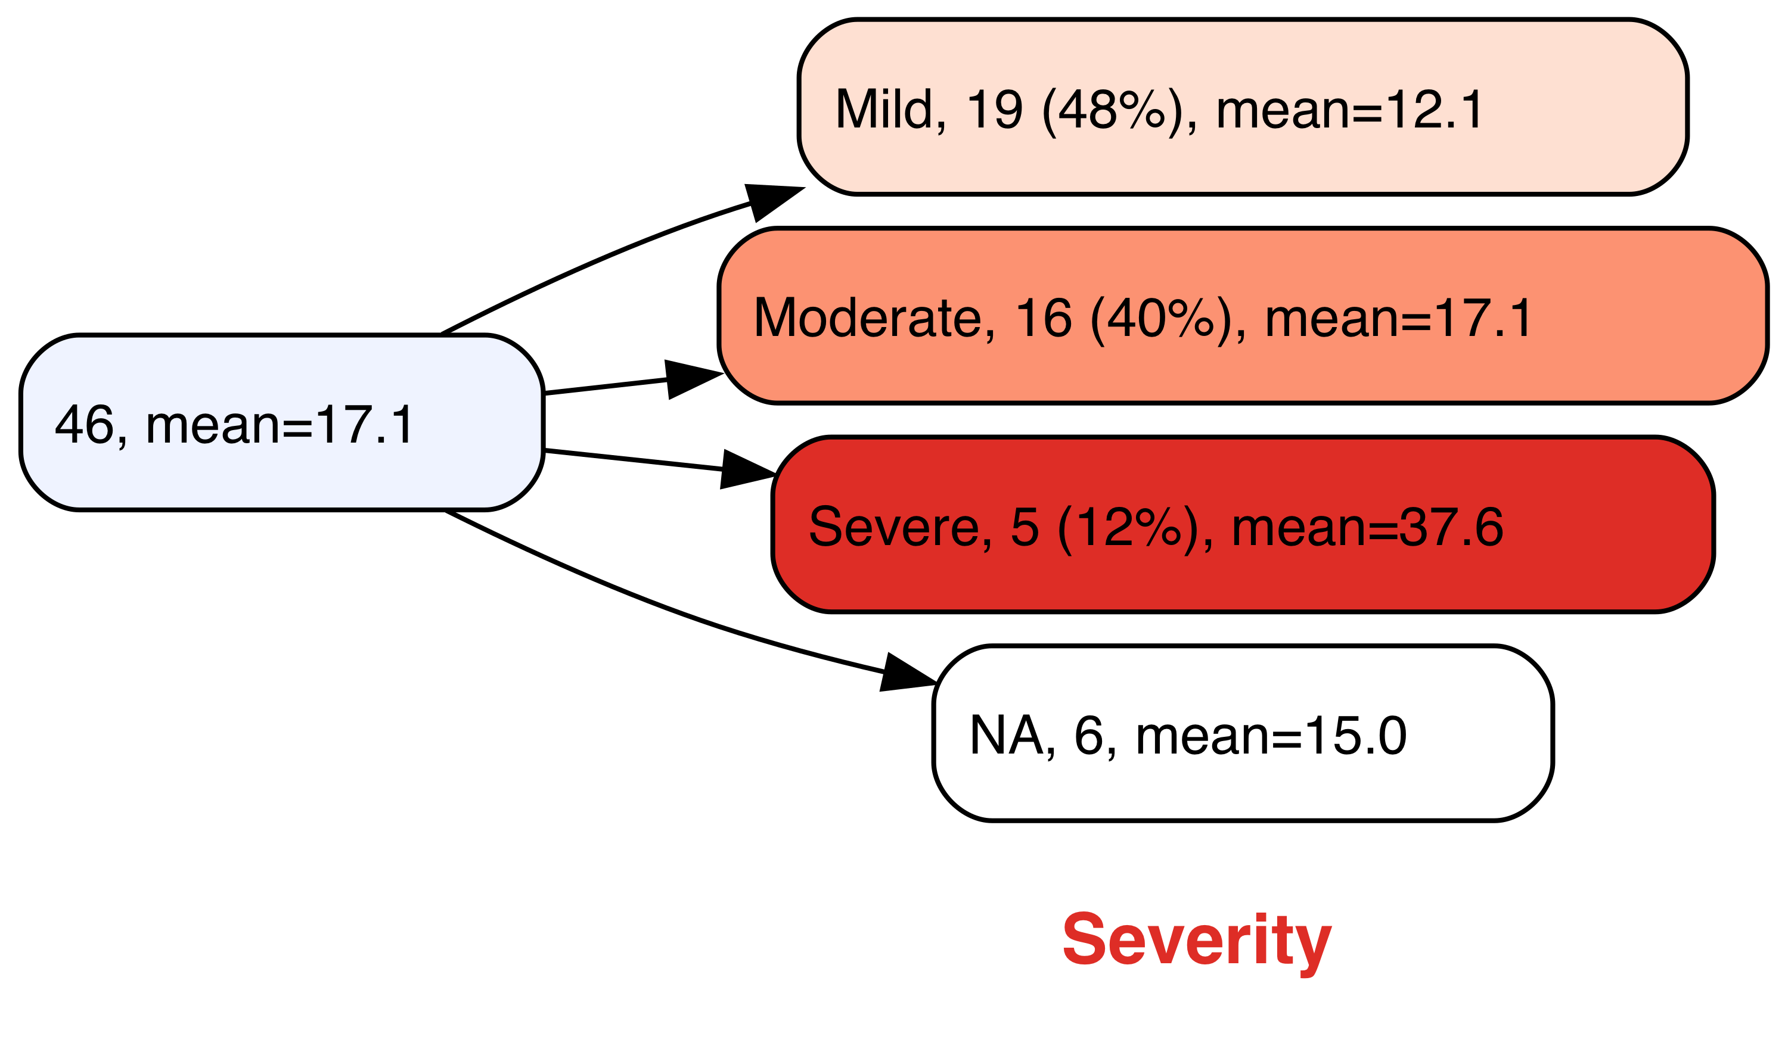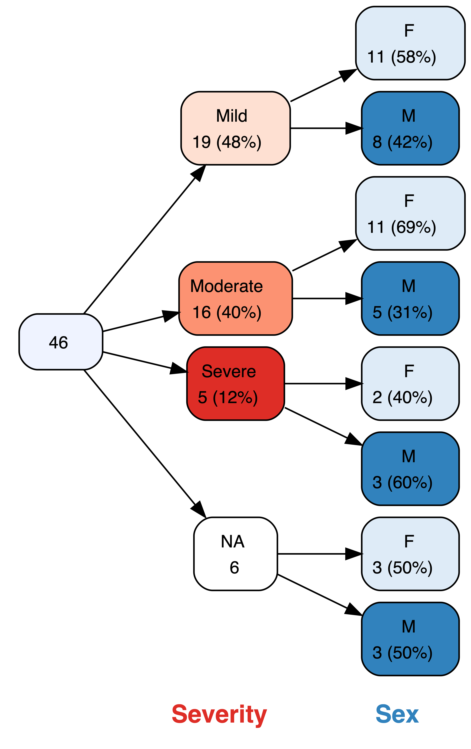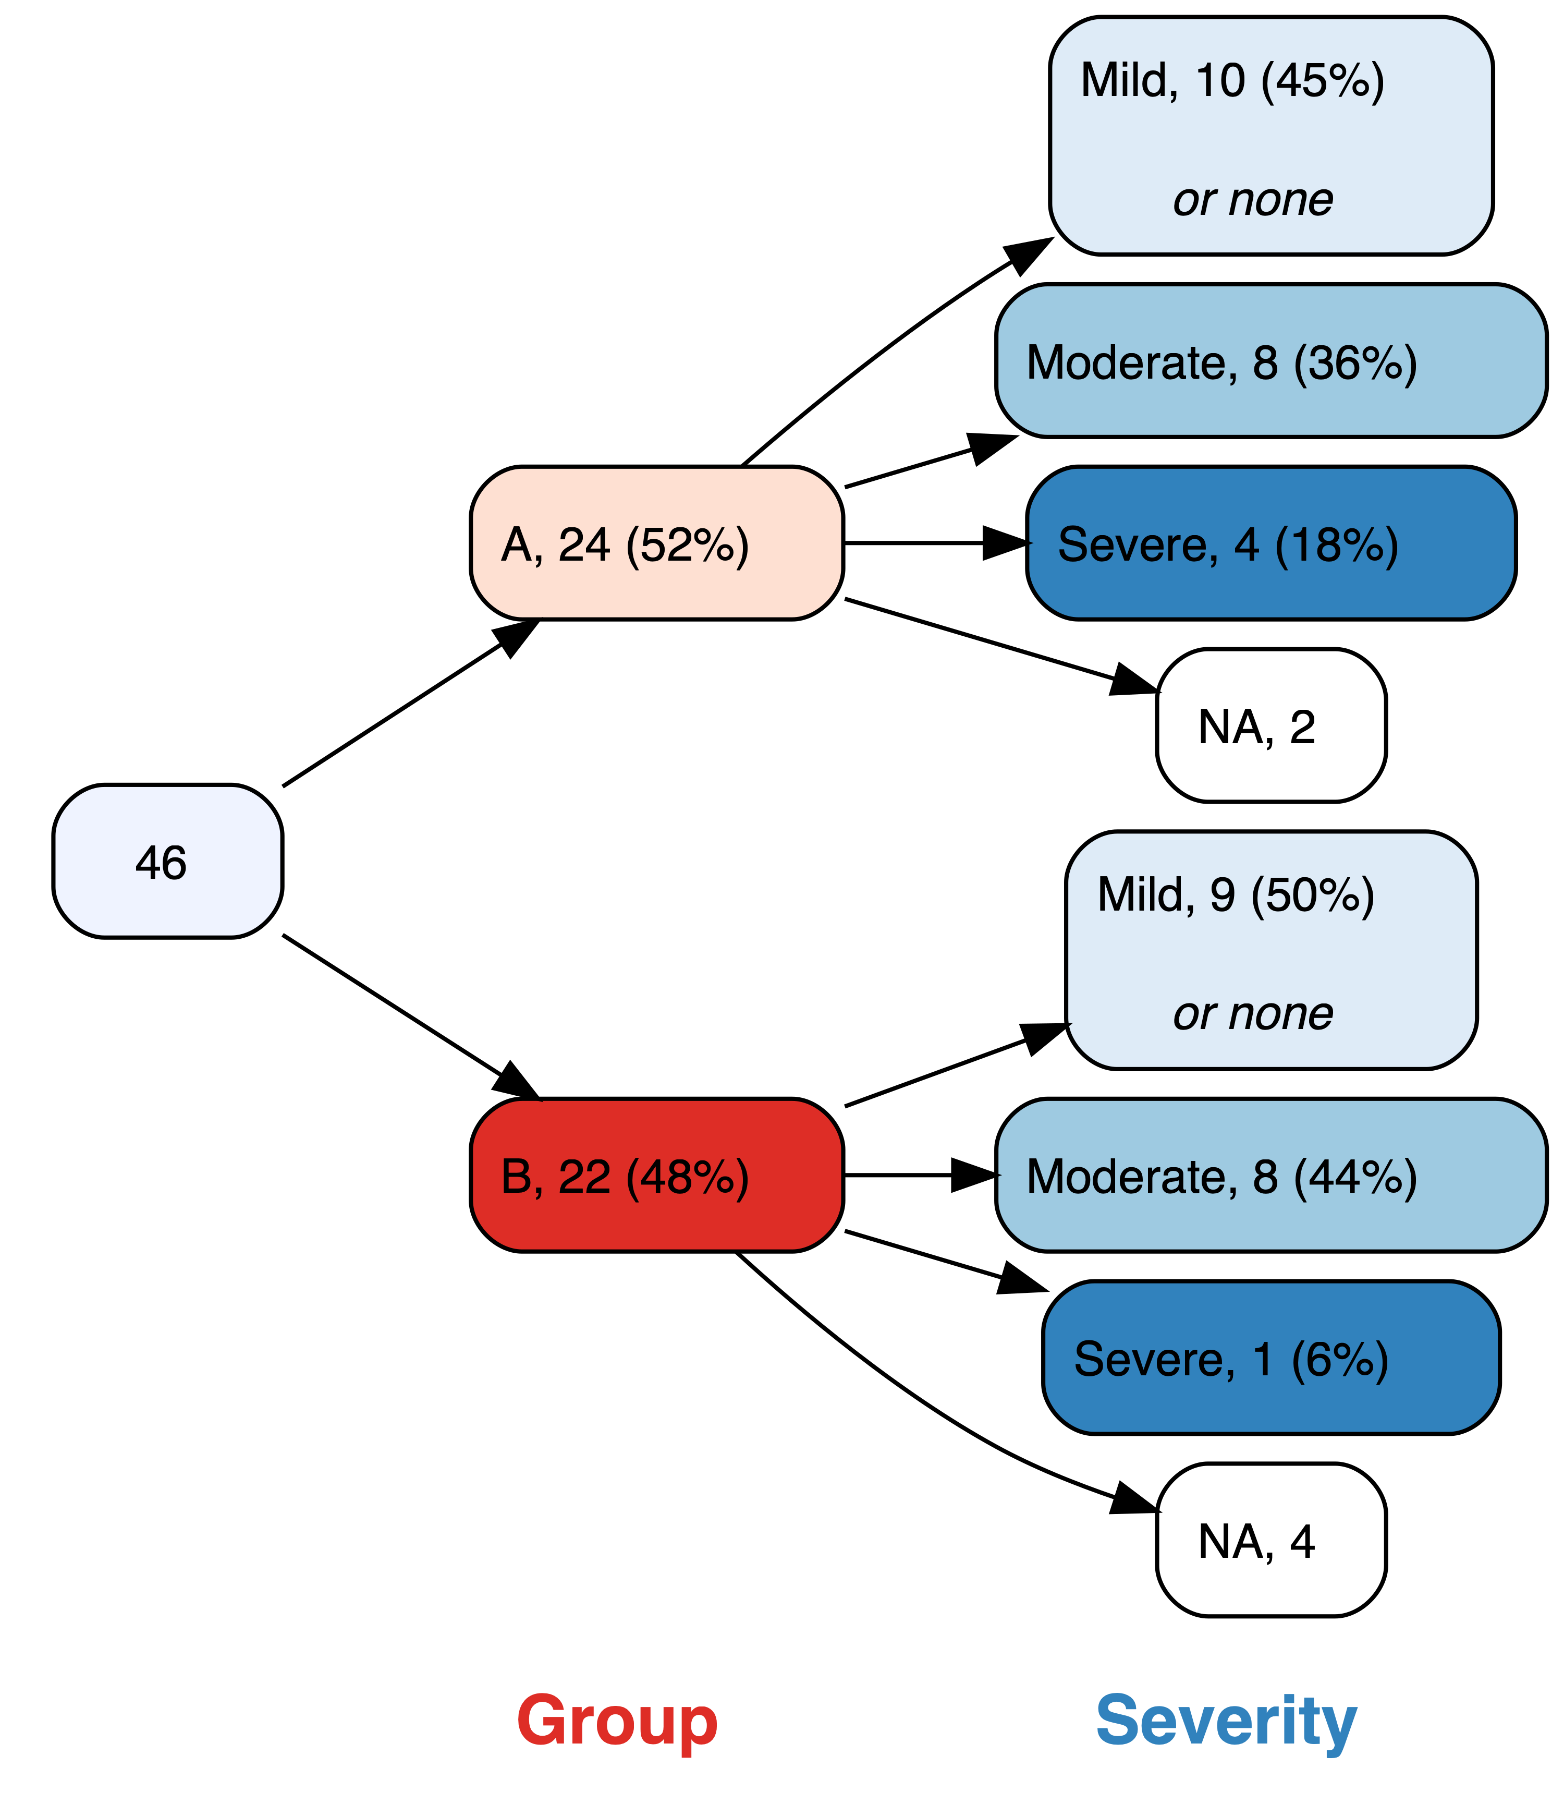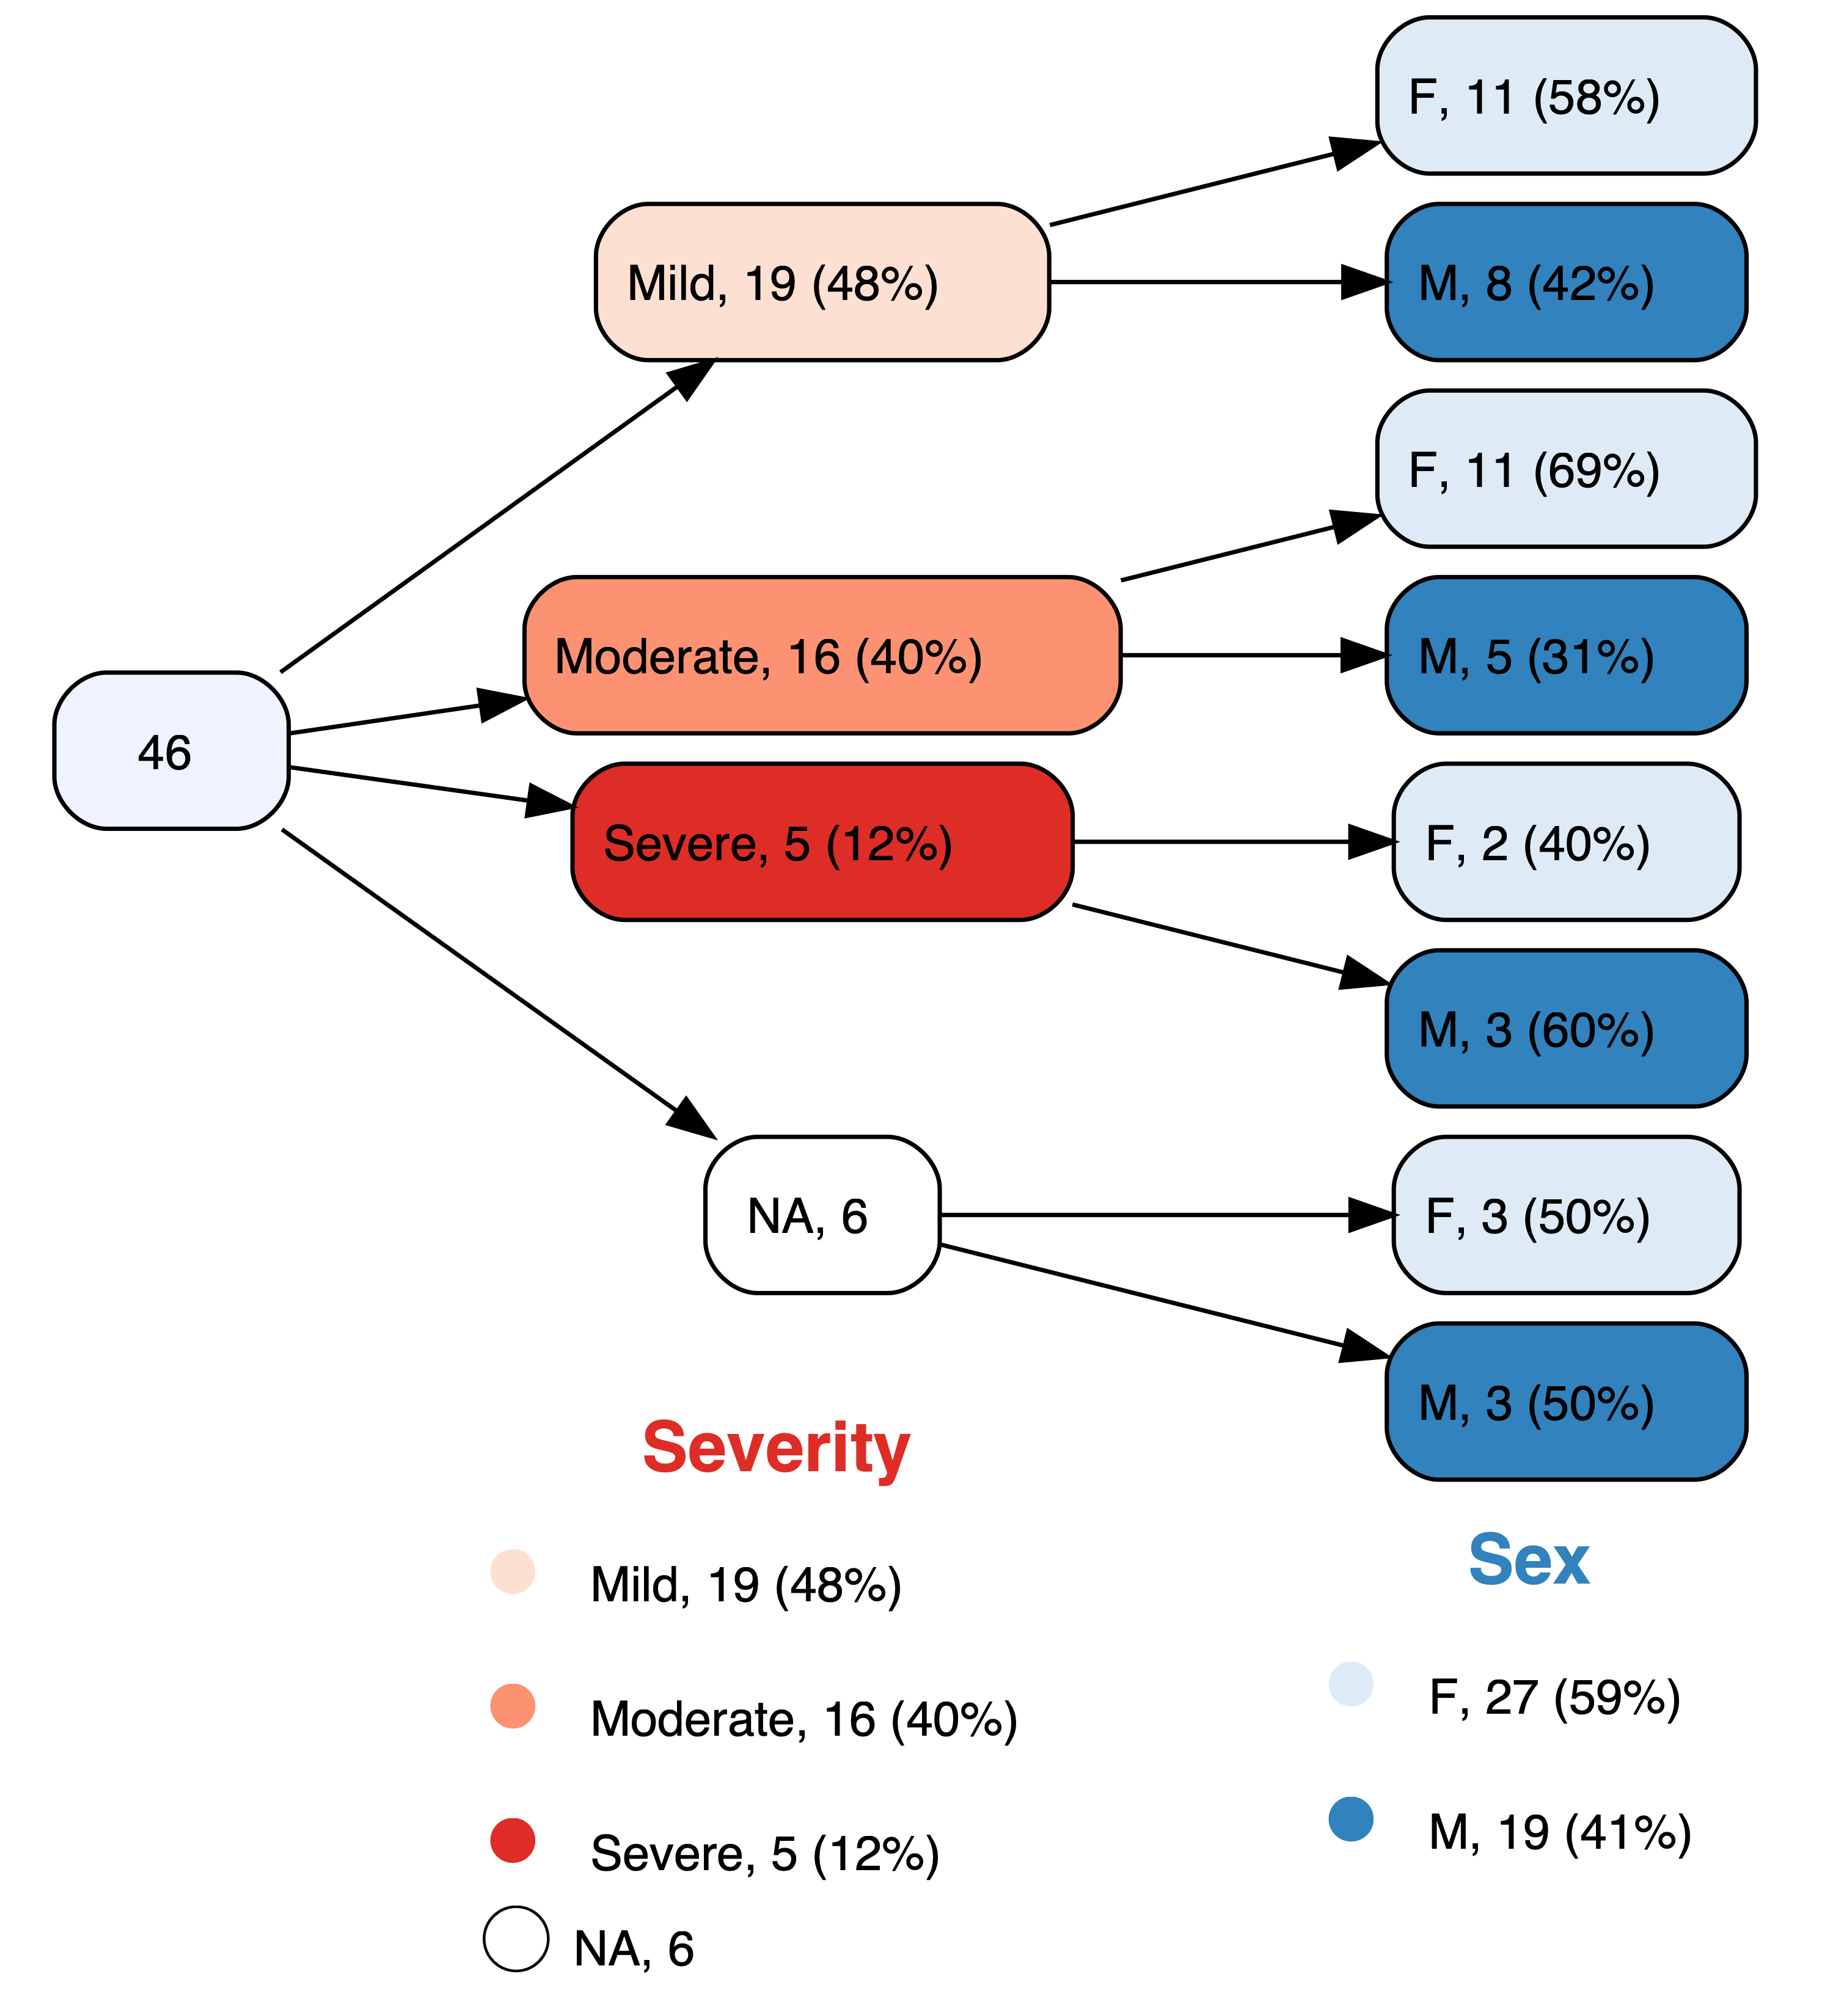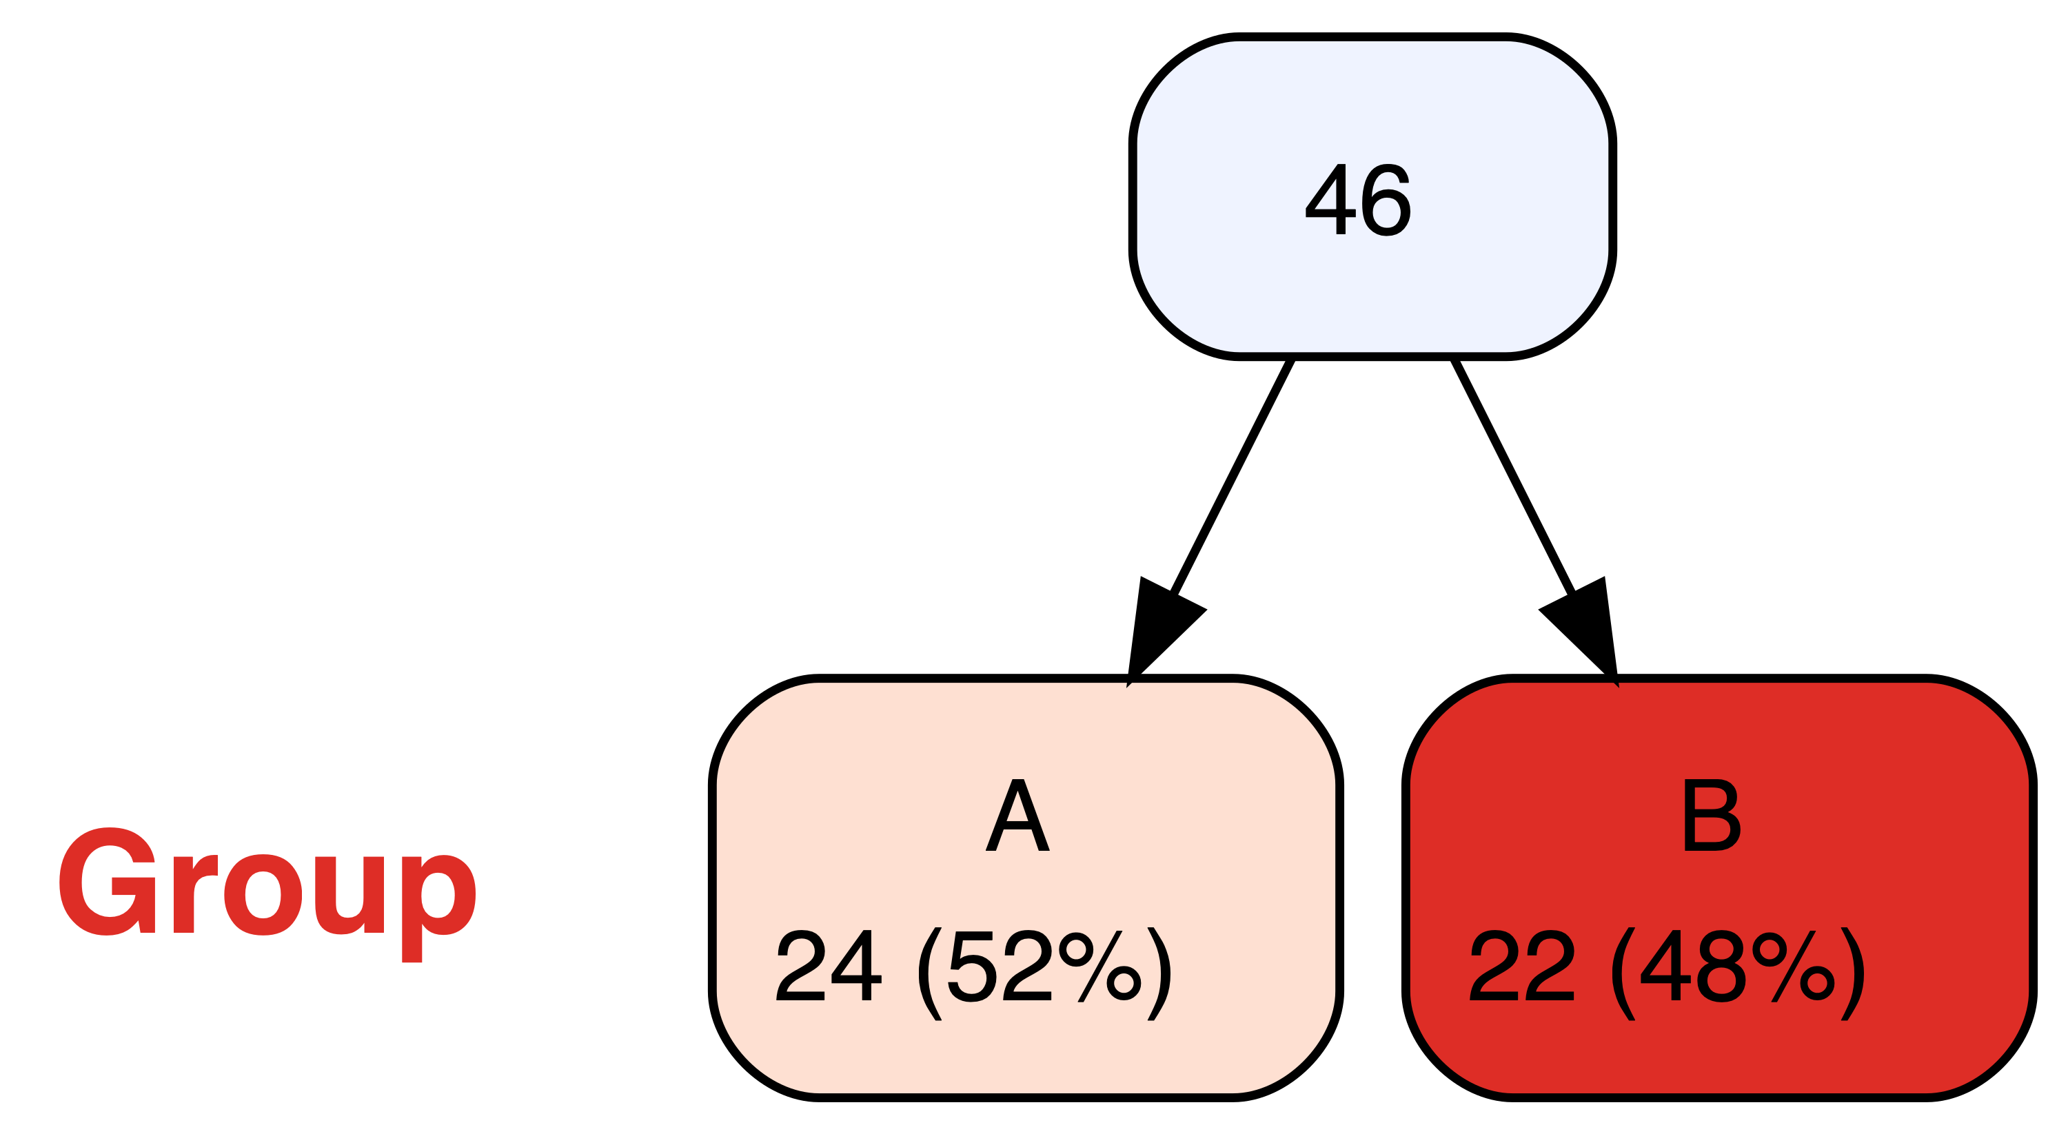

|  |
| --- |
| Parameter |
| title |
| Optional title for the root node of the tree. |
| showroot |
| Show the root node? |
| plain |
| Use "plain" (shades of blue) settings? |
| shownodelabels |
| Show node labels? |
| showvarnames |
| Show variable names |
| varnamepointsize |
| Font size (points) for variable names |
| digits |
| # of decimal digits to show in percentages |
| splitwidth |
| # of characters before linebreak |
| lsplitwidth |
| splitwidth for legends |

Handy parameters

|  |  |
| --- | --- |
| **Parameter** | **Example** |
| labelvar | labelvar=c(Severity="New label for Severity") |
| labelnode | labelnode=list(MyVariable=c(New="Old",New2="Old2")) |
| tlabelnode | tlabelnode=list(c(Group="A",Sex="F",label="girl")) |

|  |  |
| --- | --- |
| **Parameter** | **Effect** |
| prune | remove all specified nodes |
| prunebelow | remove all descendants of the specified nodes |
| keep | retain only the specified nodes |
| follow | retain descendants of only the specified nodes |

Labeling

Variable specification modifiers

In variable lists

|  |  |
| --- | --- |
| **Modifier** | **Effect** |
| prefix is.na: | replace variable with missing value indicator |
| prefix stem: | include all variables from REDCap with names based on stem |
| prefix tri: | within each node, replace variable with trichotomized variable |

In variable lists or the summary parameter

|  |  |
| --- | --- |
| **Modifier** | **Effect** |
| variable=*VALUE* | dichotomize variable at *VALUE* |
| variable<*VALUE* | dichotomize variable below *VALUE* |
| variable>*VALUE* | dichotomize variable above *VALUE* |

|  |  |
| --- | --- |
| **Parameter** | **Effect** |
| prune | remove all specified nodes |
| prunebelow | remove all descendants of the specified nodes |
| keep | retain only the specified nodes |
| follow | retain descendants of only the specified nodes |

vtree(FakeData,"Severity Age Pre Post",check.is.na=TRUE)

Checking for missing values