**vtree** cheatsheet page 2 For more information type: vignette("vtree") v0.0.1

vtree(FakeRCT,

"eligible randomized group followup analyzed",

plain=TRUE,keep=list(

eligible="Eligible",

randomized="Randomized",

followup="Followed up"),

horiz=FALSE,showvarnames=FALSE,

title="Assessed for eligibility")

CONSORT-style

vtree(FakeData,"Group Severity",showvarnames=FALSE,

**ttext=**list(

c(Group="B",Severity="Mild",text="*Excluding\nnew diagnoses*"),

c(Group="A",text="Sweden"),c(Group="B",text="Norway")))

Targeted text*

vtree(FakeData,"Ind1 Ind2 Ind3",**Venn=TRUE**)

vtree(FakeData,"Ind1 Ind2 Ind3",Venn=TRUE,

**seq=TRUE**,palette=c(Ind1=1,Ind2=2,Ind3=3))

Venn

vtree(FakeData,"Severity Sex",**plain=TRUE**)

Plain trees

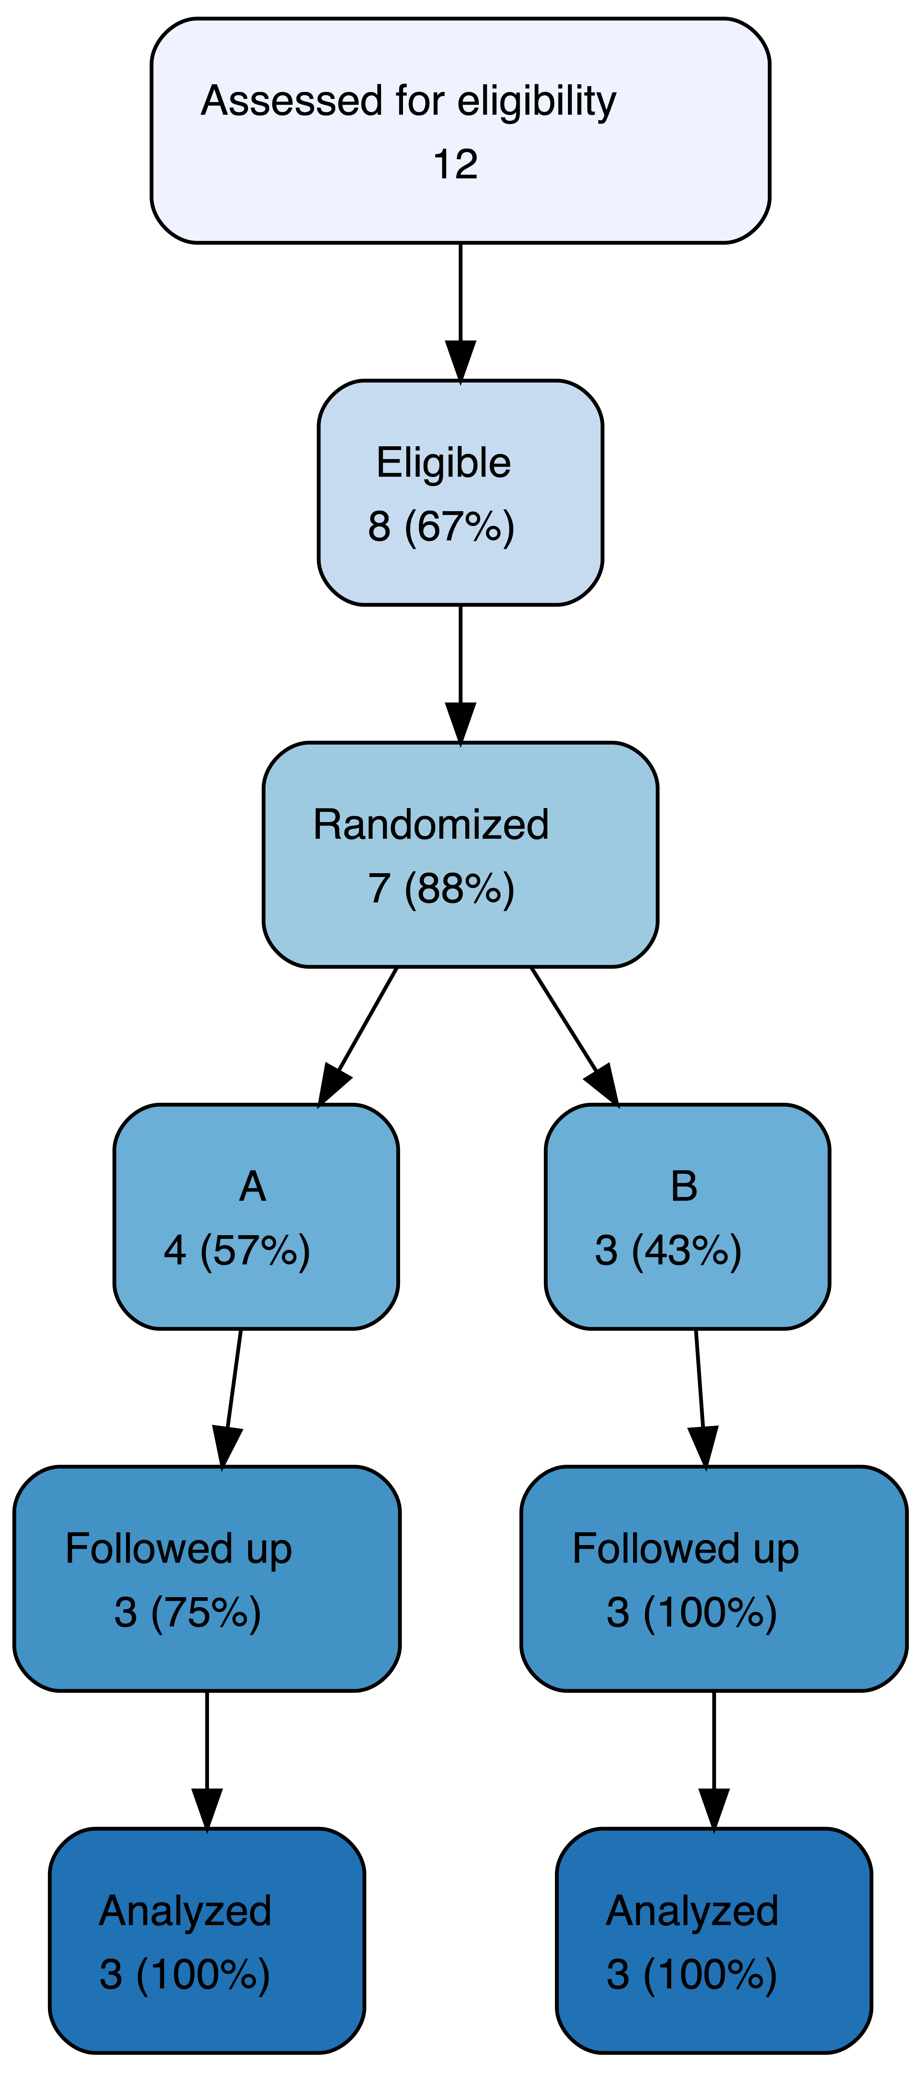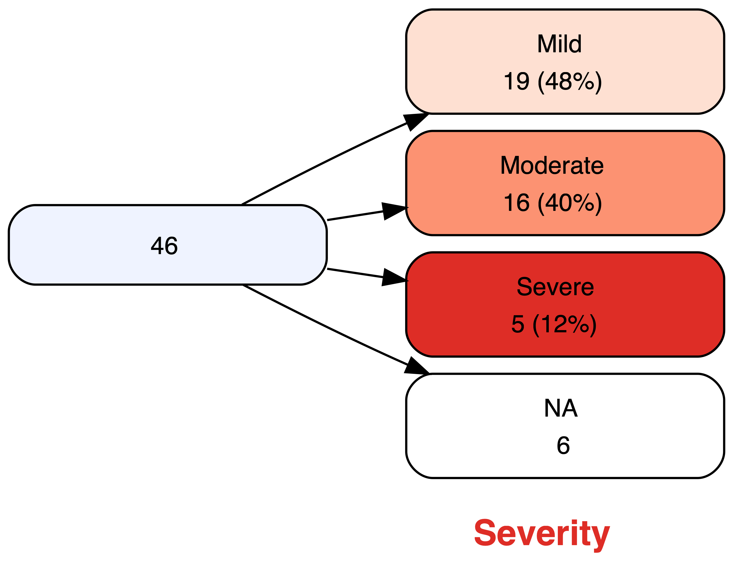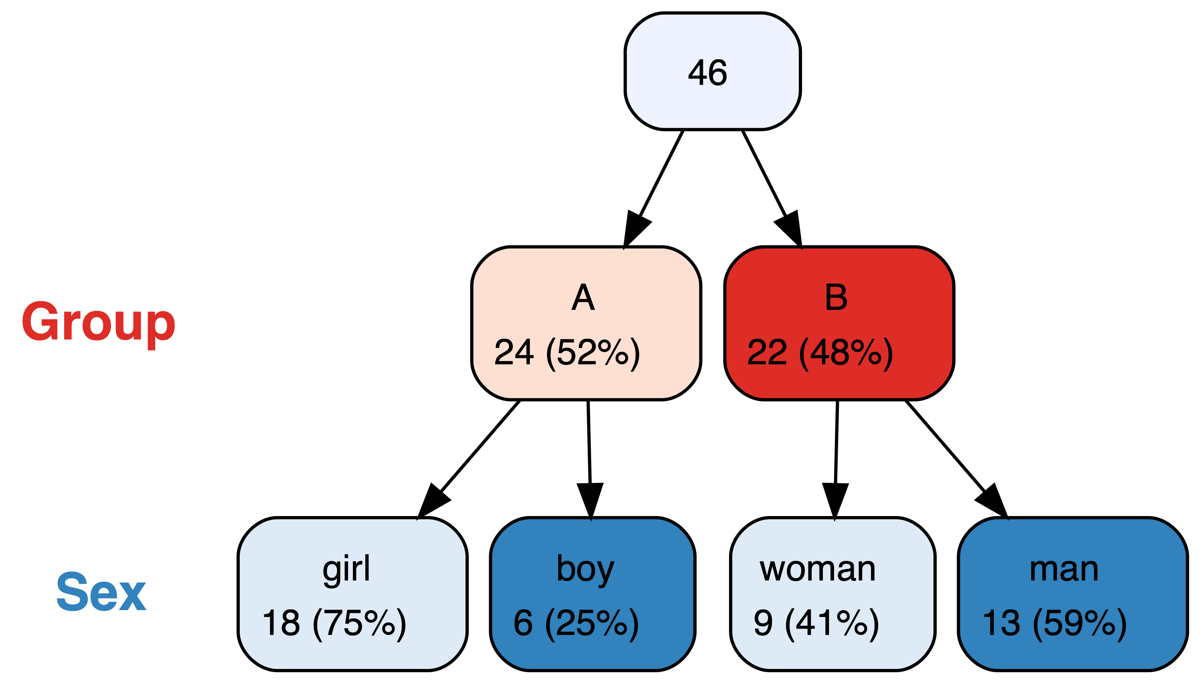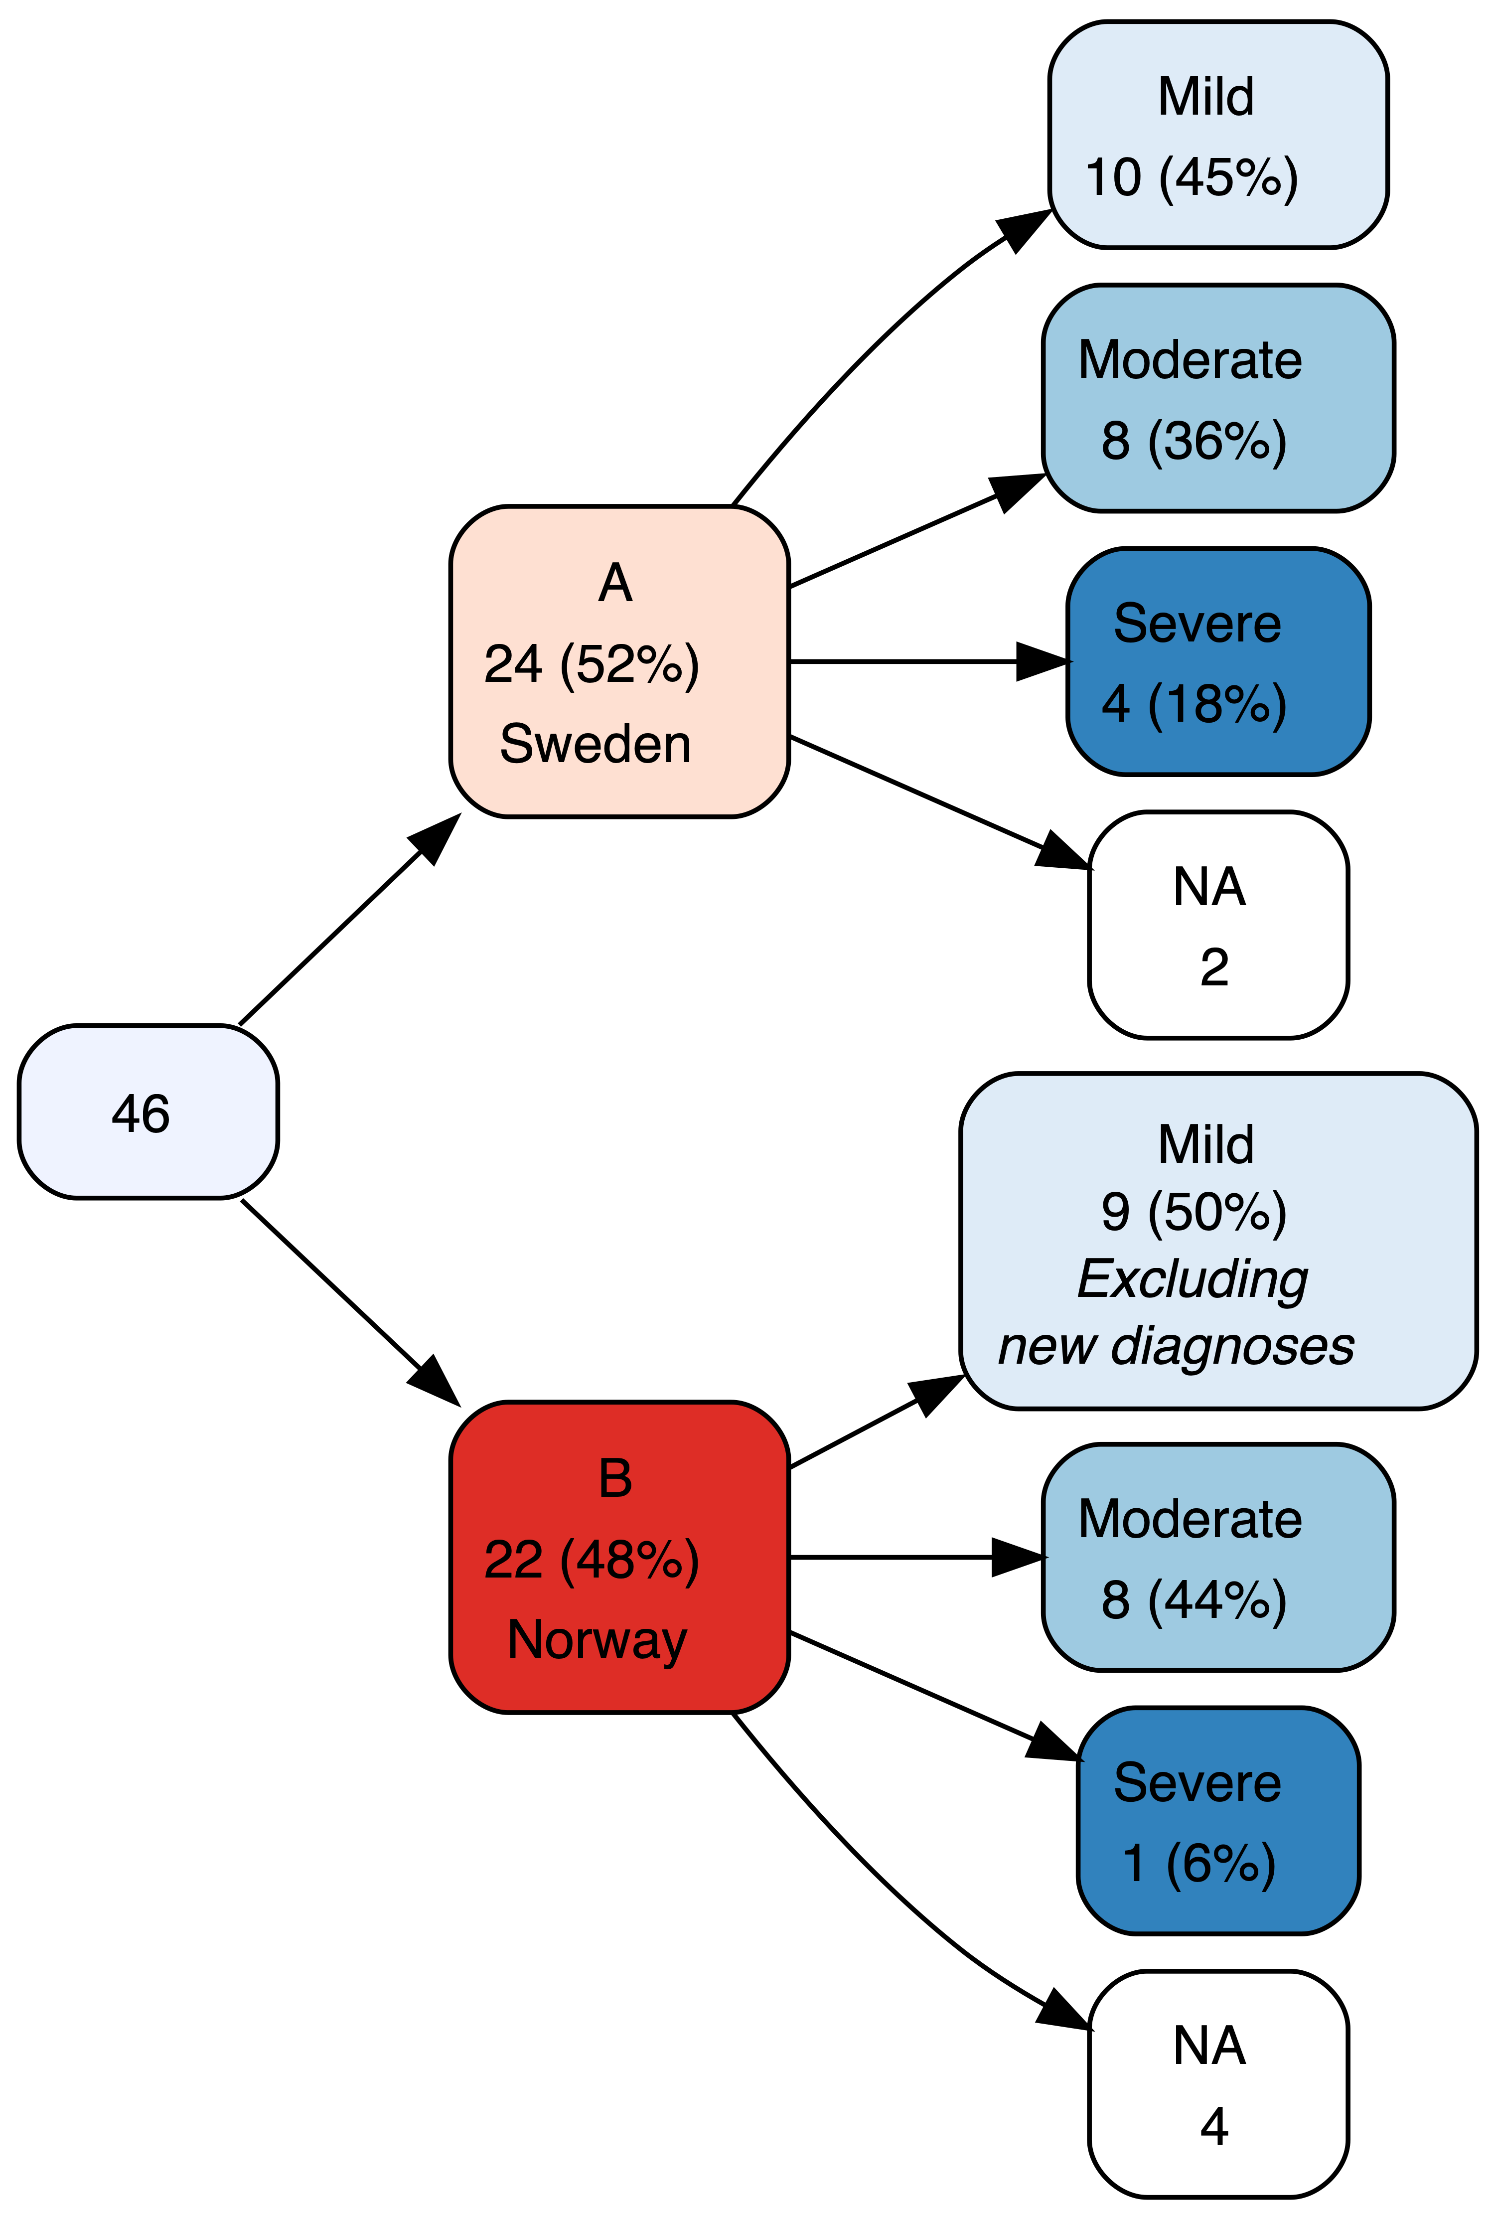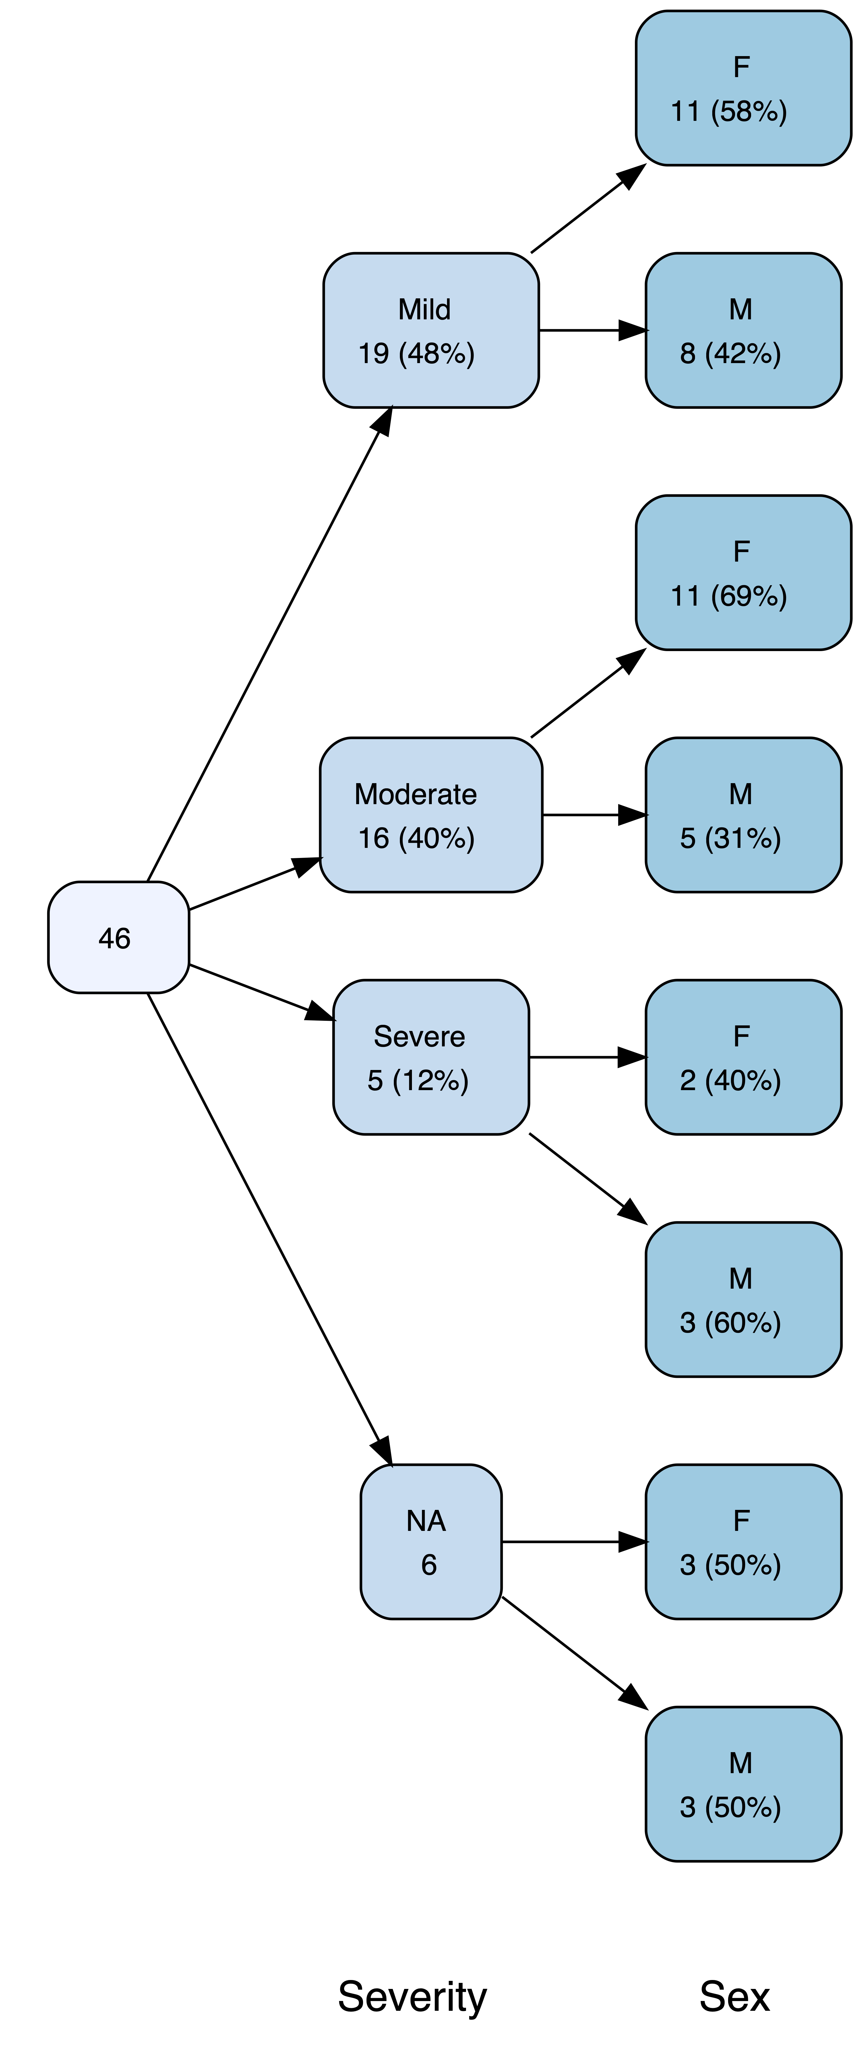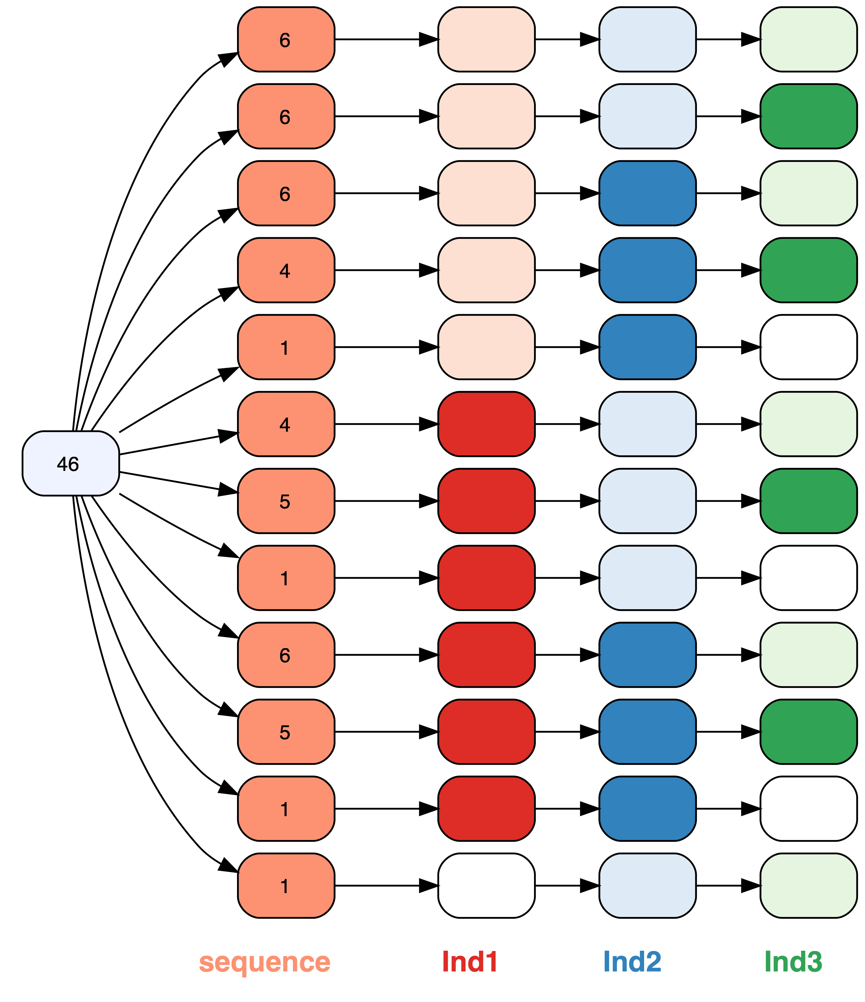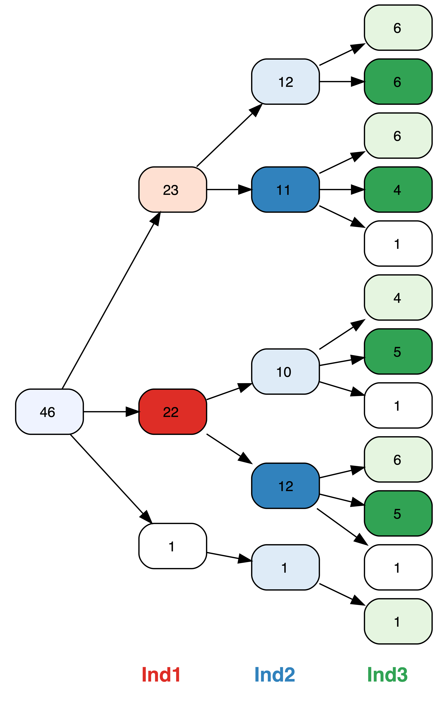

vtree(FakeData,"Group Sex",horiz=FALSE,

tlabelnode=list(

c(Group="A",Sex="F",label="girl"),

c(Group="A",Sex="M",label="boy"),

c(Group="B",Sex="F",label="woman"),

c(Group="B",Sex="M",label="man")))

Targeted labels*

* Available in the GitHub release of vtree

vtree(FakeData,"Severity",nodeattr="width=2")

Graphviz customization