**vtree** cheatsheet For more information type: vignette("vtree") v0.0.7

vtree(FakeData,"Severity",sameline=TRUE,

summary="Score \n mean=%mean%")

Summary codes

|  |  |
| --- | --- |
| Code | Meaning |
| %mean% | Mean |
| %SD% | Standard deviation |
| %min% | Minimum |
| %max% | Maximum |
| %pX% | Xth percentile |
| %median% | Median |
| %IQR% | Interquartile range (25th, 75th percentiles) |
| %list% | List of individual values |
| %mv% | Number of missing values |
| %v% | Variable name |
| %noroot% | Flag: do no show summary in the root node |
| %leafonly% | Flag: only show summary in the leaf nodes |
| %node=n% | Only show summary in node n. |
| %trunc=n% | Truncate summary at n characters. |

Summary

vtree(FakeData,"Group Severity",sameline=TRUE,

text=list(Severity=c(Mild="\n*or none*")))

Text formatting codes

|  |  |
| --- | --- |
| Code | Meaning |
| \n | Line break |
| *...* | Italics |
| **...** | Bold |
| ^...^ | Superscript |
| ~...~ | Subscript |
| %%red ...%% | Make text red (or whatever color specified) |

Text

vtree(FakeData,"Severity Sex")

vtree(FakeData,"Group",horiz=FALSE)

vtree(FakeData,"Severity Sex",

showlegend=TRUE,sameline=TRUE)

Basics

vtree(FakeData,"Severity Sex",

**prune**=list(Severity=c("Mild","Moderate")))

vtree(FakeData,"Severity Sex",

**prunebelow**=list(Severity=c("Mild","Moderate")))

vtree(FakeData,"Severity Sex",

**keep**=list(Severity=c("Mild","NA")))

vtree(FakeData,"Severity Sex",

**follow**=list(Severity=c("Mild","NA")))

Pruning

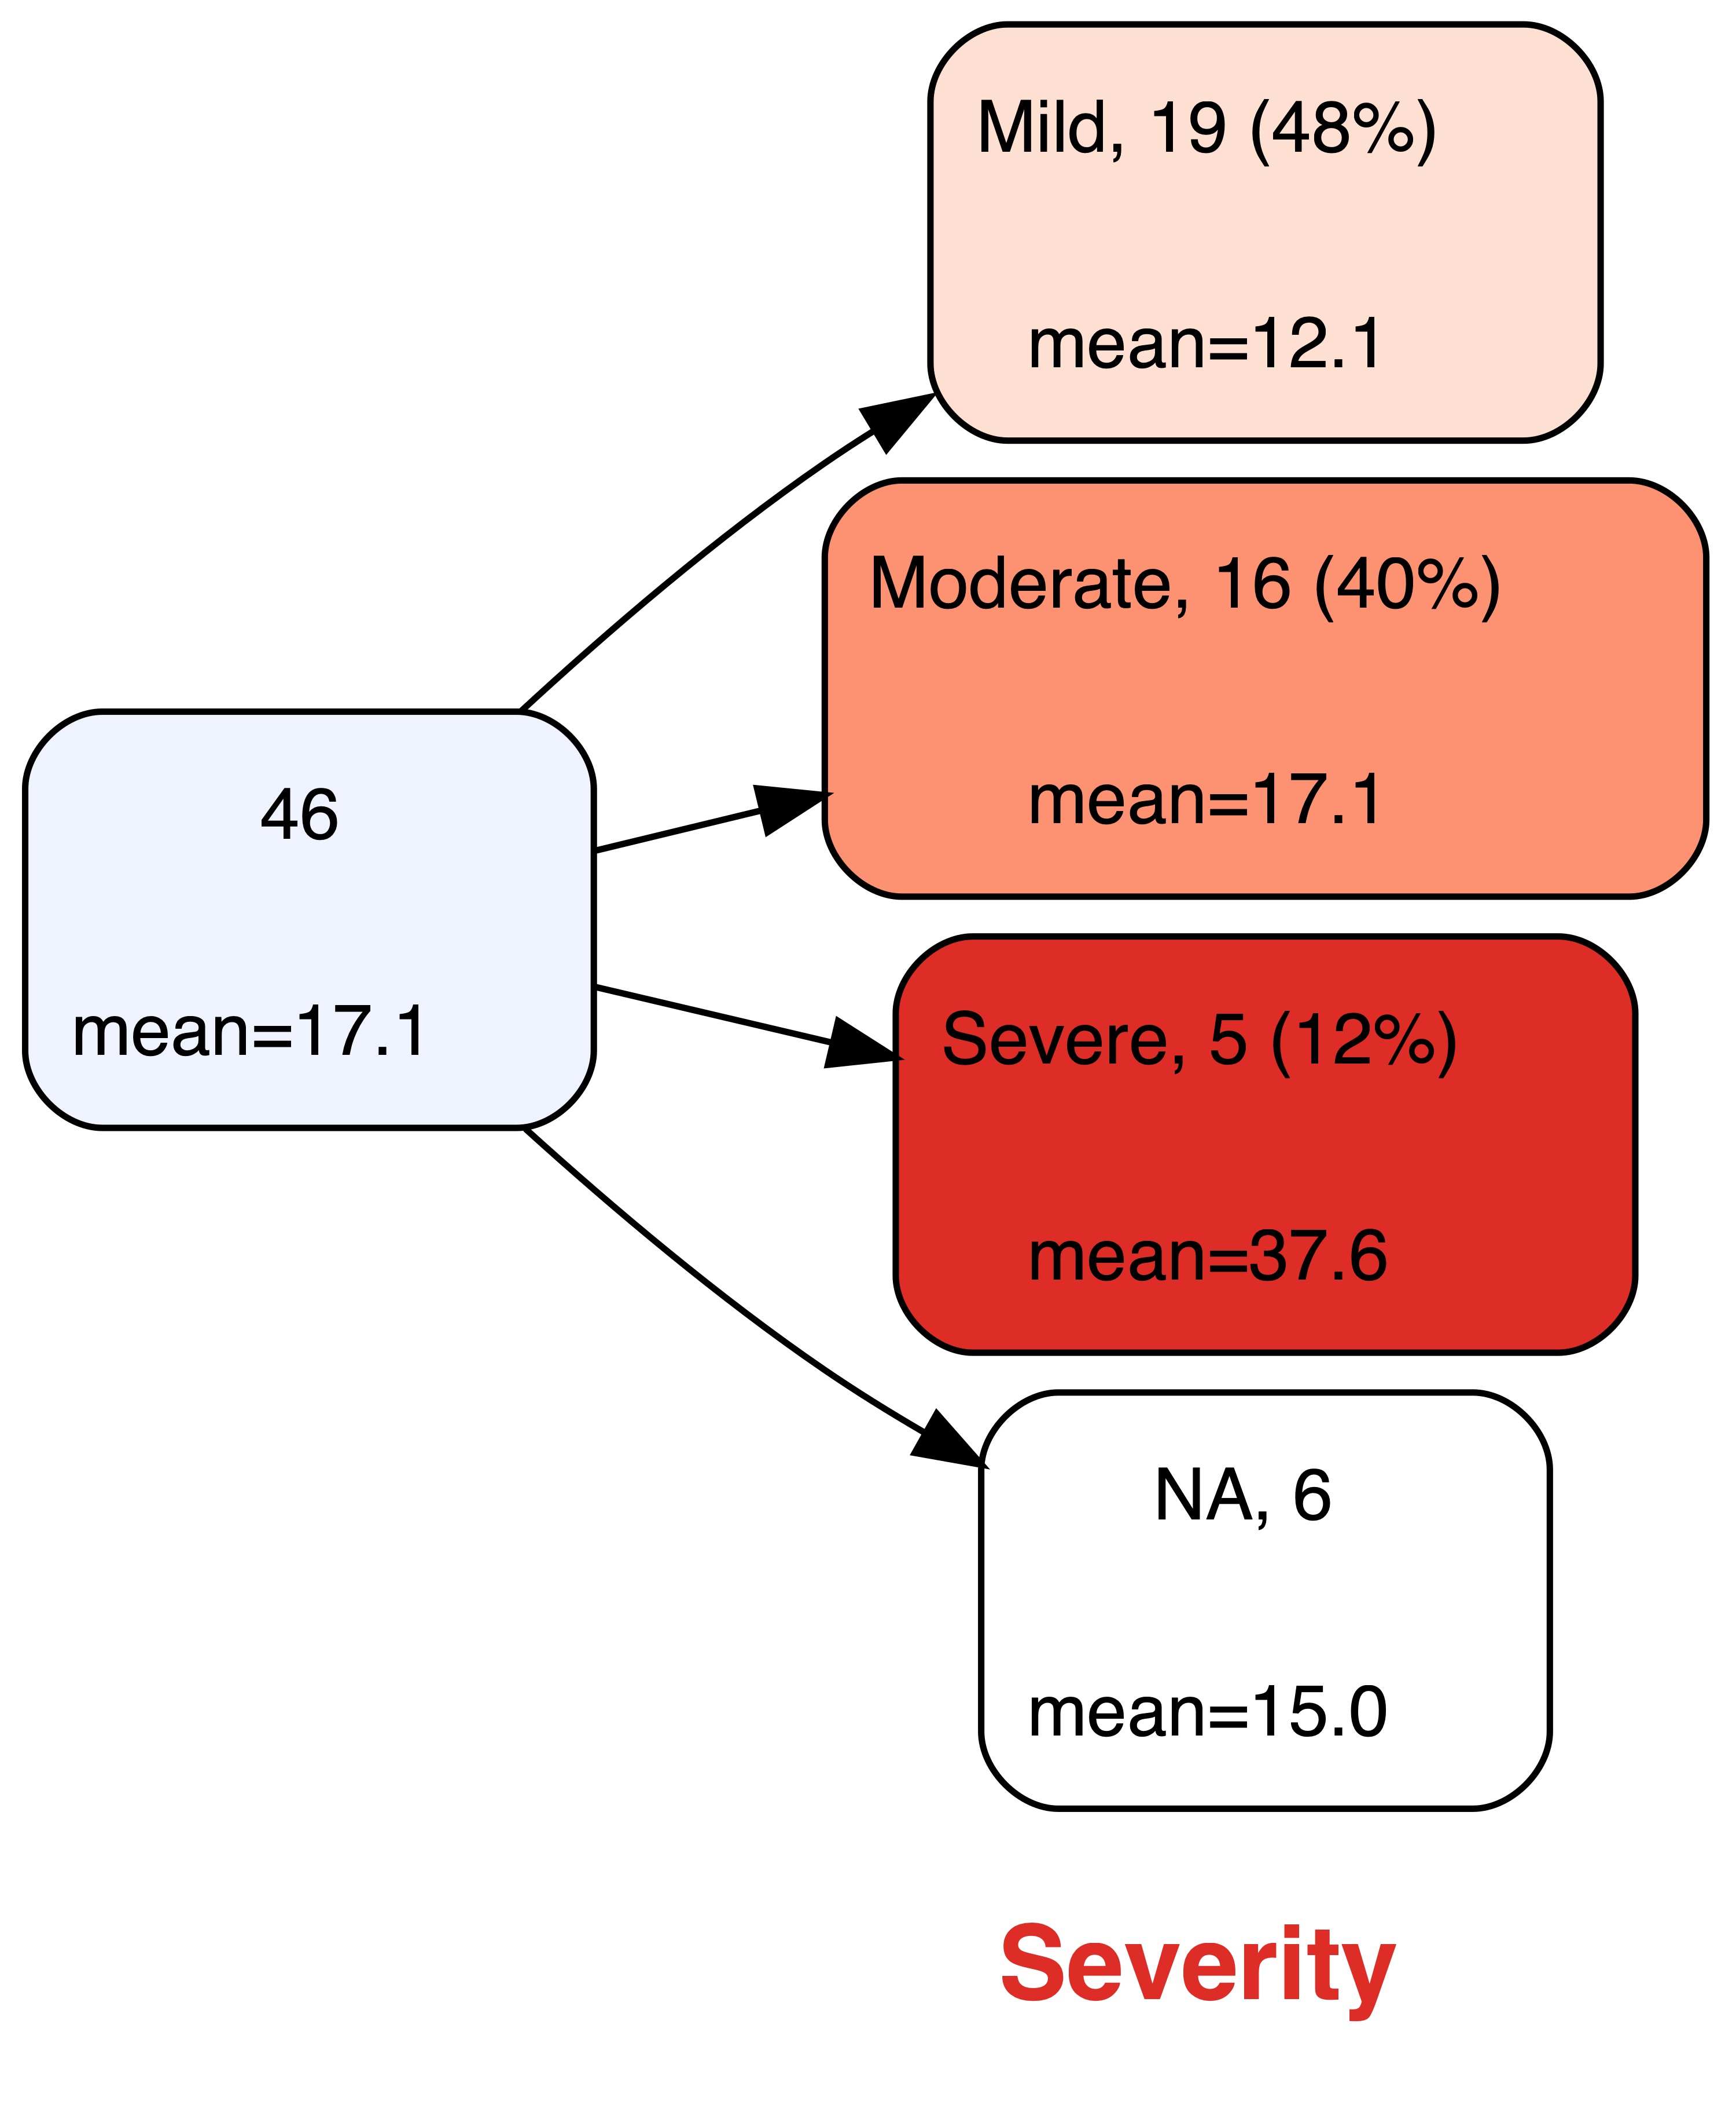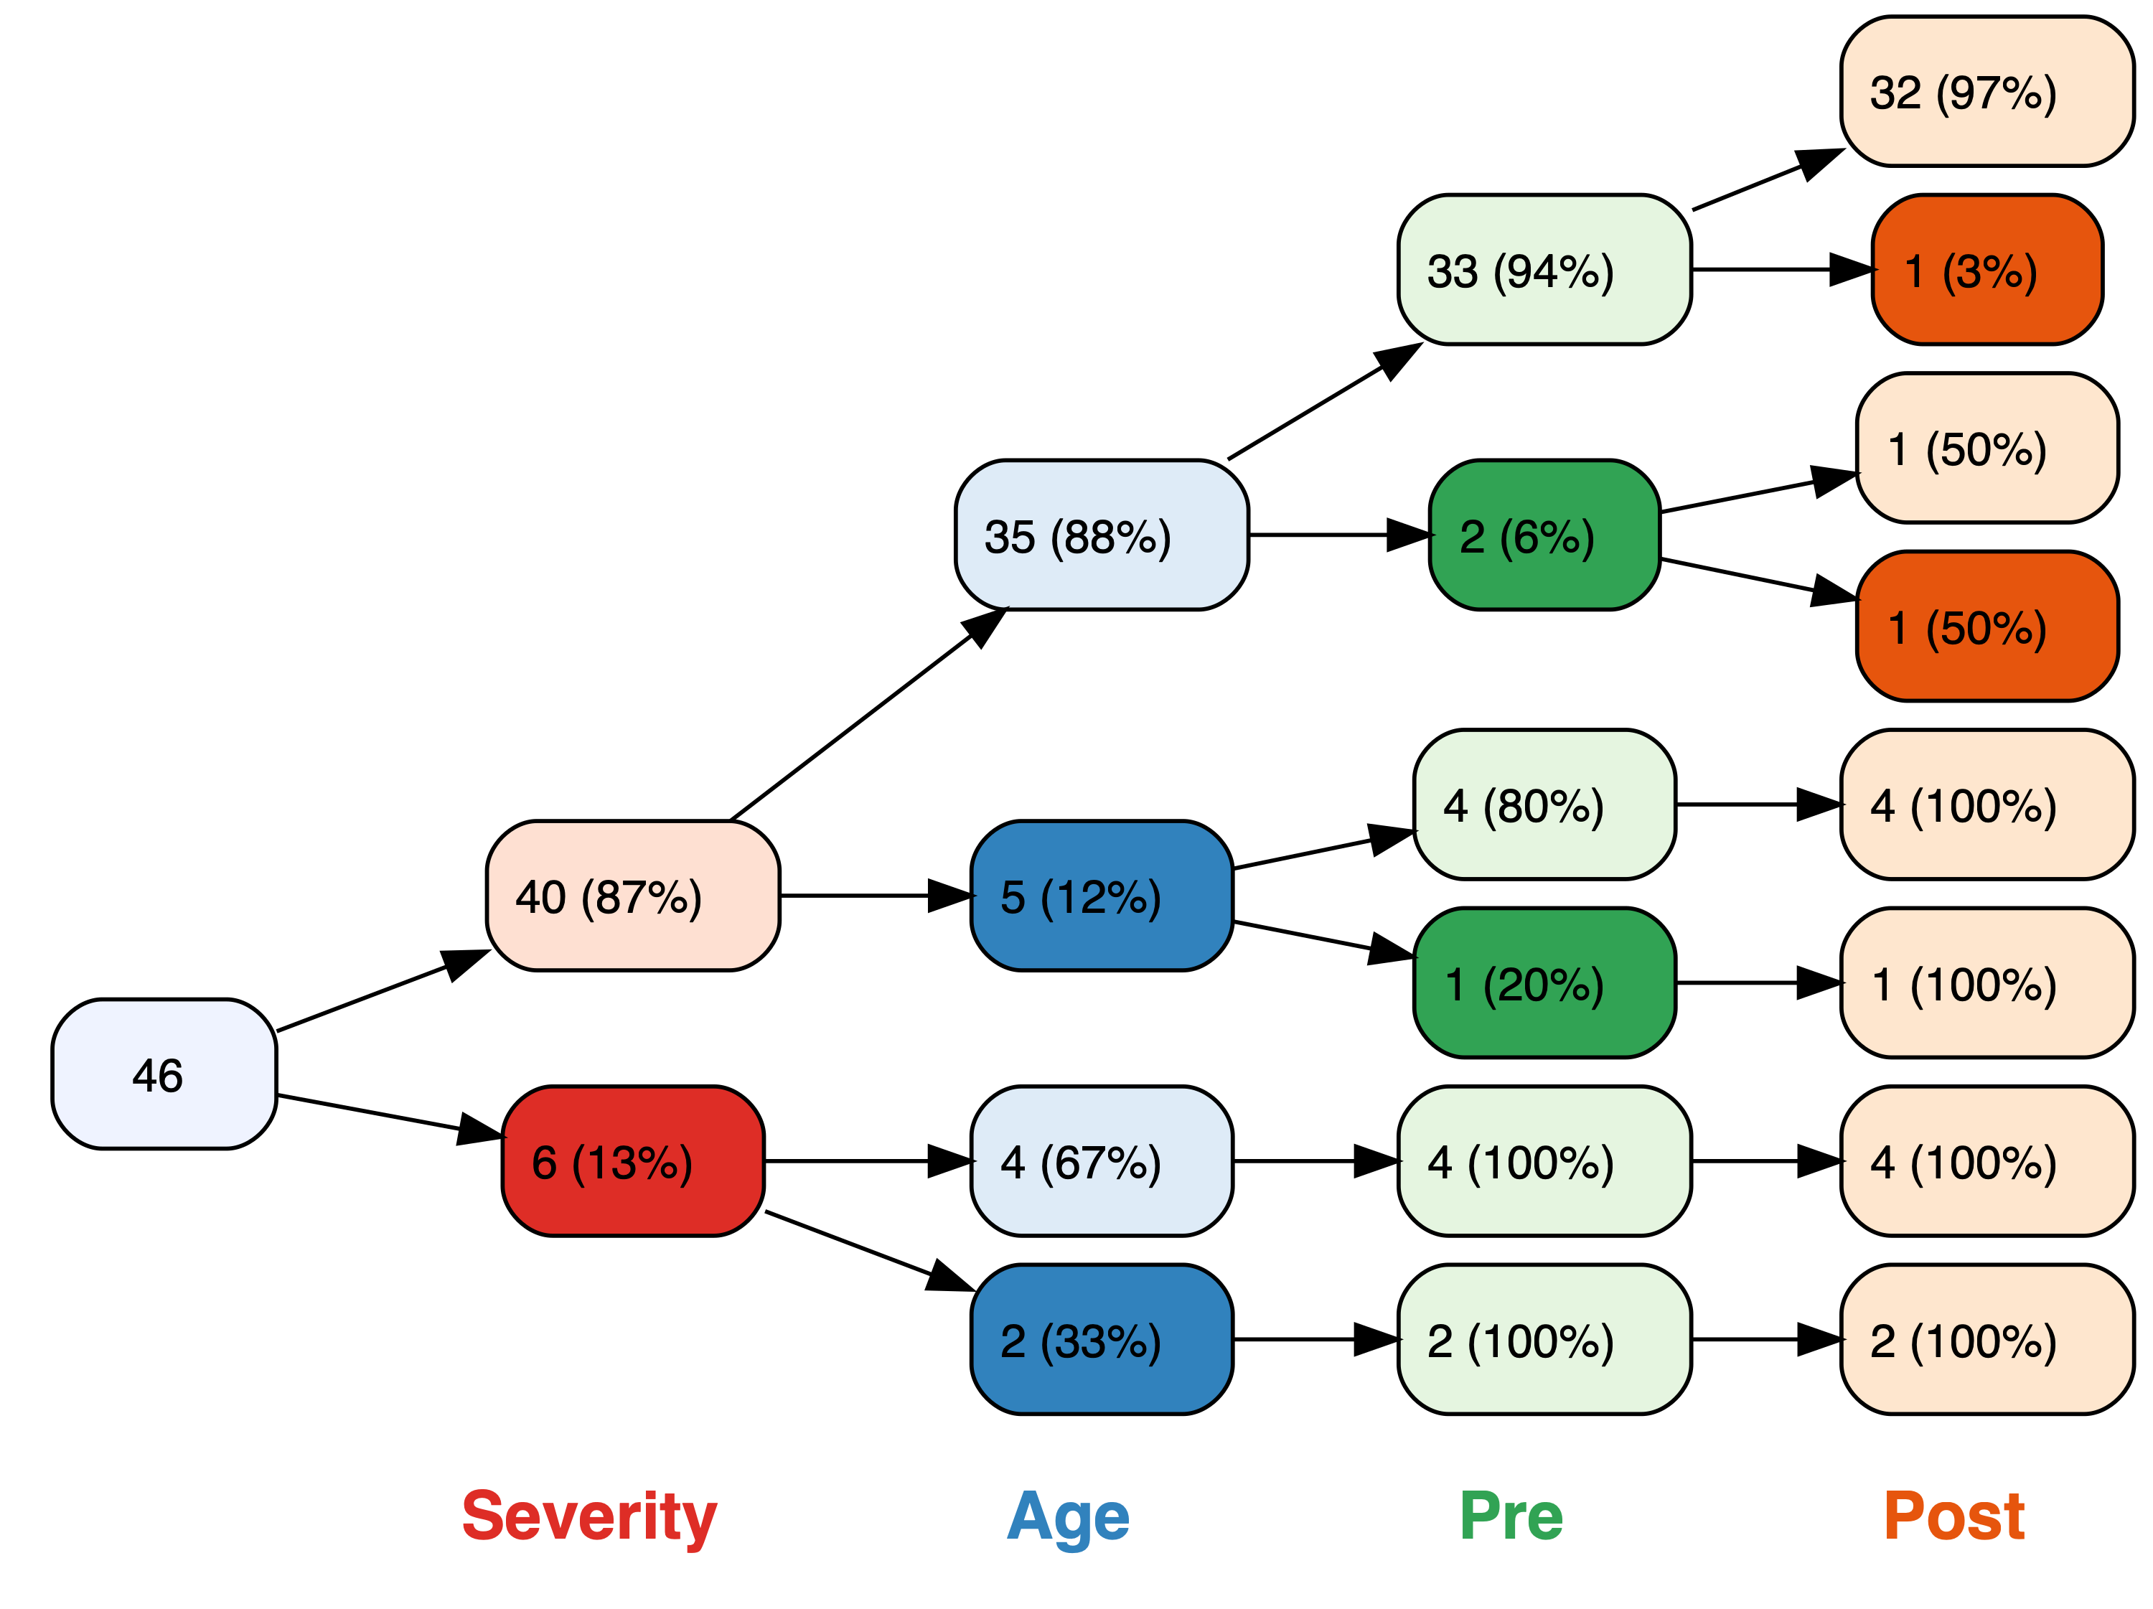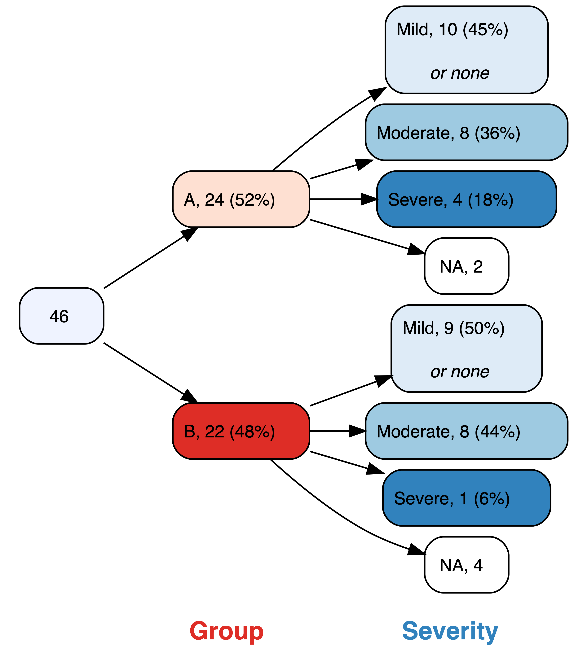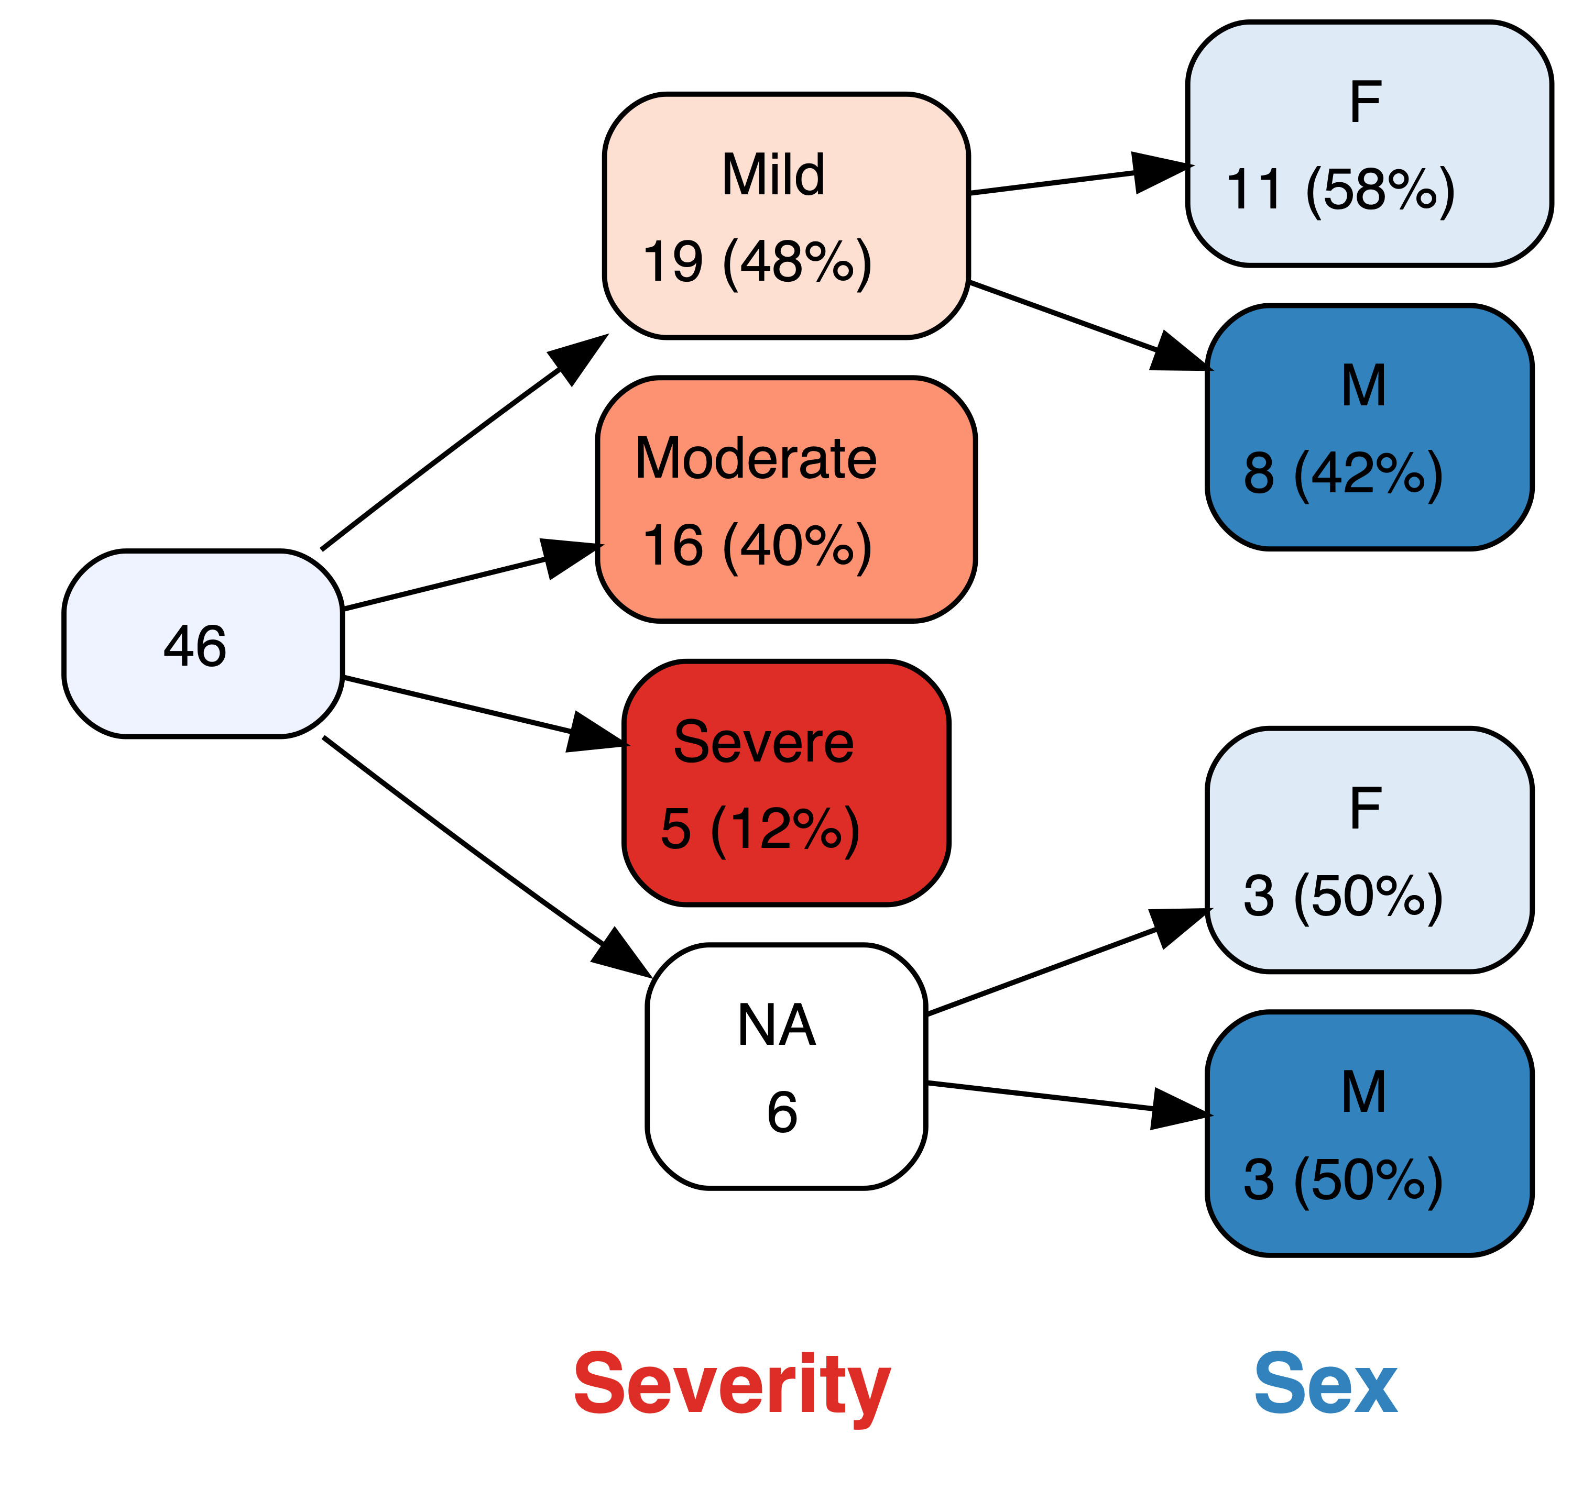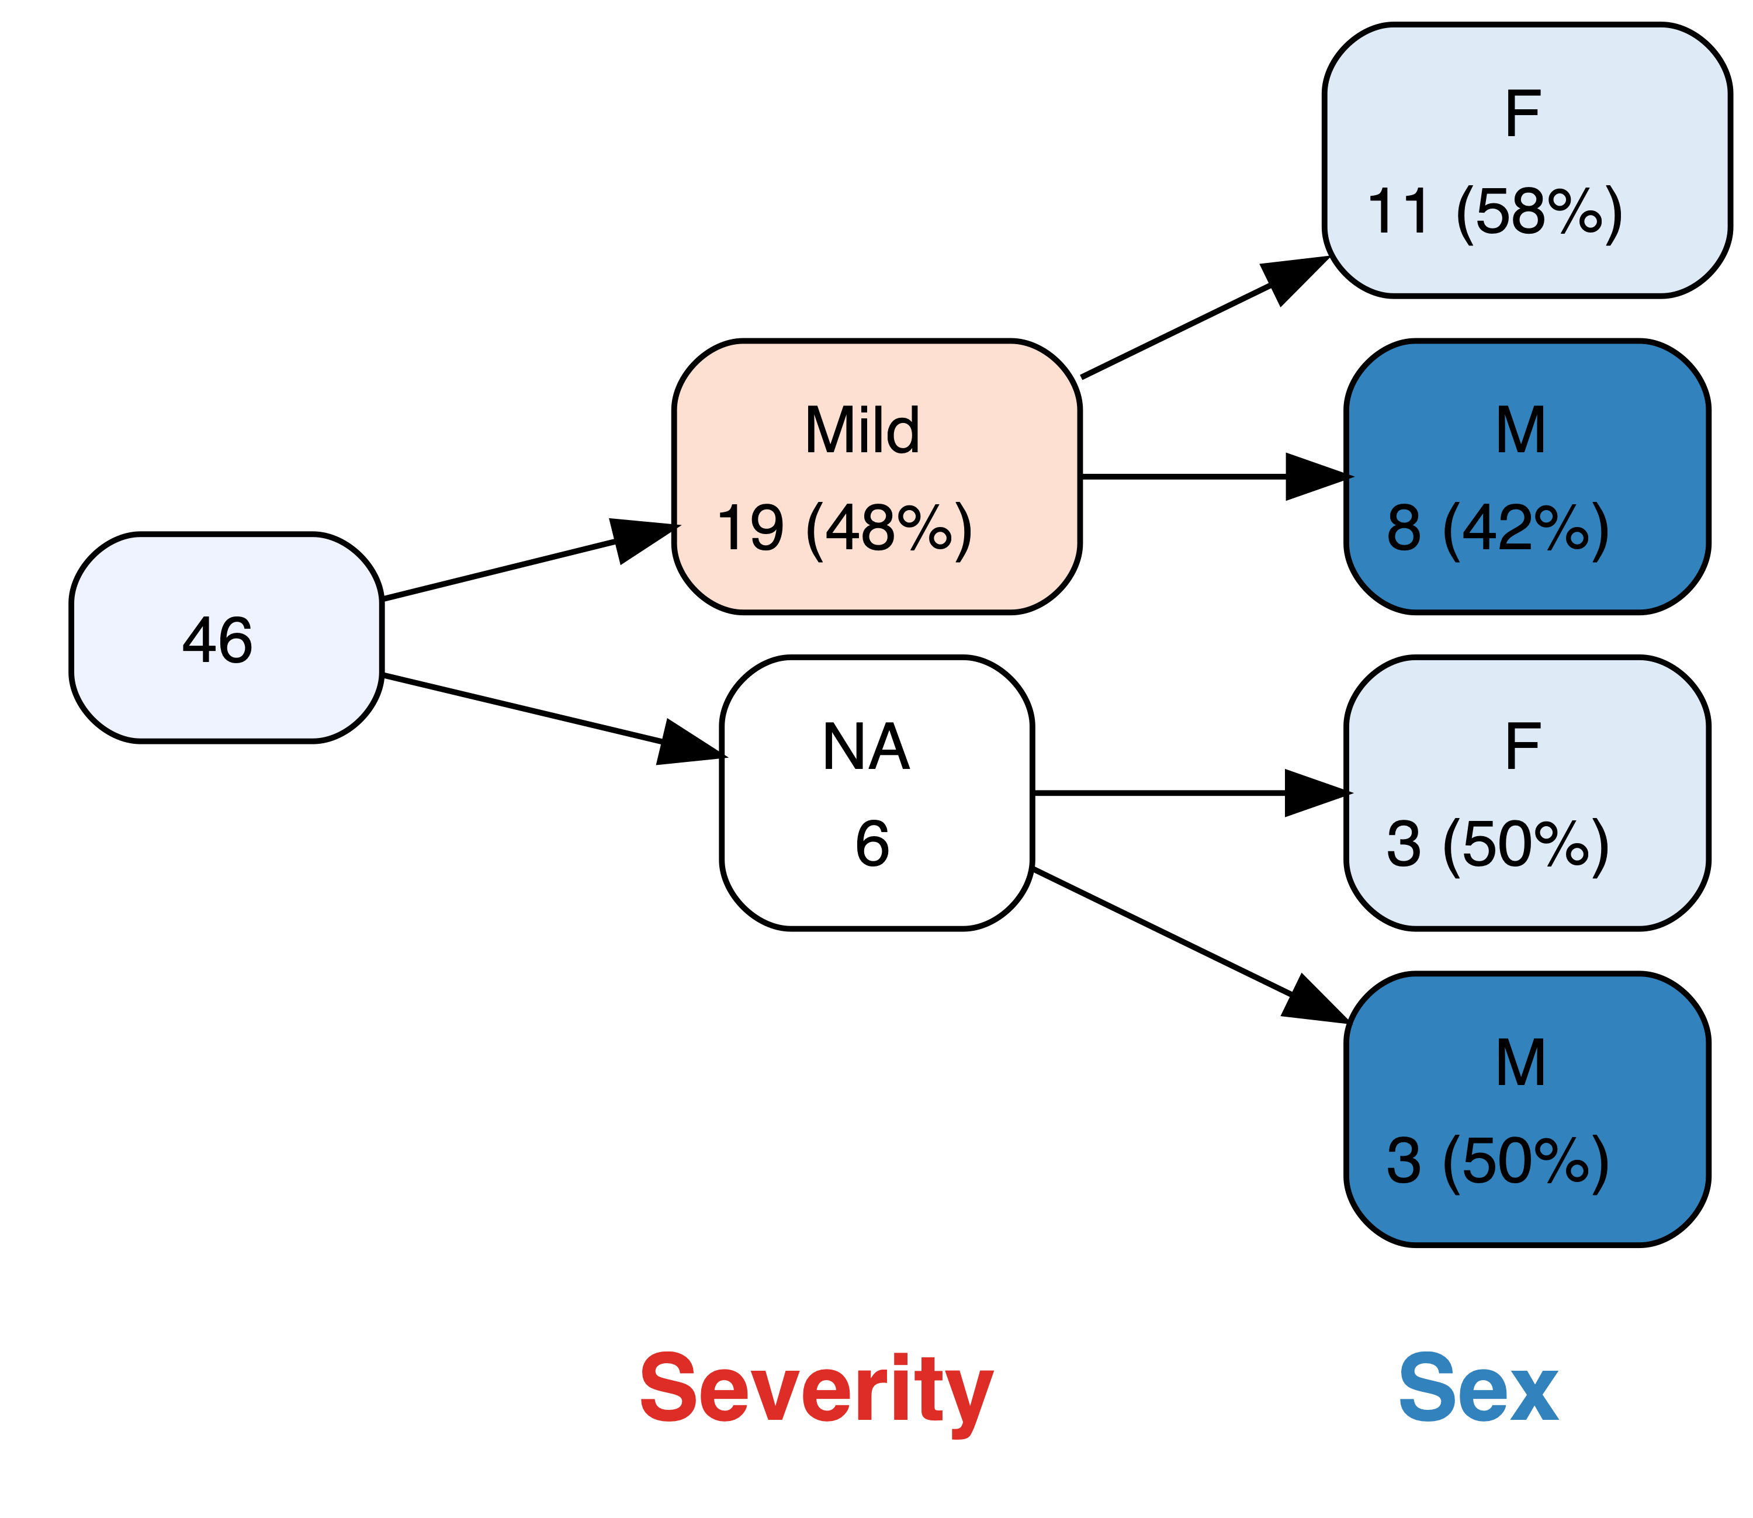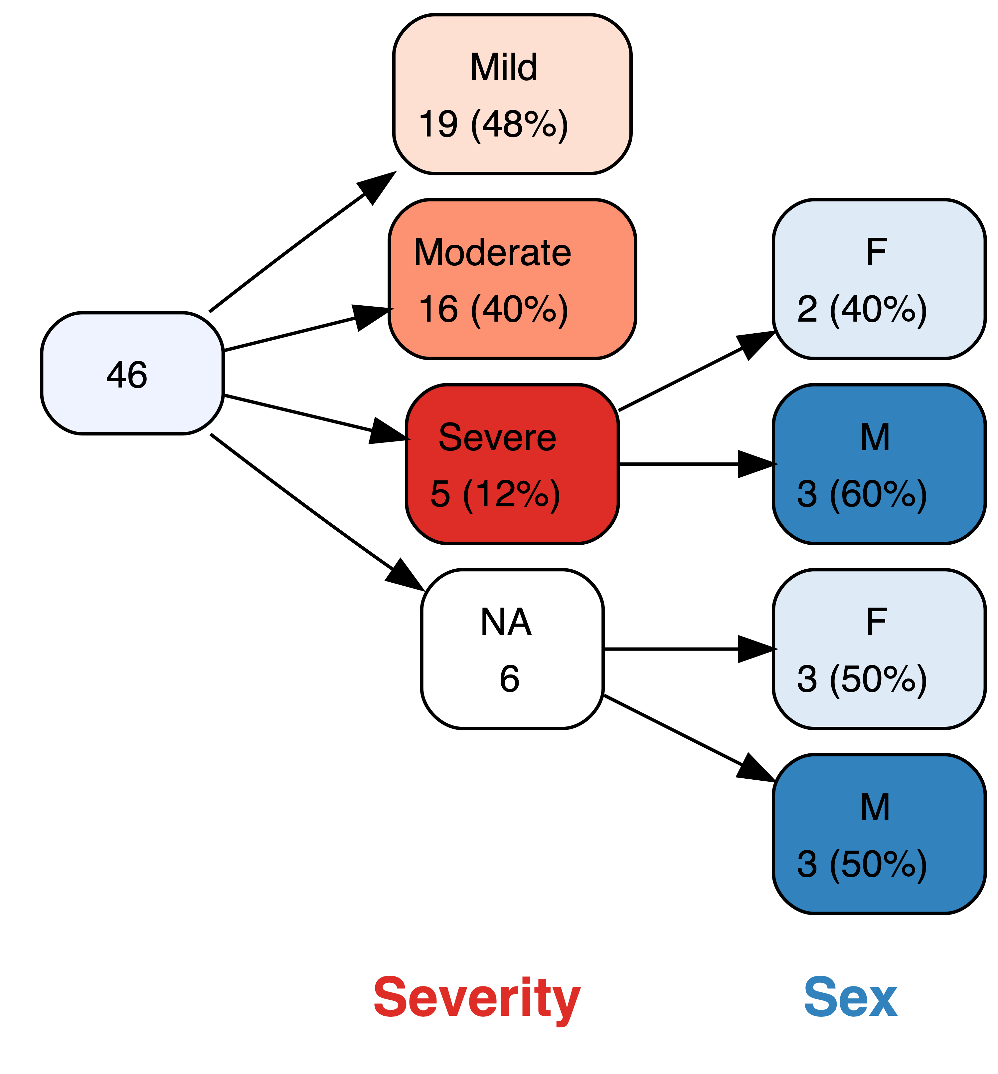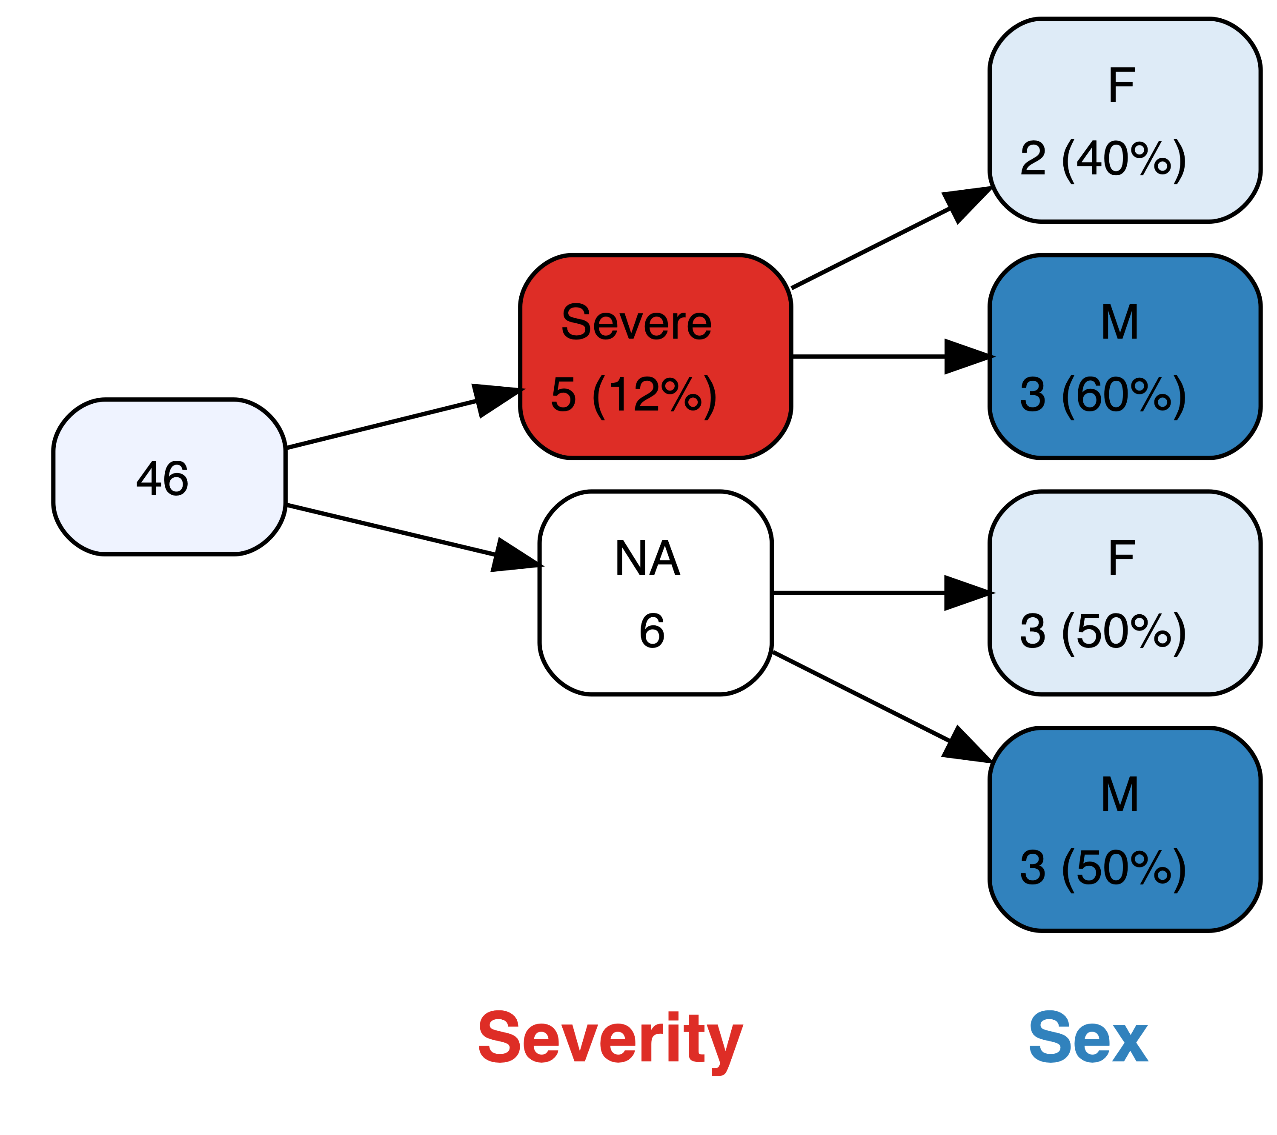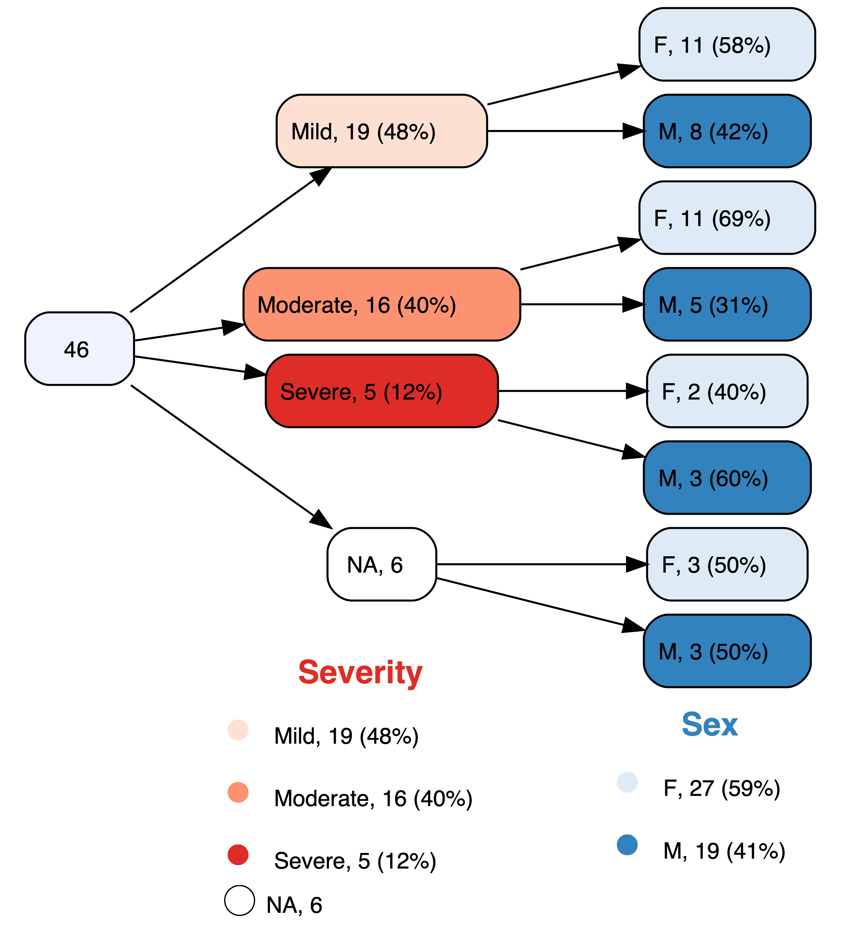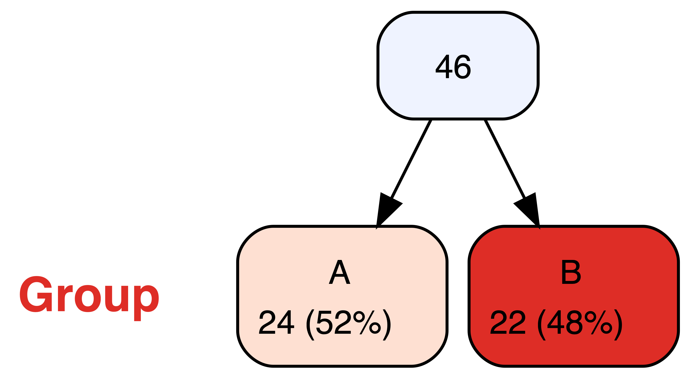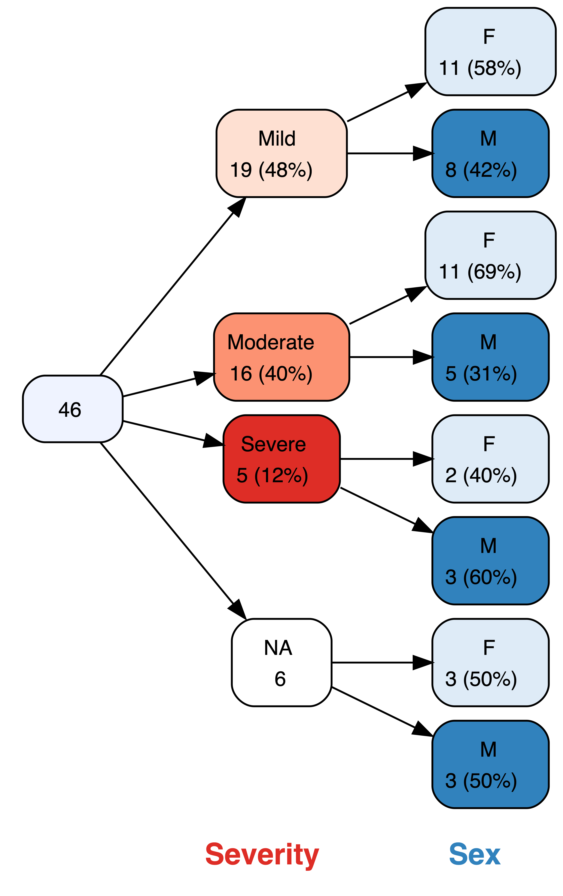

vtree(FakeData,"Severity Age Pre Post",check.is.na=TRUE)

Checking for missing values