PROJECT PHOENIX
Phase 1 Preliminary Design Review
Engineering Baseline - Revision B (Draft for Review)

Field | Value
Project | Enhanced drop-in balanced input module and intermediate power supply for Quad 521F amplifiers
Working name | Phoenix
Owner | Shep
Document status | Draft for review; decisions marked 'frozen' remain subject to this review
Prepared | 2026-07-21
Next intended phase | Detailed design, modelling and bench validation

Review objective: confirm that the requirements, architecture, closed decisions, residual risks and immediate Phase 2 work are accurately captured before the project is migrated to GitHub.

Document Control
Revision | Status | Purpose | Change authority
B Draft | For review | Initial Phase 1 engineering baseline reconstructed from the design review record | Shep
B Released | Planned | Approved baseline following review and correction | Shep

This document is deliberately written as a project baseline rather than a chronological conversation summary. It records the current engineering position, including decisions, assumptions, unresolved questions and the evidence required to progress.

Review conventions
Term | Meaning
Frozen | The decision is sufficiently justified for Phase 2 and should not be reopened without new evidence or a changed requirement.
Provisional | The preferred direction is identified, but a bounded item of analysis or bench evidence remains.
Open | A decision-critical question remains unresolved.
Deferred | Potentially useful work that is not required for the present critical path.
Rejected | Considered and not selected; rationale retained to prevent unnecessary reopening.

Contents
1. Executive Summary
2. Project Purpose, Scope and Success Criteria
3. Engineering Principles
4. Host Amplifier and As-Built Context
5. System Requirements
6. Proposed System Architecture
7. Frozen and Provisional Design Decisions
8. Trade-Study Summary
9. Mechanical Baseline
10. Electrical Interfaces and Grounding
11. Power Architecture
12. Signal Architecture
13. Current-Dumping Bridge Work
14. Validation and Test Infrastructure
15. Preliminary FMECA
16. Technical Risk and Assumptions Registers
17. Verification Matrix
18. Engineering Evidence and Literature
19. Shep's Analogue Design Handbook Outputs
20. GitHub Migration Baseline
21. Phase 2 Work Package
22. User Actions and Required Measurements
23. Items Not to Revisit Without New Evidence
24. Review Decisions Requested
Appendix A - Decision Register
Appendix B - Candidate Acceptance Tests
Appendix C - Source and Artefact Register
Appendix D - Figure and Diagram Register
Appendix E - Detailed Trade-Study Criteria
Appendix F - Bench Measurement Record Sheets
Appendix G - Detailed PDR Review Checklist
Appendix H - Planned Detailed-Design Appendices

1. Executive Summary
Project Phoenix will replace the optional active floating balanced-input module fitted to the Quad 521F with a modern, low-noise, serviceable electronic balanced receiver. It will be supported by a separate low-current intermediate power-supply module that converts the amplifier's approximately ±50 to ±55 V raw rails into clean local supplies suitable for the receiver.
The project deliberately preserves the established Quad current-dumping power amplifier, regulated-earth arrangement, gain calibration and modular construction. The intended intervention is confined to the balanced interface, its low-voltage supply, shielding, grounding implementation and documentation.
The Phase 1 conclusion is that a viable architecture exists within the original input-module envelope. The THAT1206 is the selected receiver architecture; a −6 dB conversion is well aligned with direct drive from the Topping Pre90 and the existing 521F attenuator. The receiver module will remain AC-coupled to the amplifier input, use a modified standard aluminium extrusion for screening, and receive approximately ±18 V intermediate rails followed by local ±17 V low-noise regulation.
The main unresolved design item is the remote symmetrical high-voltage preregulator. Its output tolerance, startup and shutdown behaviour, current limiting, interaction with the Quad regulated-earth node, and final positive/negative implementation require detailed derivation, modelling and bench validation. These are bounded Phase 2 tasks.

Phase 1 gate judgement
Area | Judgement | Status
Problem definition | Clear and stable | Closed
Mechanical feasibility | Confirmed from original module photographs and measurements | Closed conceptually
Receiver architecture | THAT1206, −6 dB | Frozen
Output coupling | Film-coupled, nominally 2.2 µF | Provisional value
Local final rails | ±17 V | Frozen
Local regulation | LT1761 / LT1964 preferred | Frozen subject to bench validation
Remote preregulation | Discrete, low-current, high-voltage bipolar architecture | Open detailed design
Grounding | Shield/chassis separated from Quad regulated-earth reference | Provisional pending continuity mapping
Validation capability | Sufficient bench infrastructure available or under construction | Strong

2. Project Purpose, Scope and Success Criteria

2.1 Design intent
Modernise the interface between professional balanced sources and the Quad 521F while preserving the amplifier's proven current-dumping architecture, its existing gain-adjustment method and its serviceable modular construction.

2.2 Primary use case
- Direct balanced drive from a Topping Pre90.
- Future drive from a purpose-designed balanced analogue crossover for an active Magnepan 0.7 system.
- Two Quad 521F amplifiers used to drive the Magnepan bass/mid and tweeter sections.
- A future Quad 707 or 909 intended to drive a pair of custom 4 Ω sealed subwoofers.

2.3 In scope
- Replacement of the complete dashed optional active floating input-module block.
- Balanced-to-single-ended conversion.
- RF/EMI input conditioning and fault-current limiting.
- AC-coupled interface to the existing Quad input arrangement.
- Remote conversion of the Quad high-voltage rails to low-current intermediate rails.
- Local low-noise final regulation on each receiver module.
- Mechanical replacement using the original mounting geometry and a modified standard aluminium extrusion.
- Grounding, chassis bonding, shielding and validation.
- Documentation, reproducible calculations, FMECA and acceptance testing.

2.4 Out of scope
- Redesign of the Quad current-dumping power-amplifier channel.
- Digital signal processing, microcontrollers or software control.
- Additional current sensing, 12 V services or diagnostics not required by the receiver.
- Wholesale alteration of the 521F protection or regulated-earth system.
- Multiple planned product revisions; the objective is one thoroughly validated final design.
- Custom aluminium extrusion tooling.
- Full design of the future active crossover.

2.5 Success criteria
- Measurably equal or superior balanced-input performance to the original module under the defined domestic installation.
- No adverse change to amplifier gain, clipping, noise, stability, regulated-earth behaviour or current limiting.
- Safe startup, shutdown and credible single-rail fault behaviour.
- Four identical final modules can be built, fitted and serviced with normal workshop methods.
- All critical design decisions and acceptance results are reproducible from the project repository.
- Additional complexity is included only where it creates measurable performance, reliability or risk-reduction benefit.

3. Engineering Principles
Principle | Application to Phoenix
Affordable Performance | Select higher performance or tighter tolerance only where the system analysis shows a material benefit.
Everything must earn its place | A component, process step or document must reduce risk, improve performance, improve serviceability or preserve hard-won knowledge.
Preserve proven architectures | Do not modify current dumping, amplifier gain or existing protection without compelling evidence.
Evidence before opinion | Use first principles, authoritative literature, modelling and measurement; identify engineering judgement explicitly.
Optimise the system | Receiver, power supply, grounding, host amplifier and source are assessed together.
Simplicity is an objective | The simplest architecture that meets the requirements is preferred.
Design for the next engineer | Readable silkscreen, test points, revision marking, controlled documentation and repairable packages.
No rabbit holes | Stop an investigation once it has answered the design question and reduced the relevant risk.
Realistic planning | Use dependencies and bounded engineering effort only when useful; avoid artificial calendar estimates.

4. Host Amplifier and As-Built Context

4.1 Amplifier
- Quad 521F professional stereo current-dumping amplifier.
- Approximately +50 to +55 V and −50 to −55 V raw rails in normal service.
- Active regulated-earth / COLD system used to control the supply midpoint and prevent DC through the loudspeaker.
- Original optional balanced-input module occupies a dashed functional block in the schematic and is the block to be replaced.
- Amplifier has existing input attenuators; these have been replaced by equivalent-value high-quality Bourns wire-wound multi-turn units.

4.2 Existing modifications
The annotated schematic is treated as the as-built configuration, except where later physical inspection identifies a discrepancy.
Modification or observation | Status / purpose
C2 changed to 330 nF | QuadSpot/DaDa later-family input/DC feedback alignment
C3 changed to 1 µF | As above
R5 changed to 62 kΩ | As above
C7, C9, C11 renewed and locally bypassed | Ageing/reliability and HF decoupling
D1/D2 augmented with 100 nF capacitors | HF bypass
C300 changed to 2.2 µF film | Inrush limiter component
R29/R30 adjusted | Current-dumping bridge balance calculated from Quad bridge equations
Bourns multi-turn attenuators | Drop-in electrical replacements with improved adjustment resolution
C10 remains bipolar electrolytic | Potential later film replacement remains outside Phoenix unless justified

4.3 Original balanced-input module
Parameter | Measured / observed value
Board length | 98 mm
Board width | 18 mm
Existing overall height | 22 mm; additional height is available
Mounting-hole centres | 85 mm
Hole diameter | 3 mm
Hole centres from ends | 6 mm
Hole centreline from one long edge | 6 mm; asymmetric
Construction | Long narrow PCB within an aluminium screening cover
Original functional content | Transformer, TL071-related active circuitry, zener-derived local supplies and coupling network

5. System Requirements

5.1 Functional requirements
ID | Requirement
PHX-FUN-001 | Accept a conventional balanced XLR input and produce the single-ended signal required by the existing Quad input interface.
PHX-FUN-002 | Operate correctly from the Topping Pre90 and remain compatible with a future balanced analogue crossover.
PHX-FUN-003 | Use the existing Bourns multi-turn attenuator for final amplifier sensitivity adjustment.
PHX-FUN-004 | Provide four identical modules: two channels in each of two amplifiers.
PHX-FUN-005 | Retain AC coupling between the replacement receiver and the Quad amplifier input unless complete fault testing proves direct coupling superior.

5.2 Electrical requirements
ID | Requirement
PHX-ELE-001 | Nominal receiver gain shall be −6 dB.
PHX-ELE-002 | Final receiver rails shall be nominally +17.0 V and −17.0 V.
PHX-ELE-003 | Intermediate rails shall provide adequate LDO headroom while remaining safely below the local regulators' 20 V input limit.
PHX-ELE-004 | Receiver noise and distortion shall be negligible relative to the 521F power-amplifier contribution.
PHX-ELE-005 | CMRR shall be evaluated across the audio band and with realistic source-leg impedance mismatch.
PHX-ELE-006 | Maximum credible Pre90 output shall not damage Phoenix; overload recovery shall be benign.
PHX-ELE-007 | One missing local rail shall not apply sustained hazardous DC to the Quad input.
PHX-ELE-008 | Auxiliary rail current shall be low and positive/negative loading shall be sufficiently balanced not to disturb the regulated-earth system.
PHX-ELE-009 | Input protection and RF components shall be symmetrical and shall not materially degrade CMRR.

5.3 Mechanical and service requirements
ID | Requirement
PHX-MEC-001 | Reproduce the 98 × 18 mm footprint and original mounting-hole geometry unless a direct mechanical equivalent is demonstrated.
PHX-MEC-002 | Use a stock aluminium extrusion or channel modified by cutting and drilling; no custom extrusion tooling.
PHX-MEC-003 | Prefer SOIC and conventional leaded SMD packages; smaller packages are acceptable only where the benefit is material and assembly remains practical.
PHX-MEC-004 | Provide labelled test points, rail identifiers, signal direction and PCB revision marking.
PHX-MEC-005 | Permit replacement of the receiver module without redesigning the amplifier.

6. Proposed System Architecture

6.1 System partition
Phoenix is partitioned into three functional blocks, each with one primary job:
Block | Location | Primary function
A - Remote intermediate PSU | Central amplifier bracket, adjacent to speaker-protection board | Reduce the Quad raw rails to safe low-current intermediate rails; absorb heat and contain faults.
B - Receiver module | Original balanced-module position | Balanced reception, RF protection, local final regulation, AC-coupled output interface.
C - Host interface | Existing 521F wiring, chassis and attenuator | Grounding, calibration, shielding and connection to the power-amplifier input.

6.2 Signal path
XLR pins 2/3 → symmetrical RF/fault network → THAT1206 → modest output isolation resistor → film coupling capacitor → existing Bourns attenuator → Quad amplifier input.
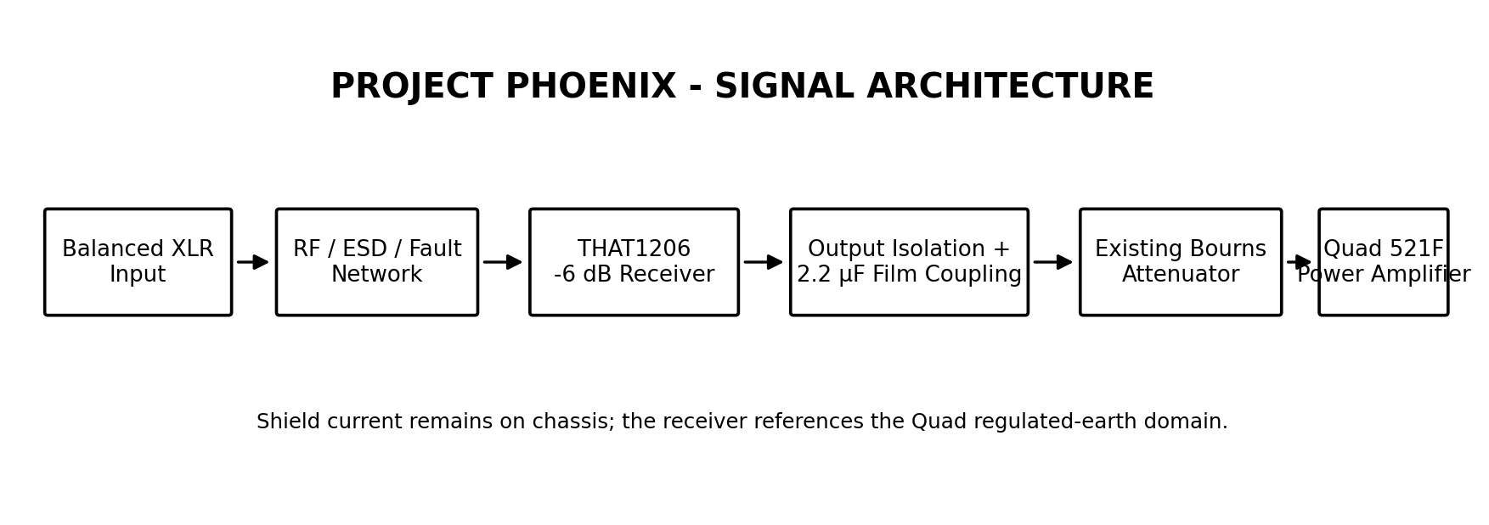
Figure 6-1. Phoenix signal architecture.

6.3 Power path
Quad H+ / H− → remote low-current high-voltage preregulator → approximately ±18 V harness → LT1761 / LT1964 local post-regulation → ±17 V receiver rails.
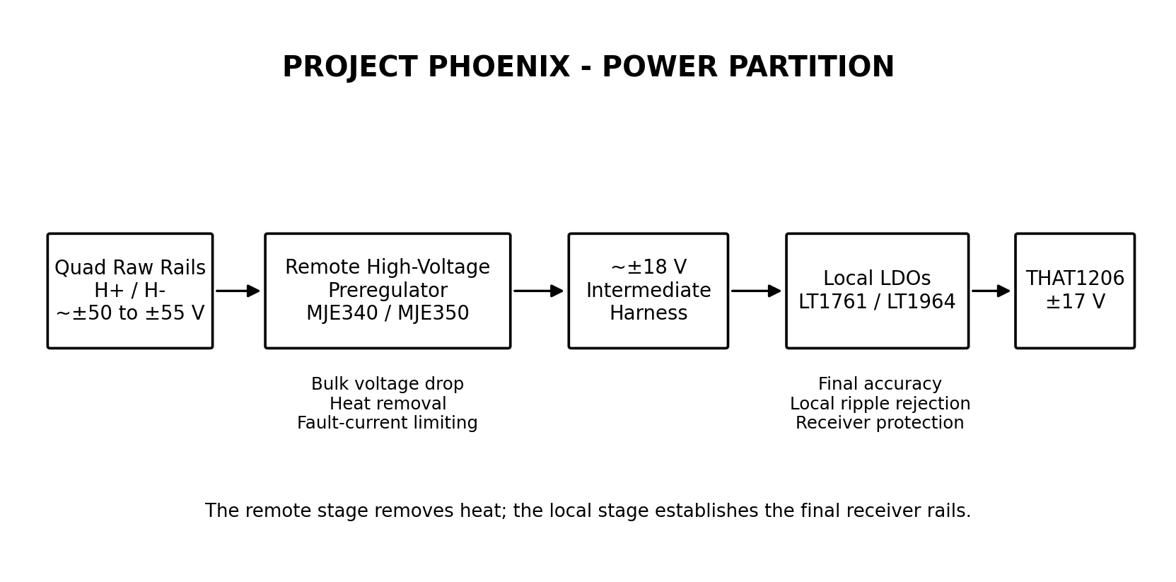
Figure 6-2. Partitioned power architecture.

6.4 Grounding domains
Domain | Intended role
Protective earth | Safety connection; never lifted as an audio remedy.
Chassis / XLR pin 1 / module extrusion | Cable shield and RF-current path.
Quad regulated earth / COLD | Active signal and supply reference; likely reference for Phoenix low-voltage supply and receiver output.
Balanced conductors | Pins 2 and 3; no use of pin 1 as an audio return.

7. Frozen and Provisional Design Decisions
Decision | Selected position | Status | Reopen only if
Receiver architecture | THAT1206S08 | Frozen | Bench evidence exposes a material deficiency.
Receiver gain | −6 dB | Frozen | System gain requirement changes.
Source optimisation | Topping Pre90 baseline; future crossover compatibility retained | Frozen | Source architecture changes.
Output coupling | AC-coupled | Frozen architecture | Complete fault testing demonstrates a clear benefit from DC coupling.
Coupling dielectric | Polypropylene film | Frozen technology | Mechanical fit or availability proves impractical.
Coupling value | 2.2 µF nominal | Provisional | Effective load or transient tests justify 1.0, 3.3 or 4.7 µF.
Final rails | ±17.0 V | Frozen | Receiver selection changes.
Local regulators | LT1761 positive; LT1964 negative | Frozen for prototype | Availability or bench sequencing reveals a material problem.
Remote pass devices | MJE340 / MJE350 class | Provisional | SOA, control or packaging analysis identifies a better solution.
Shield | Modified standard aluminium extrusion/channel | Frozen concept | Installed clearance or stock availability prevents a practical implementation.
Production philosophy | One validated final design; four identical modules | Frozen | Unavoidable prototype evidence requires a PCB correction.

8. Trade-Study Summary

8.1 Balanced receiver
Candidate | Strength | Limitation | Disposition
THAT1206 | −6 dB; InGenius source-imbalance robustness; SOIC-8; existing SparkFun hardware | Approximately 4.7 mA; no galvanic isolation | Selected
INA1651 | Modern low distortion, high input impedance, integrated EMI filtering | Unity gain; higher current; TSSOP-14; no clear system benefit | Rejected for Phoenix; retain for future crossover study
THAT1246 | Lower current; −6 dB; simple SOIC implementation | Conventional input loses CMRR with source impedance imbalance | Rejected
INA137 / INA134 | Established serviceable line receivers | No decisive advantage over selected device | Rejected
AD8273 / AD8271 | Low current and flexible difference-amplifier functions | Weaker guaranteed practical CMRR; less application-specific | Rejected
Transformer | True galvanic isolation and strong real-world CMRR | Cost, size, magnetic sensitivity and LF behaviour | Not fitted; retain as external installation-specific remedy

8.2 Local regulation
Candidate | Assessment | Disposition
LT1761 + LT1964 | Low quiescent current; 20 V inputs; leaded SMD; adequate noise and dropout; published complementary pairing | Selected
LT1762 + LT1964 | Electrically suitable but surplus output capability, larger positive package and no system benefit | Rejected
LT3032 | Elegant dual solution but exposed-pad DFN reduces low-volume serviceability | Rejected
LT3045 + LT3094 | Exceptional noise/PSRR but high standing current and complexity not justified by system budget | Rejected
LM317 / LM337 local stage | Robust but excessive minimum load, heat and package size for the receiver module | Rejected

8.3 Remote high-voltage regulation
Approach | Assessment | Disposition
TL783 | High input capability but high standing current, dropout and no negative complement | Rejected
LR8 | High voltage and low current but insufficient current margin | Rejected
Integrated positive HV LDO + discrete negative | Creates asymmetric startup, protection and loading | Rejected as baseline
MOSFET pass stages | Possible but gate protection and device asymmetry add complexity without a low-current benefit | Rejected
MJE340/MJE350 discrete pair | Repairable, high-voltage margin, low-current suitability and complementary devices | Selected architecture
Zener-only coarse stage | Simple and useful as a comparator, but tolerance margin near 20 V LDO limit is unattractive | Rejected for production
TLA431-controlled discrete stage | Accurate low-current reference; negative rail requires proper level shifting and loop analysis | Preferred detailed-design route

9. Mechanical Baseline

9.1 Receiver module
- Retain full 98 mm board length to preserve mounting compatibility and create clear functional zoning.
- Do not compress the board merely because SMT permits it; clarity, access and serviceability have priority.
- Preferred zoning: input/RF → receiver → local supply → output coupling/interface.
- 22 mm is the existing height, not a hard maximum. Additional height may be used where it materially improves capacitor choice, screening or assembly.

9.2 Screen / enclosure
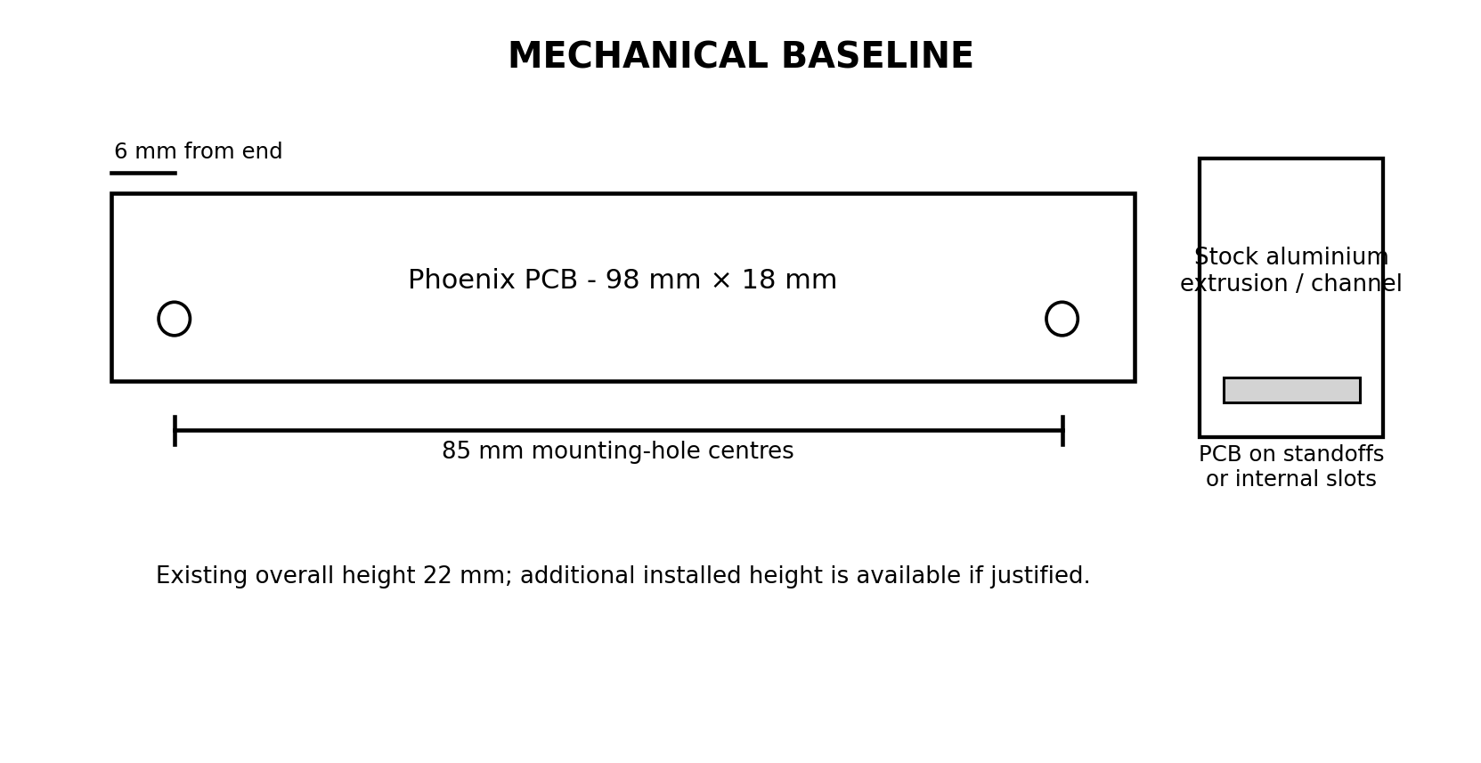
Figure 9-1. Original module geometry and proposed stock-extrusion concept.
- Select a narrow stock aluminium U-channel, PCB enclosure or extrusion with a suitable internal section.
- Modify by cutting, drilling, deburring and simple end clearances only.
- Primary roles: electrostatic/RF screening, mechanical protection and mounting rigidity.
- Bond deliberately to chassis; do not rely on paint, oxide films or incidental fastener contact.

9.3 Remote PSU module
- Target PCB footprint broadly comparable to the HiFiSonix speaker-protection board.
- Mount on one side of a vertical L-bracket; speaker-protection board on the opposite side.
- Bracket attaches to the existing front-to-back PSU/transformer structural member.
- Earlier total-height constraint of approximately 20 mm drove folded heat-dissipating components; installed measurements remain required before mechanical freeze.
- A transformer-facing screen may also act as a heat spreader if this does not create an undesirable magnetic or electrical coupling path.

10. Electrical Interfaces and Grounding

10.1 Provisional connection philosophy
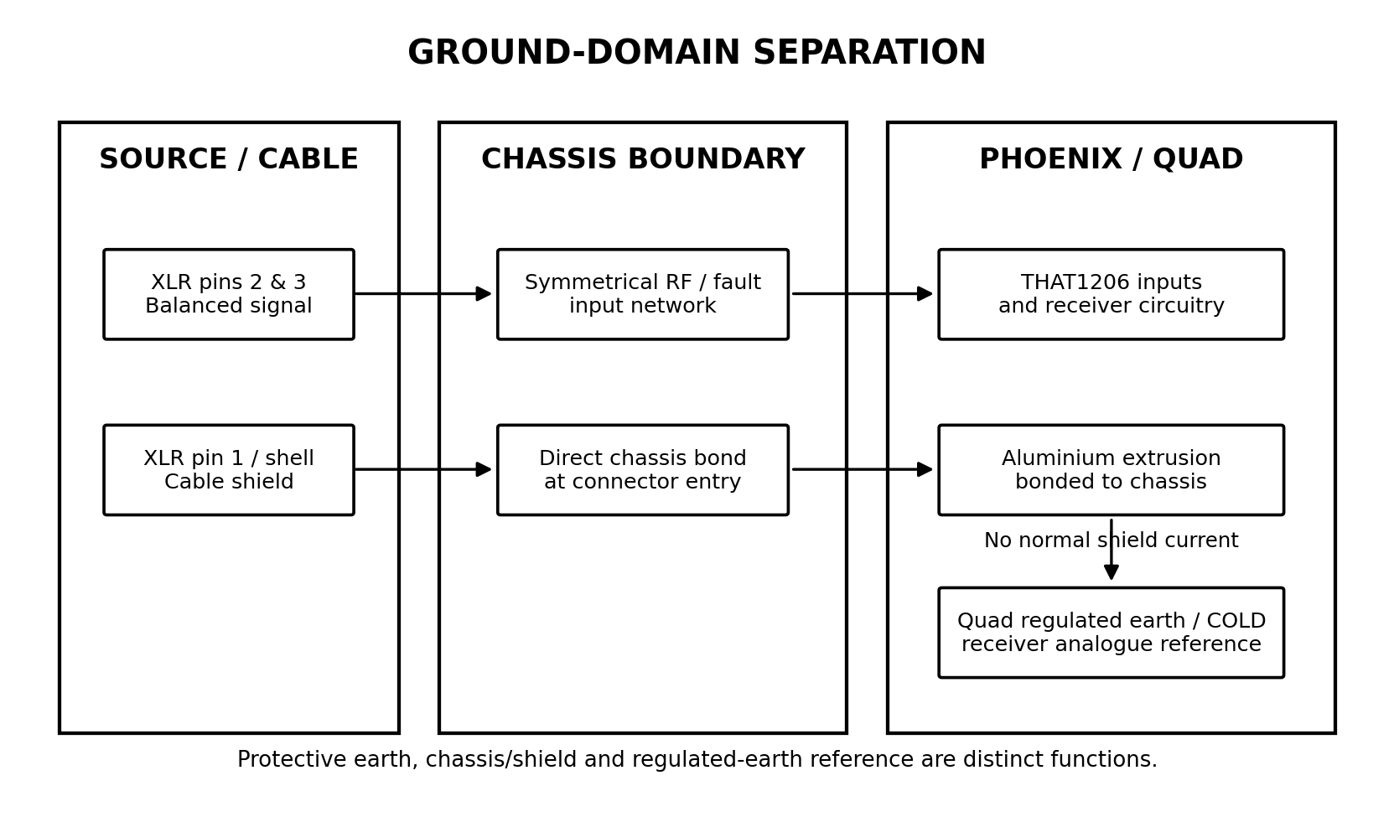
Figure 10-1. Separation of balanced-signal, chassis/shield and regulated-earth domains.
Connection | Provisional implementation
XLR pin 1 | Shortest practical bond to amplifier chassis at the connector boundary.
XLR shell | Chassis.
Phoenix aluminium extrusion | Deliberate low-impedance chassis bond.
XLR pins 2 and 3 | Symmetrical balanced input network.
Receiver analogue 0 V | Referenced to the Quad regulated-earth/COLD node at one defined point.
Common-mode RF capacitors | Return to chassis through a compact low-inductance path.
Differential RF capacitor | Across pins 2 and 3 where required.

10.2 Required continuity mapping
Before this architecture is released, the following power-off measurements shall be made on the user's amplifier:
- Protective earth to chassis continuity.
- Chassis to COLD/regulated-earth resistance or network.
- XLR pin 1 to chassis continuity.
- Original module screen to chassis continuity.
- Presence and configuration of any factory earth-separation provision.
- Continuity and resistance of the Bourns attenuator wiring and receiver-output interface.

10.3 Galvanic isolation decision
The original transformer provided galvanic isolation. Phoenix will provide electronic common-mode rejection but not isolation. For the defined domestic installation, the electronic receiver remains preferred. A quality external isolation transformer remains the contingency for an installation-specific ground-loop problem.

11. Power Architecture

11.1 Final rails
Parameter | Target
Receiver rails | +17.0 V / −17.0 V nominal
Intermediate rails | Approximately +18.0 V / −18.0 V nominal
Minimum intermediate magnitude | Approximately 17.5 V
Maximum steady-state magnitude | Approximately 18.6 V
Maximum design transient | Below approximately 19.2 V
Hard design requirement | Remain below 20 V local-regulator absolute input limit with margin
Expected normal load | Approximately 5–7 mA per rail, to be measured
Continuous design allowance | 10 mA per rail
Provisional current-limit onset | 15–18 mA per rail

11.2 Remote stage requirements
- Withstand the maximum unloaded Quad-equivalent rail voltage.
- Absorb the bulk voltage drop and dissipate heat remotely.
- Limit fault energy drawn from the host amplifier rails.
- Provide sufficiently matched positive and negative behaviour without forcing artificial component symmetry.
- Prevent startup overshoot above the local LDO input rating.
- Discharge predictably at shutdown.
- Remain stable with the intermediate harness and local LDO input capacitance.
- Use active-production, serviceable components where practical.

11.3 Local stage requirements
- Establish accurate ±17 V receiver rails.
- Reject preregulator ripple and harness pickup.
- Use the manufacturer's recommended output and reference-bypass capacitors.
- Tolerate unequal rail sequencing and outputs being pulled across ground where specified.
- Provide accessible rail test points.

12. Signal Architecture

12.1 Gain and headroom
The Topping Pre90 has ample output level for the sensitive 521F. A −6 dB receiver is therefore useful rather than wasteful: it increases interface headroom and reduces the attenuation burden at the Quad input controls.

12.2 Input network
- Matched series resistors in both signal legs.
- Symmetrical differential and common-mode RF filtering.
- Fault-current limiting for powered-source/unpowered-receiver and credible ESD/overvoltage events.
- Clamp-current paths designed so that RF and fault currents do not contaminate the analogue reference.
- No user-selectable bypass of the input protection.

12.3 Output network
- Small output isolation resistor selected from stability testing.
- 2.2 µF polypropylene coupling capacitor as the current baseline.
- Defined discharge/reference path so the downstream node cannot float.
- Existing equivalent-value Bourns attenuator retained; no additional gain switch or calibration network.
- Direct coupling is not pursued unless the complete fault matrix demonstrates a material benefit.

13. Current-Dumping Bridge Work
The first 521F has already had R29/R30 adjusted using values calculated from the Quad bridge equations. A repeatable calculation and measurement guide is required for the user's second unmodified 521F.

13.1 Planned guide
- Re-derive the relevant Quad bridge equations from the exact 521F topology.
- Identify the resistor ratios and non-ideal parameters that dominate bridge error.
- Calculate sensitivity to resistor tolerance, temperature coefficient, emitter resistance, transistor spread and load.
- Use a temporary precision adjustment only during optimisation.
- Measure at multiple frequencies, powers and defined thermal conditions.
- Replace temporary adjustment with stable precision fixed values where practical.
- Recheck stability, clipping recovery, current limiting and thermal behaviour after optimisation.
- Record the final values and measurements for both amplifiers.

13.2 Test points
Nominal output power into 4 Ω | Output voltage
1 W | 2.00 V RMS
10 W | 6.32 V RMS
50 W | 14.14 V RMS
100 W | 20.00 V RMS
150 W | 24.49 V RMS
200 W | 28.28 V RMS

Bridge optimisation shall not be based solely on the minimum 1 kHz THD result. The procedure must include high-frequency behaviour and stability.

14. Validation and Test Infrastructure

14.1 Available instrumentation
- Siglent 100 MHz four-channel digital oscilloscope.
- Tektronix 500 MHz oscilloscope.
- RS Pro signal generator with RF capability.
- HP distortion analyser.
- Lavolta BPS305 single-rail bench supply and other low-voltage supplies.
- Existing audio system including Topping Pre90.

14.2 Development fixtures
Asset | Status | Purpose
Single-rail high-voltage bench source | Available | Controlled rail-by-rail preregulator development and fault testing.
Bipolar Quad-equivalent PSU | Under construction | Both high-voltage rails rectified and smoothed but unregulated; additional ±15 V outputs.
Balanced-interface unit | Under construction | Shellac transformer/PSU module, SparkFun THAT1206 receiver and paired DRV134 drivers.
SparkFun THAT1206 boards | Available | Receiver current, noise, CMRR, headroom and transient characterisation.
Two 4 Ω dummy loads | Complete | Each rated 200 W continuous in ambient air with integral heatsink; optional forced air.
Vero fuse/current-limiting fixture | Planned / partial | Safe commissioning of high-current raw supplies and prototype boards.

14.3 Dummy-load operating envelope
Each load supports 28.28 V RMS and 7.07 A RMS at its 200 W continuous rating. Above 200 W, tests shall be short-duration only unless the manufacturer's overload data explicitly permits otherwise. Forced air may be used for repeatability, reduced cooldown and thermal margin.

14.4 Validation sequence
- Characterise the original amplifier before Phoenix installation.
- Characterise the SparkFun THAT1206 and balanced-interface fixture independently.
- Develop each preregulator rail first from a current-limited single-rail supply.
- Test the complete bipolar preregulator from the representative unregulated supply.
- Validate startup, shutdown, one-rail loss, short circuit and overload.
- Integrate Phoenix into one amplifier channel under controlled conditions.
- Repeat the original baseline tests with Phoenix fitted.
- Test both channels simultaneously into the 4 Ω loads.
- Complete bridge optimisation only after the amplifier and measurement setup are stable.

15. Preliminary FMECA
Item / function | Failure mode | Effect | Criticality | Current mitigation / action
THAT1206 | Output offset or rail-related saturation | DC or transient presented to amplifier input | Medium-High | AC coupling; one-rail testing; speaker protection.
Coupling capacitor | Short | Receiver DC/fault can propagate | High | Select reliable film part; inspect; acceptance DC test.
Coupling capacitor | Open | Loss of channel | Low-Medium | Functional test; serviceable component.
Local LDO | High output | Receiver damage | High | Intermediate rail below 20 V; preregulator limiting; rail acceptance tests.
Remote pass transistor | Collector-emitter short | Raw rail can approach local regulator | High | Fault analysis; upstream resistance/fusing; consider secondary clamp if justified.
Remote pass transistor | Open | Loss of one rail | Medium-High | AC coupling; one-rail validation; speaker protection.
Reference/control loop | Loss of feedback / overshoot | Local LDO overstress | High | Worst-case analysis, startup simulation and bench transient capture.
XLR pin 1 bond | Open or high resistance | Reduced RF immunity / hum susceptibility | Medium | Deliberate bond and continuity acceptance test.
Analogue 0 V misconnection | Shield current enters signal reference | Hum, degraded CMRR or regulated-earth disturbance | High | Ground-domain mapping and reviewed harness.
Extrusion | Poor chassis bond | Reduced screening | Medium | Bonding hardware, oxide removal and continuity test.
Current limiter | Limit too high | Excess host-rail fault energy | High | Set from measured startup current; short-circuit thermal test.
Current limiter | Limit too low | Startup failure or dropout | Medium | Measure actual receiver and capacitor charging current.

A full component-level FMECA will follow schematic capture. The present architecture FMECA is sufficient to direct the remaining design work.

16. Technical Risk and Assumptions Registers

16.1 Open technical risks
ID | Risk | Impact | Current reduction action
R-001 | Remote preregulator negative-rail controller or loop proves unnecessarily complex | Architecture delay or asymmetry | Derive two complete topologies and compare against simpler coarse preregulation.
R-002 | Preregulator overshoot exceeds local LDO margin | Component damage | Startup/shutdown modelling and capture; lower nominal intermediate voltage.
R-003 | Auxiliary rail loading disturbs Quad regulated earth | Offset, hum or protection interaction | Continuity mapping; current symmetry budget; in-amplifier measurement.
R-004 | Electronic receiver loses an installation benefit provided by transformer isolation | Ground-loop sensitivity | Correct AES-style chassis bonding; external isolator contingency.
R-005 | RF input network degrades CMRR | Hum/RF rectification or loss of immunity | Symmetry analysis and CMRR measurement.
R-006 | Small-package local LDO assembly/rework is impractical | Build risk | Generous footprints; trial assembly; authorised-supplier spare parts.
R-007 | Stock extrusion cannot satisfy internal width/height and mounting | Mechanical redesign | Select and trial-fit stock section before PCB release.
R-008 | Scope earth connection disturbs regulated-earth node during power testing | Equipment damage or invalid test | Define differential/isolated measurement method before connection.

16.2 Assumptions requiring validation
ID | Assumption | Validation
A-001 | The Pre90 source impedance and cable arrangement provide a benign common-mode environment. | CMRR and installed hum/noise testing.
A-002 | The original attenuator value is preserved by the Bourns replacements. | Part-number or resistance measurement.
A-003 | 2.2 µF coupling is sufficient across all attenuator positions and following input impedance. | Calculation and LF sweep/phase measurement.
A-004 | Normal receiver current is approximately 5–7 mA per rail. | Measure SparkFun board and final prototype.
A-005 | The regulated-earth circuit tolerates the small balanced auxiliary load. | Measure midpoint behaviour at idle, startup and loaded operation.
A-006 | The original module height can be exceeded without interference. | Installed clearance measurement.
A-007 | The high-voltage test supply reproduces the useful raw-rail voltage and ripple range. | Record transformer, reservoir and measured no-load/full-load rails.

17. Verification Matrix
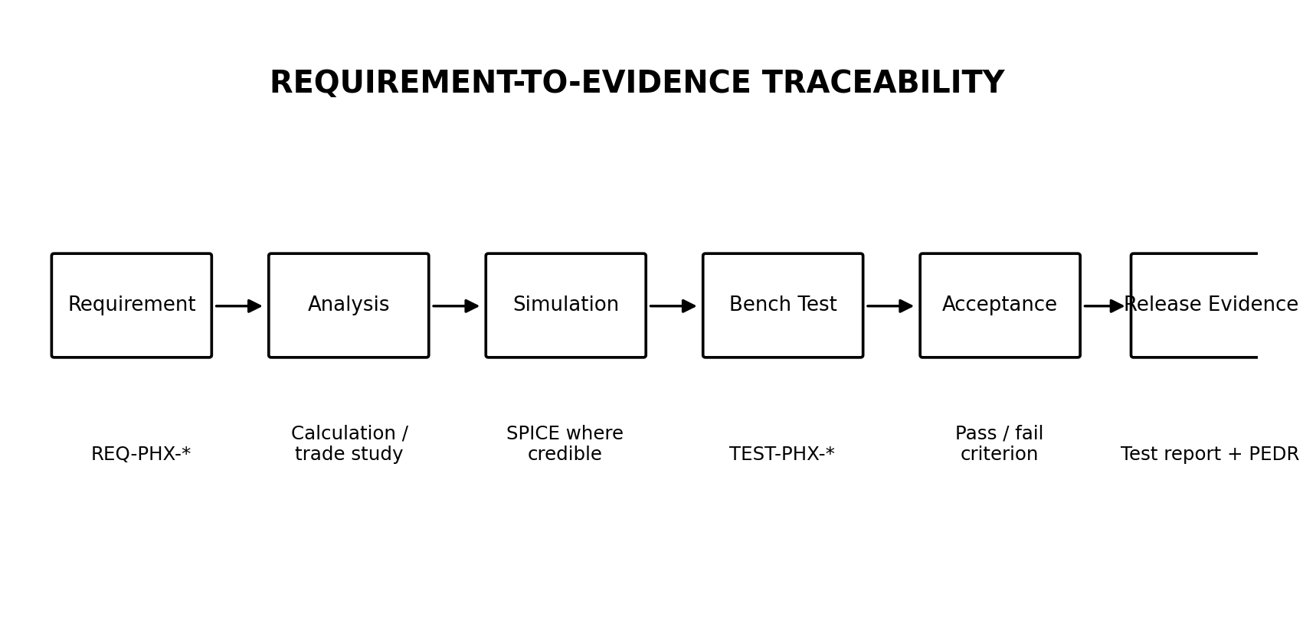
Figure 17-1. Requirement-to-evidence verification flow.
Requirement area | Method | Key evidence / acceptance direction
Mechanical fit | Inspection and trial installation | Mounting centres, hole offset, extrusion clearance, harness access.
Final rail voltage | Measure | ±17 V within final tolerance at minimum/maximum raw rails.
Intermediate rail safety | Measure + transient capture | Within steady-state envelope; no excursion near 20 V absolute limit.
Rail current | Measure | Within host loading and thermal budget; positive/negative balance recorded.
Noise | Measure with receiver terminated and installed | Negligible relative to 521F baseline; no new hum components.
Frequency response | Sweep | No material audio-band error; LF coupling response documented.
THD+N | HP analyser at multiple levels | No degradation versus original; receiver contribution below amplifier.
CMRR | Common-mode injection with defined mismatch | Meets frozen threshold to be set from fixture capability and literature.
Headroom | Increasing differential input | Clean overload; no latch-up or damaging output transient.
Startup/shutdown | Oscilloscope capture in multiple source/power orders | No sustained hazardous DC; speaker-protection behaviour acceptable.
One-rail loss | Controlled fault injection | No damage; transient contained by coupling and protection.
Short circuit | Current-limited bench test | Defined current limit and acceptable pass-device temperature.
Thermal | Temperature logging at idle and stress | Adequate junction/case margin and stable rail behaviour.
Amplifier output | 4 Ω loads, single and dual channel | Gain, clipping, rail sag, thermal and current limiting not adversely changed.
Bridge balance | Calculated and measured residual | Repeatable improvement across defined frequency/power/temperature set.

18. Engineering Evidence and Literature

18.1 Evidence hierarchy
Priority | Source type | Treatment
1 | Quad schematics, manuals, patents, service data and original Walker/Albinson papers | Primary design evidence.
2 | Semiconductor manufacturer datasheets and application notes | Primary component evidence; typical and guaranteed values distinguished.
3 | Peer-reviewed/AES/BBC and rigorous independent analysis | Strong technical evidence.
4 | Keith Snook | Expert independent analysis; check against primary sources and measurement.
5 | QuadSpot / DaDa Electronics | Applied restoration and modification guidance; classify claims by evidence and applicability.
6 | Forums and subjective commentary | Use only to identify testable failure modes or hypotheses.

18.2 High-value review conclusions
- CMRR must be assessed with realistic source-impedance imbalance, not only an ideal generator.
- Pin 1 is a chassis/shield connection; shield current shall not share the receiver analogue reference.
- Common-mode rejection is not galvanic isolation.
- The 521F regulated-earth/COLD node is an active functional reference, not a synonym for chassis.
- A DC servo is not justified where a simple reliable coupling capacitor provides required LF response and fault containment.
- High-K ceramics are inappropriate for the Phoenix series coupling position.
- Local ultralow-noise regulation must be selected against the system noise budget; headline regulator figures alone do not justify extra current or complexity.
- Bridge balancing must be derived from the exact current-dumping topology and validated over frequency, output level and temperature.

18.3 Key source locations already identified
- DaDa Electronics documentation mirror: https://dadaelectronics.com.au/doc/Audio/dadaelectronics.eu/downloads/
- QuadSpot: Revision of a Quad 520F and related 520F/606 material.
- Keith Snook archive and Wireless World current-dumping material.
- THAT Corporation 1200-series datasheet and application notes.
- Texas Instruments INA1651 and TLA431 documentation.
- Analog Devices LT1761 and LT1964 documentation.
- SparkFun THAT1206 breakout schematic, BOM, layout and repository.
- HiFiSonix speaker-protection board design pack.

19. Shep's Analogue Design Handbook Outputs
The handbook shall capture engineering that has already earned its place through an active project. It shall not become an encyclopaedia or a vanity exercise.
Planned note / section | Immediate value | Status
Balanced receiver selection | Reusable comparison method and Phoenix rationale | Working material exists
Grounding and pin-1 practice | Directly informs Shellac, Phoenix and crossover | Working material exists
Two-stage low-current high-voltage regulation | Directly supports Phoenix and future legacy interfaces | In progress
Current-dumping bridge balancing | Required for second 521F and future Quad work | High-priority planned
Capacitor technology by application | Supports Phoenix coupling, Shellac EQ and future crossover | Bounded review planned
Measurement procedures | Makes validation repeatable across projects | To be generated from actual bench work

Handbook governing rule
Nothing is promoted into the reusable handbook merely because it is interesting. It must improve a real design, reduce risk, or save meaningful effort in a future project.

20. GitHub Migration Baseline
The repository will be created only after this document is reviewed and corrected. Detailed, beginner-safe Git instructions will then be provided one command at a time.

20.1 Initial repository objective
The first repository state should be understandable without access to this conversation and should contain only approved or clearly marked draft artefacts.

20.2 Proposed initial structure
README.md
docs/pdr/Phoenix_Phase_1_PDR_Rev_A.docx
docs/requirements/
docs/decisions/
docs/fmeca/
docs/verification/
docs/references/
electronics/kicad/
electronics/spice/
electronics/calculations/
mechanical/
test/procedures/
test/results/
tools/

20.3 Configuration approach
- Use main as the released baseline.
- Use short-lived feature branches only when real design work begins.
- Commit messages shall state the engineering change and its rationale.
- No file is called 'final'; use controlled revisions and release tags.
- The repository will be taught incrementally; no assumption of prior Git confidence.

21. Phase 2 Work Package

21.1 Immediate sequence
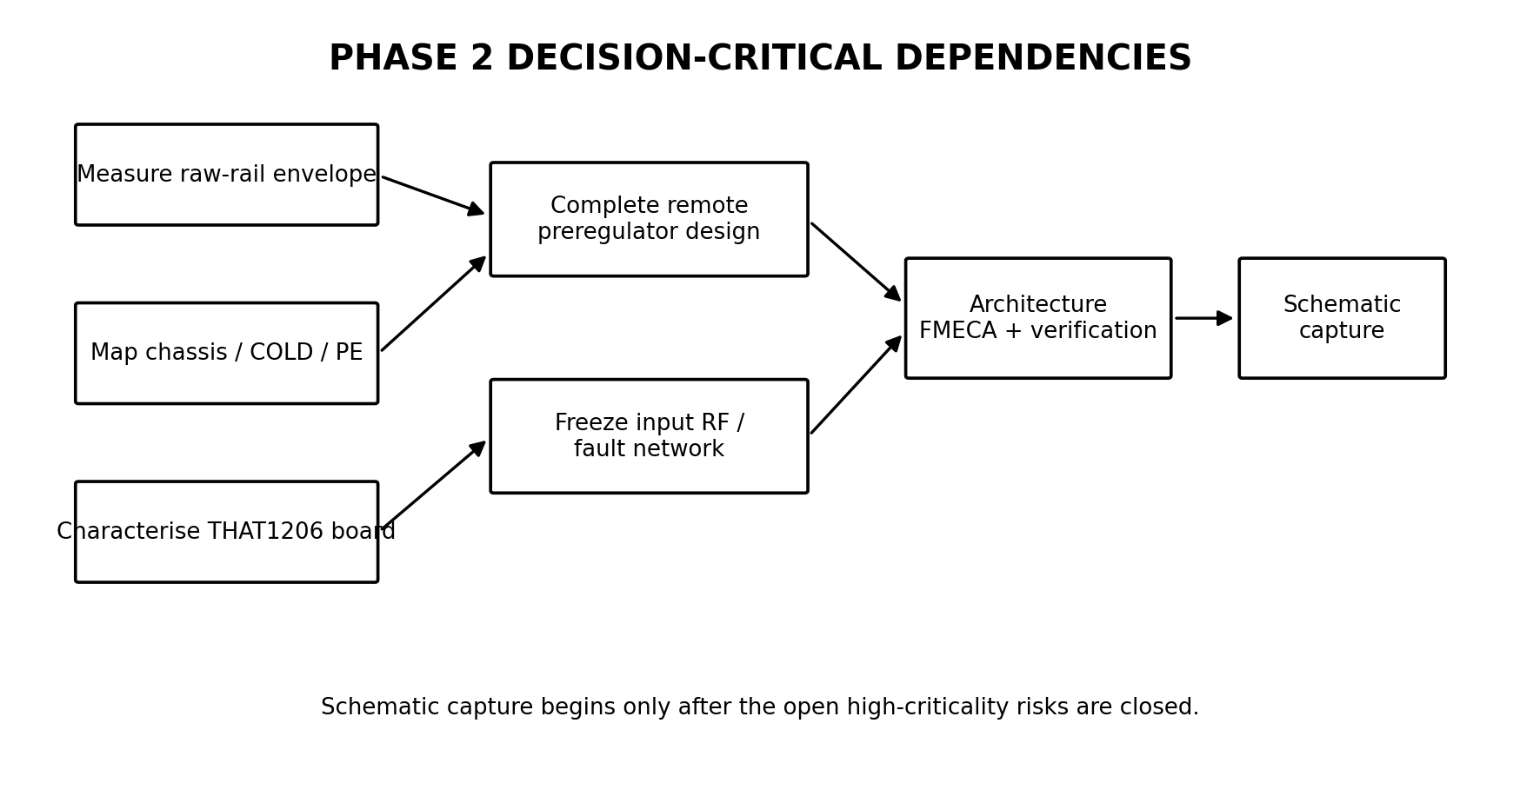
Figure 21-1. Phase 2 decision-critical dependencies.
ID | Task | Purpose
WP2-01 | Complete the positive and negative remote preregulator schematics with every component shown. | Decision-critical
WP2-02 | Perform tolerance, SOA, current-limit and thermal calculations across measured raw-rail range. | Decision-critical
WP2-03 | Model startup, shutdown, one-rail loss and short circuit where models are credible. | Decision-critical
WP2-04 | Measure the actual current and transient behaviour of the SparkFun THAT1206 board. | Decision-critical
WP2-05 | Record the user's high-voltage transformer, reservoir, series resistance/fusing and measured rail envelope. | Decision-critical
WP2-06 | Map the 521F chassis, protective-earth, pin-1 and regulated-earth relationships. | Decision-critical
WP2-07 | Select and trial-fit a stock aluminium extrusion/channel. | Decision-critical
WP2-08 | Freeze the RF/fault input network using calculation and bench CMRR testing. | Decision-critical
WP2-09 | Complete the architecture FMECA and verification thresholds. | Gate closure
WP2-10 | Proceed to schematic capture only after the above items are accepted. | Gate closure

21.2 Stopping rule
An investigation closes when it has answered the defined engineering question, reduced the material risk and enabled a defensible design decision. No further optimisation is undertaken without a changed requirement or new contradictory evidence.

22. User Actions and Required Measurements
Action | Needed for | Priority
Provide Bourns part number or measure total resistance | Confirm coupling-load calculation and documentation | Medium
Measure maximum available module height in situ | Extrusion and capacitor selection | Medium
Record high-voltage PSU transformer secondary voltages | Raw-rail envelope | High
Record reservoir capacitance and rectifier arrangement | Ripple and startup modelling | High
Record any series resistance, fuse and current-limiting arrangement | Fault and source-impedance modelling | High
Measure unloaded and representative loaded high-voltage rails | Preregulator tolerance and dissipation | High
Continuity-map PE, chassis, pin 1, module shield and COLD | Grounding architecture | High
Provide dummy-load resistor part numbers/datasheets if available | Thermal test limits and TCR | Low-Medium
Photograph PSU and speaker-protection bracket clearances when convenient | Remote PSU mechanical layout | Medium

23. Items Not to Revisit Without New Evidence
- General search for additional balanced receiver ICs.
- Unity-gain receiver as the Phoenix baseline.
- Local LM317/LM337 regulation.
- Ultralow-noise LT3045/LT3094-class regulation without a demonstrated system need.
- MOSFET remote pass devices.
- Custom aluminium extrusion.
- DC servo in place of the output coupling capacitor.
- Digital control, diagnostics or microcontroller functions.
- Multiple planned hardware revisions.
- Removal or redesign of the Quad current-dumping amplifier.
- An exhaustive general history of Quad or passive components unrelated to a current design decision.

24. Review Decisions Requested
The following points should be confirmed, corrected or rejected before Revision A is released:
Review item | Proposed disposition
Project scope and success criteria | Accept / amend
THAT1206 and −6 dB receiver baseline | Accept / reopen with evidence
LT1761 / LT1964 local regulation | Accept / amend
AC-coupled 2.2 µF polypropylene output | Accept architecture; confirm provisional value
Discrete MJE340/MJE350 remote preregulator direction | Accept for detailed design / amend
Ground-domain interpretation | Accept as provisional pending measurements
Mechanical envelope and stock-extrusion approach | Accept / amend
Phase 2 task sequence | Accept / reprioritise
GitHub repository structure | Accept in principle; implement after document approval
Handbook scope discipline | Accept / amend

Appendix A - Engineering Decision Register
ID | Decision | Status | Rationale
PEDR-001 | Replace entire optional active floating input-module block | Accepted | Avoid piecemeal modification of transformer/TL071/zener arrangement.
PEDR-002 | Use electronic balanced receiver rather than internal transformer | Accepted | Defined domestic installation; external isolation remains contingency.
PEDR-003 | Select THAT1206S08 | Accepted | −6 dB gain and source-imbalance robustness best fit the system.
PEDR-004 | Retain existing Bourns attenuator calibration | Accepted | Drop-in equivalent and already provides precise gain setting.
PEDR-005 | Retain AC coupling | Accepted | Fault containment and negligible LF penalty.
PEDR-006 | Use polypropylene coupling capacitor | Accepted | Linear, reliable and mechanically feasible with available height.
PEDR-007 | Target 2.2 µF coupling value | Provisional | Final effective load and transient test pending.
PEDR-008 | Use ±17 V final receiver rails | Accepted | Within THAT1206 recommendation and appropriate headroom.
PEDR-009 | Use LT1761/LT1964 local LDOs | Accepted for prototype | Low current, adequate performance and serviceable leaded packages.
PEDR-010 | Use separate remote and local regulation | Accepted | Partitions heat removal from final local rail conditioning.
PEDR-011 | Use MJE340/MJE350-class remote pass devices | Provisional | Low-current HV suitability and repairability.
PEDR-012 | Use TLA431-class reference/control | Provisional | Low current and stable reference; full bipolar implementation pending.
PEDR-013 | Keep high-voltage regulation out of receiver enclosure | Accepted | Thermal, noise and reliability benefit.
PEDR-014 | Use modified stock aluminium extrusion | Accepted concept | Appropriate for four-unit home build.
PEDR-015 | Treat pin 1 and extrusion as chassis functions | Accepted principle | Prevents shield current entering signal reference.
PEDR-016 | Reference receiver circuitry to Quad regulated earth at one defined point | Provisional | Host continuity mapping required.
PEDR-017 | Aim for one final PCB design | Accepted | Prototype fixtures validate architecture before PCB order.
PEDR-018 | Use FMECA rather than FMEA | Accepted | Criticality assessment is useful for host-equipment modification.
PEDR-019 | Create Shep's Analogue Design Handbook from validated project work | Accepted | Reusable knowledge capture; no speculative encyclopaedia.
PEDR-020 | Review and approve document before GitHub check-in | Accepted | Prevents an unreviewed draft becoming the baseline.

Appendix B - Candidate Acceptance Tests
ID | Test | Scope
AT-001 | Visual and mechanical inspection | PCB, extrusion, connectors, clearances and labels.
AT-002 | Continuity and insulation | Chassis bonds, isolated references, no unintended shorts.
AT-003 | No-load rail test | Intermediate and local rails across raw input range.
AT-004 | Load regulation | Rail voltages from minimum to design load.
AT-005 | Current limit | Onset, foldback/behaviour and pass-device temperature.
AT-006 | Startup/shutdown | Both source and amplifier power sequences.
AT-007 | Single-rail fault | Positive missing and negative missing.
AT-008 | Powered-off input | Live source into unpowered Phoenix.
AT-009 | Frequency response | Sub-audio to beyond audio band as appropriate.
AT-010 | Noise spectrum | Receiver fixture and installed amplifier.
AT-011 | THD+N | Multiple levels and frequencies.
AT-012 | CMRR | 50/60 Hz, 1 kHz and high audio frequency; defined source mismatch.
AT-013 | Overload and recovery | Maximum credible source output and clipping recovery.
AT-014 | Thermal soak | Receiver, remote pass devices and host amplifier.
AT-015 | 4 Ω amplifier load | Single and dual channel at defined powers.
AT-016 | Bridge optimisation | Multiple frequencies, powers and thermal states.
AT-017 | Regression test | Original versus Phoenix results using identical setup.

Appendix C - Source and Artefact Register
Artefact / source | Origin | Use
Quad 521F annotated schematic | User-provided | As-built electrical baseline.
Quad 520F PCB 12828-8 drawing | User-provided | Layout and node interpretation.
QuadSpot - Revision of a Quad 520F | User-provided / online | Lineage and modification guidance.
QuadSpot - Upgrading and Monoblocking a pair of 520F amplifiers | User-provided / online | Applied experience; evidence graded.
Quad 606, 707, 909 and related documentation | User-provided collection | Engineering lineage review.
Keith Snook archive | Online | Independent current-dumping analysis and literature access.
DaDa documentation mirror | Online | Source for Quad and DaDa manuals.
THAT1206 SparkFun design pack | User-provided / online | Prototype receiver schematic, BOM and layout.
HiFiSonix speaker-protection board | Online | Mechanical integration and protection context.
Existing module photographs and dimensions | User-provided | Mechanical baseline.
Two 4 Ω / 200 W dummy loads | User-built | Amplifier stress and bridge testing.
Bipolar Quad-equivalent PSU | User-built, in progress | Representative raw-rail testing.
Balanced receiver/driver unit | User-built, in progress | Interface characterisation.

End of Revision B Draft. Review comments should focus first on factual accuracy, diagrams, omissions, decision status and Phase 2 priorities. Editorial refinement follows technical approval.

Appendix D - Figure and Diagram Register
Figure | Title | Primary use
Figure 6-1 | Phoenix signal architecture | Signal partition and preserved host-amplifier boundary.
Figure 6-2 | Partitioned power architecture | Bulk voltage reduction, local regulation and fault partition.
Figure 9-1 | Mechanical baseline | Original dimensions, mounting centres and stock extrusion concept.
Figure 10-1 | Ground-domain separation | Cable shield/chassis current versus regulated-earth reference.
Figure 17-1 | Verification flow | Traceability from requirement to release evidence.
Figure 21-1 | Phase 2 dependencies | Bounded work required before schematic capture.

Appendix E - Detailed Trade-Study Criteria
Criterion | Assessment content
Electrical fit | Gain, headroom, common-mode range, output swing, noise, distortion and PSRR.
Installed robustness | Source imbalance, RF immunity, powered/unpowered behaviour and fault tolerance.
Power and thermal | Rail current, upstream dissipation and thermal margin.
Mechanical | Footprint, height, package, access, shielding and assembly.
Serviceability | Lifecycle, rework, alternatives, diagnosis and documentation.
System value | Measurable benefit relative to the complete Quad system.
Complexity burden | Parts, analysis burden, fault modes and validation effort.
Cost | Four final modules plus sensible spares from authorised distributors.

Appendix F - Bench Measurement Record Sheets
These blank records are intended to be completed during Phase 2 and retained in the repository.

F.1 High-voltage development supply
Parameter | Measured value / observation
Transformer secondary voltage, unloaded
Rectified rail, unloaded
Rectified rail, representative load
Reservoir capacitance
Rectifier type
Series resistance / fuse
Measured ripple at load

F.2 Ground continuity map
Parameter | Measured value / observation
PE to chassis
Pin 1 to chassis
Module shield to chassis
Chassis to COLD
COLD to signal reference
Factory earth-separation state

F.3 SparkFun THAT1206 characterisation
Parameter | Measured value / observation
Positive-rail current
Negative-rail current
Output DC offset
Noise
Gain
Maximum clean input
Startup transient
Shutdown transient

F.4 Dummy-load record
Parameter | Measured value / observation
Cold resistance
Ambient temperature
100 W steady temperature
200 W steady temperature
Forced-air condition
Hot resistance / inferred TCR

Appendix G - Detailed PDR Review Checklist
- Factual statements match the as-built 521F and available photographs.
- Frozen decisions are genuinely ready to remain closed during detailed design.
- Every open high-criticality risk has a bounded Phase 2 action.
- The grounding diagram is updated after the continuity measurements.
- The remote PSU remains inside the measured raw-rail and local-LDO limits.
- The mechanical diagram is updated after extrusion selection and trial fit.
- Every requirement has a measurable or inspectable verification method.
- The FMECA captures faults capable of damaging the amplifier or loudspeaker.
- The appendices preserve the calculations and records needed to reproduce decisions.
- The document remains an engineering baseline rather than an exhaustive history.

Appendix H - Planned Detailed-Design Appendices
These appendices are intentionally deferred until the relevant evidence exists.
ID | Appendix | Release condition
H.1 | Complete positive and negative preregulator schematics | After topology and loop review.
H.2 | Worst-case tolerance and SOA calculation pack | After measured raw-rail envelope.
H.3 | SPICE plots and model limitations | After credible device models are selected.
H.4 | RF/fault input-network derivation | After receiver fixture and CMRR testing.
H.5 | Mechanical drawing and stock extrusion part | After trial fit.
H.6 | Current-dumping bridge derivation and calculator output | Before second-amplifier optimisation.
H.7 | Released BOM with approved alternatives | At detailed-design freeze.
H.8 | Test procedures and completed acceptance records | At TRR and validation.
H.9 | Photographic assembly and service guide | During prototype build.

