Case Study

2024

Partnership Analyst

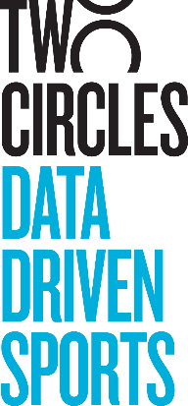

## Brief

Two Circles has been engaged by a leading property within one of the North American sports leagues to create a comprehensive database for ingesting, standardizing, and modeling disparate datasets. This platform will enable the client to better service their brand partners and demonstrate the value of these partnerships.

**Created by:**

Two Circler 1

Two Circler 2

**<Month Year>**

Your task is to model the provided datasets and produce a clean, integrated output that facilitates seamless reporting.

## Datasets Provided

Following datasets have been provided:

**Created by:**

Two Circler 1

Two Circler 2

**<Month Year>**

1. Social Media data
2. Broadcast data

## Deliverables

The deliverables for this engagement will be broken into two parts:

**Created by:**

Robert Earnhardt

**Dec-2024**

### Part 1: Data Modeling

1. Data Ingestion
   1. You will be required to load the data into your chosen SQL editor tool in order to model the data into a view. If needed, steps on how to load data into a SQL editor tool can be provided. Please reach out if you need assistance.
   2. Please address the following questions:
      1. How did you approach the data-loading process?
      2. What key observations did you make about the datasets?
      3. Did you manipulate the data before loading it? If so, how?
2. Data Cleaning & Standardization
   1. After reviewing and loading the data, you notice that there is an opportunity to clean and standardize the data.
      1. Please create custom tables or views and walk us through how you cleaned and standardized the data.
3. Modeled Output for Reporting
   1. You will need to develop an integrated modeled output that consolidates all data sets.
   2. This output should be designed for easy analysis and support a variety of client reporting needs.
   3. Explain your logic in building this output.

### Part 2: Data Analysis

The client is working towards year-end reporting and wants to evaluate their partnerships and value at the individual and collective partner level. Using your modeled view, please create visualizations and insights that the client can use for internal reporting and partner presentations.

This deliverable should be a Tableau Workbook or PowerPoint with no more than 4 slides/dashboards. Tableau screenshots can also be included in PowerPoint as slides.

## Submission Details

Any questions can be directed to Robert Earnhardt ([Robert.earnhardt@twocircles.com](mailto:Robert.earnhardt@twocircles.com)). The submit the completed case study by **Friday, January 17th, 2024**