**長庚大學資訊工程系 計算機組織隨堂練習 2015/09/18**

考試時間：1:10 PM– 2:00PM

考試規則：可翻閱參考資料。

1. Draw a timing waveform for a given circuit. The circuit is shown in Figure 1. Please complete the waveform in Figure 2. **(60 pts)**

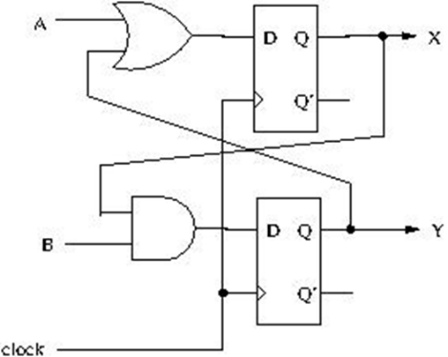

Figure 1

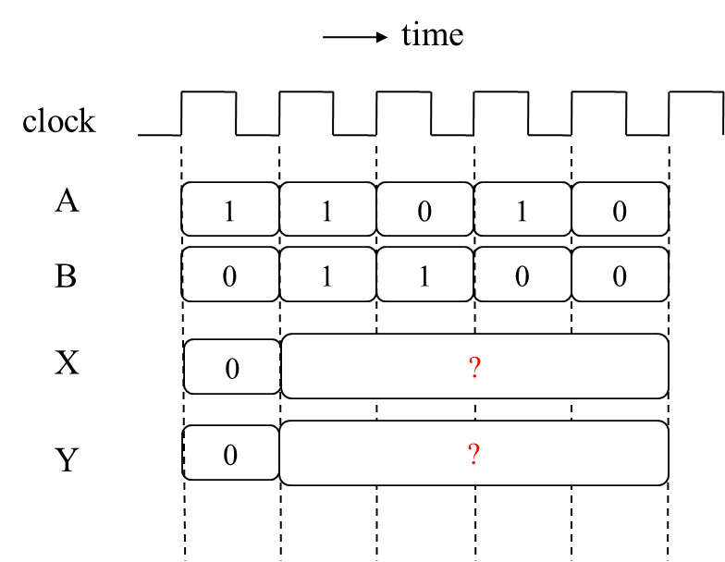

Figure 2

1. How to check whether your answer for Problem 1 is correct or not (if the teacher does not announce his own answer)? **(40 pts)**