長庚大學 資訊工程系 計算機組織 期中考試題 2010/11/15

說明：
- 可翻閱參考書藉
- 考試時間：3:10PM – 5:00PM

General rules for your answers:
- Except for problems requiring gate-level design, you can use any circuits (registers, counters, adders, etc.) mentioned in the textbook as a building block for your design. You don’t need to re-draw the gate-level circuit for these building blocks.
- For a problem requiring gate-level design, you may express the combinational part of your design with Boolean equations only. Drawing a gate-level circuit diagram is not a must.
(3) The realization of your design should be clearly understood from your description. If your design contains a hardware block not mentioned in the textbook, you have to describe a gate-level design for this block. (Again, you may just write-down the Boolean equations only.)

1. Consider the circuit shown in Figure 1. Suppose that the two D flip-flops are initialized to be zero. Complete the timing waveform shown in Figure 2. (15%)
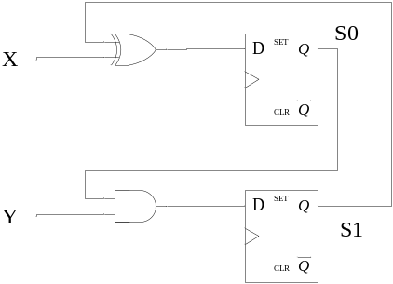
Figure 1.
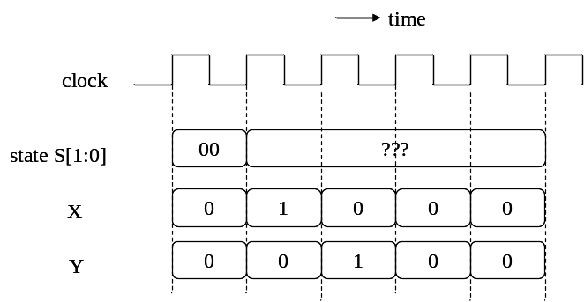
Figure 2.

2. Design the hardware circuit to realize the state-transition diagram shown in Figure 3. The circuit has four states and the transition is determined by input signal X. Note that, at state 10, the circuit transits to state 00 at the next cycle without observing the value of X. Please present the gate-level design to realize the circuit. (You can just specify a block of combinational circuit in Boolean equations without drawing detailed circuit diagram.) (15%)
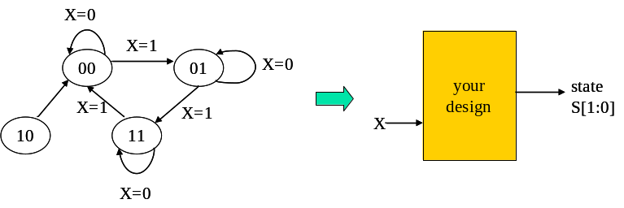
Figure 3.

3. Design the 4-bit bi-directional rotation register with parallel load, as specified in Figure 4. The rotation register receives data from the 4-bit input D and the content of the register is present at the 4-bit output Q. Functions of the rotation register are controlled by the 2-bit input signal S, as shown in Figure 4. Please draw the circuit diagram of the rotation register. (You can just use MUX directly without specifying the detail.) (15%)
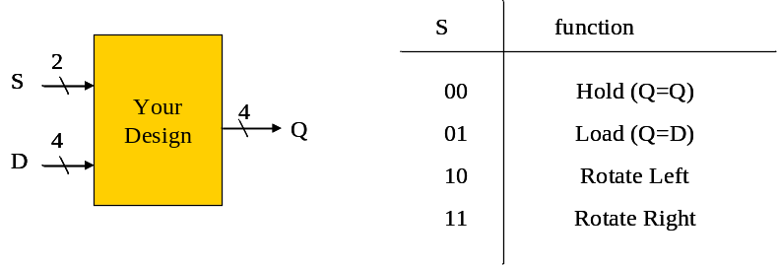
Figure 4.

4. Design the count-down timer as specified in Figure 5. The timer has three buttons “START”, “STOP”, “RESET” and displays 4-digit time mm:ss, with 2-digit mm for minutes and 2-digit ss for seconds. The timer receives an 1-KHz clock signal for working and refresh its time for every one second. The buttons control the counting as follows.
    - The timer starts counting down from 59:59 and down to 00:00 after “START” button pressed
    - The timer holds its current time value when “STOP” button pressed. The timer will resume counting from the time value it holds if “START” button is pressed again.
    - The “RESET” button causes the time value to be reset to 59:59.
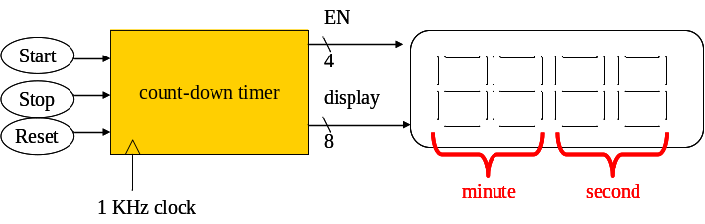
Figure 5
Design the timer as follows.
- Design a circuit to generate an 1-cycle pulse per second from an 1-KHz clock input. Note that you should setup a counting-enable signal to let the circuit been controlled by the control unit. (5%)
- Design the 4-digit core counters to count the time mm:ss. Both fields (mm and ss) ranges from 59 down to 0. (5%)
- Draw the state-transition diagram of the control unit to accept button inputs and control the counting. Control signal values for each state should be clearly specified. (5%)

5. You are asked to design a circuit to retrieve the maximum and minimum number from a sequence of 4 input numbers. The spec of the circuit is shown in Figure 6. The circuit starts working upon receiving an input signal “start”. The four unsigned numbers are given in sequence through the input port D. After receiving the four input numbers, the circuit sends out the maximum and minimum number in sequence through the output port Q. In your design, you can use only two registers in the data path. Write-down your design as follows:
(a) Draw the circuit diagram of the data path. Control signals in the data path should be clearly named. (10%)
(b) Draw the state-transition diagram of the control unit to realize your design. For each state, you should specify clearly the control signal values to send out. (10%)
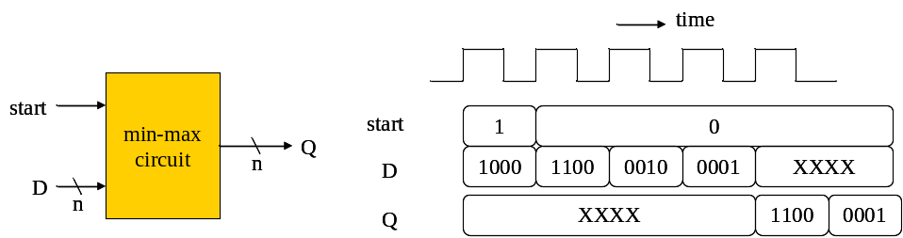
Figure 6.

6. You are asked to design the data path to realize a series of arithmetic computation. The circuit receives data from input port X and sends out the result throughput output port C, as shown in Figure 7. The computation to be realized is as follows:
Step 1: A←X
Step 2: B←X
Step 3: C←A+B
Step 4: D←X
Step 5: C←C-D
Assume that each of the values A, B, C, and D has a dedicated register. Write-down your design as follows:
(a) Draw the circuit diagram of the data path. Control signals should be named clearly in your design (15%)
(b) For each step in the computation, write-down the control signal value to realize the computation. (5%)
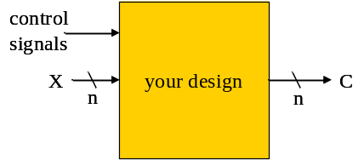
Figure 7.

7. Consider the series of computation in Problem 6. Design the data path circuit to realize the computation with minimum amount of registers. (Each of the value A, B, C, D now does not necessary has a dedicated register). Explain how you devise the optimized design. (25%)

