長庚大學資訊工程系 計算機組織隨堂練習 2010/09/16

考試範圍：數位電路課程全部
考試時間：1:10 PM– 2:00PM
考試規則：可翻閱參考資料，1:40後開放討論

1. Given a circuit shown in Figure 1. Suppose the initial state of the D flip-flops is: A=0 and B=0. The input signal X changes with time as shown in Figure 2. Draw the timing waveform to show the state changes on flip flops A and B. (30%)
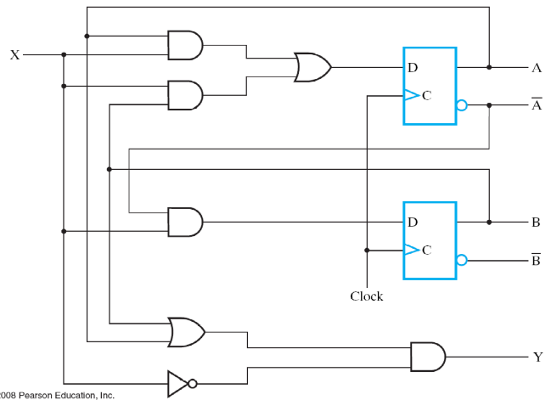
Figure 1

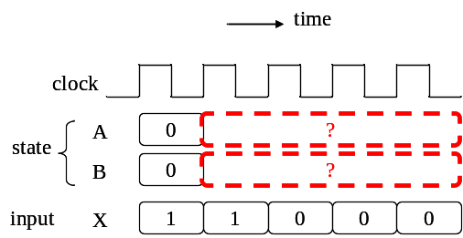
Figure 2

2. Design an LED box specified as follows. The LED box, as shown in Figure 3, has two buttons A and B and two LEDs R and G. The LEDs respond for the buttons as follows.
(i) The LED G is ON and R is OFF if one of buttons A and B pressed.
(ii) Both LEDs G and R is ON if both two buttons A and B pressed.
(iii) Both LEDs are OFF if none of the buttons pressed.

Draw the circuit diagram to realize this LED box. (20%)

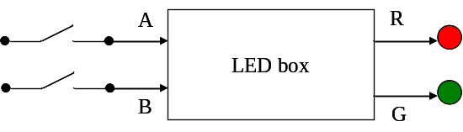
Figure 3

3. You are asked to design another LED box, as shown in Figure 4. This LED box has a button X and an LED R. The button X toggles the ON/OFF state of the LED R. That is:
(i) Pressing X once turns on the LED R if R is originally OFF
(ii) Pressing X once turns off the LED R if R is originally ON
(iii) The LED R remains its original state if X is not pressed
Figure 4 shows a schematic design of the LED box. The button X is connected to a filter that generates a one-cycle pulse A each time X is pressed, as shown in Figure 6. Please draw the circuit diagram of the state controller to finish the design. (20%)
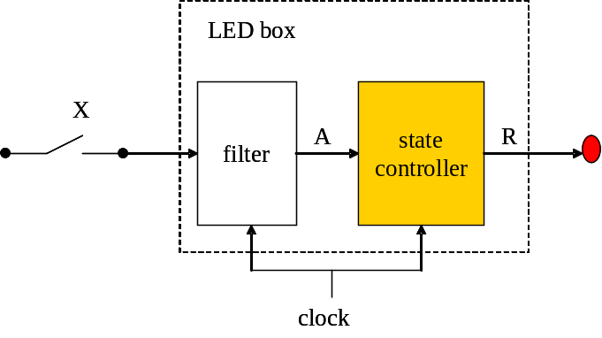
Figure 4

4. Consider your answers for Problem 2 and 3. Indicate which one is a combinational circuit and which one is a sequential circuit. (10%)

5. You are asked to analyze the performance of the circuit in Figure 5. Suppose:
(1) the delay of an AND gate is 3 ns.
(2) the delay of an OR gate is 4 ns.
(3) the setup time and clock-to-output time of a D flip-flop is 2 ns and 1 ns, respectively.
What is the maximum clock frequency that the circuit can work correctly? (20%)
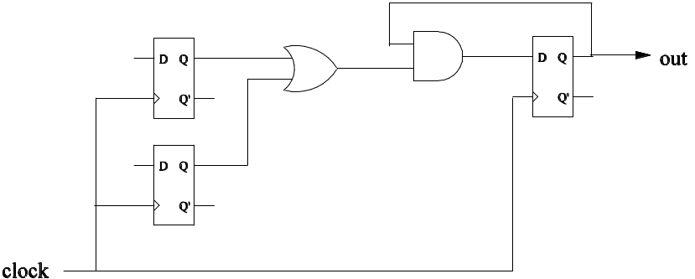
Figure 5.

Terminologies:
- The delay time of a gate is the time required for the output signal to respond for a change on input signals. (Figure 6)
- The setup time of a D flip-flop is the minimum amount of time the input data should be held steady so that the data is reliably sampled by the clock. (Figure 7)
- The clock-to-output time of a D flip-flop is the time the flip-flop takes to change its output after clock trigger. (Figure 7)
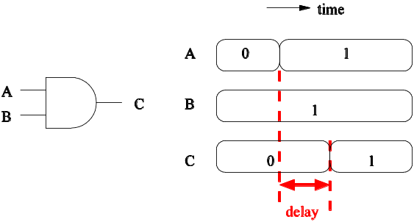
Figure 6

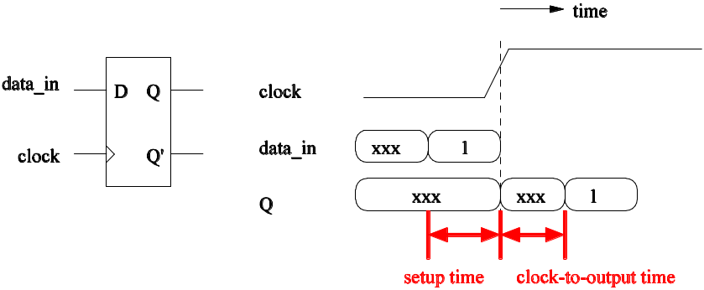
Figure 7

