長庚大學 資訊工程系碩士班 專業能力鑑定 計算機架構試題 2010/09/07

說明:
- 可翻閱參考書籍
- 滿分 110 分

- In a modern computer system, you may execute a program larger than the RAM size. For example, in a PC with i7 and Windows XP, you may execute a 2GB program with only 1 GB RAM.
  - Which mechanism provides you to execute such a huge program? (4%)
  - In this mechanism, how the physical location of a piece of data is found? (8%)

- Consider the MIPS processor pipeline without data forwarding as shown in Figure 1. For each type of the data hazards listed below, indicate whether this hazard may cause pipeline stall or not. Give an example program and draw the pipeline behavior of a stall if your answer is YES. On the other hand, briefly explain why a hazard won’t cause a pipeline stall if your answer if NO.
  - RAW (read-after-write) hazard (7%)
  - WAW (write-after-write) hazard (7%)
  - WAR (write-after-read) hazard (7%)

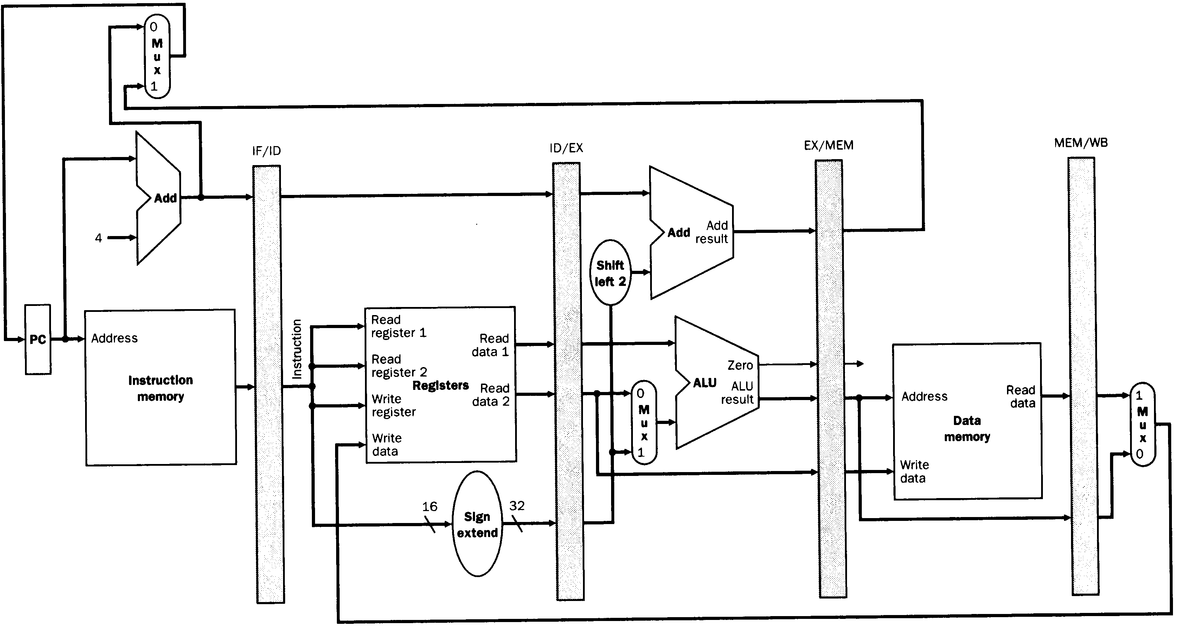
Figure 1. MIPS pipeline data path

- Write a MIPS assembly program to compute the sum of difference over two integer arrays:
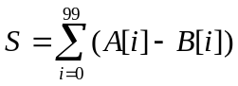
A reference of MIPS instruction set is in Figure 2. (15%)

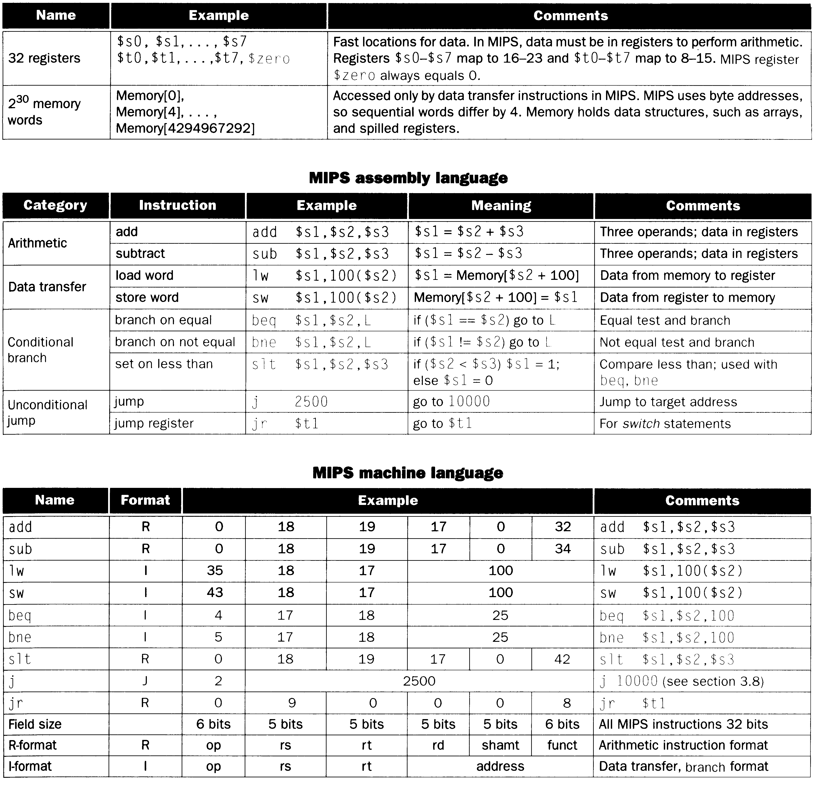
Figure 2. MIPS instructions table

- Consider a low-cost embedded processor without hardware multiplier. (Of course, you don’t have multiply instruction in assembly.) Write a C program to show how to realize the following computation efficiently:
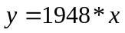
In the computation, the 1st operand is a constant known at programming time and the 2nd operand x is a variable with its value available only at run time. You can use only addition (+), negation (-), and shift operation (<<) in the program. By the term efficiently, we mean that you should realize the multiplication with additions on no more than 4 partial products. Please write the C program for such computation. (15%)
(Hints: (1) 1948=(0000011110011100)₂, (2) recall how Booth encoding reduces amount of partial products)

- Consider a 64KByte 4-way set associative cache with 8-byte cache-lines. Show how to find the cache line from a 32-bit physical address. You should indicate clearly the address format (with bit positions) to access the cache. (15%)

- You are asked to modify the MIPS processor architecture for the following modifications on the instruction set.
- Modification 1: In the revised MIPS processor, a load/store instruction has no immediate offset associated with the instruction. For example, a load instruction may be as follows:
LD R2, R3; //R2=mem[R3]
- Modification 2: Additional load instruction, named LDI, with automatic address increment in the revised MIPS processor. The instruction LDI loads a memory word and increments the address register by 1. For example, an LDI instruction may be as follows:
LDI R2, R3; //Step 1: R2=mem[R3]; Step 2: R3=R3+1
Answer the following questions to present your design.
  - Draw the pipeline data path (with data forwarding) of your revised design. However, to avoid long clock period time, you should not put memory and ALU operations in the same pipeline stage. (8%)
  - Draw the block diagram of the register file for your revised design. (8%)
  - Describe the scheme to control data forwarding. Express your answer in the format like Figure 3. (8%)
  - What’s the advantage of the revised design? (4%)
  - What’s the drawback of the revised design? (4%)

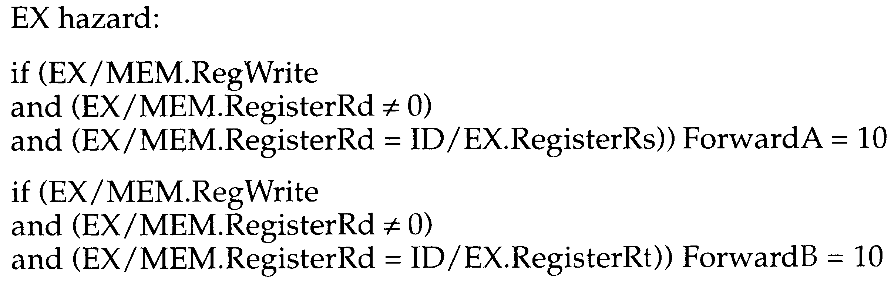
Figure 3. Format to represent a control scheme

