**長庚大學資訊工程系 計算機組織隨堂練習 2015/11/13**

考試規則：可翻閱參考資料。

1. You are asked to design an up- and down- timer, with counting direction controlled by external buttons. The user interface is shown in Figure 1. The device has an one-digit decimal counter that counts between 0 to 9. The counter is reset to 0 at initial. Counting is controlled by two buttons with functions described as follows:
2. When the counter stops at 0, pushing the “START” button starts counting up-ward. If the “REVERSE” button is not pressed, the counter will count to 9 and then hold at 0.
3. During the counting process, a hit to the “REVERSE” button will reverse the counting direction. For example, during the process of counting up from 0 to 9, hitting the “REVERSE” will turn the counting direction downwards from its present value back to 0. On the other hand, hitting the “REVERSE” during count-down process will revert the counting to the count-up process again. Note that a user may push the “REVERSE” button multiple times.

In your design, you can assume that you have a fast clock signal (say hundreds of KHz) and a 1-cycle pulse per second available. Draw your circuit design including two parts:

1. Circuits of the control unit, and accompanied with your state-transition diagram.
2. Circuits of the data path for counting.

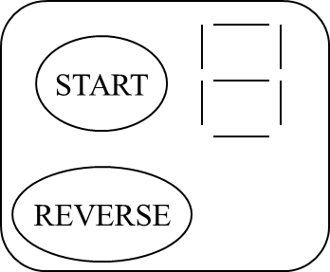

**Figure 1.**