**長庚大學資訊工程系 計算機組織隨堂練習 2012/09/21**

考試時間：1:10 PM– 2:00PM

考試規則：可翻閱參考資料，1:30後開放討論

1. Draw a timing waveform for a given circuit. The circuit is shown in Figure 1. Please complete the waveform in Figure 2.

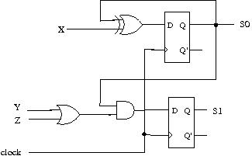

Figure 1

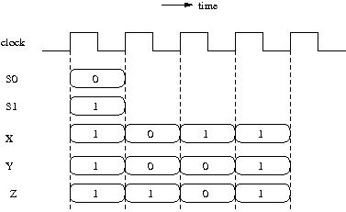

Figure 2