**長庚大學資訊工程系 計算機組織隨堂練習 2016/09/19**

考試時間：11:10 PM– 12:00PM

考試規則：可翻閱參考資料。

1. Draw a timing waveform for a given circuit. The circuit is shown in Figure 1. Please complete the waveform in Figure 2. **(40 pts)**

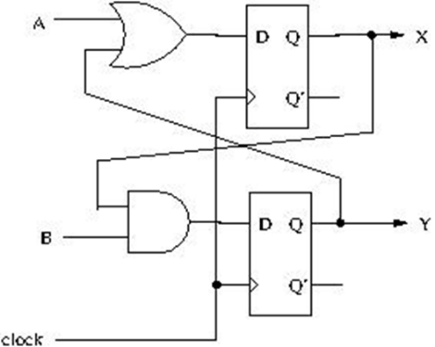

Figure 1

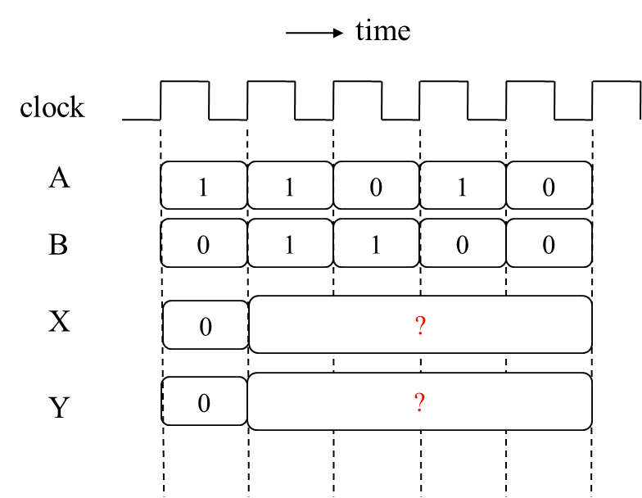

Figure 2

1. How to check whether your answer for Problem 1 is correct or not (if the teacher does not announce his own answer)? **(20 pts)**
2. 請說明上學期修完數位電路課程的心得，並回答下列問題：
3. 設計過最複雜也最值得驕傲的電路設計為何?
4. 你想修或不想修這門課的理由?

**(20 pts)**