Digital video clips of all morphs used in this paper | Demo.html
The enlarging figures in the proposed paper | Figure.doc

The Digital video clips
- A morphing between the models of a cow and a horse. | CowToHorse.gif
- A morphing between the models of a triceratops and a pig. | DinoToPig(256_256).gif  DinoToPig(256_256)Rotation.gif
- A morphing between the models of a man’s head and a venus’s head. | ManToVenus(256_256).gif  ManToVenus(1024_1024).gif
- A morphing between the models of a clown’s head and a man’s head. | ClownToMan(Type5).gif
- A morphing between the models of a shaven head and a venus’s head. | HeadToVenus(25_256).gif  HeadToVenus(1024_1024).gif  HeadToVenus(1024_1024)Rotation.gif
- Shape transition between three dolphins with different poses | D1ToD2(256_256).gif  D2ToD3(256_256).gif
- A transition between two 2D embeddings. | Flattem.gif

Demonstrate how the popping effects are reduced using our strategies.
 | Rough Vertex Matching | Priority Control Function | Video clips
A1 | No | No | ClownToMan(WithoutMatching).gif
A2 | Yes | No | ClownToMan(Type4).gif
A3 | Yes | 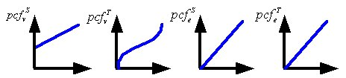 | ClownToMan(Type5).gif
A4 | Yes | 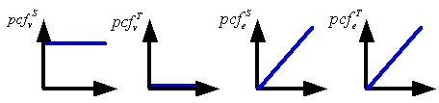 | ClownToMan(Type2).gif

