Chad Galloway
CST-250 Programming in C# II
Grand Canyon University
Nov. 09, 2025
Milestone 3

Files
https://github.com/CGalloway3/CST-250-Projects/tree/master/Milestone3

Video
https://www.loom.com/share/8b1ac99b02a140b4a7d6ef4c050dcf95

UML Class Diagram

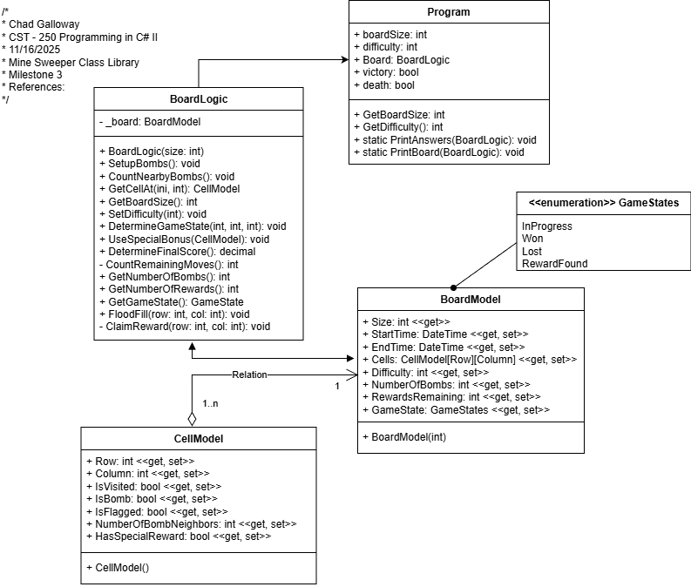
Figure 1: UML Class Diagram with Milestone 3 changes

Screen Shots

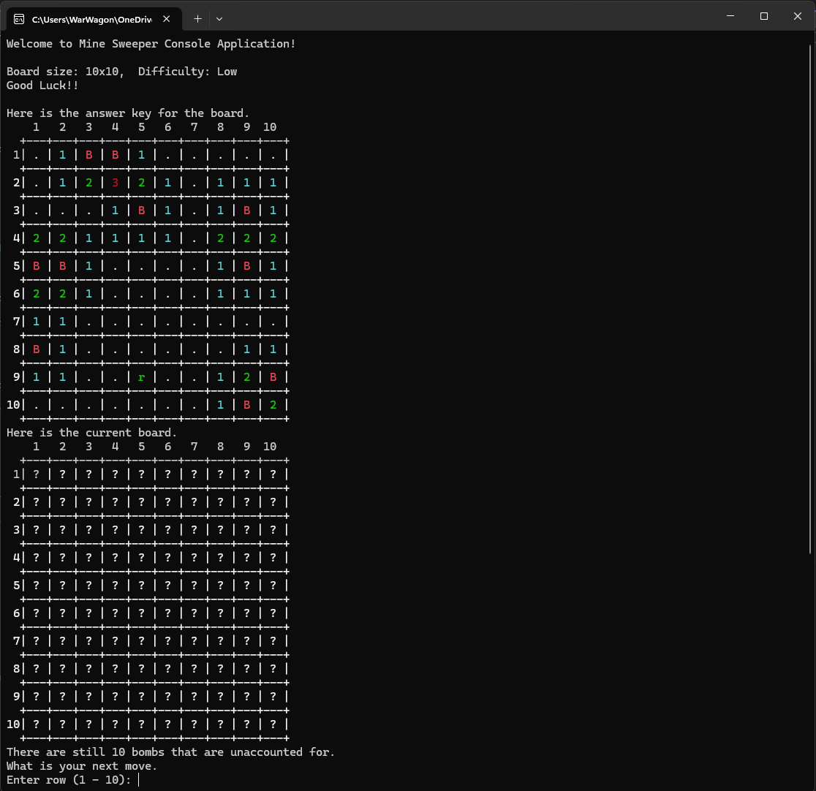
Figure 2: Screenshot of the initial loading state of the game after selecting 10 for board size and 1 for difficulty

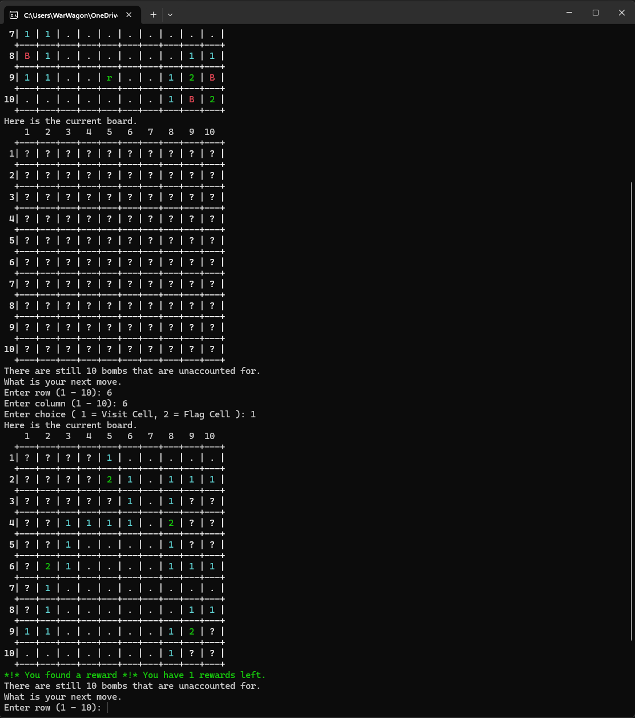
Figure 3: Screenshot of flood fill of an area after selecting 6, 6 to visit. The reward was still collected even if the user did not click directly on it.

Code Changes

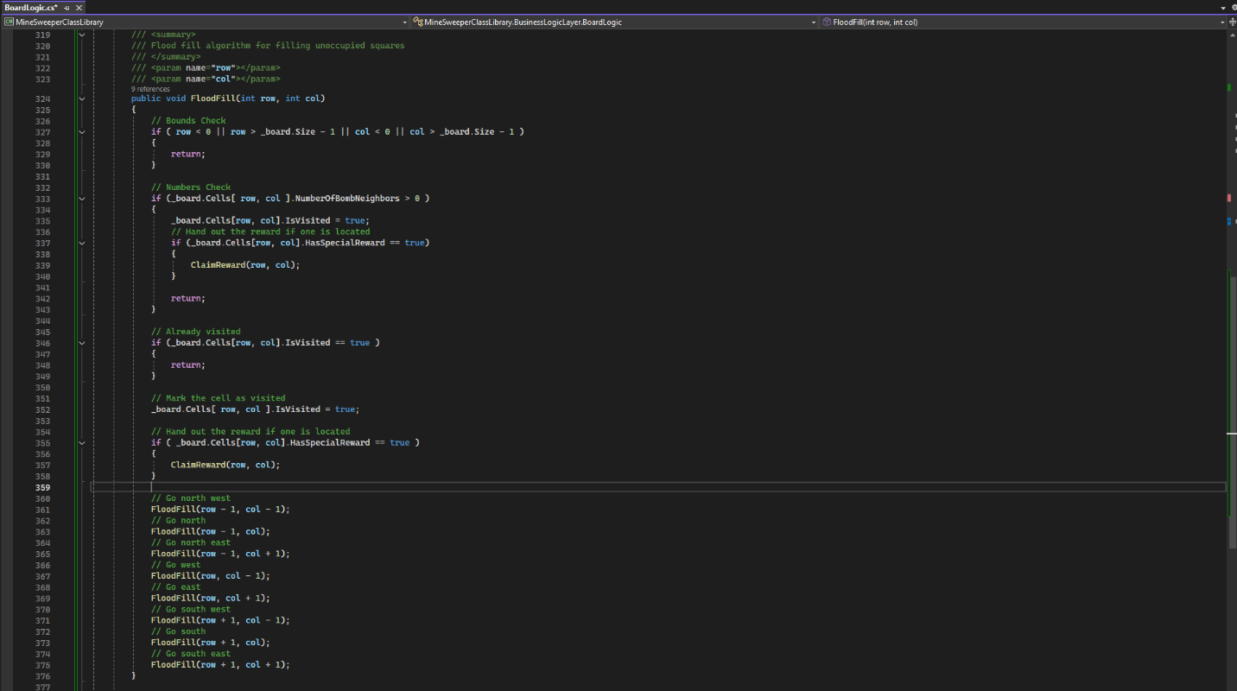
Figure 4: Screenshot of flood fill code addition.

Figure 5: Screenshot of ClaimRewards() method all rewards were handled in the determine game state method but I moved it to the flood fill and into its own method because it needed to be called from two different locations to function properly. Ideally, I would like to move it to an event and add a listener but I need to do more research on that. I fully understand the concept of events and listeners but I am foggy on the implementation so hopefully next week I can have it in to remove the overhead in the flood fill.

Summary of Concepts

This week we learned recursion and how to use it in practical applications. Minesweeper is just one instance of such an occasion using recursion flood fill to fill all the empty space on the map is an excellent demonstration of a typical use case. Other cases involve image editing applications and terrain manipulation algorithms where 3D voids are space might be present. Recursion is a rather elegant way to handle many complex problems by breaking them down into smaller more manageable chunks.

