Activity 5: Creating a Timer-Driven Game with Dynamic UI Controls

Introduction 2
Objectives 3
Part 1 – Timer Control 4
Part 2 – Create a "Whack-a-Mole" Game 12
Part 3 – Whack-A-Mole Challenges 16
What You Learned in This Lesson 18
Check for Understanding 19
Deliverables 21

Introduction
In this activity, we'll explore timer events and game features in WinForms applications. In this lesson, you'll learn how to manage timers and use them to create a "Whack-a-Mole" game. We'll start by setting up basic timer functions, then move on to dynamically controlling game elements and adding features such as scoring and custom graphics. By the end, you'll not only have built an engaging game but also gained valuable skills in handling events and user interface (UI) controls in a .NET environment.
The GCU College of Engineering and Technology Coding Guidelines and Best Practices for C#, available in the Class Resources, must be followed in all CST-250 projects to ensure consistency, readability, and professionalism in student code. These guidelines promote a clear separation of concerns by organizing code into the Models, BusinessLogicLayer, and DataAccessLayer folders. The document also outlines essential standards for casing, naming conventions, code structure, commenting, and organization. Additionally, it emphasizes best practices in object-oriented design, exception handling, and the use of design patterns. Adhering to these expectations is required for successful completion of course assignments.

Objectives
- Configure and user a timer control.
  - Describe the purpose of a timer in controlling periodic events within a WinForms application.
  - Configure a timer's properties, such as interval and enabled status, to control event timing.
  - Develop event handlers that respond to timer events to update application state or UI components such as labels.
- Create and manipulate UI controls dynamically.
  - Dynamically add and position controls on a form based on runtime conditions.
  - Modify properties of controls, such as visibility and position, in response to events.
  - Construct a simple interactive game using timer events to move a target randomly across the form.
  - Implement event handlers that adjust the placement and size of UI controls when the form is resized to maintain layout consistency
- Create game functionality.
  - Implement game mechanics such as scoring and target visibility toggling upon user interactions.
  - Add complexity to the game by introducing levels, penalties, custom graphics, and form resizing responsiveness.
  - Design and implement a scoring system and manage game statistics using files.
  - Create additional forms for user interaction, such as inputting a player name or displaying high scores.

Part 1 – Timer Control
- Create a new WinForms application with the name "WhackAMole" using the most recent long-term support version of .NET, as shown in Figure 1.
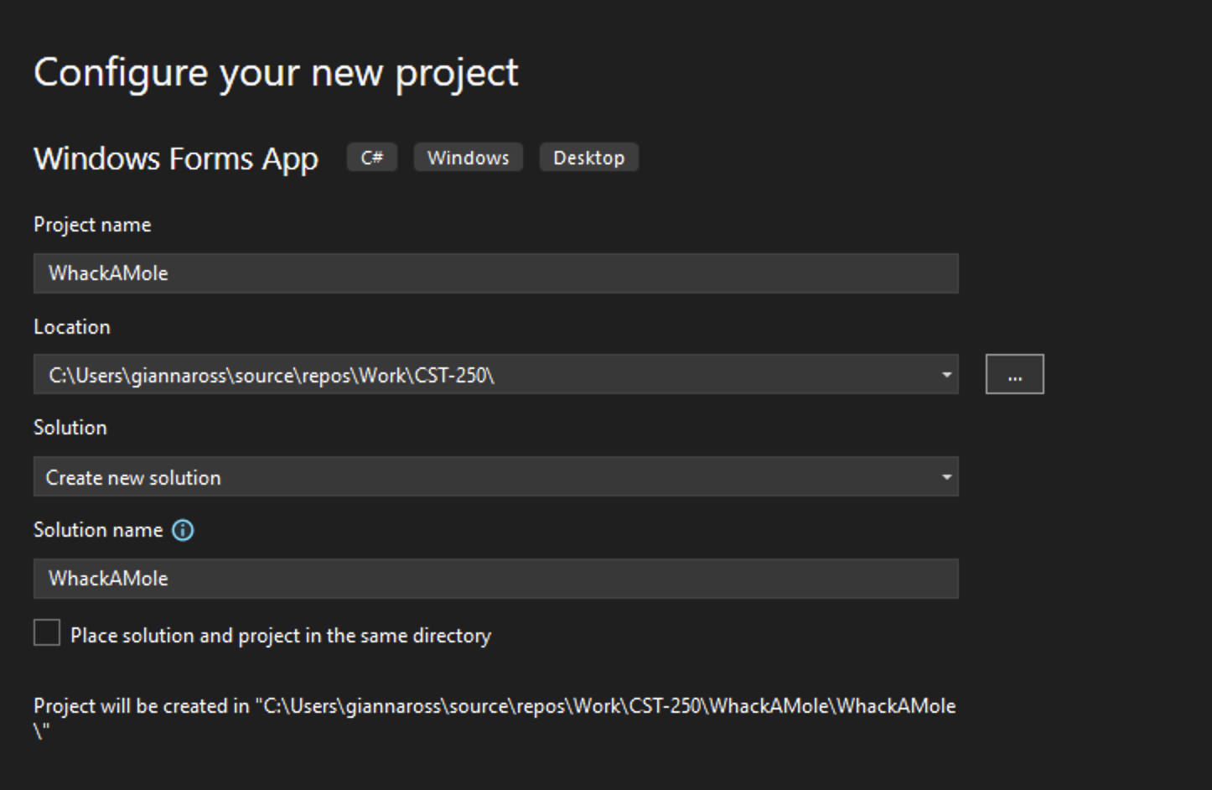
Figure 1: Creating the WhackAMole project

- Add the project to source control.
- See the Class Resources for a detailed tutorial on GitHub source control.
- Right click on Form1 and rename it to FrmStopwatch, as shown in Figure 2.
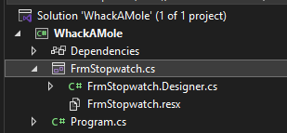
Figure 2: Rename Form1 to FrmStopwatch
- Create a Presentation folder under your project and name it "PresentationLayer". Drag FrmStopwatch into the folder, as shown in Figure 3.
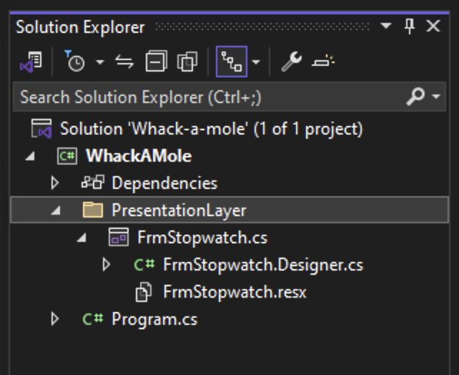
Figure 3: Moving FrmStopwatch to the PresentationLayer Folder
- Under FrmStopwatch’s Properties, change the name for Form1 to FrmStopwatch using the Name attribute, as shown in Figure 4. Additionally, update the Text attribute so that the form reads Stopwatch.
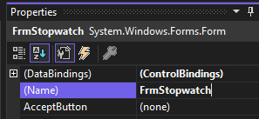
Figure 4: Updating the name of the form to FrmStopwatch

- Resize FrmStopwatch and create three buttons and a label, as shown in Figure 5.
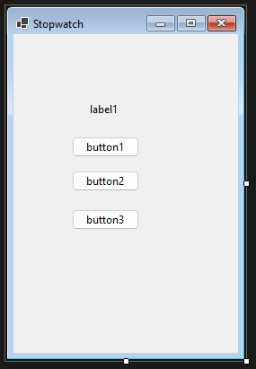
Figure 5: Adding buttons and a label to FrmStopwatch
- Rename the label as lblTimeElapsed and each of the buttons as btnStart, btnStop, and btnReset, respectively. You can also change the text for each button to Start, Stop, and Reset as shown in Figure 6.
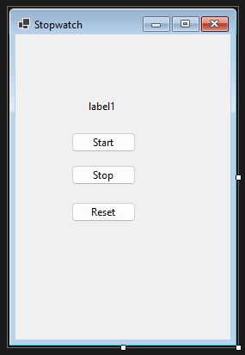
Figure 6: FrmStopwatch with the Start, Stop, and Reset buttons
- Next, add a Timer control to FrmStopwatch, as shown in Figure 7. The control will not be visible on your form but will show up in the bar at the bottom of the designer.
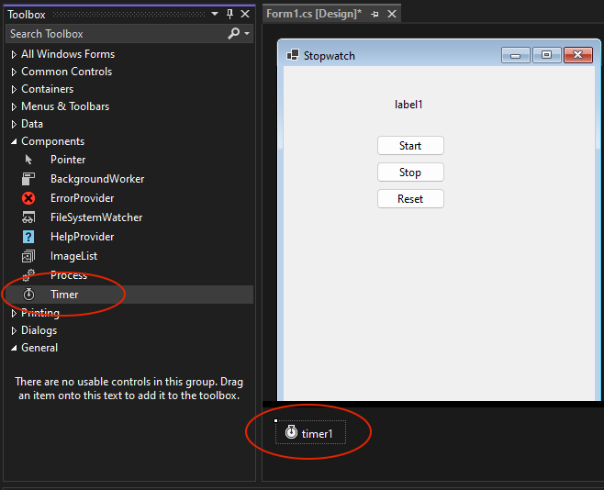
Figure 7: Adding a timer control to FrmStopwatch
- Using the timer naming convention, tmr, rename timer1 to tmrStopwatch. Then, find the Enabled property for the timer and set it to true. Finally, set the interval to 1000 (this is measured in milliseconds), as shown in Figure 8.
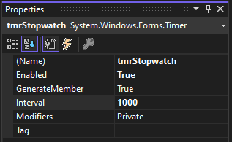
Figure 8: Updating the timer properties

- Right click on FrmStopwatch and open the code for the form. Add a citation to the top as shown in Figure 9.
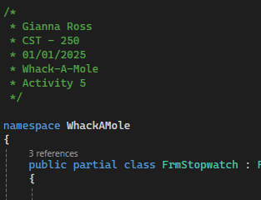
Figure 9: Citation for FrmStopwatch
- Add a click event handler with a summary comment to btnStart named BtnStartClickEH. This method will use the Start method for the timer to start the timer, as shown in Figure 10.
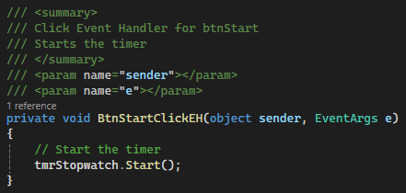
Figure 10: Click event handler for btnStart
- Next, add a click event handler to btnStop named BtnStopClickEH. This will stop the timer using the Stop method, as shown in Figure 11. Make sure to add a summary comment to the method.
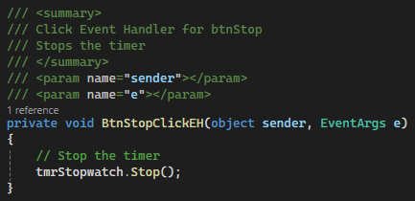
Figure 11: Click event handler for btnStop

- Commit all changes in the project to source control.
- Commit Message: Finish the UI and add stop and start functionality to the timer.
- Add a class-level variable named timeElapsed of type TimeSpan to FrmStopwatch, as shown in Figure 12. This variable will keep track of the time on the timer control.
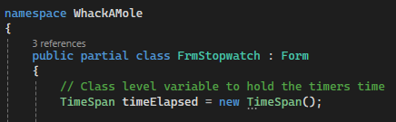
Figure 12: Adding the timeElapsed variable to the form
- Add a Tick event handler to tmrStopwatch named TmrStopwatch, as shown in Figure 13. This event handler will trigger on the interval specified by the interval property of the timer (1000 milliseconds here). Remember to add a summary comment to the method, as shown in Figure 14.
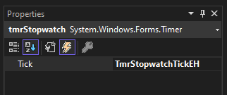
Figure 13: Adding a Tick event handler to tmrStopwatch
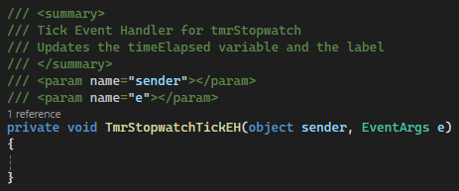
Figure 14: TmrStopwatchTickEH with a summary comment
- To update the timeElapsed variable, we should get the interval from tmrStopwatch and convert it to milliseconds using TimeSpan.FromMilliseconds. Then, use the Add method to get a TimeSpan object whose value equals the sum of the current timeElapsed variable and the given interval in milliseconds. Set timeElapsed equal to this object. Finally, update the text for lblTimeElapsed to show the current value of the variable, as shown in Figure 15.
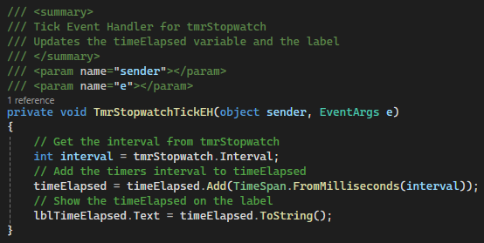
Figure 15: Logic to update timeElapsed and lblTimeElapsed
- For the last event handler for our stopwatch, add a click event handler to btnReset named BtnResetClickEH. Add a summary comment, as shown in Figure 16.
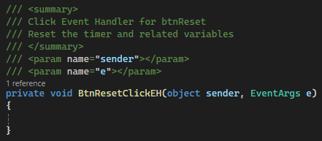
Figure 16: BtnResetClickEH with a summary comment

- Add logic to the method to stop the timer, reset timeElapsed by setting the variable equal to a new TimeSpan object, and update lblTimeElapsed, as shown in Figure 17.
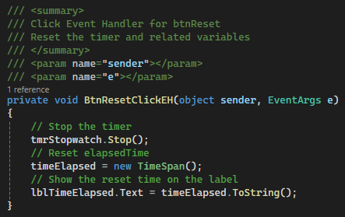
Figure 17: Adding logic to reset the stopwatch

- Commit all changes in the project to source control.
- Commit Message: Finish functionality to reset the timer and display the current time elapsed.
- Run the program and test the stopwatch.

- Take a screenshot of the application running at this point.
- Take a screenshot of the citation for FrmStopwatch. Make sure to include the class declaration in the image.
- Take a screenshot of the BtnStartClickEH, BtnStopClickEH, TmrStopwatchTickEH, and BtnResetClickEH methods.
- Take a screen shot of the UML for the FrmStopwatch class.
- Paste the images into a Word document.
- Put a caption below each image explaining what is being demonstrated.

Part 2 – Create a "Whack-a-Mole" Game
Next, we will extend the game to create a version of Whack-A-Mole, a game in which the user clicks on randomly moving objects to score points.
- Reset the stopwatch form and move the buttons and label to the edges of the form, as shown in Figure 18.
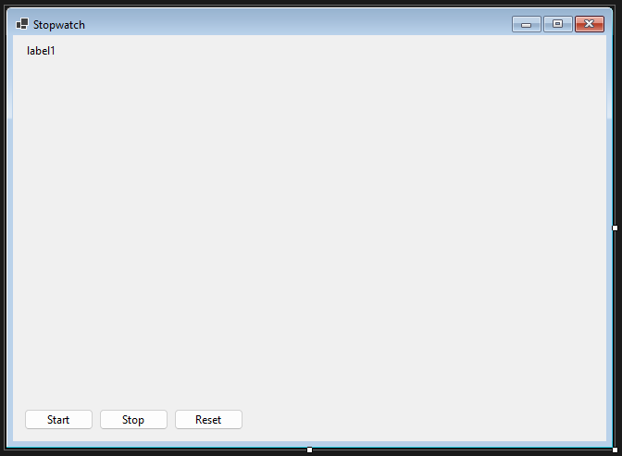
Figure 18: Reconfiguring FrmStopwatch

- Add a new button named btnTarget to the form. Update the text for the button to say "Target" and resize the button, as shown in Figure 19. This button will be the target for the user to click as our program is running.
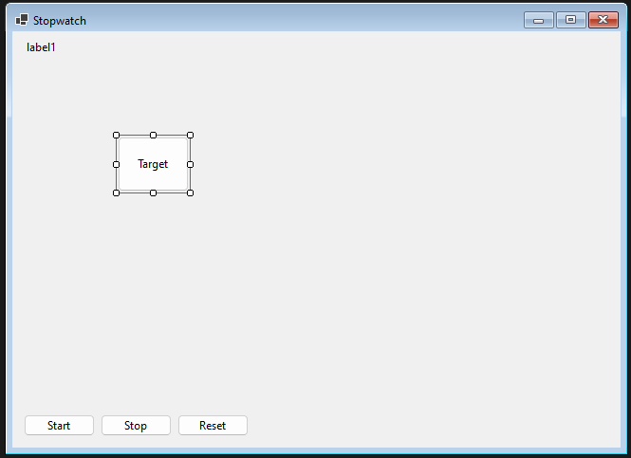
Figure 19: Adding a target button to FrmStopwatch

- Commit all changes in the project to source control.
- Commit Message: Rearrange the UI to prepare for the Whack-A-Mole game.
- Add a click event handler to btnTarget named BtnTargetClickEH. Add a summary comment and logic to hide the button to the method, as shown in Figure 20.
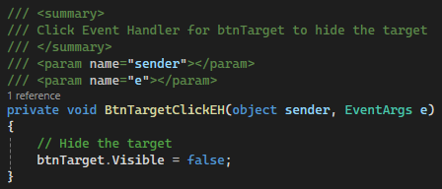
Figure 20: Click event handler for btnTarget
- To move the target button around the screen, we will need to create a random object to generate new locations. Open the code behind FrmStopwatch and add a class-level variable named Random, as shown in Figure 21.
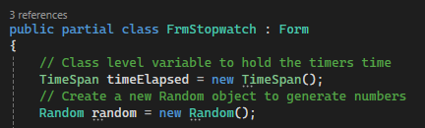
Figure 21: Adding a random object to generate numbers
- Next, we will update our TmrStopwatchTickEH method to randomly relocate the Target button. First, update the summary comment for TmrStopwatchTickEH and add an end-of-method comment to the method, as shown in Figure 22.
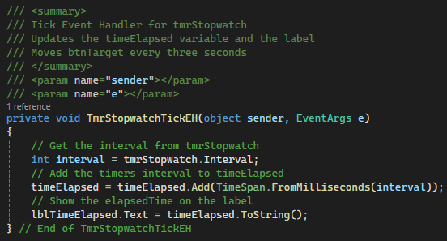
Figure 22: Updated summary comment and end-of-method comment for TmrStopwatchTickEH

- We will relocate the target button every 3 seconds by checking whether the time elapsed in seconds is divisible by 3. If it is, we can generate numbers for the Top, Left, and BackColor properties for the target button and set the control to be visible, as shown in Figure 23.
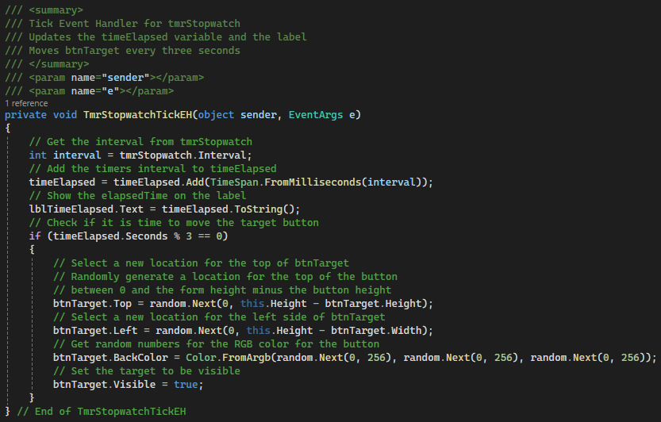
Figure 23: Adding logic to TmrStopwatchTickEH to relocate the target every 3 seconds

- Commit all changes in the project to source control.
- Commit Message: Add functionality to move the target as well as hide it when clicked by the user.

- Take a screenshot of the application running at this point.
- Take a screenshot of the BtnTargetClickEH and TmrStopwatchTickEH methods.
- Take a screenshot of the UML for the FrmStopwatch class.
- Paste the images into a Word document.
- Put a caption below each image explaining what is being demonstrated.

Part 3 – Whack-A-Mole Challenges
Now that you have created a basic game with a timer control, add a minimum of six of the following features using the principals of N-layer architecture (See instructor for selection).
- Score
Keep score of the number of hits on the target button. You could award 1 point per click or a different scoring method.
- End the Game
Select a point at which to end the game. This could be an amount of time, a certain score, or anything else.
- High Score Hall of Fame
Manage a list of high scores from previous games played using a model class, such as "GameScoreModel," that could include a score, date, and player name. This would allow us to keep several stats about each game. You could get the players’ names using a second form.
Send the scores to a text file using the business and DAO layers of N-layer architecture so that future players can see past high scores.
- Penalty Click
Decide what will happen if the player clicks on the form instead of the button (missed click). You can set a form click event in the FrmStopwatch properties. You decide what penalty the player receives for clicking the form instead of clicking the button. For example, you could end the game, subtract points, or make the player lose a life.
- Create Levels
Create levels based on time passed, score, or any other event. Levels can include a smaller target, the target moving faster, a larger application window, etc.

- Custom Graphics
Modify the appearance of the buttons with colors, fonts, and form background images. Instead of a TARGET button, you could perform the same effect with a picture control.
- Account for Form Resize
When a form is resized by the user, the buttons may need to be repositioned to keep them near the bottom edge of the form. The FrmStopwatch Resize event can be used to rearrange the form if it is resized. Use your knowledge of FrmStopwatch.Width, FrmStopwatch.Height, btnTarget.Top and btnTarget.Left to calculate the proper location of each button and label.
- Decoy
Create a second button as a false target. Move it around like the Target button. Use it as a decoy or "bomb" that damages the player's game in some way.
- Increasing Difficulty
As the levels increase, change the difficulty of the game. You could change the speed of the timer, add more decoy buttons, make the target button smaller, or a combination of any of these.
- Rewards
Create a series of accomplishments that the player can unlock. Perhaps they could see a page of certificates or "badges” or earn an extra life in the game.

- Commit the challenges to source control with a commit message.

- Take a screenshot of the application running after the new features have been added.
- Take a screenshot of each method added or updated to implement the features.
- Take a screenshot of the updated UMLs for any classes with added methods.
- Paste the images into a Word document.
- Put a caption below each image explaining what is being demonstrated.

What You Learned From This Activity
1. Timer Control Usage
Learned to set up and use a timer control in a WinForms application to manage periodic events, adjusting properties, such as interval and enabling status, and developing event handlers to update the application state or UI components.
2. Dynamic UI Control Manipulation
Mastered adding and dynamically positioning controls on a form, modifying control properties such as visibility and position during events, and handling form resizing to adjust control layout.
3. Game Functionality Development
Implemented key game mechanics such as scoring and target visibility, introduced additional complexity with levels and custom graphics, and created a scoring system. Also, learned to develop forms for interactive user input and display of high scores.

Check for Understanding
These quiz questions will help you review important concepts from the lesson. These are not graded. You do not have to submit your score.
- Which control in WinForms is used to create and manage periodic events?
  - Label
  - Button
  - Timer
  - ListBox
- What property of a timer control determines how frequently it triggers events in milliseconds?
  - Interval
  - Frequency
  - TickRate
  - Speed
- Which event is used to update the game state at each interval of the timer?
  - Click
  - Tick
  - Change
  - Move
- Which form event can be used to dynamically reposition controls when the form size changes?
  - Paint
  - Resize
  - Load
  - Click

Answer Key:
- Which control in WinForms is used to create and manage periodic events?
- Timer
- What property of a timer control determines how frequently it triggers events in milliseconds?
- Interval
- Which event is used to update the game state at each interval of the timer?
- Tick
- Which form event can be used to dynamically reposition controls when the form size changes?
- Resize

Deliverables
You must submit two separate files:
- One PDF containing Parts 1–3.
- One zip file containing the complete codebase for Part 4.
Part 1: Activity Submission
- Cover Page
  - Use APA formatting for the cover page.
- GitHub Repository Link
  - At the top of the second page, provide a link to your private GitHub repository.
  - Be sure to add your instructor and grading assistant (if applicable) as collaborators.
- Updated Flowchart
  - Include the latest flowchart reflecting your current application design.
- Updated UML Diagram(s)
  - Provide UML diagrams that reflect the current implementation.
- Base Application Screenshots
  - Include screenshots as required in the activity instructions.
  - Each screenshot must have a clear caption directly below the image explaining what is being demonstrated.
  - All code must be properly commented.
- Section Headers
  - Use clear headers as outlined in these deliverables to identify each part of the assignment within the PDF.
- Citations
  - Include a citation at the top of each page containing code, flowcharts, or UML diagrams.
- File Naming
  - Name the PDF according to the activity title and include your full name.
- Coding Standards Compliance
  - Ensure GCU College of Engineering and Technology Coding Guidelines and Best Practices, found in the Class Resources, have been followed to ensure consistency, readability, and professionalism in student code.

Part 2: Activity Challenges
- Challenge Screenshots
  - Include screenshots that demonstrate completion of the challenge requirements as described in the activity guide.
- Minimum Features
  - Implement and document at least six features from the challenge section.
Part 3: Planning for Topic 6 Activity 6
- Flowchart for Topic 6 Activity 6
  - Use the requirements, as outlined in Topic 6 Activity 6, to create a high-level flowchart. Showcase the logic and data flow that can be used as a template for the software design.
- UML Diagram(s) for Topic 6 Activity 6
  - Provide UML diagram(s) based on the same requirements.
Part 4: Code Submission (Separate Zip File)
- Zip Your Project Folder
  - Compress the full folder containing all source code and necessary files into a .zip file.
- Executable Submission
  - Ensure the application runs correctly. The zip file will be unzipped and tested during grading, so include all dependencies.
- File Naming
  - Name the zip file according to the activity and include your full name.
Submission Reminder
Do not submit a single zip file that contains both the PDF and the code. Each file must be uploaded separately.

