Chad Galloway
CST-250 Programming in C# II
Grand Canyon University
Nov. 30, 2025
Activity 6

Files
https://github.com/CGalloway3/CST-250-Projects/tree/master/Activity6

Video
https://www.loom.com/share/bc2cd3bd543e4dfe88c3ea271fee2a43

Part 1: Creating the UI

FLOW CHART
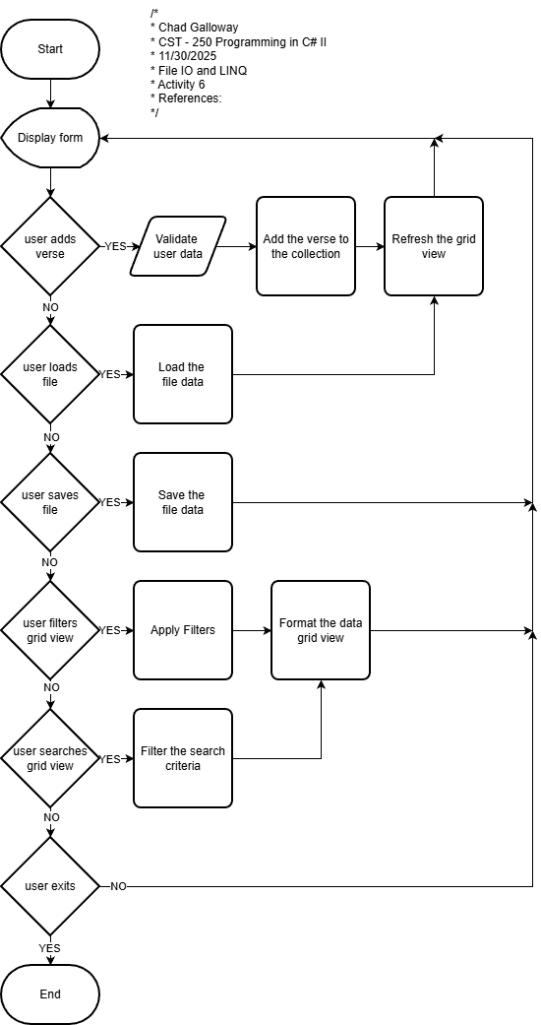
Figure 1: Flow chart of Activity 6

UML Class Diagram

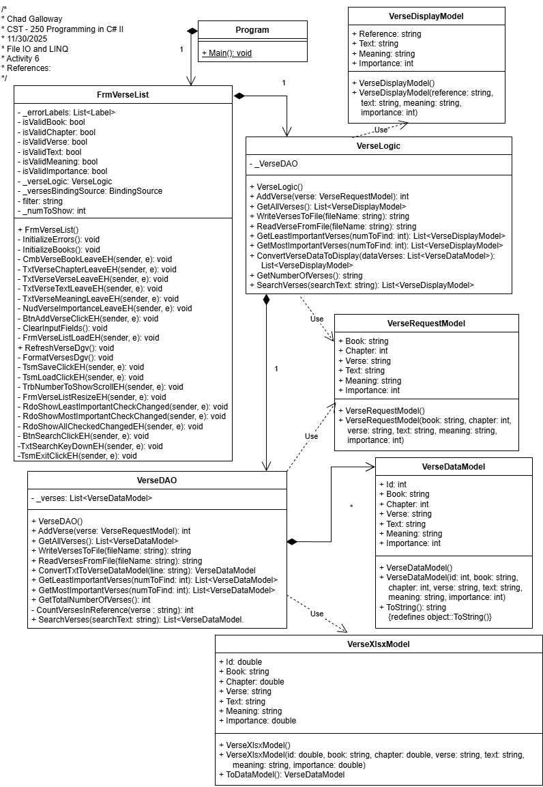
Figure 2: UML Class Diagram
Screen Shots

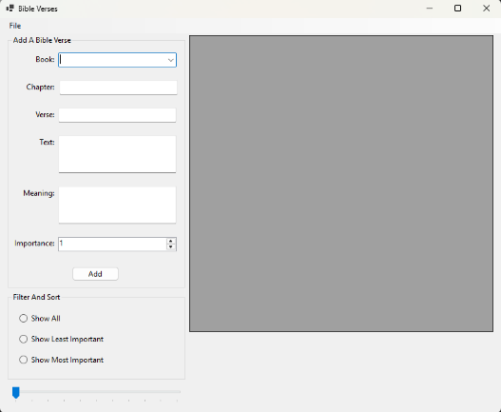
Figure 1-3: Part 1 App Running in the current default load state. This is what the user sees after starting the application.

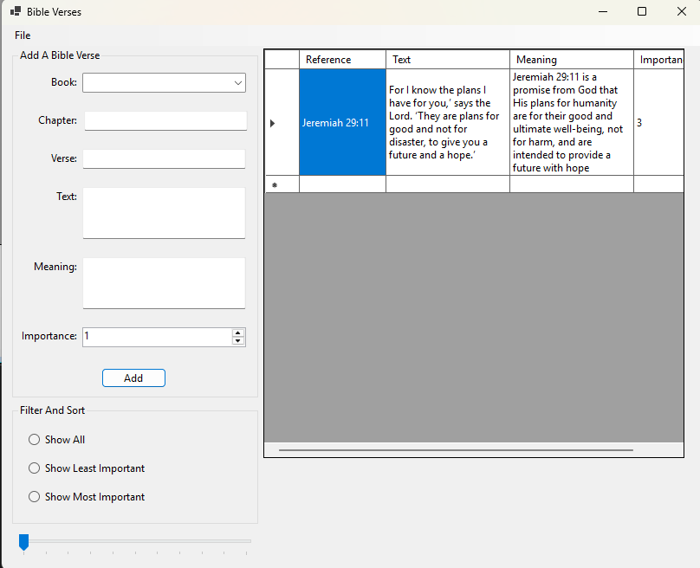
Figure 1-4: Screenshot of successful output when the user enters a verse correctly and clicks the add button.

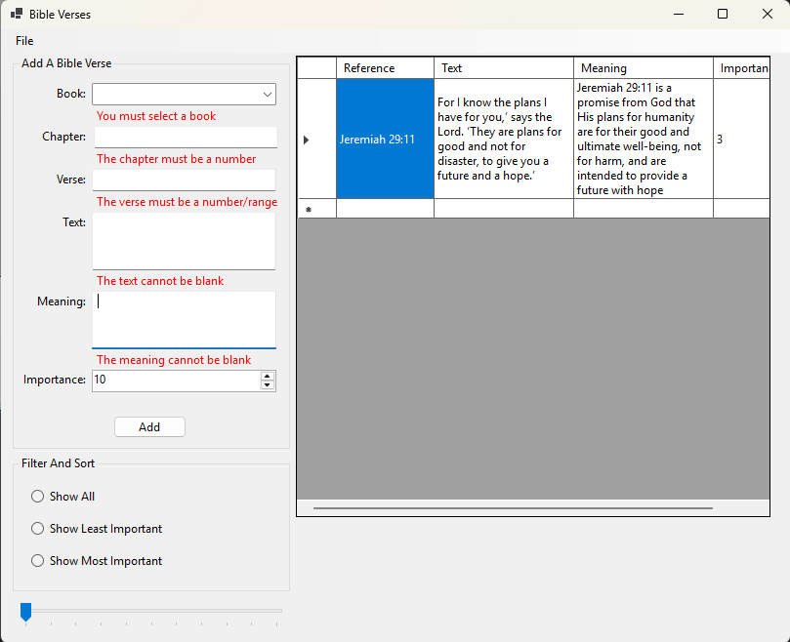
Figure 1-5: Screenshot of Error Handling the user data entry fields. The NUD control still has an error label but in the Visual Studio IDE I set the minimum and maximum properties to 1 and 10 respectively so the app will not let the user enter values out of that range. If the user were to say enter 55 the number would change automatically to 10. Programmatically changing the value to a number that is out of range causes an error so some of the values on the ClearInputFields() method were adjusted from 0 to 1 to prevent out of bounds errors.
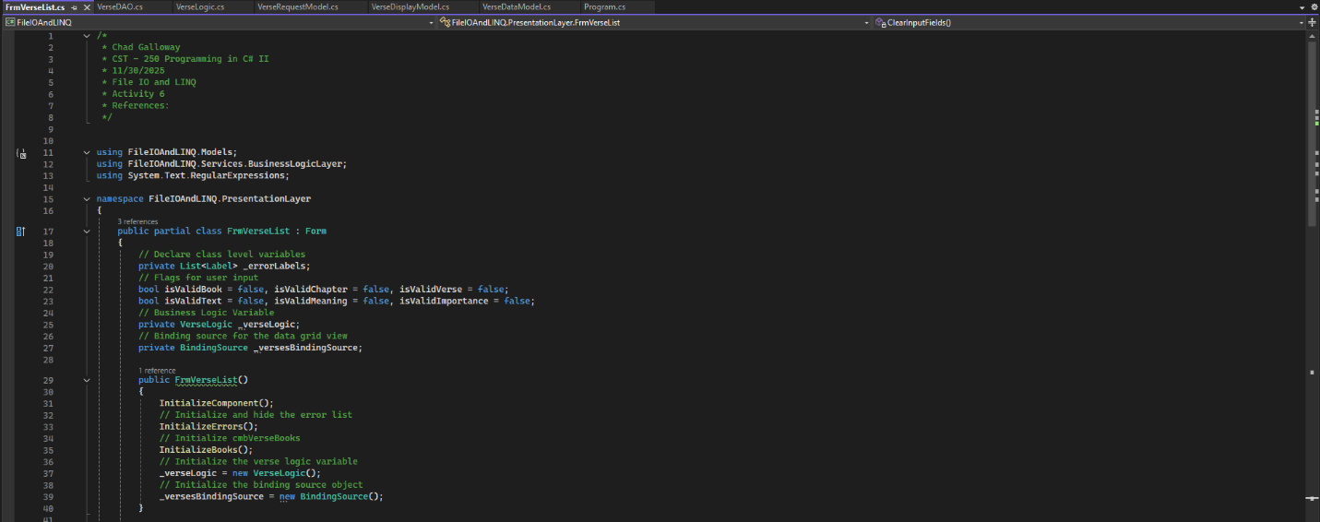
Figure 1-6: Screenshot of the FrmVerseList citation, variables, and constructor

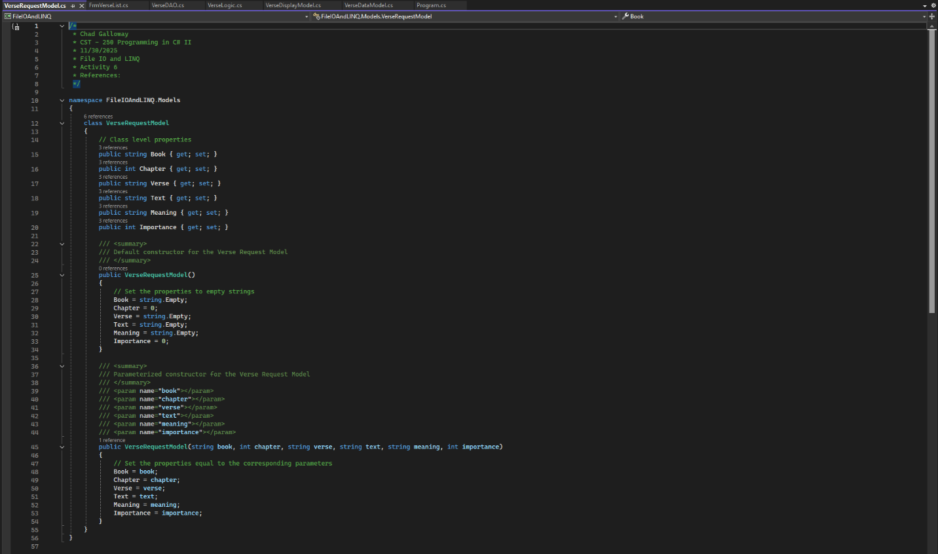
Figure 1-7: Screenshot of the VerseRequestModel citation, properties, and constructors.

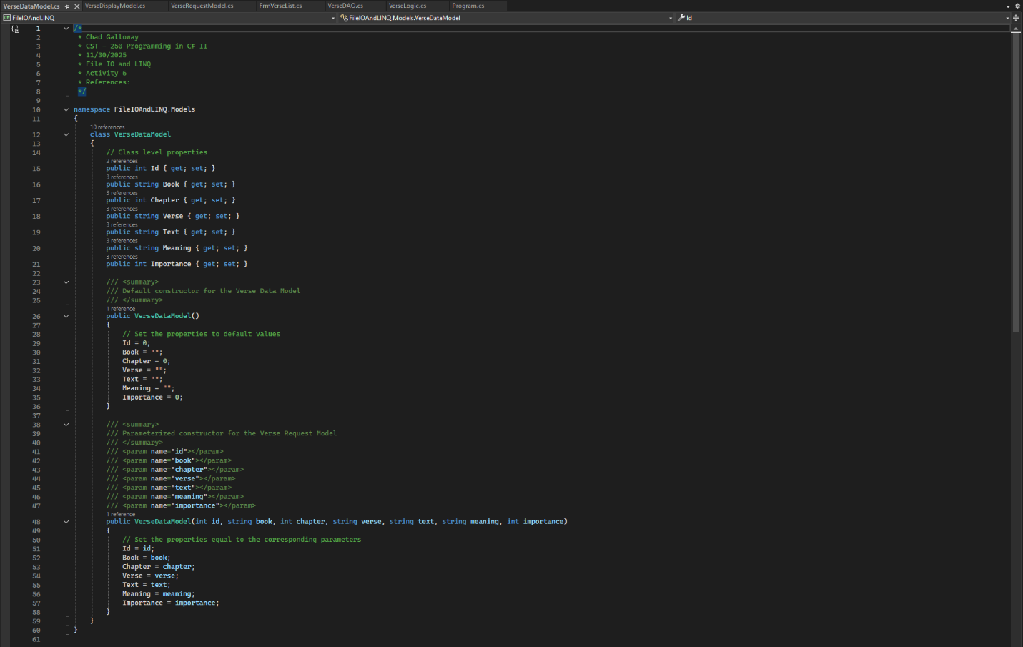
Figure 1-8: Screenshot of the VerseDataModel citation, properties, and constructors.

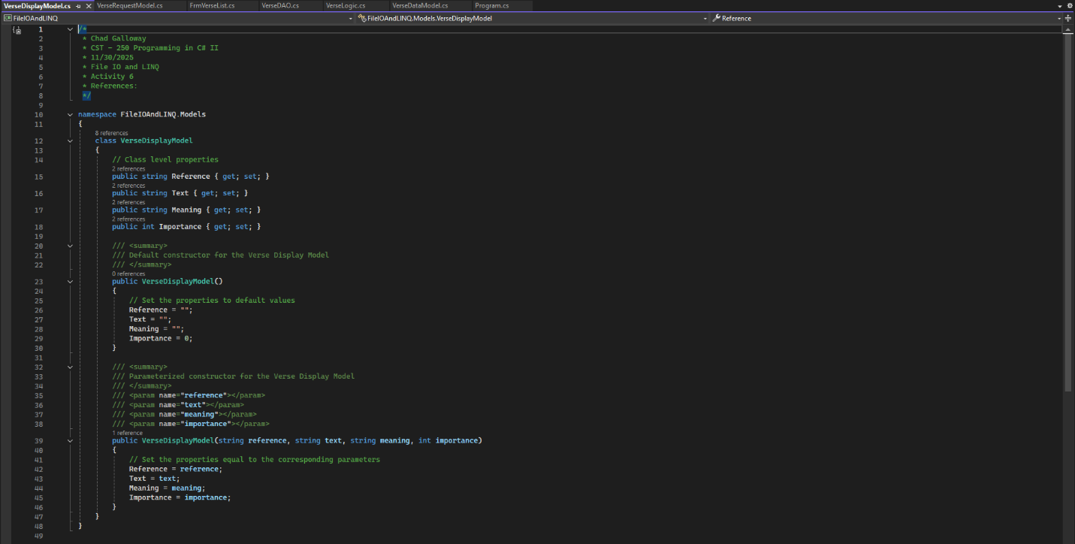
Figure 1-9: Screenshot of the VerseDisplayModel citation, properties, and constructors.

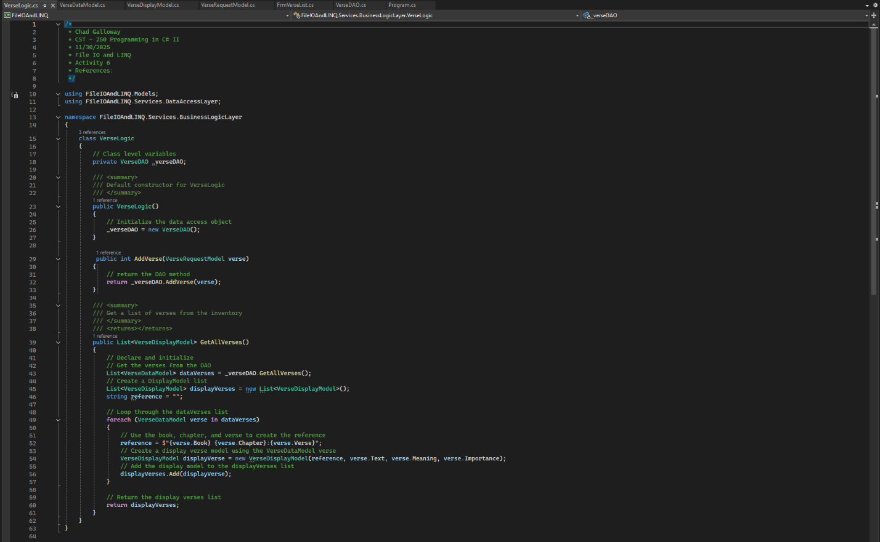
Figure 1-10: Screenshot of the VerseLogic citation, variables, constructor, and methods AddVerse() and GetAllVerses()

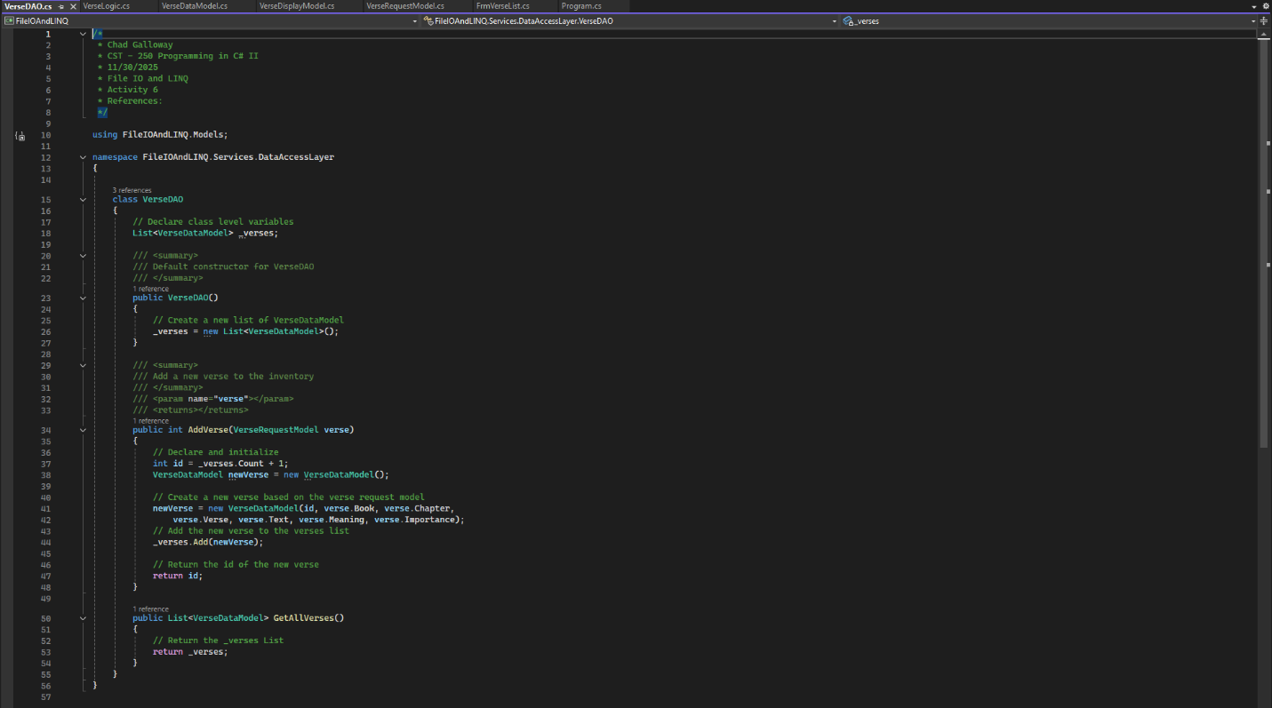
Figure 1-11: Screenshot of the VerseDAO citation, variables, constructor, and methods AddVerse() and GetAllVerses()
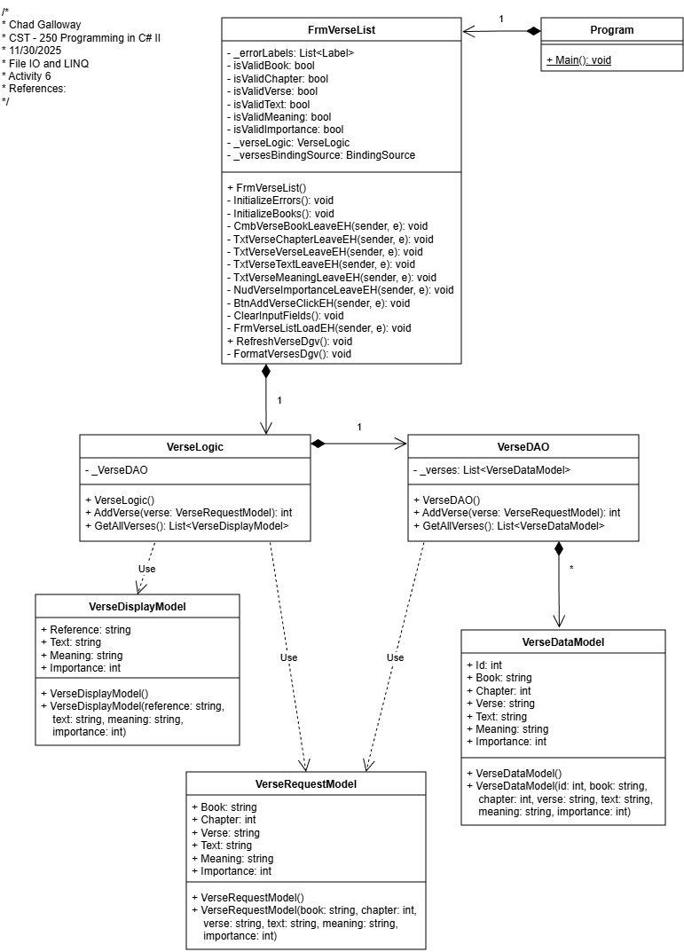
Figure 1-12: Screenshot of the UML for all the classes as they are now.

Part 2: File I/O

Screen Shots

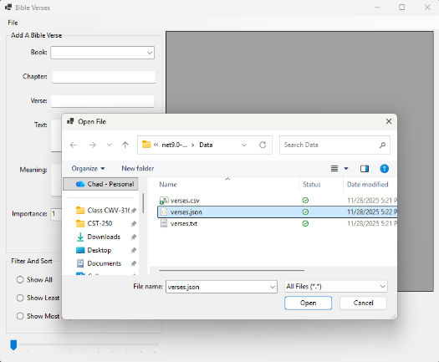
Figure 2-1: Part 2 Application load file dialog.

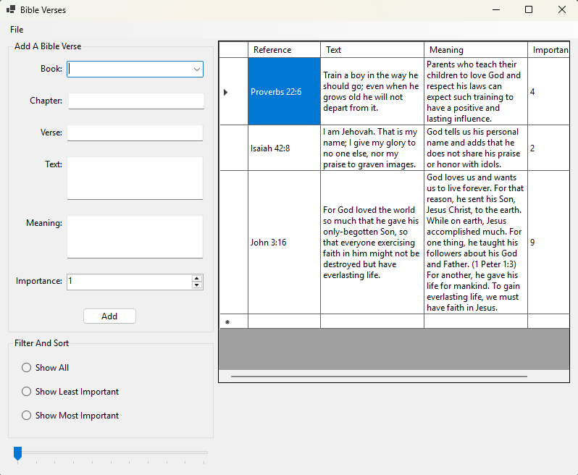
Figure 2-2: Screenshot of successful file loaded.

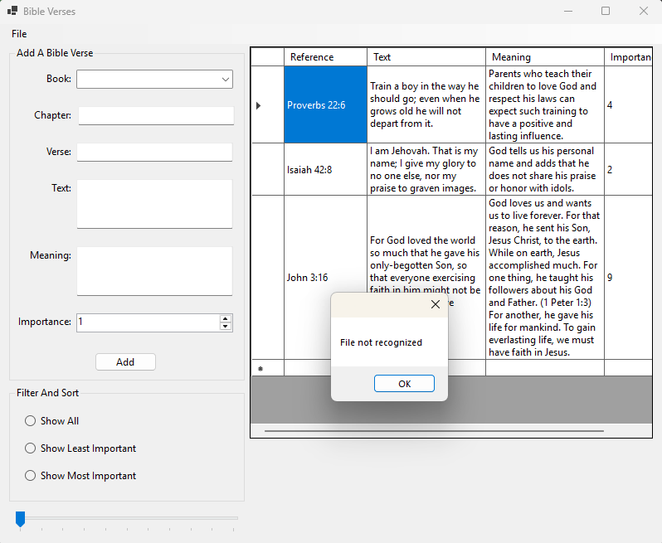
Figure 2-3: Screenshot of Error Handling for invalid file types.

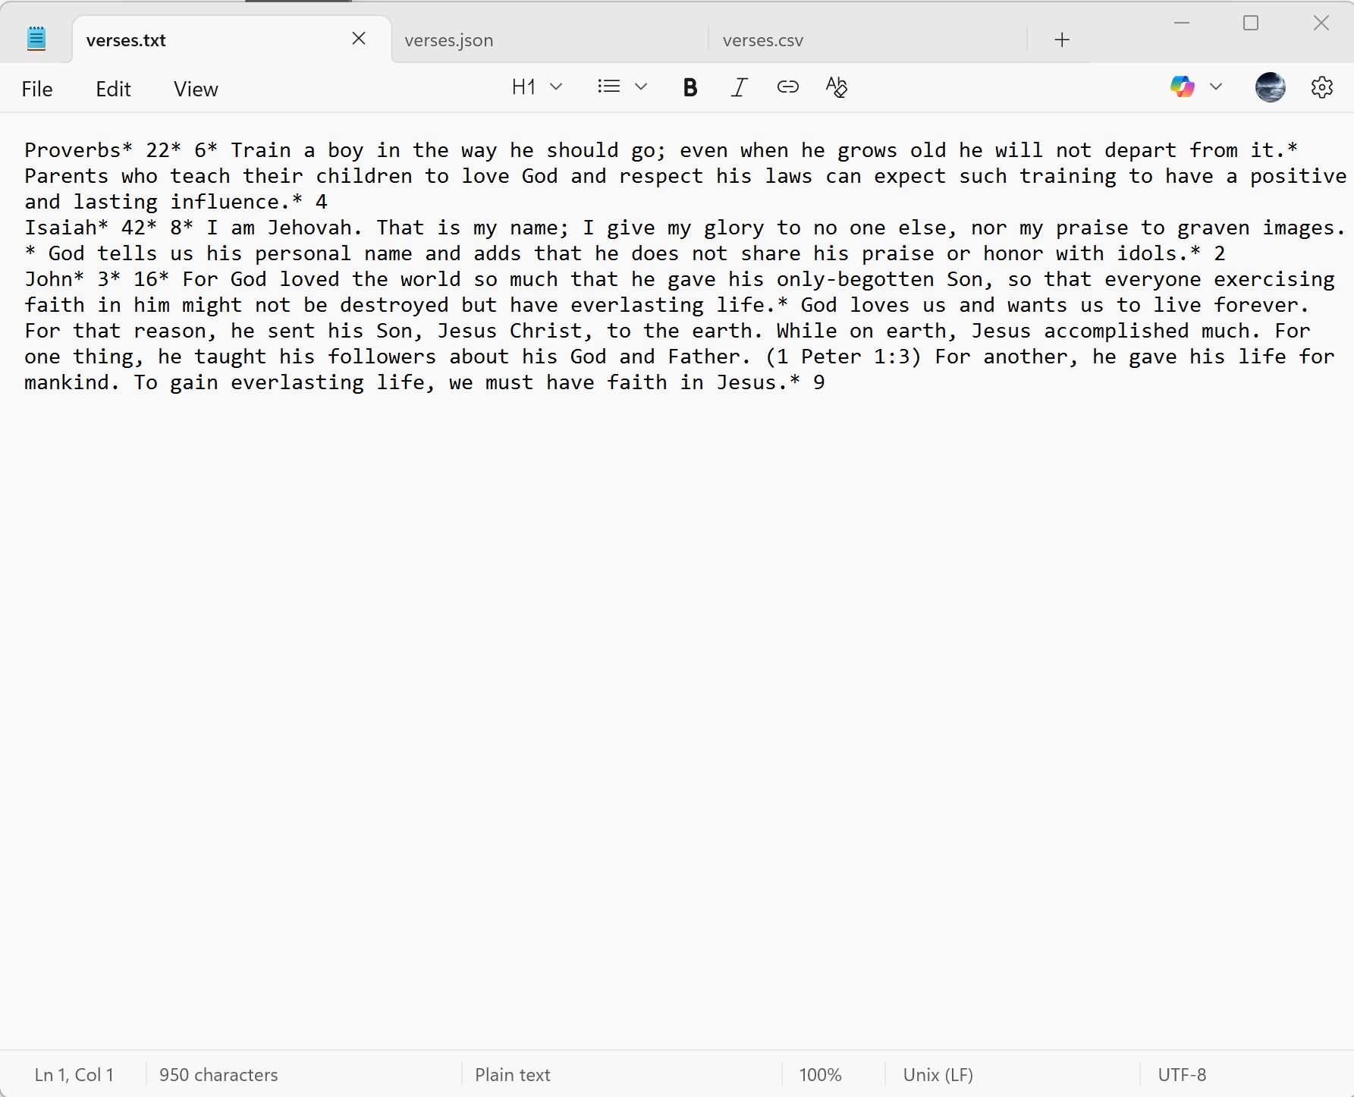
Figure 2-4: Screenshot of .txt verses file
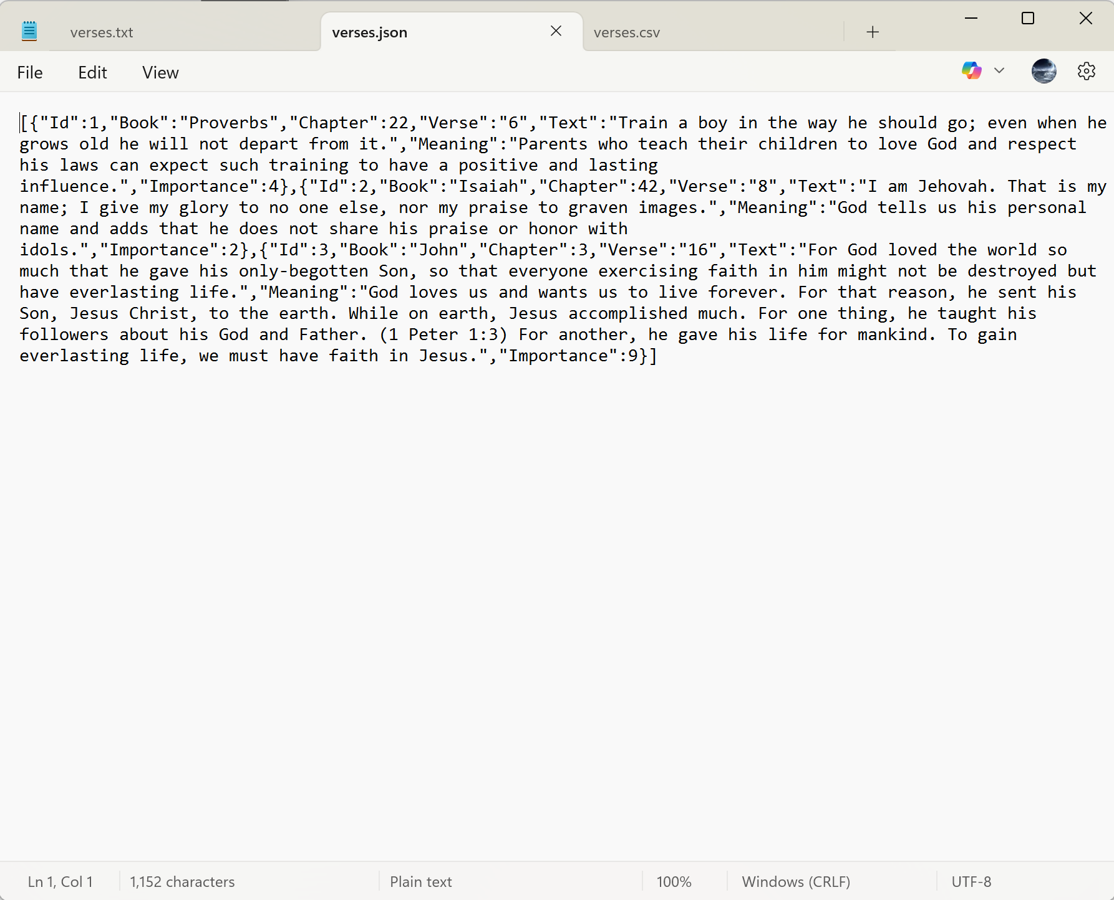
Figure 2-5: Screenshot of .json verses file

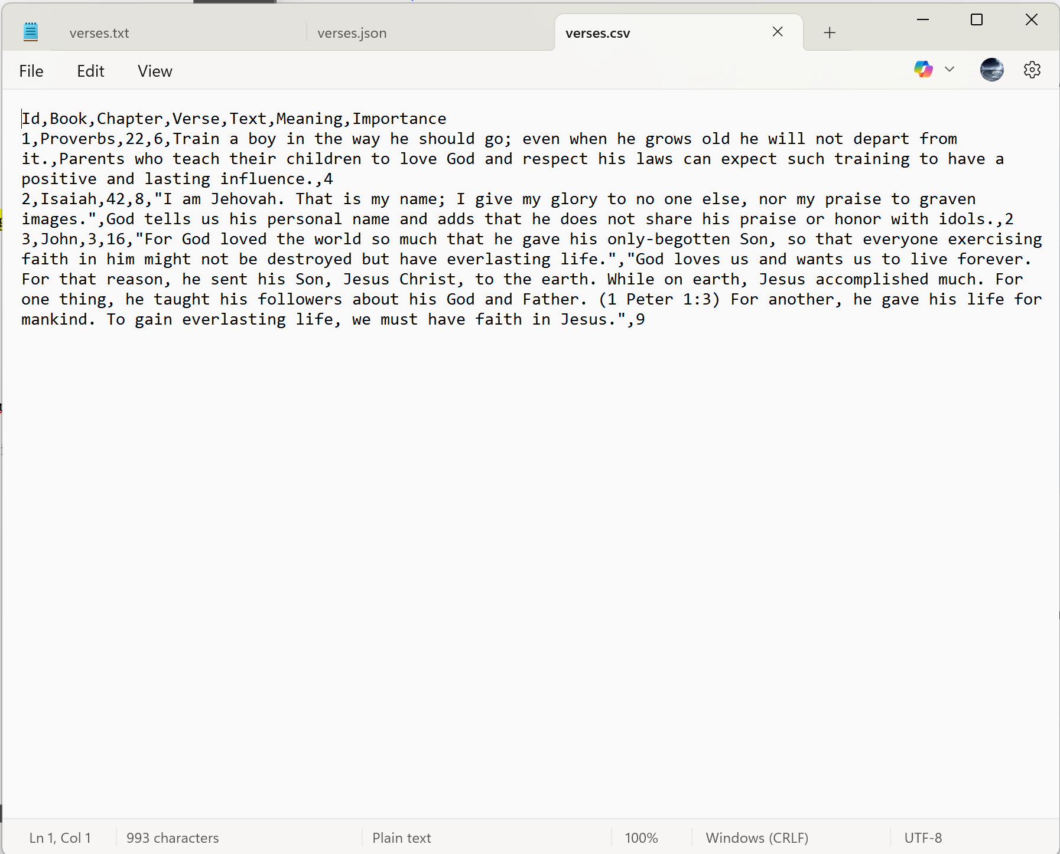
Figure 2-6: Screenshot of .csv verses file

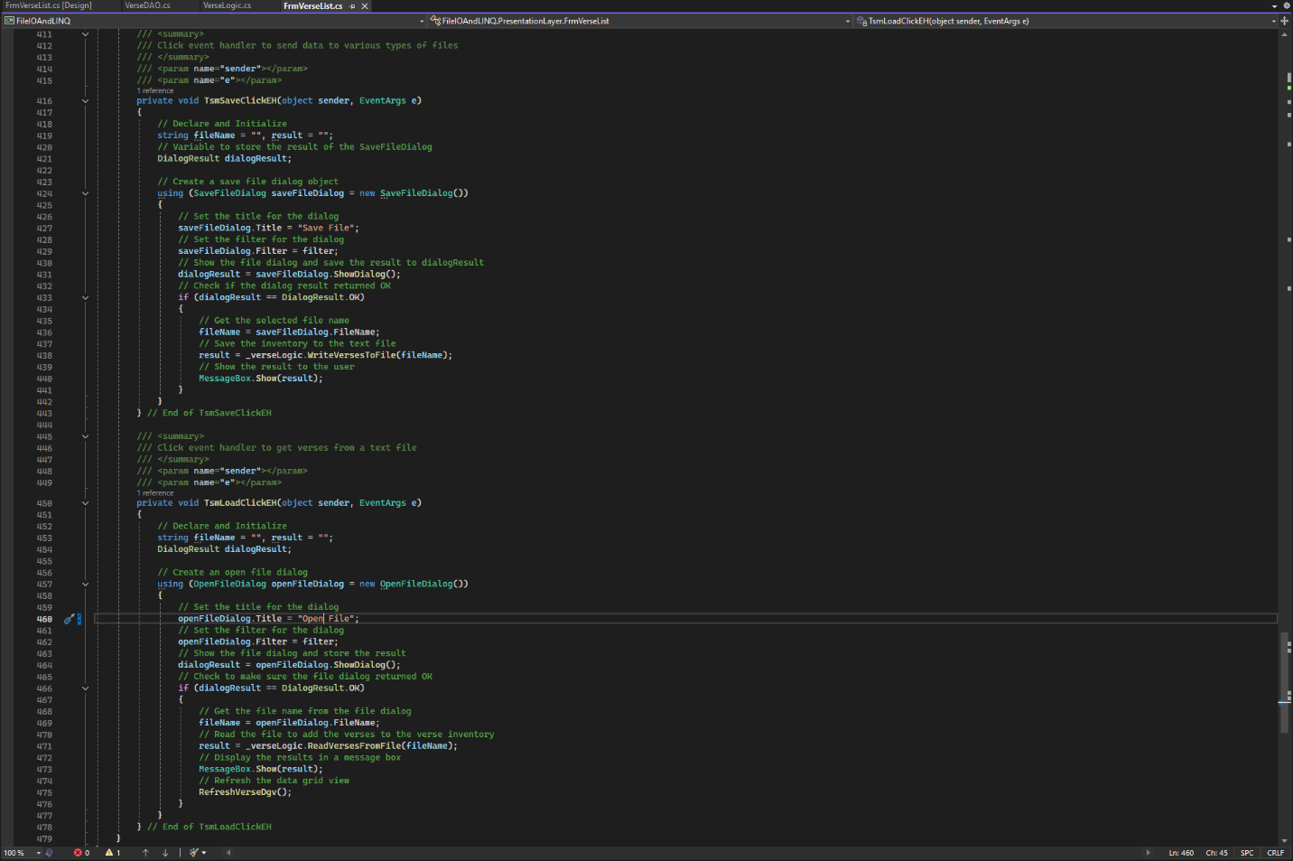
Figure 2-7: Screenshot of the save and load click event handlers for the menu items save and load.

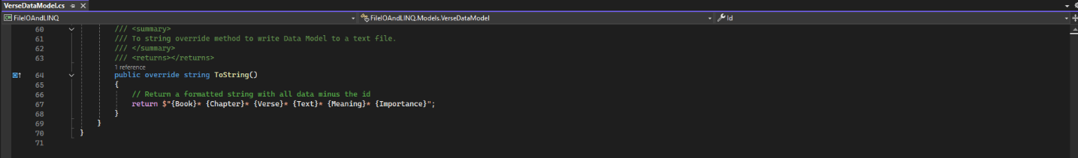
Figure 2-8: Screenshot of the overridden ToString() method within the VerseDataModel

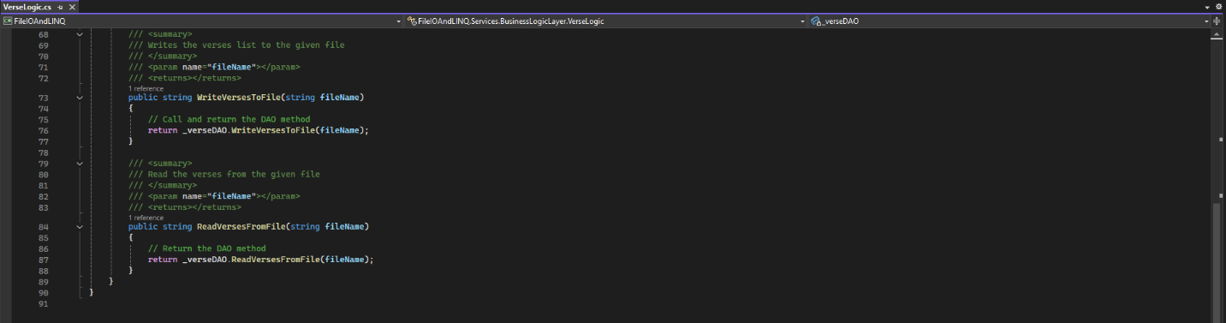
Figure 2-9: Screenshot of the write verses to file and the read verses from file methods inside the verse logic class.

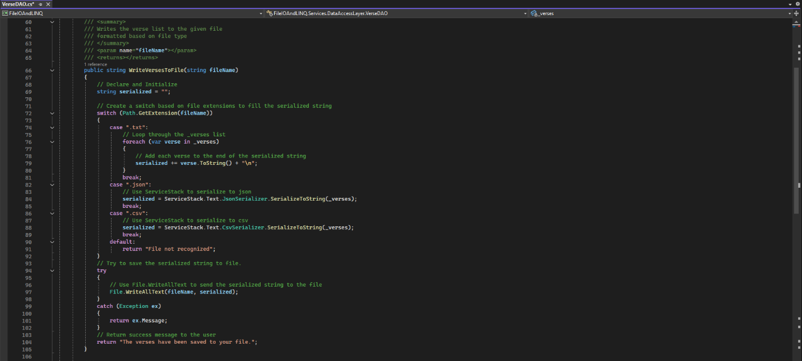
Figure 2-10: Screenshot of the write verses to file method inside the verse DAO class.

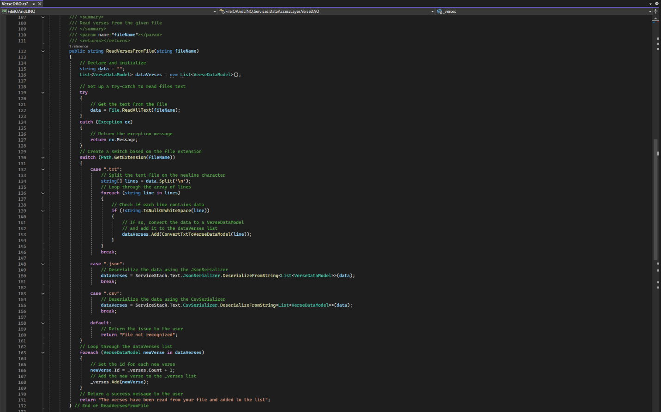
Figure 2-11: Screenshot of the read verses from file method inside the verse DAO class.
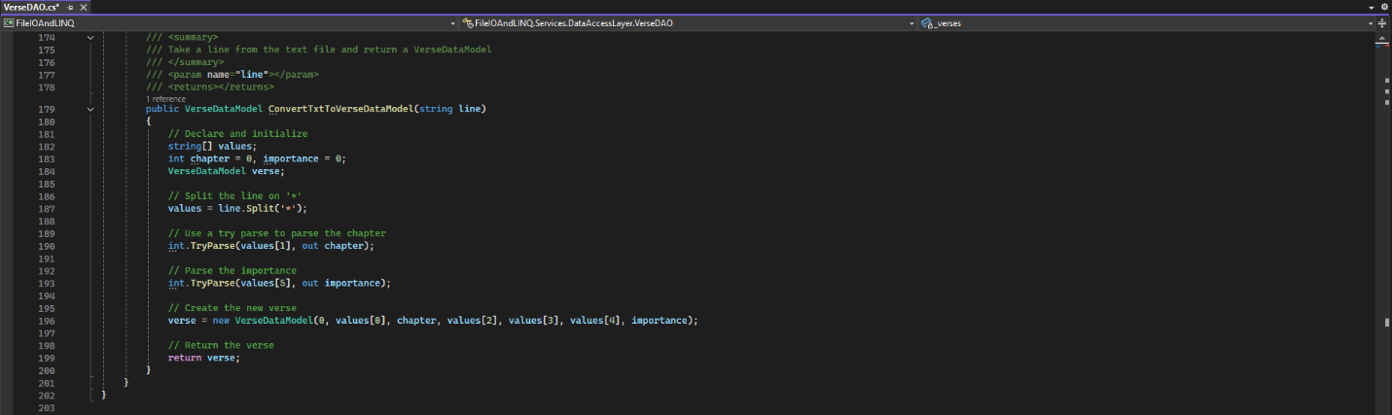
Figure 2-12: Screenshot of the convert txt to verse data model

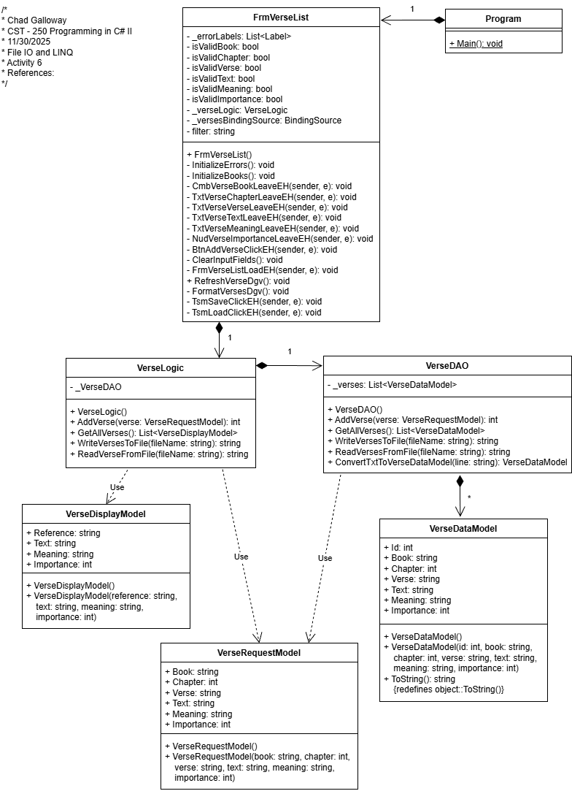
Figure 2-13: Screenshot of UML as the project exists now.

Part 3: Filter and Sort

Screen Shots

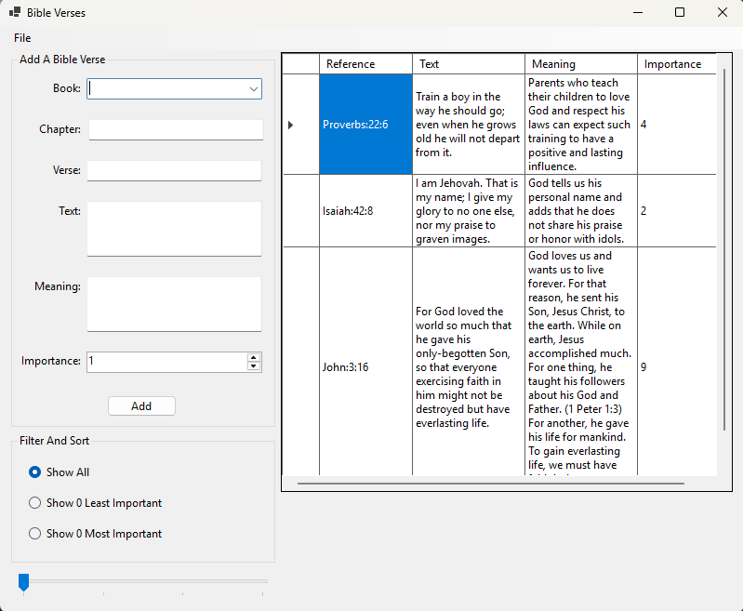
Figure 3-1: Part 3 App Running with a file loaded in. I set the application to start with the Show All radio button checked and the text for the other two radio buttons to display the number 0 as this better represents the starting state of the application to the user.

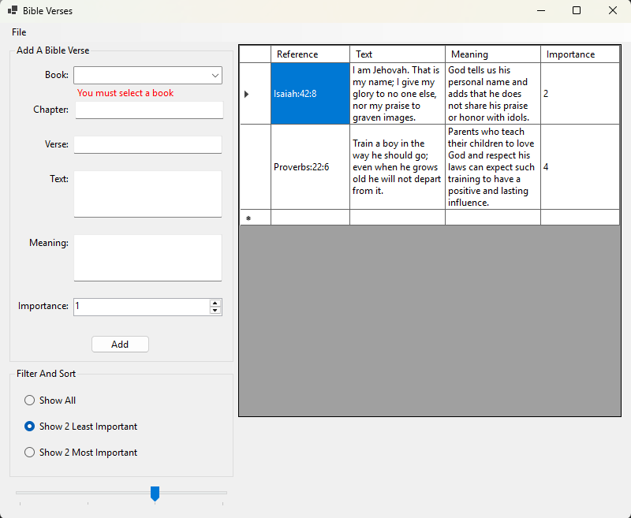
Figure 3-2: Screenshot of the application showing only the least important verses. I added handling of the adjustment of the track bar while a filter is selected by calling the selected changed event handlers when the scroll changes because previously the user had to change filters for track bar scroll changes to be visible.

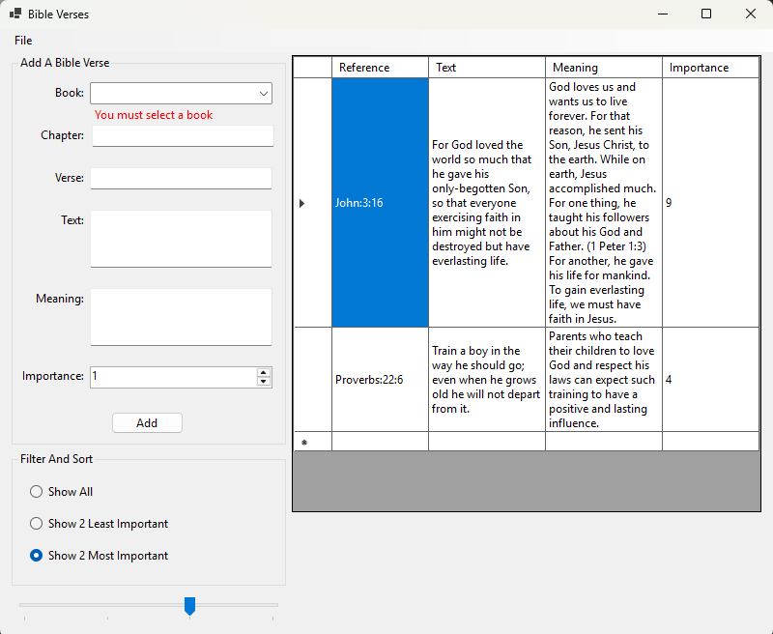
Figure 3-3: Screenshot of the application showing only the most important verses.

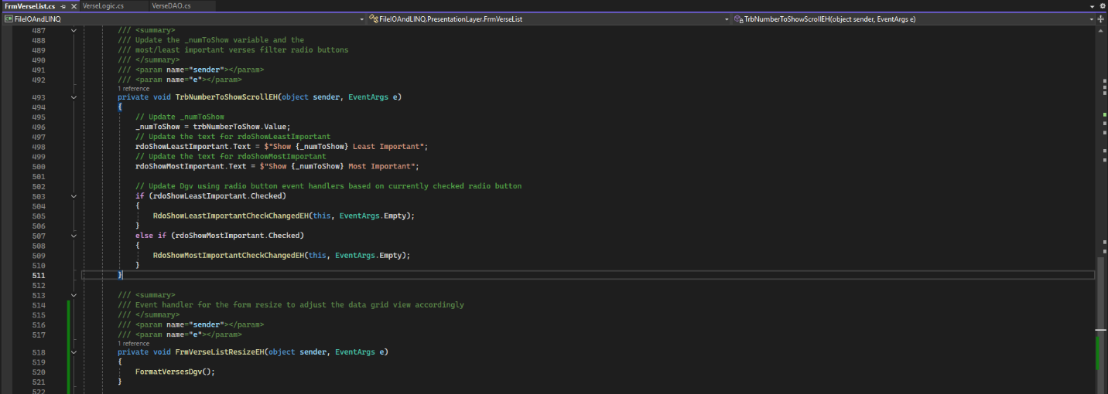
Figure 3-4: Screenshot of the track bar number to show scroll event handler and an additional form resize event handler I added in to keep the DGV the correct size if the user resizes the form. I also added a few lines in the track bar scroll event handler to recall the event handlers for the radio buttons to keep the DGV up to date when the track bar number is changed.

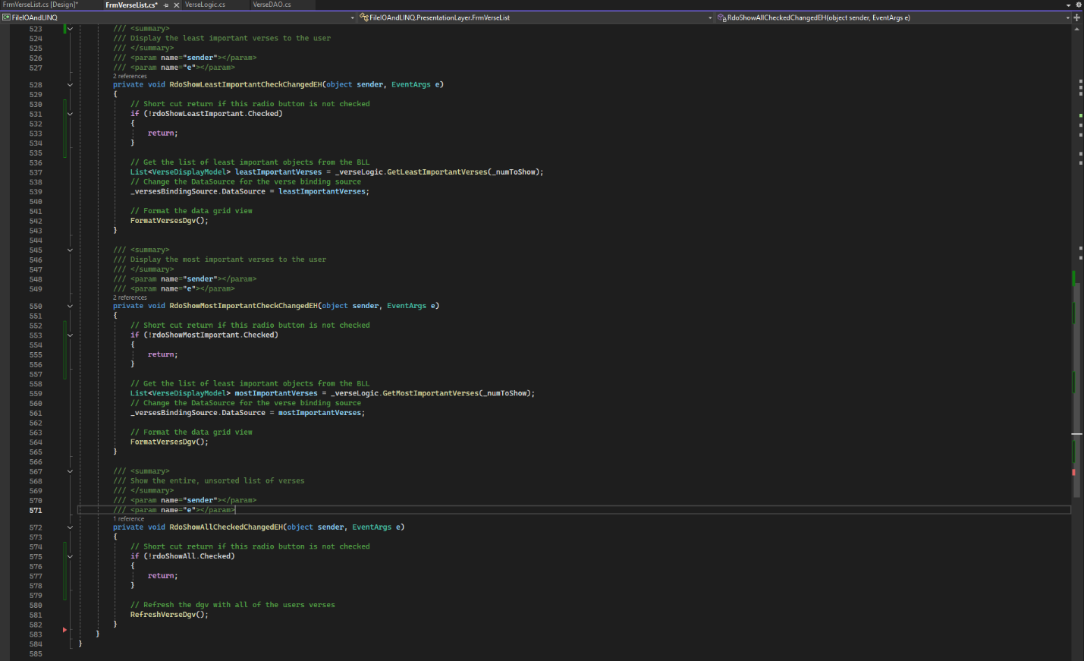
Figure 3-5: Screenshot of all three of the radio buttons check changed event handlers. I added a short cut return check to all three event handlers to return without running the logic if their state is unchecked. Using the logic in this activity an event fires on a filter being unchecked and then again on the new filter being checked so without this short cut all logic would fire twice. If I was writing the project I would point all three radio buttons to the same event handler and use the sender property to figure out what which filter to process. An unchecked short cut check would still be included at the beginning but condensing all three radio buttons into one method is a much better practice for grouped radio buttons.

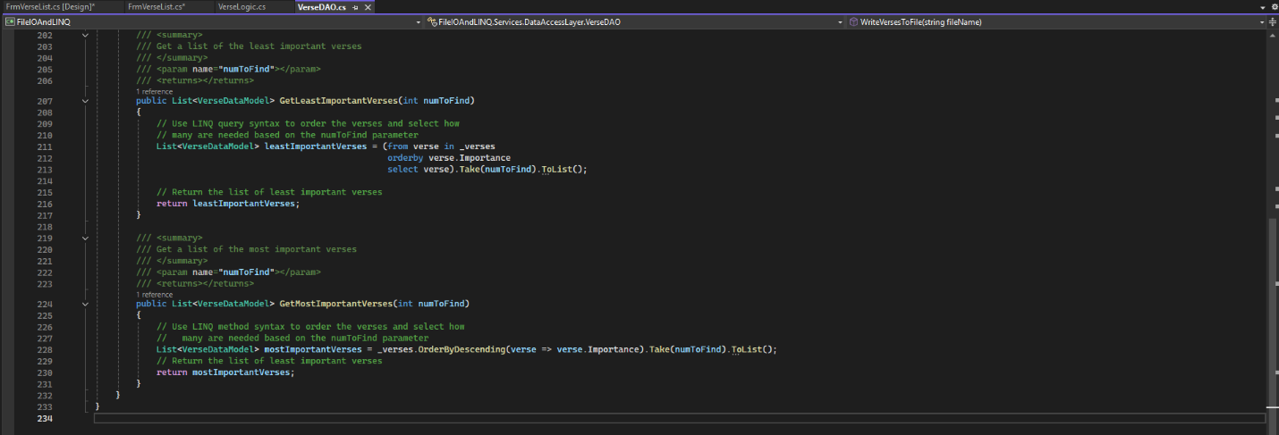
Figure 3-6: Screenshot of the code behind the get least important and get most important verse methods in the Verses DAO class

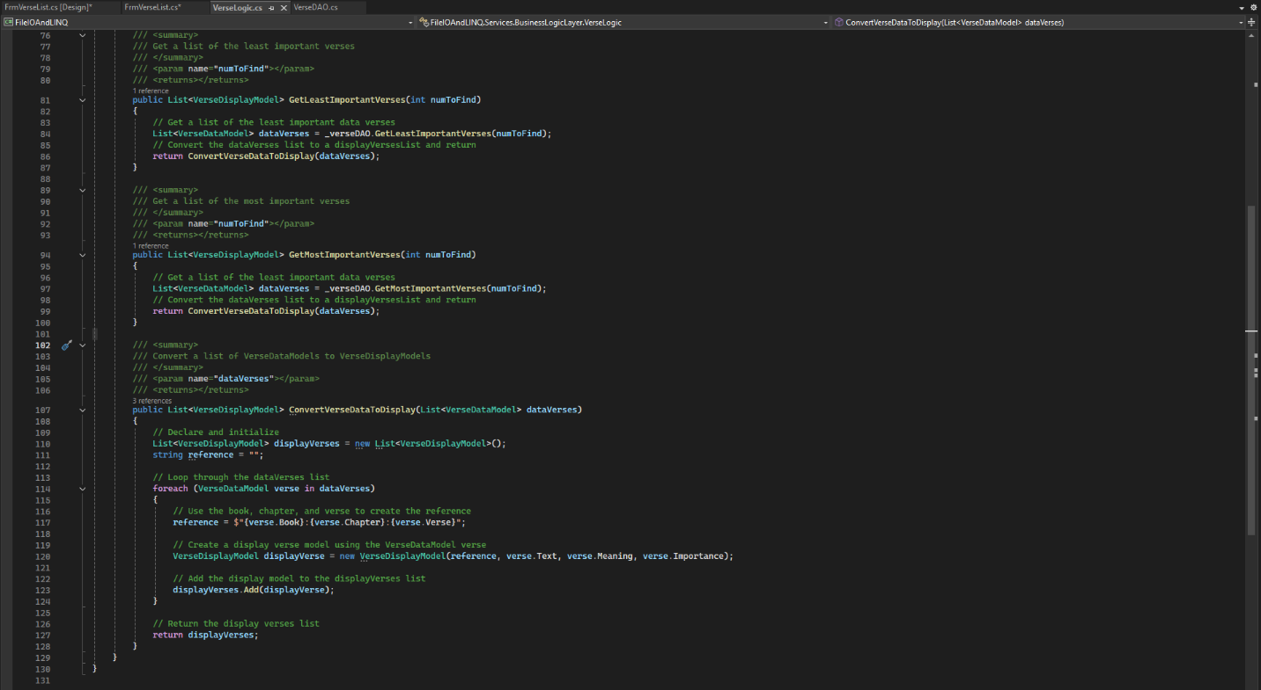
Figure 3-7: Screenshot of the get most important verse and get least important verse methods from the verse logic class along with the convert verse data to display from the same class that both methods use for converting their input parameter(dataModel) to displayable return(displayModel) values.

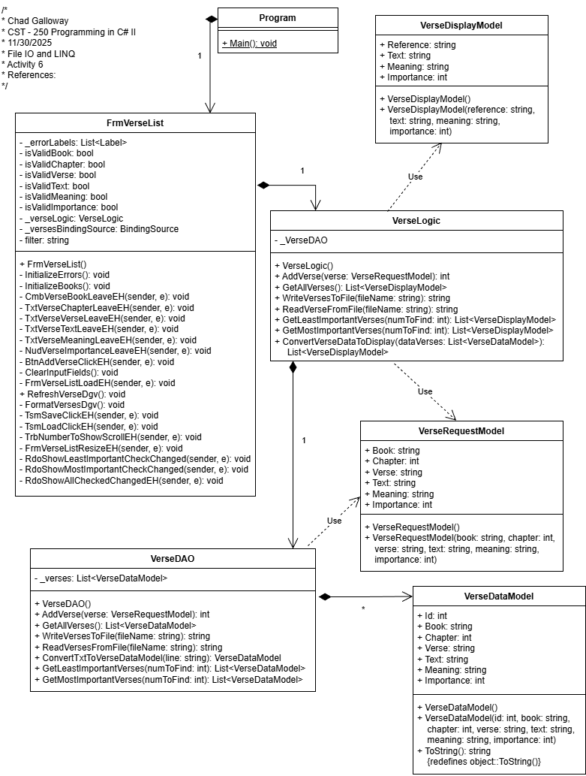
Figure 3-8: Screen shot of the UML as the project exists currently.

Part 4: Challenges

Screen Shots

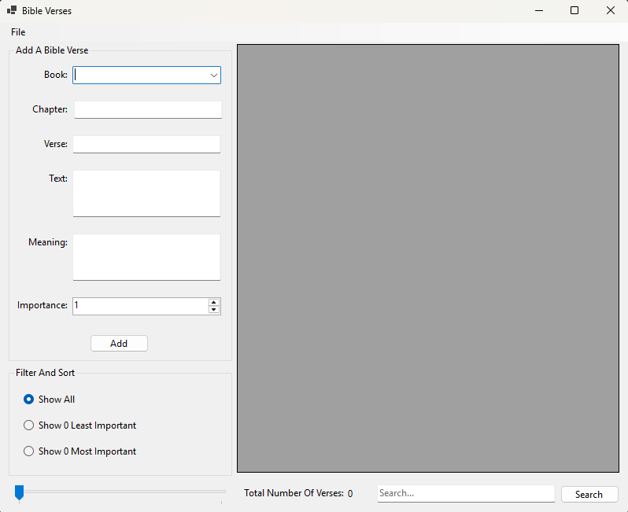
Figure 4-1: Part 4 App Running in the initial load state. This is what the user will see when they first launch the application.

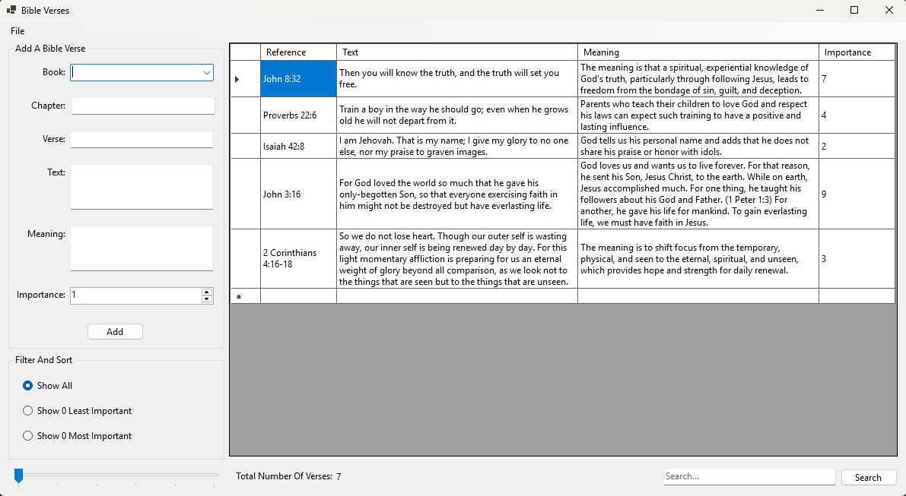
Figure 4-2: Screenshot of successful file loaded in and form resized.
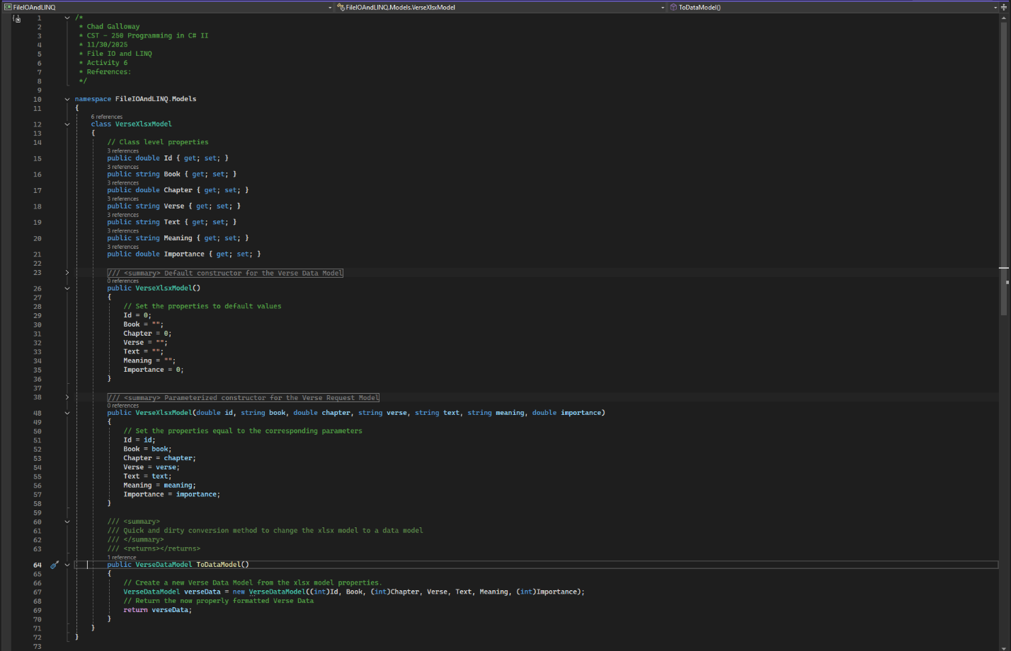
Figure 4-3: Screenshot of the code behind the verse xlsx model I added in to receive the data coming in from the excel files. Excel stores numbers as doubles and the data model is int so I created a small class to hold the doubles and then create and return a data model with ToDataModel() method. I am not 100% sure putting the ToDataModel here was the best practice but it was quick and clean which I guess is the best practice.
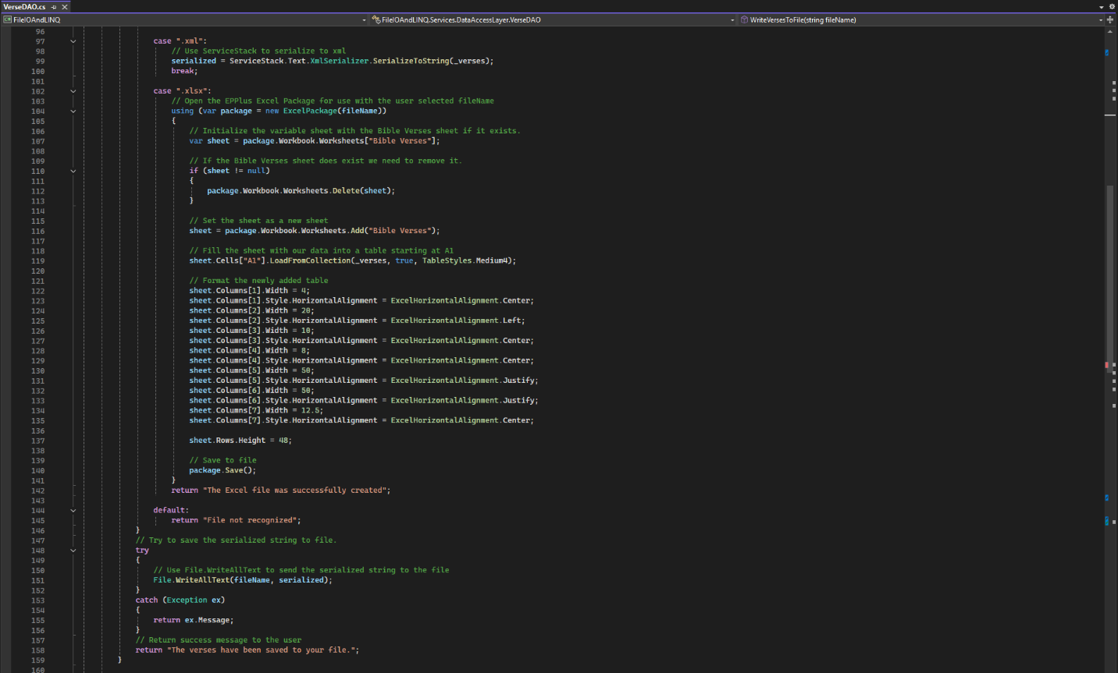
Figure 4-4: Screenshot of the case additions to write verses to file for .xml and .xlsx. The xml addition went pretty smoothly; the Excel addition was a little more complicated and required a bit of trial and error with the documentation on the EPPlus web site to get the look I wanted in the outputted file. Another issue was figuring out how to handle file overwrites. I ended up needing to delete the worksheet every time and rewrite it.

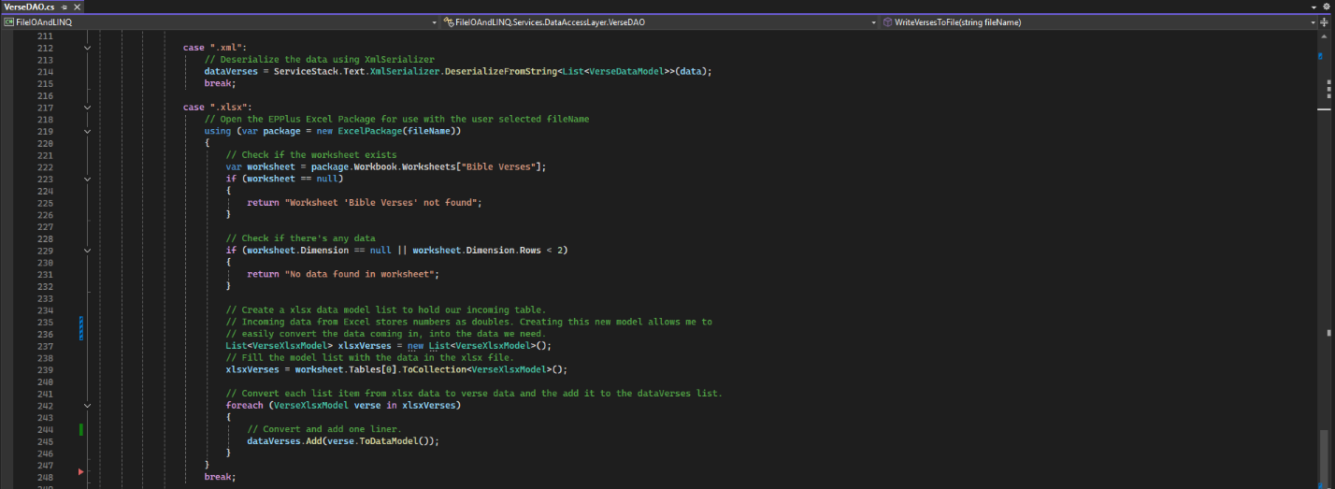
Figure 4-5: Screenshot of the case additions to read verses from file for .xml and .xlsx. Again, xml was really straight forward using the previously installed ServiceStack. At this point the reading of the Excel file was pretty painful. I tried several different fixes and methods for getting the Excel data back into the data grid view. After a few hours of messing around what turned out to be the issue was the numbers in Excel being represented as double values and the data model I was trying to store the files data in looking for int values. I created an additional class to hold the excel data and then converted it after the fact to a verse data model. This got everything working as intended.

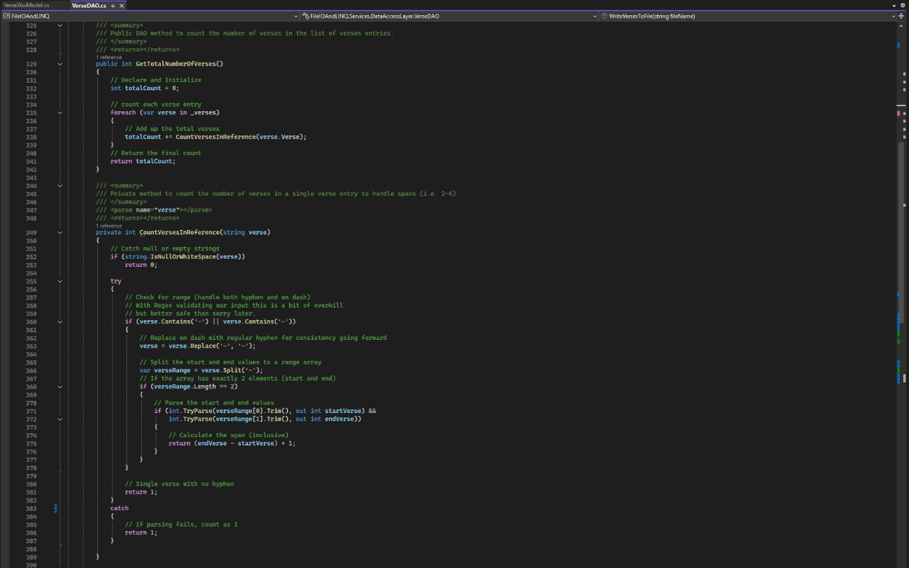
Figure 4-6: Screenshot of the get total number of verses and count verses in reference methods used to get the total number of verses the user has collected.

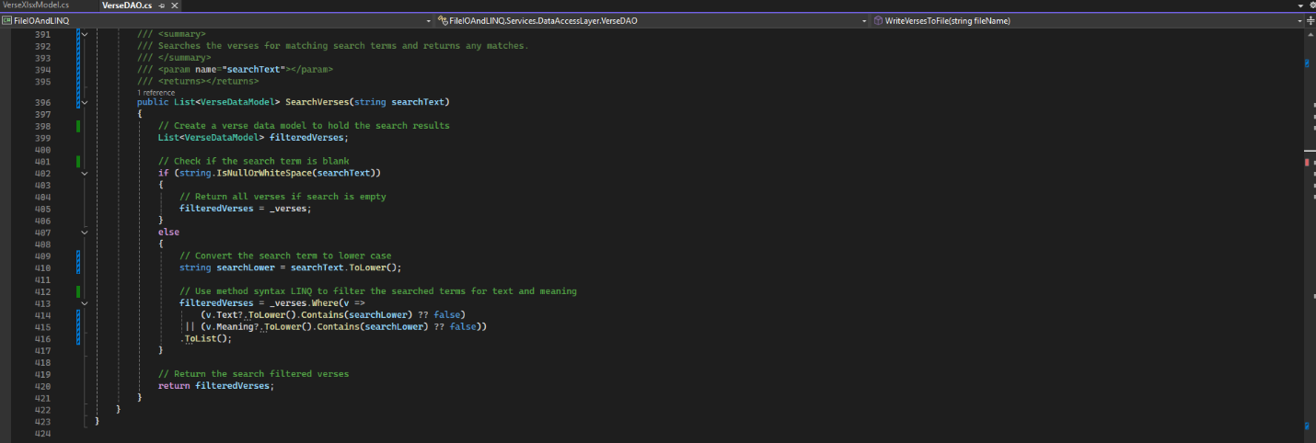
Figure 4-7: Screenshot of the search verses method in the Verse DAO that finds and returns all verses that match the given search term. LINQ method syntax is used to iterate over all the _verses and add the ones that match to the filtered verses list before returning the filtered list.

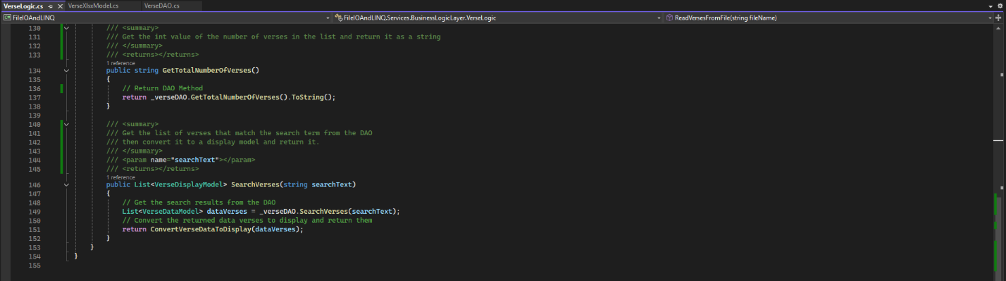
Figure 4-8: Screenshot of the changes to the verse logic class. The read and write file methods were unchanged, all the heavy lifting there was done in the DAO. I did add some methods to get the number of verses and the search results from the DAO.

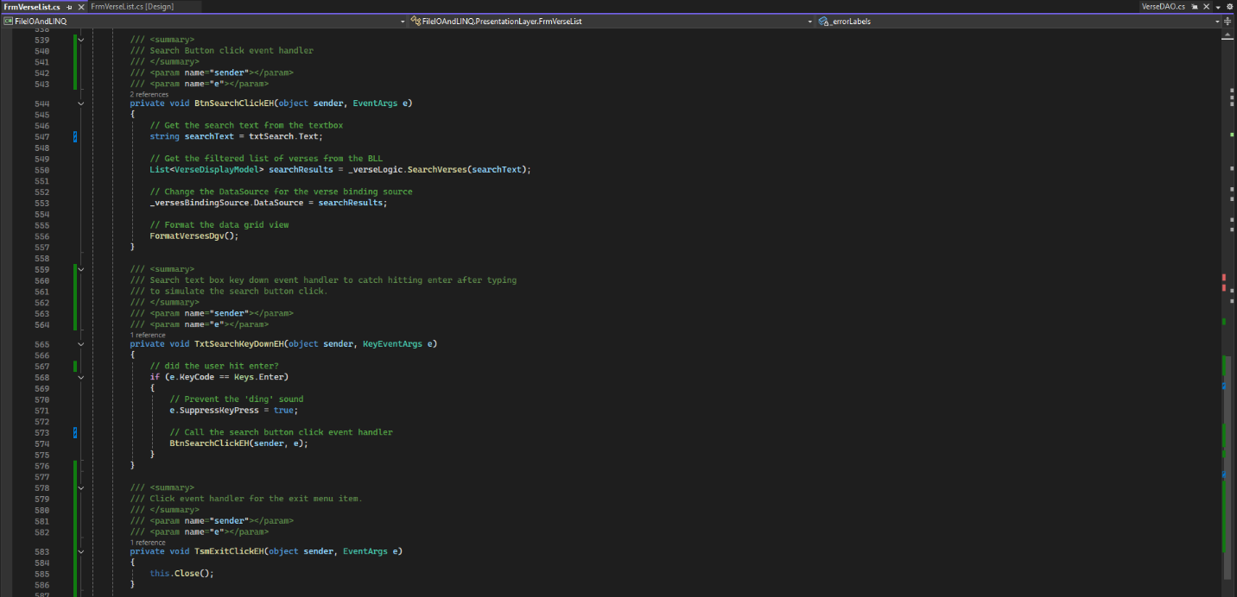
Figure 4-9: Screenshot of event handlers added to the form verse list to handle the presentation of the search functionality and the final menu item Exit implemented.

Figure 4-10: Screenshot of the UML as it stands now.

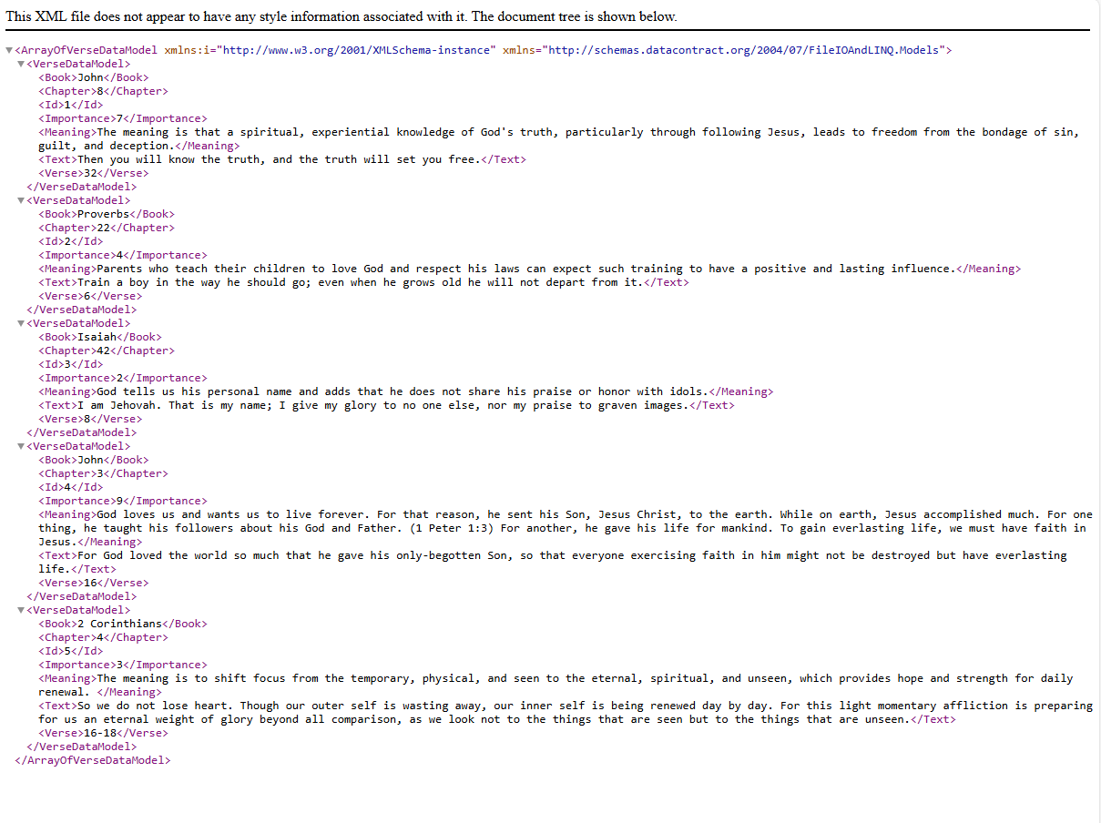
Figure 4-11: Screenshot of xml file opened in Microsoft Edge

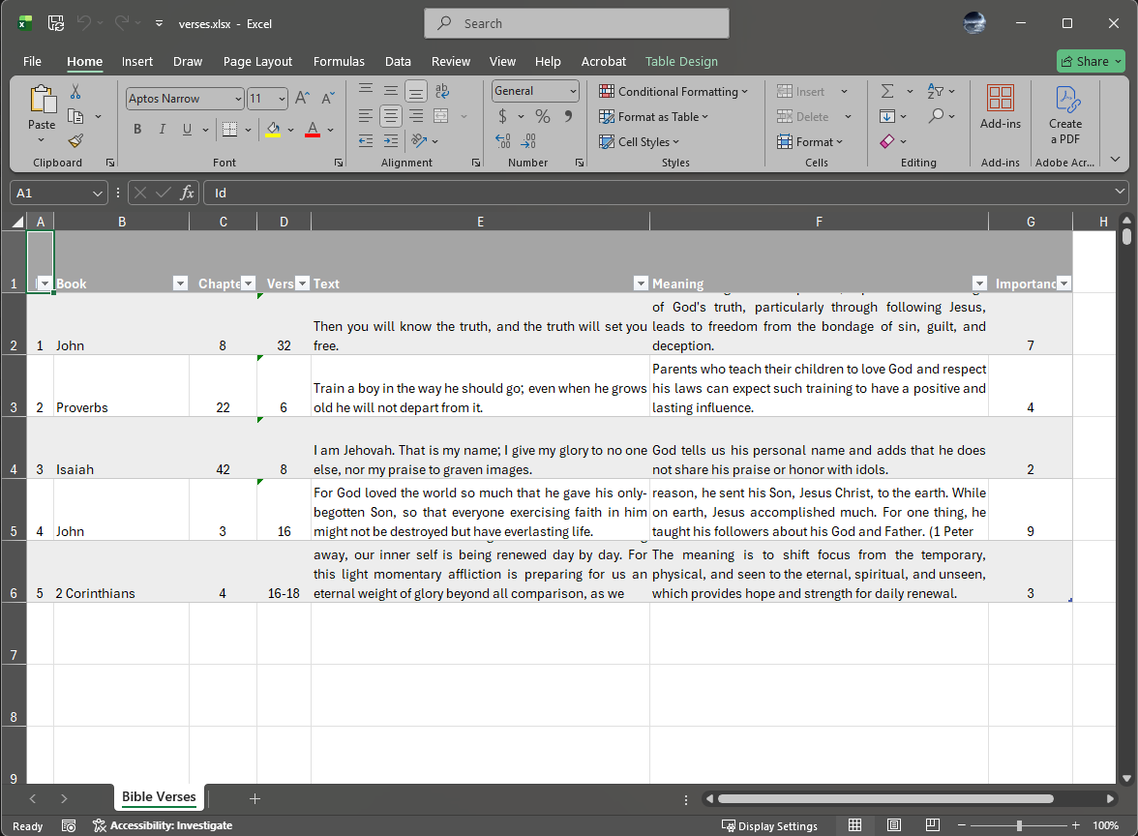
Figure 4-12: Screenshot of the xlsx file opened in Excel.

