Activity 6: Building an N-Layer Application With Advanced File I/O, LINQ, and Data Binding
Introduction 2
Objectives 3
Part 1: Creating the UI 4
RegEx Explained 22
RegEx in This Application 24
Part 2: File I/O 50
Add a Dependency for Text Serialization using NuGet 50
Part 3: Filter and Sort 65
Challenges 76
What You Learned From This Activity 77
Check for Understanding 79
Deliverables 82

Introduction
In this lesson, you will explore file input/output operations, language integrated query (LINQ), and regular expressions (RegEx). Through hands-on exercises, you'll learn to integrate external libraries using NuGet and manipulate commonly used data formats such as JavaScript Object Notation (JSON), comma separated values (CSV), and extensible markup language (XML). By the end of this lesson, you will have developed an application capable of handling various data interactions, showcasing your ability to manage file operations, enhance user interfaces (UI), and perform advanced data queries.
The GCU College of Engineering and Technology Coding Guidelines and Best Practices for C#, available in the Class Resources, must be followed in all CST-250 projects to ensure consistency, readability, and professionalism in student code. These guidelines promote a clear separation of concerns by organizing code into the Models, BusinessLogicLayer, and DataAccessLayer folders. The document also outlines essential standards for casing, naming conventions, code structure, commenting, and organization. Additionally, it emphasizes best practices in object-oriented design, exception handling, and the use of design patterns. Adhering to these expectations is required for successful completion of course assignments.

Objectives
- Data Binding and Grid Controls: Bind collections to grid controls for display, leveraging data binding to manage UI updates.
- RegEx: Employ RegEx to check format for verse entry.
- NuGet: Integrate external libraries using NuGet to enhance functionality.
- Serialization: Use external libraries such as ServiceStack for serialization.
- File Input/Output Operations: Read from and write to text, JSON, and CSV files.
- LINQ: Understand and apply basic LINQ queries to perform sorting and filtering of data collections using both long form (Query) syntax and method (Fluent) syntax.
We will be building an application to keep track of Bible verses. The final application will mirror Figure 1.
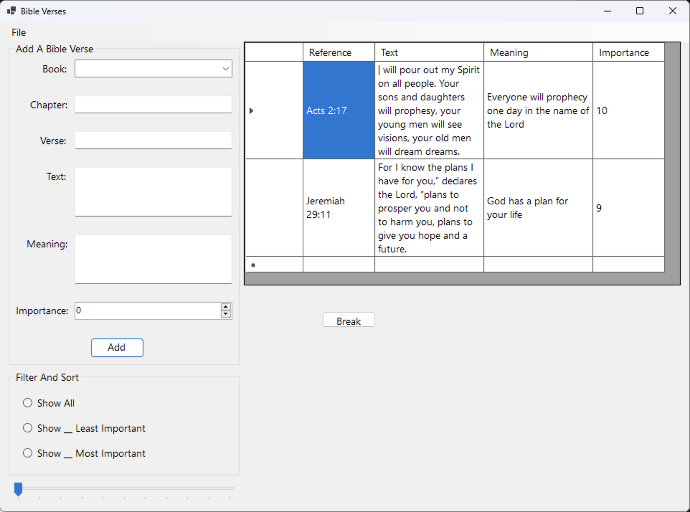
Figure 1: Final stage of the application built in this activity.

Part 1: Creating the UI
- Create a new Windows Forms App project named "FileIOAndLINQ," as shown in Figure 2. Use the most recent long-term support version of .NET.
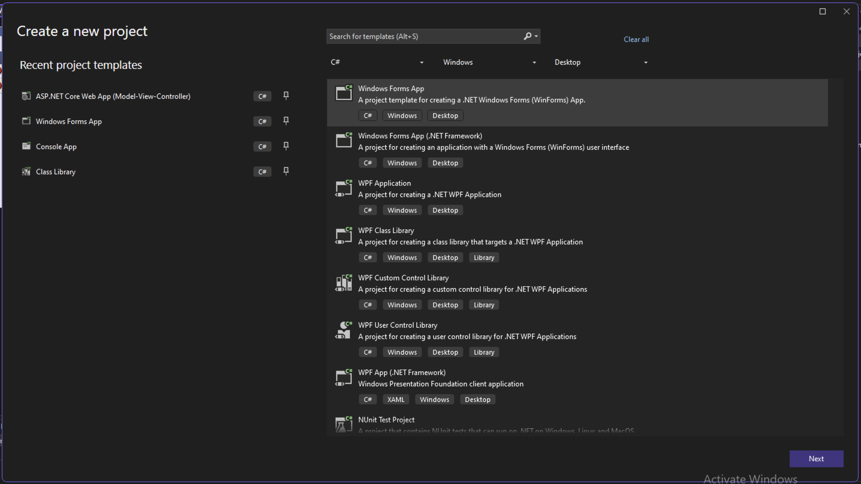
Figure 2: Creating the FileIOAndLINQ project

- Right click on Form1.cs to delete it from the solution, as shown in Figure 3.
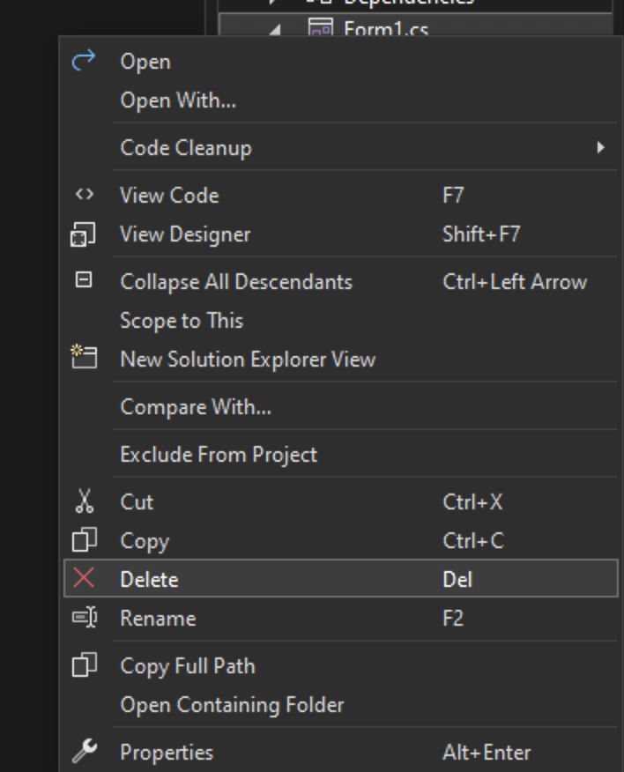
Figure 3: Deleting Form1
- Add a new folder to the project named PresentationLayer, as shown in Figure 4. This folder will contain our forms for the application.
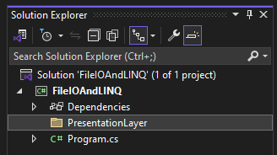
Figure 4: Adding a PresentationLayer folder to the project

- Add a new form to the PresentationLayer folder named FrmVerseList.cs, as shown in Figure 5.
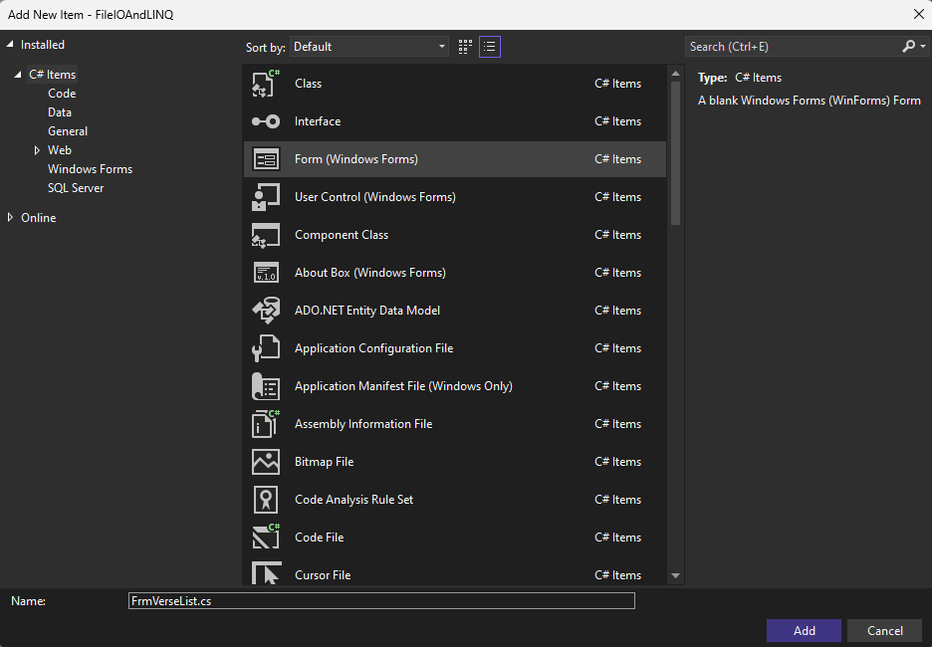
Figure 5: Adding FrmVerseList.cs to the PresentationLayer folder

- Add the project to source control.
- See the Class Resources for a detailed tutorial on GitHub source control.
- Use the Text property to change the text for the new form to "Bible Verses," as shown in Figure 6.
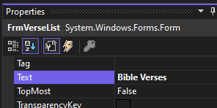
Figure 6: Changing the text for FrmVerseList
- If you try to run the program currently, you will get an error because the application cannot find Form1 to run. To fix this, open the Program.cs file and find the Application.Run method. Replace Form1() with FrmVerseList(), as shown in Figure 7. You may need to add a using statement for FileIOAndLINQ.PresentationLayer. You should now be able to run the app.
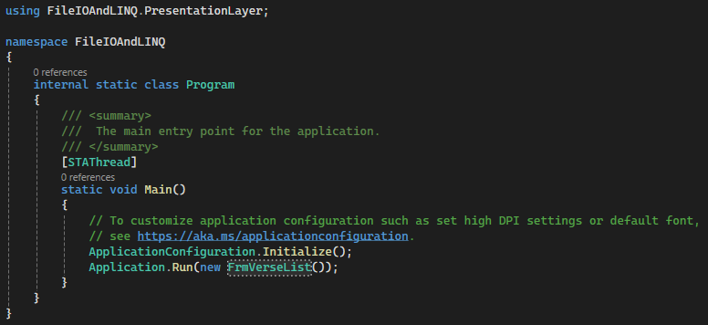
Figure 7: Updated Program.cs file to run FrmVerseList
- Back in FrmVerseList, we need to populate our form with controls. First, add a MenuStrip control to the form, as shown in Figure 8. This will allow us to create a drop down of selections for the user similar to the menu buttons at the top of your screen (File, Edit, View, etc.). Change the name of the menu strip to mnsFileActions using the naming convention for menu strips: mns.
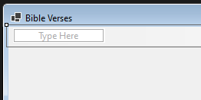
Figure 8: Adding a MenuStrip control

- Click on the box labeled "Type Here" and enter "File" to create a new tool strip menu item, as shown in Figure 9. This will add a drop down to the top of our page. The naming convention for tool strip menu items is tsm, so we will rename the new control to tsmFile.
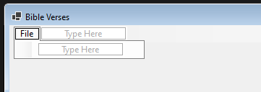
Figure 9: Adding a File tool strip menu item to the menu strip
- In the File menu, we will have three buttons, Save, Load, and Exit. Use the second "Type Here" box to add these buttons, as shown in Figure 10, and rename them to tsmSave, tsmLoad, and tsmExit, respectively.
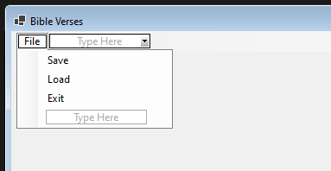
Figure 10: Adding Save, Load, and Exit to the menu strip control
- Add a group box for the controls to add a new Bible verse. Name the group box grpAddVerse and change the text to "Add A Bible Verse" as shown in Figure 11.
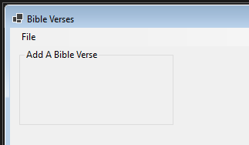
Figure 11: Add A Bible Verse group box on FrmVerseList
- Inside the group box, we will start by adding six labels: "Book:," "Chapter:," "Verse:," "Text:," "Meaning:," and "Importance:," as shown in Figure 12.
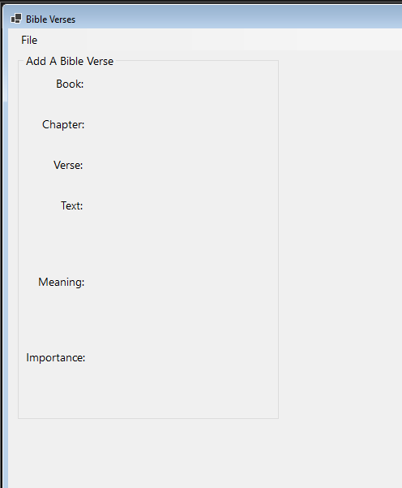
Figure 12: grpAddVerse with labels
- Next, add a comboBox named cmbVerseBook and two text boxes named txtVerseChapter and txtVerseVerse, as shown in Figure 13.
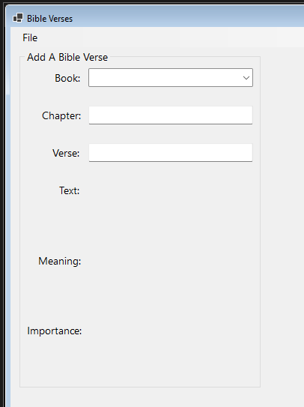
Figure 13: Adding the book combo box and the text boxes for chapter and verse
- Add two more text boxes named txtVerseText and txtVerseMeaning to the group box as shown in Figure 14. By changing the Multiline property to true, we can allow the user to enter multiple lines of text.
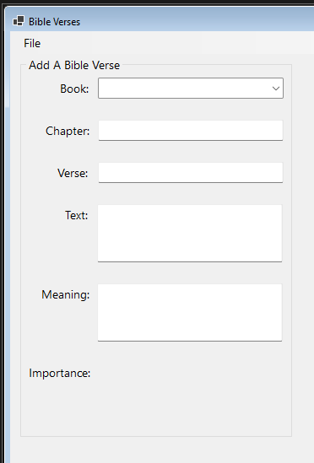
Figure 14: Adding two multiline text boxes to the Add A Bible Verse group box

- Next, add a NumericUpDown control to the form named nudVerseImportance for the importance attribute of our verse. This will allow the user to select how important the verse is to him/her. This will be a range of 1–10, so we will need to update the Maximum property to 10 for the control. Then, add in a button named btnAddVerse and change the text to "Add Verse," as shown in Figure 15. This will allow the user to add his/her verse to the application.
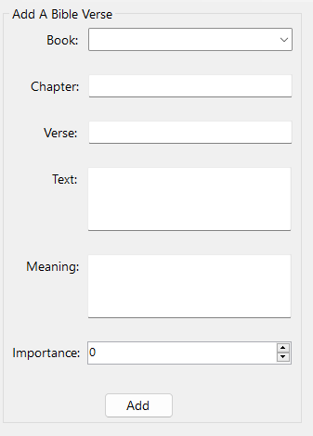
Figure 15: Adding NumericUpDown and button controls to the group box

- Finally, add labels for each control to allow us to display errors to the user. Change the ForeColor for each label to red, as shown in Figure 16. We will also need to name the labels, as we will reference them from the back-end. The labels should be named lblVerseError, lblChapterError, lblVerseError, lblTextError, lblMeaningError, and lblImportanceError, respectively. Also, change the text for each label to reflect its purpose.
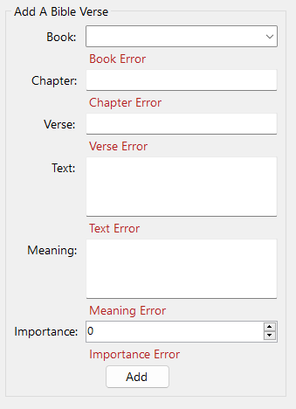
Figure 16: Final grpAddVerse

- Next, we will need another group box. This one should have the text "Filter And Sort," as shown in Figure 17. This box will contain radio buttons to filter and sort the verses in our list.
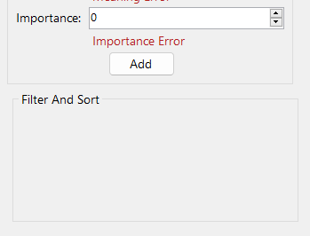
Figure 17: Adding the Filter And Sort group box to the form
- Inside the group box we just created, add three radio buttons with the text "Show All," "Show Least Important," and "Show Most Important," as shown in Figure 18. Change the names for the radio buttons to rdoShowAll, rdoShowLeastValuable, and rdoShowMostValuable.
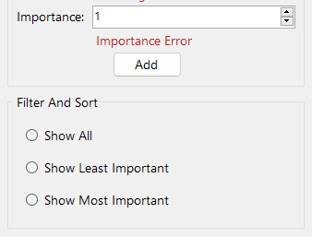
Figure 18: Finished Filter And Sort group box

- Add a TrackBar control to the form beneath the Filter and Sort group box, as shown in Figure 19. This control will allow us to select the number of least and most important items to show. The naming convention for track bars is trb, so name the TrackBar trbNumberToShow.
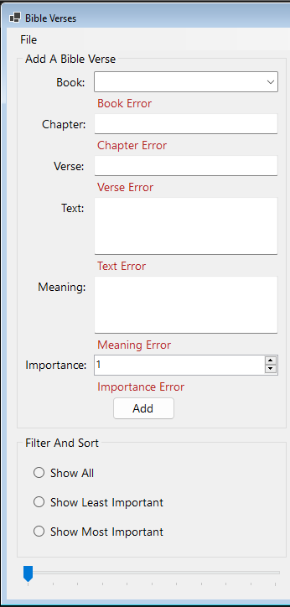
Figure 19: Adding a TrackBar to the Verse List form

- Add a DataGridView control to the right of the group boxes we have created, as shown in Figure 20. This will be used to show the list of verses in the inventory. The naming convention for data grid views is dgv, so name the control dgvVerseDisplay.
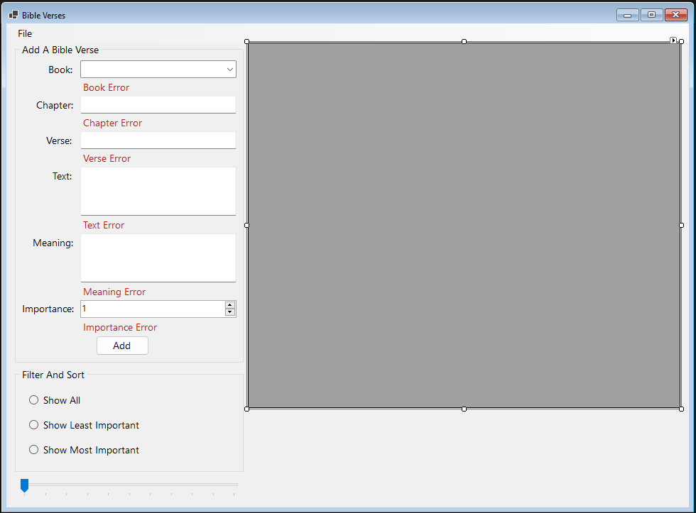
Figure 20: Adding the data grid view to FrmVerseList

- Commit all changes in the project to source control.
- Commit Message: Finish the UI for the File I/O and LINQ project.

- Open the code for FrmVerseList and add a citation to the top, as shown in Figure 21.
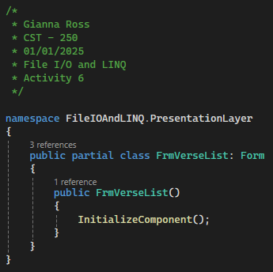
Figure 21: Citation for FrmVerseList
- Create a private class-level variable that will contain a list of labels, as shown in Figure 22. This list will allow us to quickly hide our error labels.
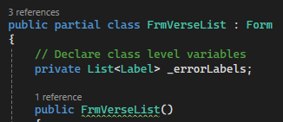
Figure 22: Creating the _errorLabels list

- Create a new, private method that will set up the error label list and hide each error, as shown in Figure 23. Then, call the method from the FrmVerseList constructor. You should also add a summary comment to the constructor.
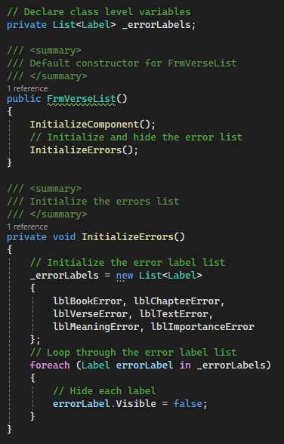
Figure 23: Initialize the error list

- Create a second private method that will set up our Bible books named InitializeBooks, as shown in Figure 24. First, create a list of strings that contains a string for each book of the Bible. Then, we can set the DataSource for the combo box to our BibleBooks variable. By setting the selected index to -1, we can remove the default selected book. Finally, we can set up auto complete for the list. We will use the suggest mode, which will filter the list of books based on the user types. We will also need to set the auto complete source for the application to ListItems, which will pull from the DataSource list for the combo box.
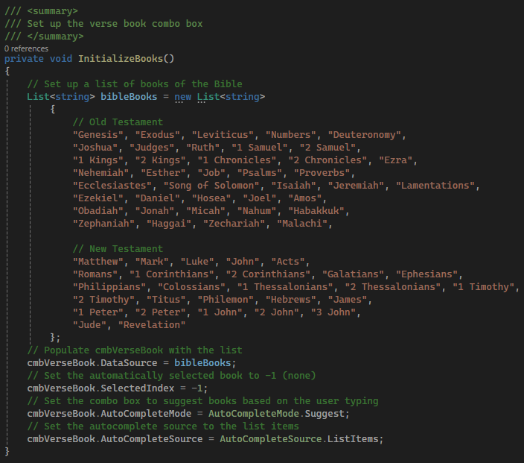
Figure 24: Creating the InitializeBooks method
- Call the InitializeBooks method in the constructor, as shown in Figure 25.
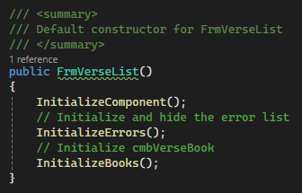
Figure 25: Calling the IntititalizeBooks method

- Commit all changes in the project to source control.
- Commit Message: Finish initialization of error labels and book combo box.
- Next, we will need to set up event handlers for each input control for the user to add a new verse. To make sure that we have valid data for each control, we should set up a flag for each of the necessary inputs for the verse. as shown in Figure 26. As we receive valid data for each control, we can set the flags to true.
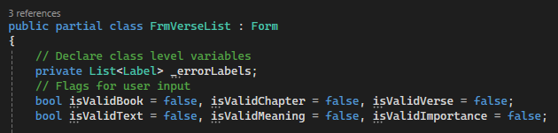
Figure 26: Set up flags for each input field in the UI
- Attach a Leave event handler named CmbVerseBookLeaveEH to cmbVerseBook, as shown in Figure 27. Add a summary comment to the created method.
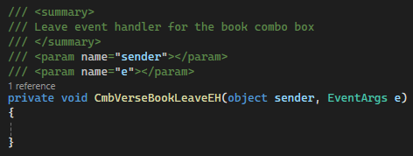
Figure 27: Setting up the event handler for the verse's book

- To check whether the book that the user has selected is valid, we will need to make sure that the selected index is greater than or equal to 0 and set the isValidBook flag accordingly, as shown in Figure 28. We should also update the error label if necessary and show/hide the label.
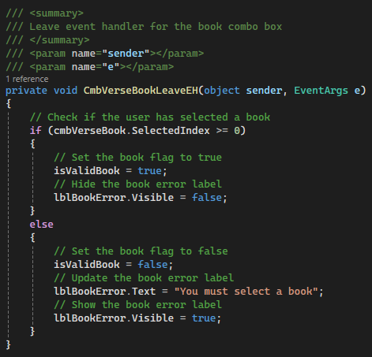
Figure 28: Check whether the selected book is valid
- Next, add a Leave event handler to txtVerseChapter named TxtVerseChapterLeaveEH, as shown in Figure 29. Make sure to add a summary comment to the method.
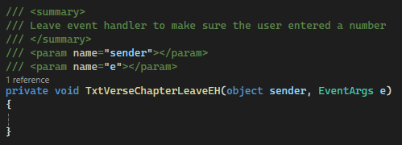
Figure 29: Creating a leave event handler for txtVerseChapter

- To make sure the user entered a number into the chapter text box, we will use a RegEx, which will allow us to pattern match the text to ensure that it is in the correct format (see the "RegEx Explained" and "RegEx in This Application" sections below). Based on the result of the RegEx, we can update the isValidChapter variable and lblChapterError label, as shown in Figure 30.
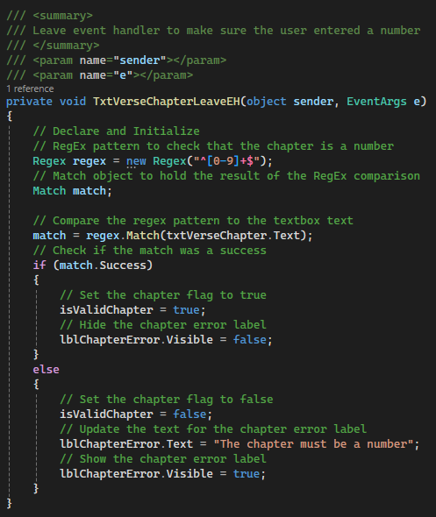
Figure 30: Using RegEx to check txtVerseChapter

- Commit all changes in the project to source control.
- Commit Message: Add data validation event handlers for the book and chapter of new verses.

RegEx Explained
RegEx is a tool that is used for defining search patterns. It is most used for string matching but can also be used for data validation, text parsing, and extraction as well as find and replace operations and input filtering. RegEx is very flexible and useful, making it a valuable tool to learn.
The syntax and readability of RegEx can be very challenging, so this example will go over some of the most common tokens (pieces of RegEx) as well as a more detailed explanation of the RegEx used in this application. With these examples, keep in mind that RegEx is case sensitive, so a and A are different characters.
Common RegEx Tokens
z | Matches a single character
[abc] | Matches a single character in the range of a–c.; can also be written [a-c] or as multiple ranges of characters [a-cA-C]
[^a-z] | Matches a character that is not in the range of a–z
. | Matches any one character
\. | Matches a single period character; the backslash escapes the period, so it does not match any character
a|b | The pipe character signifies an alternate, so this pattern matches either a or b
\d | Matches any digit; this can also be written as [0-9]
a? | Matches zero or one a
a* | Matches zero or more a characters
a+ | Matches one or more a characters
a{3} | Matches exactly three a characters
a{3,} | Matches three or more a characters
a{3,6} | Matches between three and six a characters
(?:…) | Create a noncapturing group; functions similarly to a set of parentheses within math
(…) | Captures matched content with IDs for later reference
Any expression that matches a singular character can also be used with brackets to have it match a range or list of characters.

RegEx in This Application
The regular expression used in this application is for checking the format for currency in a text box. The breakdown of the tokens in the expression is below.
Chapter RegEx
^ and $ | Matches the start and end of the string. Ensures that the RegEx matches the entire string passed in.
[0-9]+ | Matches one or more digits. This will represent the chapter of the Bible.
Verse RegEx
^ and $ | Matches the start and end of the string. Ensures that the RegEx matches the entire string passed in.
\d+ | Matches one or more digits. This will represent the verse of the Bible.
(?: )? | Creates an optional group for the range of the verse.
- | Matches a dash character.
\d+ | Matches 1 or more digits.
For more information about RegEx tokens and building your own regex, visit regex101.com.

- We will create a similar event handler for the verse text box. Start by creating a Leave event handler for txtVerseVerse named TxtVerseVerseLeaveEH with a summary comment, as shown in Figure 31.
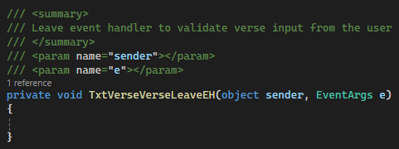
Figure 31: Creating a Leave event handler for txtVerseVerse
- Set up a new RegEx pattern to make sure the user entered a number or a range of numbers. The @ symbol at the beginning of the RegEx string creates a verbatim string literal and allows us to use backslash characters without the need to escape them. Then, based on the result of the match, update the isValidVerse variable and lblVerseError label, as shown in Figure 32.
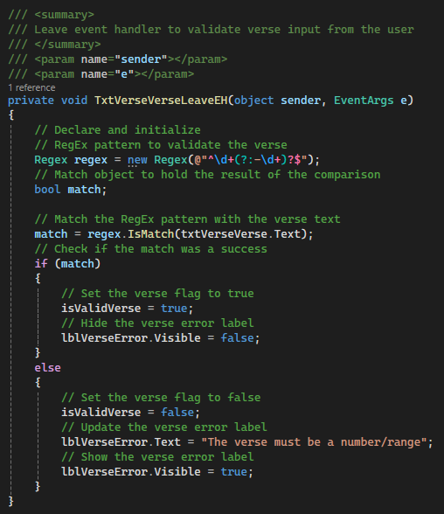
Figure 32: Using RegEx to check the verse text box
- We will also need to make sure the user entered text for the verse’s text. Add a Leave event handler to txtVerseText named TxtVerseTextLeaveEH and add a summary comment, as shown in Figure 33.
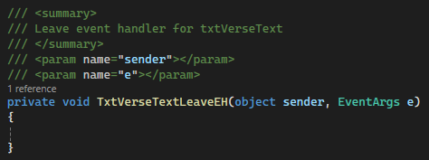
Figure 33: Adding a text changed event handler to verse text box
- In TxtVerseTextLeaveEH, add logic to check whether the text box is null, empty, or whitespace (spaces, tabs, or new lines). If it is, set the isValidText flag to false and update the text error label to tell the user that the text cannot be blank and show the label. If the text box contains text, set the flag to true and hide the error label, as shown in Figure 34.
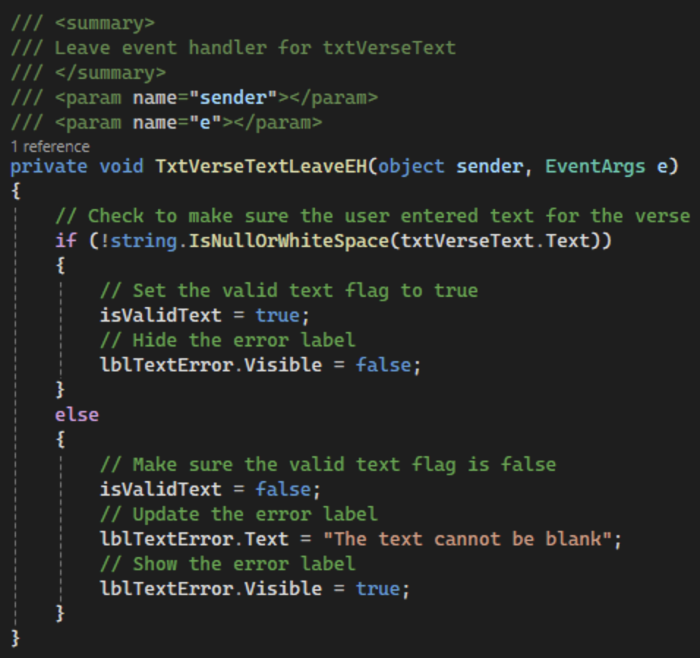
Figure 34: Logic to make sure the user enters text for the new verse

- Commit all changes in the project to source control.
- Commit Message: Add data validation event handlers for the verse and text of new verses.
- Next, add a Leave event handler to txtVerseMeaning. as shown in Figure 35. This method will have the same functionality as the Leave event handler we just created. Remember to add a summary comment to the method.
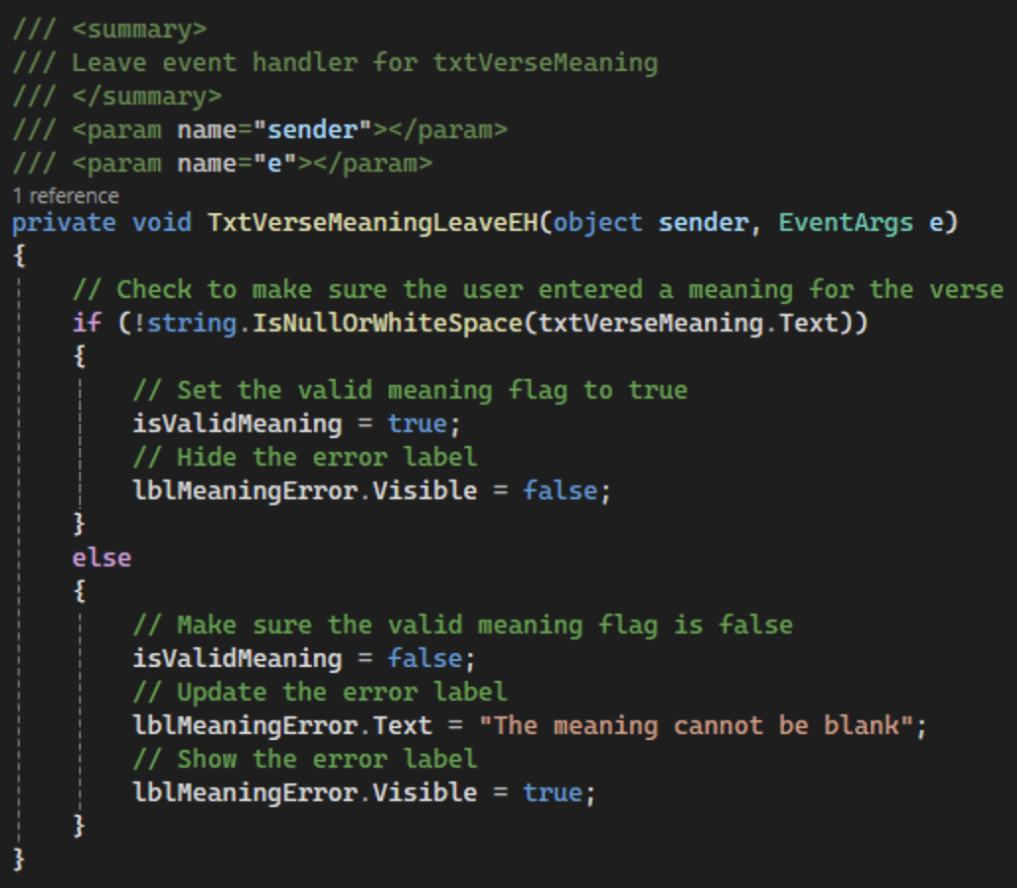
Figure 35: Leave event handler for TxtVerseMeaning
- The last user input we need to validate is the importance numeric up-down control. Attach a Leave event handler to nudVerseImportance named NudVerseImportanceLeaveEH with a summary comment, as shown in Figure 36.
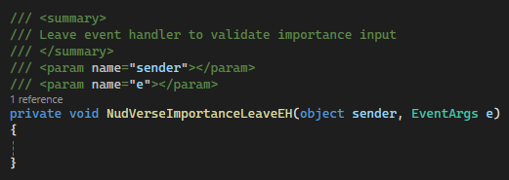
Figure 36: Creating the NudVerseImportanceLeaveEH method
- To check for valid input for the numeric up-down control, we will make sure the value of numVerseImportance is between 1 and 10, as shown in Figure 37. If it is, we can set its flag to true and hide the error label. Otherwise, we will need to set the flag to false, update the error label, and display it to the user.
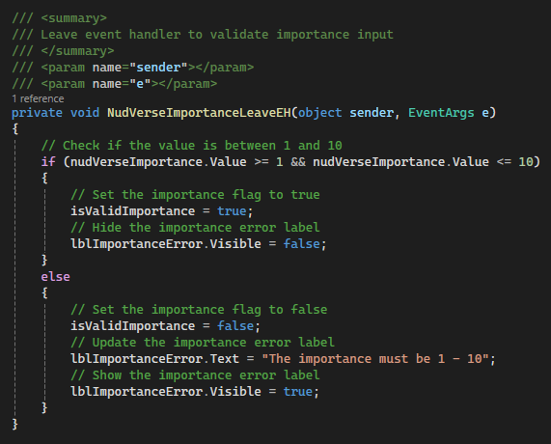
Figure 37: Finishing the NudVerseImportanceLeaveEH method

- Commit all changes in the project to source control.
- Commit Message: Add data validation event handlers for the meaning and importance of new verses.

- To contain our verse data, we will create three data models, a VerseRequestModel, a VerseDataModel, and a VerseDisplayModel. The VerseRequestModel will contain all three of our properties: Address, Text, and Meaning. It will be used to send data down the N-layer architecture (from the presentation layer to the data access layer). On the other hand, the VerseDataModel will have a fourth property, an int Id and will hold our verses in the DAO. Finally, the VerseDisplayModel will be used to send data up the layers and will contain the Id property.
The three models may also have different methods. For example, the Data model’s ToString method might format the data for file I/O, while the Display model could have a ToString that would format the data for display to a user. Start by creating a new Models folder in the project, as shown in Figure 38.
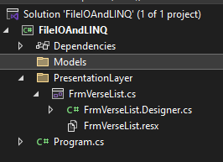
Figure 38: Adding a Models folder to the project
- Add a class to the Models folder named VerseRequestModel and add a citation, as shown in Figure 39.
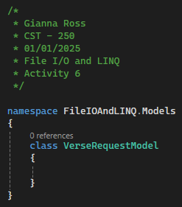
Figure 39: VerseRequestModel with a citation
- Add six class level properties to the class: a string Book, an int Chapter, a string Verse, a string Text, a string Meaning, and an int Importance, as shown in Figure 40.
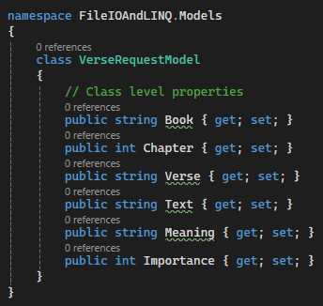
Figure 40: Setting up the properties for VerseRequestModel

- Add two constructors to the request model: a default constructor and a parameterized constructor. The default constructor will set all six properties to default values. The parameterized constructor will take all six properties, as shown in Figure 41.
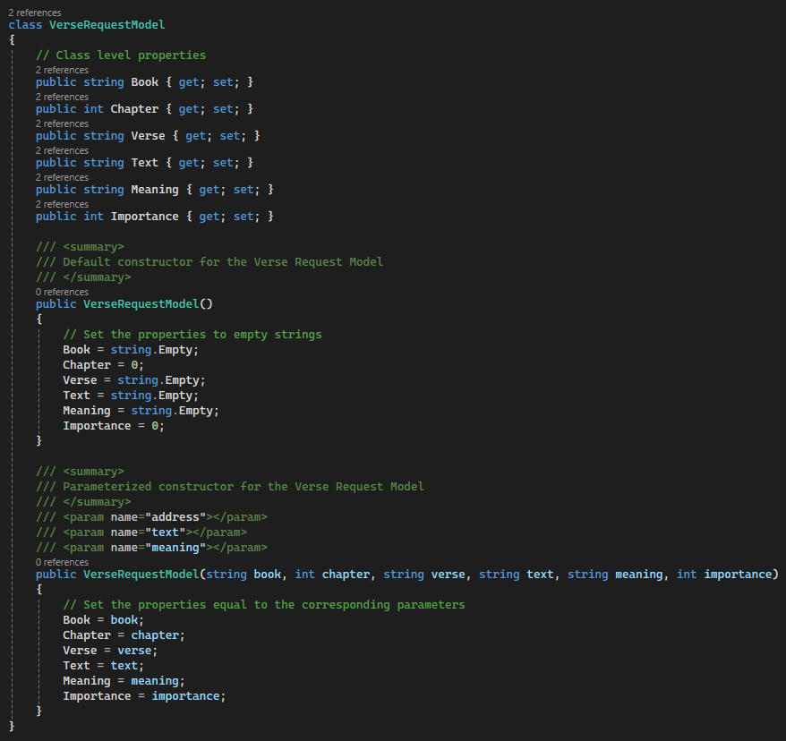
Figure 41: Default and parameterized constructors for VerseRequestModel

- Create a second class for our VerseDataModel with a citation, as shown in Figure 42.
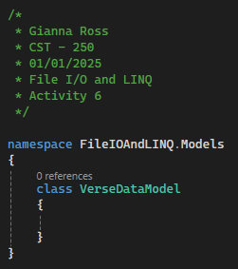
Figure 42: VerseDataModel with a citation
- The VerseDataModel will have seven properties: an int Id, a string Book, an int Chapter, a string Verse, a string Text, a string Meaning, and an int Importance, as shown in Figure 43.
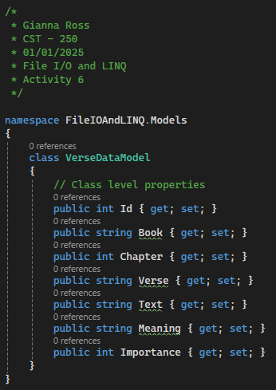
Figure 43: Adding properties to VerseDataModel

- To complete the model, we will also need default and parameterized constructors, as shown in Figure 44. The default constructor will initialize the string properties with empty strings and the Id property to 0. The parameterized constructor will take values for all four properties and assign them to their corresponding properties.
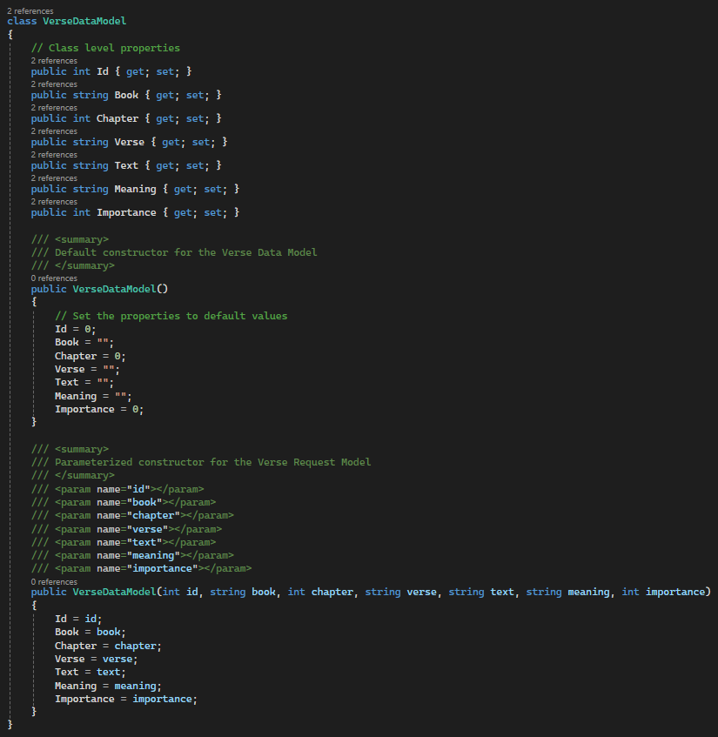
Figure 44: VerseDataModel constructors

- Add a third model to the Models folder named VerseDisplayModel with a citation, as shown in Figure 45.
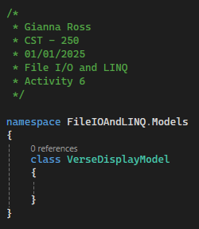
Figure 45: VerseDisplayModel class with a citation
- Add four class-level properties to the class: a string Reference, a string Text, a string Meaning, and an int Importance, as shown in Figure 46.
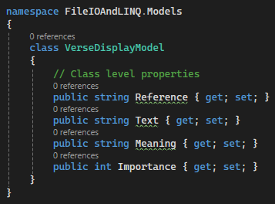
Figure 46: Setting up the properties for the VerseDisplayModel class

- Add two constructors to the response model: a default constructor and a parameterized constructor. The default constructor will set all three string properties to empty strings and the Importance property to 0. The parameterized constructor will take all four properties, as shown in Figure 47.
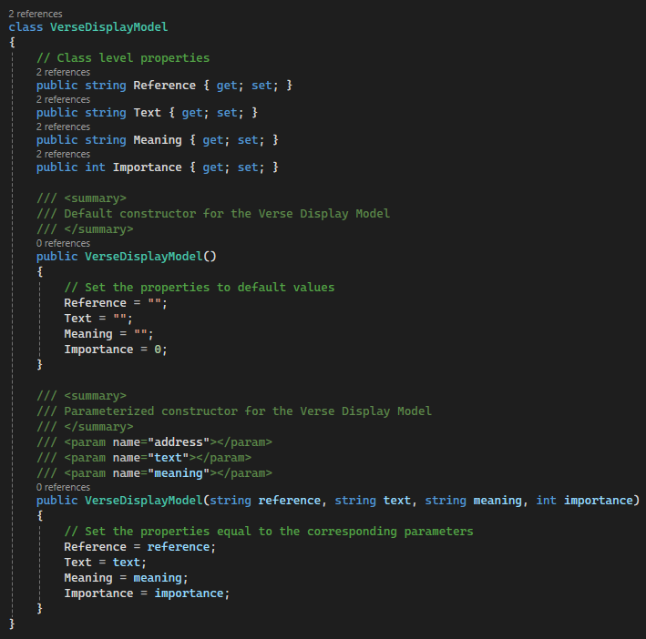
Figure 47: Default and parameterized constructors for the VerseDisplayModel class

- Commit all changes in the project to source control.
- Commit Message: Add request, data, and display models for the verses.

- Back in FrmVerseList, add a click event handler to btnAddVerse named BtnAddVerseClickEH with a summary and end of method comment, as shown in Figure 48.
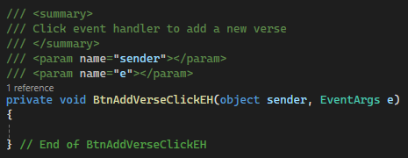
Figure 48: BtnAddSupplyClickEH with a summary comment

- We will start this method by checking the flags for book, chapter, verse, text, meaning, and importance. If all six flags are true, we know that we have valid data. If any of the flags fail, we should show its error label, as shown in Figure 49.
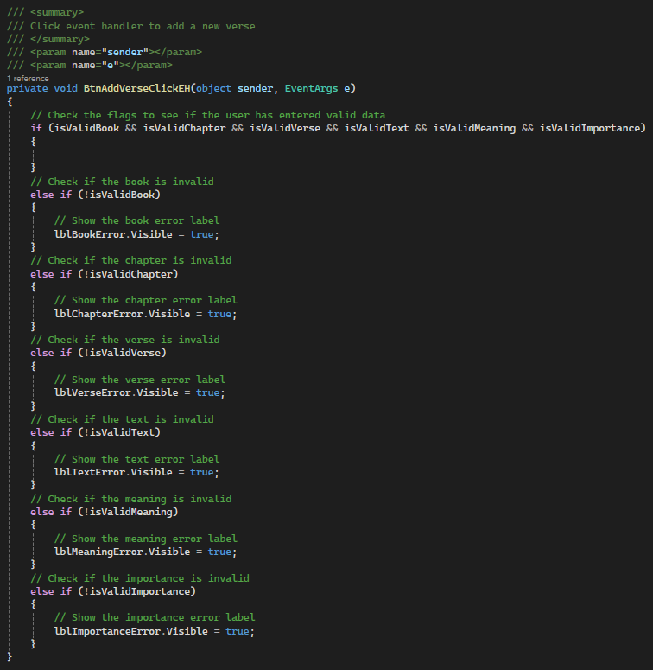
Figure 49: Check to see whether the flags are all true

- Next, we will create the VerseRequestModel for the new verse. To get the chapter as an integer, we should set up a try-catch to parse the text from txtVerseChapter. Then we can create a new VerseRequestModel with our data, as shown in Figure 50. We will also have to cast the importance value to an integer, but this does not require a try-catch, as we are only truncating a decimal to an integer.
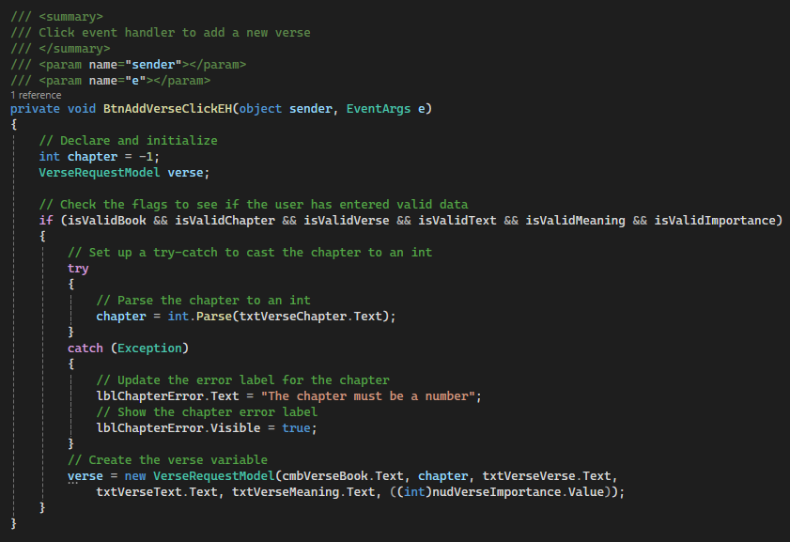
Figure 50: Begin the Click EH by making sure you have valid data

- To add a verse to our verse list, we will need to create a data access object and a logic object. Start by making a Services folder in the project. Within that folder, add two more named BusinessLogicLayer and DataAccessLayer, as shown in Figure 51.
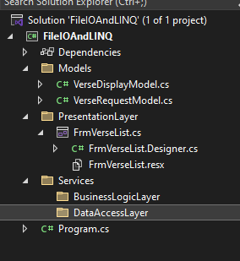
Figure 51: Adding folders for the BusinessLogic and DataAccess layers of our project
- In the DataAccessLayer folder, create a data access object named VerseDAO, as shown in Figure 52. Remember to add a citation to the top of the class.
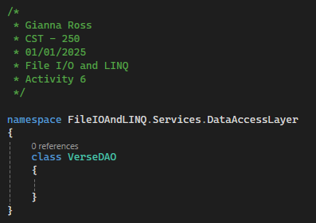
Figure 52: VerseDAO class with a citation

- Create a private, class level list of VerseDataModels named _verses, as shown in Figure 53. Even though we will be sending our verses to various files, this list will act as the storage for our application. Also create a VerseDAO constructor to initialize the verses variable.
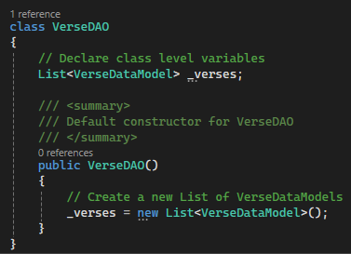
Figure 53: Class level list to store our verse inventory
- Create a public method named AddVerse that will return an int and has a VerseRequestModel as a parameter. This method will use the data in the request model to create a VerseDataModel to store in the inventory list. We can base the ID of the new verse on the length of the _verses list, as shown in Figure 54. We will also return the new ID.
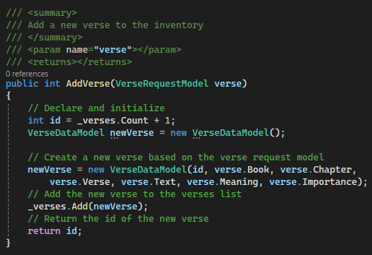
Figure 54: Creating the DAO AddVerse method

- Commit all changes in the project to source control.
- Commit Message: Create a VerseDAO and add logic to add a new verse.
- Next, we will need to create a BusinessLogicLayer AddVerse method. Add a new class to the BusinessLogicLayer folder named VerseLogic with a citation, as shown in Figure 55.
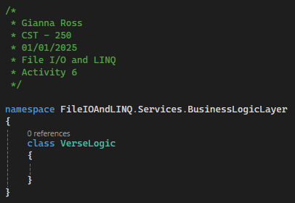
Figure 55: Starting the VerseLogic class with a citation
- Declare a private, class-level VerseDAO variable in VerseLogic to hold our DAO instance. We will also need a default constructor to initialize the _verseDAO object, as shown in Figure 56.
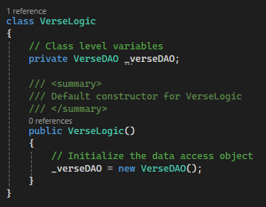
Figure 56: Declaring and initializing the _verseDAO object

- Add a method to VerseLogic named AddVerse that returns an int and takes a VerseRequestModel, as shown in Figure 57. We will use the _verseDAO variable to call the AddVerse method in the VerseDAO class.
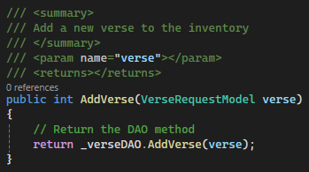
Figure 57: VerseLogic AddVerse method
- Back in FrmVerseList, create a new, private, class-level VerseLogic variable in FrmVerseList and initialize it in the constructor, as shown in Figure 58.
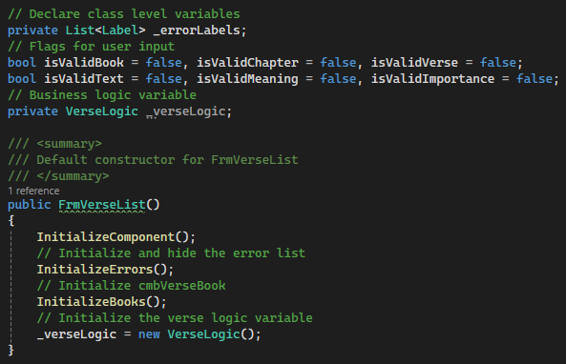
Figure 58: Creating the _verseLogic variable

- In BtnAddVerseClickEH, add a call to the Verse Logic AddVerse method to add the new verse, as shown in Figure 60. Then, call the ClearInputFields method. We will create this method next.
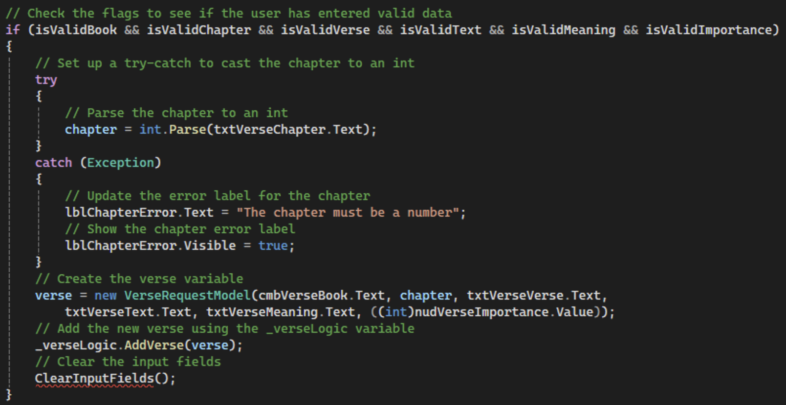
Figure 59: Calling the AddVerse and ClearInputFields methods
- Next, create a new method named ClearInputFields with a summary comment. Add logic to clear each control used for user input for adding a verse, as shown in Figure 60. We can clear the text boxes using the OfType<> method.
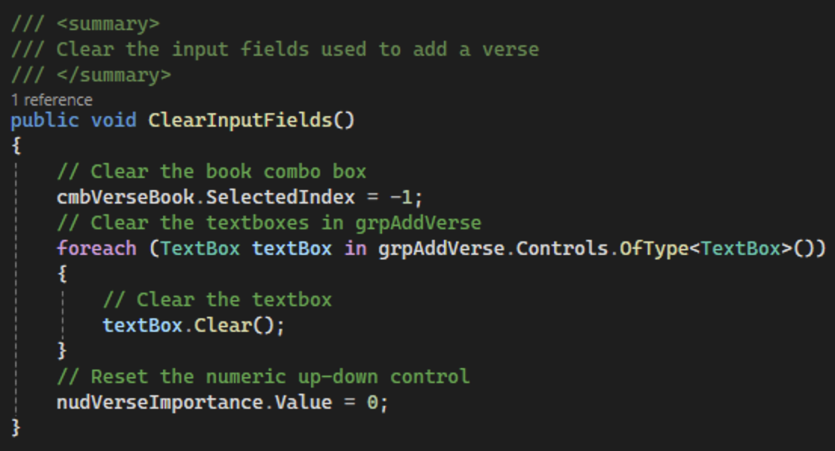
Figure 60: Adding the ClearInputFields method

- Commit all changes in the project to source control.
- Commit Message: Add a BusinessLogicLayer and finish the logic to add a new verse.
- To populate the data grid view with our verses, we will need a binding source object in our form class. The object will allow us to send a list of objects to our data grid view using its DataSource property. Add another private class-level variable named _versesBindingSource of the Binding source type and initialize it in the FrmVerseList constructor, as shown in Figure 61.
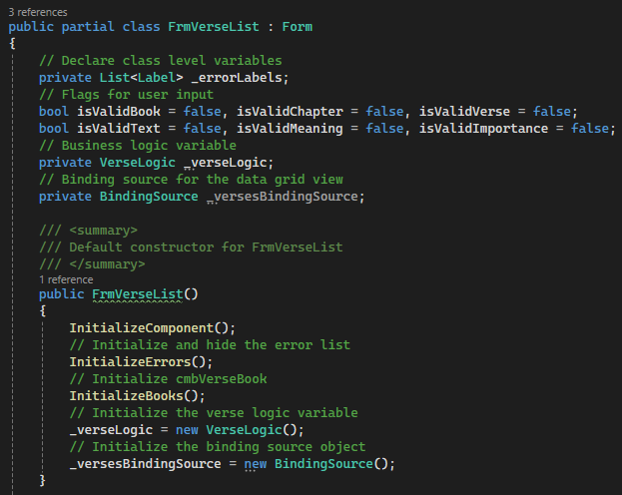
Figure 61: Adding a BindingSource object to the form
- To display our verses in the data grid view, we will need to link the versesBindingSource to dgvVerseInventory. Add a Load event handler to FrmVerseList named FrmVerseListLoadEH, as shown in Figure 62. Don’t forget to add a summary comment.
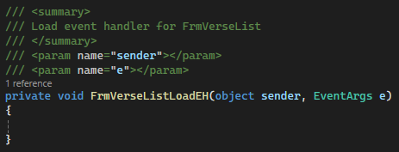
Figure 62: FrmVerseListLoadEH with a summary comment
- Set the DataSource property for dgvVerseDisplay to the _versesBindingSource, as shown in Figure 63.
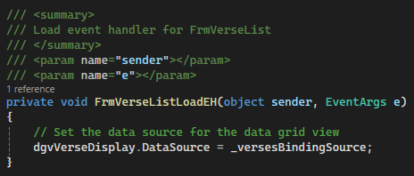
Figure 63: Set up the data grid view
- Next, create a method that will be called each time our inventory is changed. This method will get the updated inventory from our back-end and sync it with our data grid view. Begin by creating a RefreshVersesDgv method in FrmVerseList with a summary comment, as shown in Figure 64.
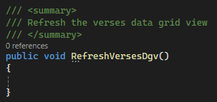
Figure 64: Setting up RefreshVersesDgv
- To set up the data grid view, we will need to be able to get the list of verses from the DAO. In VerseDAO, add a new method that return a VerseDataModel list named GetAllVerses, as shown in Figure 65. This method will return the _verses list.
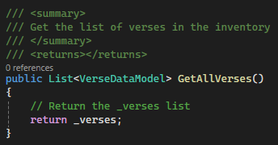
Figure 65: Creating the GetAllVerses method in VerseDAO
- Create a mirroring method in VerseLogic that calls the VerseDAO method. This method will loop through the DAO list and take each VerseDataModel to convert it to a VerseDisplyModel, as shown in Figure 66.
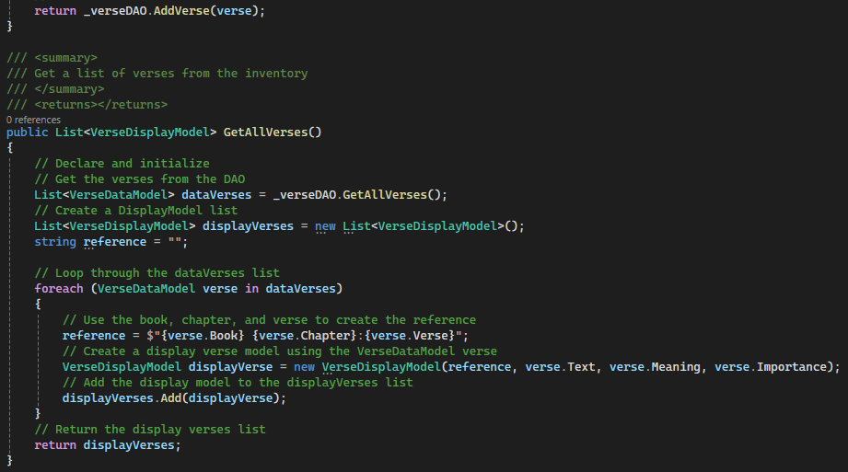
Figure 66: Create the VerseLogic GetAllVerses method
- In the RefreshVersesDgv method in FrmVerseList, call the GetAllVerses method from VerseLogic and save the result to a VerseDisplayModel list. Then, set the DataSource property of versesBindingSource to the list, as shown in Figure 67. This will update the data grid view with the new verses.
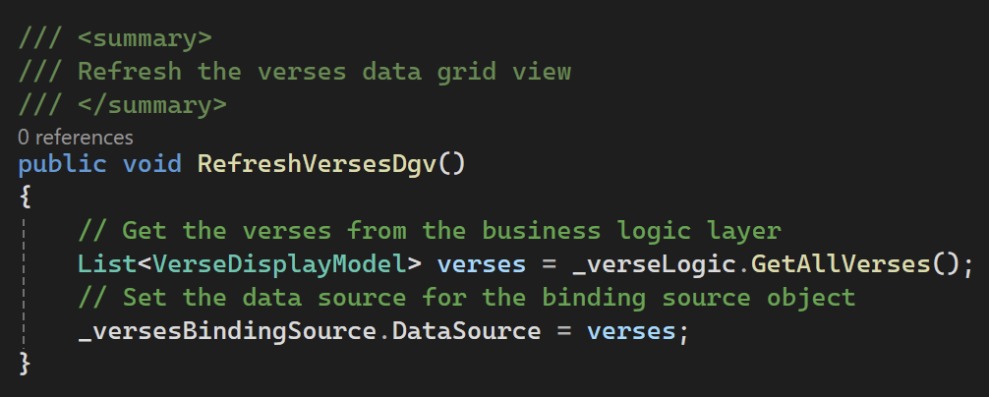
Figure 67: Logic for the RefreshVersesDgv method
- We should also add styling for the data grid view. Start by creating a new method below the RefreshVersesDgv method named FormatVersesDgv with a summary comment. Calculate the width for our verse and meaning columns. This will be done by getting the width of the data grid view, the column that will hold our reference, and the importance column. Subtract the reference and importance columns from the total width and divide the final answer by 2, as shown in Figure 68. Then, set the width of the text and meaning columns to the number we just calculated. Finally, we can change the wrap mode for the data grid view so that our text will wrap. We can also call the AutoSizeRows method so that more rows can be displayed to the user.
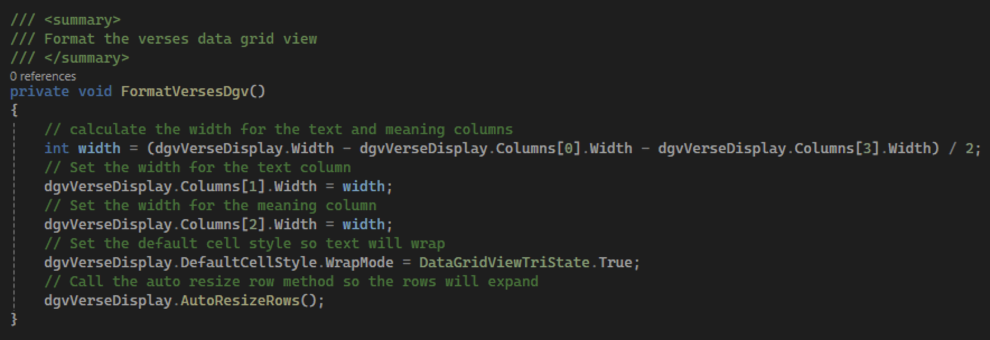
Figure 68: FormatVersesDgv to format the data grid view

- Call the FormatVersesDgv from RefreshVersesDgv, as shown in Figure 69.
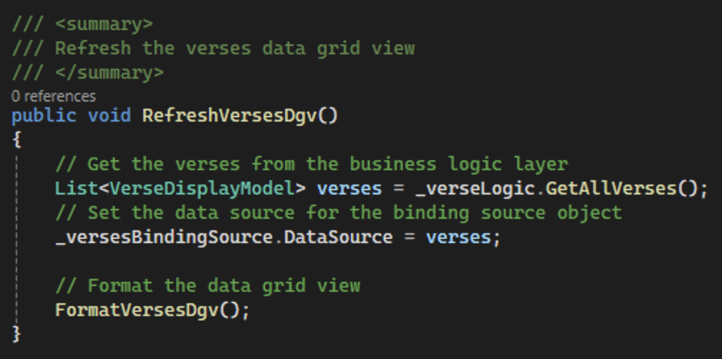
Figure 69: Update the RefreshVersesDgv with the formatting for the data grid view
- Finally, update BtnAddVerseClickEH to call the RefreshVersesDgv to refresh the data grid view after we have added a new verse to the inventory, as shown in Figure 70.
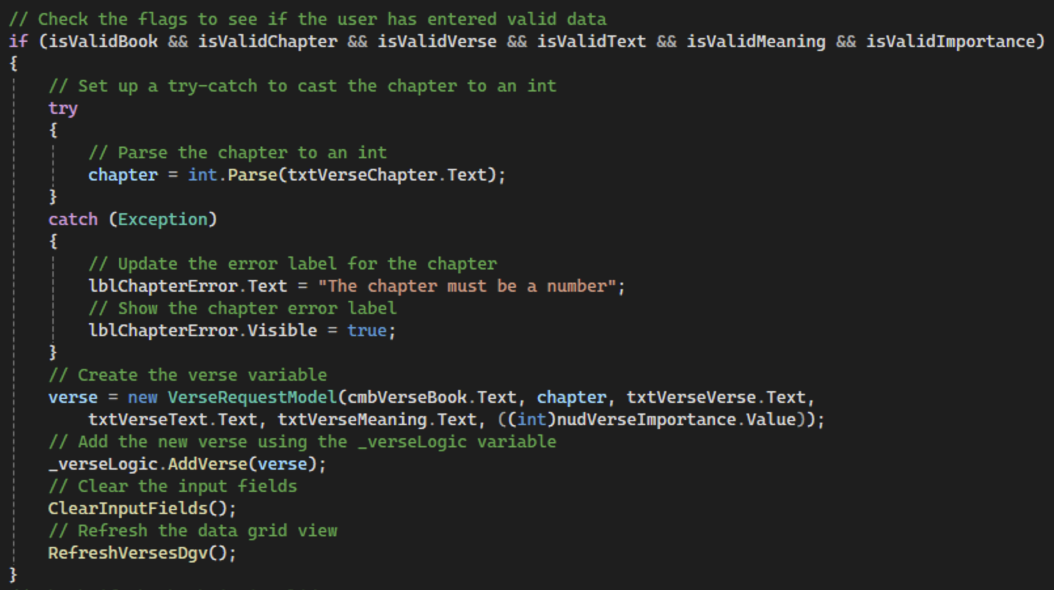
Figure 70: Updating BtnAddVerseClickEH with the RefreshVersesDgv method
- You should now be able to run the program and add some verses to the inventory.

- Commit all changes in the project to source control.
- Commit Message: Finish AddVerse and GetAllVerses functionality.
- Take a screenshot of the application running at this point.
- Take a screen shot of the citations for FrmVerseList, VerseRequestModel, VerseDataModel, VerseDisplayModel, VerseLogic, and VerseDAO. Make sure to include the class declarations in the images.
- Take a screenshot of the FrmVerseList, InitializeErrors, InitializeBooks, , CmbVerseBookLeaveEH, TxtVerseChapterLeaveEH, TxtVerseVerseLeaveEH, TxtVerseTextLeaveEH, TxtVerseMeaningLeaveEH, NudVerseImportanceLeaveEH, BtnAddVerseClickEH, FrmVerseListLoadEH, RefreshVersesDgv, and FormatVersesDgv methods in FrmVerseList.
- Take a screenshot of the parametrized and default constructors in VerseRequestModel, VerseDataModel, and VerseDisplayModel.
- Take a screenshot of the AddVerse and GetAllVerses methods in VerseLogic and VerseDAO.
- Take a screenshot of the UMLs for the FrmVerseList, VerseDisplayModel, VerseDataModel, VerseRequestModel, VerseLogic, and VerseDAO classes.
- Paste the images into a Word document.
- Put a caption below each image explaining what is being demonstrated.

Part 2: File I/O

Add a Dependency for Text Serialization using NuGet
What is NuGet?
NuGet is a package manager for .NET. It is used to allow you to use third-party packages. Packages are compilations of code (libraries) that can be added to any project, allowing functionality to be expanded without having to write code from scratch. NuGet connects to a central repository where packages are stored, which can be accessed via the NuGet Gallery (nuget.org). Developers can download libraries needed for their projects from this repository.
Dependency Resolution
When a package is added to a project, NuGet manages not only the installation of that package but also its dependencies (other packages it relies on to function). This means that if a package requires other packages, NuGet automatically retrieves and installs these as well, ensuring that all dependencies are satisfied without manual intervention.
Version Management
NuGet also keeps track of the versions of packages installed, allowing developers to specify exact versions or ranges of versions. This helps maintain compatibility and stability within projects, especially when working with multiple developers or when updating libraries.

- We need to add a library for JSON and CSV object serialization. Right click on the Solution name in the Solution Explorer, as shown in Figure 71. Choose “Manage NuGet Packages for Solution…” to open the NuGet package manager.
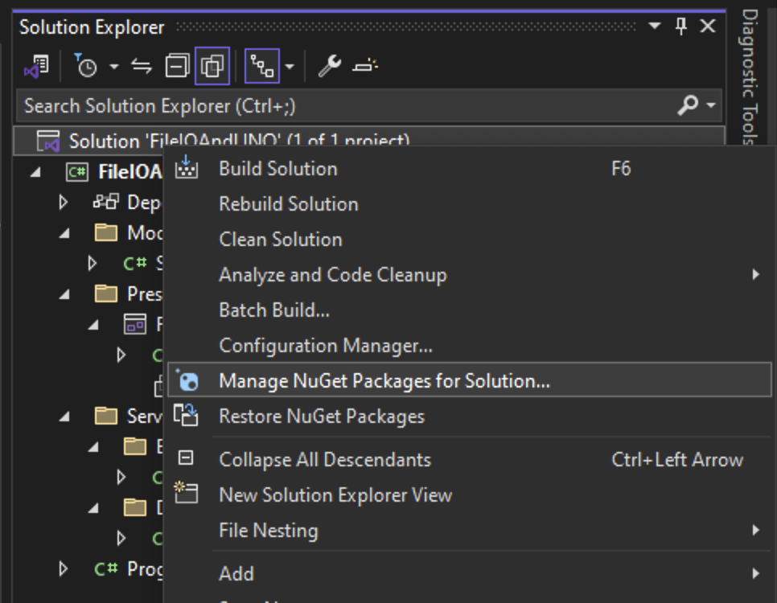
Figure 71: Manage NuGet Packages for Solution in Solution Explorer
- Click Browse, search for “CSV,” and look for “ServiceStack.Text,” as shown in Figure 72.
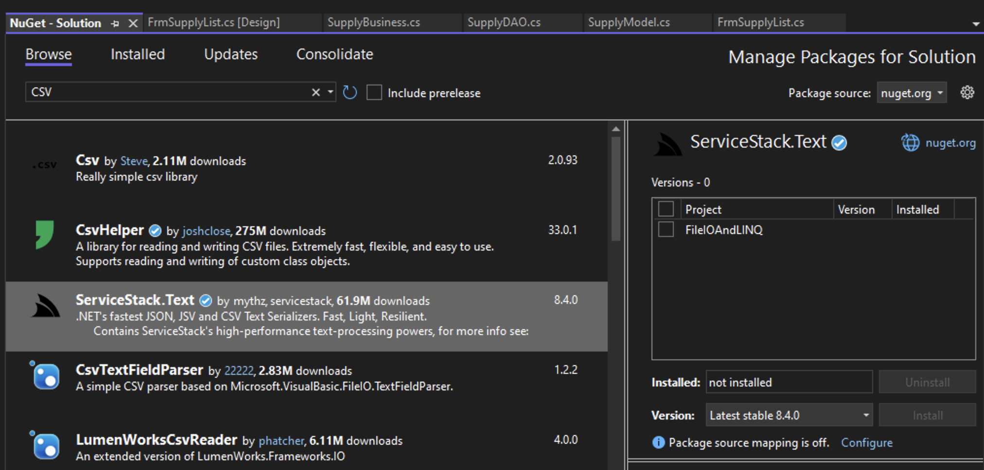
Figure 72: ServiceStack.Text in the NuGet package manager
- Check the box for the FileIOAndLINQ and click Install, as shown in Figure 73. A window will open to preview changes. Select Apply. Accept the license terms for ServiceStack.Text. Then, close the NuGet package manager.
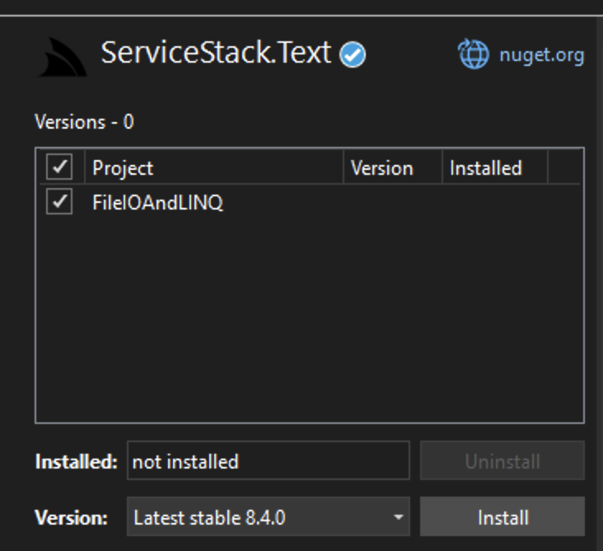
Figure 73: Installing ServiceStack.Text
- Add a click event handler to TsmSave in the menu strip named TsmSaveClickEH and add a summary and end of method comment at the last curly brace of the method, as shown in Figure 74.
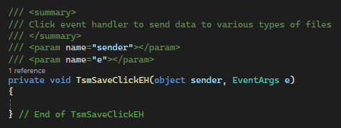
Figure 74: TsmSaveClickEH method with summary comment

- The TsmSaveClickEH method will be used to send data to different types of files, depending on what type the user selects from their file system. First, we need to create a new SaveFileDialog object inside a using statement. We then set the title and filter of the saveFileDialog. The filter attribute sets up filters for file selection. Each filter has a description followed by a vertical bar (“|”) and a filter pattern (the asterisk in the pattern signifies a wild card). Each new filter is separated from the previous one using the same vertical bar, as shown in Figure 75. We should also set up variables for the DialogResult, file name, and the result from our back-end.
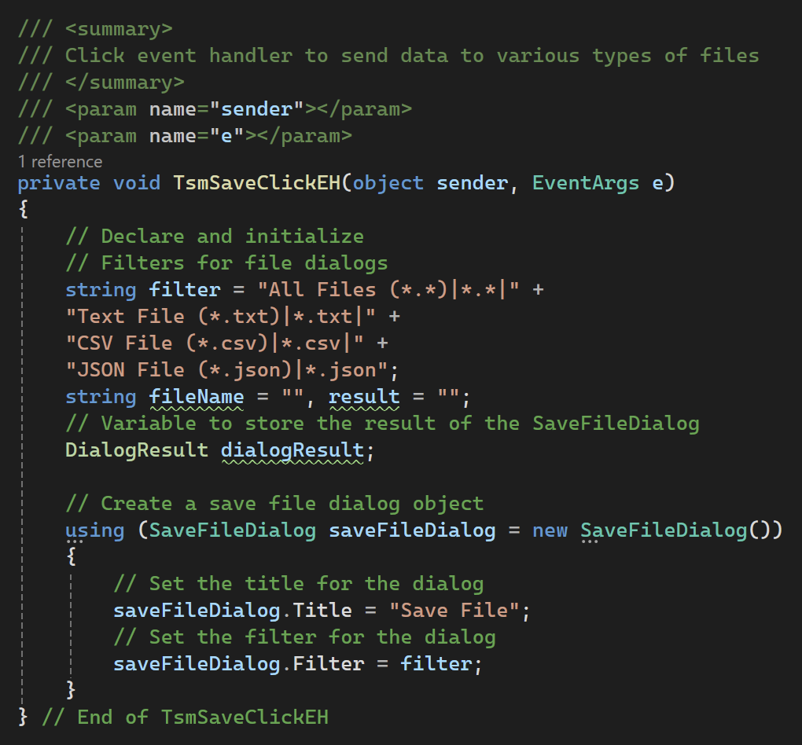
Figure 75: Set up the TsmSaveClickEH to show the user a file dialog

- Next, we will show the dialog and save the result to the DialogResult object, once the user picks a file, and check to make sure there were no issues with the file selection. Then, get the file name from the save file dialog, as shown in Figure 76. We will send this filename to the BusinessLogicLayer after we create a method to receive it.
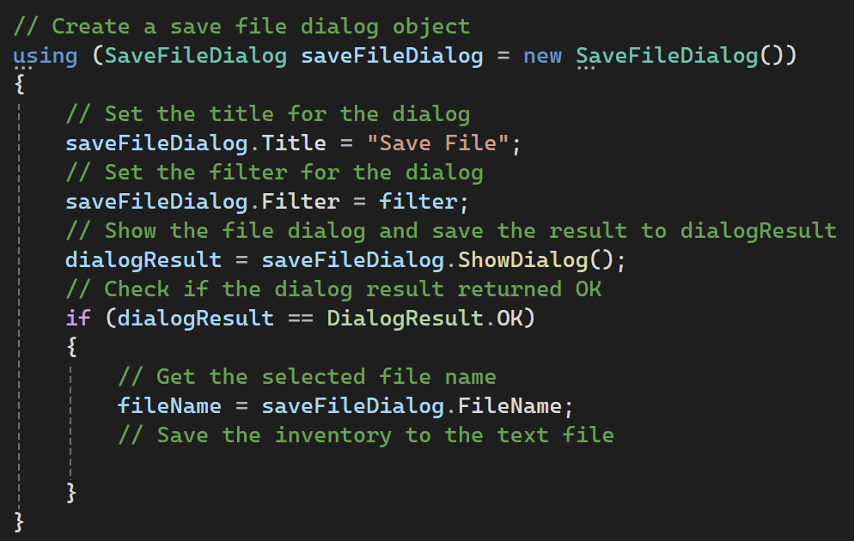
Figure 76: Use the SaveFileDialog to get a filename from the user to save the inventory to
- Initially, we will handle writing to txt, JSON, and CSV files. To write to text files easily, we will begin by adding to ToString method to the VerseDataModel, as shown in Figure 77. This method will format the text to send to a file. We will not send the ID to the text file, as this will allow us to populate it as the verses are read out of the file. We will use an asterisk-space to separate the values, instead of the traditional comma-space, in case the verse or meaning contains commas.
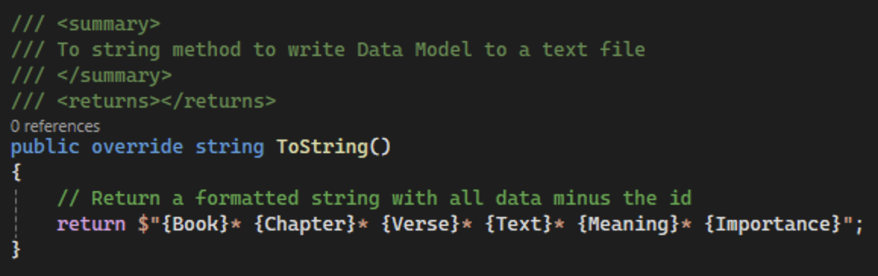
Figure 77: Overridden ToString for VerseDataModel

- In the VerseDAO, add a new method named WriteVersesToFile, which will accept a string filename and return a string. Begin by initializing a string variable to hold our serialized data named serialized. Then, create a switch statement based on the file extension of the parameter. We can get this value using the Path.GetExtension method, as shown in Figure 78.
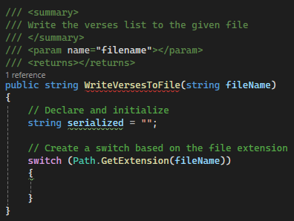
Figure 78: Create a switch statement to handle different file types
- Create a switch case for .txt. Use a foreach loop to loop through the verses in the _verses list and add each one to the serialized string, followed by a newline character, as shown in Figure 79.
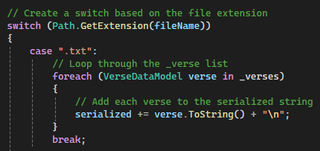
Figure 79: Create the serialized string for sending verses to a text file
- Next, set up a .json case in our switch statement. We will use ServiceStack.Text.JsonSerializer to serialize the verses list to a string and save it to the serialized string, as shown in Figure 80.
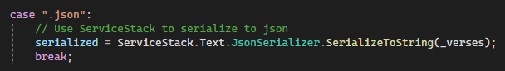
Figure 80: Using the ServiceStack.Text.JsonSerializer to serialize the _verses list
- Create a switch case for .csv and use the ServiceStack.Text.CsvSerializer to serialize the _verses list to the serialized string, as shown in Figure 81.
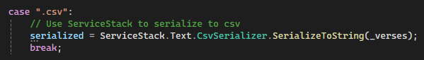
Figure 81: Using the ServiceStack.Text.CsvSerializer to serialize the _verses list
- Create a default case to return a “File not recognized” message to the user. Then, use the File.WriteAllText method to send the serialized text to the given file, as shown in Figure 82. We will surround this line with a try-catch, as there are many possible errors that can occur.
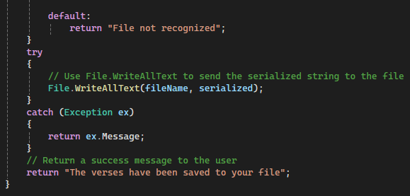
Figure 82: Finishing the WriteVersesToFile method
- In the verse logic class, add a method named WriteInventoryToFile that will call and return the same method from verseDAO, as shown in Figure 83.
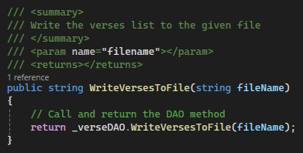
Figure 83: WriteVersesToFile method in VerseLogic
- Back in the TsmSaveClickEH in FrmVerseList, add a call to the new WriteVersesToFile method and save the result to the corresponding string. Then, show the user a message box with the resulting string, as shown in Figure 84.
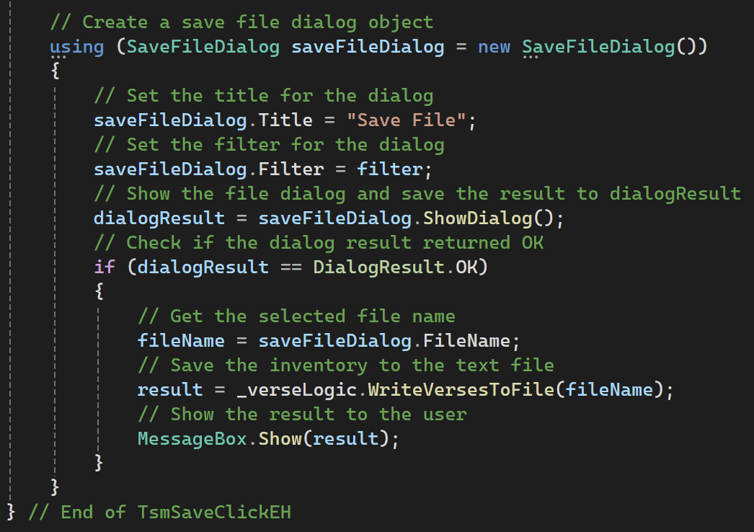
Figure 84: Finishing the TsmSaveClickEH method
- Run the program. Add some verses to the inventory and save them to .txt, .json, and .csv files. Make sure the verses show up in the files.

- Commit all changes in the project to source control.
- Commit Message: Add functionality to write to files.
- Next, add a click event handler to TsmLoad in the menu strip named TsmLoadClickEH and add a summary and end of method comment at the last curly brace of the method, as shown in Figure 85.
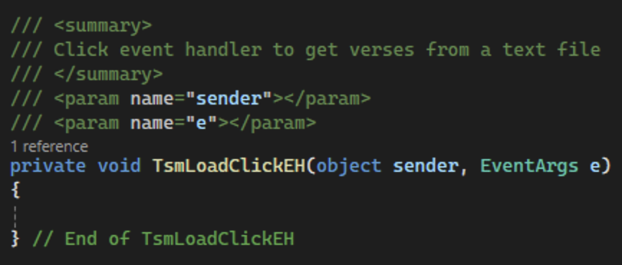
Figure 85: Method and summary comment for TsmLoadClickEH
- Because we will be using the same set of filters for the Load event handler that were used in the Save event handler, we should take the filter variable out to a class-level variable, as shown in Figure 86.
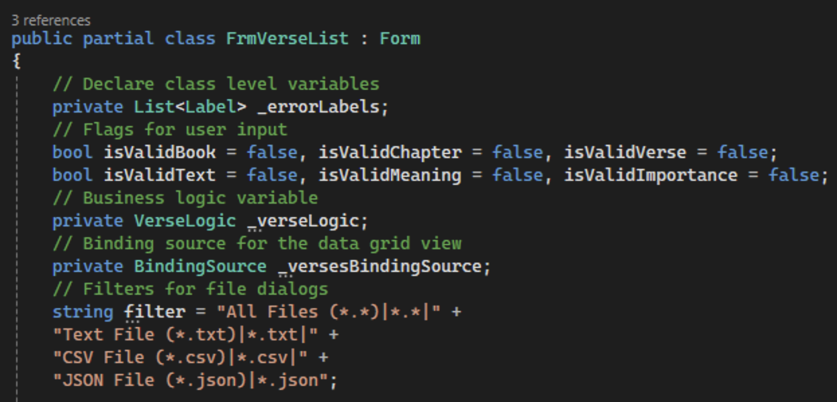
Figure 86: Moving the filter to a class-level variable

- Back in TsmLoadClickEH, set up the same file name, result, and dialog result variables we used in TsmSaveClickEH. We will then use an OpenFileDialog to open a file from the user’s files. However, we can still set the same Title and Filter properties in the open file dialog, as shown in Figure 87. After we show the dialog to the user, we can check whether the dialog result is OK. If so, we can get the file name to prepare to make a call to the verse logic method we will create next.
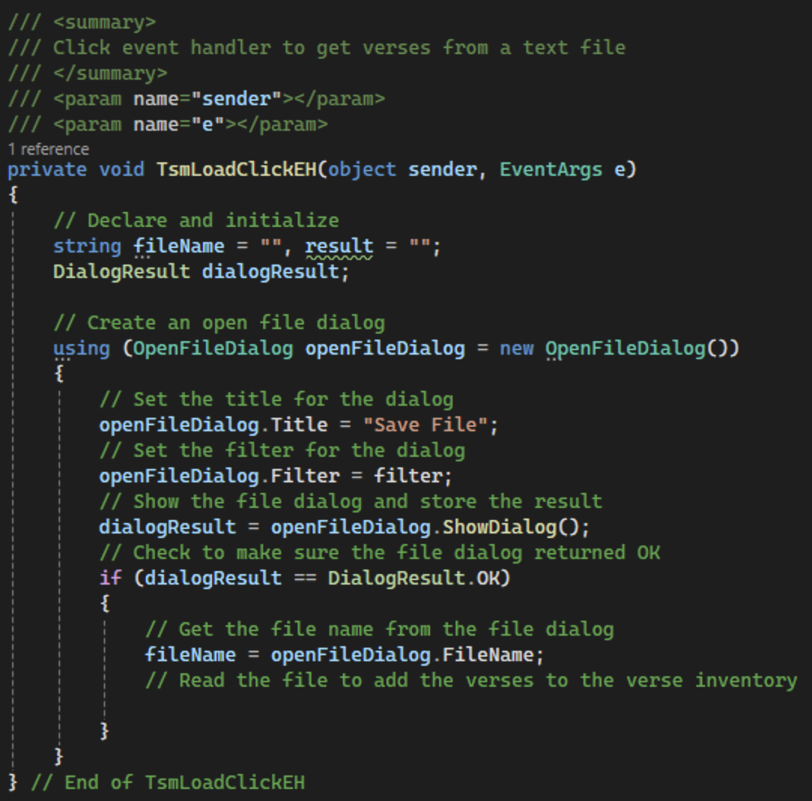
Figure 87: Preparing TsmLoadClickEH for the call to our business layer

- In the VerseDAO class, create a new public method named ReadVersesFromFile with a summary comment and an end-of-method comment that accepts a string file name as a parameter and returns a string. Declare a string to hold the data from the file as well as a VerseDataModel to hold any verses from the file. Then, use a try-catch statement to read the text out of the given file and store it in the data string, as shown in Figure 88.
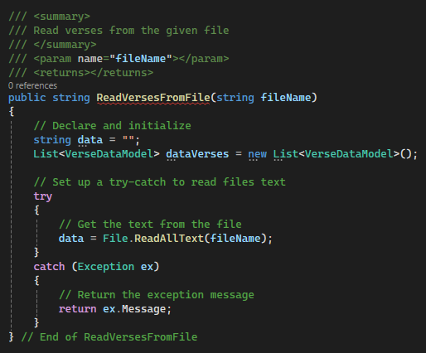
Figure 88: Reading the text from the file

- Next, create a switch statement based on Path.GetExtension. This switch statement will have cases for .txt, .json, and .csv files as well as a default case. If the file is a text file, split the data string on the newline character and loop through the resulting lines. If each line contains data, we should send it to the ConvertTxtToVerseDataModel method that we will create next, as shown in Figure 89. The method will return a VerseDataModel object that we will add to the dataVerses list.
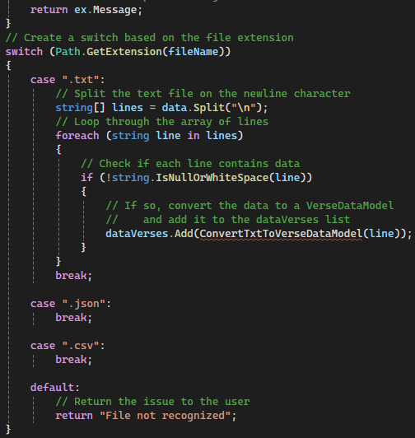
Figure 89: Switch case for the file extension
- Create a new method named ConvertTxtToVerseDataModel that accepts a string line and returns a VerseDataModel, as shown in Figure 90. Make sure to add a summary comment to the method.
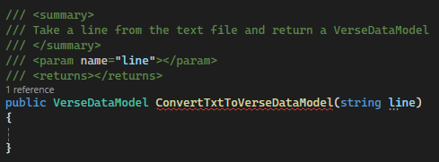
Figure 90: Create the ConvertTxtToVerseDataModel method
- Within the method, create a string array named values, an int chapter, an int importance, and a VerseDataModel verse, as shown in Figure 91. Then, split the given line on the asterisk-space and parse the values for the verses, chapter, and importance. Finally, create a new verse using the values array and the parsed integers and return the verse.
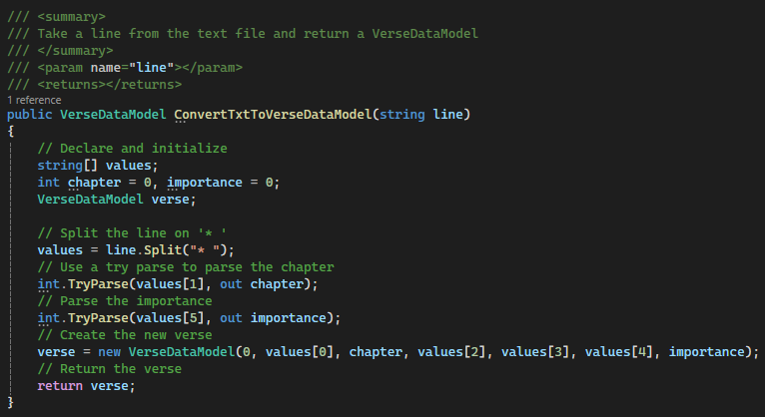
Figure 91: Method to convert a line to a VerseDataModel object
- Back in the ReadVersesFromFile method, add logic for the .json and .csv file extensions. These cases will both use a serializer from ServiceStack.Text to deserialize the data string. The value within the <> for the DeserializeFromString method represents the data form that the data should be deserialized to. Save the results from both methods to the dataVerses list, as shown in Figure 92.
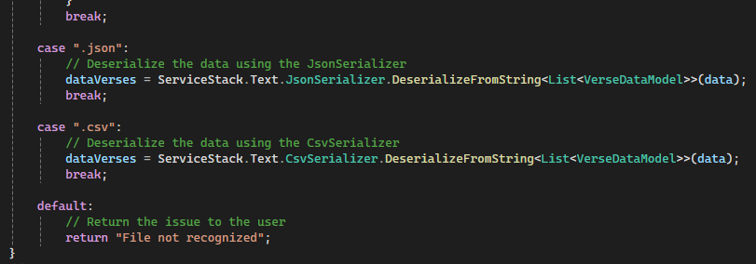
Figure 92: Adding deserialization for JSON and CSV files
- Finally, add logic to loop through the dataVerses list, set the id for each verse based on the _verses list, and add the verse to the list. Then, return a success message to the user, as shown in Figure 93.
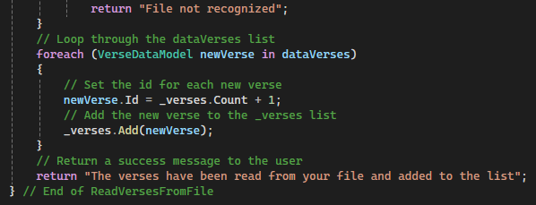
Figure 93: Finishing the ReadVersesFromFile method
- In VerseLogic, add a mirroring method to the VerseDAO ReadVersesFromFile method, as shown in Figure 94, that will call and return the VerseDAO method. Remember to add a summary comment.
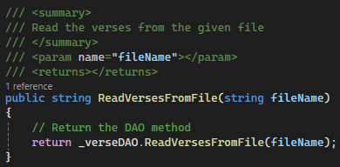
Figure 94: ReadVersesFromFile method in VerseLogic

- Back in the TsmLoadClickEH method in FrmVerseList, call the ReadVersesFromFile method using the _verseLogic variable. Then show the result in a message box and refresh the data grid view, as shown in Figure 95.
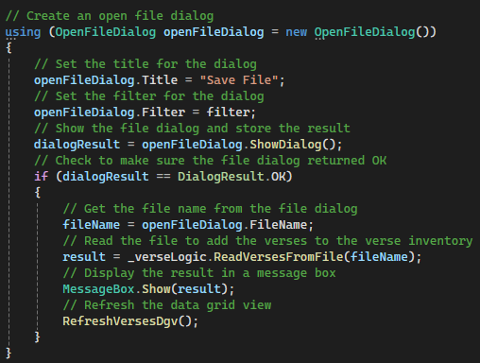
Figure 95: Finished using statement for TsmLoadClickEH
- Run the program. Save and load data using files to verify the application is running properly.

- Commit all changes in the project to source control.
- Commit Message: Add functionality for reading verses from a file.
- Take a screenshot of the .txt, .json, and .csv files with the saved verses.
- Take a screenshot of the TsmSaveClickEH and TsmLoadClickEH methods in FrmVerseList.
- Take a screenshot of the ToString method for the VerseDataModel.
- Take a screenshot of the WriteVersesToFile and ReadVersesFromFile methods in VerseLogic and VerseDAO.
- Take of screenshot of the ConvertTxtToVerseDataModel method in VerseLogic.
- Take a screenshot of the updated UMLs for the FrmVerseList, VerseDataModel, VerseLogic, and VerseDAO classes.
- Paste the images into a Word document.
- Put a caption below each image explaining what is being demonstrated.

Part 3: Filter and Sort
For the next portion of our application, we need to program radio buttons for filtering and sorting our data. First, we need to program our track bar control to determine how many verses the user wants to see.
- Add a class level variable to FrmVerseList to keep track of how many verses the user wants to see. This variable will be a private int named _numToShow, as shown in Figure 96.
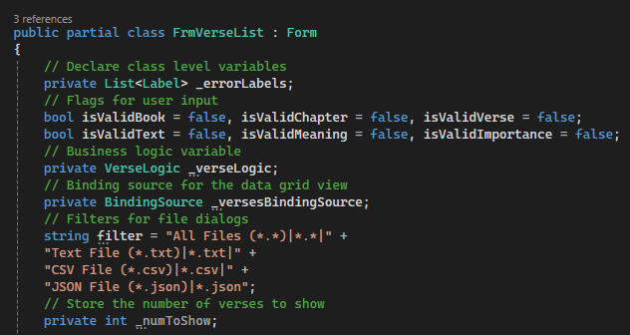
Figure 96: Adding a private _numToShow variable
- Next, add a Scroll event handler to the trbNumberToShow track bar with a summary comment, as shown in Figure 97. This will allow us to update a variable every time the user scrolls on the track bar.
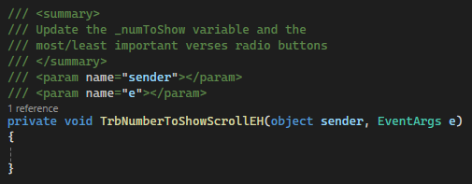
Figure 97: TrbNumberToShowScrollEH with summary comment

- Using the Value property of the track bar, update the numToShow variable and most/least important radio buttons every time the track bar is scrolled, as shown in Figure 98.
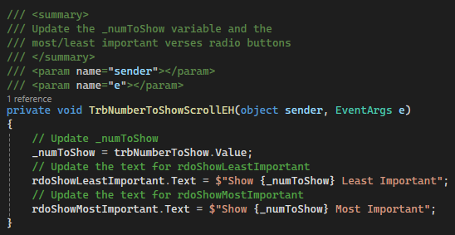
Figure 98: Updating the numToShow variable and most/least important radio buttons

- Commit all changes in the project to source control.
- Commit Message: Add logic to dynamically update the filter and sort box based on the number of verses selected.
- We should also update the maximum value of the track bar every time we refresh the data grid view. We can do this in the RefreshVersesDgv method using the Maximum property of the track bar as, shown in Figure 99.
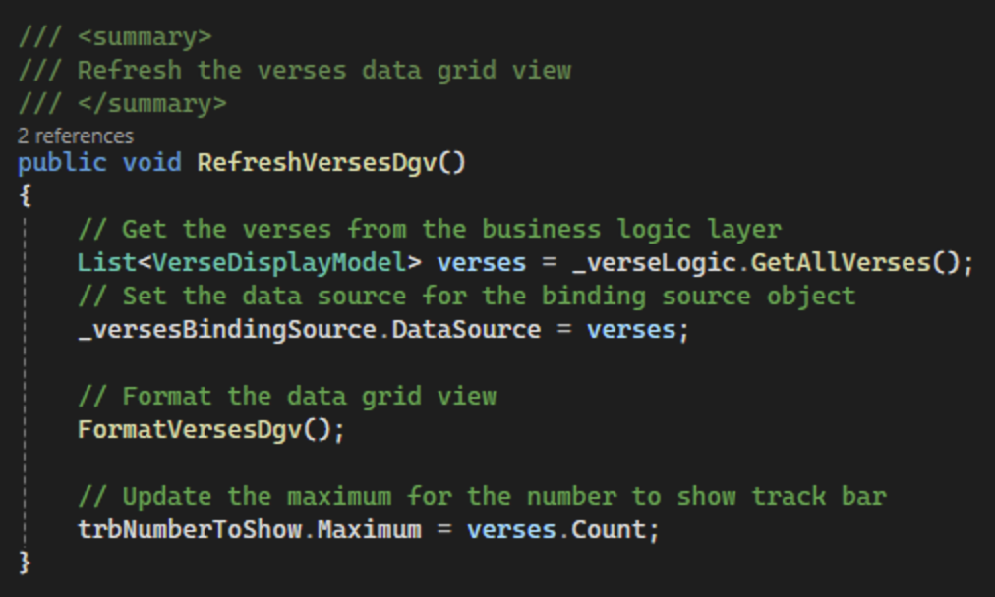
Figure 99: Updated RefreshVersesDgv with track bar max property update
- We should also set the maximum for the track bar in the form constructor, as shown in Figure 100.
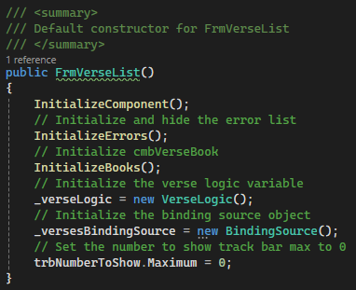
Figure 100: Updating the trbNumberToShow max to 0
- Now that we have the number of items to display, we can add logic for our radio buttons. Add a CheckedChanged event handler for rdoShowLeastImportant named RdoShowLeastImportantCheckChangedEH. Add a summary comment, as shown in Figure 101.
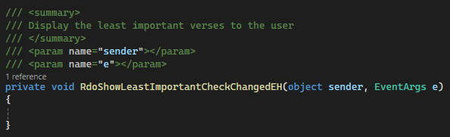
Figure 101: RdoLeastValuableCheckedChangedEH method with summary comment

- To get the least important verses, we will need to create a new method in VerseDAO named GetLeastImportantVerses that will accept an int numToFind parameter and return a VerseDataModel list, as shown in Figure 102.
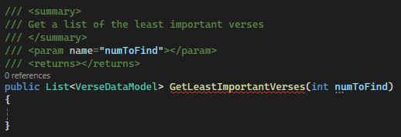
Figure 102: Creating the GetLeastImportantVerses method
- We will use LINQ with query syntax to order the verses. LINQ query syntax resembles an SQL query and can be easier to read than method syntax. However, it is also longer than method syntax, which we will use to get the most important verses.
While LINQ statements are one line of code, it is often easier to read if it is broken up over multiple lines, as shown in Figure 103. The "from verse in _verses" works similarly to a foreach loop by looking at every VerseDataModel object in the _verses list. The "orderby verse.Importance" orders the list of verses based on their value, and the "select verse" means that the verse object will be used in the final result. This statement is like a List.Add(verse) method for LINQ. By using the Take method, we can limit the number of verses returned to the value in our numToFind variable. Lastly, we can use the ToList method to convert the Enumerable result to a List of VerseDataModel objects that we can return. In addition to the LINQ clauses used in this example, there are other LINQ clauses, such as "where" that filters the collection based on a condition.
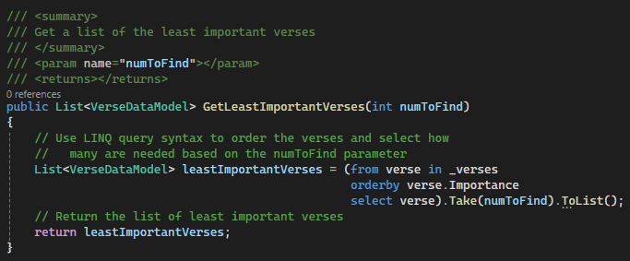
Figure 103: Use LINQ query syntax to get the least important verses
- Create a public GetLeastImportantVerses method in VerseLogic that takes an int numToFind and returns a list of VerseDisplayModels, as shown in Figure 104. The method will call VerseDAO method we just created. Remember to add a summary comment to the method.
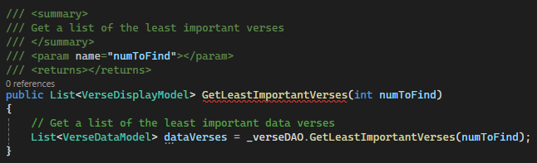
Figure 104: Setting up the VerseLogic GetLeastImportantVerses method
- We now need to take our dataVerses list and create a corresponding VerseDisplayModel. Because this was code we wrote earlier, we can remove the code from the GetAllVerses method to create a separate method that we can reuse. Start by adding a public ConvertVerseDataToDisplay method that accepts a VerseDataModel list and returns a VerseDisplayModel list, as shown in Figure 105. Make sure to add a summary comment.
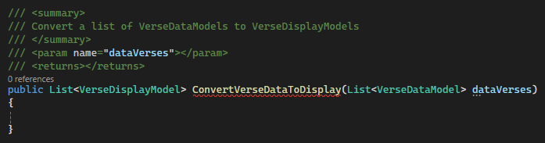
Figure 105: Creating the ConvertVerseDataToDisply method

- Copy the logic from to GetAllVerses method into ConvertVerseDataToDisplay, as shown in Figure 106.
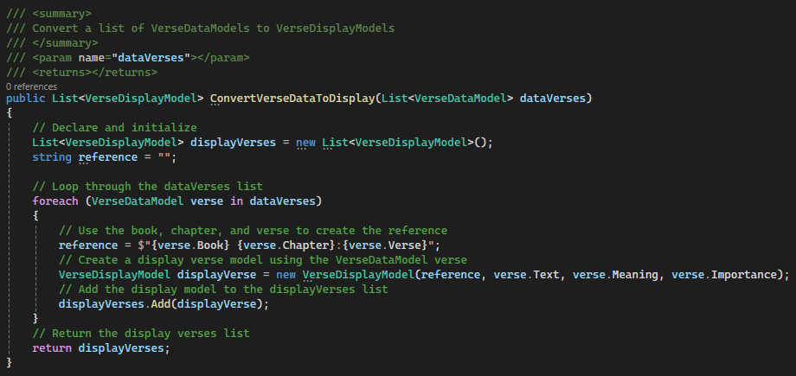
Figure 106: Adding logic to convert a VerseDataModel list to a VerseDisplayModel list
- Replace the logic in the GetAllVerses method with a call to the method we just created, as shown in Figure 107.
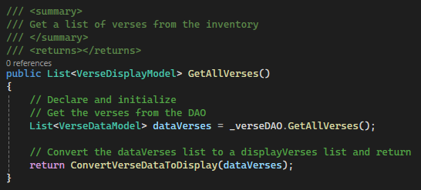
Figure 107: Update the GetAllVerses method with the ConvertVerseDataToDisplay method

- Back in the GetLeastImportantVerses method, call and return the ConvertVerseDataToDisplay method, as shown in Figure 108.
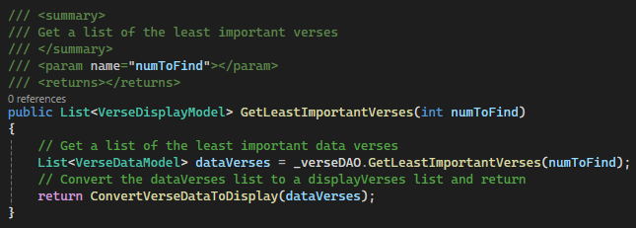
Figure 108: Finishing the GetLeastImportantVerses method in VerseLogic
- Back in the RdoShowLeastImportantCheckedChangedEH method in FrmVerseList, add a call to get the least important verses using the _verseLogic variable and the numToShow variable as the argument. Then, set the DataSource for _verseBindingSource to the list and call the FormatVersesDgv method to format the data grid view, as shown in Figure 109.
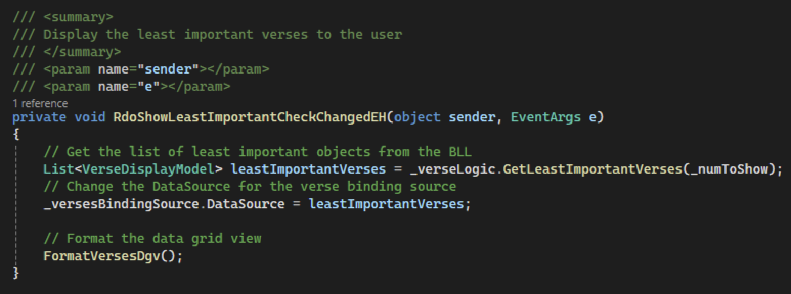
Figure 109: Finsihing the RdoShowLeastImportantCheckChangedEH method

- Commit all changes in the project to source control.
- Commit Message: Add functionality for getting the least important verses.
- Next, we will add similar functionality for the most important verses button. In VerseDAO, add a GetMostImportantVerses method with a summary comment. as shown in Figure 110.
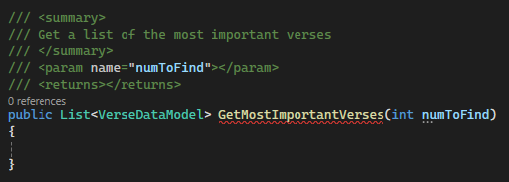
Figure 110: Setting up the GetMostImportantVerses method
- This method will use LINQ method syntax and a lambda expression to order the inventory and select the necessary number of items to return, as shown in Figure 111. Method syntax is often more concise than query syntax and can by more useful for chaining multiple operations.
The List object contains a method named OrderByDescending that requires a parameter of the property to sort by. The lambda expression (verse => verse.Important) selects the value from each verse to use for the comparison. The Take and ToList methods are the same as the query syntax example.
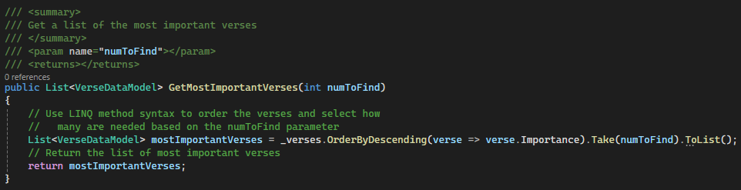
Figure 111: Using method syntax and a lambda expression to select the most important verses

- Now that we have our DAO method, we can move to the BusinessLogicLayer to create the mirroring GetMostImportantVerses method, which will call the method we just created in verseDAO. Then, we can use the conversion method we created earlier to get the right model to return, as shown in Figure 112.
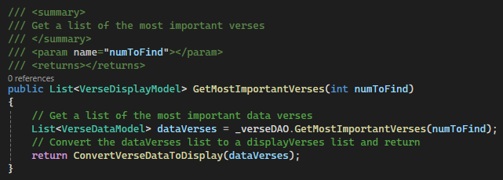
Figure 112: GetMostImportantVerses method in VerseLogic
- Finally, we can create another event handler in the presentation layer to use the logic we have just created to show the most important verses. Add a CheckedChanged event handler to rdoShowMostImportant named RdoShowMostImportantCheckedChangedEH. Add a summary comment, as shown in Figure 113.
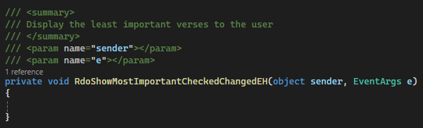
Figure 113: RdoMostValuableCheckedChangedEH with summary comment

- Add logic within the event handler to get a list of the most important verses using the numToShow variable, as shown in Figure 114. Then, we will update the versesBindingSource using the list to display the most important verses and format the data grid view.
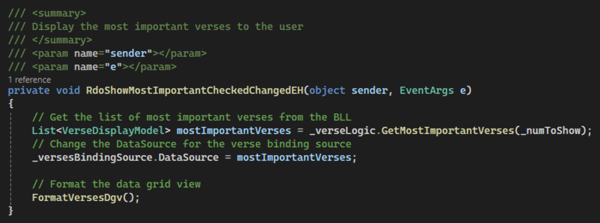
Figure 114: Logic to get the most important verses and display them to the user

- Commit all changes in the project to source control.
- Commit Message: Add functionality for the most important verses radio button.
- For our last control, we need to add logic to rdoShowAll that will allow us to show our entire, unsorted inventory. We can do this by adding a ChangedChecked event handler to rdoShowAll named RdoShowAllCheckedChangedEH with a summary comment, as shown in Figure 115.
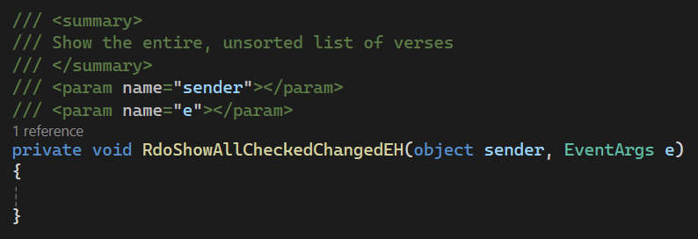
Figure 115: RdoShowAllCheckedChangedEH method with summary comment

- The only logic necessary in this method is a call to the RefreshVersesDgv method we created earlier, as shown in Figure 116. Because that method calls the GetAllVerses method in VerseLogic, it will automatically get the unsorted the list from the data access layer.
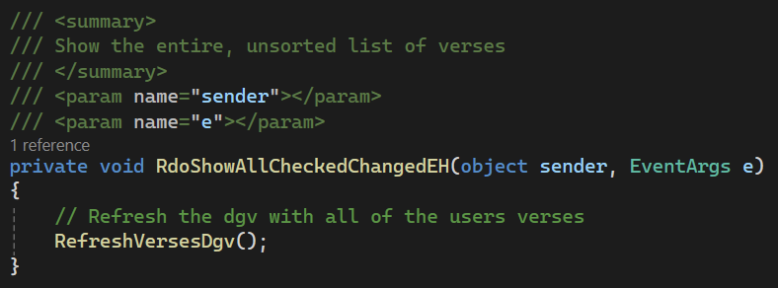
Figure 116: Add logic to the event handler to reset the data grid view with all verses in inventory

- Commit all changes in the project to source control.
- Commit Message: Finish Filter and Sort group box with the show all radio button functionality.
- Take a screenshot of the application running at this point.
- Take a screenshot of the TrbNumberToShowScrollEH, RdoShowLeastImportantCheckedChangedEH, RdoShowMostImportantCheckedChangedEH, and RdoShowAllCheckedChangedEH method in FrmVerseList.
- Take a screenshot of the GetLeastImportantVerses and GetMostImportantVerses methods in VerseLogic and VerseDAO.
- Paste the images into a Word document.
- Put a caption below each image explaining what is being demonstrated.

Challenges
Add the following features to the application.
- XML
In addition to JSON, CSV, and the TXT version of file types, add XML to save and load data.
- Excel
To extend the functionality of your application to save data in Excel format, you will need to use libraries that can handle these specific file types. For Excel, the popular choice is EPPlus, which handles Excel files without requiring Microsoft Office to be installed. See https://epplussoftware.com/docs/5.3/api/OfficeOpenXml.ExcelPackage.html for code examples.
- Search Functionality
Add a search bar to filter displayed items in real-time based on the Display properties, enhancing user experience in managing large datasets.
- Total Verses
Calculate the total number of verses the user has saved. Make sure to include the number of verses that ranges span (ex. Genesis 1:1–3 should count as three verses).

- Commit the challenges to source control with a commit message.
- Take a screenshot of the application running after the new features have been added.
- Take a screenshot of each method added or updated to implement the features.
- Take a screenshot of the updated UMLs for any classes with added methods.
- Take a screenshot of the XML and xlsx files.
- Paste the images into a Word document.
- Put a caption below each image explaining what is being demonstrated.

What You Learned From This Activity
In Activity 6, you explored advanced file handling and data manipulation techniques, focusing on LINQ and RegEx. Here’s what was covered and what you've learned.
File Input/Output Operations
You learned to handle file I/O operations efficiently, using formats such as JSON, CSV, TXT, XML, and XLSX. This included reading from and writing to files, which is fundamental for any application that needs data persistence.
Using NuGet and External Libraries
You integrated external libraries via NuGet, enhancing the application's functionality. This included using ServiceStack for serialization, which simplifies the conversion of objects to and from JSON and CSV formats.
Regular Expressions (Regex)
You utilized RegEx to check data validity. This skill is invaluable for data validation and processing in software development, as it allows for complex pattern matching and text manipulation.
LINQ for Data Manipulation
You applied LINQ to perform sorting and filtering of data collections. The use of both "Query" syntax (long form) and "Method" syntax (fluent form) provided a deep understanding of how powerful LINQ can be for querying data in an intuitive and readable manner.
Data Binding and Grid Controls
You mastered data binding techniques to link collections directly to grid controls for display. This technique is essential for creating dynamic UIs that automatically update in response to data changes.
Key Takeaways
Versatility of File Formats: Understanding different file formats and how to manipulate them within .NET enhances your ability to design flexible software that can interact with various data sources and systems.
Power of LINQ: You've seen how LINQ transforms the way data is handled in .NET, making code more readable and easier to maintain. It's particularly effective for querying collections of data in a declarative manner.
RegEx Proficiency: RegEx is a powerful tool for parsing and validating text. Learning to construct and understand complex RegEx patterns is an essential skill in software development.
Practical Application Development Skills: The comprehensive nature of this activity means you now have practical experience in a wide range of software development aspects, from back-end processing to UI design.
N-layer architecture design can be built from the DAO up or the PresentationLayer down. Both are correct, and the one you choose to use is based on your own coding style.
This activity not only equipped you with practical skills but also prepared you to tackle more complex software development challenges, enabling you to build robust, efficient, and user-friendly applications.

Check for Understanding
These quiz questions will help you review important concepts from the activity. These are not graded. You do not have to submit your score.
- What does the acronym LINQ represent in .NET programming?
  - Language integrated query
  - Localized input query
  - Language interpreted query
  - Linear input query
- What is the main use of RegEx in this application?
  - To convert data formats such as CSV to JSON
  - To validate entered data
  - To encrypt or decrypt textual data
  - To validate and format JSON data
- What is a typical use of RegEx in programming?
  - To build complex user interface controls
  - To link methods to user interface actions
  - To evaluate the likelihood of an email being spam
  - To retrieve specific data from structured text files

- What role does the "Where" clause play in a LINQ query?
  - It sorts a collection of objects.
  - It filters a collection based on a specific condition.
  - It categorizes elements in a collection.
  - It merges two collections into one.
- How is LINQ's query syntax often described, based on its structural similarity?
  - Comparable to Python's list comprehensions
  - Similar to JavaScript's function syntax
  - Analogous to SQL query syntax
  - Related to HTML tag structures

Answer Key:
1. What does the acronym LINQ represent in .NET programming?
a. Language integrated query
2. What is the main use of RegEx in this application?
b. To parse and extract data from formatted text
3. What is a typical use of RegEx in programming?
d. To retrieve specific data from structured text files
4. What role does the 'Where' clause play in a LINQ query?
b. It filters a collection based on a specific condition.
5. How is LINQ's Query Syntax often described, based on its structural similarity?
c. Analogous to SQL query syntax

Deliverables
You must submit two separate files:
- One PDF containing Parts 1–2.
- One zip file containing the complete codebase for Part 3.
Part 1: Activity Submission
- Cover Page
  - Use APA formatting for the cover page.
- GitHub Repository Link
  - At the top of the second page, provide a link to your private GitHub repository.
  - Be sure to add your instructor and grading assistant (if applicable) as collaborators.
- Updated Flowchart
  - Include the latest flowchart reflecting your current application design.
- Updated UML Diagram(s)
  - Provide UML diagrams that reflect the current implementation.
- Base Application Screenshots
  - Include screenshots as required in the activity instructions.
  - Each screenshot must have a clear caption directly below the image explaining what is being demonstrated.
  - All code must be properly commented.
- Section Headers
  - Use clear headers as outlined in these deliverables to identify each part of the assignment within the PDF.
- Citations
  - Include a citation at the top of each page containing code, flowcharts, or UML diagrams.
- File Naming
  - Name the PDF according to the activity title and include your full name.
- Coding Standards Compliance
  - Ensure GCU College of Engineering and Technology Coding Guidelines and Best Practices, found in the Class Resources, have been followed to ensure consistency, readability, and professionalism in student code.

Part 2: Activity Challenges
- Challenge Screenshots
  - Include screenshots that demonstrate completion of the challenge requirements as described in the activity guide.
- Minimum Features
  - Implement and document all features from the challenge section.
Part 3: Code Submission (Separate Zip File)
- Zip Your Project Folder
  - Compress the full folder containing all source code and necessary files into a .zip file.
- Executable Submission
  - Ensure the application runs correctly. The zip file will be unzipped and tested during grading, so include all dependencies.
- File Naming
  - Name the zip file according to the activity and include your full name.
Submission Reminder
Do not submit a single zip file that contains both the PDF and the code. Each file must be uploaded separately.

