Chad Galloway
CST-250 Programming in C# II
Grand Canyon University
Nov. 09, 2025
Activity 3

Files
https://github.com/CGalloway3/CST-250-Projects/tree/master/Activity3

Video
[Video Link]

PART 1
Flow Chart

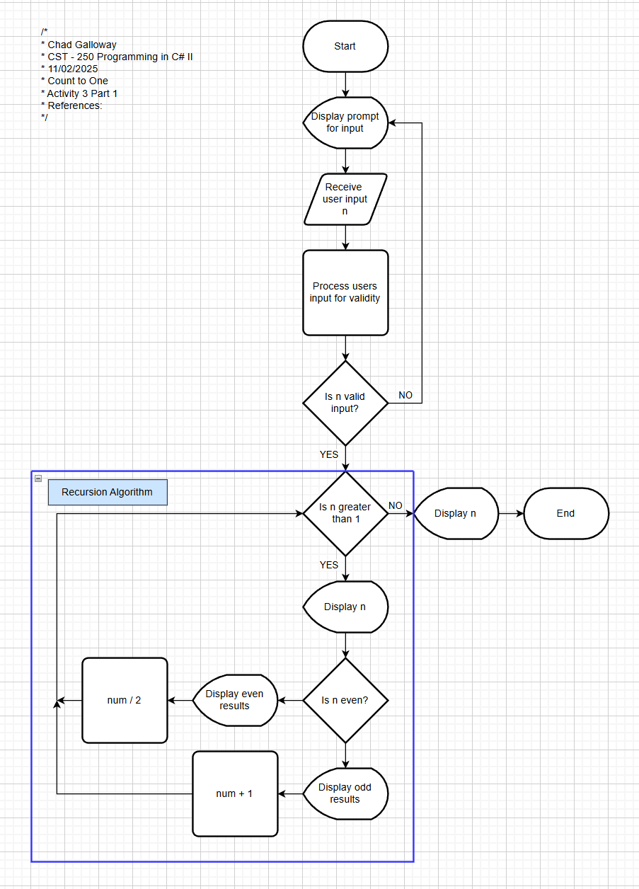
Figure 1: Flow chart of Activity 3 part one, count to one recursion console application.
UML Class Diagram

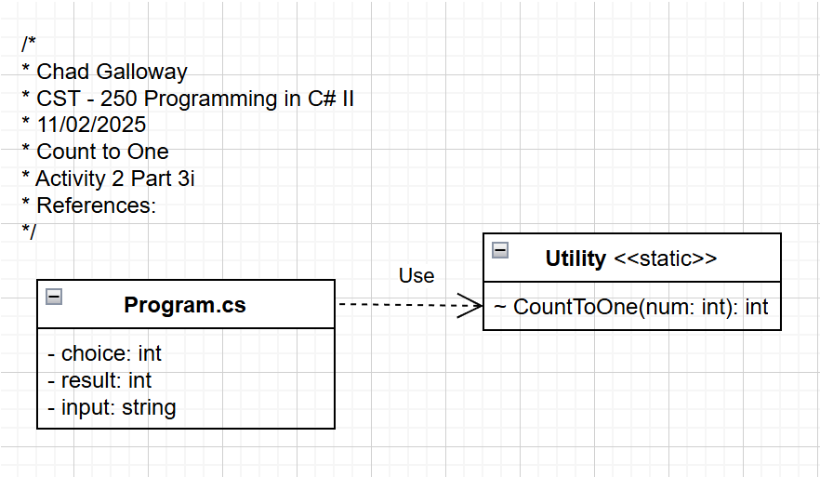
Figure 2: UML Class Diagram for Activity 3 part one, count to one recursion console application.

Screen Shots

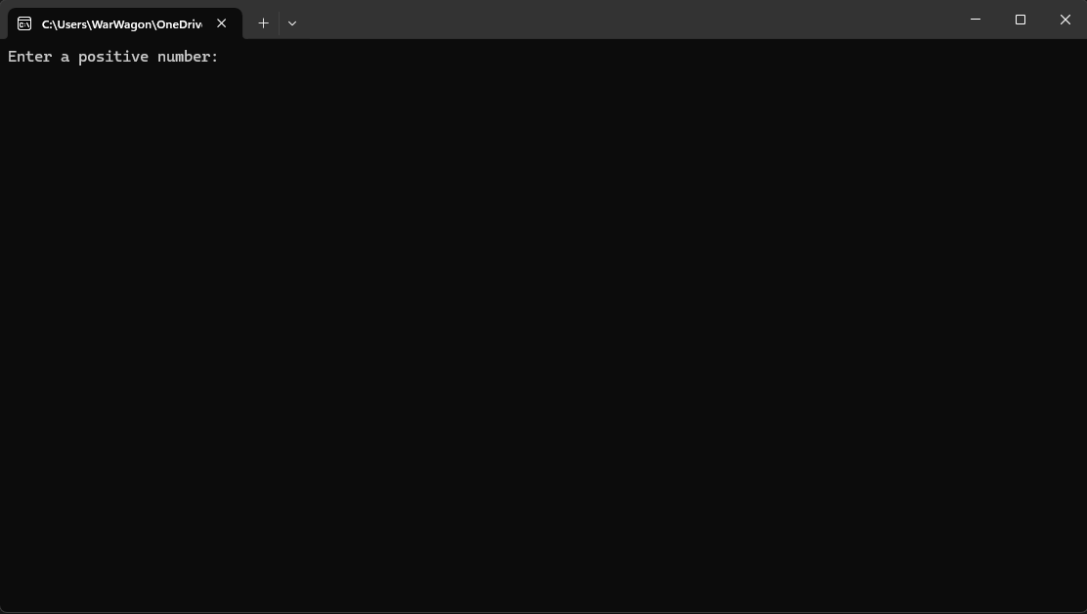
Figure 3: Part 1 App Running in Initial load state.
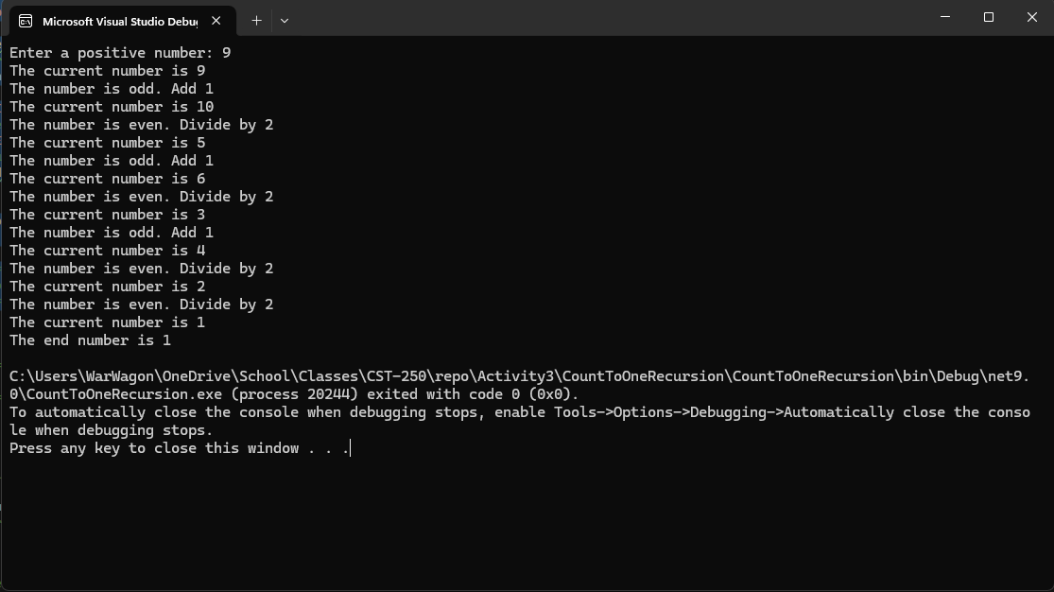
Figure 4: Screenshot of successful output

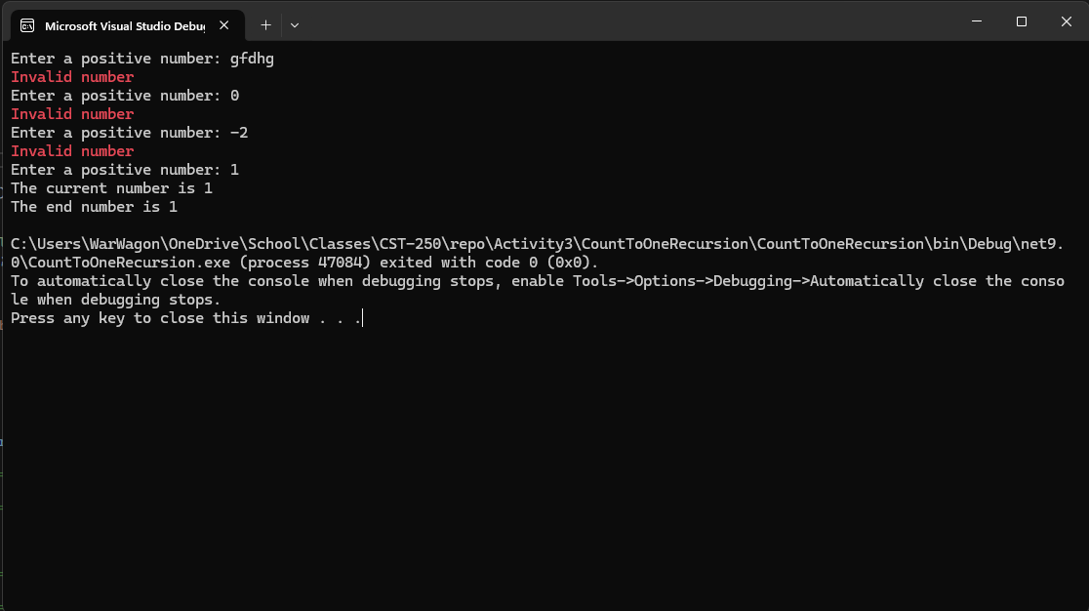
Figure 5: Screenshot of Error Handling

Code

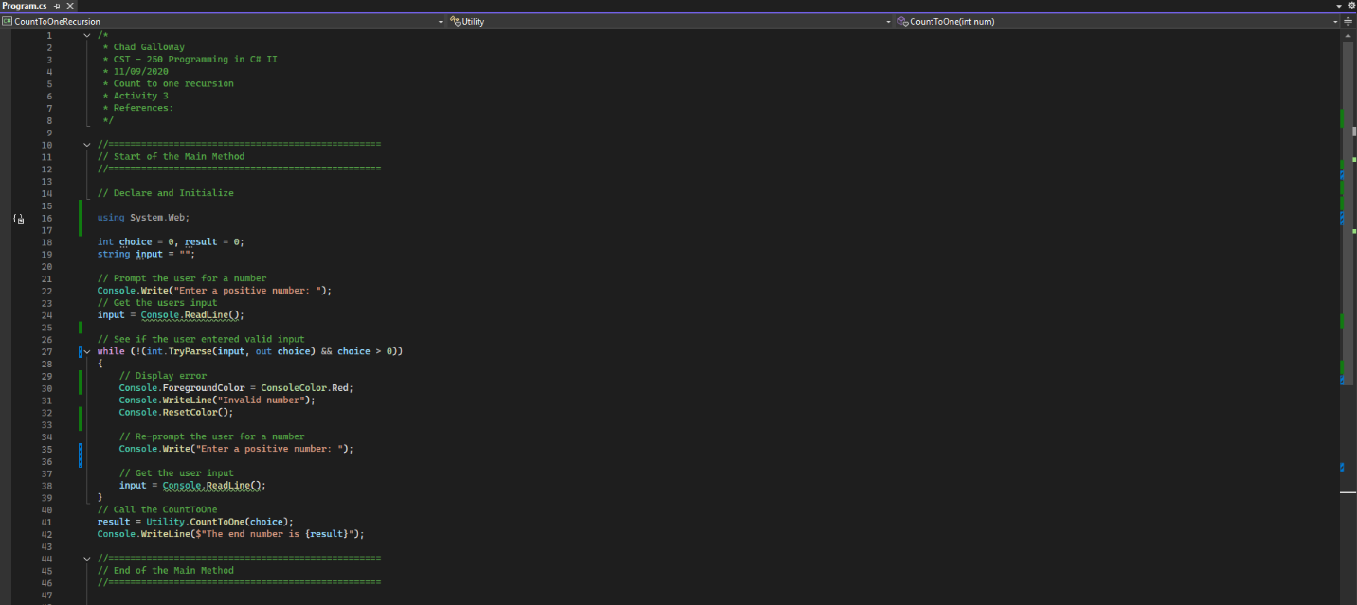
Figure 6: Code Citations and the main method.

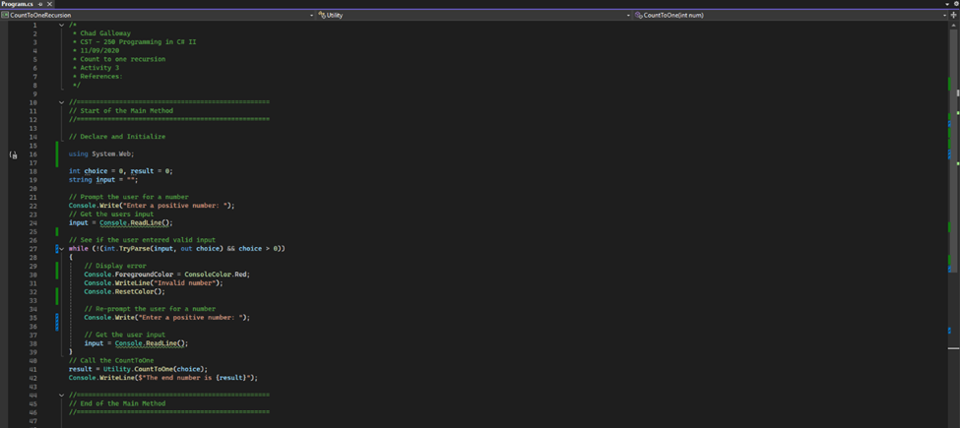
Figure 7: Utility class and the count to one method.

PART 1 CHALLENGES

Screen Shots

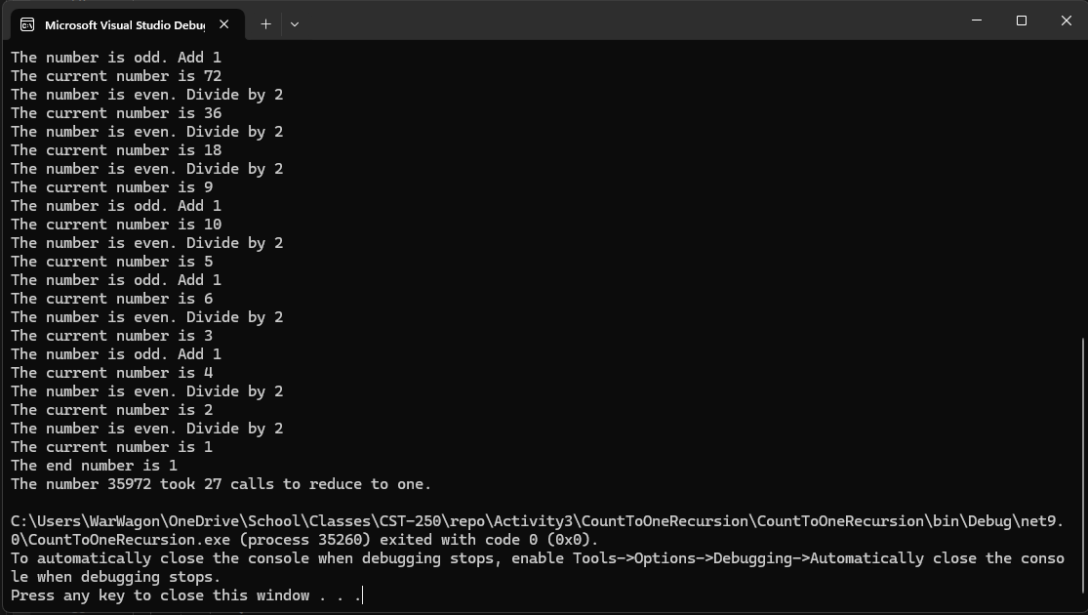
Figure 8: Task 1 challenge successful program completion.

Code

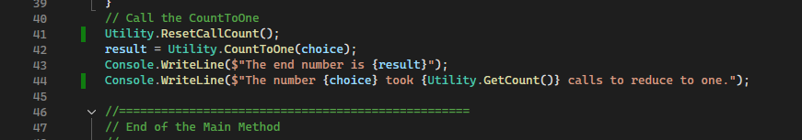
Figure 9: Changes to the main method for task 1 challenge.

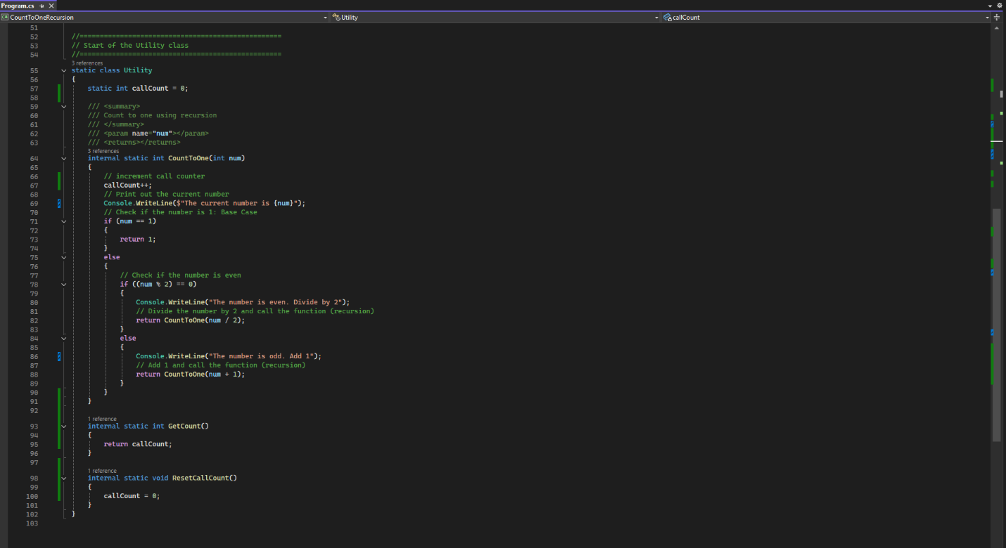
Figure 10: Changes to the Utility class for task 1 challenge.

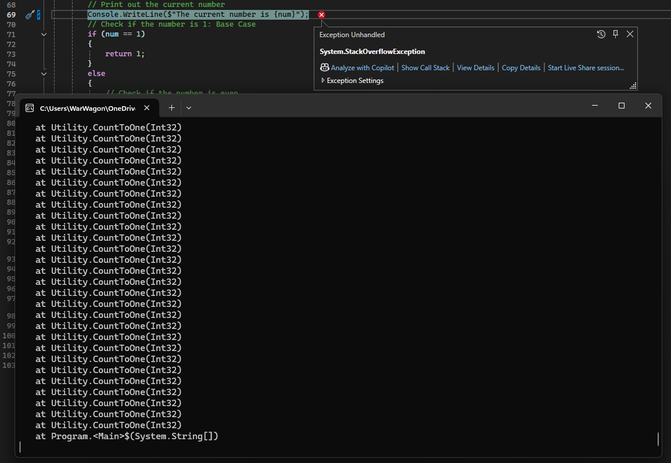
Figure 11: Changing to add two to odd numbers causes a stack overflow. Adding 2 to an odd number keeps the number odd forever and cause the recursion to loop until it crashes
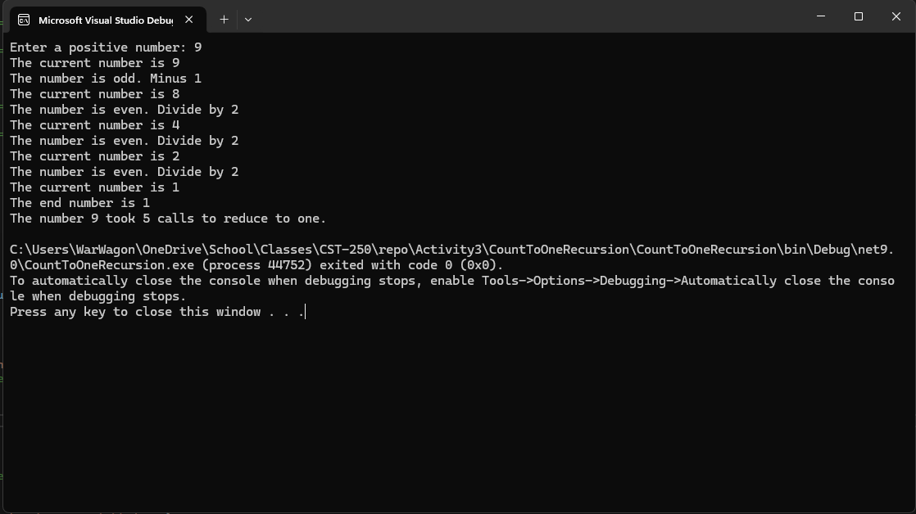
Figure 12: Changing to “minus one” runs successfully but the number of calls is reduced. In previous runs entering “9” would make eight calls using the plus one odd number adjustments. Using minus one does not adversely affect the programs operation but it reduced those eight calls to five. With larger numbers (35,972) this variation is less significant at ~ 25% but here in cases of low numbers it is an almost ~38% reduction in call overhead.
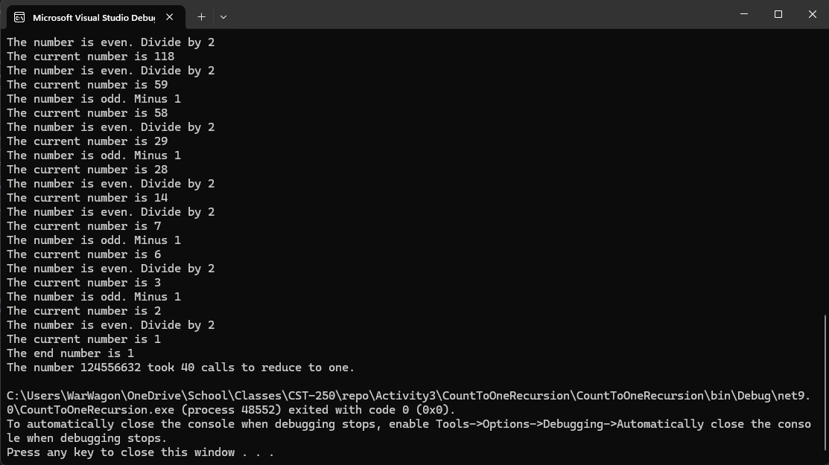 Figure 13: Strangely, in the cases of 124,556,632 the number of calls using minus one increased by one compared to using plus one.

One thing that Figure 12 and 13 clearly demonstrate is don’t be afraid to try different methods of adjusting outliers in your recursion loop. A simple thing like flipping a plus sign to minus had a massive effect on some of the lower number’s computational efficiency.

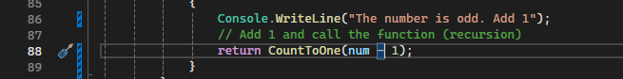
Figure 14: The only value changed to go from crashing to a reduction in calls was the number at the tail end of the return call to CountToOne

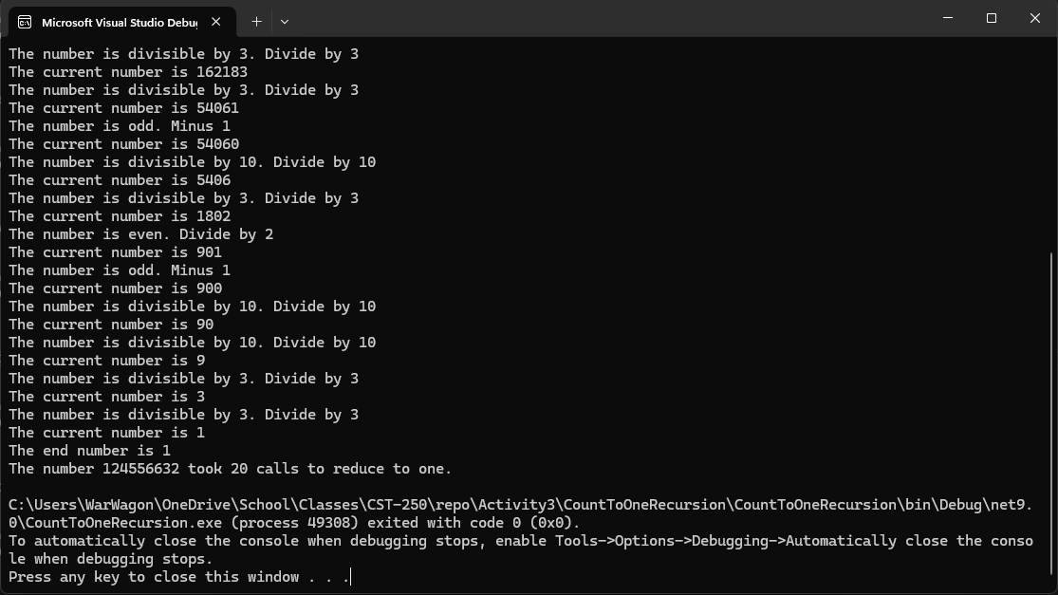
Figure 15: Extra Divisions added at mod 10, 5, 4, and 3 reduced the method calls to 20 for tack 2 in the challenges list.

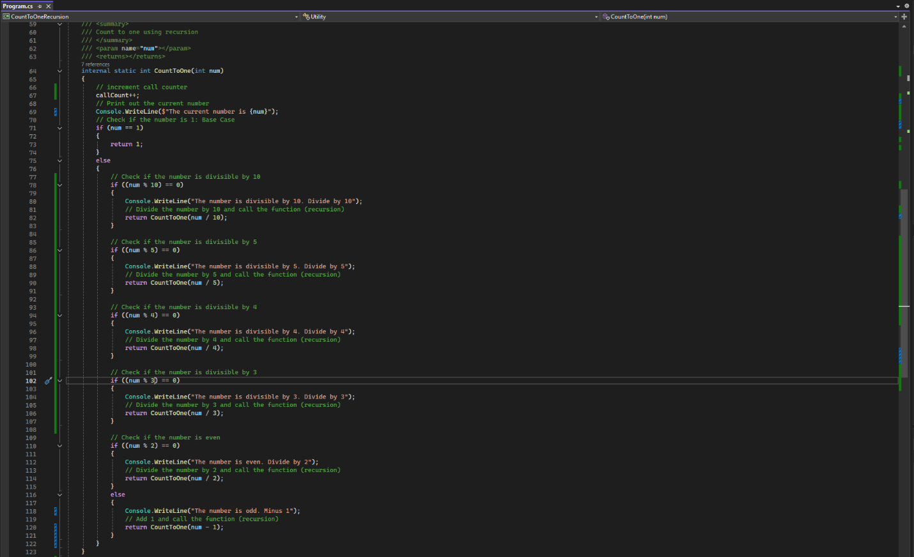
Figure 16: Code changes to get the extra divisions running in the CountToOne() method.

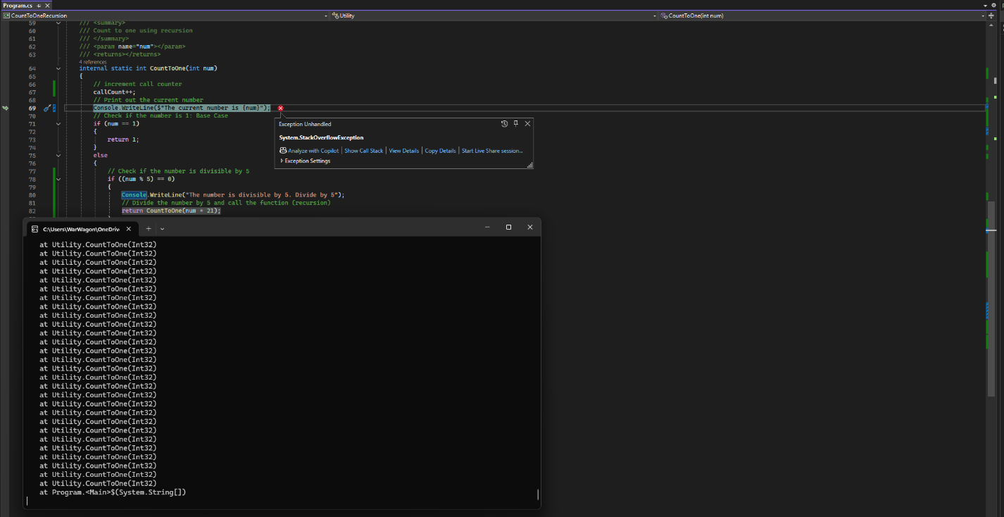
Figure 17: Trying task four we run into a stack overflow error, same as we did when we tried adding two to odd numbers. When the number becomes divisible by 5 it is then multiplied by a factor of 21 and it is then still divisible by 5 so the recursion loop runs indefinitely until we get an overflow. We need to be careful of these cases in recursion.

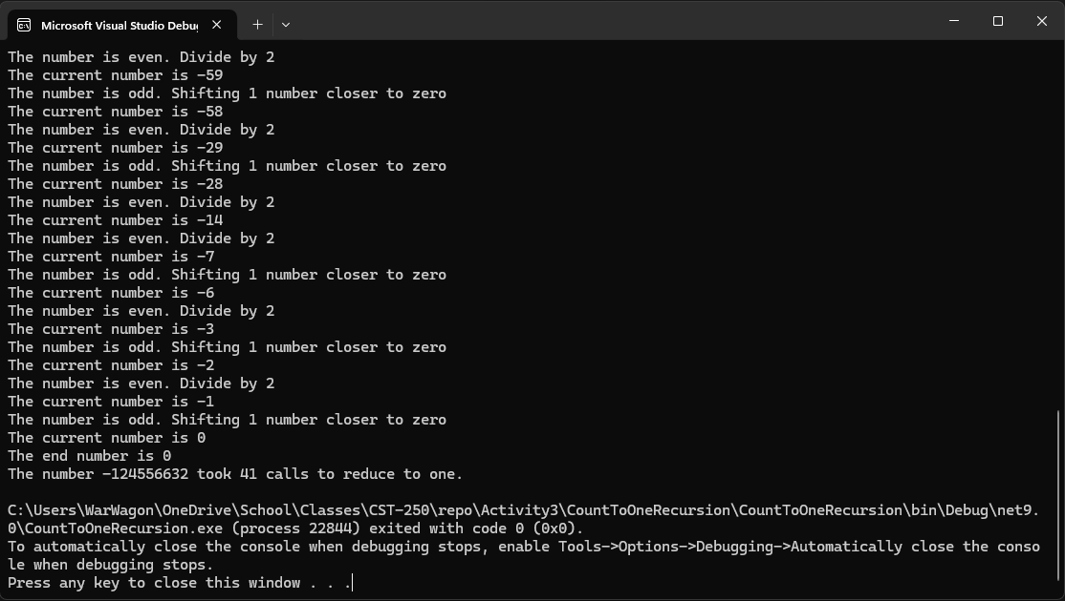
Figure 18: Running with negative number and zero tolerance.

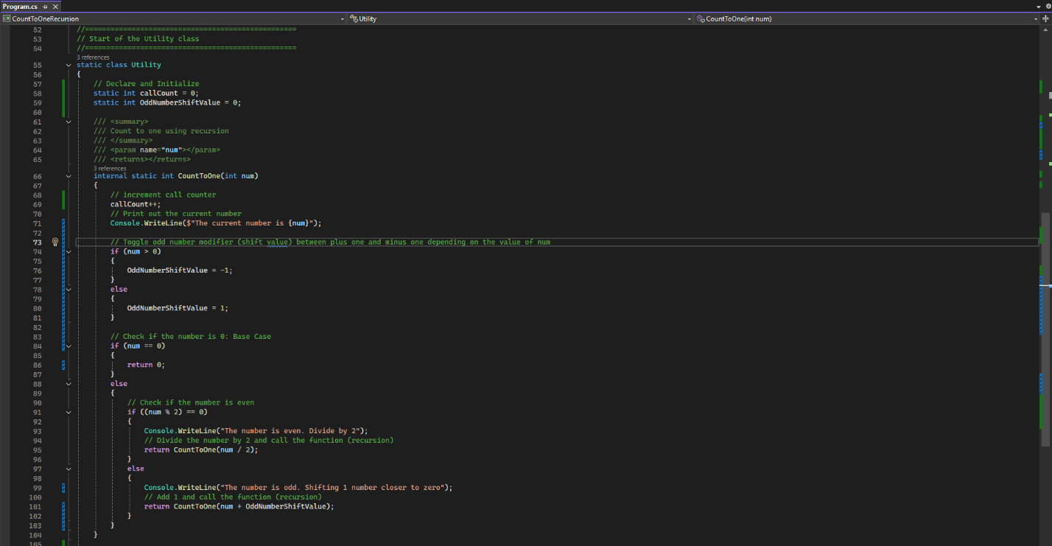
Figure 19: Code changes to count to one for negative numbers

Figure 20: Slightly altered error checking in main method to allow negative numbers

PART 2

Flow Chart


Figure X: Flow chart of XXXXXXX

"Lorem ipsum dolor sit amet, consectetur adipiscing elit, sed do eiusmod tempor incididunt ut labore et dolore magna aliqua. Ut enim ad minim veniam, quis nostrud exercitation ullamco laboris nisi ut aliquip ex ea commodo consequat. Duis aute irure dolor in reprehenderit in voluptate velit esse cillum dolore eu fugiat nulla pariatur. Excepteur sint occaecat cupidatat non proident, sunt in culpa qui officia deserunt mollit anim id est laborum."

UML Class Diagram


Figure X: UML Class Diagram

Lorem ipsum dolor sit amet, consectetur adipiscing elit, sed do eiusmod tempor incididunt ut labore et dolore magna aliqua. Ut enim ad minim veniam, quis nostrud exercitation ullamco laboris nisi ut aliquip ex ea commodo consequat. Duis aute irure dolor in reprehenderit in voluptate velit esse cillum dolore eu fugiat nulla pariatur. Excepteur sint occaecat cupidatat non proident, sunt in culpa qui officia deserunt mollit anim id est laborum.

Screen Shots


Figure X: Part 2 App Running

Lorem ipsum dolor sit amet, consectetur adipiscing elit, sed do eiusmod tempor incididunt ut labore et dolore magna aliqua. Ut enim ad minim veniam, quis nostrud exercitation ullamco laboris nisi ut aliquip ex ea commodo consequat. Duis aute irure dolor in reprehenderit in voluptate velit esse cillum dolore eu fugiat nulla pariatur. Excepteur sint occaecat cupidatat non proident, sunt in culpa qui officia deserunt mollit anim id est laborum.


Figure X: Screenshot of successful output

Lorem ipsum dolor sit amet, consectetur adipiscing elit, sed do eiusmod tempor incididunt ut labore et dolore magna aliqua. Ut enim ad minim veniam, quis nostrud exercitation ullamco laboris nisi ut aliquip ex ea commodo consequat. Duis aute irure dolor in reprehenderit in voluptate velit esse cillum dolore eu fugiat nulla pariatur. Excepteur sint occaecat cupidatat non proident, sunt in culpa qui officia deserunt mollit anim id est laborum.


Figure X: Screenshot of Error Handling

Lorem ipsum dolor sit amet, consectetur adipiscing elit, sed do eiusmod tempor incididunt ut labore et dolore magna aliqua. Ut enim ad minim veniam, quis nostrud exercitation ullamco laboris nisi ut aliquip ex ea commodo consequat. Duis aute irure dolor in reprehenderit in voluptate velit esse cillum dolore eu fugiat nulla pariatur. Excepteur sint occaecat cupidatat non proident, sunt in culpa qui officia deserunt mollit anim id est laborum.

Code


Figure 6: Code Citations and the main method.


Figure 7: Utility class and the count to one method.

PART 2 CHALLENGES

Screen Shots

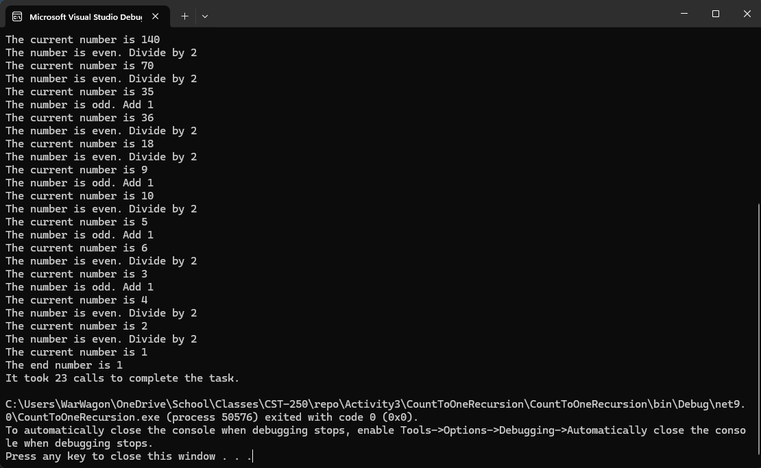

Code


Figure 6: Code Citations and the main method.


Figure 7: Utility class and the count to one method.

PART 3

Flow Chart


Figure X: Flow chart of XXXXXXX

"Lorem ipsum dolor sit amet, consectetur adipiscing elit, sed do eiusmod tempor incididunt ut labore et dolore magna aliqua. Ut enim ad minim veniam, quis nostrud exercitation ullamco laboris nisi ut aliquip ex ea commodo consequat. Duis aute irure dolor in reprehenderit in voluptate velit esse cillum dolore eu fugiat nulla pariatur. Excepteur sint occaecat cupidatat non proident, sunt in culpa qui officia deserunt mollit anim id est laborum."

UML Class Diagram


Figure X: UML Class Diagram

Lorem ipsum dolor sit amet, consectetur adipiscing elit, sed do eiusmod tempor incididunt ut labore et dolore magna aliqua. Ut enim ad minim veniam, quis nostrud exercitation ullamco laboris nisi ut aliquip ex ea commodo consequat. Duis aute irure dolor in reprehenderit in voluptate velit esse cillum dolore eu fugiat nulla pariatur. Excepteur sint occaecat cupidatat non proident, sunt in culpa qui officia deserunt mollit anim id est laborum.

Screen Shots


Figure X: Part 3 App Running

Lorem ipsum dolor sit amet, consectetur adipiscing elit, sed do eiusmod tempor incididunt ut labore et dolore magna aliqua. Ut enim ad minim veniam, quis nostrud exercitation ullamco laboris nisi ut aliquip ex ea commodo consequat. Duis aute irure dolor in reprehenderit in voluptate velit esse cillum dolore eu fugiat nulla pariatur. Excepteur sint occaecat cupidatat non proident, sunt in culpa qui officia deserunt mollit anim id est laborum.


Figure X: Screenshot of successful output

Lorem ipsum dolor sit amet, consectetur adipiscing elit, sed do eiusmod tempor incididunt ut labore et dolore magna aliqua. Ut enim ad minim veniam, quis nostrud exercitation ullamco laboris nisi ut aliquip ex ea commodo consequat. Duis aute irure dolor in reprehenderit in voluptate velit esse cillum dolore eu fugiat nulla pariatur. Excepteur sint occaecat cupidatat non proident, sunt in culpa qui officia deserunt mollit anim id est laborum.


Figure X: Screenshot of Error Handling

Lorem ipsum dolor sit amet, consectetur adipiscing elit, sed do eiusmod tempor incididunt ut labore et dolore magna aliqua. Ut enim ad minim veniam, quis nostrud exercitation ullamco laboris nisi ut aliquip ex ea commodo consequat. Duis aute irure dolor in reprehenderit in voluptate velit esse cillum dolore eu fugiat nulla pariatur. Excepteur sint occaecat cupidatat non proident, sunt in culpa qui officia deserunt mollit anim id est laborum.

Code


Figure 6: Code Citations and the main method.


Figure 7: Utility class and the count to one method.

PART 3 CHALLENGES

Screen Shots



Code


Figure 6: Code Citations and the main method.


Figure 7: Utility class and the count to one method.

PART 4

Flow Chart


Figure X: Flow chart of XXXXXXX

"Lorem ipsum dolor sit amet, consectetur adipiscing elit, sed do eiusmod tempor incididunt ut labore et dolore magna aliqua. Ut enim ad minim veniam, quis nostrud exercitation ullamco laboris nisi ut aliquip ex ea commodo consequat. Duis aute irure dolor in reprehenderit in voluptate velit esse cillum dolore eu fugiat nulla pariatur. Excepteur sint occaecat cupidatat non proident, sunt in culpa qui officia deserunt mollit anim id est laborum."

UML Class Diagram


Figure X: UML Class Diagram

Lorem ipsum dolor sit amet, consectetur adipiscing elit, sed do eiusmod tempor incididunt ut labore et dolore magna aliqua. Ut enim ad minim veniam, quis nostrud exercitation ullamco laboris nisi ut aliquip ex ea commodo consequat. Duis aute irure dolor in reprehenderit in voluptate velit esse cillum dolore eu fugiat nulla pariatur. Excepteur sint occaecat cupidatat non proident, sunt in culpa qui officia deserunt mollit anim id est laborum.

Screen Shots


Figure X: Part 4 App Running

Lorem ipsum dolor sit amet, consectetur adipiscing elit, sed do eiusmod tempor incididunt ut labore et dolore magna aliqua. Ut enim ad minim veniam, quis nostrud exercitation ullamco laboris nisi ut aliquip ex ea commodo consequat. Duis aute irure dolor in reprehenderit in voluptate velit esse cillum dolore eu fugiat nulla pariatur. Excepteur sint occaecat cupidatat non proident, sunt in culpa qui officia deserunt mollit anim id est laborum.


Figure X: Screenshot of successful output

Lorem ipsum dolor sit amet, consectetur adipiscing elit, sed do eiusmod tempor incididunt ut labore et dolore magna aliqua. Ut enim ad minim veniam, quis nostrud exercitation ullamco laboris nisi ut aliquip ex ea commodo consequat. Duis aute irure dolor in reprehenderit in voluptate velit esse cillum dolore eu fugiat nulla pariatur. Excepteur sint occaecat cupidatat non proident, sunt in culpa qui officia deserunt mollit anim id est laborum.


Figure X: Screenshot of Error Handling

Lorem ipsum dolor sit amet, consectetur adipiscing elit, sed do eiusmod tempor incididunt ut labore et dolore magna aliqua. Ut enim ad minim veniam, quis nostrud exercitation ullamco laboris nisi ut aliquip ex ea commodo consequat. Duis aute irure dolor in reprehenderit in voluptate velit esse cillum dolore eu fugiat nulla pariatur. Excepteur sint occaecat cupidatat non proident, sunt in culpa qui officia deserunt mollit anim id est laborum.

Code


Figure 6: Code Citations and the main method.


Figure 7: Utility class and the count to one method.

PART 4 CHALLENGES

Screen Shots



Code


Figure 6: Code Citations and the main method.


Figure 7: Utility class and the count to one method.

