Chad Galloway
CST-250 Programming in C# II
Grand Canyon University
Oct. 26, 2025
Activity 1

Files
https://github.com/CGalloway3/CST-250-Projects/tree/master/Activity%201

Video
https://www.loom.com/share/0b708cd1a5ec482eac7e5269918f2441

Part 1

FLOW CHART

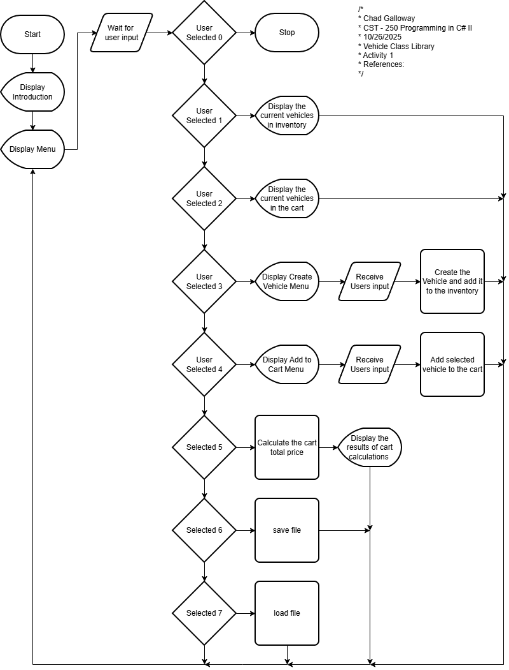
Figure X: Flow chart of Activity 1

UML Class Diagram

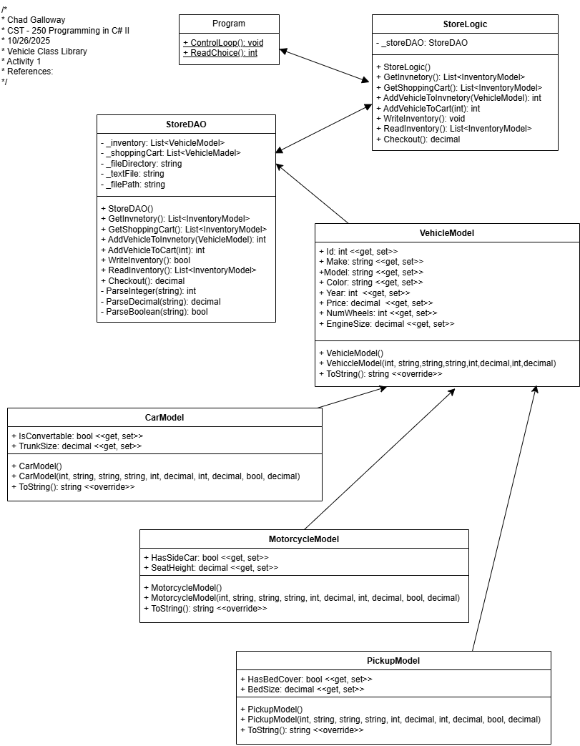
Figure X: UML Class Diagram

Screen Shots

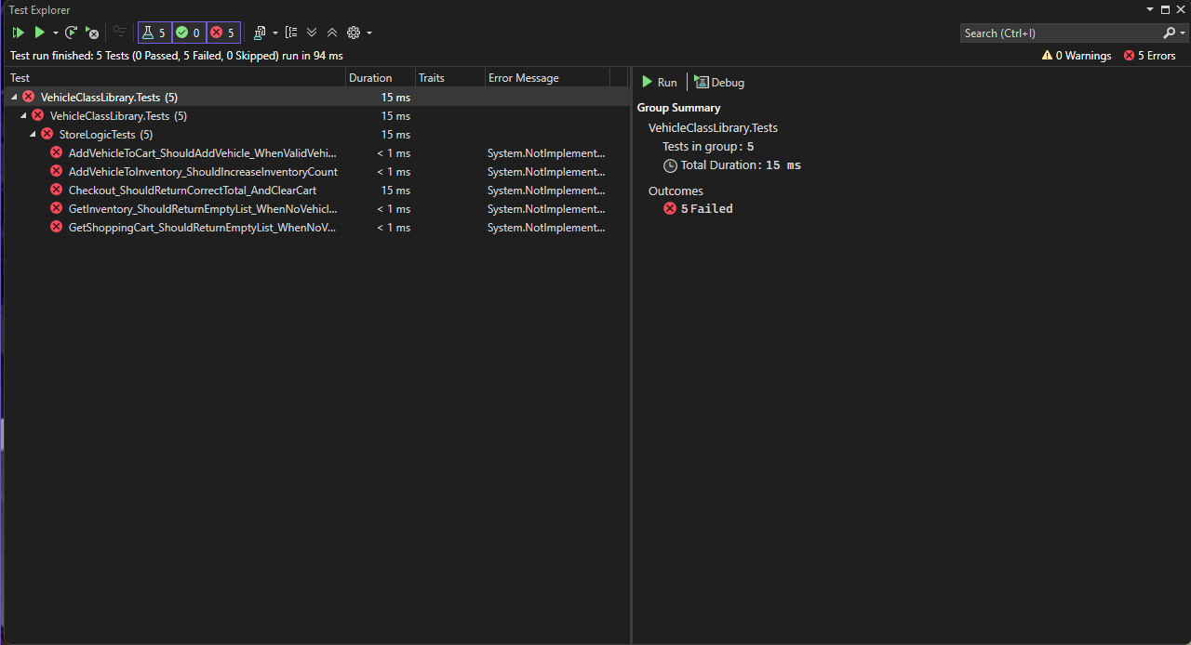
Figure 3: Screenshot of xUnit test

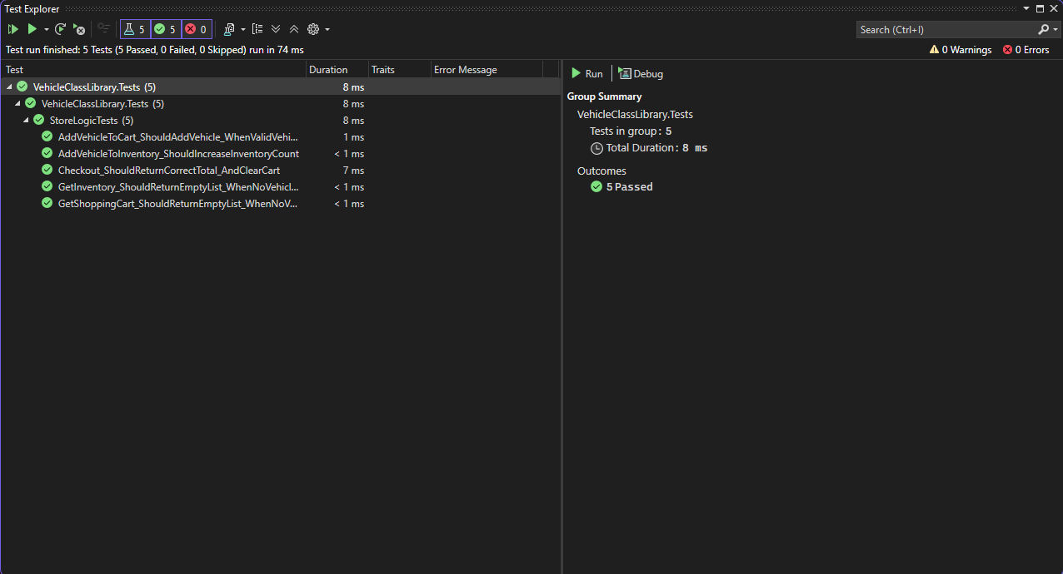
Figure 4: Screenshot of unit test

Figure 3 and 4 are screenshots of the unit tests. 3 is unsuccessful and 4 is successful completion of the tests.
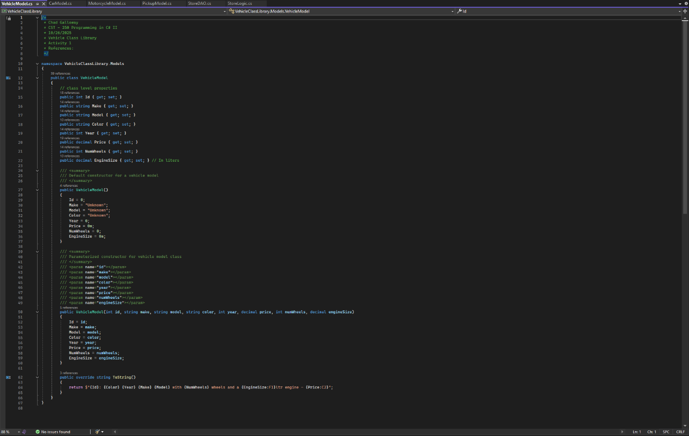
Figure 5: Vehicle Model

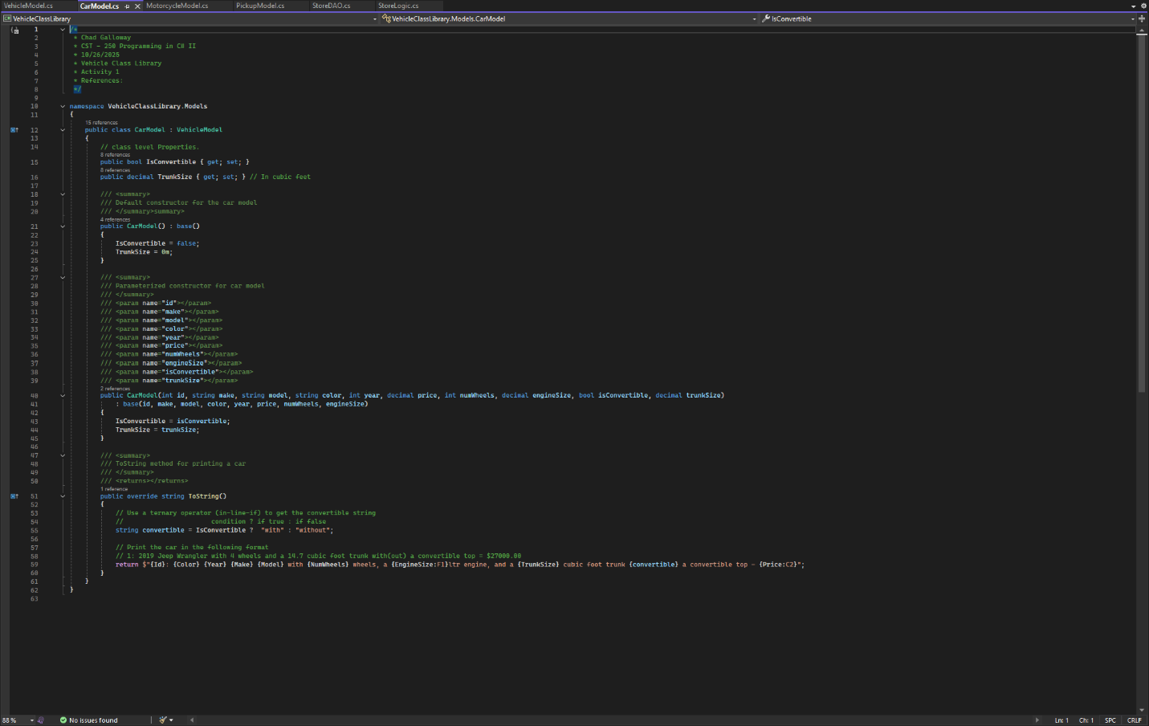
Figure 6: Car Model
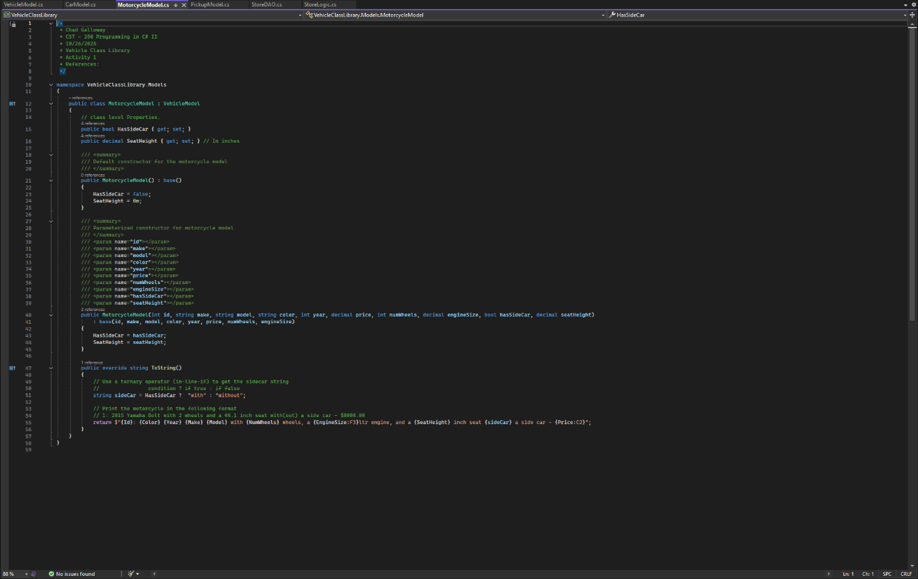
Figure 7: Motorcycle Model

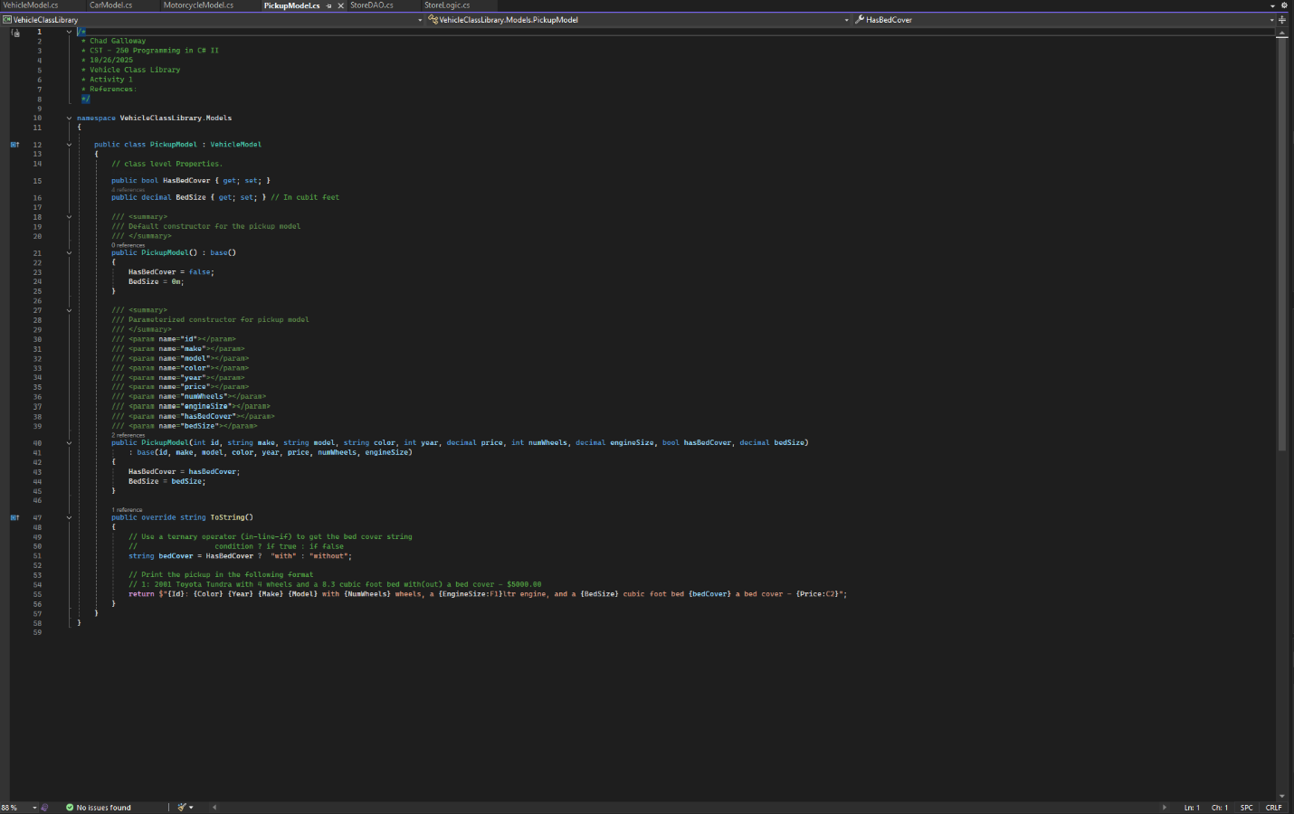
Figure 8: pickup model

Figures 5, 6, 7, and 8 are screen shots of the different models for vehicles in the application. Each screenshot covers the citations, constructors, and the overridden ToString() methods.

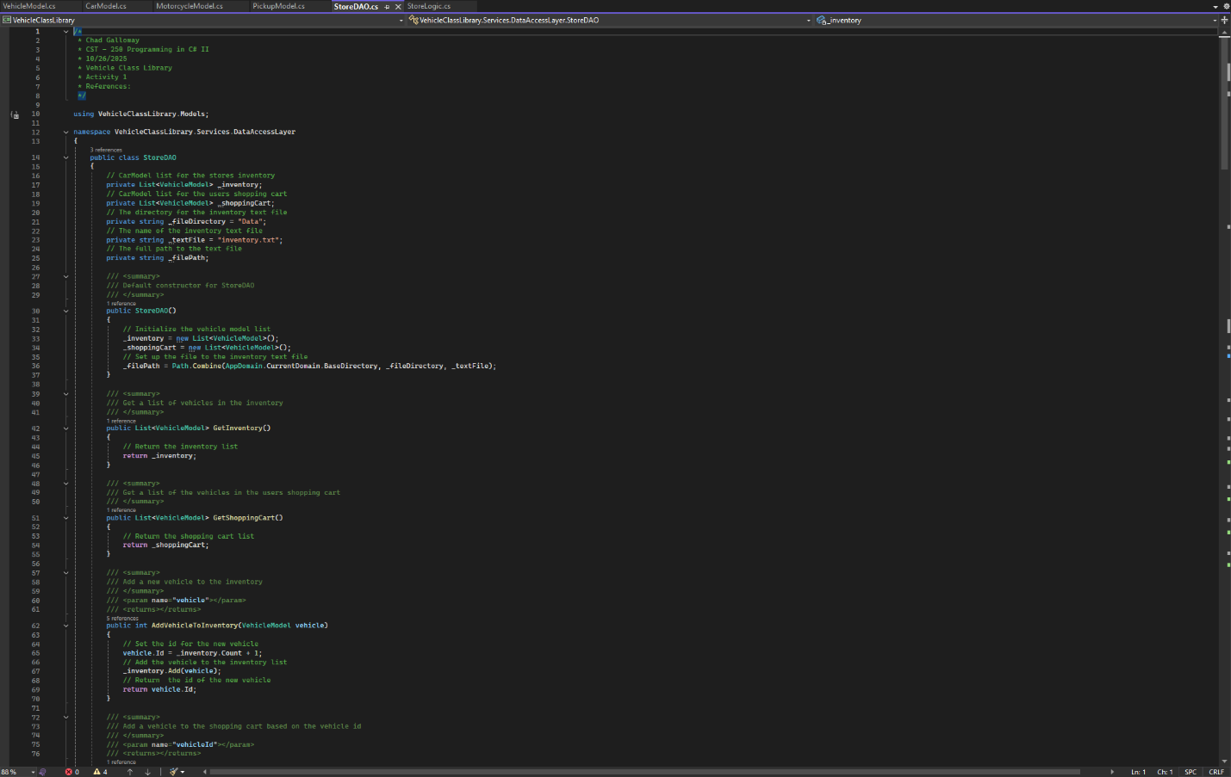
Figure 9: StoreDAO citations and constructors.
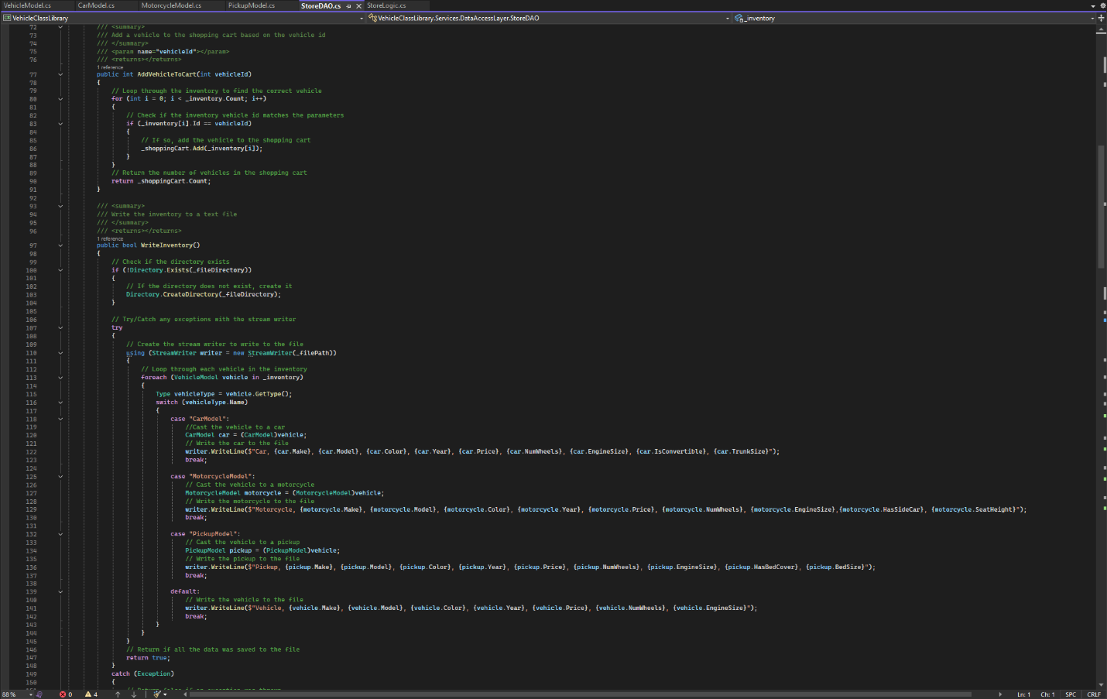
Figure 10: continuation of StoreDAO

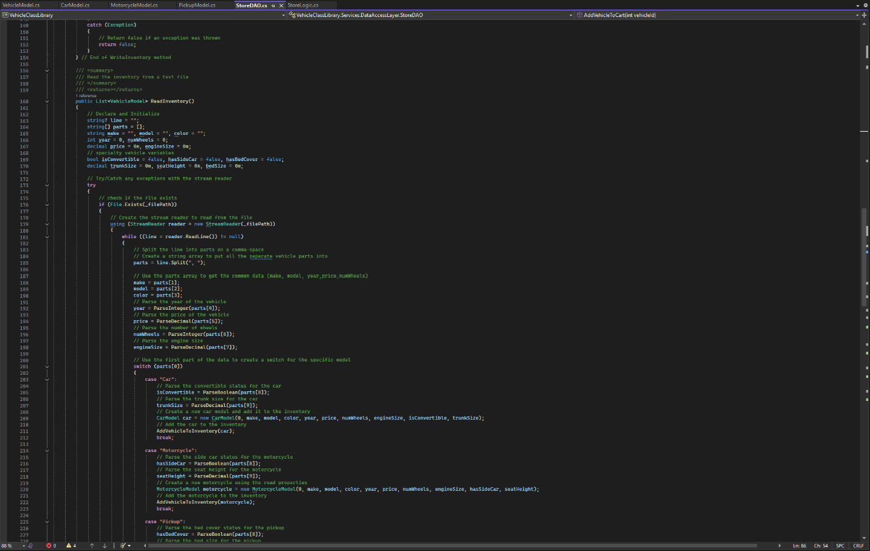
Figure 11: continuation of StoreDAO
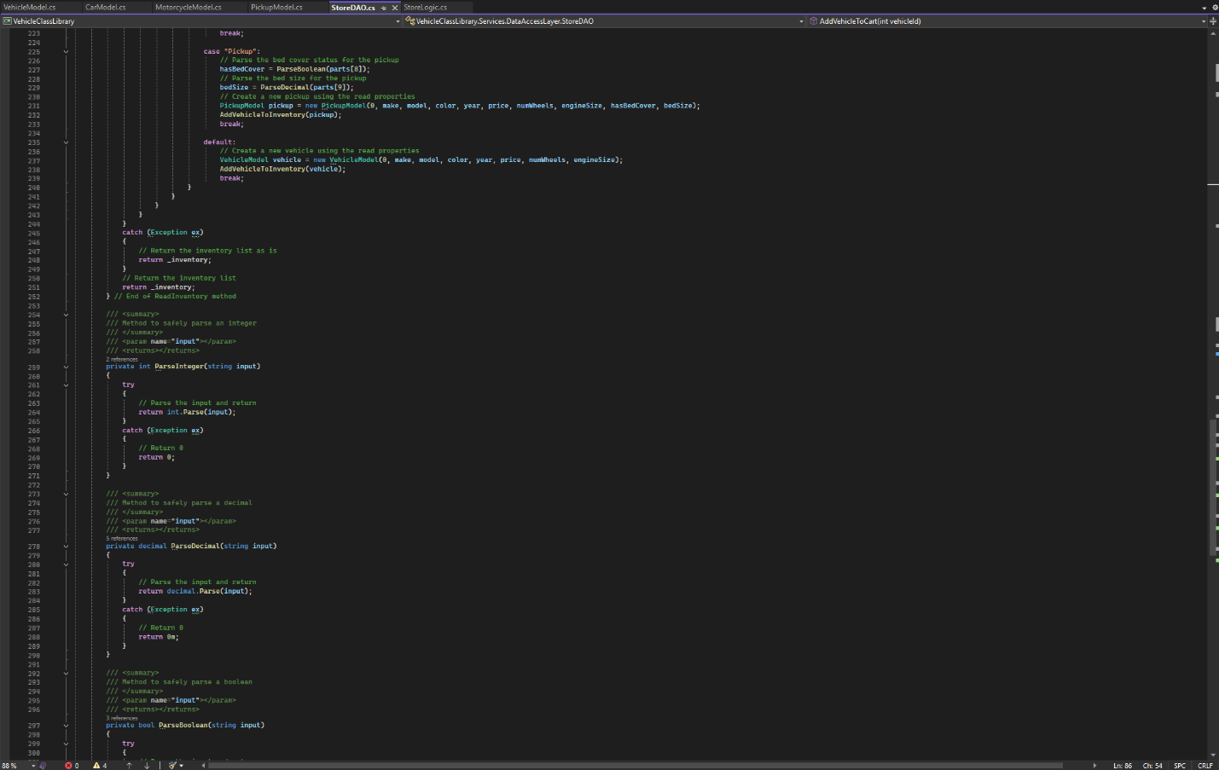
Figure 12: continuation of StoreDAO

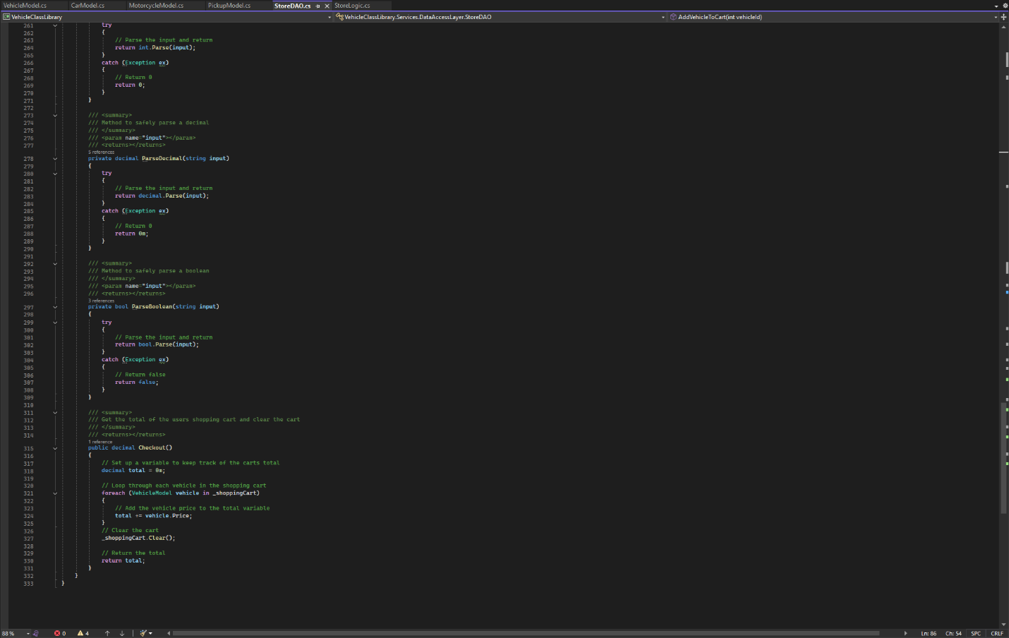
Figure 13: Final screenshot of StoreDAO
Figures 9-13 are screen shots of the StoreDAO class in its entirety. Every method is represented in the screen shots.

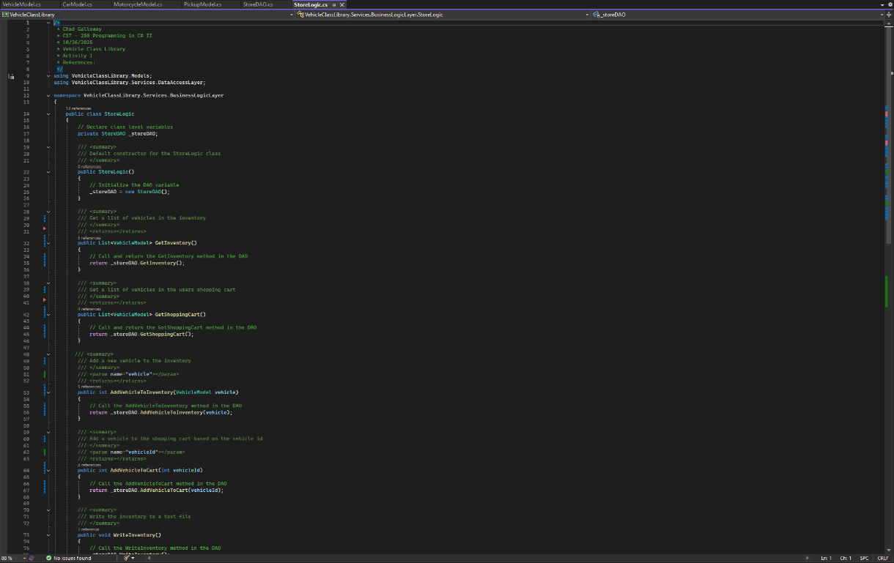
Figure 14: StoreLogic class citations and constructor

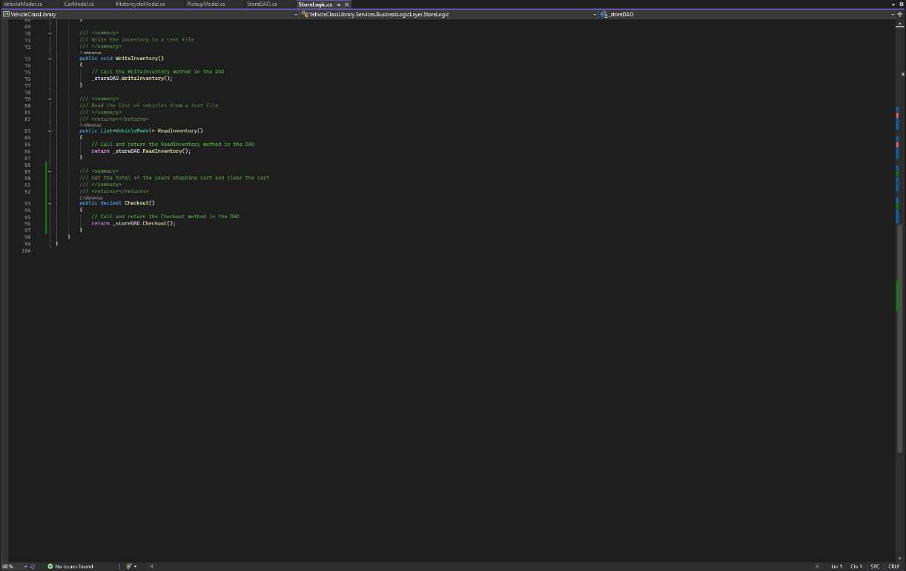
Figure 15: StoreLogic methods

Figure 14 and 15 are screenshots of the StoreLogic class.

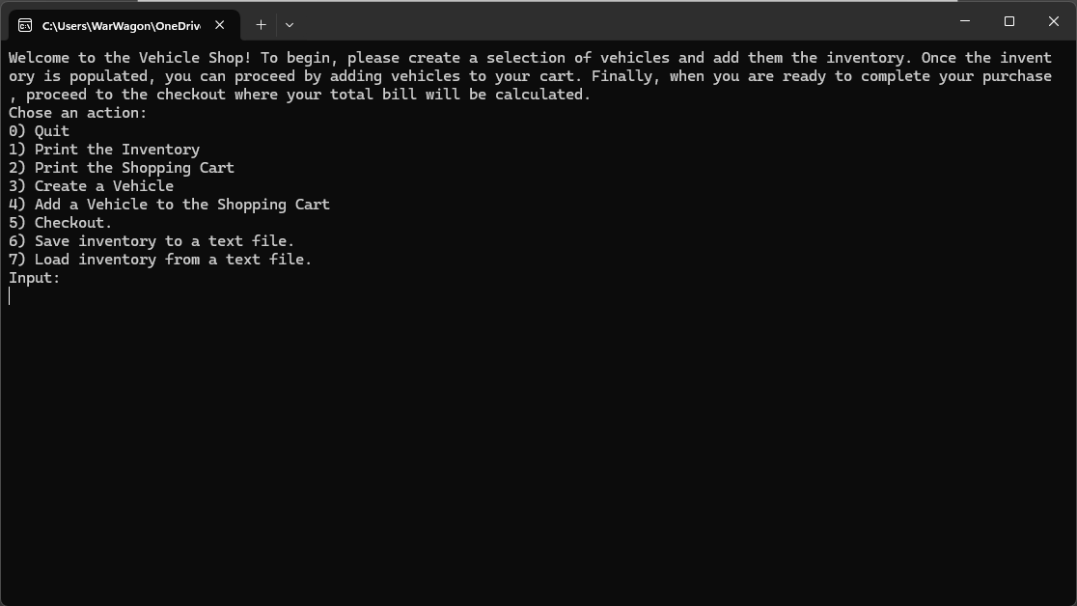
Figure 16: Initial load state of the console app

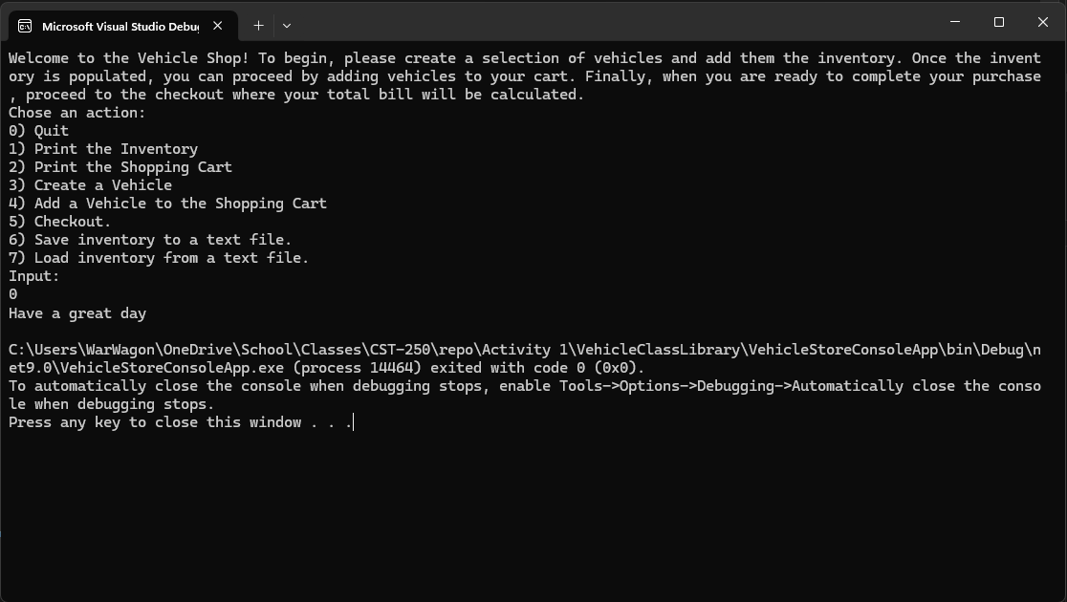Figure 17: user input 0

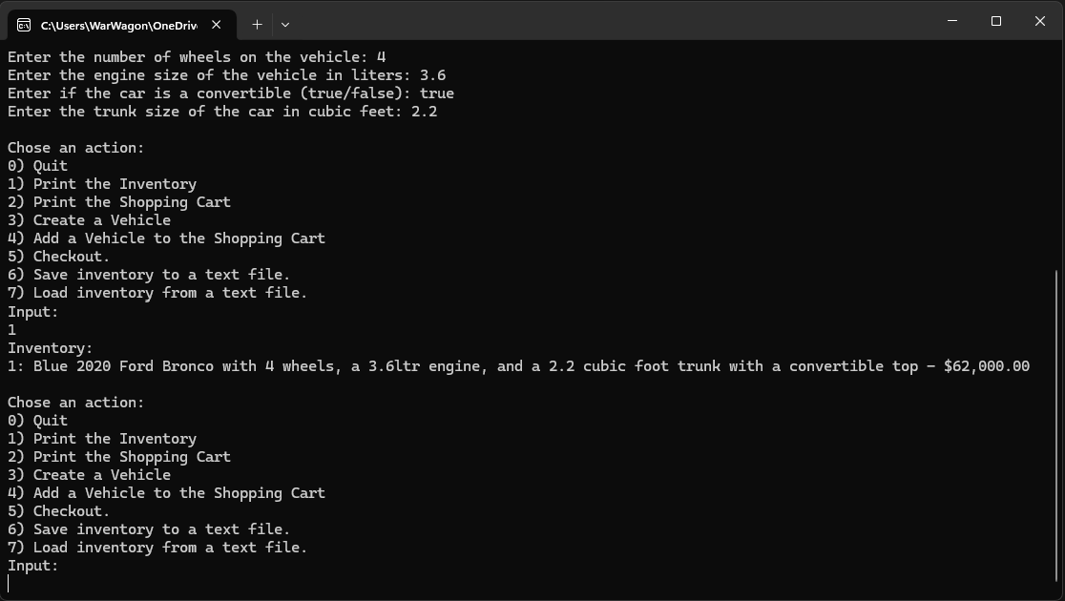
Figure 18: user input 1

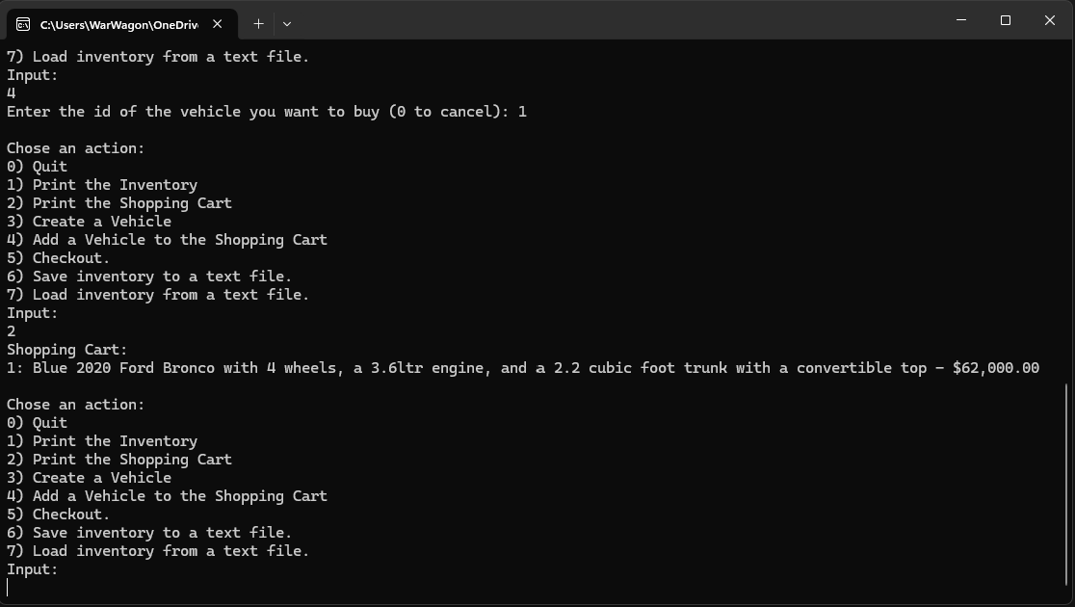
Figure 19: user input 2

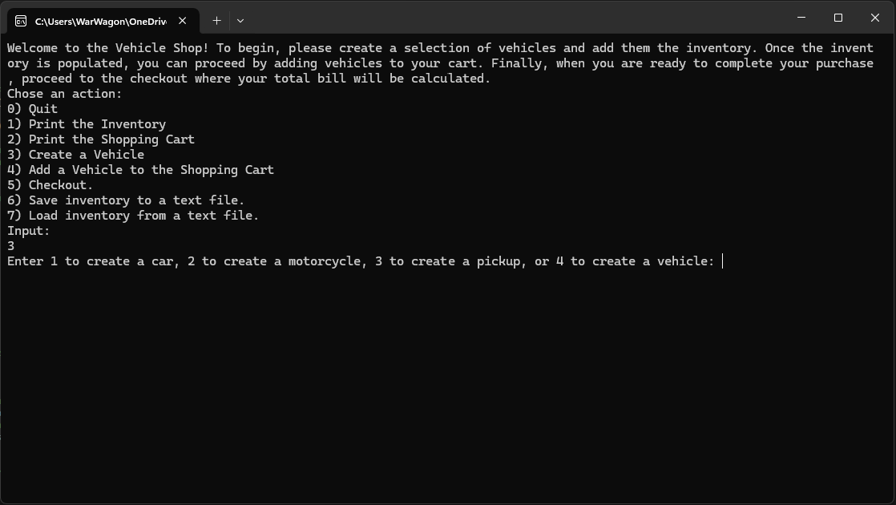
Figure 20: user input 3

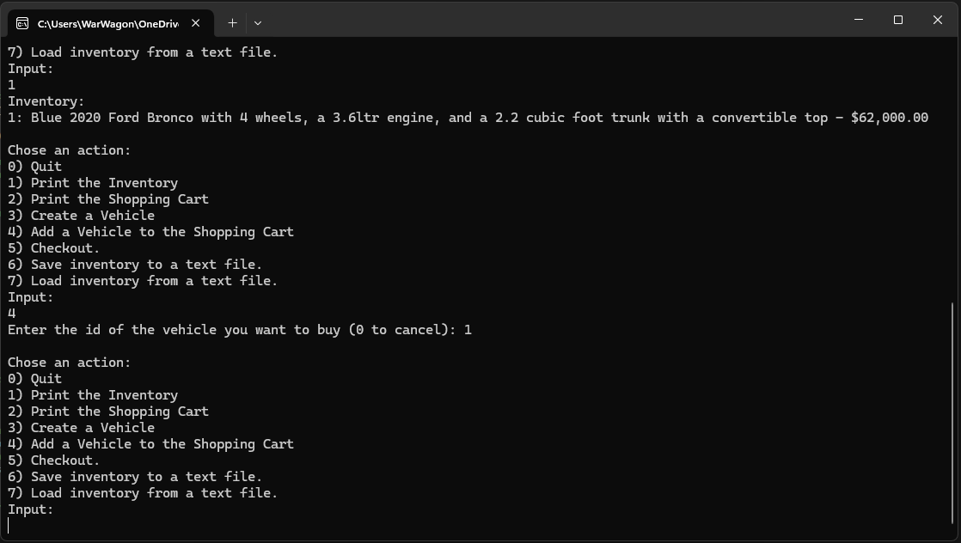
Figure 21: user input 4

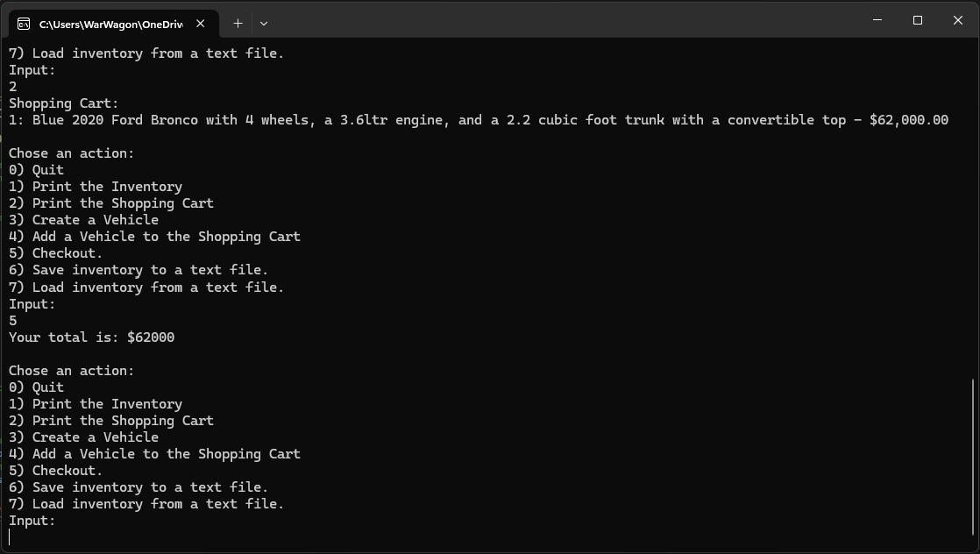
Figure 22: user input 5

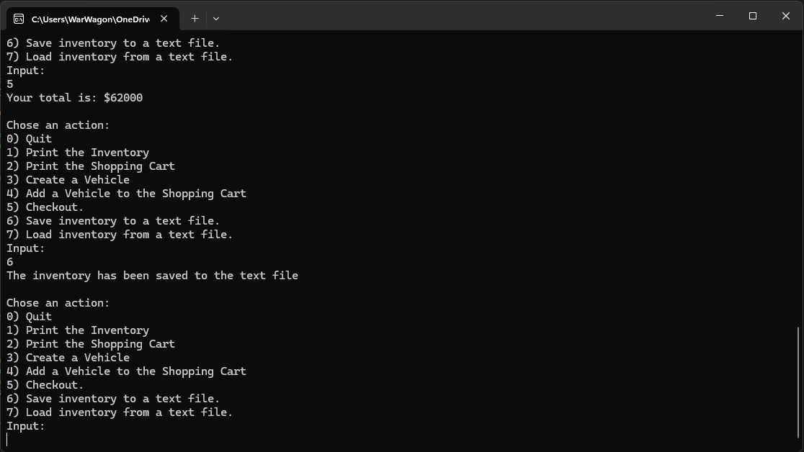
Figure 23: user input 6

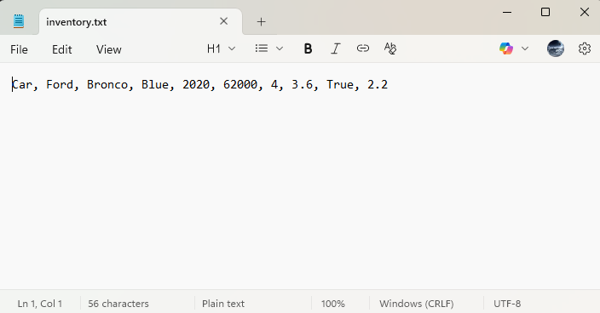
Figure 24: File contents after save (number 6)

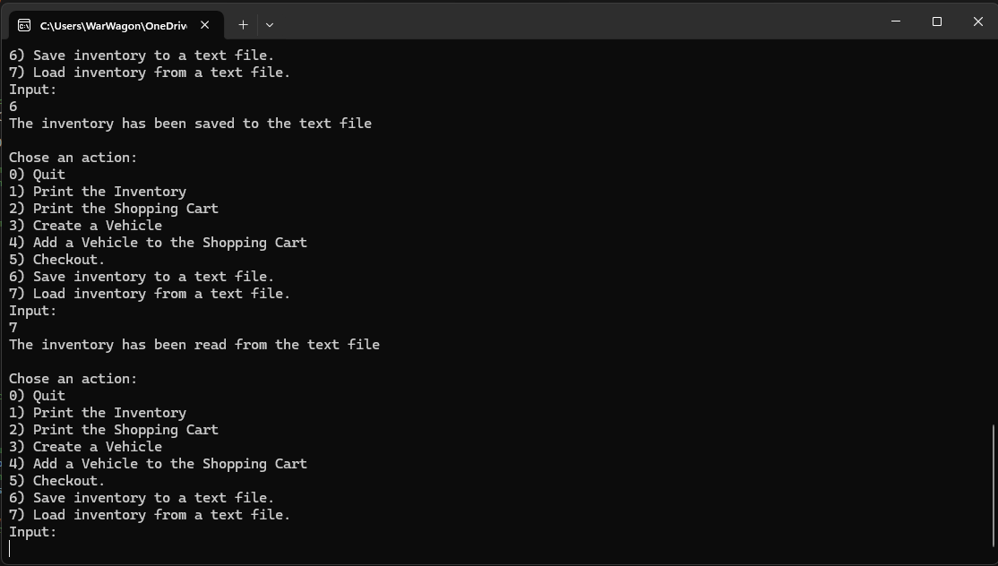Figure 25: user input 7

Figure 16- 25 are screenshots of the application running and demonstrating the different menu option selections made by the user

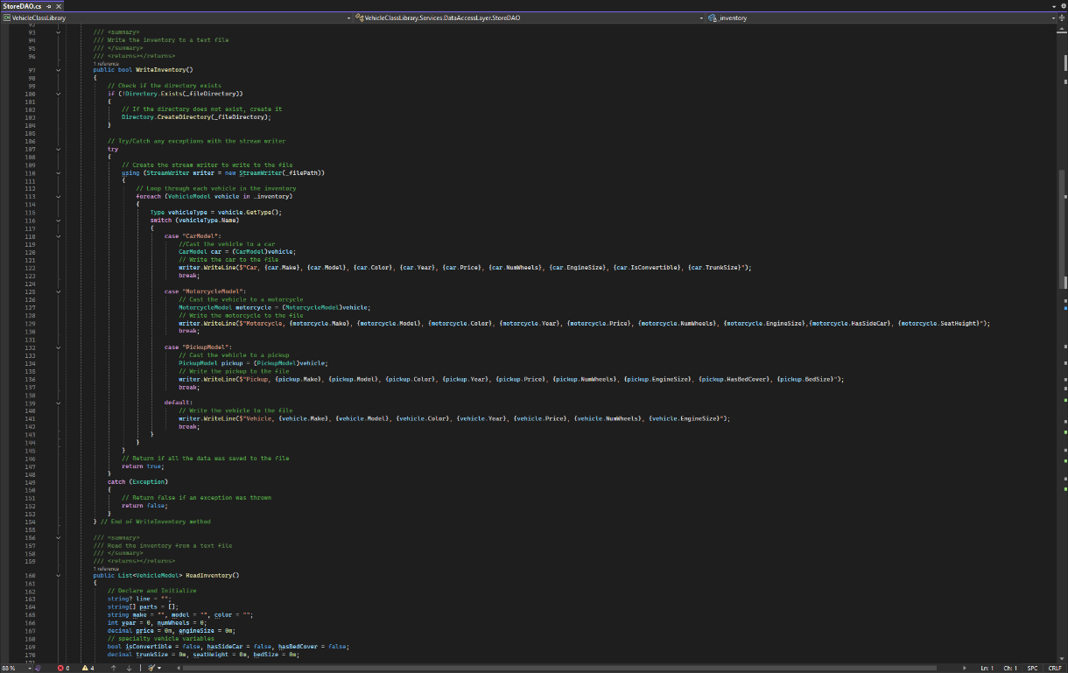
Figure 26: Challenge Changes

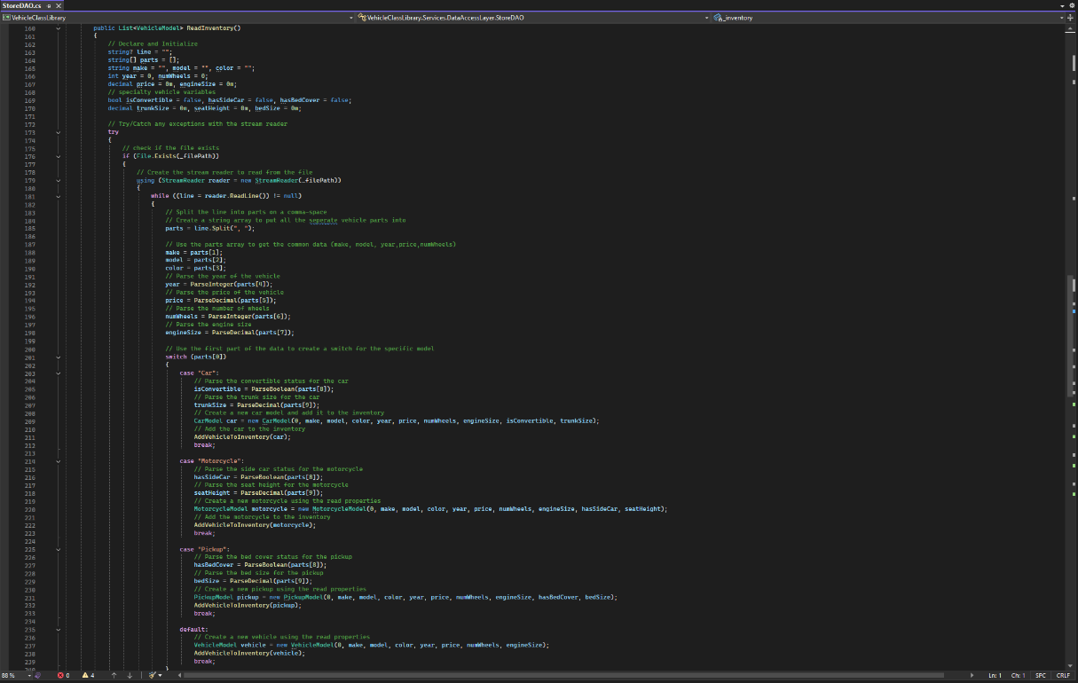
Figure 27 Challenge changes

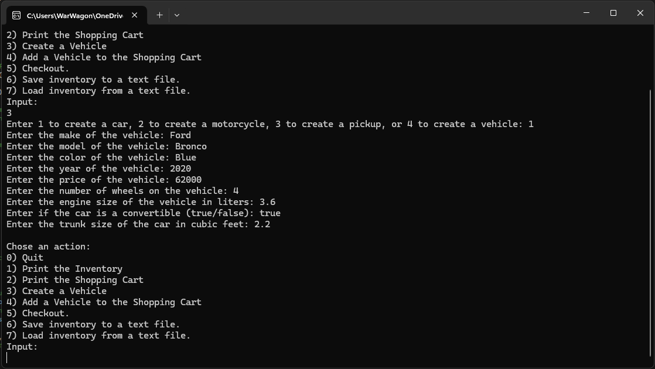
Figure 28: Changes running

Figures 26-28 are the changes to add the new properties and the application running with the new properties added to the create vehicle screens

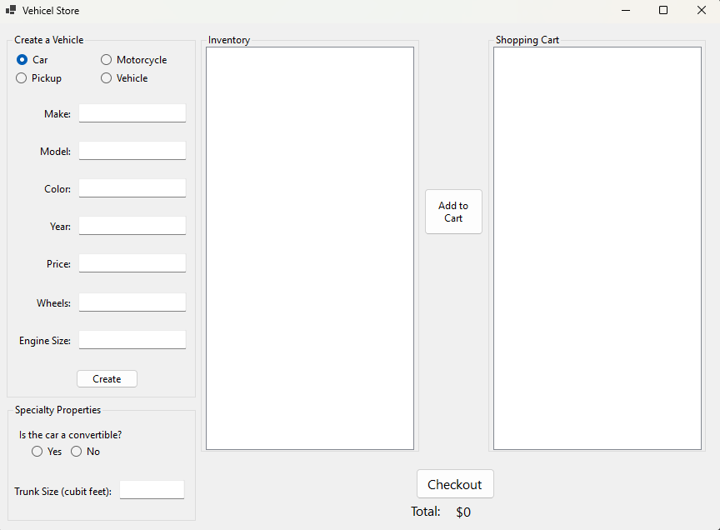
Figure 29: Initial state of UI
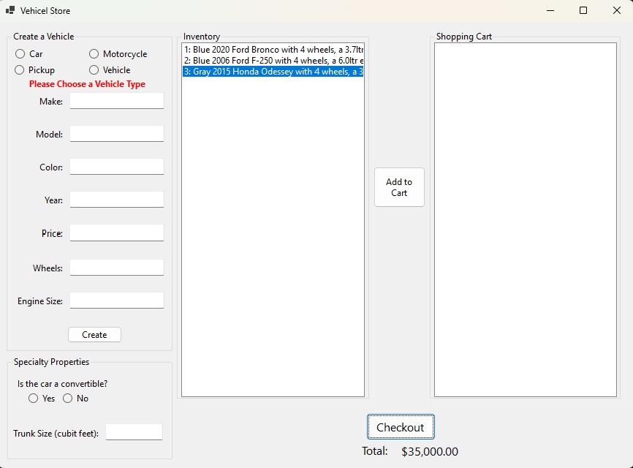
Figure 30: Ui after creating some vehicles and checking one out

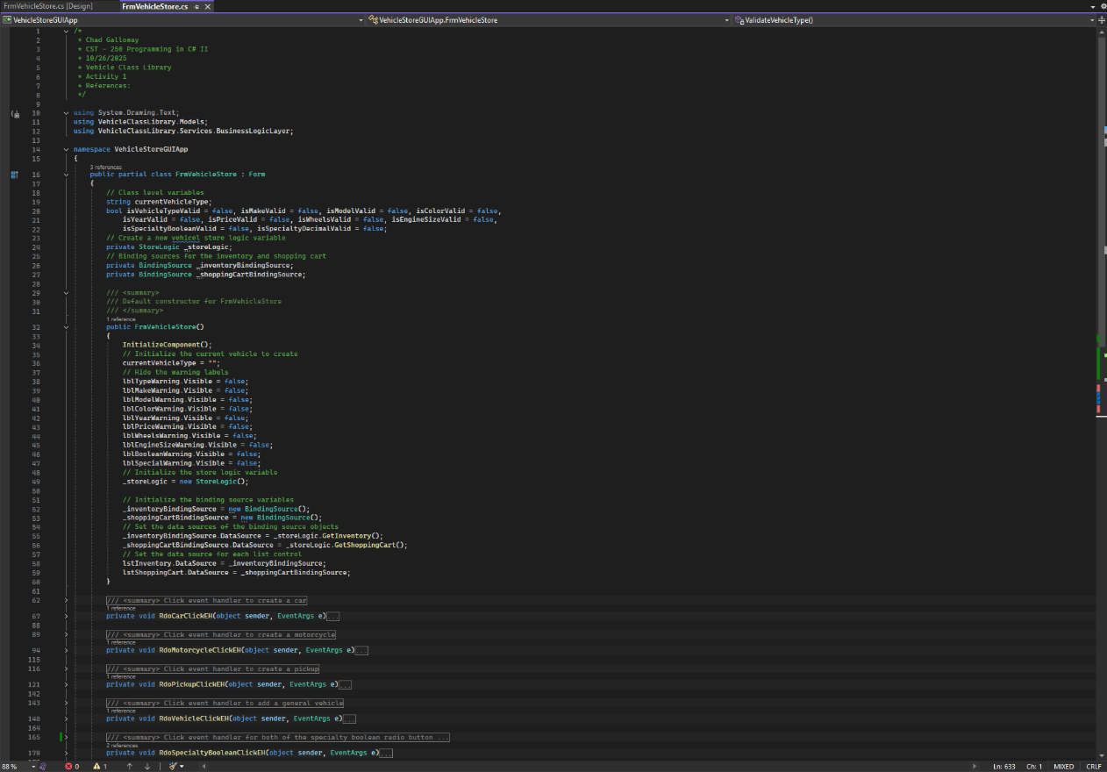
Figure 31: The FrmVehicleStore class declaration, citations, and constructors

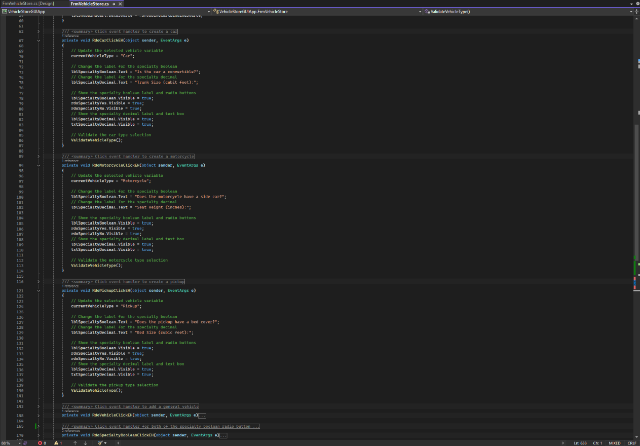
Figure 31: event handlers for Car, Motorcycle, and Pickup radio buttons

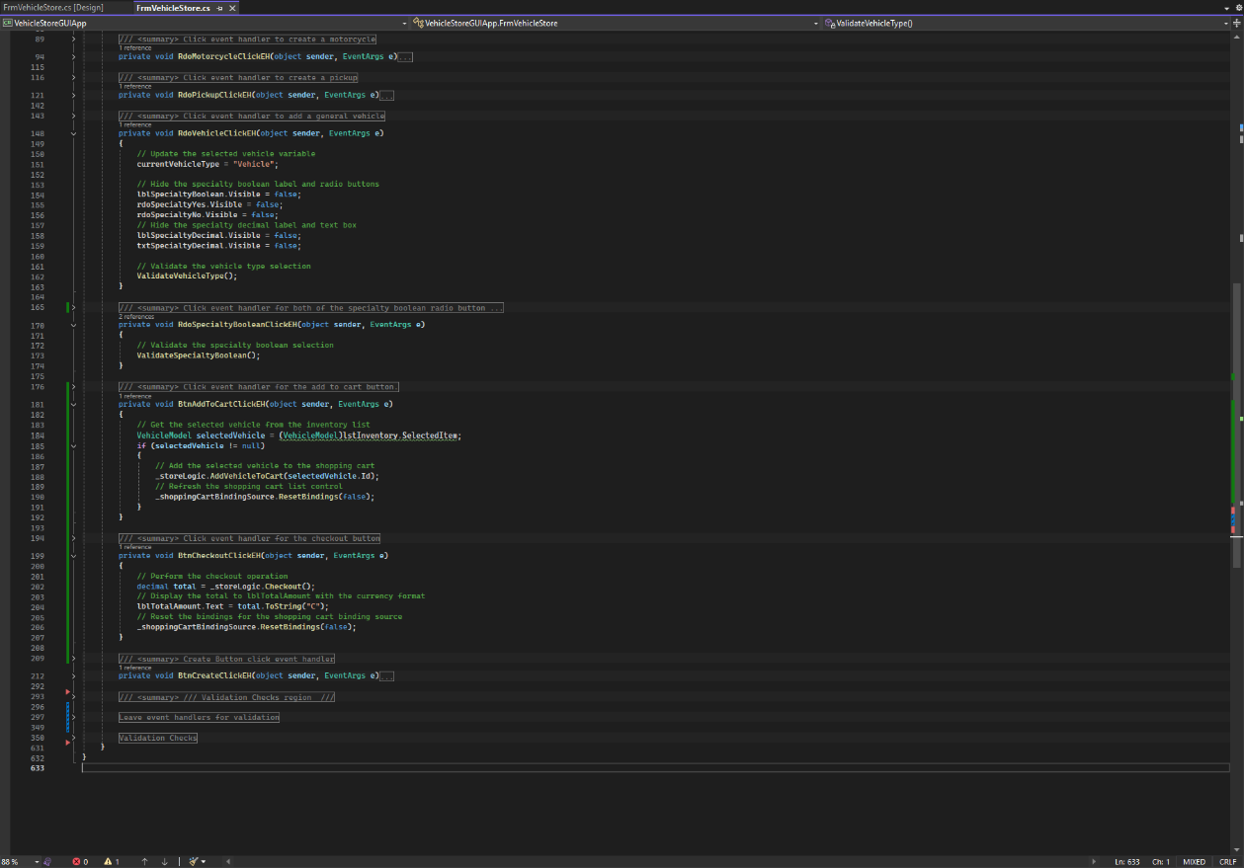
Figure 32: Event handlers for the remaining two radio buttons and the add to cart and checkout buttons.
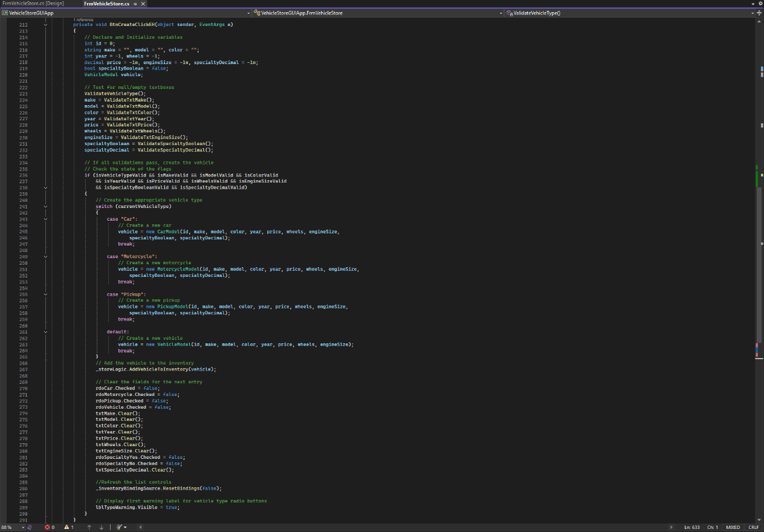
Figure 33: Create Button click event handler.

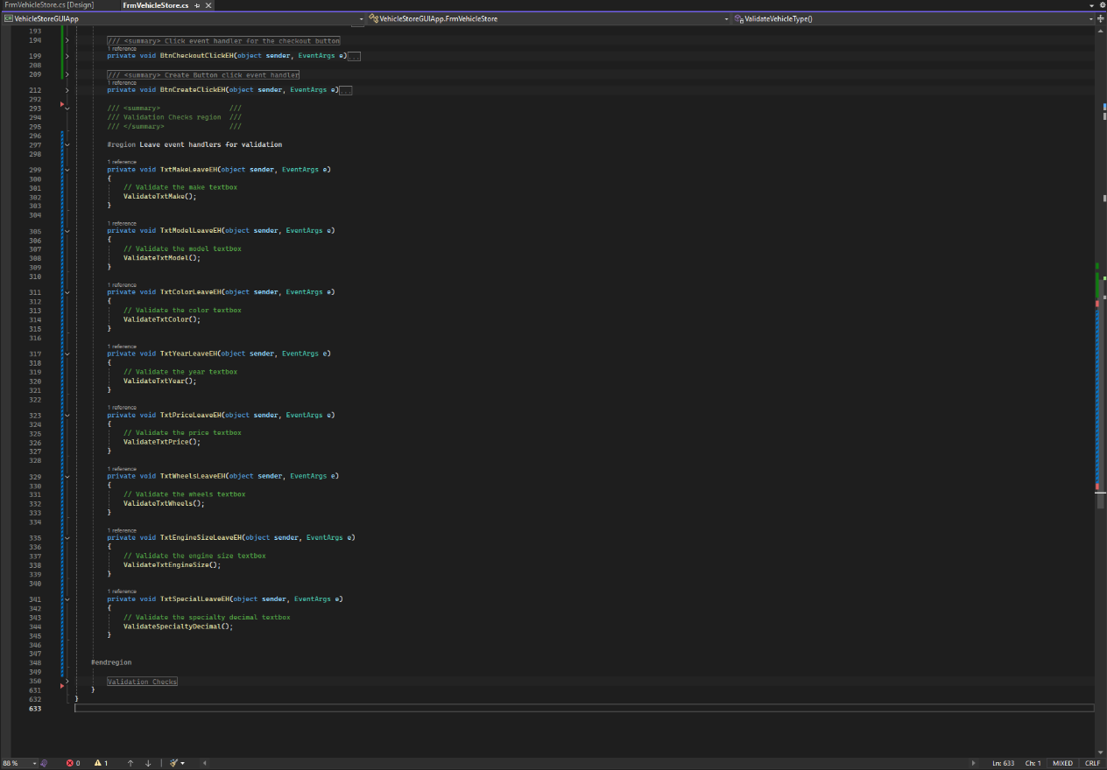
Figure 34: All the leave event handlers

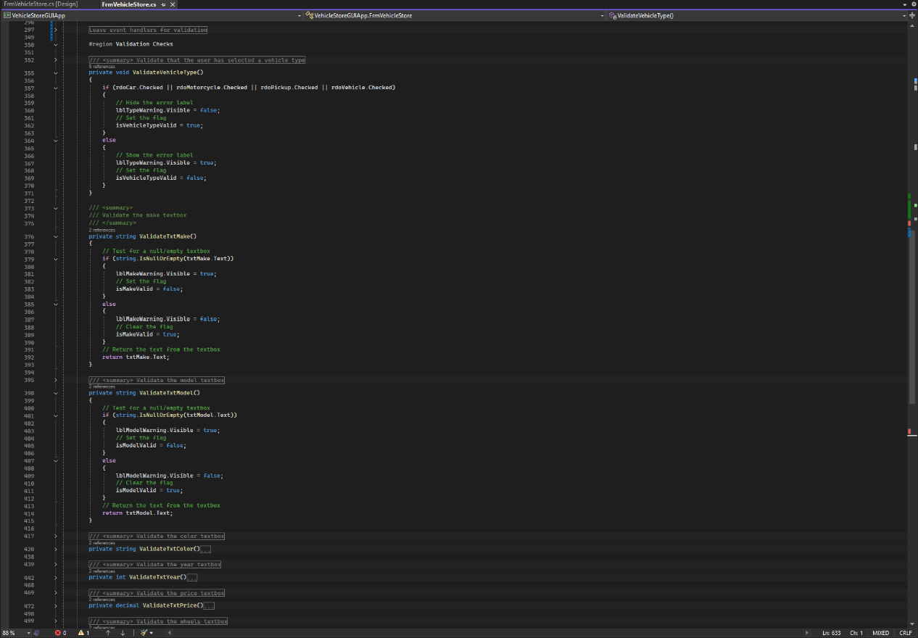
Figure 35: Textbox and radio button validation checks

Part 2
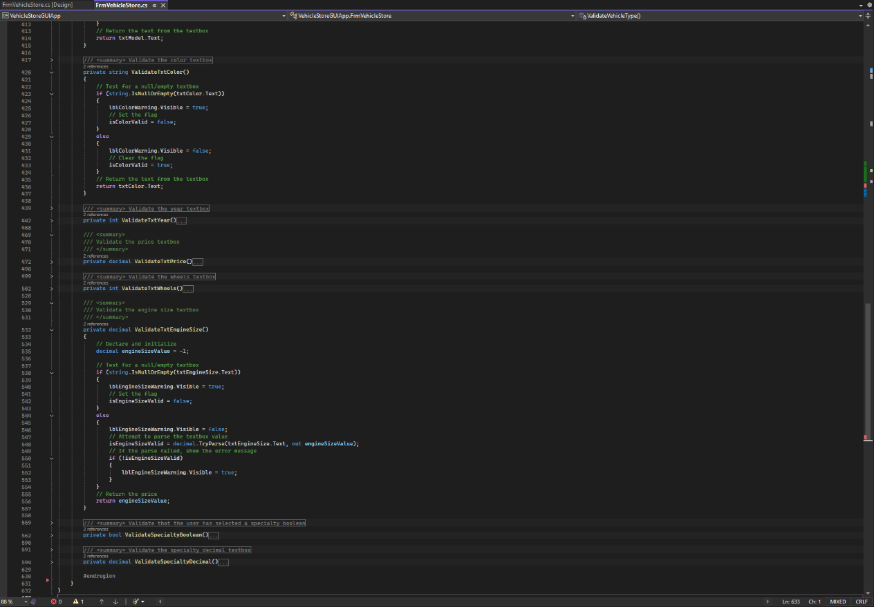
Figure 36: New property validation checks

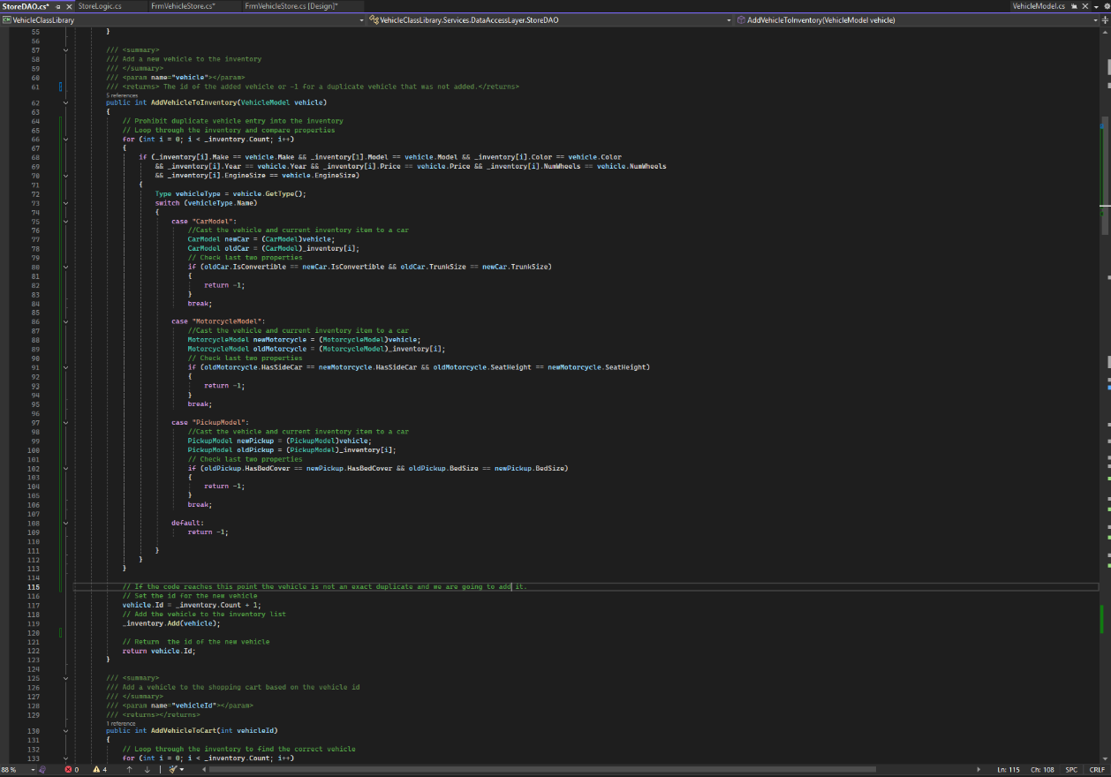
Figure 37: new code added to StoreDAO to prevent duplicates

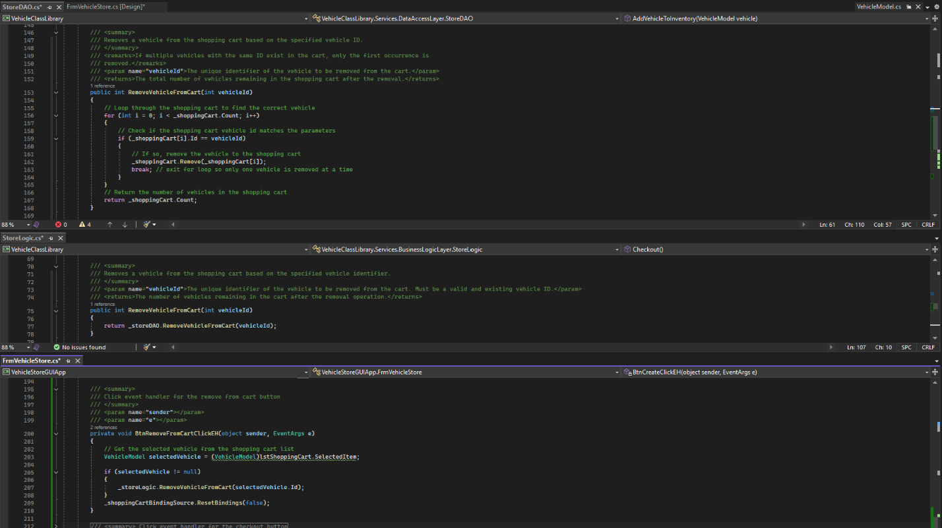
Figure 38: The three methods responsible for removing a vehicle from the cart in all three layers, the StoreDAO, the StoreLogic and the FrmVehicleStore

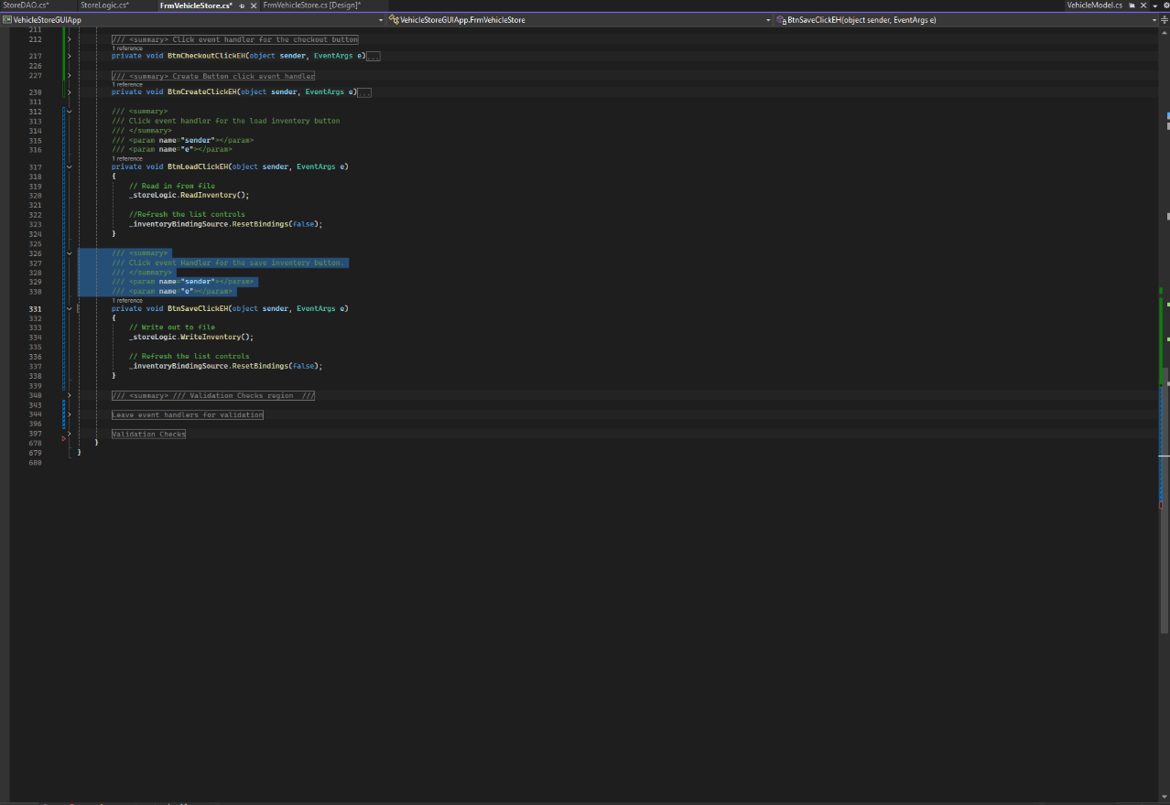
Figure 39: Implementation of the save and load functionality for the GUI
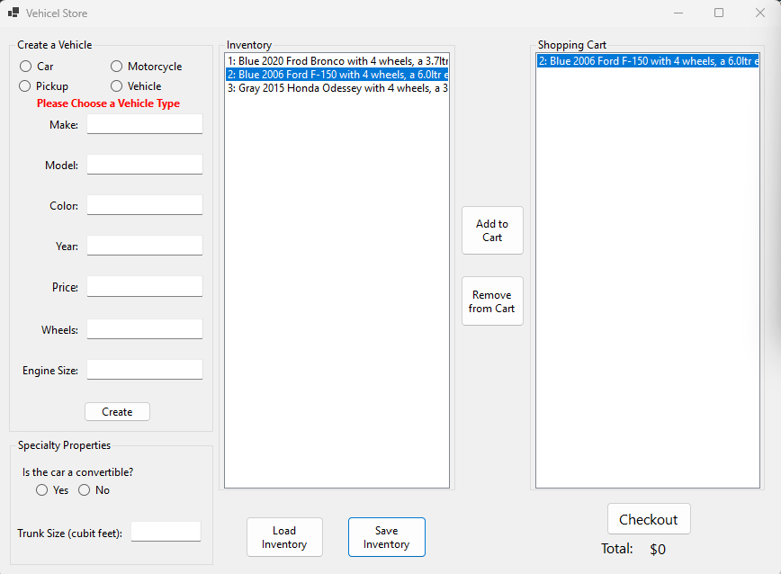
Figure 40: the GUI with all the new features implemented

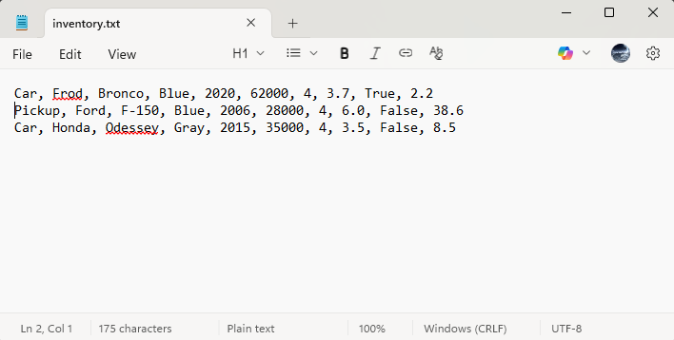
Figure 41: The contents of the save file after hitting save inventory in the above figure 40 screenshot
Part 3

Flowchart

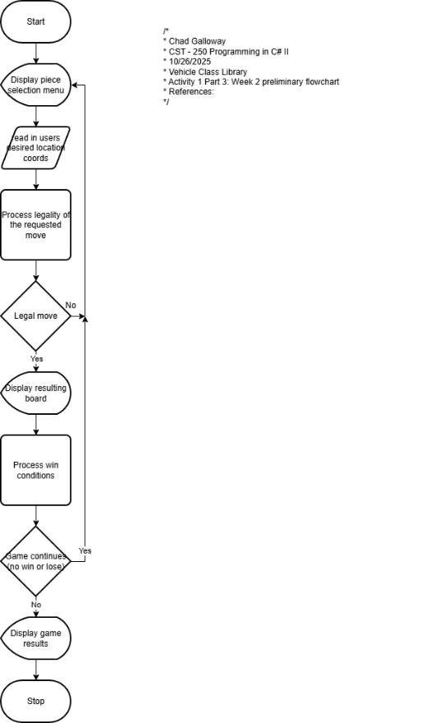
Figure 42: Screenshot Flowchart for week 2

UML

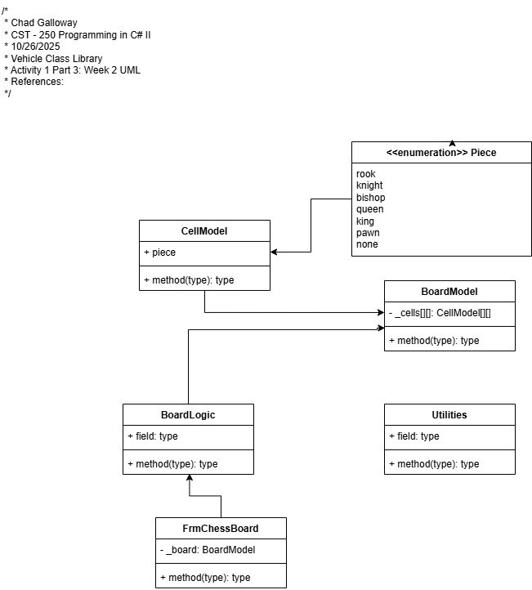
Figure 43: Screenshot of week 2 UML

