Chad Galloway
CST-250 Programming in C# II
Grand Canyon University
Nov. 2, 2025
Activity 2

Files
https://github.com/CGalloway3/CST-250-Projects/tree/master/Activity%202
Video
https://www.loom.com/share/d1423fe160ca4765b5de2ed1553af23d

FLOW CHART

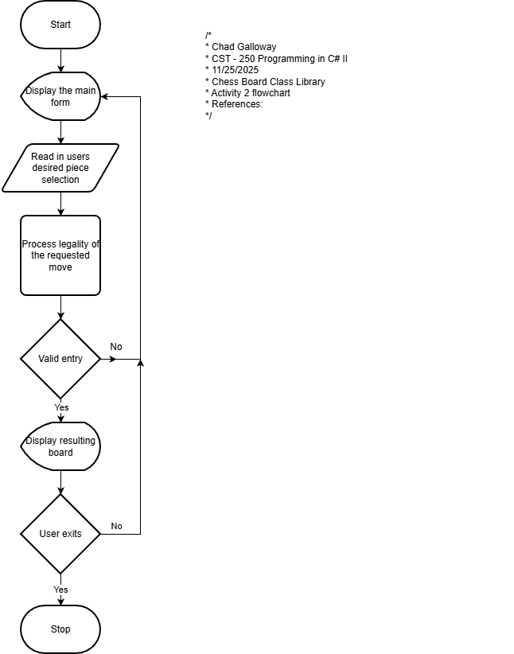
Figure 1: Flow chart of Activity 2

UML Class Diagram

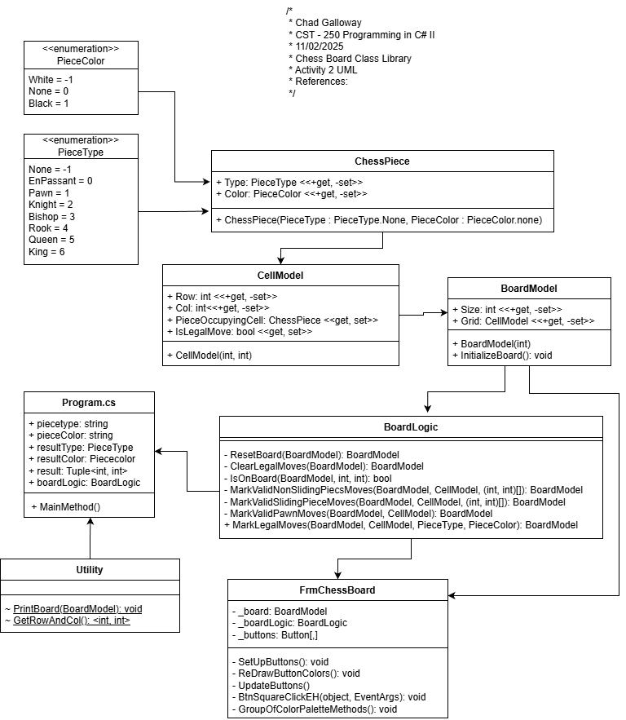
Figure 2: UML Class Diagram for Activity 2

Part 1
Screen Shots

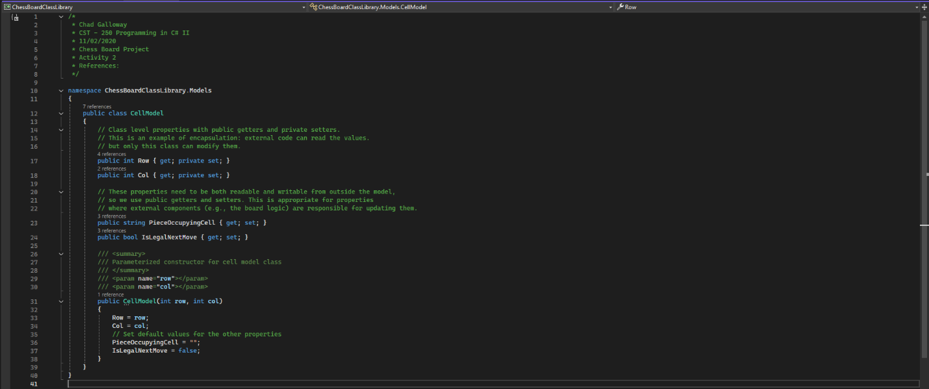
Figure 3: CellModel citations and constructor

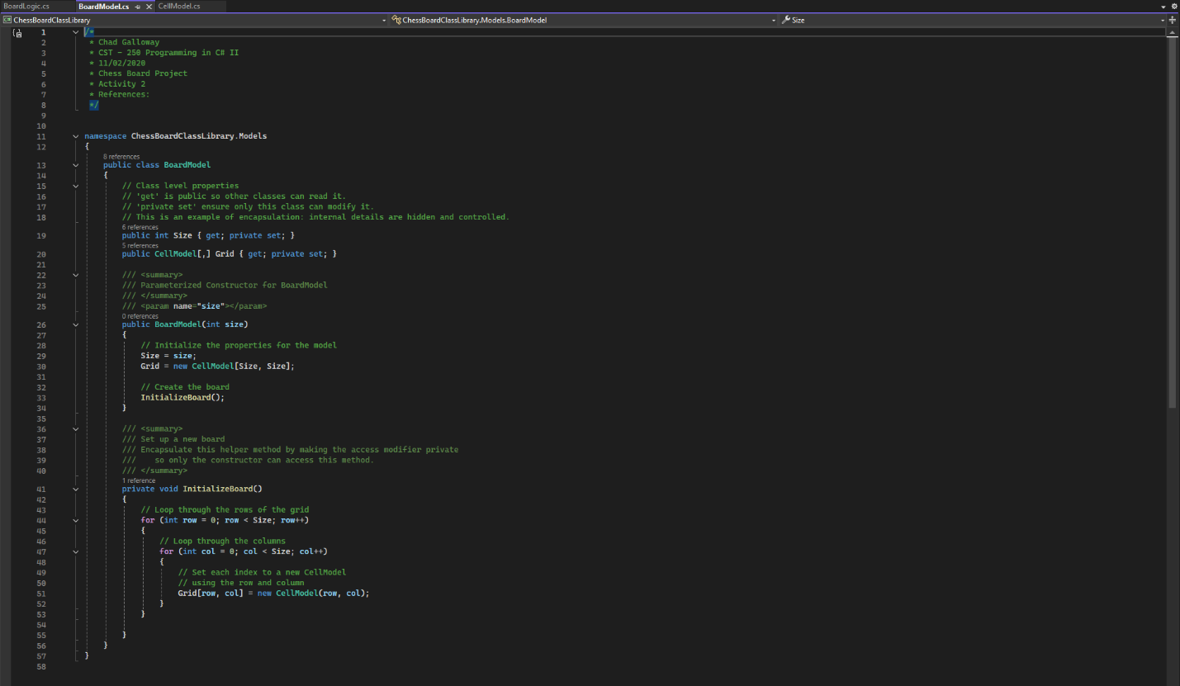
Figure 4: BoardModel citations and constructor

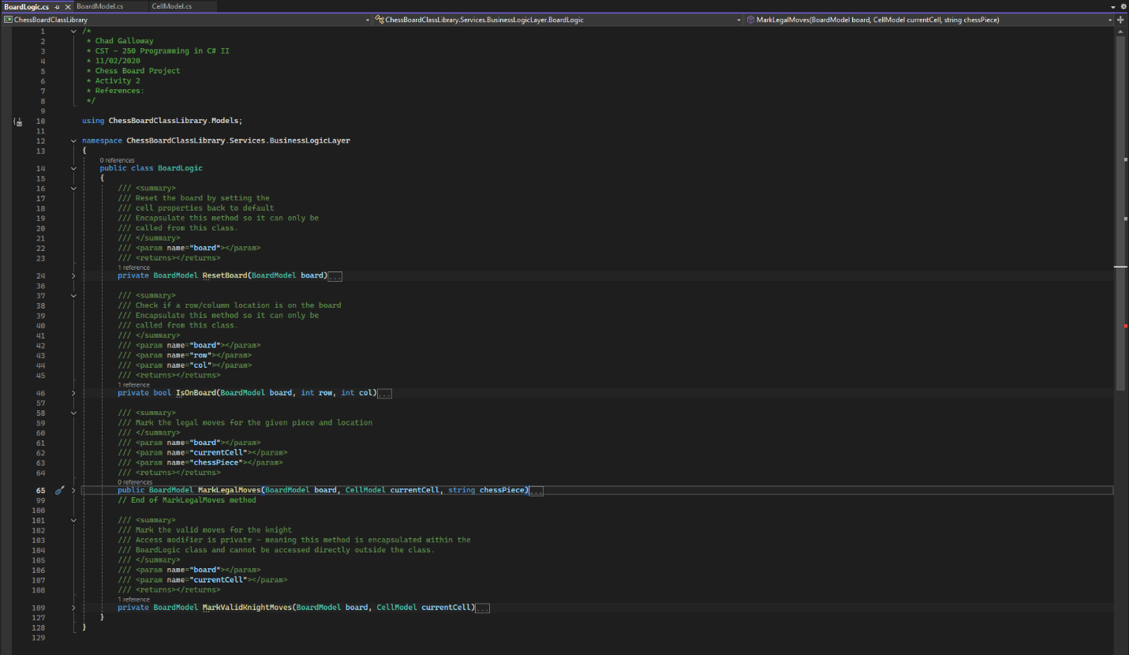
Figure 5: BoardLogic and collapsed methods with expanded summary

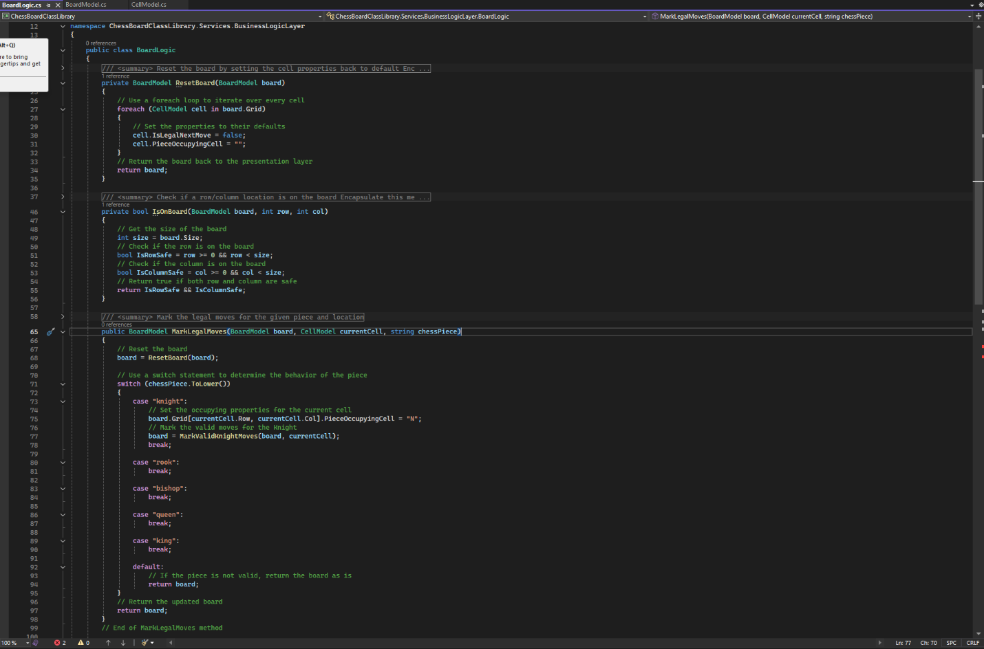
Figure 6: BoardLogic: ResetBoard(), IsOnBoard(), and MarkLegalMoves() with collapsed summaries
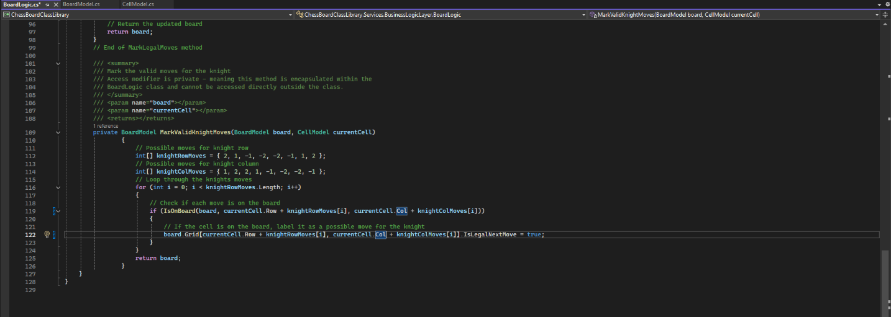
Figure 7: BoardLogic.MarkValidKnightMoves()

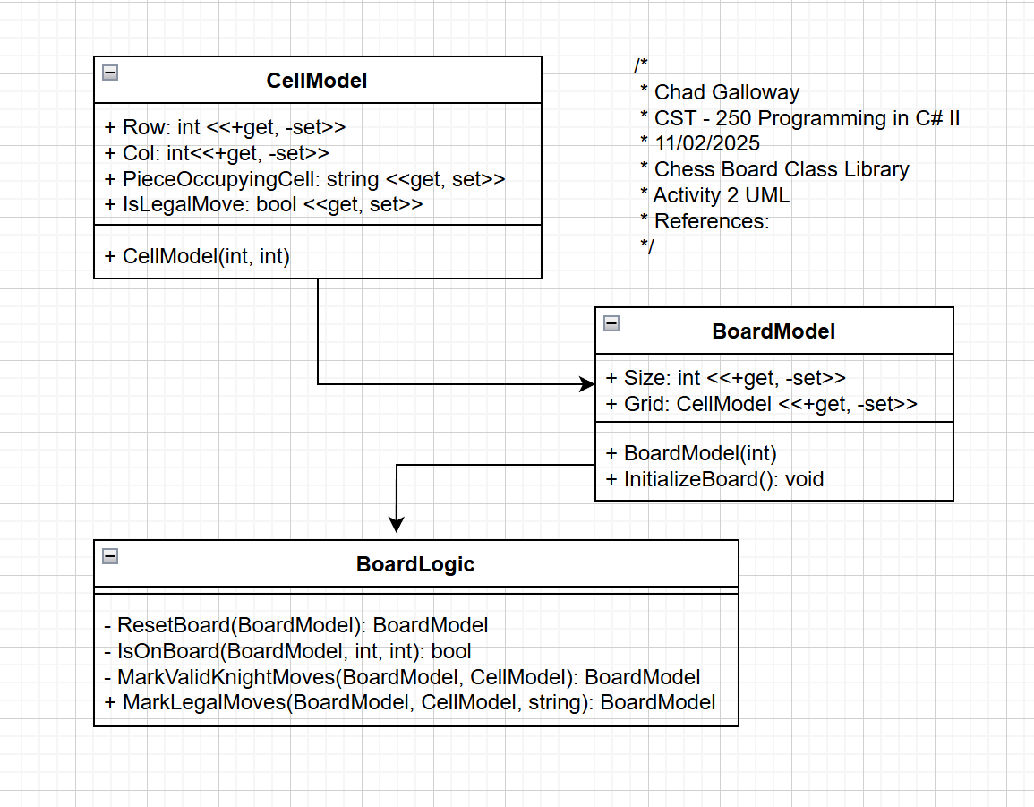
Figure 8: Screenshot of UML for CellModel, BoardModel, and BoardLogic

Challenges

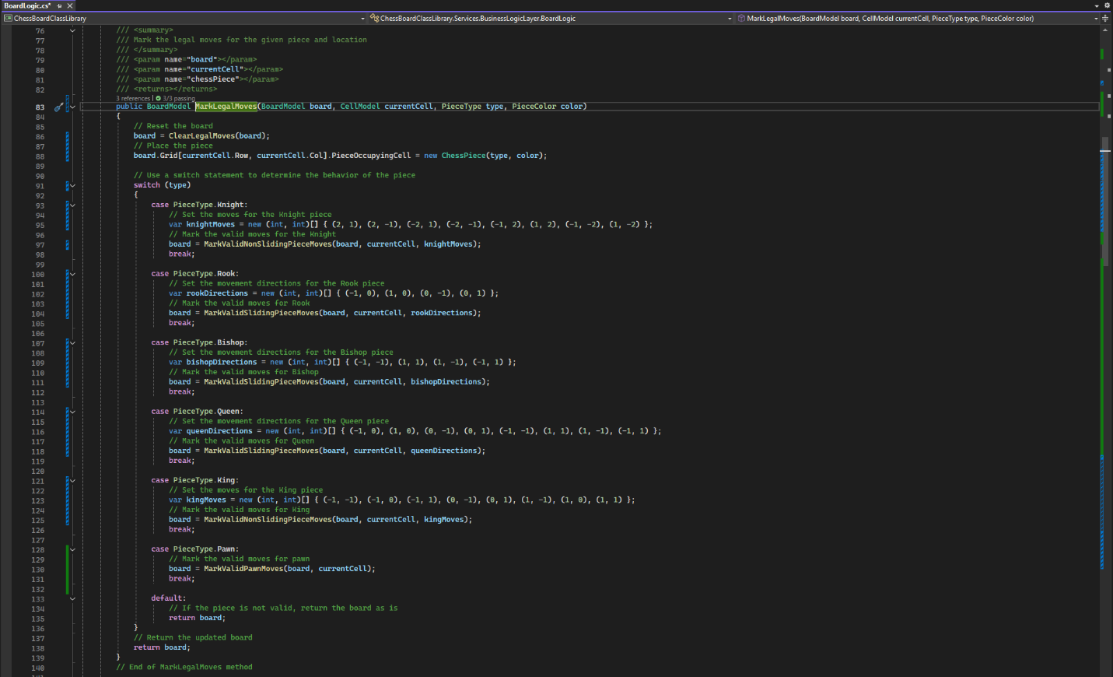
Figure 9: Updated and completed BoardLogic.MarkLegalMoves() method. Changed the string parameter for piece to type and color enums I created. Moved piece creation out of the cases and into the main body using a ChessPieice class I ceated.

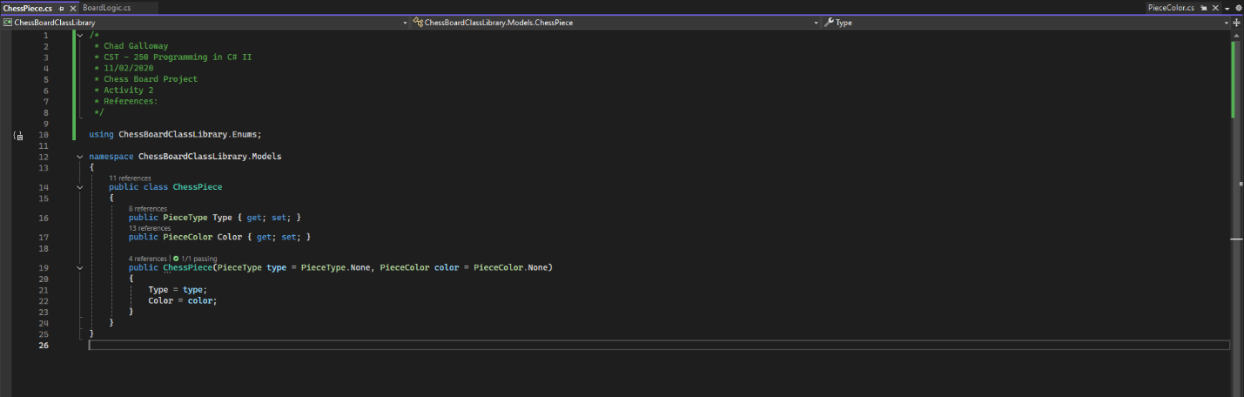
Figure 10: ChessPiece class. Contains piece type and piece color. Currently the piece doesn’t do anything (no methods). In the future it might have some movement methods added in we will see.

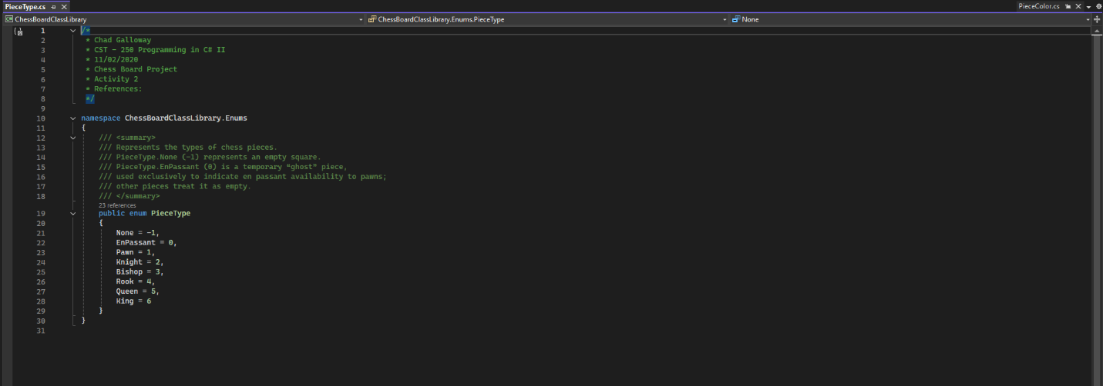
Figure 10a: PieceType enum to hold all the different piece types including none and en passant a “ghost” piece type only visible in code to pawns for preforming the en passant move.

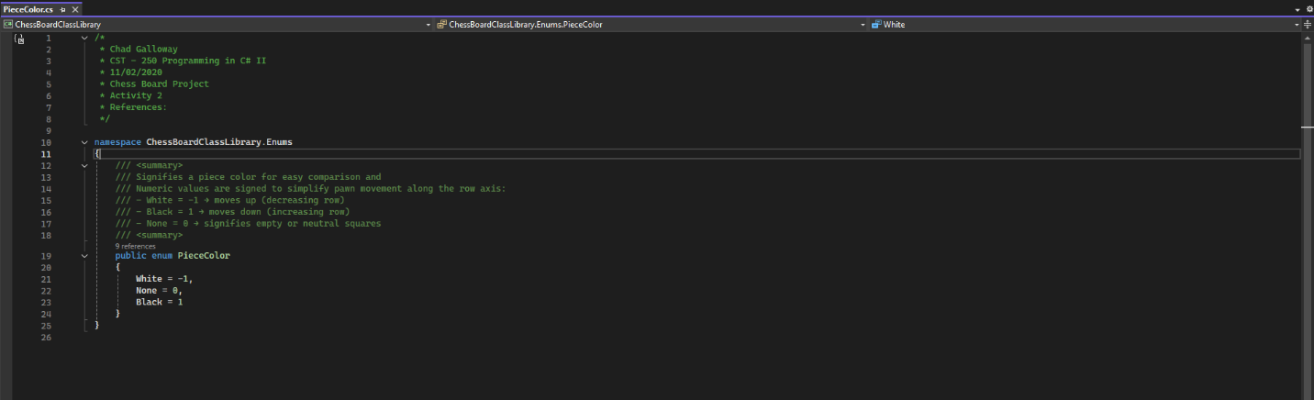
Figure 10b: PieceColor emun to hold the colors of pieces. Used to determine if a legal move of taking an enemy piece is available and it is also a directional indicator of the movement directions of the two colored pieces for pawns. Black pawns move down the board +1, and white pawns move up the board -1.

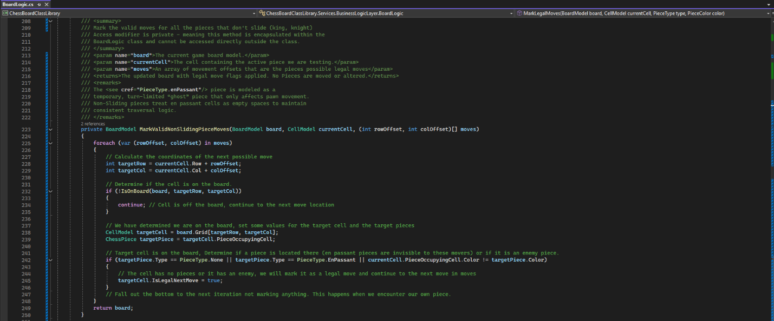
Figure 11: BoardLogic.MarkValidKnightMoves() was removed and combined with the king logic into a method for all non-sliding pieces MarkValidNonSlidingPieceMoves(). It handles knights and kings.

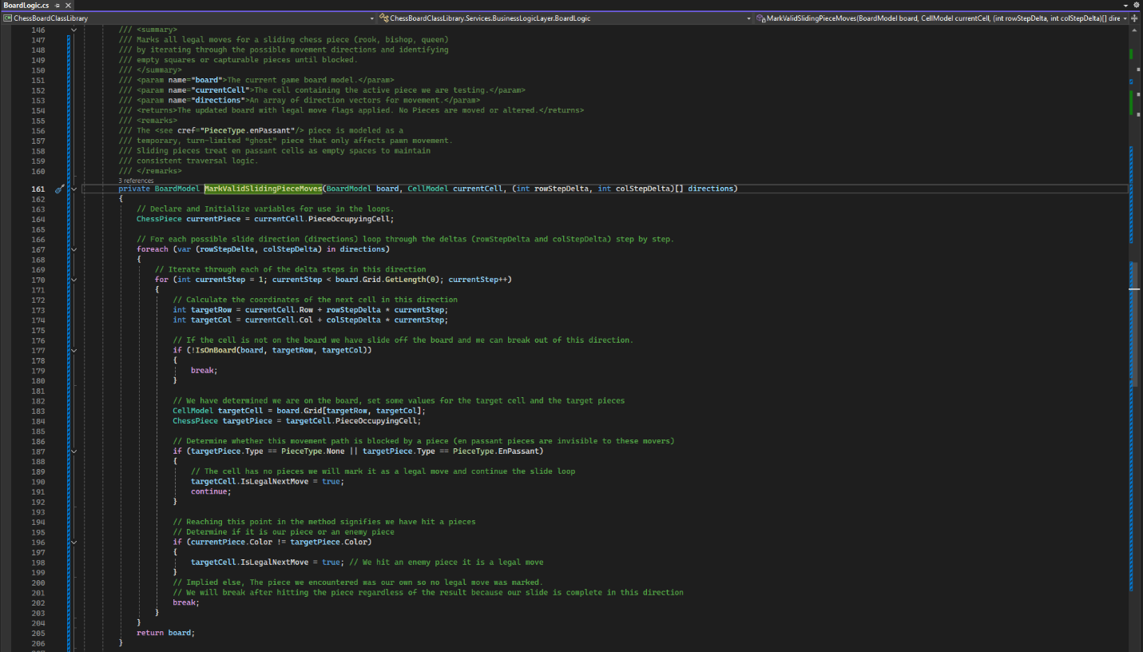
Figure 12: BoardLogic.MarkValidSlidingPieceMoves() was added to handle pieces that slide (i.e. rook, bishop, and queen)

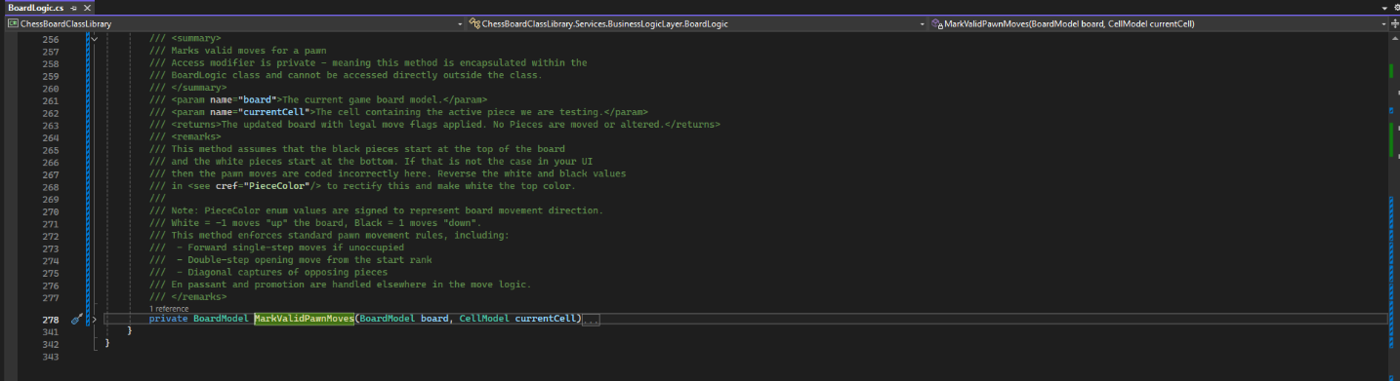
Figure 13: Summary for MarkValidPawnMoves()

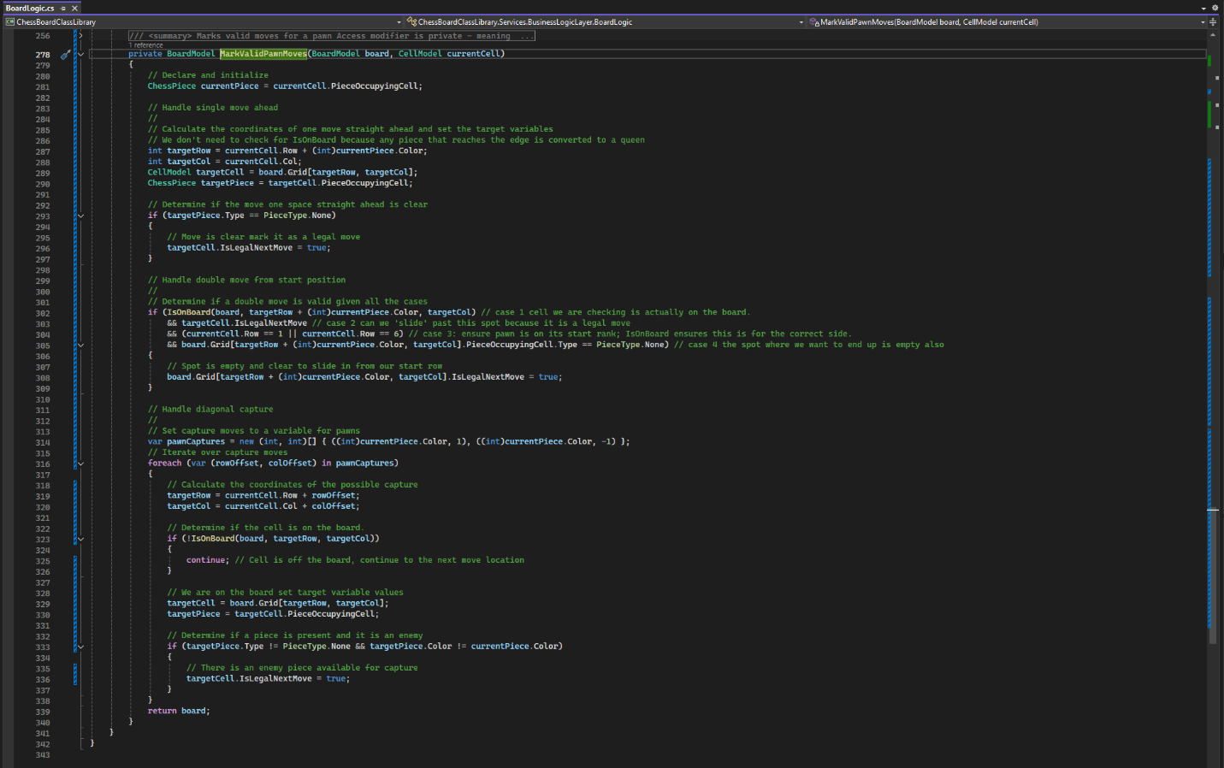
Figure 14: BoardLogic.MarkValidPawnMoves() marks all the movement cases for pawns. Promotions for reaching the last rank and en passant will be handled in the actual move logic. Here we are just highlighting what might be a legal move.
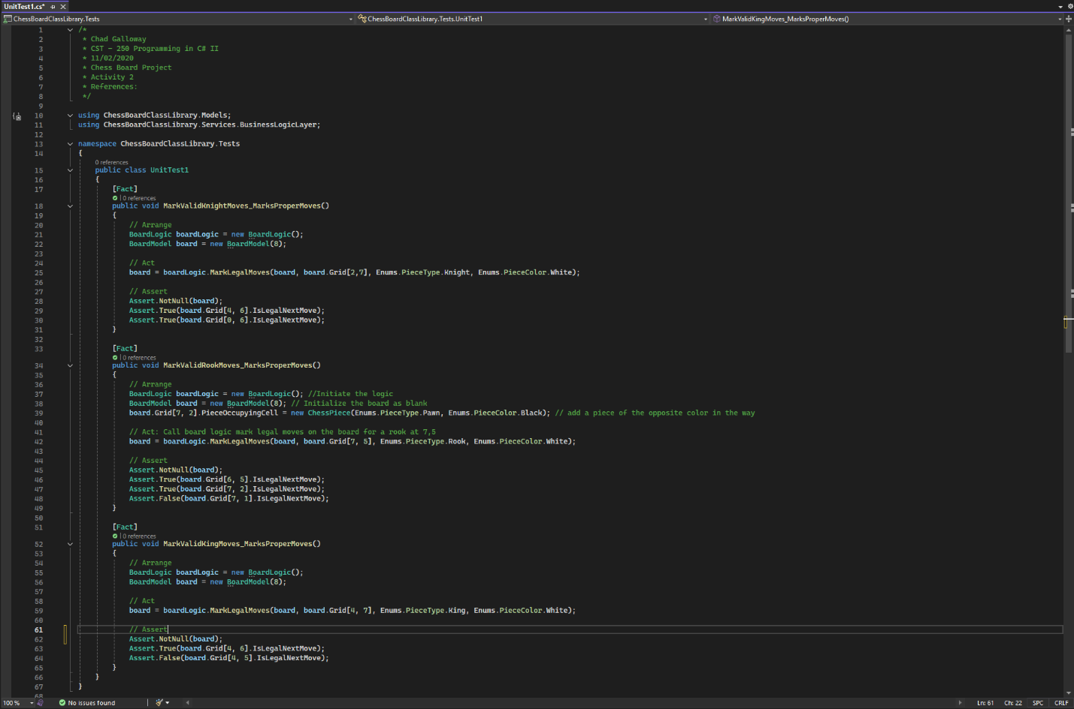
Figure 15: Several unit tests were created for the project to make coding the different MarkValid methods easier.

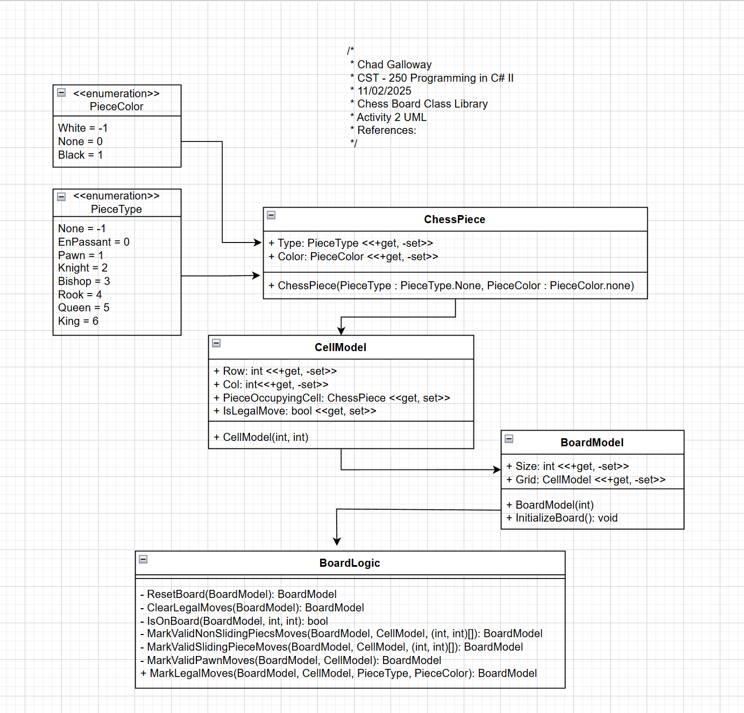
Figure 16: Projects UML so far.

Part 2
Screen Shots

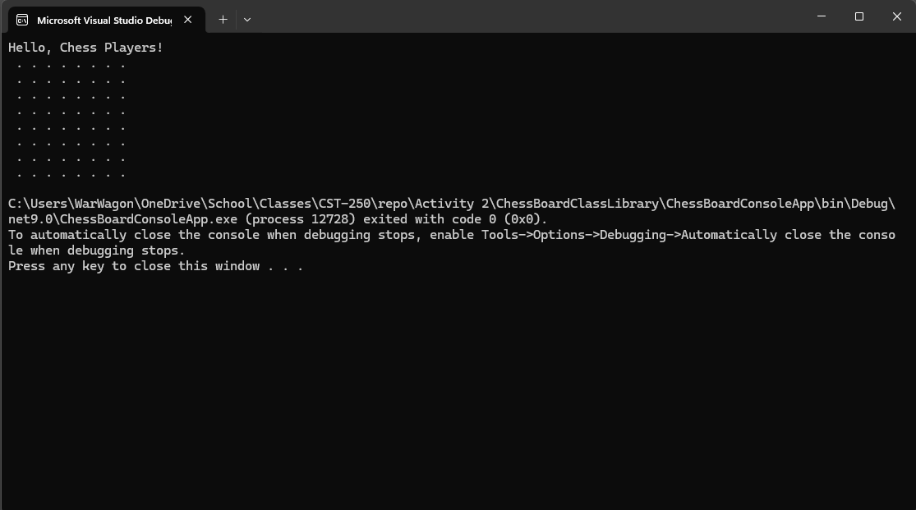
Figure 17: Part 2 App Running after writing PrintBoard() method

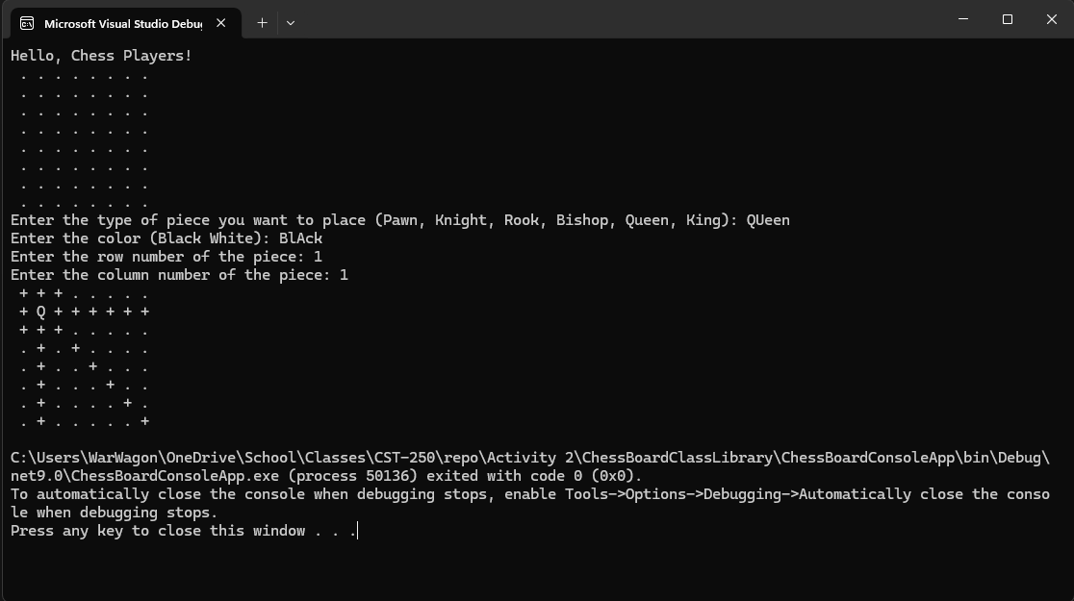
Figure 18: Screenshot of successful output with a Queen at 1, 1

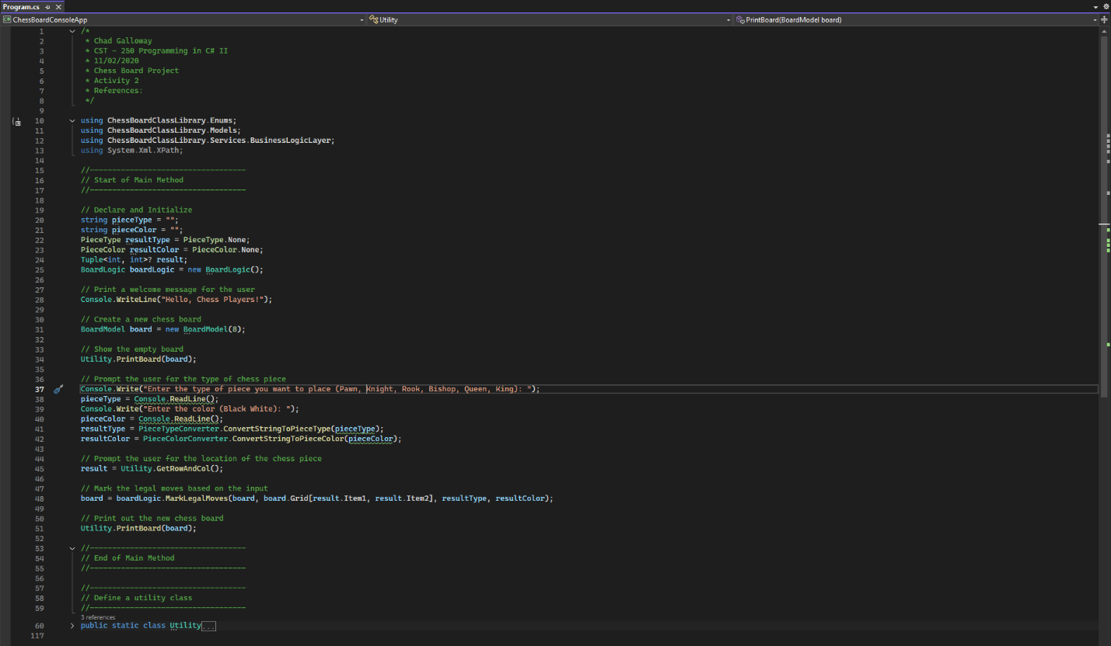
Figure 19: Screen shot of the Propgram.cs and its’ citations

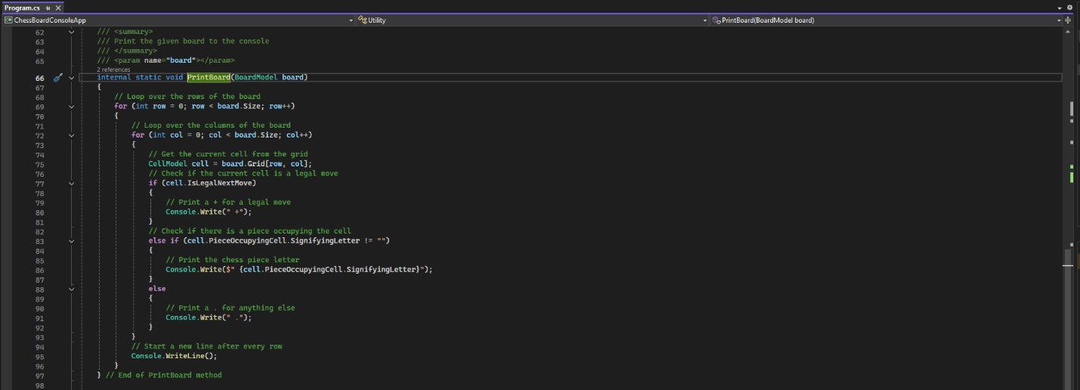
Figure 20: PrintBoard() method

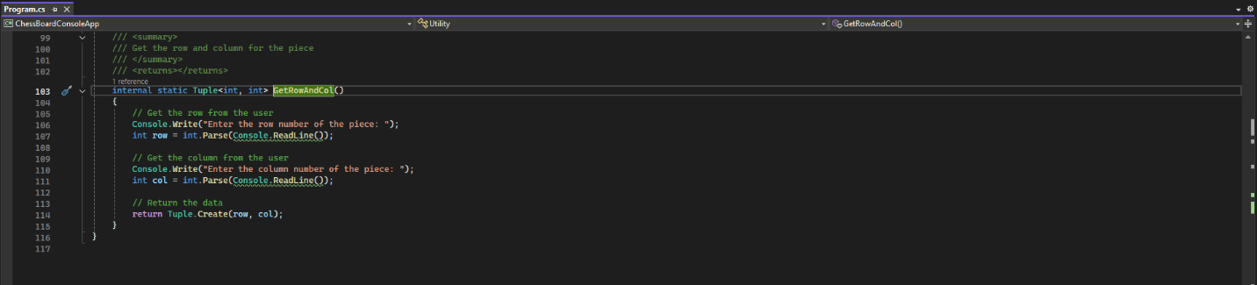
Figure 21: GetRowAndCol() method

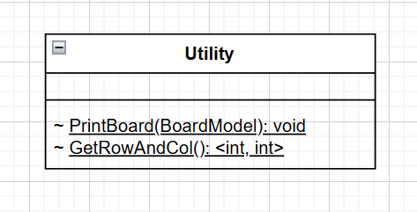
Figure 22: UML

Challenges
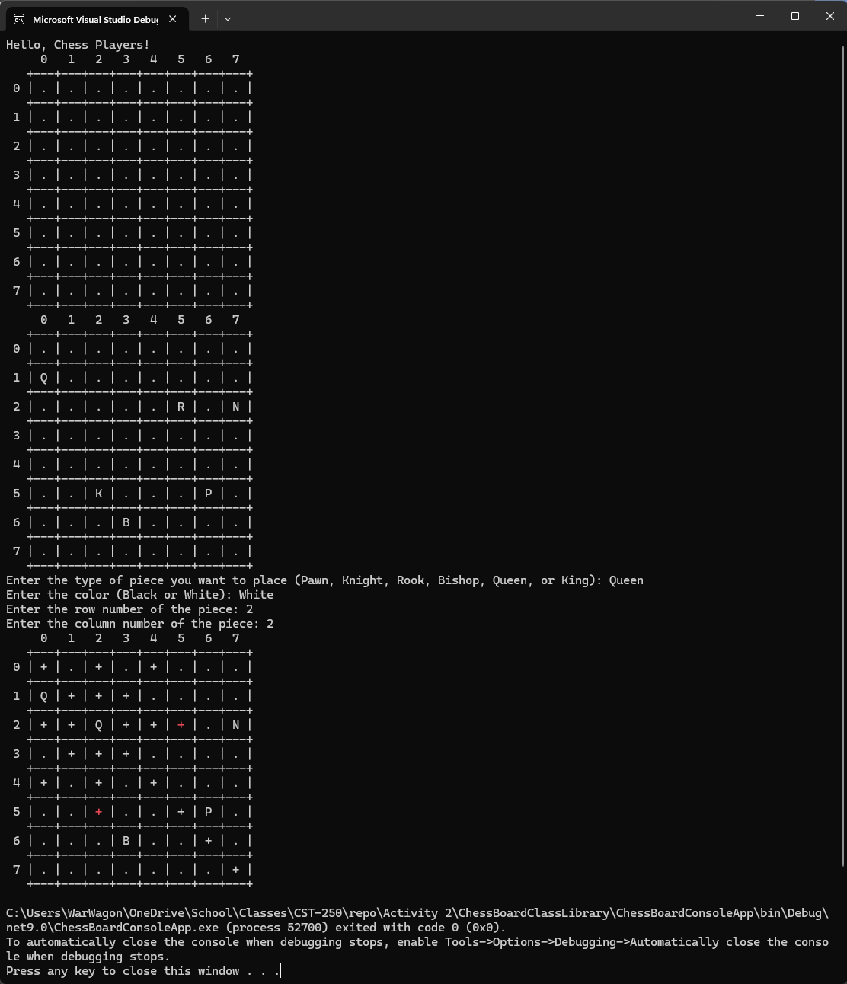
Figure 23: Console running after successful completion of the challenge tasks. The First board is defalult. The second board has some pieces added for demonstration and the third board shows off the capabilities of the MarkValid methods I created. White + is a possible move and a red + is a possible piece capture opportunity. With further moves behind pieces that are present being unavailable. Changing the Queen to black removes the red + and displays the piece type because the rook and the king displayed on board 2 are black. Further improvements would be changing the pieces display colors…. I just thought of a novel way to do it so see below.

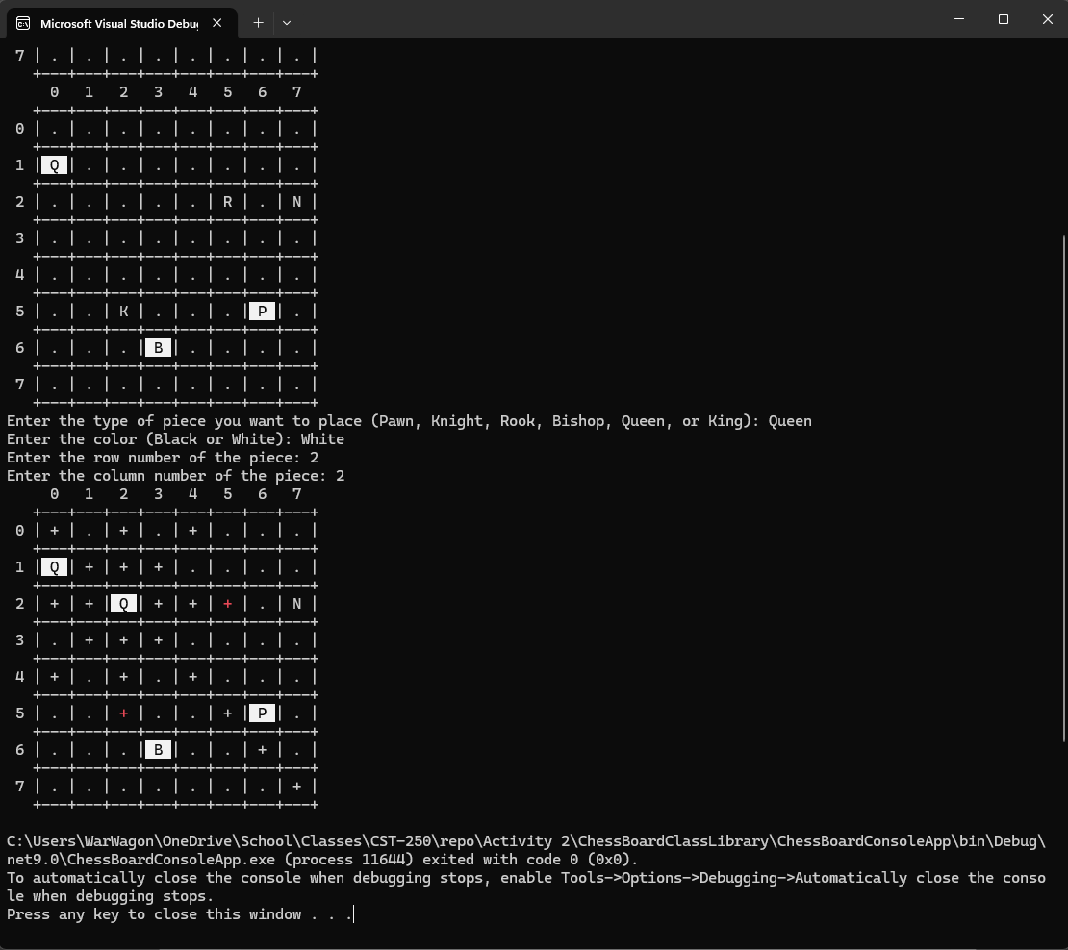
Figure 24: Screen shot of the application with colored pieces implemented. Some other color choices may be in order later like making valid moves yellow and attempting to properly color the board checkered black and white but those are lofty and a bit much for a simple console version when we are about to make a windows forms version with a much better GUI.

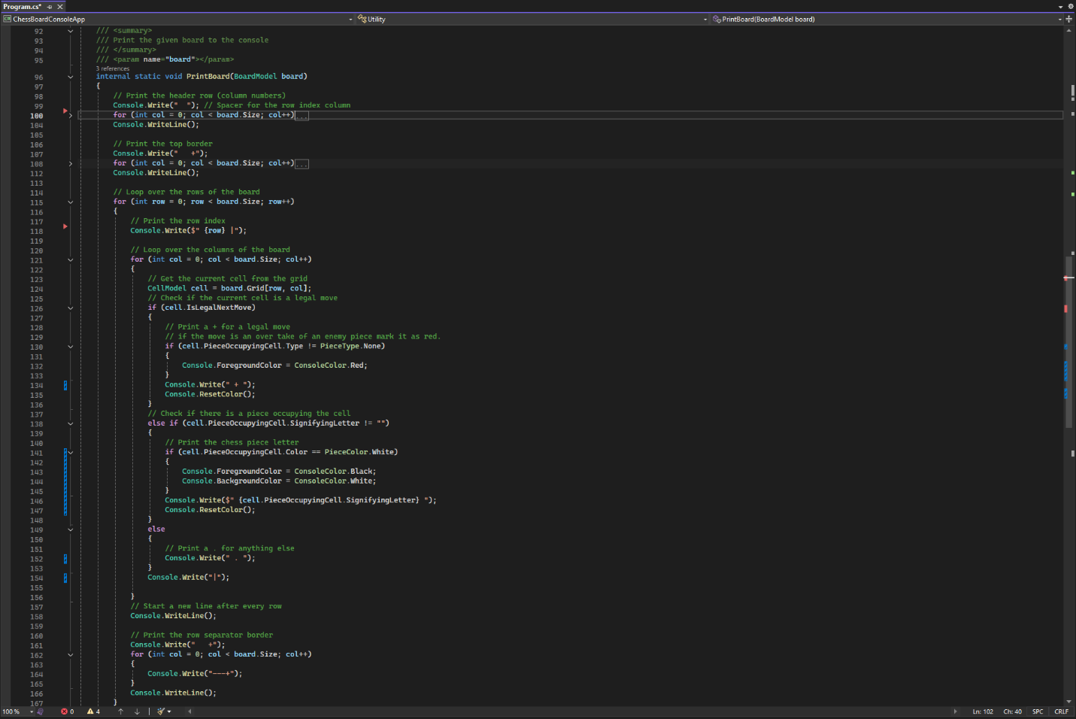
Figure 25: The print board method in the utility class

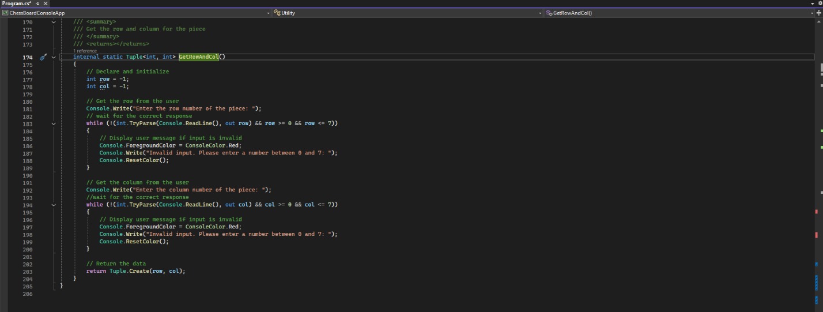
Figure 26: The get row and column method in the utility class
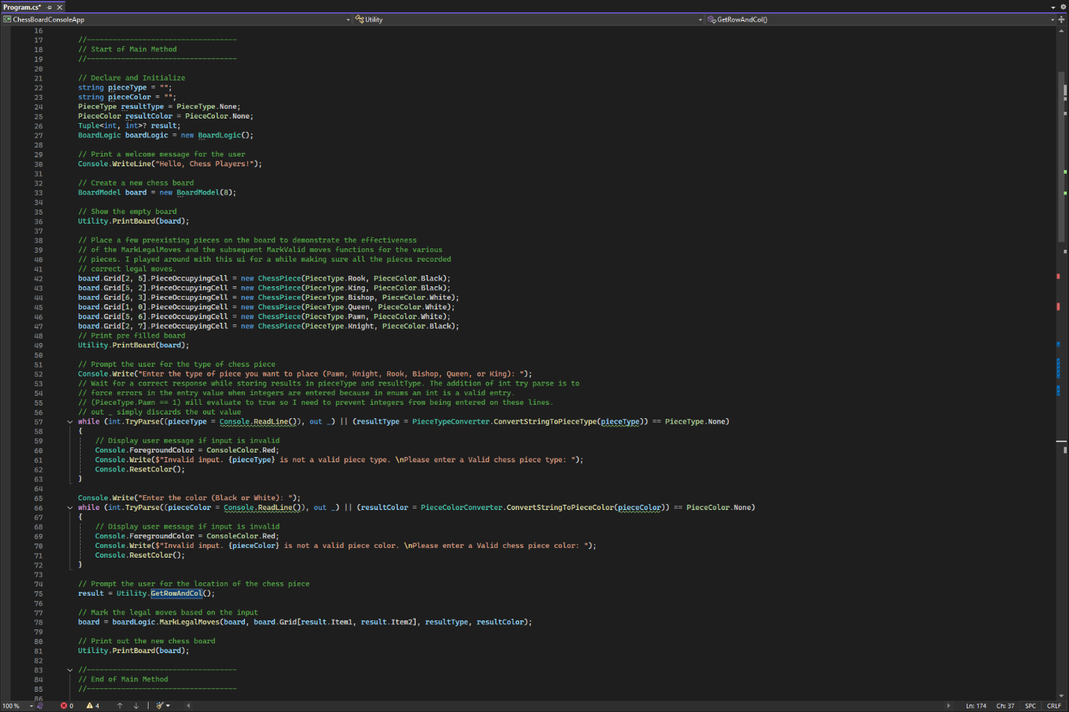
Figure 27: The main method for the console chess app

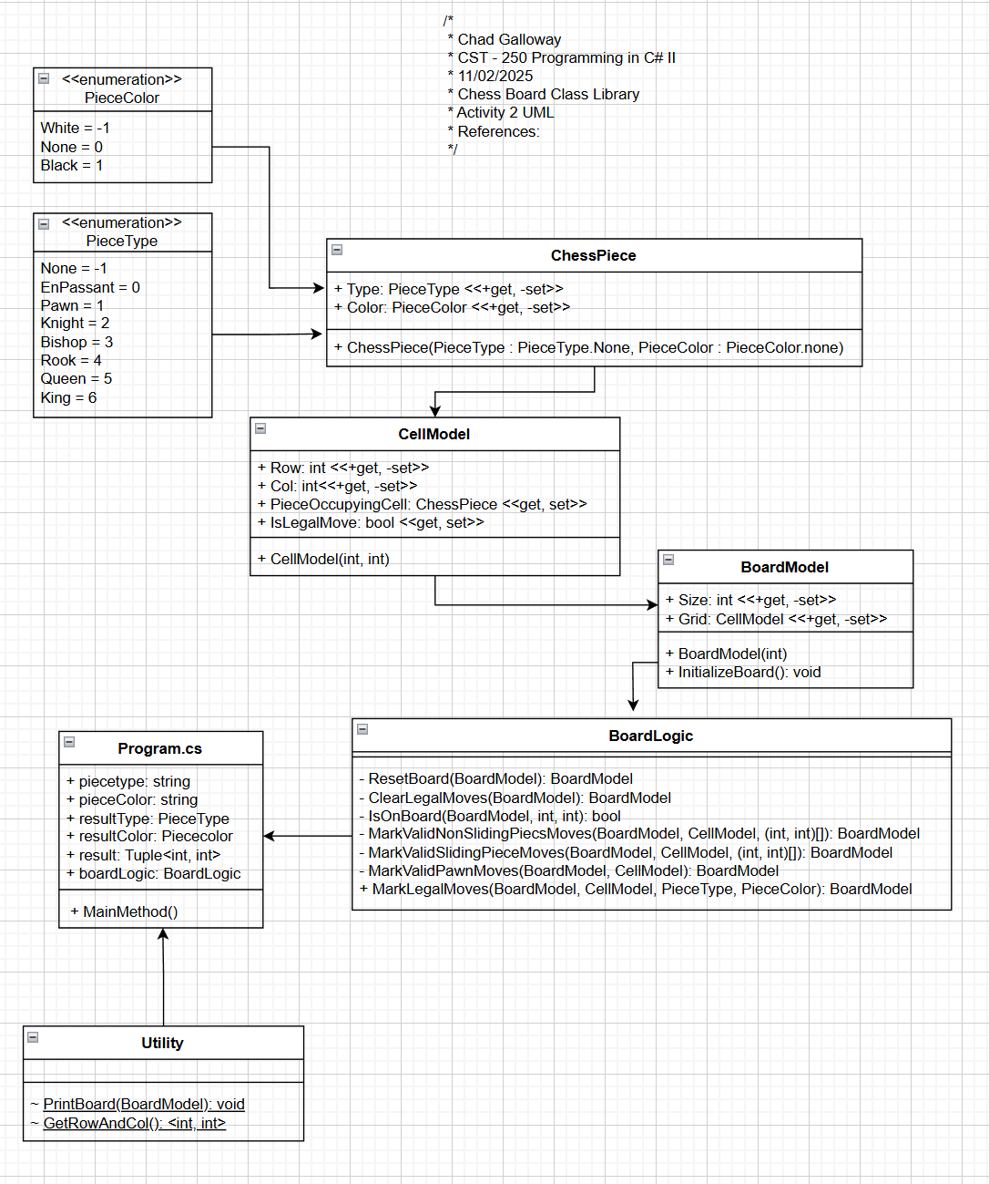
Figure 28: Current state of the application’s UML
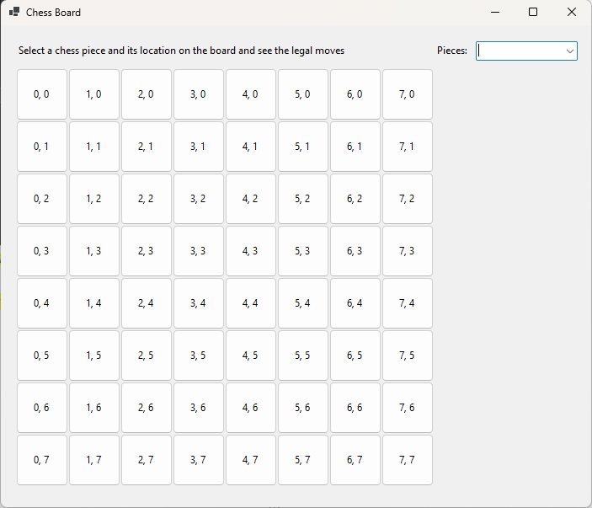
Figure 29: The Windows Forms app running

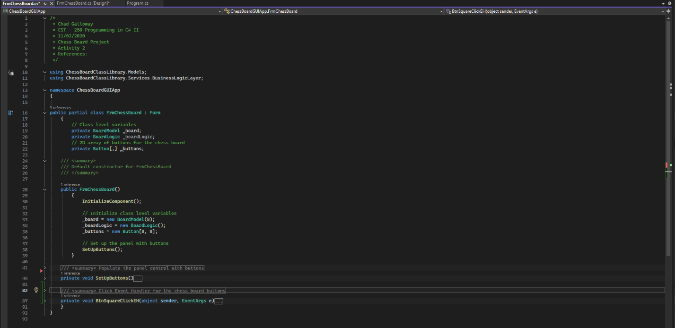
Figure 30: FrmChessBoard.cs citations and constructor.

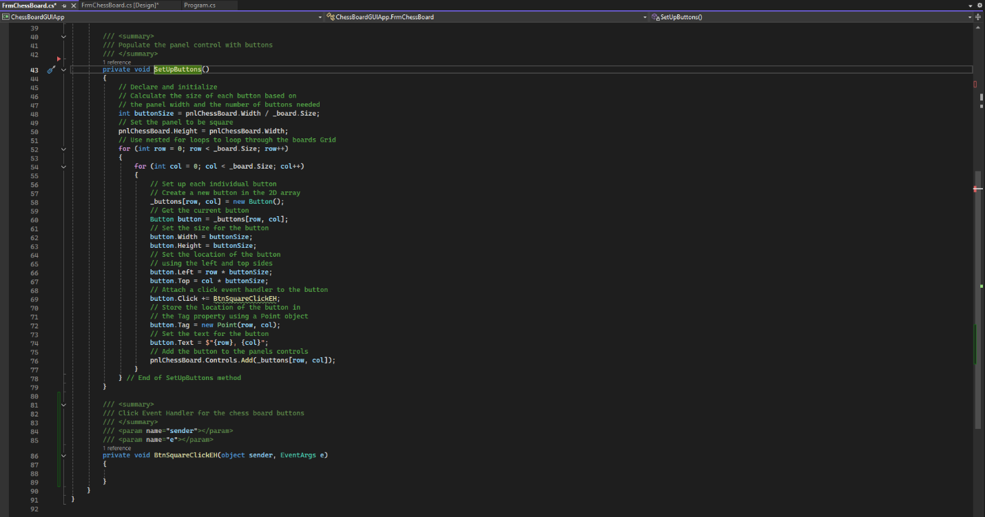
Figure 31: FrmChessBoard.cs SetUpButtons() method.

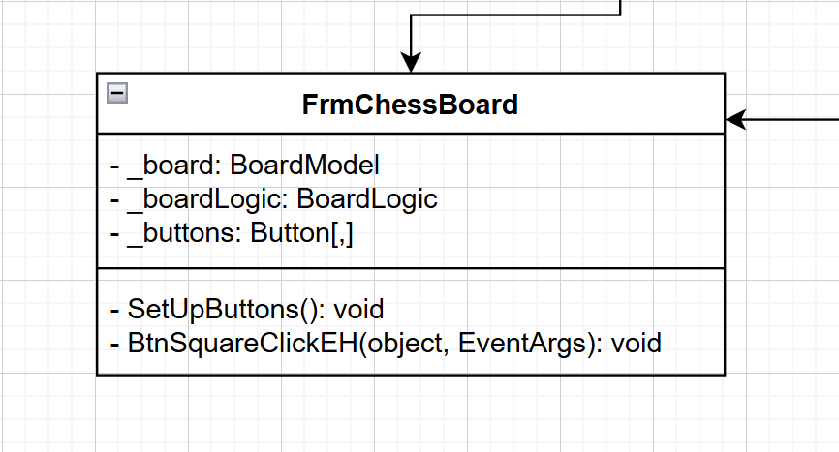
Figure 32: UML for the FrmChessBoard application.

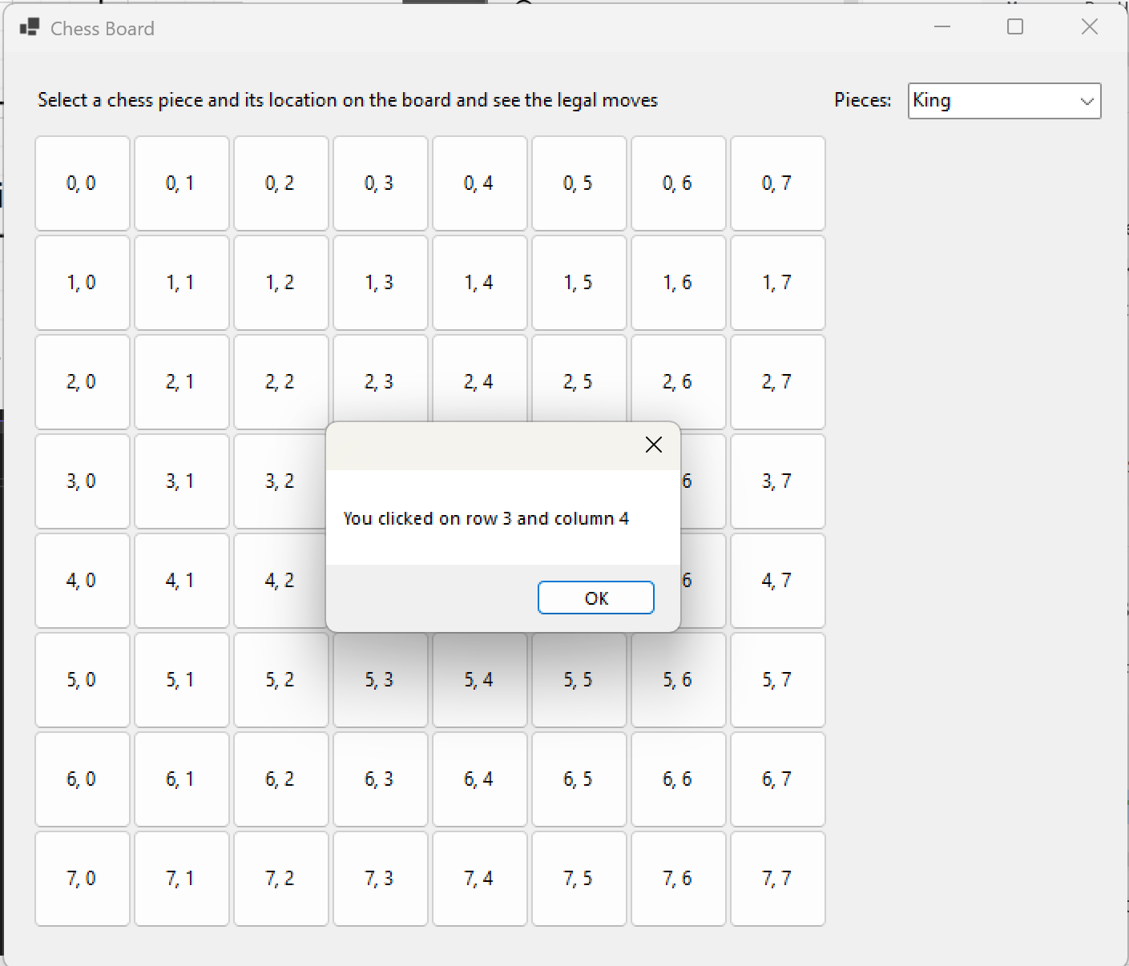
Figure 33: Message box

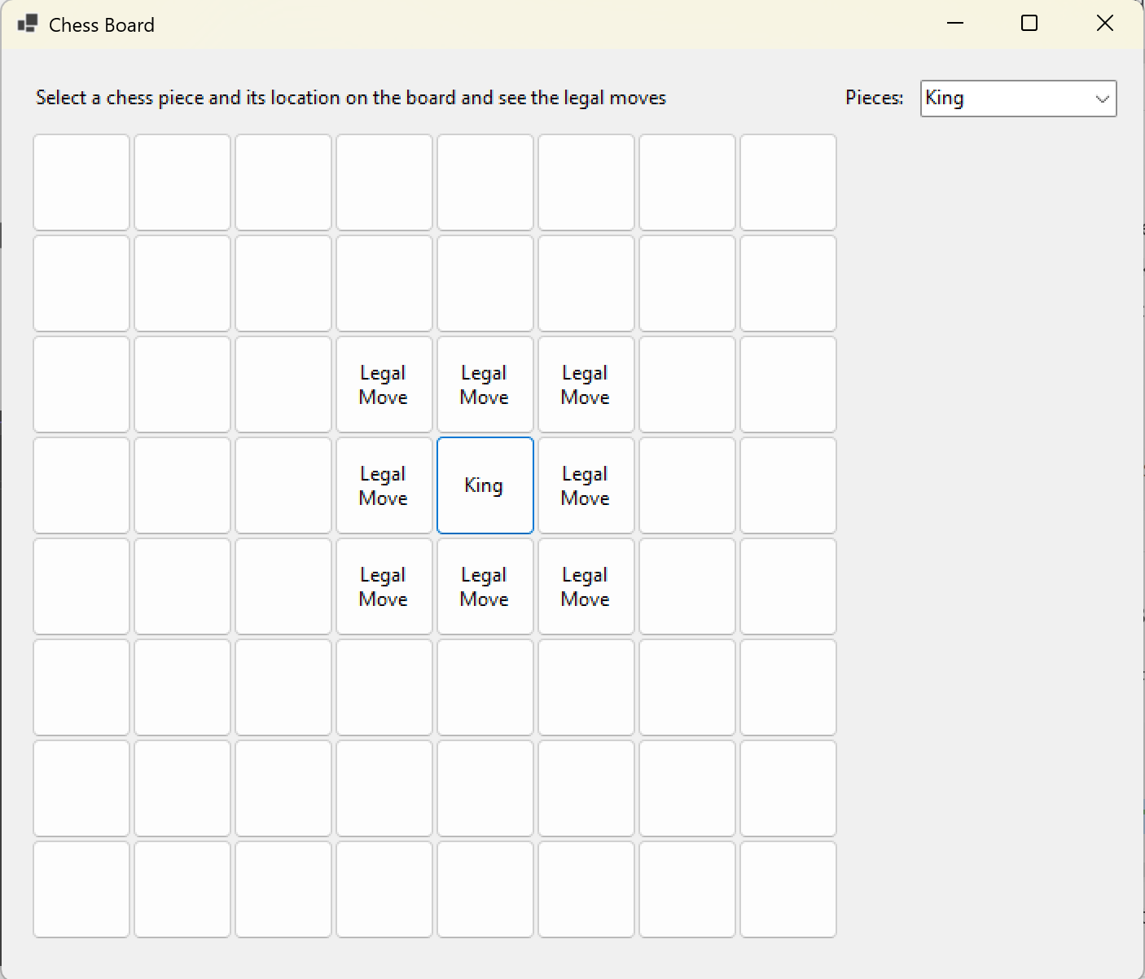
Figure 34: King

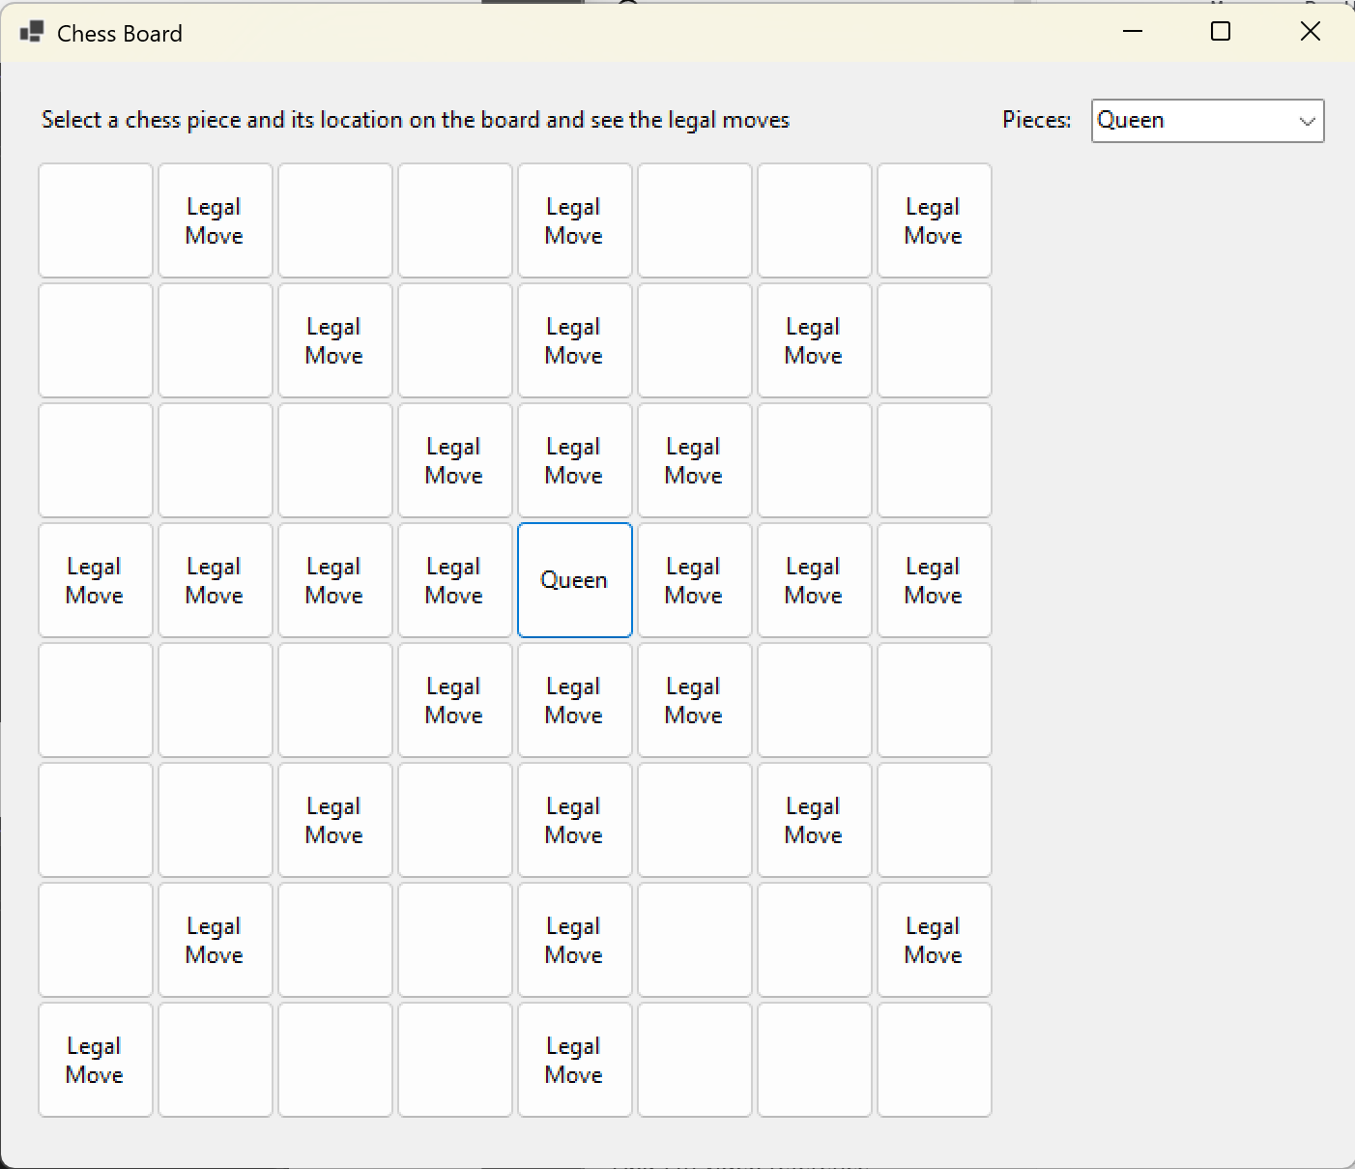
Figure 35: Queen

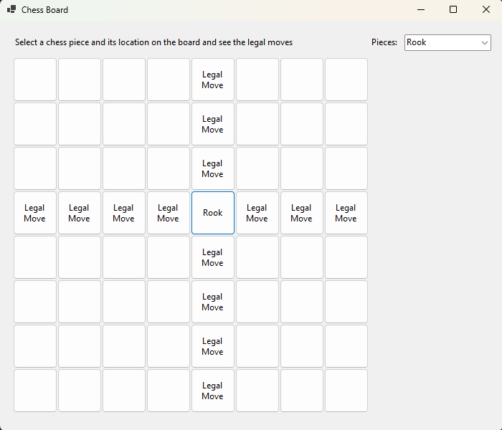
Figure 36: Rook

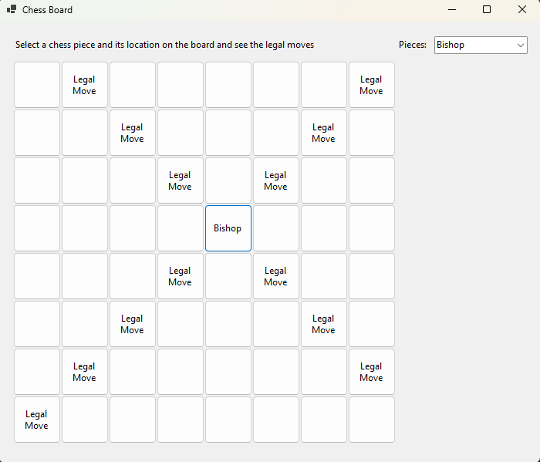
Figure 37: Bishop

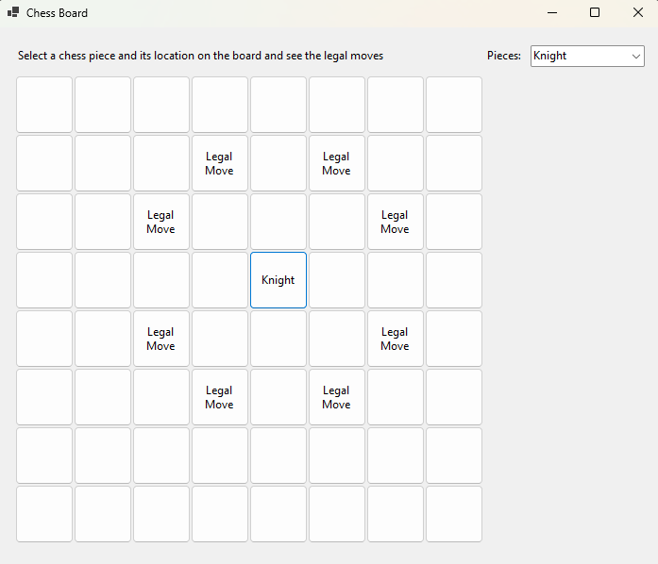
Figure 38: Knight

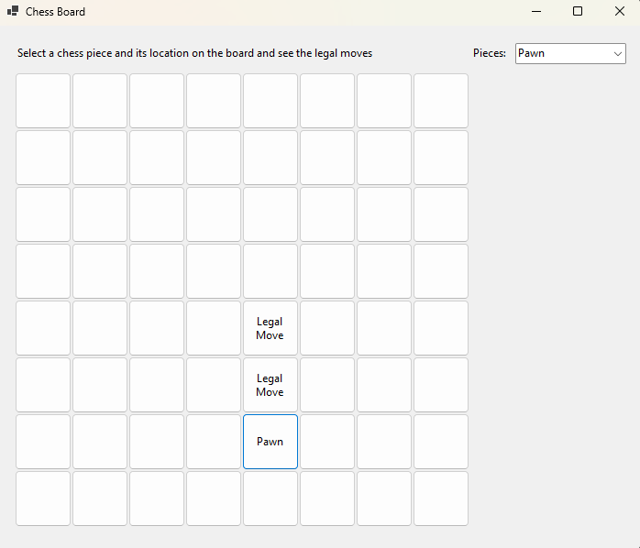
Figure 39: Pawn

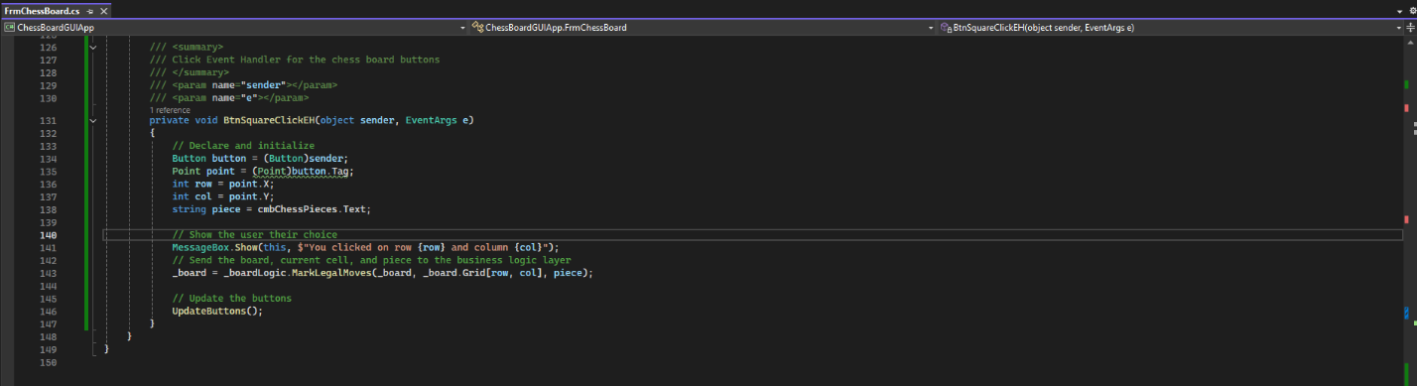
Figure 40: BtnSquareClickEH

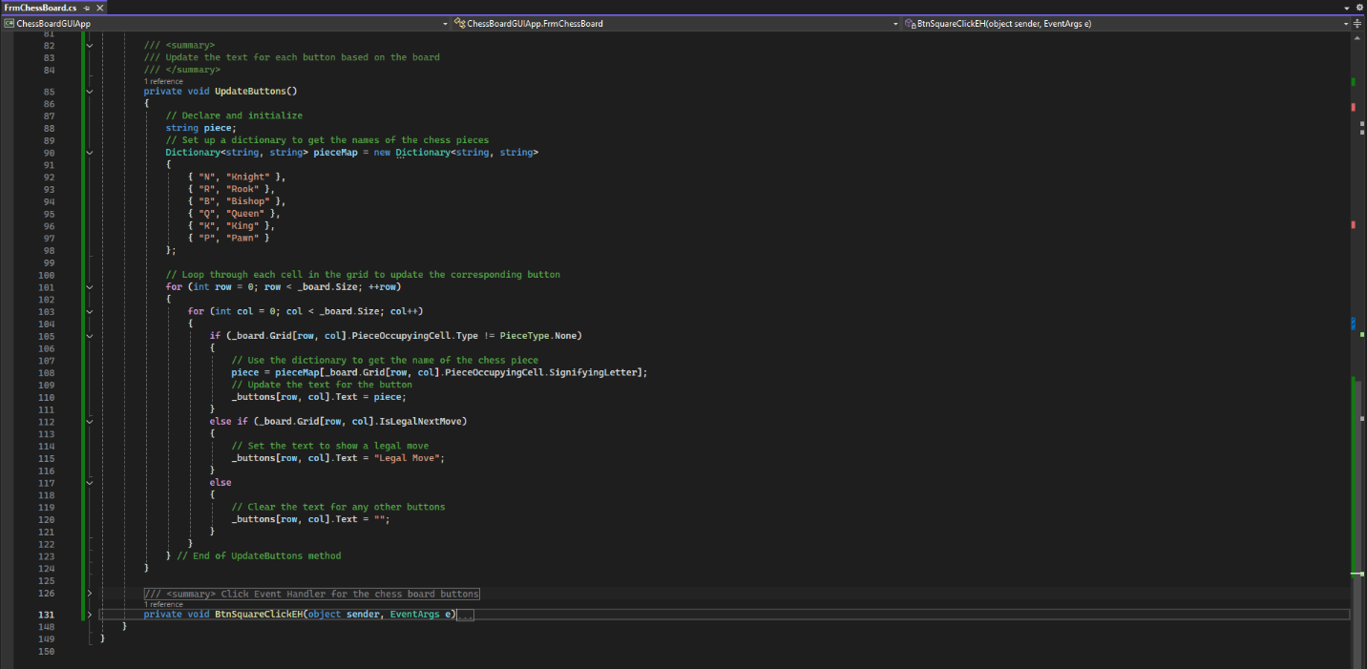
Figure 41: Update Buttons

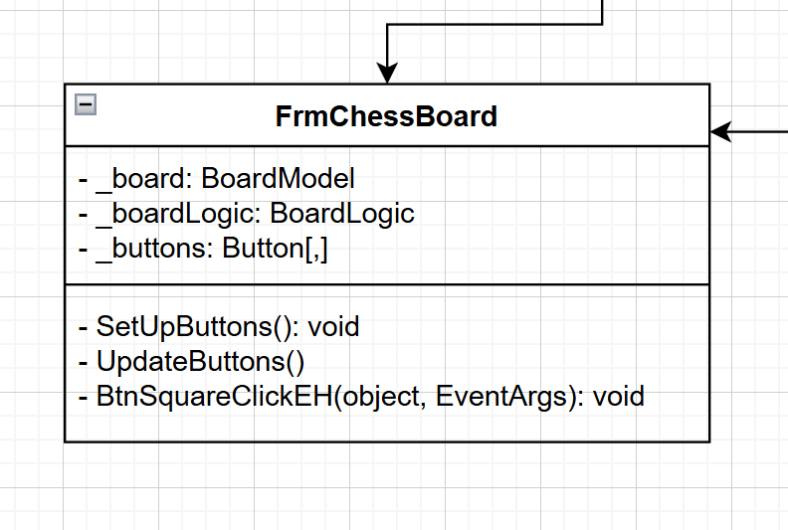
Figure 42: UML

Challenges
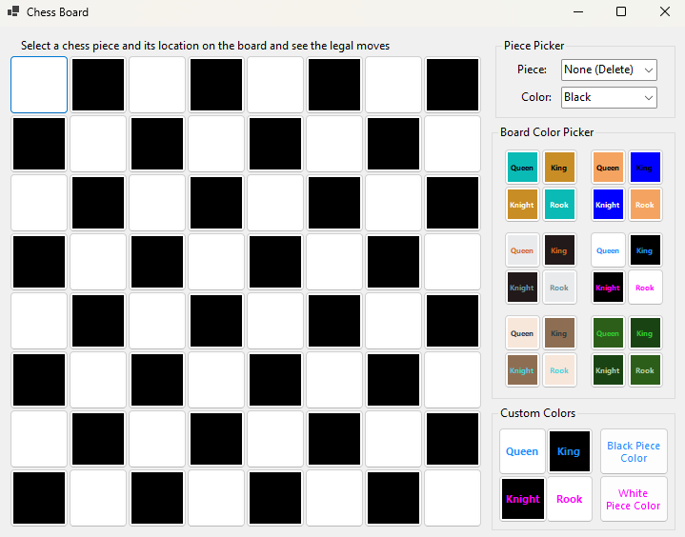
Figure 43: Default load state of the application

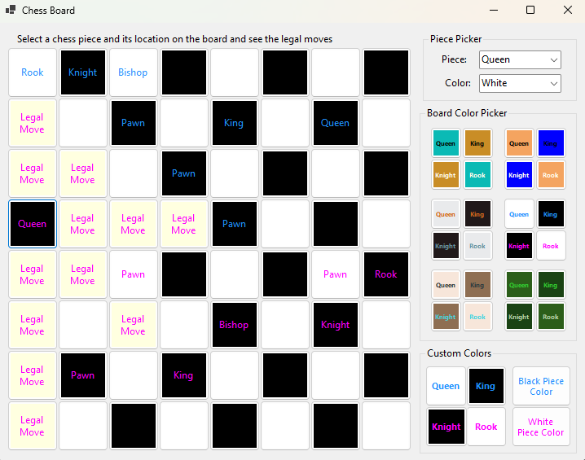
Figure 44: A few pieces placed on the board. I made the decision to not clear pieces off the board when putting a new piece.
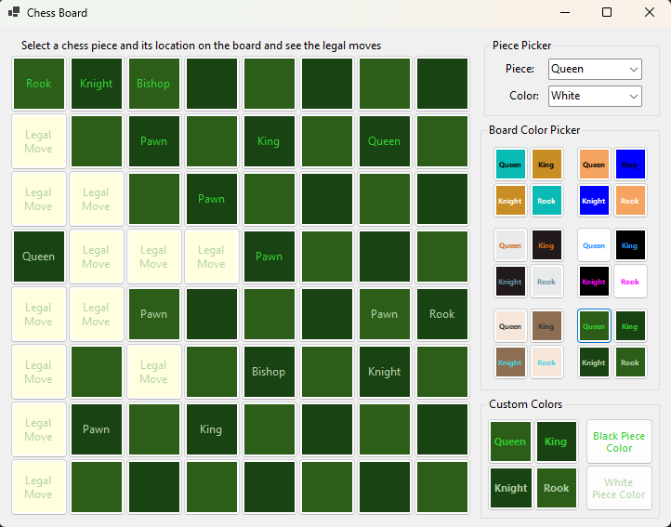
Figure 45: Changed color of the board by clicking one of the preset color palettes

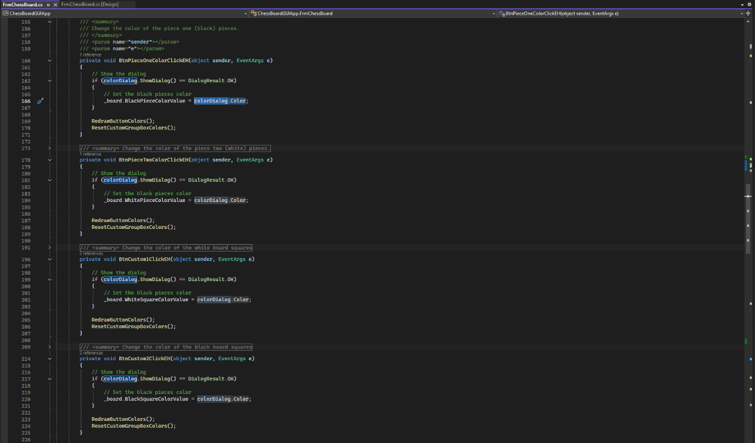
Figure 46: Custom color picker methods

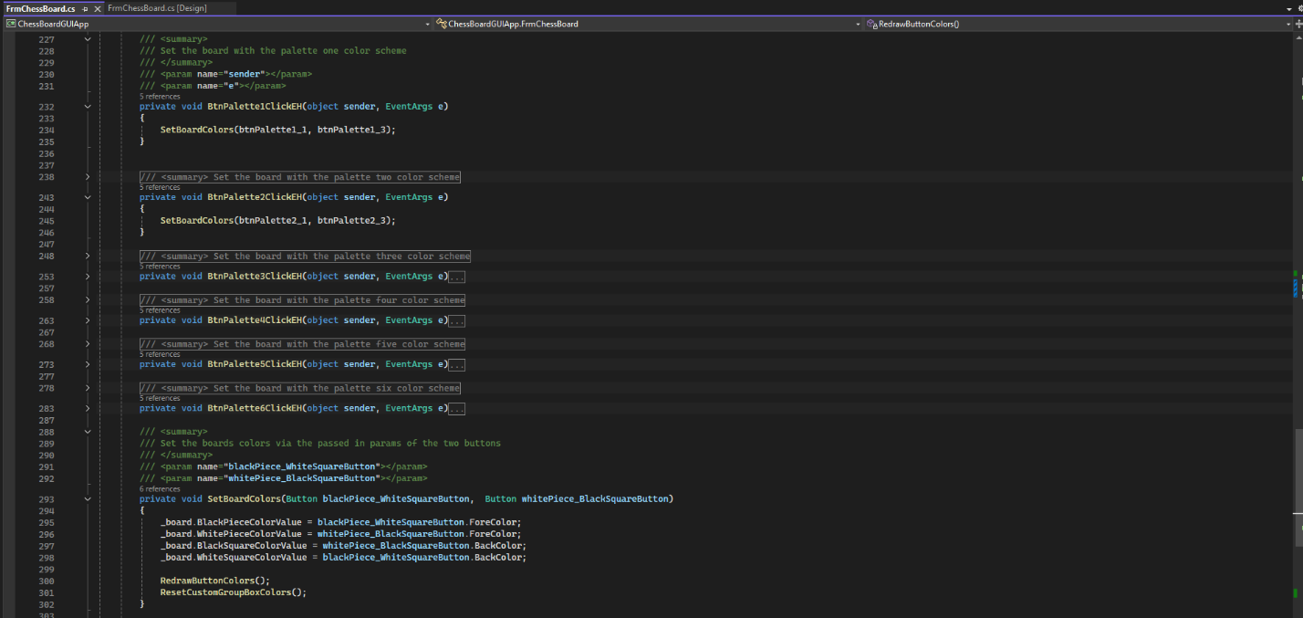
Figure 47: Group of Methods for the preset color palettes
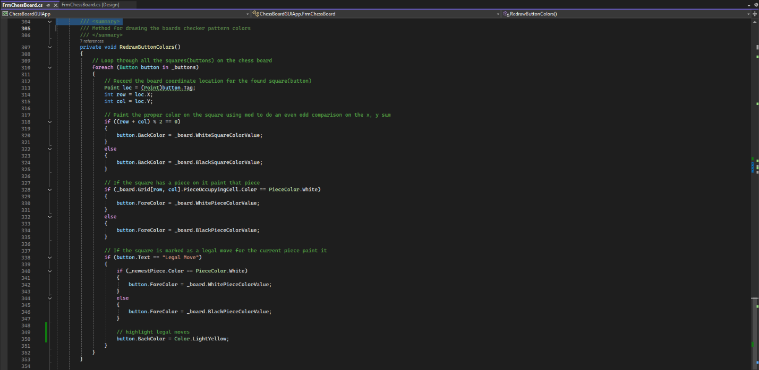
Figure 48: RedrawButtonColors() for redrawing the buttons inside the chess board when needed.

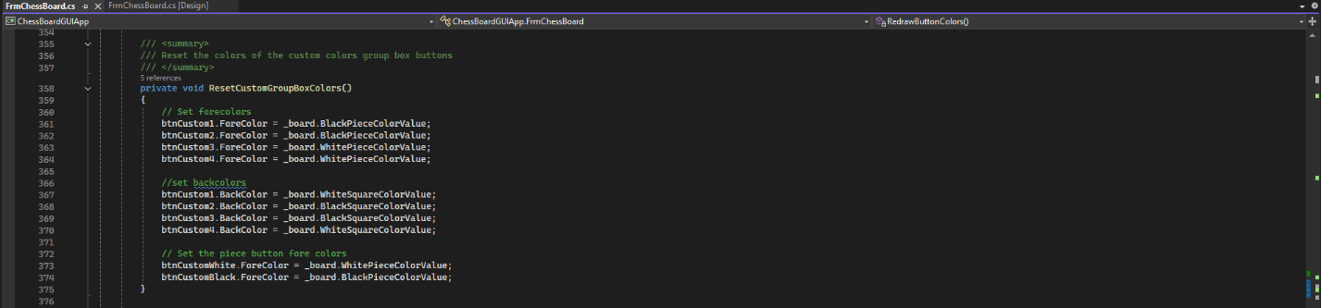
Figure 49: When we change any color, we need to update the custom color group box items. That is handled here ResetCustomGroupBoxColors();

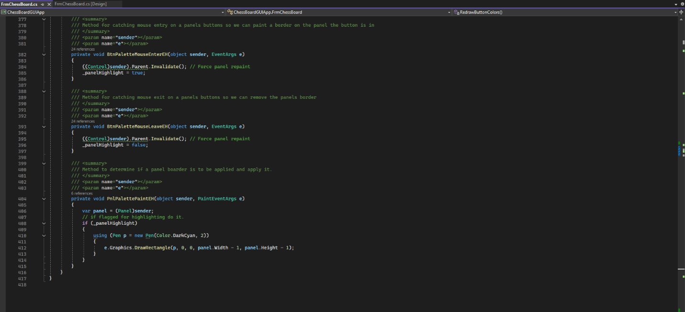
Figure 50: Methods for handling the mouse over highlighting of the preset color palette panels

Week 3
FLOW CHART
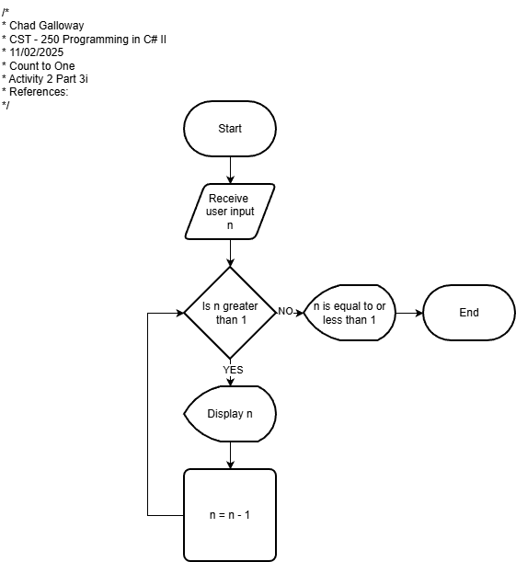
Figure 51: Flow chart of Activity 2 Part 3 i Count to One

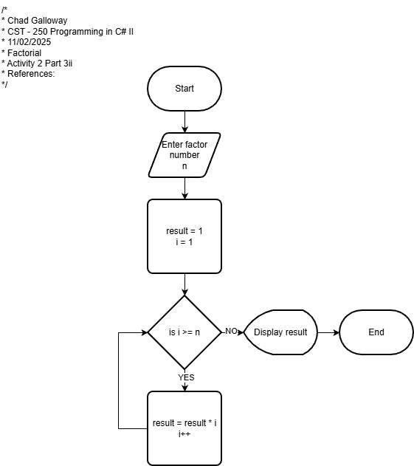
Figure 52: Flow chart of Activity 2 Part 3 ii Factorial

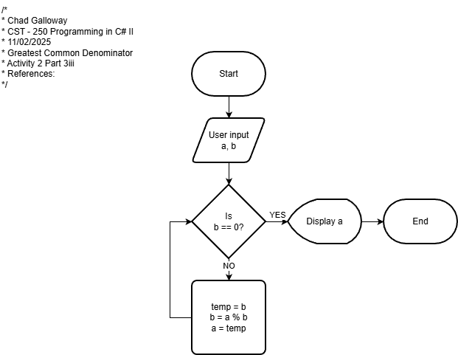
Figure 53: Flow chart of Activity 2 Part 3 iii GCD

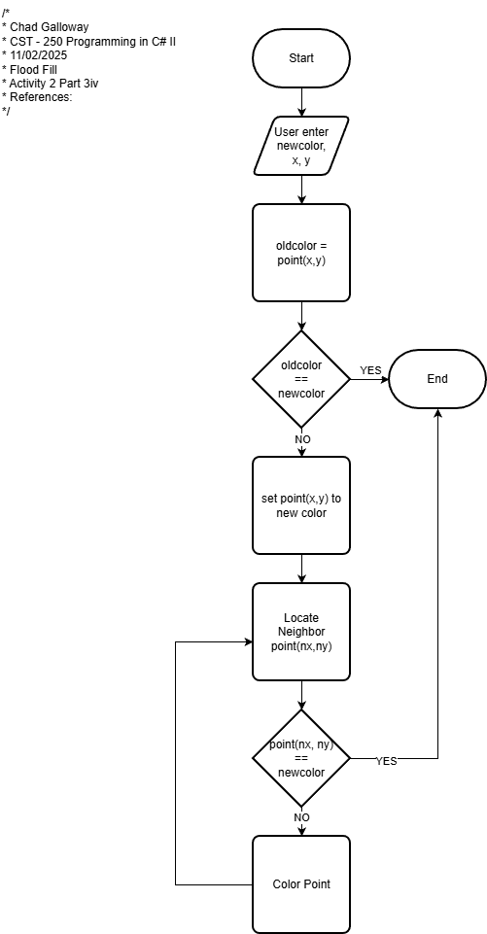
Figure 54: Flow chart of Activity 2 Part 3 iv Flood Fill

UML Class Diagram

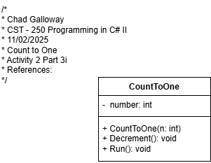
Figure 55: UML Class Diagram for Activity 2 Part 3 i Count to One

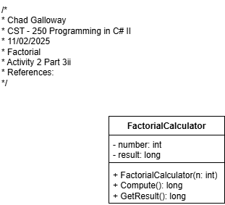
Figure 56: UML Class Diagram for Activity 2 Part 3 ii Factorial

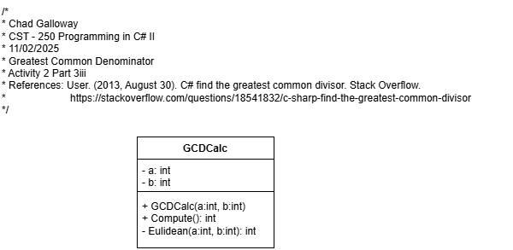
Figure 57: UML Class Diagram for Activity 2 Part 3 iii GCD

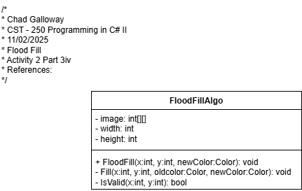
Figure 58: UML Class Diagram for Activity 2 Part 3 iv Flood Fill

