CST-250 Activity 3: Implementing Recursive Algorithms for Real-World Problem Solving

Overview 2
Recursion Examples 3
Part 1 – Count to One 4
Creating the program 5
Count To One Challenges 10
Part 2 – Factorial 11
Creating the program 12
Part 3 – Greatest Common Divisor 20
Creating the program 21
Greatest Common Divisor Challenges 26
Part 4 – Flood Fill 27
Creating the program 28
Flood Fill Challenges 48
Check for Understanding 50
Deliverables 53

Overview
Recursion is a programming concept where a function calls itself to solve a problem iteratively. This method is particularly useful for breaking down complex tasks into simpler, manageable subtasks. This activity will go over the idea of recursion, how to use it in programs, and common use cases.
Learning Objectives:
      - Solve a variety of problems to see examples of recursion in action.
      - Explain the steps of a recursive algorithm by using debugging techniques.
      - Apply recursion solutions to real world problems.
Details: We will build four projects to show different uses and solutions using recursion:
- Count to One using recursion – demonstrates a basic recursion method using a positive integer and various rules.
- Factorial using recursion – compute the factorial of a number by multiplying every positive integer from the number to 1. For example, 5! = 5 x 4 x 3 x 2 x 1.
- Greatest Common Divisor using recursion – find the largest number that divides evenly into two given numbers. This will be done using a Euclidean algorithm.
- Flood Fill using recursion – introduce the flood fill algorithm, which is used for graphics in many games and programs. Involves using recursion to fill a connected space with a color or attribute.
The GCU College of Engineering and Technology Coding Guidelines and Best Practices for C#, available in the Class Resources, must be followed in all CST-250 projects to ensure consistency, readability, and professionalism in student code. These guidelines promote a clear separation of concerns by organizing code into the Models, BusinessLogicLayer, and DataAccessLayer folders. The document also outlines essential standards for casing, naming conventions, code structure, commenting, and organization. Additionally, it emphasizes best practices in object-oriented design, exception handling, and the use of design patterns. Adhering to these expectations is required for successful completion of course assignments.

Recursion Examples
Recursion is a powerful programming concept used in everyday applications that many people may not immediately recognize. Here are some common examples.

- Searching Folders on a Disk Drive: This is a classic example where recursion is used. When you search for a file within a folder, and that folder contains subfolders, recursion allows the search function to "dig" into each subfolder until the file is found or all folders have been checked.
- Website Navigation: Web crawlers used by search engines employ recursion to navigate through webpages. Starting from a single page, the crawler follows all links recursively to index a vast number of pages across the internet.
- Computer Games: Many computer games use recursion for various tasks, such as calculating the score, simulating AI behavior, or generating complex game worlds. For instance, games with large worlds, like Minecraft, may use recursive algorithms to procedurally generate terrain.
- Mathematical Calculations: Recursion is used in implementing algorithms for calculating mathematical operations like exponentiation, computing Fibonacci numbers, and solving factorial-based calculations, which are common in statistical applications and financial models.

- Sorting Algorithms: Several classic sorting algorithms use recursion, such as QuickSort and MergeSort. These algorithms divide the data into smaller parts, sort those recursively, and then combine them back together in a sorted form.
- Fractals: Many fractal shapes are drawn using recursive algorithms. Software that draws fractals like the Mandelbrot set and the Koch snowflake uses recursion to create the infinitely repeating patterns that fractals are known for.
- Testing Frameworks: Certain testing frameworks utilize recursion to navigate through all possible paths to ensure comprehensive testing, especially when testing graphical user interfaces or exploring different user interaction scenarios.

Part 1 – Count to One
In this example, we are going to learn about a simple recursive function that takes any positive number and reduces it to one. This example shows how a function can call itself to solve a problem step-by-step.
This function starts with any positive number and follows these steps:
- Base Case: If the number is 1, the method stops. This is important to keep the method from running forever.
- Even Number: If the number is even, divide it by 2 and call the method again. This makes the number smaller much faster than subtracting from it.
- Odd Number: If the number is odd, add 1 to it and call the method again. This changes an odd number into an even number, so the next step can divide it by 2.
Using this function, you will:
- See how a recursive function works by calling itself with new values each time.
- Understand why it is important to have a stopping point in a recursive function.

Creating the program
- Create a new console application in Visual Studio as shown in Figure 1.
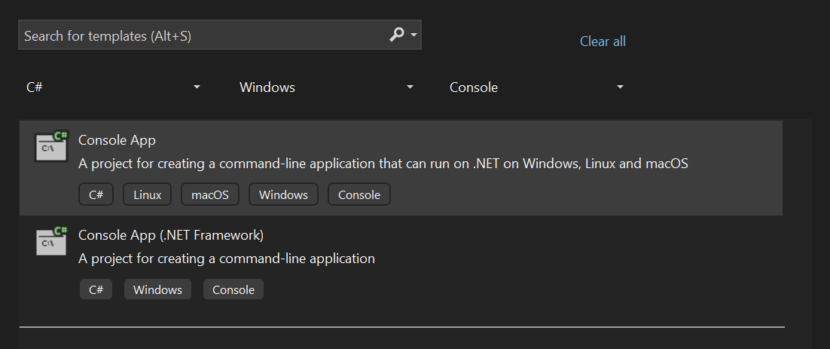
Figure 1: Creating a new console app
- Name the project CountToOneRecursion. Make sure that "Do not use top-level statements" is not selected as shown in Figure 2.
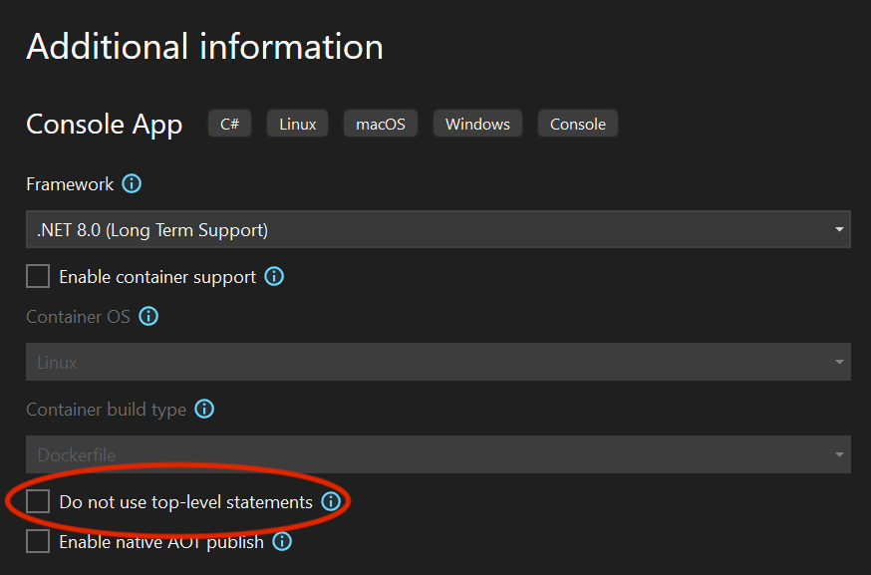
Figure 2: Making sure that the Program.cs class will not have a formal main method

- Add the project to source control.
- See the Class Resources for a detailed tutorial on GitHub source control.
- In the Program.cs file, add your citation and outline the main method as shown in Figure 3.
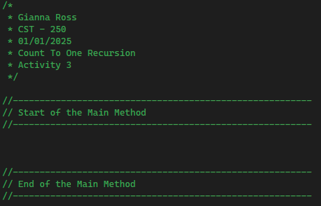
Figure 3: Outlining the main method for the count to one program
- Below the main method, create a new static Utility class as shown in Figure 4.
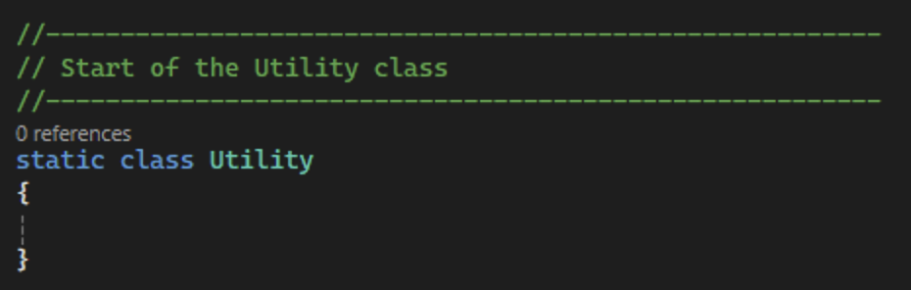
Figure 4: Creating the Utility class

- Create an internal static method in the Utility class named CountToOne that will accept and return an integer as shown in Figure 5. Make sure to add a summary comment.
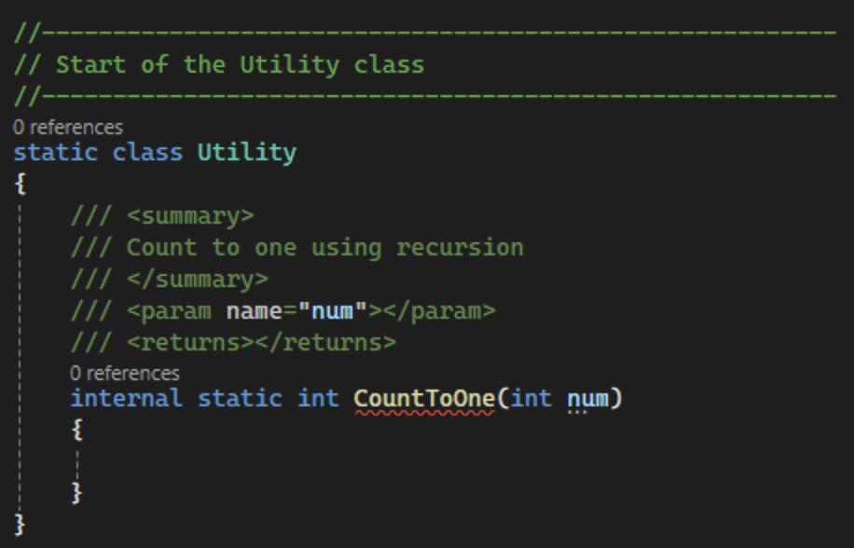
Figure 5: Creating the CountToOne function
- First, print out the current number and set up our base case for the recursive function as shown in Figure 6. This will make sure that our program does not run forever.
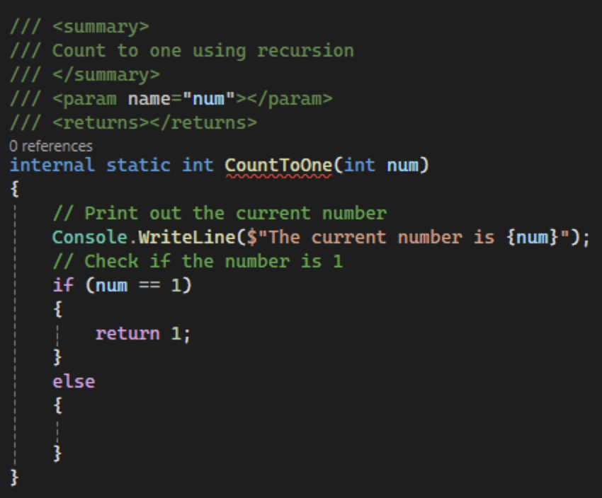
Figure 6: Set up the base case for the recursion

- Next, set up an if statement to see if the number is even or odd. If the number is even, divide it by 2 and then call the CountToOne function again with the new number. We should return the function as shown in Figure 7. When the base case is eventually returned, this will return the integer all the way up the call stack. If the number is odd, add 1 to the number and return the function call for the same reason. By calling the function within the function, we create recursion.
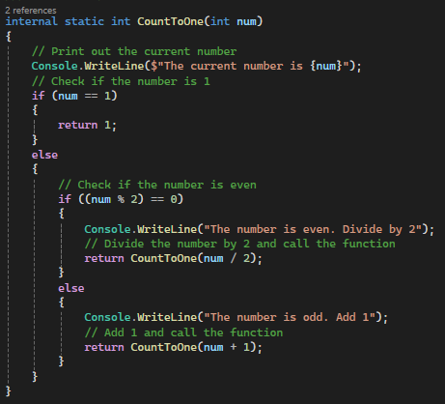
Figure 7: Add logic to set up recursion for the function

- Now, set up the main method for the function by reading a positive number from the user and calling the CountToOne function as shown in Figure 8. We can use a try-parse to make sure the user entered a valid number.
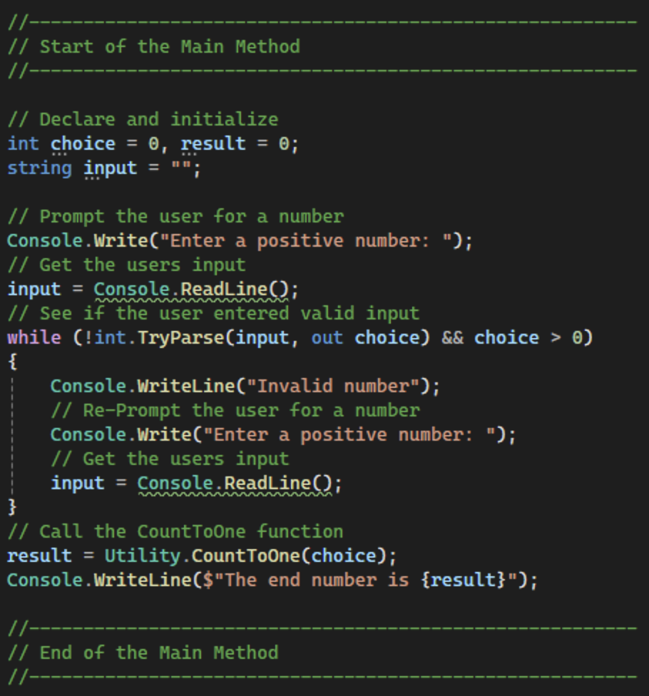
Figure 8: Main method for CountToOne example

- Commit all changes in the project to source control.
- Commit Message: Add functionality for the CountToOne recursive method.

- Take a screenshot of the application running at this point.
- Take a screenshot of the citation for Program.cs.
- Take a screenshot of the CountToOne and main methods.
- Take a screenshot of the UMLs for the Utility class.
- Paste the images into a Word document.
- Put a caption below each image explaining what is being demonstrated.

Count To One Challenges
Experiment with the recursive CountToOne function to become more familiar with recursive behavior. Implement these changes to see how different modifications affect the behavior and outcome of the recursion:
- Implement a Counter: Include a counter to track how many steps (or recursive calls) it takes to reduce different starting numbers to one. This is useful for comparing the efficiency of different versions of the function or understanding the computational cost.
- Change the Increment for Odd Numbers: Instead of adding 1 to make an odd number even, try adding 2 or subtracting 1. This change could alter the sequence and number of steps the function takes to reach one, providing insight into how different operations impact the process.
- Modify the Division: Instead of dividing by 2, experiment with dividing by larger even numbers like 3 or 4 when the number is divisible by those values. This can significantly change the reduction pattern and might lead to different recursive depths or loops.
- Introduce Multiplication for Specific Conditions: Add a condition where if the number meets a specific criterion (e.g., divisible by 5), the number is then multiplied by a factor. This would add complexity and test how the function handles larger or smaller values dynamically.
- Add Functionality for 0 and Negative Numbers: Add logic to the function so that the program works if negative numbers or a 0 is entered.

- Commit the challenges to source control with a commit message.

- Take a screenshot of the application running after the new features have been added.
- Take a screenshot of each method added or updated to implement the features.
- Take a screenshot of the updated UMLs for any classes with added methods.
- Paste the images into a Word document.
- Put a caption below each image explaining what is being demonstrated.

Part 2 – Factorial
Factorial is a mathematical expression that multiplies every positive integer from a number to 1. For example:
6! = (6 * 5) * (4 * 3) * (2 * 1) = (30 * 12) * 2 = 360 * 2 = 720
This can be solved two different ways:
- Standard for loop:
4! = 1 * 2 * 3 * 4 or 4 * 3 * 2 * 1 = 24
- Recursive thinking:
4! = 4 * 3!
= 4 * (3 * 2!)
= 4 * (3 * (2 * 1!))
= 4 * (3 * (2 * (1)))
= 24

Creating the program
- Create a new console application in Visual Studio as shown in Figure 9.

Figure 9: Creating a new console app
- Name the project FactorialRecursion. Make sure that "Do not use top-level statements" is not selected as shown in Figure 10.

Figure 10: Making sure that the Program.cs class will not have a formal main method

- Add the project to source control.
- See the Class Resources for a detailed tutorial on GitHub source control.
- In the solution explorer, add a new folder named Services. Add a second folder into the Services folder named BusinessLogicLayer as shown in Figure 11.
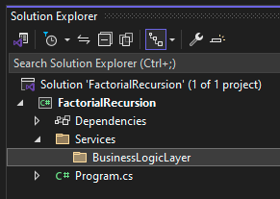
Figure 11: Setting up the file structure for the factorial recursion project
- In the BusinessLogicLayer, create a new class named FactorialLogic.cs as shown in Figure 12. This class will contain logic to solve the factorial problem in two different ways, iteration and recursion.
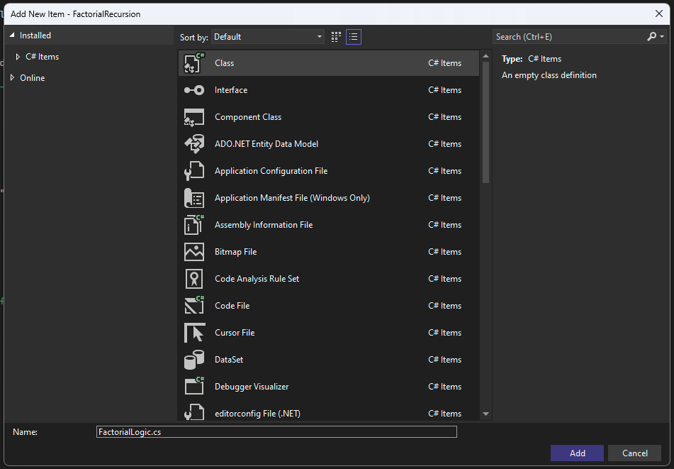
Figure 12: Creating the FactorialLogic class
- Add a citation to the top of the class as shown in Figure 13.
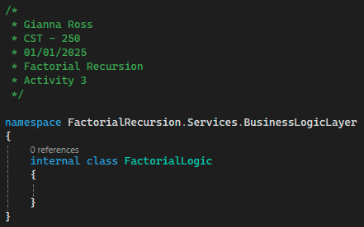
Figure 13: Citation for FactorialLogic class
- The first method we will create will solve the factorial problem using iteration with a for loop. Create a method in the FactorialLogic class named SolveIterativeFactorial as shown in Figure 14. This method will accept an integer and return a BigInteger. By using BigInteger instead of int, we will not have to worry about overflowing the int with larger factorials. An integer could calculate a maximum of 16! while a BigInteger can calculate much higher factorials (such as 10,000). Because this method will not be referenced outside of the current project, we can set the access specifier to internal. Remember to add a summary comment to the method.
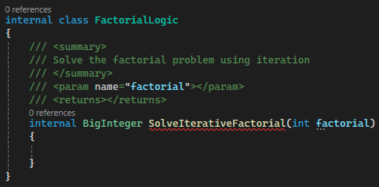
Figure 14: Setting up the SolveIterativeFactorial method
- Next, declare and initialize the result variable and set up a for loop to solve the problem. The result variable must start at 1 because we are using it for multiplication. Then, loop through each number from the factorial to 1 and multiply them together as shown in Figure 15. We could also loop from 1 to the factorial, as the answer will remain the same. At the end of the method, return the result.
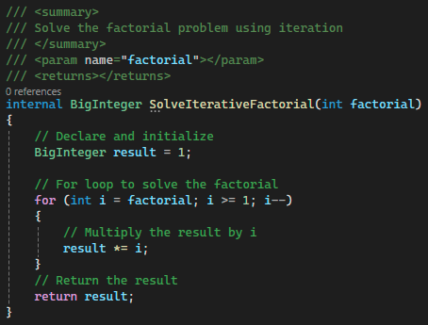
Figure 15: Solving the factorial function using iteration
- The second way we will solve the factorial problem is using recursion. Set up a second method named SolveRecursiveFactorial with a summary comment. Like the iterative method, this method will accept an integer and return a BigInteger as shown in Figure 16.
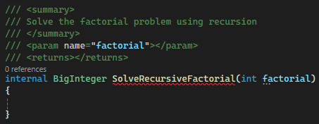
Figure 16: Setting up the recursive factorial method
- Inside the method, set up a base case and recursive call for the method. If the factorial is 1 or 0, return 1. This will ensure that our program does not run forever. If the program does not fall into the base case, return the factorial number multiplied by SolveRecursiveFactorial of one less than the factorial as shown in Figure 17.
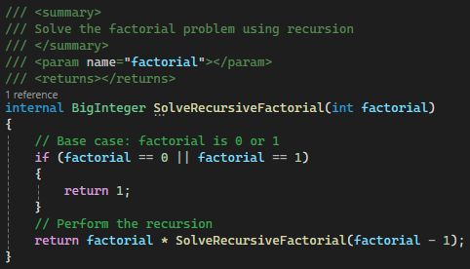
Figure 17: Solving the factorial problem using recursion

- Commit all changes in the project to source control.
- Commit Message: Add logic to solve the factorial problem using iteration or recursion.

- In the Program.cs file, outline the main method and add your citation as shown in Figure 18.
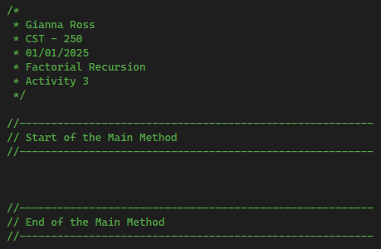
Figure 18: Main method and citation for factorial project
- Next, add a new Utility class to the Program.cs file. This class will contain logic to read input from the user.
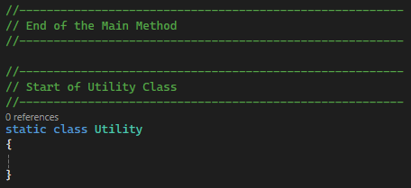

- Add an internal method to the Utility class with a summary comment to read an integer input from the user. The method will return an integer and use an int.TryParse to parse the user's input as shown in Figure 19.
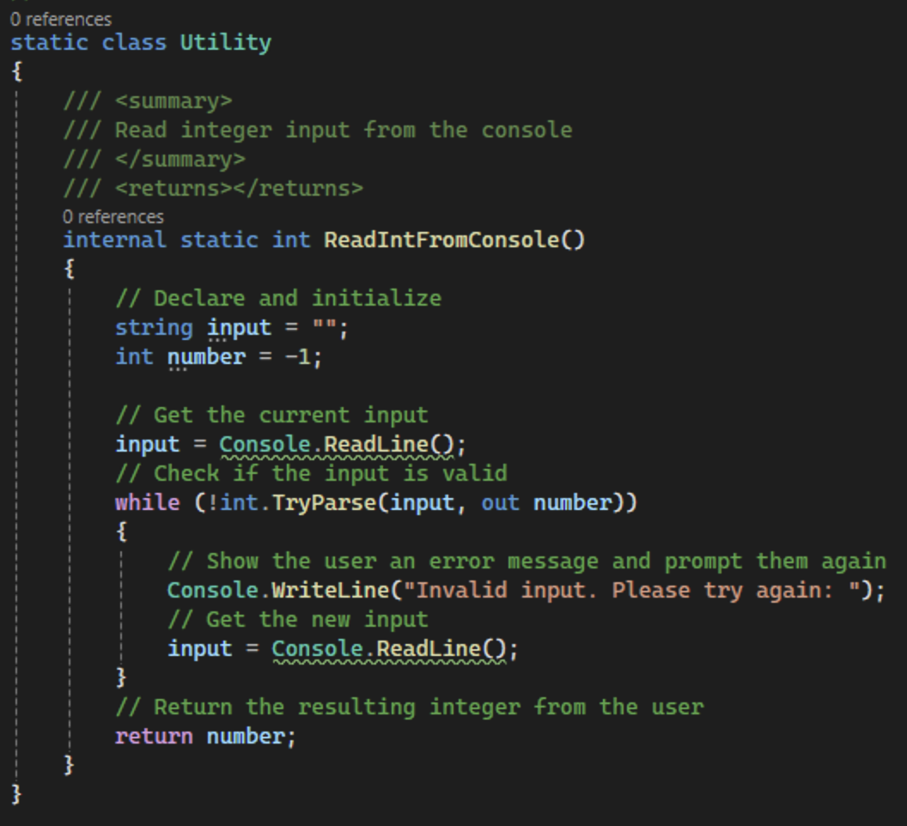
Figure 19: ReadIntFromConsole method for FactorialRecursion project
- Begin the main method by declaring and initializing an instance of the FactorialLogic class along with variables for the users input and the results of the iterative and recursive methods. Then, use the method we created in the Utility class to get the users input as shown in Figure 20.
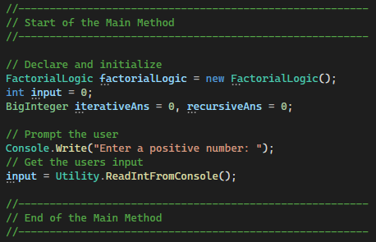
Figure 20: Getting user input in the main method
- Next, use the factorialLogic object to call the factorial functions using iteration and recursion we wrote earlier as shown in Figure 21. Print out the results to the user.
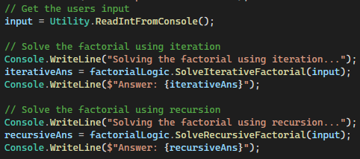
Figure 21: Solving the factorial problem

- Commit all changes in the project to source control.
- Commit Message: Add a Utility class to read user input and call the factorial methods.

- Take a screenshot of the application running at this point with an input of 5.
- Take a screenshot of the captions for FactorialLogic and Program.cs. Make sure to include the class declarations in the images.
- Take a screenshot of the main, ReadIntFromConsole, SolveIterativeFactorial, and SolveRecursiveFactorial methods.
- Take a screenshot of the UMLs for the FactorialLogic and Utility classes.
- Paste the images into a Word document.
- Put a caption below each image explaining what is being demonstrated.

Part 3 – Greatest Common Divisor
We need to find the largest number that will divide evenly into two numbers we are given.
There is a method for computing the greatest common divisor (GCD) for any two integers using a series of steps:
- Start with two numbers.
- Divide the first number by the second and record the remainder.
- If the remainder is 0, then stop. The GCD answer is the last remainder found.
- If the remainder is not zero, then repeat the process using the second number and the remainder in the next step.
Num 1 | Num 2 | N1 % N2 = remainder
440 | 80 | 440 / 80 = 5 remainder 40
80 | 40 | 80 / 40 = 0 remainder 40
40 | 40 | 40 / 40 = 1 remainder 0

Creating the program
- Create a new console application and name the project GreatestCommonDivisorRecursion as shown in Figure 22.
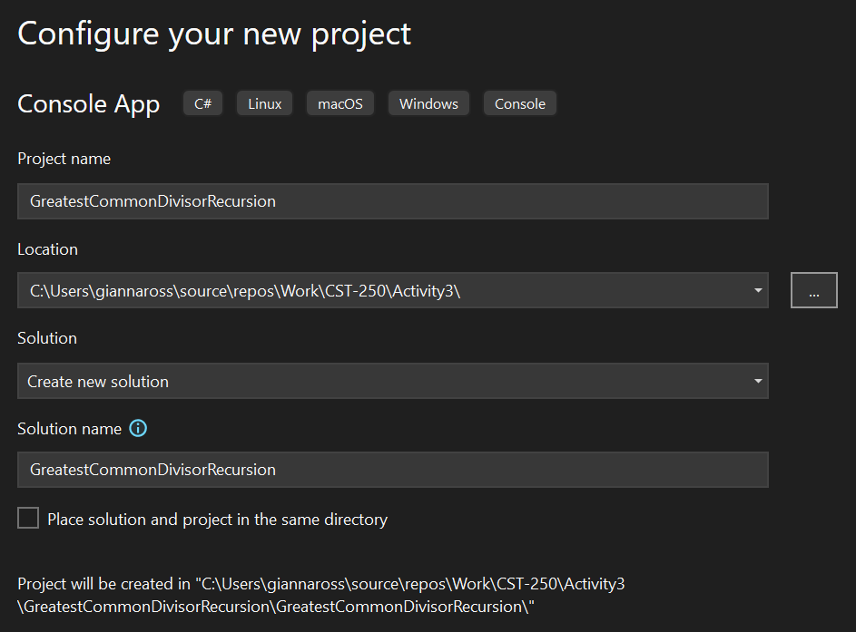
Figure 22: Creating a Greatest Common Divisor Recursion project

- Make sure that "Do not use top-level statements" is not selected as shown in Figure 23: Making sure that the Program.cs class will not have a formal main method.

Figure 23: Making sure that the Program.cs class will not have a formal main method


- Add the project to source control.
- See the Class Resources for a detailed tutorial on GitHub source control.

- First, outline the main method for the program and add your citation as shown in Figure 24.
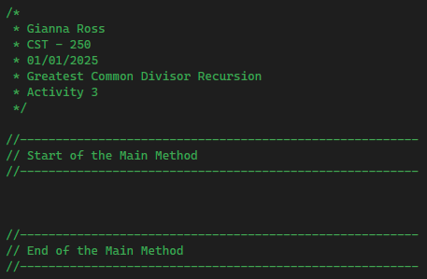
Figure 24: Citation and outlining the main method
- Below the main method outline, add a new public Utility class as shown in Figure 25.
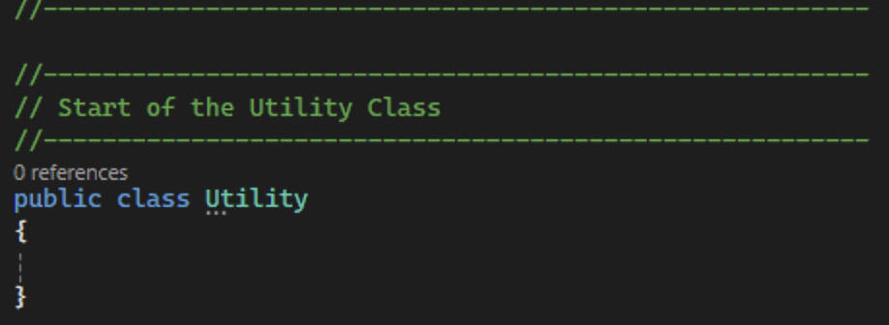
Figure 25: Creating the Utility class
- Next, set up an internal method named GreatestCommonDivisor that returns an int to calculate the greatest common divisor of two numbers as shown in Figure 26.
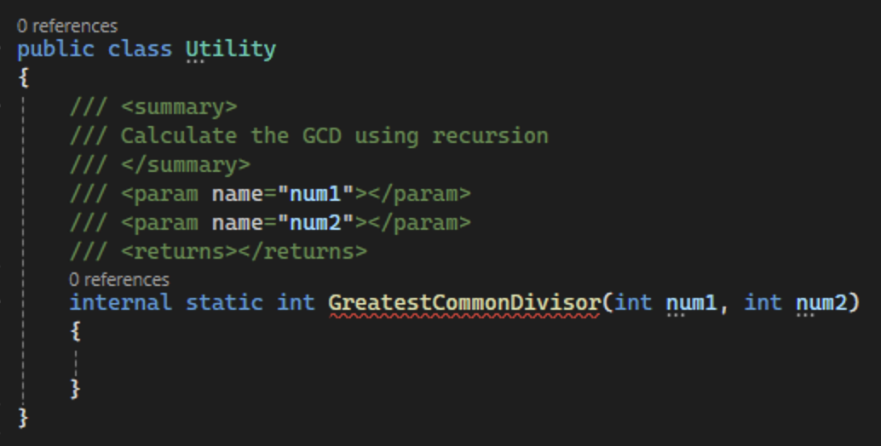
Figure 26: Set up a GCD function
- First, set up the base case by checking if the second number is 0. If it is, you have found the greatest common divisor. Return the first number. Else, get the new remainder and print an update to the user. Then, return a call to the GreatestCommonDivisor function using the second number and the remainder as shown in Figure 27.
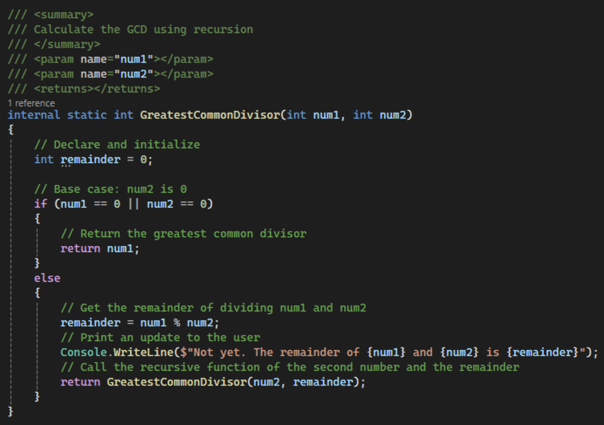
Figure 27: Finish the greater common divisor function

- Commit all changes in the project to source control.
- Commit Message: Create a Utility class and add logic to reclusively calculate the greatest common divisor.

- Next, set up the main method for the program. Use 440 and 80 as sample numbers to call the GreatestCommonDivisor and store the result in a variable as shown in Figure 28. Print the information to the user.
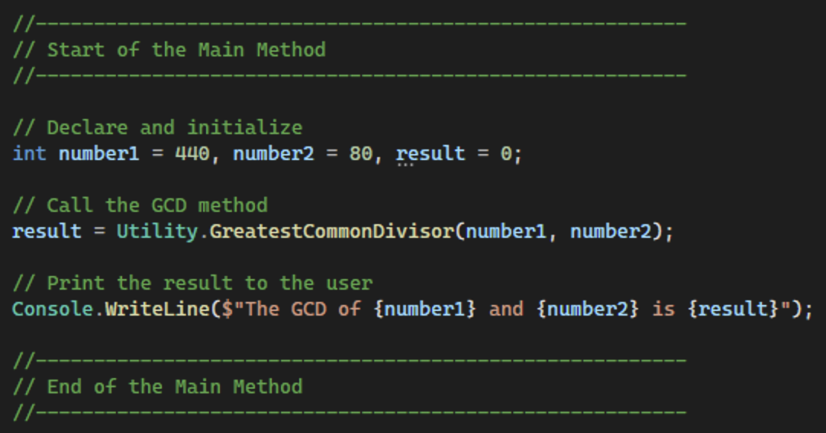
Figure 28: Main method for greatest common divisor

- Commit all changes in the project to source control.
- Commit Message: Add main method logic to run the GCD program.

- Take a screenshot of the application running at this point.
- Take a screenshot of the citation for Program.cs. Make sure to include the class declaration in the image.
- Take a screenshot of the main and GreatestCommonDivisor methods.
- Take a screenshot of the UMLs for the Utility class.
- Paste the images into a Word document.
- Put a caption below each image explaining what is being demonstrated.

Greatest Common Divisor Challenges
After creating the GCD application, extend it with these features:
- User Input: Instead of hard coding the numbers in the program, prompt the user for input. Check for error handling.
- Compare Recursive and Iterative Solutions: Implement an iterative solution to find the GCD of two numbers. Loop from 1 to the first number. Find and save each divisor for the number into a list. Repeat the process for the second number. Find the largest common number between both lists.
- Extend to Multiple Numbers: Typically, GCD is computed between two numbers. You can extend this to calculate the GCD of three or more numbers. This can be achieved by computing the GCD of the first two numbers and then using the result to find the GCD of the next number.
- Time Comparison: Show the performance of the iterative approach compared to the recursive in terms of execution time. This should show the trade-offs between recursion and iteration.
- Test Limits and Robustness: Test the limits of the GCD function with very large numbers or very small numbers (including negative numbers, if not initially considered). Test how the function handles edge cases, such as one or both inputs being zero.

- Commit the challenges to source control with a commit message.

- Take a screenshot of the application running after the new features have been added.
- Take a screenshot of each method added or updated to implement the features.
- Take a screenshot of the updated UMLs for any classes with added methods.
- Paste the images into a Word document.
- Put a caption below each image explaining what is being demonstrated.

Part 4 – Flood Fill
Introduction
In this example, we will explore flood fill. This algorithm allows us to fill an entire area connected by a common attribute (such as color) with a new attribute as shown in Figure 29 and Figure 30. Its applications range from filling in regions on a digital painting application to generating areas in a game map, and even in solving puzzles and mazes programmatically.

Figure 29: Four-way flood fill does not account for diagonal fill. Flood moves North, South, East or West.

Figure 30: Eight-way flood fill allows the color to jump over a diagonal barrier.
Understanding Flood Fill
Flood fill operates by starting at a given point and spreading out to fill all adjacent points that share the same characteristics as the initial point. For instance, in a graphics editing program, if a user clicks on a pixel within an enclosed boundary of blue pixels and chooses to fill with yellow, the flood fill algorithm will replace all connected blue pixels with yellow starting from the clicked pixel.
Where Flood Fill Is Useful
      - Graphics Editing: The most common use of flood fill is in graphics software where users need to change the color of a region bounded by certain colors.
- Game Development: In games, developers use flood fill for terrain generation, map analysis, and dynamically changing game environments.
- Puzzles and Mazes: Flood fill can help in solving and generating puzzles by determining accessible areas or regions within a maze.
- Image Analysis: In computer vision, this algorithm helps in segmenting different parts of an image, which is useful in object recognition and tracking.
Flood Fill and Recursion
The flood fill algorithm is inherently recursive. It starts at a point and recursively applies the same operation to neighboring cells. This recursive nature is perfect for tackling problems where a simple repetitive action needs to be applied across a connected space.
How Recursion Comes Into Play
- Base Case: If the current cell does not meet the test condition, the recursion stops.
- Recursive Step: If the current cell meets the criteria (e.g., color matches "black"), the cell's attribute is changed, and the flood fill function is called recursively on neighboring cells (up, down, left, right).
Project Goal
Our goal is to program the flood fill algorithm in a console application. This will include:
- Setting up a grid-based representation of a board.
- Using the console for input and output to interactively choose starting points for filling.
- Implementing flood fill using recursive techniques to spread the fill across the board.
- Visual feedback in the console to watch flood fill in action, enhancing understanding of both the algorithm and recursion.

Creating the program
- Create a new console application and name the project FloodFillRecursion as shown in Figure 31. Make sure that "Do not use top-level statements" is not selected.
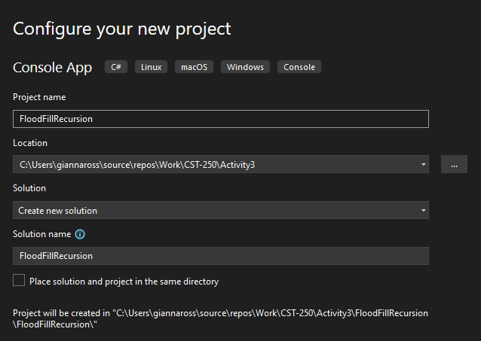
Figure 31: Creating the flood fill recursion app

- Make sure that "Do not use top-level statements" is not selected as shown in Figure 32.

Figure 32: Making sure that the Program.cs class will not have a formal main method


- Add the project to source control.
- See the Class Resources for a detailed tutorial on GitHub source control.
- Create a new folder named Models and add a CellModel.cs class to the folder as shown in Figure 33.
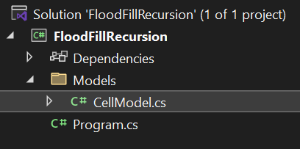
Figure 33: Folder structure after CellModel class
- Create three properties within the CellModel class: an int Row, an int Column, and a string Contents as shown in Figure 34. The row and column will hold the location of the cell. The contents property will show "E" for empty, "W" for wall, and "F" for filled. We will leave this class as internal so that nothing outside of this project can access its contents. Additionally, create a parameterized constructor that accepts all three properties for the CellModel. Remember to add a citation at the top of the class.
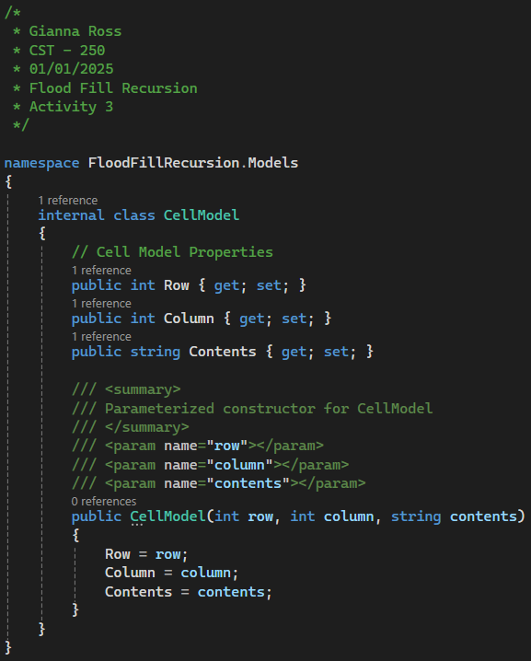
Figure 34: CellModel class with properties and a constructor

- Create a BoardModel class with a citation in the Models folder as shown in Figure 35.
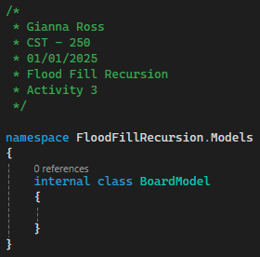
Figure 35: New BoardModel class
- Add three properties to the new class: an int Size, a 2D array of CellModels Grid, and an int NumShapes. Additionally, add a constructor that takes the Size and NumShapes property and creates the Grid array as shown in Figure 36.
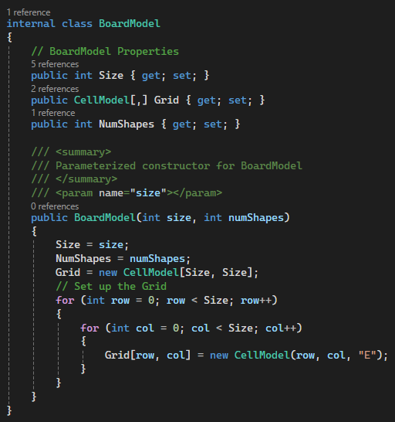
Figure 36: Properties and constructor for BoardModel class
- Next, create a private method called PlaceShapes in the BoardModel class to be called by the constructor. By making PlaceShapes private, nothing outside of the class will be able to reference the method. It will create random shapes to place on the board. We will create squares to start, but you will extend this method to add other shapes later in this activity. Add a summary comment and an end-of-method comment to the method before we start as shown in Figure 37.
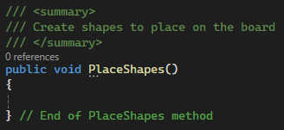
Figure 37: Creating the PlaceShapes method
- First, create a new random object within the method as shown in Figure 38. This will allow us to generate random numbers using the Next method. These numbers will allow us to place squares at random places on the board. The size of these squares will be determined using the Size property halved. We can also set up row and col variables for later. Lastly, set up a for loop so that we can create squares based on the NumShapes property.
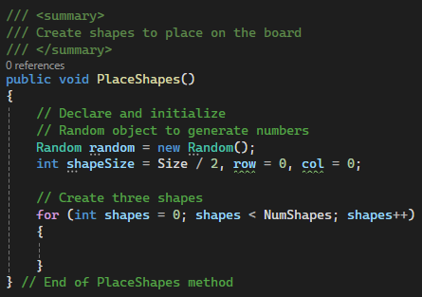
Figure 38: Add a random object to the method to prepare for placing the squares

- Inside the for loop, generate two random numbers for the row and column of the top, left corner for the square. This will use the Next method in the random object with a parameter for the minimum value and maximum value. By setting the max to the difference between the Size property and the square size plus 1, we can ensure that the square fits into the board. Then, create another for loop for the size of the square and create walls for the shapes. Set the contents of each wall to "W" as shown in Figure 39.
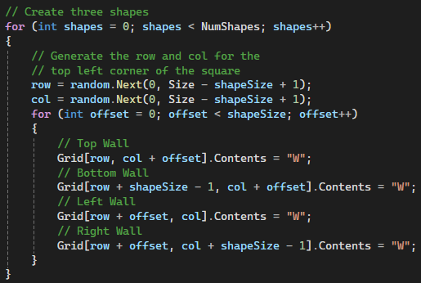
Figure 39: Setting the outline of each random square to W's
- Call the PlaceShapes method in the BoardModel constructor as shown in Figure 40.
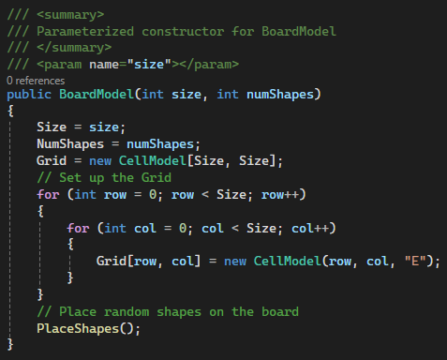
Figure 40: PlaceShapes method in use

- Commit all changes in the project to source control.
- Commit Message: Add Board and Cell Models to the project.
- In the Program.cs class, outline the main method using comments as shown in Figure 41. Remember to add a citation at the top of the class.
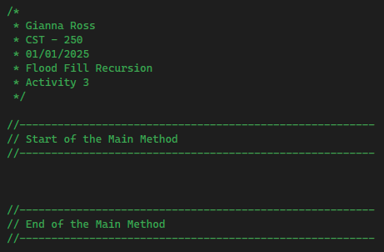
Figure 41: Citation and main method outline for Program.cs
- Then, outline a new utility class to hold helper methods for the console application as shown in Figure 42.
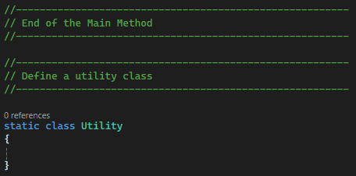
Figure 42: Defining a utility class

- Create an internal method inside the Utility class to print the BoardModel to the console with summary and end of method comments. This method will accept the BoardModel as a parameter and use nested for loops to print the contents of each CellModel in the Grid as shown in Figure 43.
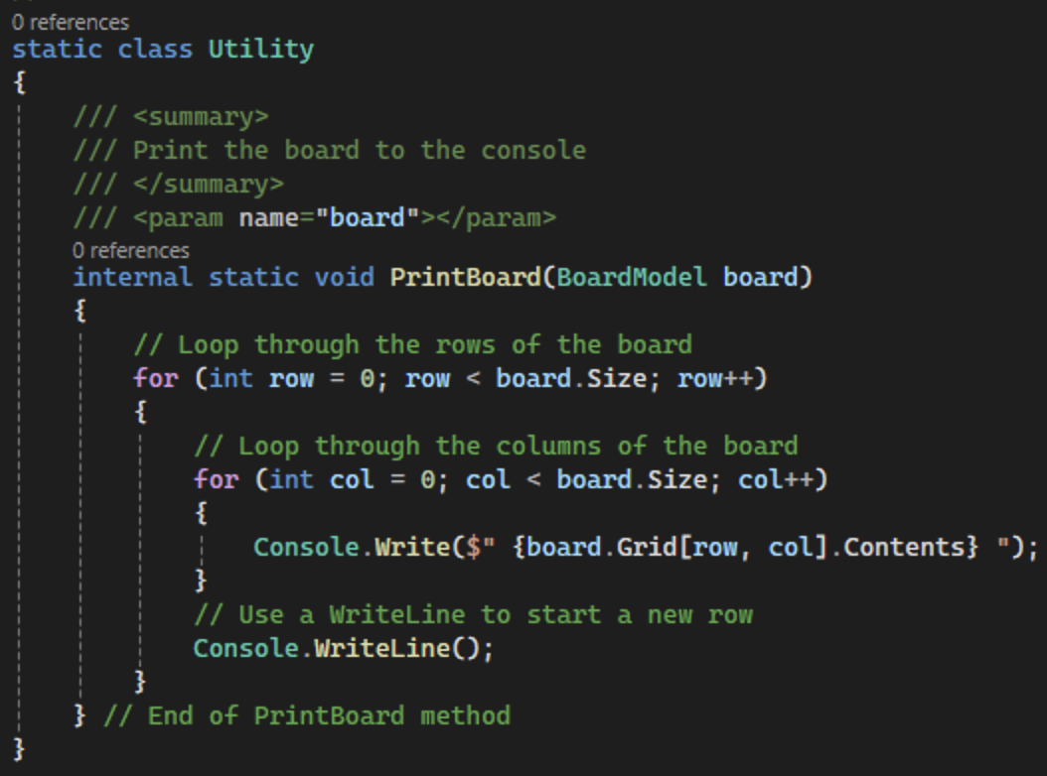
Figure 43: Creating a method to print the board to the console
- In the main method, create a new BoardModel object with the size of 20 and print it to the console as shown in Figure 44.
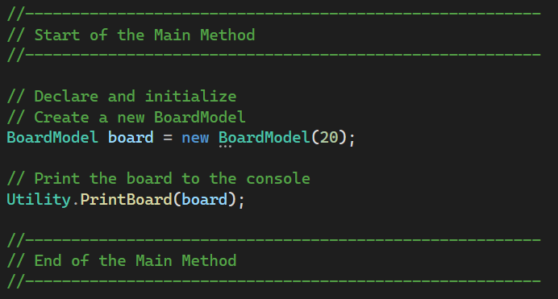
Figure 44: Starting the main method

- Take a screenshot of the application running at this point.
- Paste the image into a Microsoft Word document.
- Put a caption below the image explaining what is being demonstrated.
- To improve the readability of the PrintBoard method, we can change the text color using the Console.ForegroundColor property and replace the empty squares with periods as shown in Figure 45.
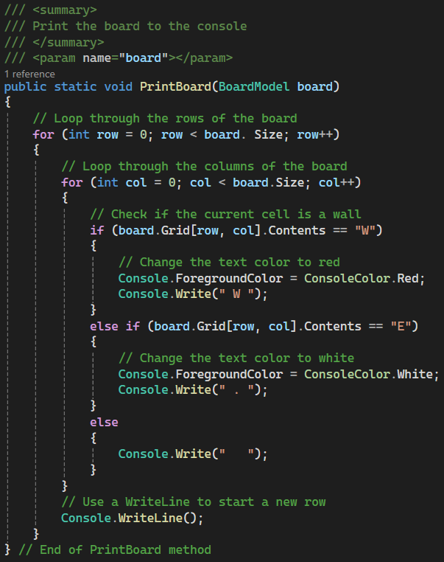
Figure 45: Updated PrintBoard method for wall color

- Take a screenshot of the application running at this point.
- Paste the image into a Microsoft Word document.
- Put a caption below the image explaining what is being demonstrated.

- Next, add to the PrintBoard method so that row and column numbers are printed. Print the column numbers in their own for loop at the top of the method as shown in Figure 46. We can add space before the column numbers so that they align with the columns of our grid. Additionally, we need a Console.WriteLine after the column numbers to make sure that the first row of the grid is below the column numbers. We can append each row and column number with the ", 2" formatting so that each number takes up two spaces. This means that one- and two-digit numbers will take up the same amount of space, keeping everything aligned. Row numbers can be added before we begin to print the contents of each row as shown in Figure 47. Remember to change the foreground color before printing.
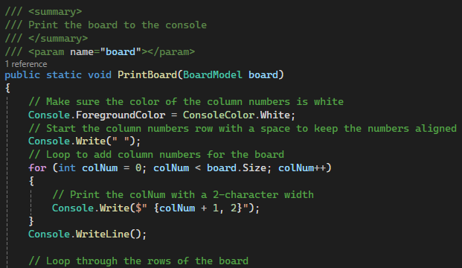
Figure 46: Printing the column numbers for the board
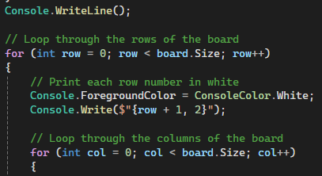
Figure 47: Printing the row numbers for the board

- Take a screenshot of the application running at this point.
- Paste the image into a Microsoft Word document.
- Put a caption below the image explaining what is being demonstrated.

- Commit all changes in the project to source control.
- Commit Message: Add a Utility class with a PrintBoard method to display the board to the user.
- Next, create an internal FloodFill method in the Utility class with parameters for a BoardModel object and a row and col for the location of the cell. The method will return a BoardModel object. Make sure to add a summary comment and an end of method comment as shown in Figure 48.
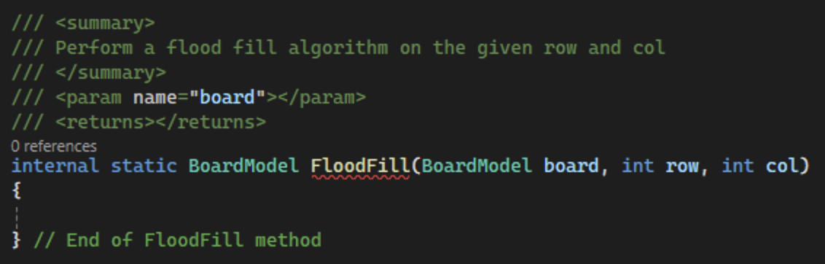
Figure 48: Setting up the FloodFill method

- To perform the flood fill algorithm, we begin by checking if the location of the current cell is on the board. Then, we check if the cell is a wall (W) or already filled (F). If so, the method is ended by returning the board. If not, the contents of the cell are set to "F" and the FloodFill method is called on the four cells directly north, east, south, and west of the cell, creating the recursion aspect, as shown in Figure 49. Then, return the updated board.
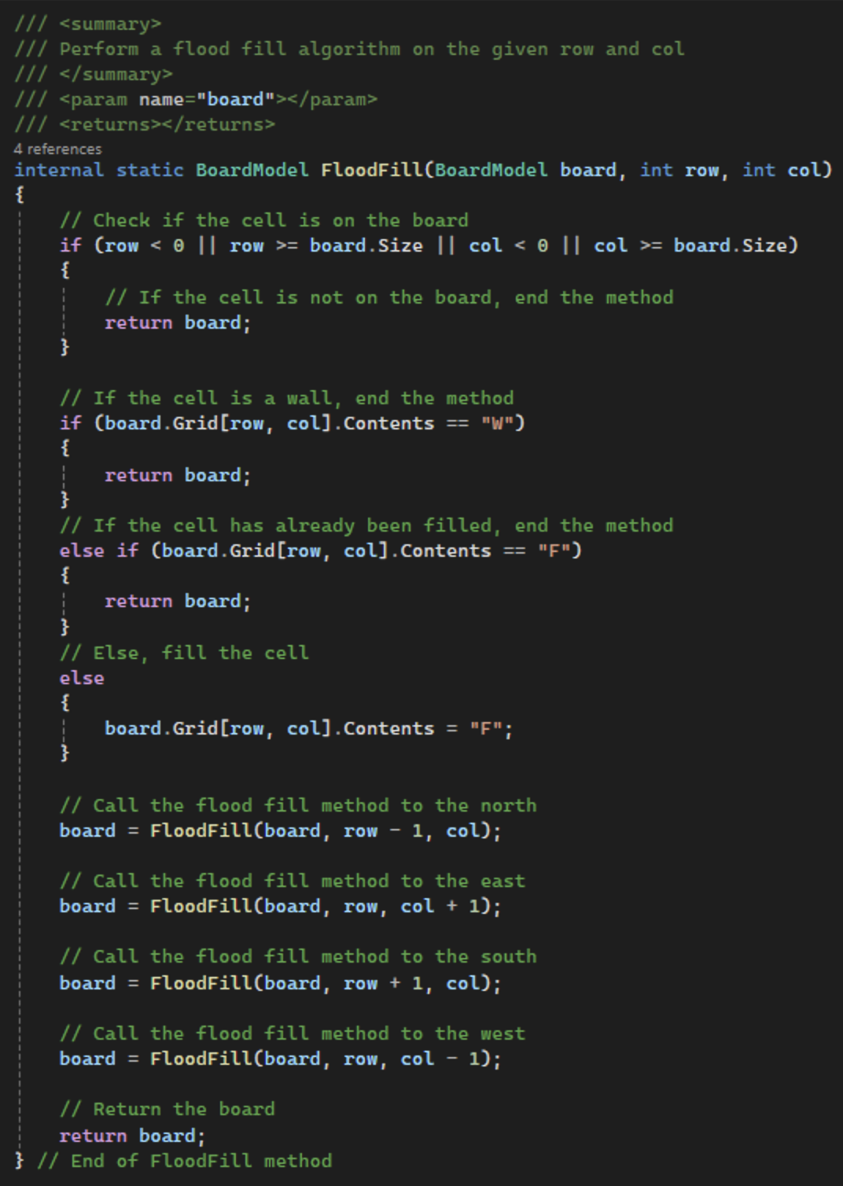
Figure 49: FloodFill algorithm

- Back in the main method, use the Utility class to call the FloodFill method. Then print the board out to the console as shown in Figure 50. The console should look like Figure 51 when the program is run.
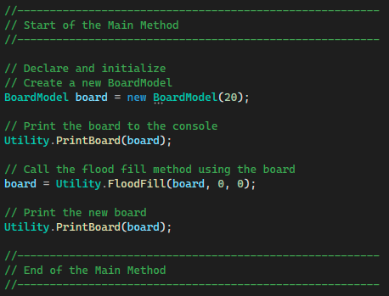
Figure 50: Calling the FloodFill method in the main method
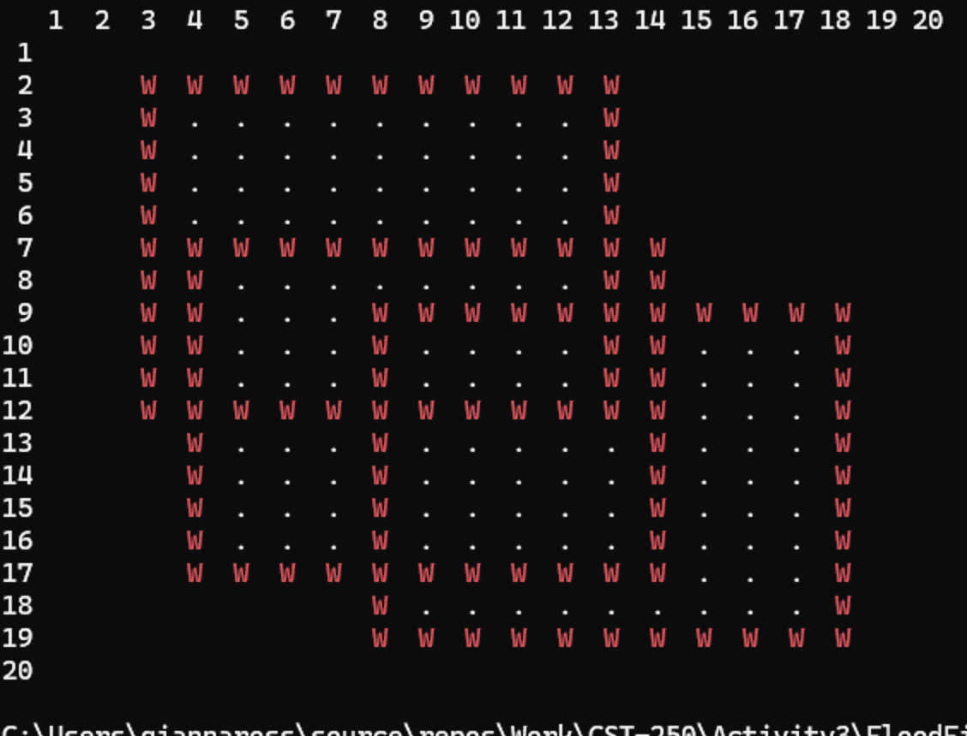
Figure 51: Initial FloodFill results

- As we can see based on the console, the filled cells are falling into the else block of our PrintBoard method. To fix this, we can add another "else if" block to check for filled cells (F). We can use a different color and symbol to make it easy to see which cells have been filled as shown in Figure 52.
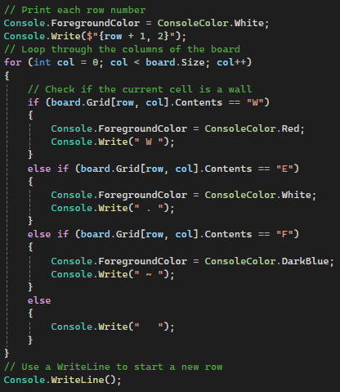
Figure 52: Updating the PrintBoard method to show filled cells

- Take a screenshot of the application running at this point.
- Paste the image into a Microsoft Word document.
- Put a caption below the image explaining what is being demonstrated.

- Next, we will update the FloodFill method to print logs of the moves the recursive algorithm takes. Additionally, we can use the Thread.Sleep method to pause the method for a specified number of milliseconds. This can be used so the user can track the flood fill algorithm as it is happening. First, define the number of milliseconds to sleep at the top of the FloodFill method. Then, write the current row and column to the console in white and have the program sleep for the specified number of milliseconds as shown in Figure 53.
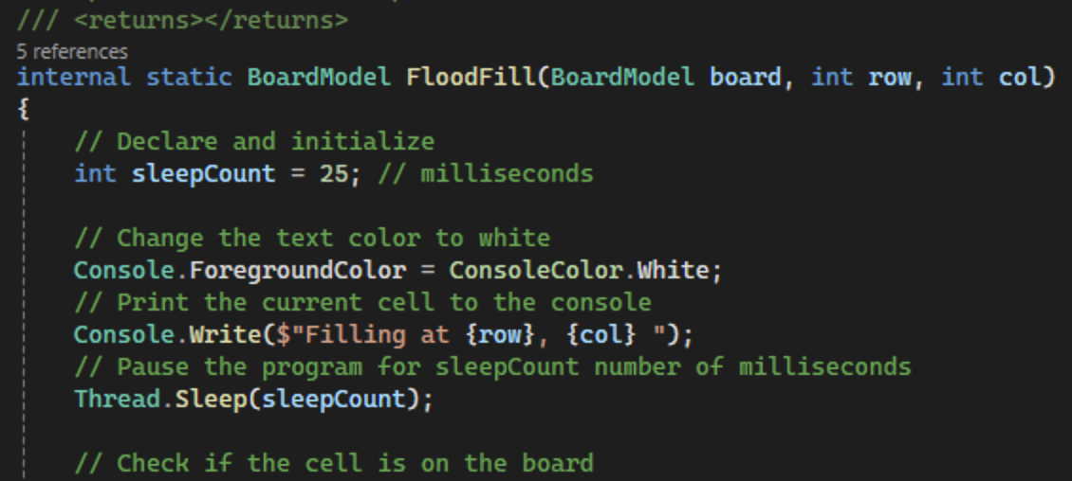
Figure 53: Printing the current cell to the console

- Print messages and sleep before returning the board if the cell is out of bounds, a wall, or already filled as shown in Figure 54. After marking a cell as filled, have the program pause so the user can track the change.
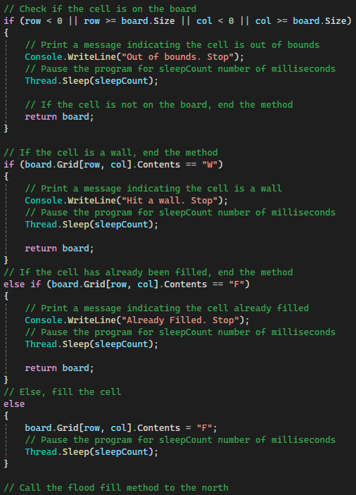
Figure 54: Adding logging for out of bounds, walls, and already filled cells

- Lastly, print the board and add console logs for the four recursive calls as shown in Figure 55. By changing the color of the logs, they become more readable. We can also add code to clear the console. This will improve the visual effects of the flood fill but remove the history of the program.
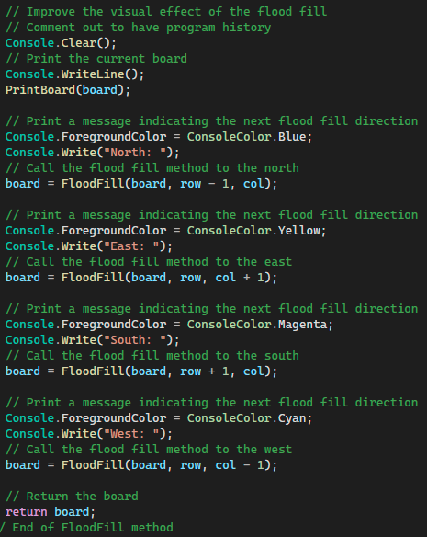
Figure 55: Logs for recursive calls

- Commit all changes in the project to source control.
- Commit Message: Add a FloodFill method to perform the flood fill algorithm on a board.

- Add a new internal method to the Utility class to read an integer input from the user. The method will return an integer and use an int.TryParse to parse the user's input as shown in Figure 56.
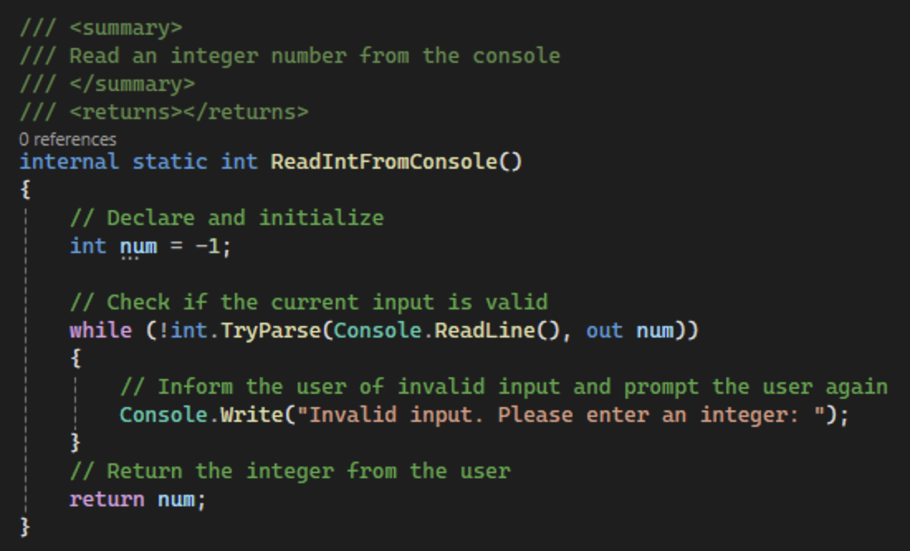
Figure 56: ReadIntFromConsole method in Utility class

- Lastly, update the main method to prompt the user for the row and column the user would like to start the flood fill from, using the ReadIntFromConsole method after the initialize board print as shown in Figure 57.
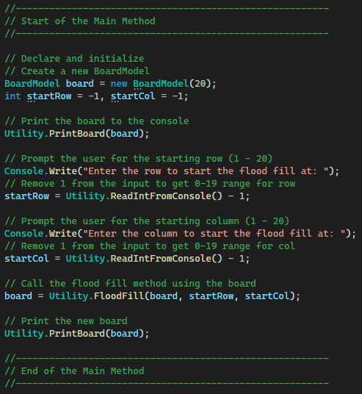
Figure 57: Main method with user input for start point of flood fill

- Commit all changes in the project to source control.
- Commit Message: Finish program with user input.

- Take a screenshot of the application running at this point.
- Take a screenshot of the citations for CellModel, BoardModel, and Program.cs. Make sure to include the class declarations in the images.
- Take a screenshot of the PrintBoard, FloodFill, ReadIntFromConsole, and main methods.
- Take a screenshot of the BoardModel and CellModel constructors and the PlaceShapes method in BoardModel.
- Take a screenshot of the UMLs for the CellModel, BoardModel, and Utility classes.
- Paste the images into a Word document.
- Put a caption below each image explaining what is being demonstrated.

Flood Fill Challenges
Modify the program to enhance your understanding of the flood fill algorithm.
- Use different ordering of the recursion
Start the flood fill process with a different direction other than north. Compare the results with the starting four directions given in the code.
- Modify the shapes
Change the setup to use something besides three squares. Try triangles, random points, or other "wall" patterns.
- Eight-Way Flood Fill
Implement an eight-way recursion. Add NW, NE, SW and SE directions. Demonstrate that the fill can jump.
- Optional – Change the print method
Customize the appearance of colors, characters, and type styles.

- Commit the challenges to source control with a commit message.

- Take a screenshot of the application running after the new features have been added.
- Take a screenshot of each method added or updated to implement the features.
- Take a screenshot of the updated UMLs for any classes with added methods.
- Paste the images into a Word document.
- Put a caption below each image explaining what is being demonstrated.

What You Learned
In Activity 3, you have looked at a variety of examples of recursion, a programming technique where a function calls itself to solve problems iteratively. Here are the key learnings and skills you have developed throughout this lesson:
- Understanding of Recursion: You have gained a solid understanding of how recursive functions work, including the importance of base cases to prevent infinite recursion and recursive cases that drive the function towards this base case.
- Application of Recursion to Solve Problems: You have applied recursion to solve a variety of problems, from simple mathematical tasks like counting and factorial calculations to more complex algorithms such as finding the greatest common divisor and implementing the flood fill algorithm. These examples have shown you the power and efficiency of recursion in breaking down complex tasks into simpler, manageable steps.
- Real-World Applications of Recursion: Through discussing real-world applications, you have seen how recursion is embedded in many everyday technologies, from file searching on computer systems and undo functionalities in applications, to web crawling and parsing nested structures.
- Algorithmic Thinking: You have enhanced your ability to think algorithmically, particularly in how you approach problem-solving with recursive methods. This includes setting up conditions that effectively manage the recursive process and ensure that it terminates properly.
- Practical Coding Skills: You have sharpened your C# programming skills by implementing several recursive functions. This hands-on experience has helped you understand the syntactical and logical aspects of recursion in coding.
- Debugging Recursive Functions: By testing and modifying recursive functions, you have learned how to debug and optimize them. This includes understanding how changes in the recursive logic affect the function's behavior and output.
- Visualization of Recursion: Through examples like the flood fill algorithm, you have learned to visualize how recursion spreads and processes data, which is crucial in understanding its impact and behavior in larger systems.

Check for Understanding
These quiz questions will help you review important concepts from the lesson. These are not graded. You do not have to submit your score.
- What is recursion in computer programming?
  - A function that calls another function
  - A function that calls itself to solve a problem
  - A loop that repeats until a condition is met
  - A syntax error in the code
- Which case must every recursive function have to avoid infinite recursion?
  - Recursive case
  - Iterative case
  - Base case
  - Default case
- What does the factorial function compute?
  - The sum of all numbers up to a given number
  - The product of a number and every number below it down to one
  - The difference between the highest and lowest number
  - The average of all numbers in a sequence
- In the context of the lesson, what would be an example of a recursive function in real-world applications?
  - Calculating interest rates
  - Incrementing a counter in a loop
  - Sending emails to a list of contacts
  - Searching folders on a disk drive

- How is the flood fill algorithm typically used in computer graphics?
  - To clear a region of all colors
  - To convert images from one format to another
  - To fill a connected region with a specific color
  - To reduce the size of images without losing clarity
- In a recursive function that counts down from a given number to 1, what would likely be the base case?
  - When the number reaches 1
  - When the number reaches 10
  - When the number reaches 0
  - When the number reaches 100
- Why might a recursive flood fill function include a check for if a cell is "out of bounds" or "already visited"?
  - To modify the color of all cells
  - To ensure it does not process cells outside the grid or repeat processing the same cell, avoiding infinite loops
  - To increase the function's runtime efficiency
  - To comply with user interface guidelines

Answer Key:
- What is recursion in computer programming?
  - A function that calls itself to solve a problem
- Which case must every recursive function have to avoid infinite recursion?
  - Base case
- What does the factorial function compute?
- The product of a number and every number below it down to one
- In the context of the lesson, what would be an example of a recursive function in real-world applications?
  - Searching folders on a disk drive
- How is the flood fill algorithm typically used in computer graphics?
- To fill a connected region with a specific color
- In a recursive function that counts down from a given number to 1, what would likely be the base case?
  - When the number reaches 1
- Why might a recursive flood fill function include a check for if a cell is "out of bounds" or "already visited"?
- To ensure it does not process cells outside the grid or repeat processing the same cell, avoiding infinite loops

Deliverables
You must submit two separate files:
- One PDF containing Parts 1–3.
- Four zip files containing the complete codebases for Part 4.
Part 1: Activity Submission
- Cover Page
  - Use APA formatting for the cover page.
- GitHub Repository Link
  - At the top of the second page, provide a link to your private GitHub repository.
  - Be sure to add your instructor and grading assistant (if applicable) as collaborators.
- Updated Flowcharts
  - Include the latest flowchart reflecting each current application design including:
    - Count To One
    - Factorial
    - Greatest Common Divisor
    - Flood Fill
- Updated UML Diagram(s)
  - Provide UML diagrams that reflect the current implementation for each app including:
    - Count To One
    - Factorial
    - Greatest Common Divisor
    - Flood Fill
- Base Application Screenshots
  - Include screenshots as required in the activity instructions.
  - Each screenshot must have a clear caption directly below the image explaining what is being demonstrated.
  - All code must be properly commented.

- Section Headers
  - Use clear headers as outlined in these deliverables to identify each part of the assignment within the PDF.
- Citations
  - Include a citation at the top of each page containing code, flowcharts, or UML diagrams.
- File Naming
  - Name the PDF according to the activity title and include your full name.
- Coding Standards Compliance
  - Ensure GCU College of Engineering and Technology Coding Guidelines and Best Practices, found in the Class Resources, have been followed to ensure consistency, readability, and professionalism in student code.
Part 2: Activity Challenges
- Challenge Screenshots
  - Include screenshots that demonstrate completion of the challenge requirements as described in the activity guide for each section:
    - Count To One
    - Greatest Common Divisor
    - Flood Fill
Part 3: Planning for Topic 4 Activity 4
- Flowchart for Topic 4 Activity 4
  - Use the requirements as outlined in Topic 4 Activity 4 to create a high-level flowchart. Showcase the logic and data flow that can be used as a template for the software design.
- UML Diagram(s) for Topic 4 Activity 4
  - Provide UML diagram(s) based on the same requirements.
Part 4: Code Submission (Separate Zip File)
- Zip Your Project Folders
  - Compress the full folder containing all source code and necessary files into zip files for the following apps:
    - Count To One
    - Factorial
    - Greatest Common Divisor
    - Flood Fill
- Executable Submission
  - Ensure the applications run correctly. The zip files will be unzipped and tested during grading, so include all dependencies.
- File Naming
  - Name the zip file according to the activity and include your full name.
  - Name the zip file according to the activity and include your full name.
Submission Reminder
Do not submit a single zip file that contains both the PDF and the code. Each file must be uploaded separately.

