Chad Galloway
CST-250 Programming in C# II
Grand Canyon University
Nov. 16, 2025
Milestone 4

Files
https://github.com/CGalloway3/CST-250-Projects/tree/master/Milestone4
Video Part 1
https://www.loom.com/share/320fe85e85534d029625da4563f3b1a9
Video Part 2
https://www.loom.com/share/f833a8f1d59d408597bfc65ae60550a8

FLOWCHART

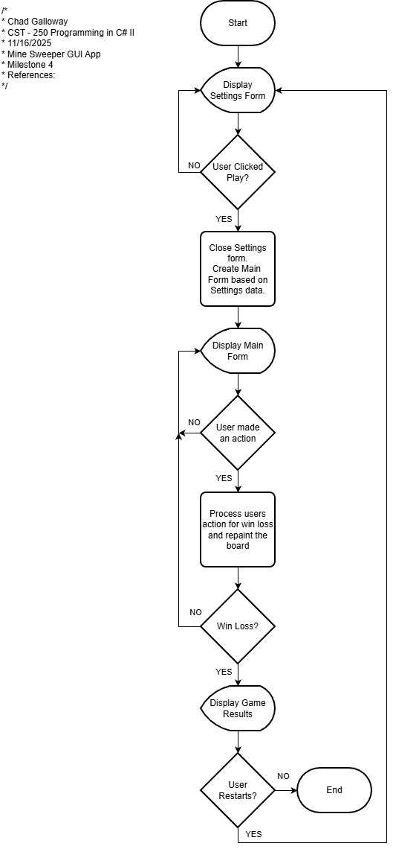
Figure 1: Flowchart of Logic in Milestone 4 Mine Sweeper GUI App

UML Class Diagram

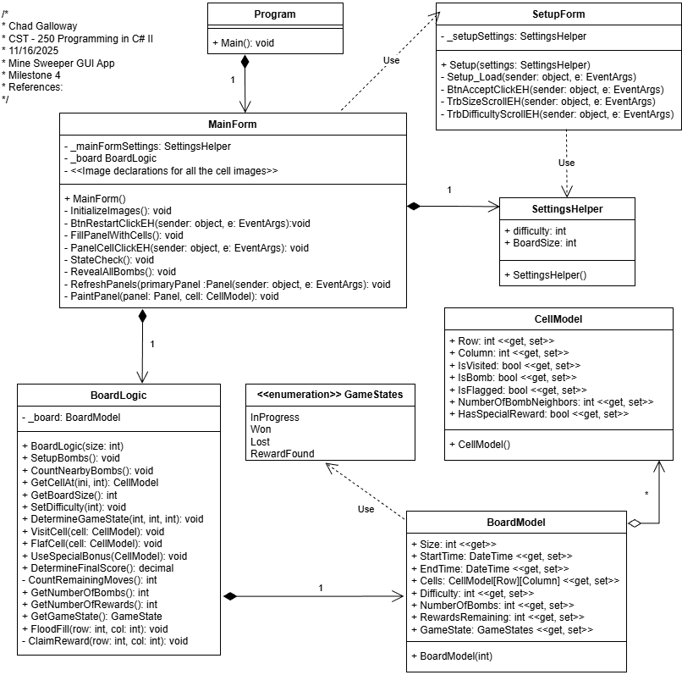
Figure 2: UML Class Diagram for Milestone 4 Mine Sweeper GUI App

Screen Shots

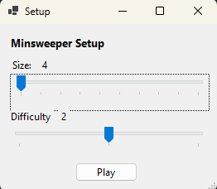
Figure 3: Screenshot of the setup window that loads when the App starts.

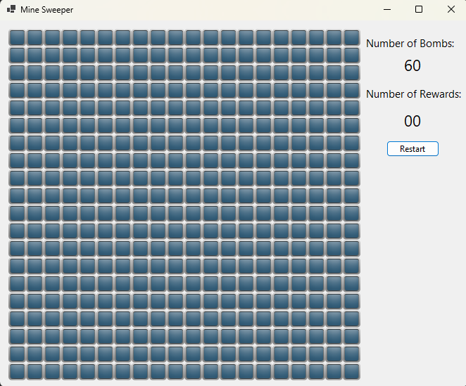
Figure 4: Screenshot of main form with size 20 and difficulty 2

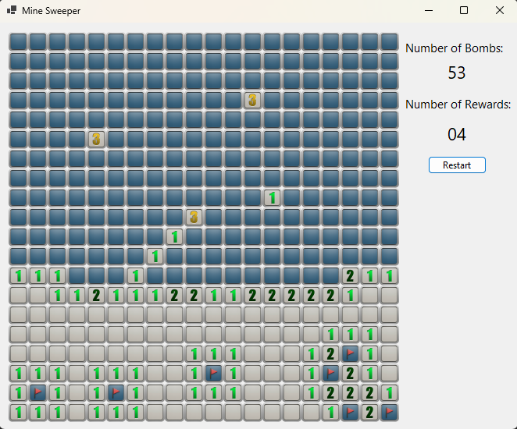
Figure 5: Screenshot of an example of the flood fill in action. The user reveals a cell by left clicking.

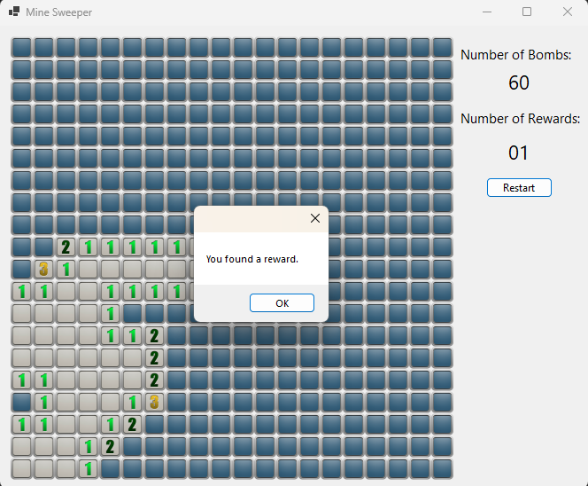
Figure 6: Screenshot of the notification the user receives when they find a reward.

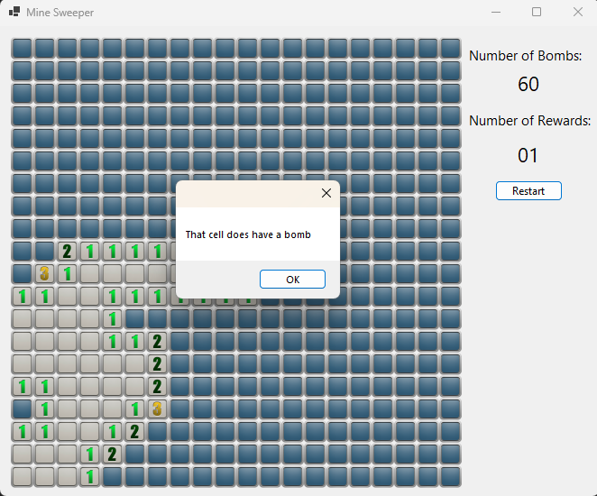
Figure 7: Screenshot of the notification the user receives when a reward is used. The user can use a reward by middle mouse button clicks ( or any other button besides left or right, the use reward functionality is a fall through of all remaining click args that are not left or right.)

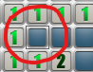
Figure 8: Screenshot of a highlight placed on cells that have had rewards used on them. In my testing I found it very difficult to know the exact cell you clicked to use a reward. After acknowledging the MessageBox with the result of the rewards usage it was often difficult to know where you had used the reward. I added this highlight feature in so it was easier to know where you used the reward. Any subsequent clicks on that cell removes the highlight.

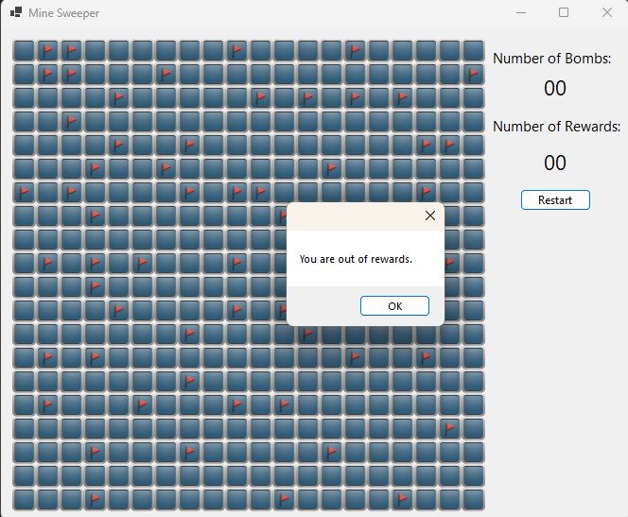
Figure 9: Screenshot of catching the cases where a user has no rewards but still attempts to use one.

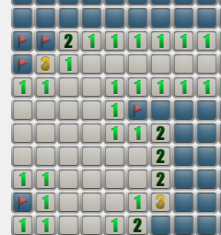
Figure 10: Screenshot of close up of the cells with bomb flags marked on them. The user can place and remove bombs by right clicking. The user is not allowed to place more flags than there are bombs and they cannot place a flag in an already revealed cell. These two cases are displayed in the next two Figures 11 and 12.

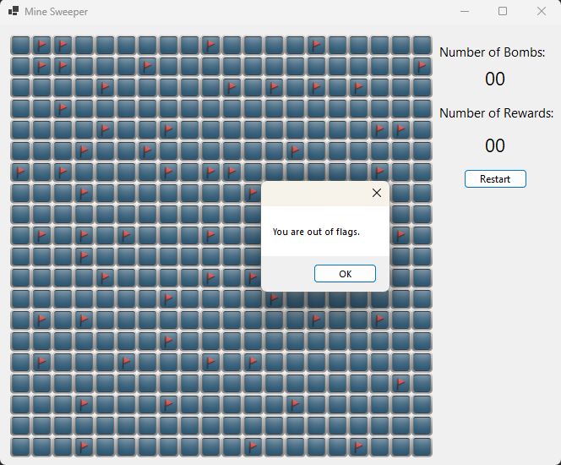
Figure 11: Screenshot of message the user gets if they have no remaining flags to use.

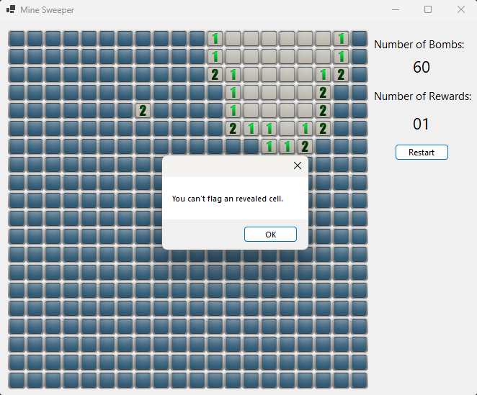
Figure 12: Screenshot of message displayed to the user when they try to flag an already revealed cell.

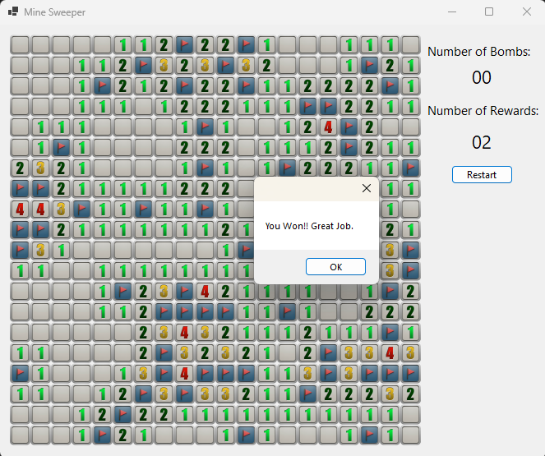
Figure 13: Screenshot of a Win condition

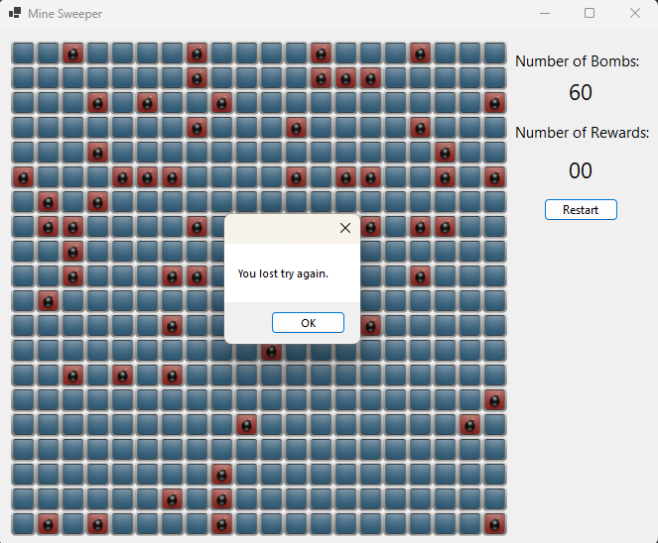
Figure 14: Screenshot of a loss condition.
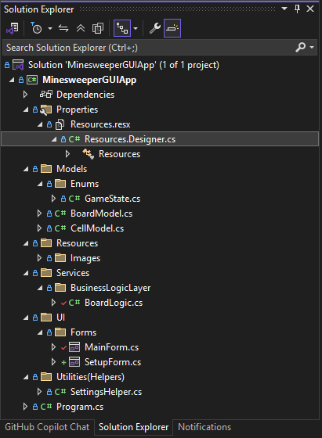
Figure 15: Screenshot of the Solution Explorer layout for the project.

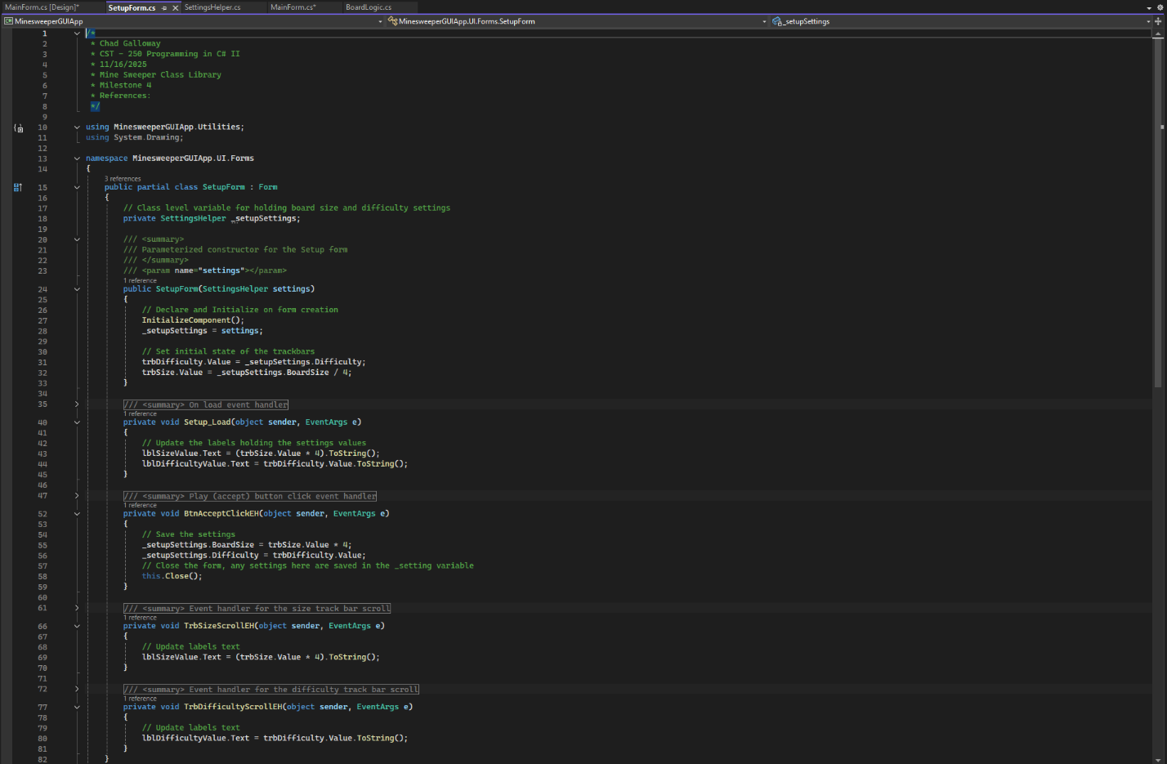
Figure 16: Screenshot of the code for the setup form.

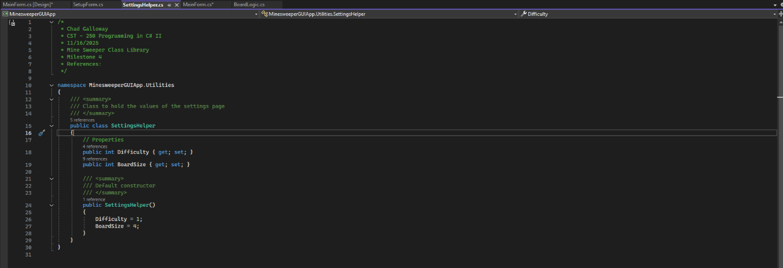
Figure 17: Screenshot of the code for the settings helper class. This class makes it easy to pass data between the two forms.

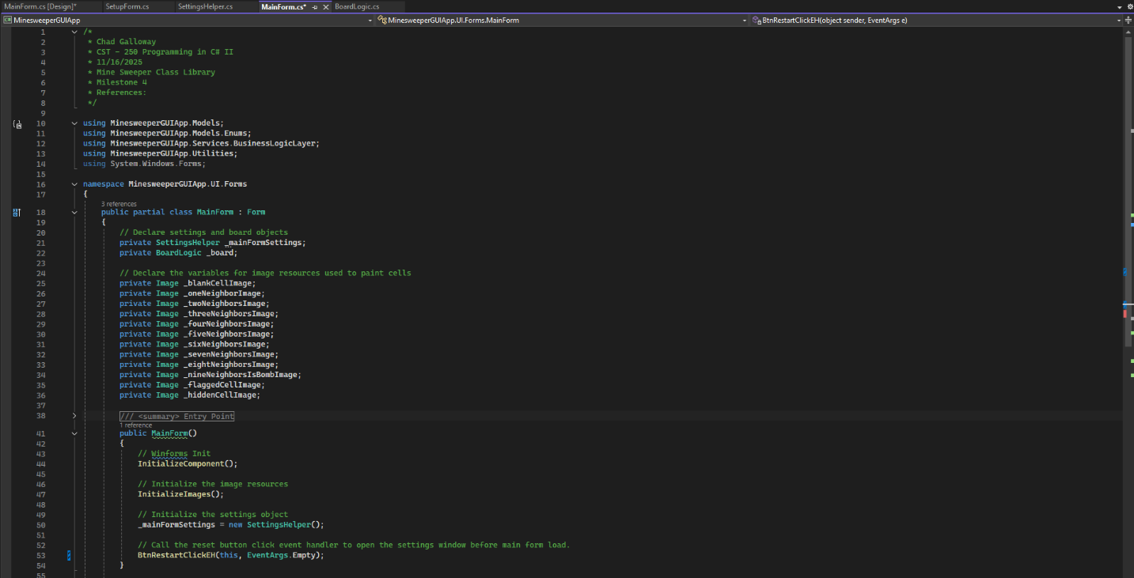
Figure 18: Screenshot of the citations and constructor for the main form.

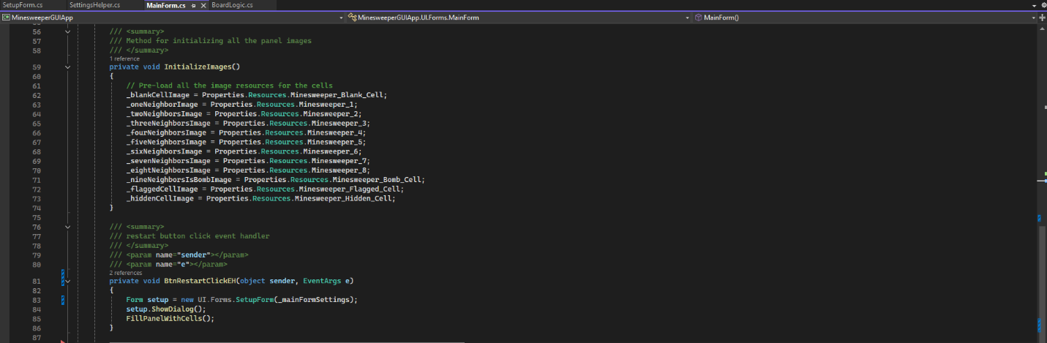
Figure 19: Screenshot of the Initialize images and restart button click event handler.

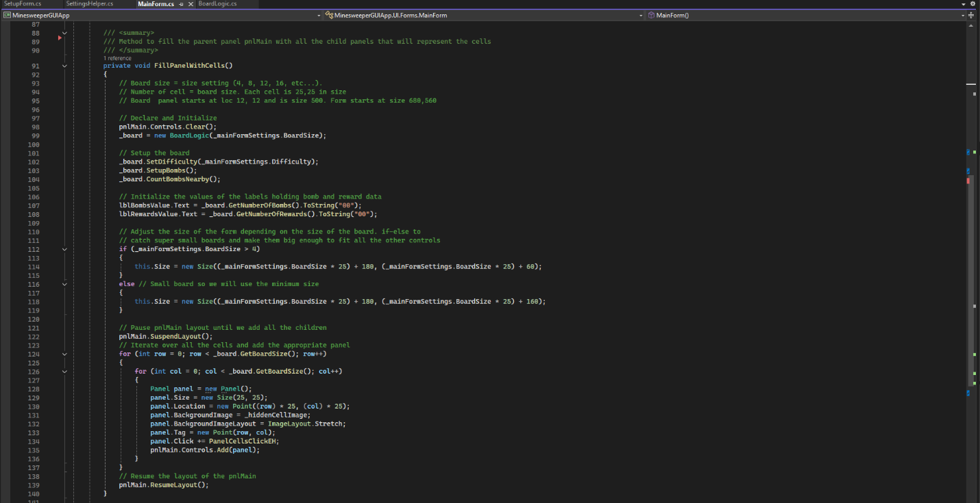
Figure 20: Screenshot of the fill panel with cells method. This method is called once per game and sets the main forms size, fills the main panel with all the child panels, and does all the other heavy lifting required to start a new game.

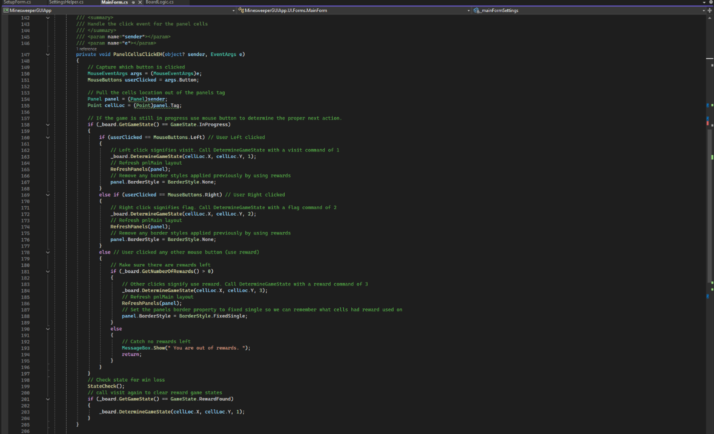
Figure 21: Screenshot of the panel cell click event handler. This event handler uses the button information passed in from EventArgs to determine the action to preform based on which button the user clicked. It calls the boards determine state method, refresh panels, and state check before finishing.

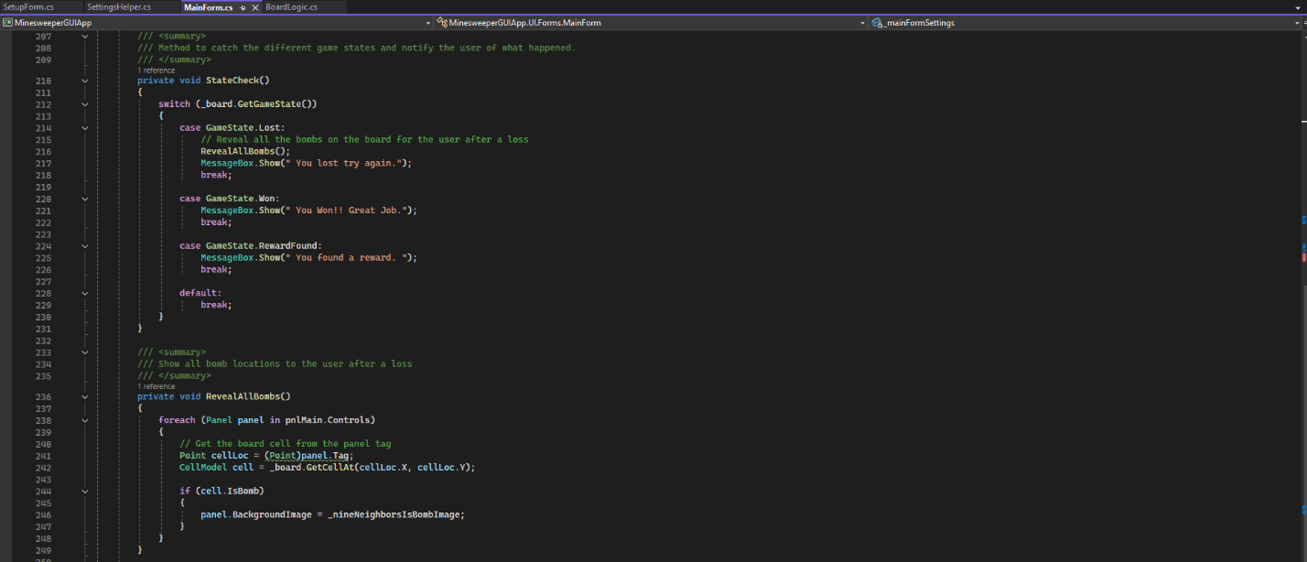
Figure 22: Screenshot of the state check and reveal all bombs methods. State check catches win, loss, and reward events to display the result to the user. Reveal all bombs is called if the user loses to show the location of all the bombs.
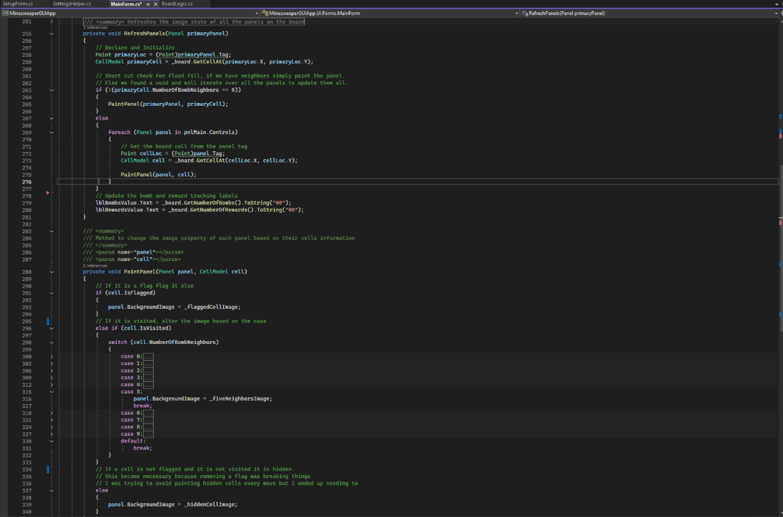
Figure 23: Screenshot of the Refresh panel and paint panel methods. Paint is called by refresh. The two methods were originally one method but I separated them to cut down on the size of refresh and make it more readable.

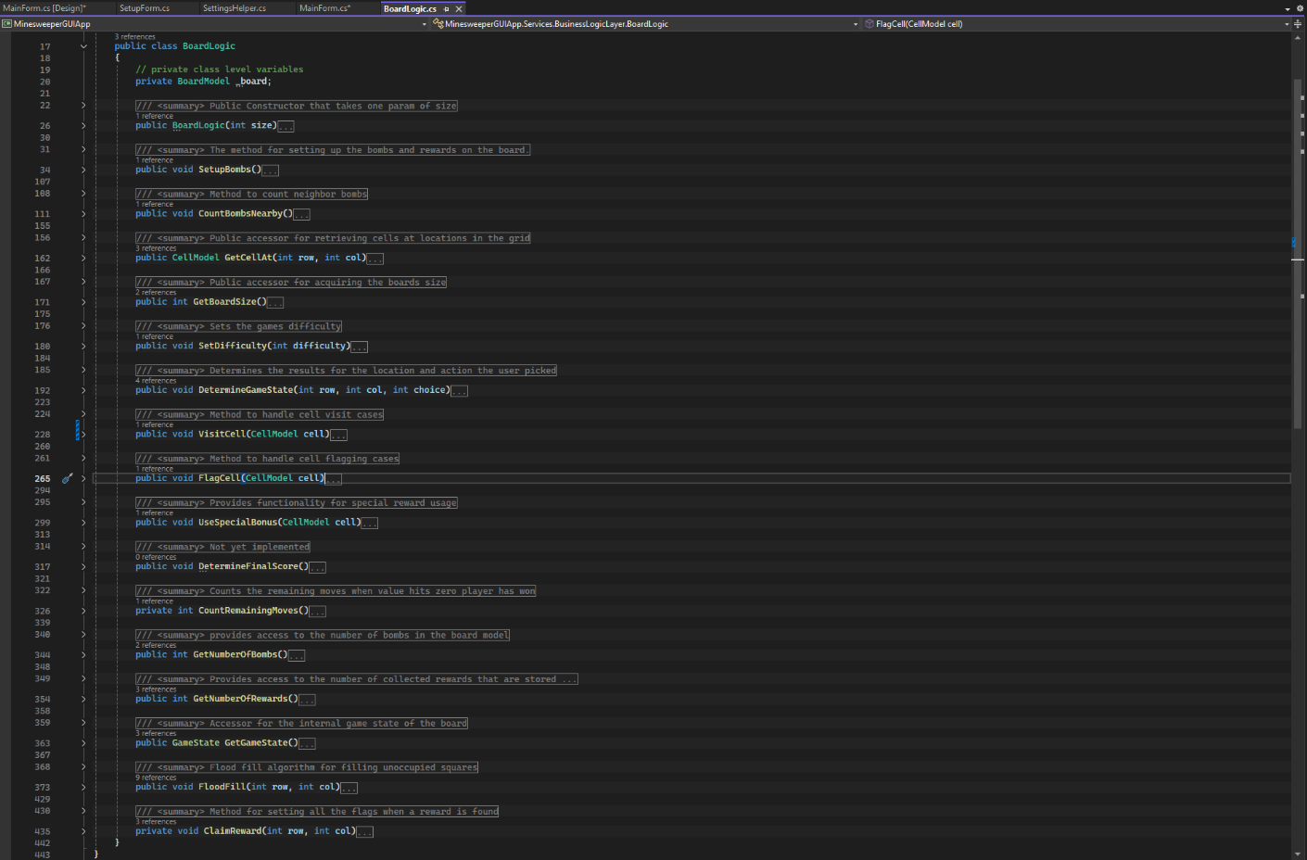
Figure 24: Screenshot of the board logic class. It is largely unchanged from previous versions. Changes are shown below in Figure 25.

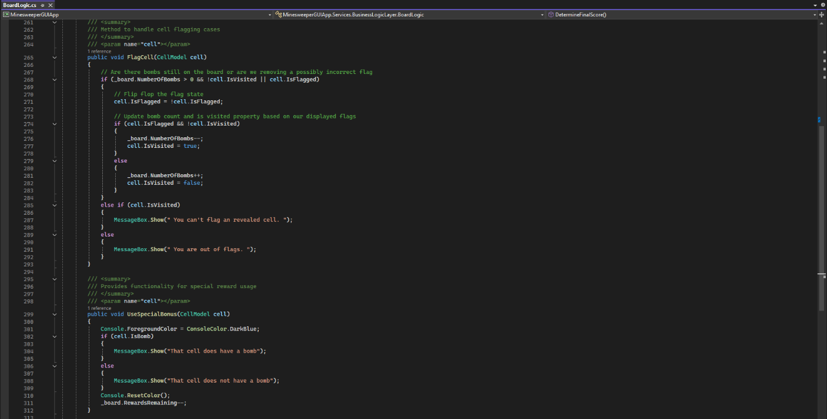
Figure 25: Screenshot of the flag cell and use special bonus methods from the board logic. Both of these classes previously used console write line to output information to the user. I now have them using message box show. I don’t like using ui elements like message box here in the business layer but I unsure of a proper way to implement it. I considered more game state flags in that enumeration but I don’t like that idea. I have run into things like this in the past and I have always struggled with figuring out a proper and elegant way to solve it. I am open to ideas but not sure on the best way.

The key concepts demonstrated in this week’s milestone are multi-form navigation, event-driven programming, and separation of concerns. This week we transitioned from a console application to an event driven windows forms application with a GUI. We demonstrated how an application written with proper separation of concerns can use the same back-end element (BoardLogic) to drive completely different looking front ends. We demonstrated how to use multiple forms to pass information in one form to another. The milestone showcased event-driven programming through button click handlers and dynamic UI updates, where the game board state is continuously reflected in the visual interface via a programmed refresh method.

