**Industrial Internship Report on**

**Crop and Weed Detection**

**Prepared by**

**Ganesh Kumar C**

|  |
| --- |
| *Executive Summary* |
| This report provides details of the Industrial Internship provided by Upskill Campus and The IoT Academy in collaboration with Industrial Partner UniConverge Technologies Pvt Ltd (UCT).  This internship was focused on a project/problem statement provided by UCT. We had to finish the project including the report in 6 weeks’ time.  My project was Crop and Weed Detection. This project addresses the critical need for accurate and efficient classification of crops and weeds in agricultural imagery. In recent years, Deep Learning (DL) has emerged as a powerful tool in the field of object identification and detection. By leveraging advanced DL techniques, specifically YOLO (You Only Look Once) object detection model, the project aims to revolutionize agricultural practices by enabling automated and precise crop management.  This internship gave me a very good opportunity to get exposure to Industrial problems and design and implement solutions for that. It was an overall great experience to have this internship. |

**TABLE OF CONTENTS**

1 Preface 3

2 Introduction 4

2.1 About UniConverge Technologies Pvt Ltd 4

2.2 About Upskill Campus 8

2.3 Objective 9

2.4 Reference 9

2.5 Glossary 10

3 Problem Statement 11

4 Existing and Proposed solution 12

5 Proposed Design/ Model 13

5.1 High Level Diagram (if applicable) 13

5.2 Low Level Diagram (if applicable) 13

5.3 Interfaces (if applicable) 13

6 Performance Test 14

6.1 Test Plan/ Test Cases 14

6.2 Test Procedure 14

6.3 Performance Outcome 14

7 My learnings 15

8 Future work scope 16

# Preface

The Data science and machine learning internship duration was 6 weeks. The first week of the internship was to explore the problem statements which were provided by the management and understand their background to start with the project. Also learned about UCT. The second week of the internship was to understand and follow the project instructions provided by UCT. And, also to plan for the solution of the existing problem. The third week of internship is to start for the actual working of the project. The fourth week of the internship was to continue with the work on the project and check whether there are improvements required for the project. The fifth week of the internship was to validate your implementation and evaluate your performance. And the final week of the project is to submit your project report and get certification.

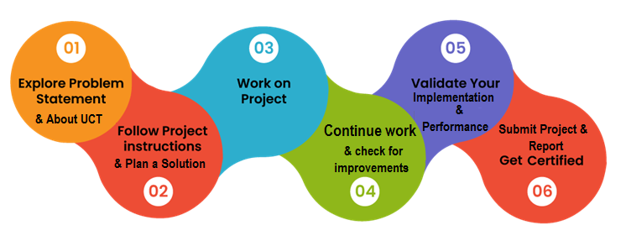

Internships are an opportunity to network with great people and sharpen your skills before entering the workforce. They also help tremendously with figuring out your true passion. Companies often look at them to gain experience and exposure to make a smooth transition into your role when hired.

**Problem Statement**

In the agricultural sector, accurately identifying and distinguishing between crops and weeds is essential for optimizing yield and resource optimization. Traditional methods often involve time-consuming manual inspection, leading to inefficiencies and potentially inaccurate decisions. The project’s goal is to develop an object detection model that can accurately identify and differentiate between crop and weed instances within images, providing farmers and agricultural professionals with valuable insights for informed decision making.

**Note of Thanks**

Thank you UCT and Upskill Campus for the opportunity and great experience. I would also like to thank one of my peer batch members Bhargav for guiding me by providing some insights.

**Message to Juniors and Peers**

Dear Juniors and Peers,

I want to take a moment to share some thoughts and insights that I've gathered from my experiences in the field of AI and technology. As we navigate our journeys through learning, innovation, and collaboration, I believe these reflections might be valuable:

Embrace Curiosity: Curiosity is the engine of progress. Always be eager to learn, explore, and ask questions. The more you inquire, the more you discover, and the more you grow.

Fear Not Failure: Failure is not the end, but a steppingstone towards success. Don't be afraid to try new things, experiment, and make mistakes. Each setback brings you closer to mastery.

Collaboration Amplifies Impact: Great ideas often emerge through collaboration. Engage with peers, mentors, and experts. Collaborative efforts lead to creative solutions and growth.

Build Strong Foundations: A solid understanding of fundamentals is crucial. Master the basics before diving into advanced topics. Strong foundations make complex concepts easier to grasp.

Share Knowledge: Sharing knowledge not only benefits others but reinforces your own understanding. Teaching is a powerful way to solidify your expertise.

Remember, every step you take is a contribution to your growth and the advancement of technology. As we move forward in this exciting field, let's support each other, embrace innovation, and work together to shape a brighter future.

# Introduction

## About UniConverge Technologies Pvt Ltd

A company established in 2013 and working in Digital Transformation domain and providing Industrial solutions with prime focus on sustainability and RoI.

For developing its products and solutions it is leveraging various**Cutting Edge Technologies e.g. Internet of Things (IoT), Cyber Security, Cloud computing (AWS, Azure), Machine Learning, Communication Technologies (4G/5G/LoRaWAN), Java Full Stack, Python, Front end**etc.

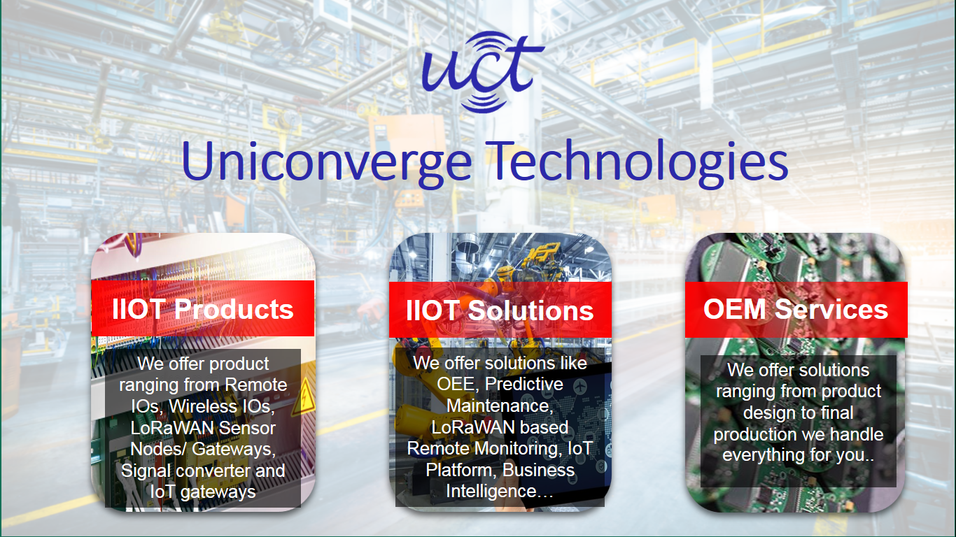

1. UCT IoT Platform **(****)**

**UCT Insight** is an IOT platform designed for quick deployment of IOT applications at the same time providing valuable insights for your process/business. It has been built in Java for backend and ReactJS for Front end. It has support for MySQL and various NoSQL Databases.

* It enables device connectivity via industry standard IoT protocols - MQTT, CoAP, HTTP, Modbus TCP, OPC UA
* It supports both cloud and on-premises deployments.

It has features to  
• Build Your own dashboard  
• Analytics and Reporting  
• Alert and Notification  
• Integration with third party application (Power BI, SAP, ERP)  
• Rule Engine

 

1. **Smart Factory Platform (****)**

Factory watch is a platform for smart factory needs.

It provides Users/ Factory

* with a scalable solution for their Production and asset monitoring
* OEE and predictive maintenance solution scaling up to digital twin for your assets.
* to unleased the true potential of the data that their machines are generating and helps to identify the KPIs and also improve them.
* A modular architecture that allows users to choose the service that they what to start and then can scale to more complex solutions as per their demands.

Its unique SaaS model helps users to save time, cost and money.

 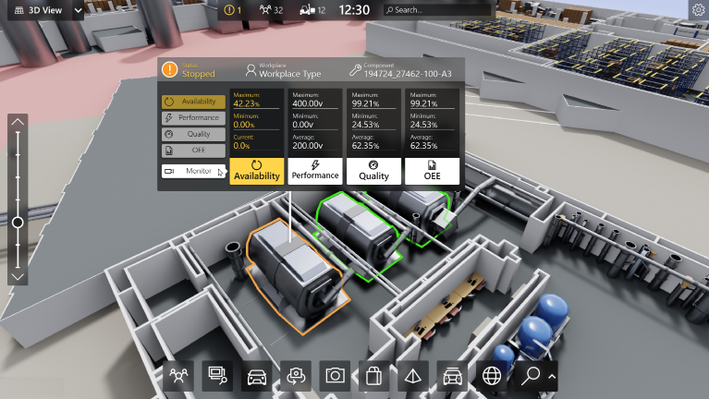

1. 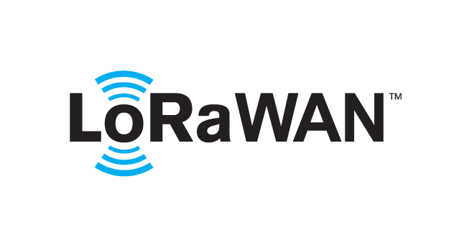 based Solution

UCT is one of the early adopters of LoRAWAN teschnology and provides solutions in Agritech, Smart cities, Industrial Monitoring, Smart Street Light, Smart Water/ Gas/ Electricity metering solutions etc.

1. Predictive Maintenance

UCT provides Industrial Machine health monitoring and Predictive maintenance solution leveraging Embedded system, Industrial IoT and Machine Learning Technologies by finding Remaining useful life time of various Machines used in production process.



## About upskill Campus (USC)

Upskill Campus along with The IoT Academy and in association with Uniconverge technologies has facilitated the smooth execution of the complete internship process.

USC is a career development platform that delivers **personalized executive coaching** in a more affordable, scalable and measurable way.



Seeing need of upskilling in self-paced manner along-with additional support services e.g. Internship, projects, interaction with Industry experts, Career growth Services

<https://www.upskillcampus.com/>

upSkill Campus aiming to upskill 1 million learners in next 5 year

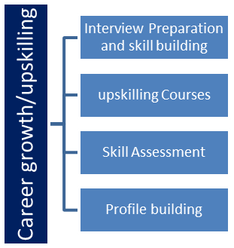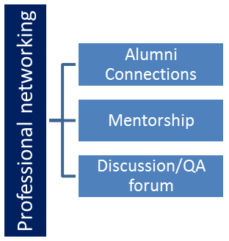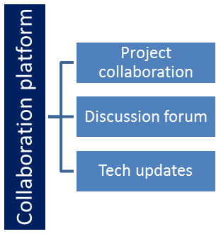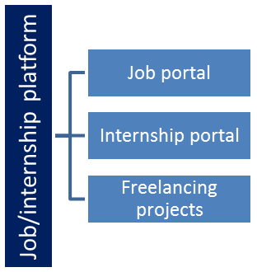

## The IoT Academy

The IoT academy is EdTech Division of UCT that is running long executive certification programs in collaboration with EICT Academy, IITK, IITR and IITG in multiple domains.

## Objectives of this Internship program

The objective for this internship program was to

 ☛ get practical experience of working in the industry.

 ☛ to solve real world problems.

 ☛ to have improved job prospects.

 ☛ to have Improved understanding of our field and its applications.

 ☛ to have Personal growth like better communication and problem solving.

## Reference

[1] Dataset: <https://drive.google.com/file/d/1MNdDKYB0x0PEW7P71bE1Jx_uLllvORA0/view/>

[2] Learning: <https://learn.upskillcampus.com/s/courses/6441224de4b0f11fbe0f621e/take/>

[3] Model: <https://github.com/ultralytics/yolov5/>

## Glossary

|  |  |
| --- | --- |
| Terms | Acronym |
| AI | Artificial Intelligence |
| YOLO | You Only Look Once |
| DL | Deep Learning |
| ML | Machine Learning |
| DS | Data Science |

# Problem Statement

In the agricultural sector, accurately identifying and distinguishing between crops and weeds is essential for optimizing yield and resource optimization. Traditional methods often involve time-consuming manual inspection, leading to inefficiencies and potentially inaccurate decisions. The project’s goal is to develop an object detection model that can accurately identify and differentiate between crop and weed instances within images, providing farmers and agricultural professionals with valuable insights for informed decision making.

The objective of this project is to develop an accurate and efficient object detection model capable of identifying crops and weeds. The successful completion of this project will result in a robust object detection model. The model’s outputs will help farmers and agricultural professionals make informed decisions regarding resource allocation, pest management, and overall crop health. The project aims to contribute to the advancement of precision agriculture, resource efficiency, and improved yield optimization.

# Existing and Proposed solution

**Existing Solutions** for crop and weed identification in agricultural imagery have predominantly employed machine learning and computer vision techniques. Some of the common approaches include:

Traditional Image Processing: Based on color, texture, and shape parameters, crops and weeds are segmented using traditional image processing methods. However, these techniques might have trouble with changes in lighting, different kinds of crops, and overlapping situations.

Convolutional Neural Networks (CNNs): CNN-based techniques have demonstrated potential for identifying crops and weeds. It has been used to transfer learning from previously trained models like VGG, ResNet, and Inception. These models might not account for the traits of various crops and weeds.

R-CNN, Fast R-CNN, and Faster R-CNN are region-based CNNs. These strategies include steps for proposal creation and object detection. They may not meet real-time needs since they can be computationally expensive despite being accurate.

**Limitations of Existing Solutions**

Manual Feature Engineering: Traditional methods require manual feature extraction, which can be time-consuming and less robust.

Computationally Intensive: Some advanced models are computationally demanding, hindering real-time implementation.

Lack of Scalability: Custom models trained for specific crops might not generalize well to new crops or changing environments.

**Proposed Solution**

The proposed solution involves leveraging the YOLO (You Only Look Once) object detection architecture to accurately identify and differentiate between crop and weed instances in agricultural images. YOLO's real-time processing capability, coupled with its ability to detect multiple objects in a single pass, makes it suitable for on-field applications. By training the YOLO model on labeled images in YOLO format, the model will learn to recognize the distinct visual characteristics of crops and weeds. This will enable the system to automatically detect and classify crops and weeds within the images, achieving expected and timely results.

**Value Addition**

Combined with the integration of Robo-Flow’s automation we can quickly finish the preprocessing of the dataset for the required specifications and customizations. It also offers convenient image annotation system and augmentation etc.,

Efficiency: YOLO's real-time inference speed allows for swift decision-making, aiding prompt intervention and resource allocation.

Real-time Monitoring: The model's fast inference speed enables real-time monitoring of agricultural fields, helping farmers respond to changes quickly.

Enhanced Accuracy: By training the model on the given dataset with suitable augmentation, preprocessing and fine-tuning it, the proposed solution aims to achieve accurate crop and weed identification across varying conditions.

Resource Optimization: Accurate detection and differentiation facilitate targeted resource allocation, reducing waste and environmental impact. With the power of GPU's offered by Google Colab we can speed up the training process.

## Code submission (GitHub link)

<https://github.com/CGaneshKumar2002/Upskill-Campus-UCT-Crop-and-Weed-Detection.git/>

## Report submission (GitHub link)

## <https://github.com/CGaneshKumar2002/Upskill-Campus-UCT-Crop-and-Weed-Detection.git/FinalReport/>

# Proposed Design/ Model

Data Preprocessing using RoboFlow: The dataset was subjected to data preprocessing using RoboFlow. This involved augmentation techniques to increase dataset diversity, resizing images to the appropriate dimensions for the YOLOv5 model, and ensuring data consistency.

Dataset Splitting for Training and Validation: The preprocessed dataset was split into training, testing and validation subsets. A carefully chosen split ratio ensured that the model's performance could be evaluated effectively.

Model Selection and Configuration: The YOLOv5 architecture was chosen as the model of choice due to its real-time object detection capabilities. Model configuration involved selecting hyperparameters, defining anchor box sizes, and determining the number of classes (crop and weed).

Training the YOLOv5 Model: The model was trained on the training subset using the preprocessed images by varying the number of epochs and batches to get more favorable results.

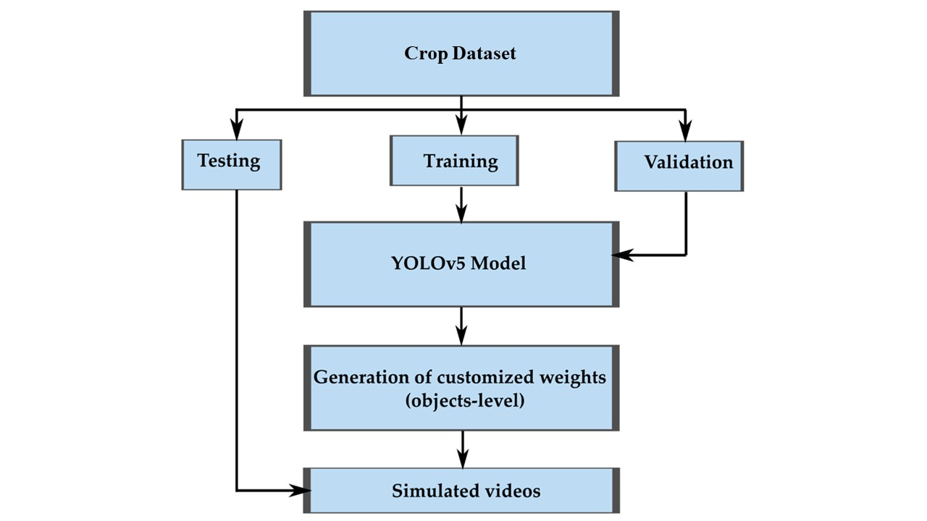Evaluation and Performance Metrics: Trained models were evaluated using the validation subset. Metrics like precision, recall, and mean average precision (mAP) were displayed to gauge the model's accuracy and effectiveness.

YOLOv5, short for "You Only Look Once version 5," is a state-of-the-art object detection model that belongs to the YOLO family of architectures. YOLO models are known for their real-time object detection capabilities, making them suitable for applications requiring fast and accurate detection of objects within images.

Outcome:

The culmination of the project yielded an accurate and efficient YOLOv5-based object detection model. This model, trained on annotated agricultural images, demonstrated the capability to identify and differentiate between crop and weed instances. Its performance was verified through evaluation metrics.

# Performance Test

In the context of crop and weed detection using YOLOv5, conducting performance tests and addressing identified constraints is crucial to showcase the practical applicability of the solution in real industries.

**Constraints Identified**

Real-Time Inference Speed: The solution needs to provide real-time or near-real-time object detection, ensuring prompt decision-making and intervention in agricultural scenarios.

Memory and Computational Resources: The model's memory usage and computational demands should be optimized to ensure efficient processing and deployment, especially on resource-constrained devices.

Prediction Accuracy: The accuracy of the object detection predictions is paramount to ensure reliable identification of crops and weeds.

**Constraint Handling**

Real-Time Inference Speed: Utilized the GPU resources provided by Google Colab to accelerate computations and achieve real-time inference speed.

Memory and Computational Resources: Leveraged the GPU's parallel processing capabilities to enhance computational efficiency, thereby optimizing memory and resource utilization.

Prediction Accuracy: The model was trained on diverse datasets to ensure it can accurately distinguish between crop and weed instances in varying agricultural scenarios.

## Test Plan/ Test Cases

**Objective:** To ensure the accuracy, efficiency, and real-world applicability of the crop and weed detection solution.

**Caution:** It's important to note that the outcomes and considerations outlined below are based on the specific context of this project and the available resources. Variations may occur based on factors such as hardware configurations, dataset diversity, and environmental conditions. While these considerations provide a framework for testing and evaluation, real-world results may differ. Therefore, it's recommended to adapt the testing approach and expectations according to the specific circumstances of deployment and use. The outlined considerations serve as a starting point and should be adjusted based on the dynamic nature of real-world applications.

1. Inference Accuracy Test:

* Upload sample images containing crops and weeds for detection.
* Compare the detected instances with ground truth annotations.
* Calculate precision, recall, and mean average precision (mAP).

2. Real-Time Inference Test:

* Use a diverse set of images with varying object densities.
* Measure inference speed and confirm real-time or near-real-time performance.

3. Resource Utilization Test:

* Monitor GPU utilization during model training and inference.
* Check for efficient memory usage and computational efficiency.

## Test Procedure

1. Procedure for Inference Accuracy:

* Upload diverse images for detection.
* Run the model for inference on each image.
* Compare the detected instances with annotations.
* Calculate precision, recall, and mAP for the entire test set.

2. Procedure for Real-Time Performance:

* Use a predefined set of images with varying object densities.
* Measure the inference time for each image using GPU acceleration.
* Calculate the average inference time across all images.
* Verify if the average inference time meets real-time or near-real-time requirements.

3. Procedure for Resource Utilization:

* Monitor GPU utilization during model training.
* Record memory consumption during different stages of training.
* Measure computation times for forward and backward passes.
* Repeat the monitoring process during inference on a set of test images.

## Performance Outcome

The below listed are some of the performance outcomes that can be achieved during the runtime of the project.

1. Optimal precision, recall, and mAP demonstrate accurate crop and weed detection across diverse scenarios.
2. Consistently meeting real-time inference requirements ensures reliable application in time-sensitive agricultural decisions.
3. GPU utilization enhancements indicate optimized computational efficiency for both training and inference stages.

# My learnings

Throughout the journey of developing a crop and weed detection model using YOLOv5, I have gained valuable insights and skills that have significantly contributed to my personal and career growth.

Deep Learning for Agriculture: This project allowed me to dive deep into deep learning concepts and how deep learning techniques, specifically object detection using the YOLO architecture, can be harnessed to address critical challenges in the agricultural sector. I have gained a compressive understanding of how YOLO works, from anchor boxes to multi-scale training.

Data Preparation: An integral part of the project was data collection, annotation, and preprocessing. I learned how to deal with the dataset and curate as well as format annotations in YOLO format and efficiently preprocess images for training the model.

Model Implementation and Optimization: Developing the YOLOv5 model required in-depth knowledge of neural network architecture, hyperparameter tuning, and optimization techniques.

Evaluation and Metrics: Understanding and applying evaluation metrics like precision and recall and mean average precision (mAP) helped me gauge model accuracy and make informed decisions for improvement.

Real-World Application: Implementing the model for crop and weed detection in agricultural scenarios exposed me to real-world challenges such as varying lighting conditions, occlusion, and other such issues.

**Career Growth Impact**

The knowledge and experience gained from this project have a profound impact on my career growth:

Skill Enhancement: I am now proficient in using YOLOv5 for object detection, a skill highly sought after in industries requiring computer vision solutions.

Problem Solving: Addressing challenges like dataset curation, real-time processing, and model optimization has honed my problem-solving skills and ability to innovate.

Portfolio Enhancement: The completed project adds a practical and impressive item to my portfolio, demonstrating my capabilities to potential employers or collaborators.

Continuous Learning: This project is a steppingstone. It has instilled in me the importance of staying updated with the latest advancements in AI and computer vision to remain relevant and contribute effectively.

# Future work scope

User Interface: Creating a user interface for interacting with the crop and weed detection model is a promising future direction. This interface, although not developed in the current project, could significantly enhance usability and accessibility for users like farmers and agricultural experts. Potential features include image upload for analysis, displaying detection results overlaid on images, interactive visualizations with detailed information on instances, and real-time monitoring of live camera feeds for timely decision-making.

Varieties of Crops and Weed Species: The dataset used for training likely included a representative selection of crops and weeds. However, expanding the dataset to include a wider variety of crop types and weed species would enhance the model's ability to generalize across different agricultural contexts.

Transfer Learning on Crop-Specific Models: To improve accuracy for specific crops, considering transfer learning by fine-tuning the model on datasets specific to each major crop type (e.g., wheat, corn, rice). This could lead to higher precision in identifying crop instances.

Alternative Object Detection Architectures: While YOLOv5 was the primary focus, experimenting with other state-of-the-art object detection architectures, such as EfficientDet or RetinaNet, could yield insights into which architecture performs best for crop and weed detection in different scenarios.