Daventry Metals VPN setup guide

1. Open Internet Explorer and go to this web address https://86.188.184.198:444/sslvpn_logon.shtml
2. Enter your username and password (this is your Daventry Metals username and password)
3. Make sure the domain is davmet.local as below

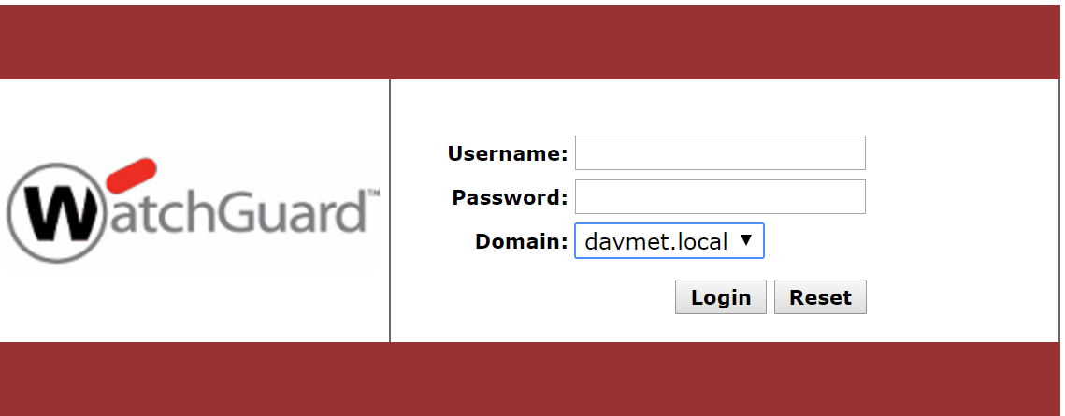

1. Download the client relevant to your machine

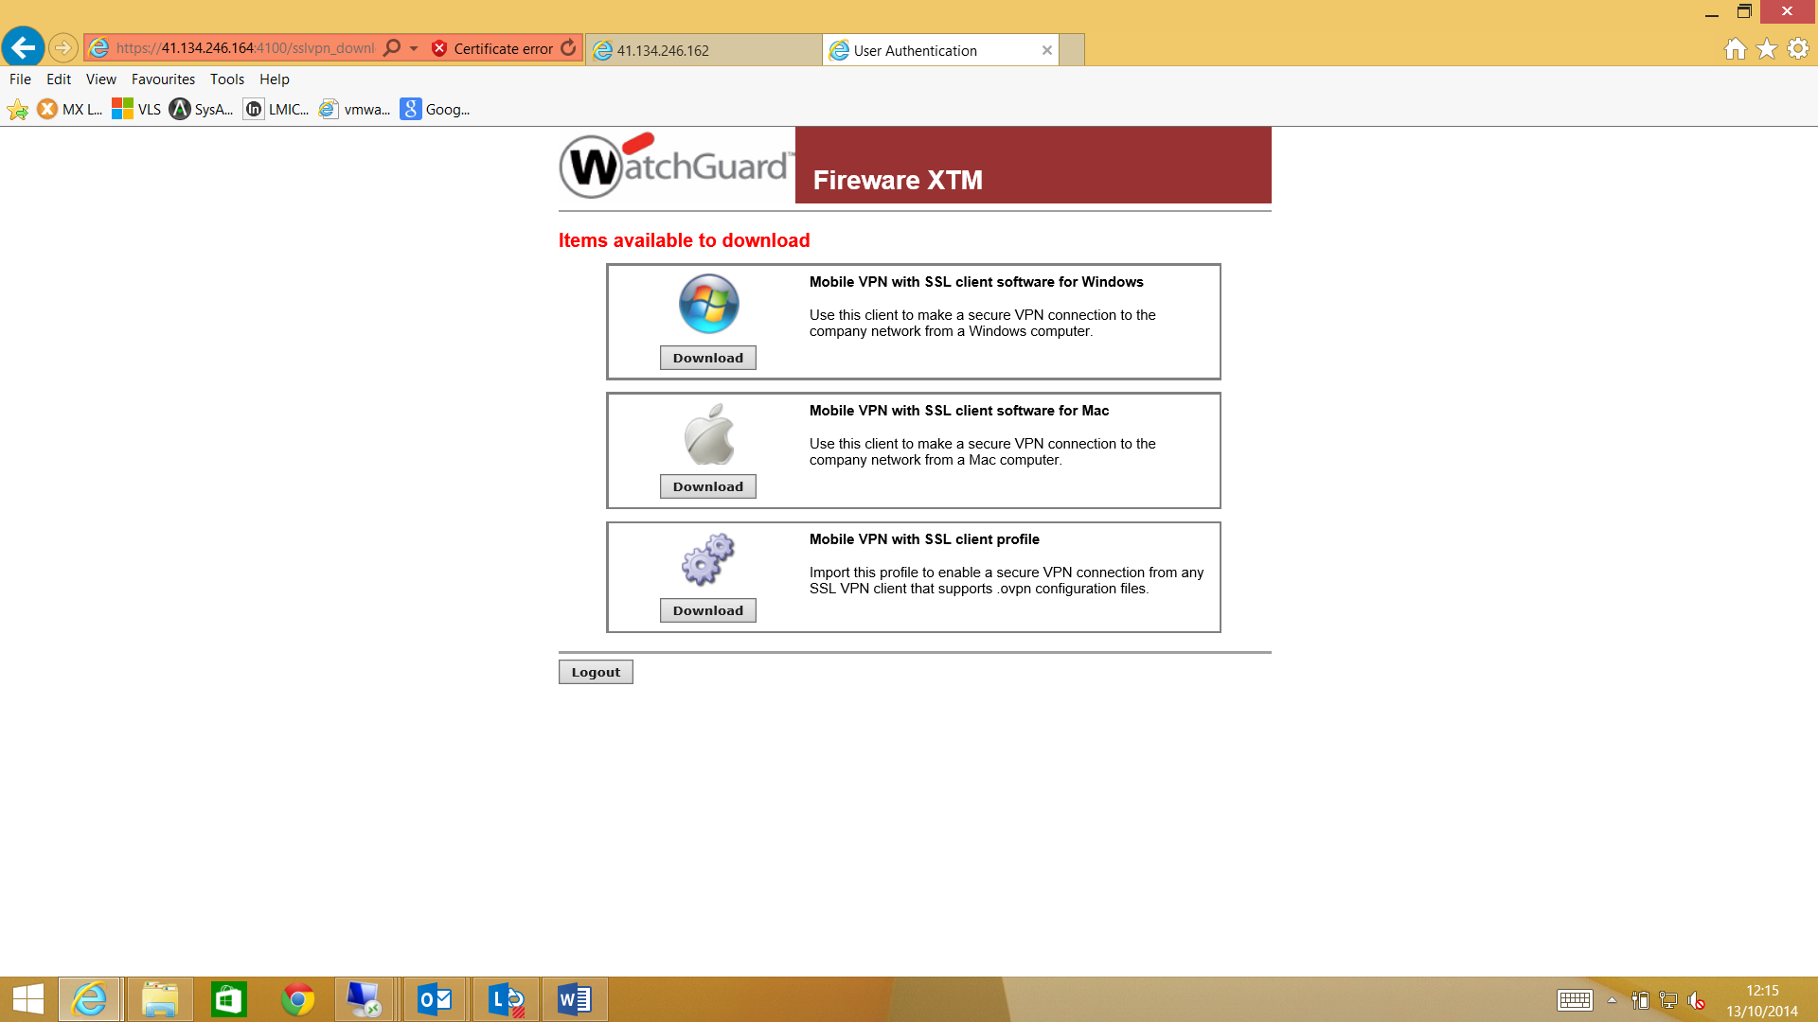

1. Once downloaded, install the client. (or select run instead of save at the download screen)
2. Click next through all of the installation to install the client.
3. Make sure “Launch Mobile VPN with SSL client” is ticked and then click Finish

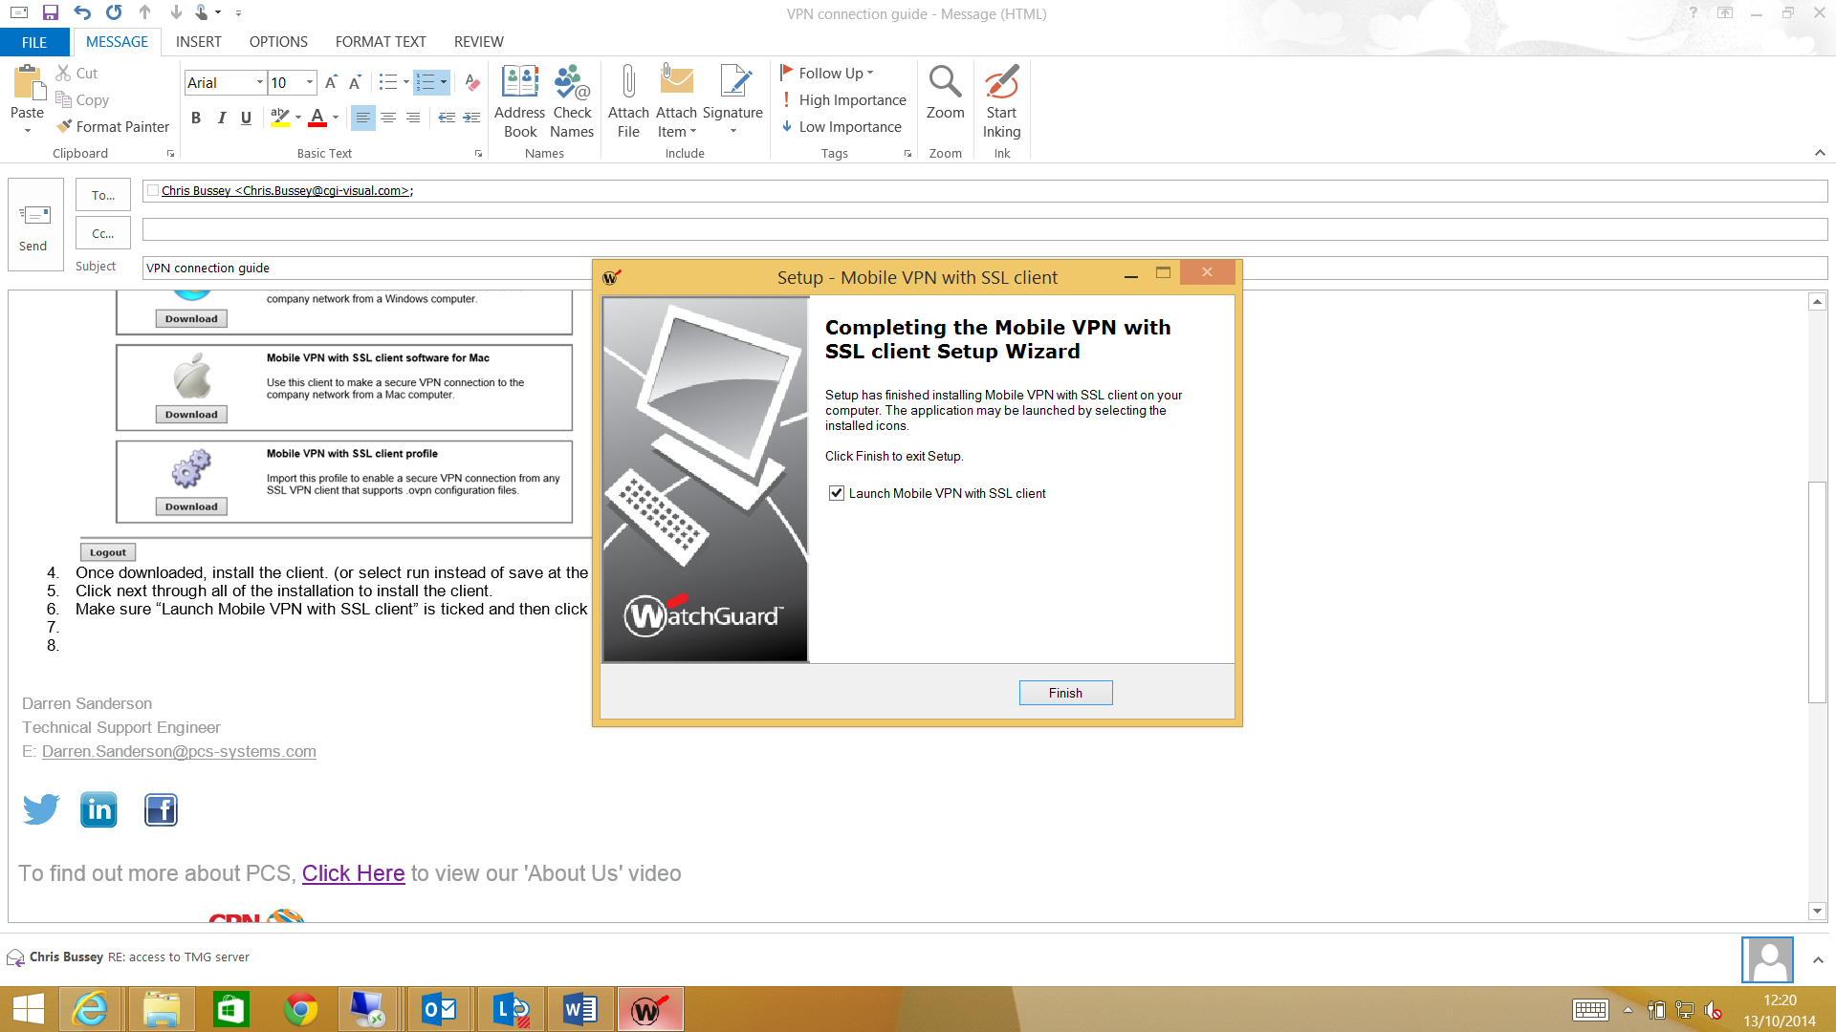

1. In the Server box type 86.188.184.198:444, the username and password are your Daventry Metals credentials again. ***Please ensure the username is prefixed with davmet.local***
2. Click connect
3. Click yes to the certificate message.

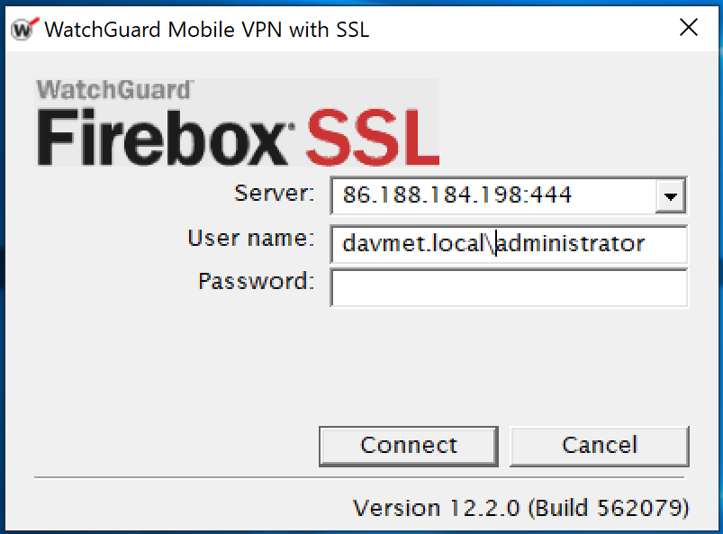

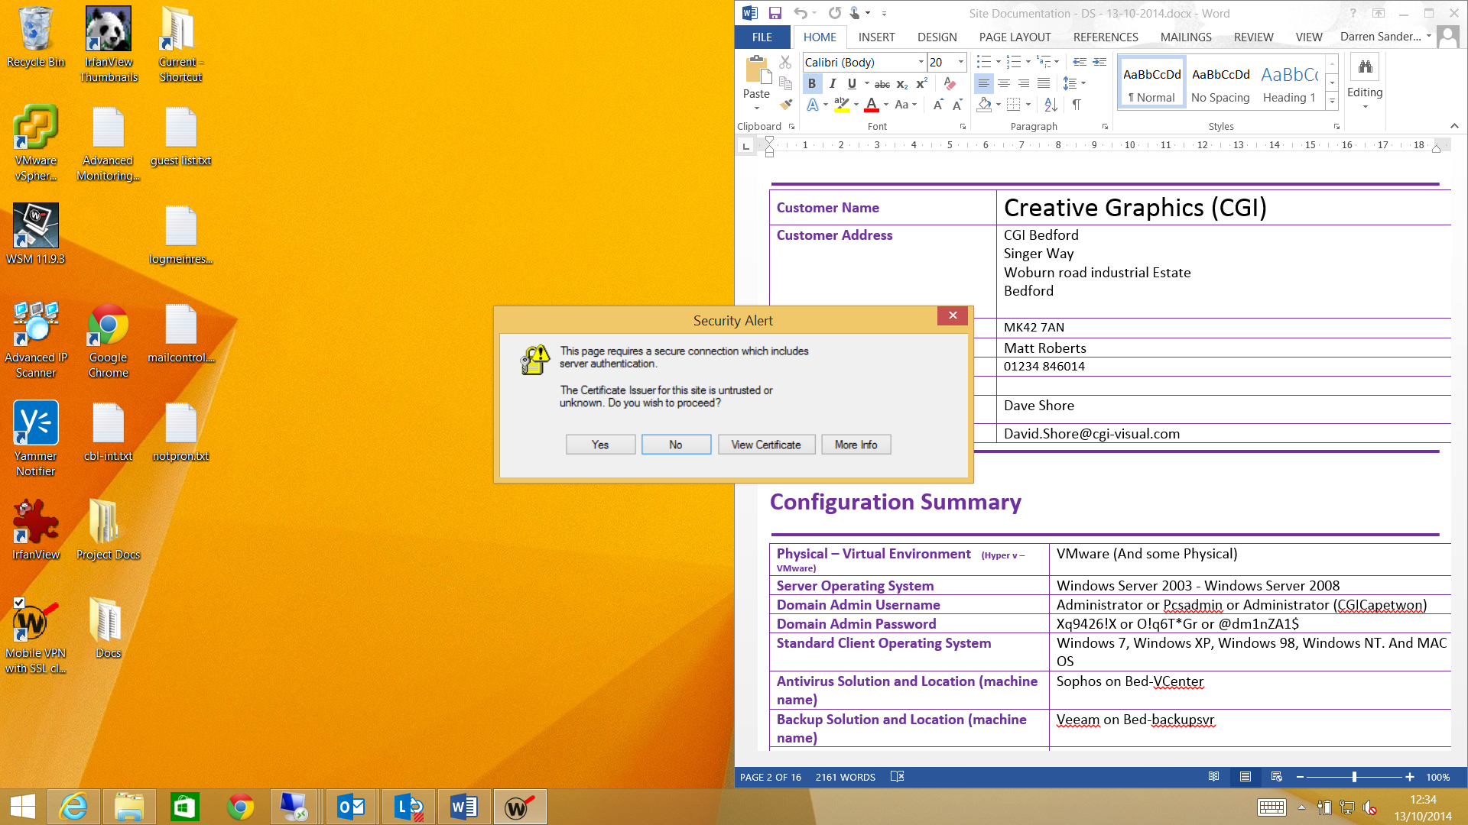

1. The VPN should then connect
2. If you have any Issues, please contact the Service Desk on 08543 735784 or servicedesk@pcs-systems.com