##### **Clariecia Groves**

##### **August 24, 2020**

##### **IT FDN 130 A - Foundations of Database Management**

##### **Assignment 07**

<https://github.com/CGroves3-UW/DBFoundations-Module07>

**Creating Functions in a Database**

**_____________________________________________________________________________________**

# Introduction

For this assignment, I learned more about how to create databases, joins, views and functions. Joins are helpful for extracting data from multiple tables. Views and functions allow you to save simple and complex select statements so that they can be stored into a database. These options provide an easy way to execute saved code using simple select statements which makes it easier for business users to access various reports and data. Built-in and custom functions are presented in this module along with scalar, inline, and multi-statement functions.

# SQL User-Defined Functions

Explain when you would use a SQL UDF.

SQL user-defined functions (UDFs) are blocks of code that perform specific tasks defined by the user. UDFs accept parameters, perform actions, and return the results as a value. The return value can either be a single scalar value or a result set (<https://docs.microsoft.com/en-us/sql/relational-databases/user-defined-functions/user-defined-functions?view=sql-server-ver15#:~:text=Like%20functions%20in%20programming%20languages,value%20or%20a%20result%20set.>, 2020).

The advantages of using UDFs are as follows:

* They allow for faster execution.
* They help to automate repetitive tasks.
* They allow for shorter and simpler written code when performing complex tasks.
* They can be used in a Select, Where or Case statement.

In this assignment we had separate tables for products and categories. The products table contained the ProductID, ProductName, CategoryID, and UnitPrice. The categories table contained the CategoryID and CategoryName. Figure 1 provides example code for creating a function that shows a list of category and product names along with the unit price of each product.

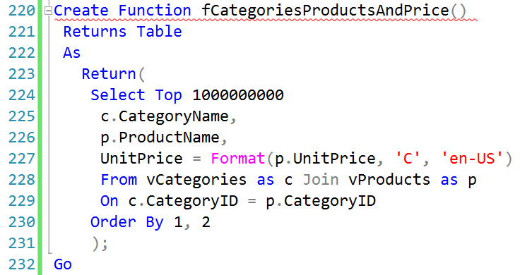

**Figure 1: SQL UDF with Join on the Categories and Products Views**

# Scalar, Inline, and Multi-Statement Functions

Explain the differences between Scalar, Inline, and Multi-Statement Functions.

In this section, we will highlight some of the differences between scalar, inline, and multi-statement functions.

* A scalar function returns a single (scalar) value as an expression.
* An inline function returns a result set as opposed to a single scalar value.
* A mult-statement function returns a result set with a more powerful result.

Figure 2 provides a table comparison of the similar features and description of scalar, inline, and multi-statement functions.

|  |  |  |
| --- | --- | --- |
| Function | Similar Features | Description |
| Scalar | Similar to Built-In Functions | Returns a single value |
| Inline | Similar to Views with Parameters | Returns a table as the result of a single Select statement |
| Multi-Statement | Similar to Stored Procedures | Returns a new table as the result of Insert statements |

**Table 1: Similar Features and Description of Scalar, Inline, and Multi-Statement Functions (**<https://slideplayer.com/slide/10623411/>**, 2020)**

# Summary

After completing this module which included reading supplemental websites, watching videos, and practicing exercises, I was able to successfully create functions in a database. This written assignment demonstrates my knowledge of joining tables, creating views, and user-defined functions. I am excited to continue learning more about databases in future modules and hope to build my own database in practice.