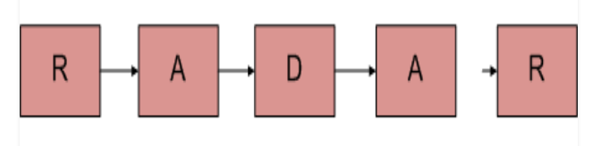

First Approach

1. Create a Stack DS.
2. Loop through the Linked List and Add elements to the Stack
3. Pop elements from the Stack and Iterate through the List second time
4. If Both are Equal Then Print Palindrome else not palindrome.

Second Approach

This method takes O(n) time and O(1) extra space.   
**1)** Get the middle of the linked list.   
**2)** Reverse the second half of the linked list.   
**3)** Check if the first half and second half are identical.   
**4)** Construct the original linked list by reversing the second half again and attaching it back to the first half