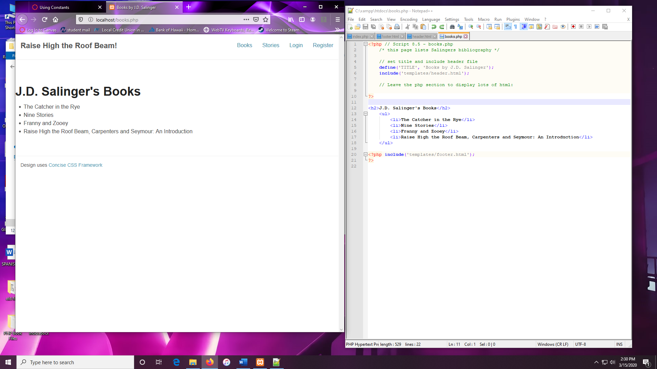

---- TITLE NOT DEFINED. DEFAULT TITLE GIVEN on welcome page.

