Questions

1. String and it method related, concat(), replace()

- Yes, it work with String

- Yes, it returns new String, with concat, etc

2. Can we over ride main method?

- No

3. Access modfifiers in packages? which is accessible and where?

- <https://www.javatpoint.com/access-modifiers>

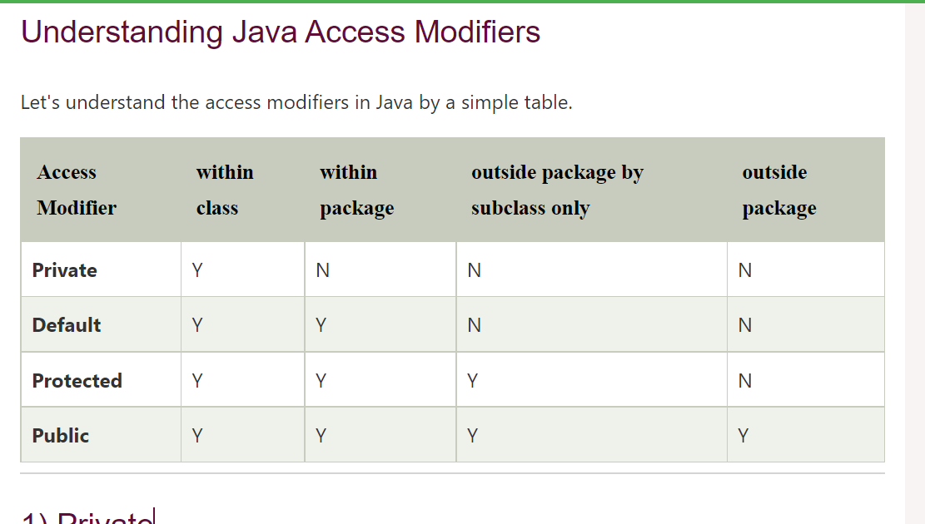

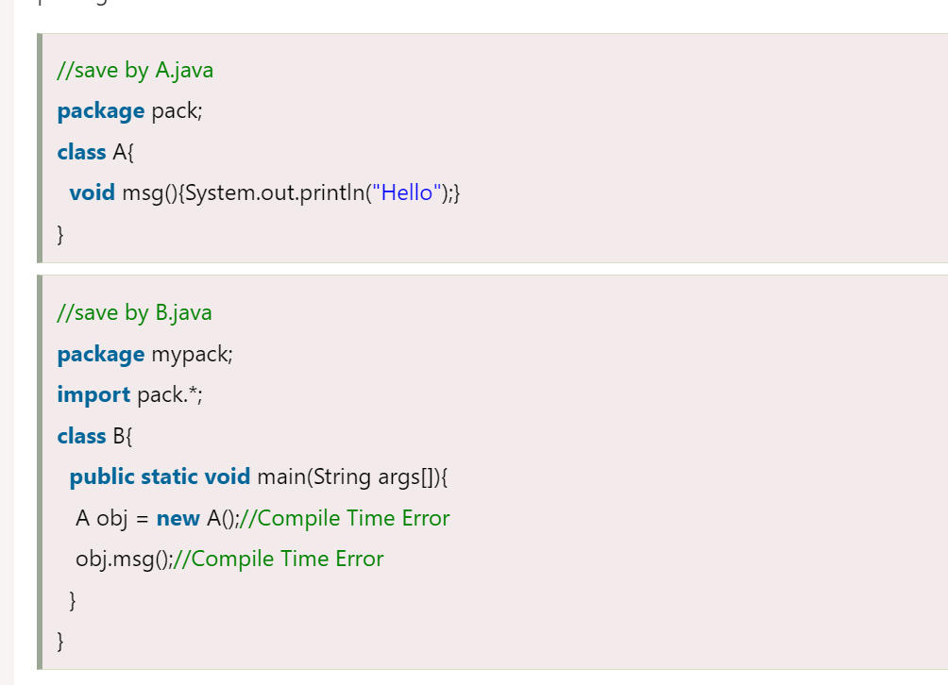

4. How is map internally stored?

https://www.youtube.com/watch?v=wZLn2BN1TvY

https://medium.com/javarevisited/internal-working-of-hashmap-in-java-97aeac3c7beb#:~:text=Working%20Of%20hashmap%3A-,HashMap%20uses%20its%20static%20inner%20class%20Node,new%20entry%20can%20be%20added.

The HashMap class does not preserve the order of insertion of entries into the map.

HashMap has multiple buckets or bins which contain a head reference to a singly linked list. That means there would be as many linked lists as there are buckets. Initially, it has a bucket size of 16 which grows to 32 when the number of entries in the map crosses the 75%. (That means after inserting in 12 buckets bucket size becomes 32)

HashMap is almost similar to Hashtable except that it’s unsynchronized and allows at max one null key and multiple null values.

Insert

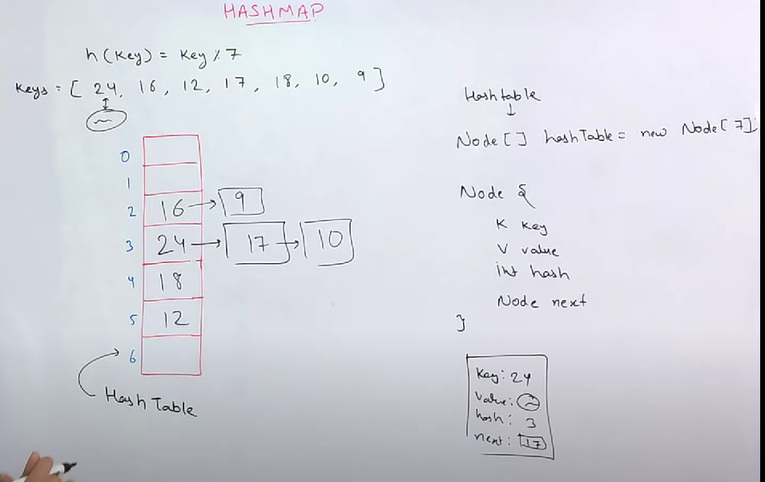

5. throw custom exception eg. if we encountered NPE, but we still has to throw IlleagalArgException how can we achieve this?

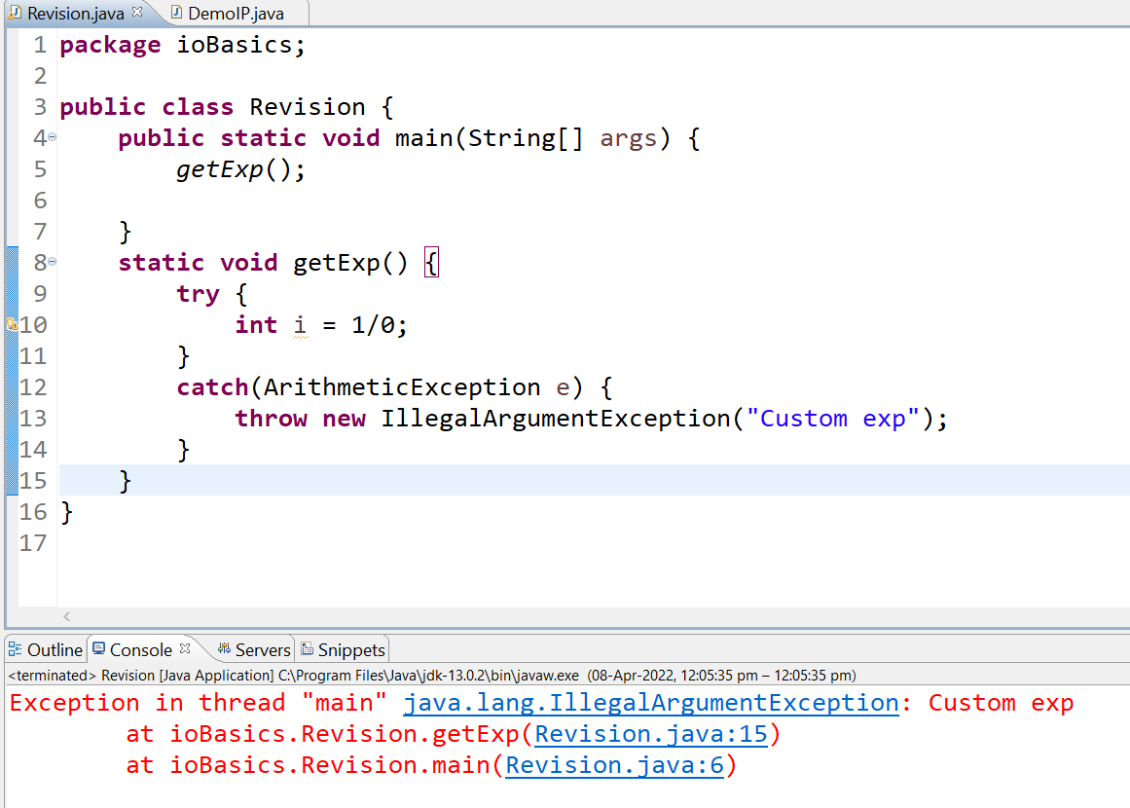

6. Difference between C & Java wrt Platform dependent? how can it be useful?

<https://www.youtube.com/watch?v=_gUr7W02LY8>

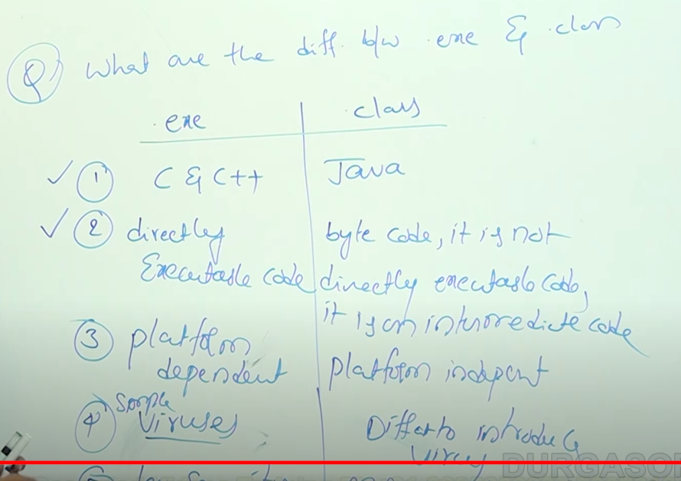

7. Why is C++ not platform independent?

Above ans

Other Java topics

1. SQL? DML, DDL

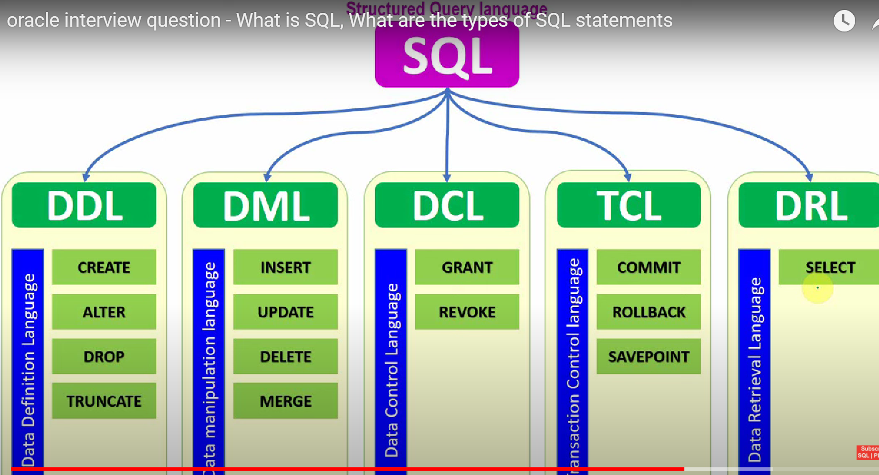

2. Features of Java?

<https://www.tutorialspoint.com/What-are-the-major-features-of-Java-programming>

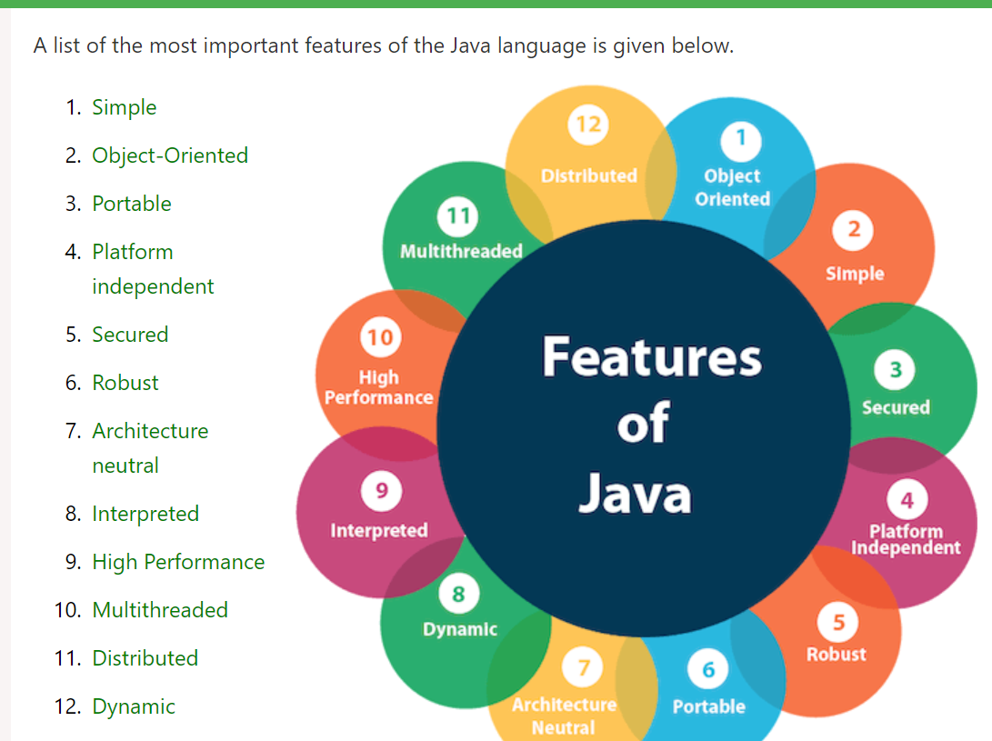

Multithreading etc? Thread life cycle

<https://www.javatpoint.com/multithreading-in-java>

<https://www.youtube.com/watch?v=TCd8QIS-2KI>

3. Better example of abstraction, encapsulation? Why is it needed?

4. Spring, Spring Boot, Spring Cloud, Microservices, Hibernate? Dockers?

Spring, Spring Boot done, Docker, Hibernate left

5. String Argument? input?

Hi Hello -> len(args[]) = 2

“Hi Hello” -> len(args[]) = 1

“Hi” “Hello” -> len(args[]) = 2

6. test methods in Junit, modifier for same?

<https://www.javatpoint.com/junit-tutorial>

https://www.guru99.com/junit-annotations-api.html

7. SuitClassAnnotation() -> method signature

https://www.tutorialspoint.com/junit/junit_suite_test.htm

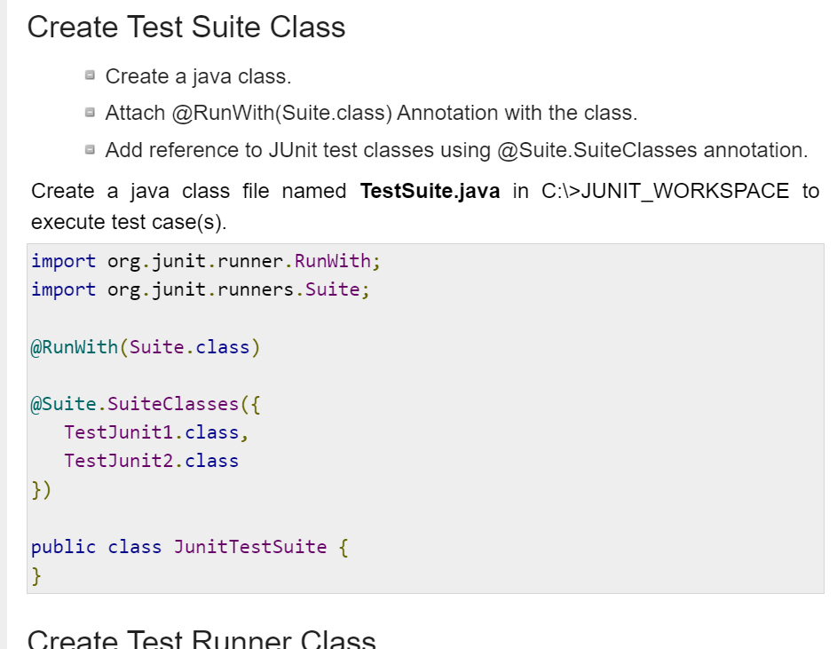

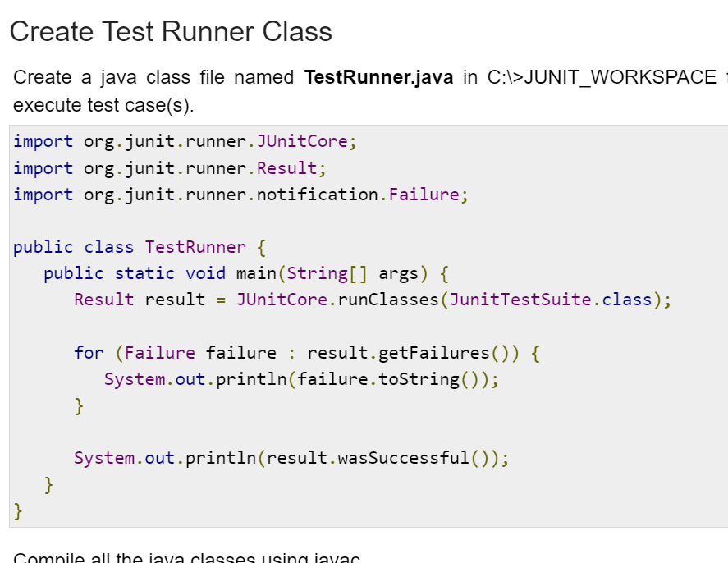

Web services methods in servlet?

8. SOAP / REST

<https://youtu.be/_fq8Ye8kodA>

<https://stackify.com/soap-vs-rest>

https://www.youtube.com/watch?v=TvGLm7BijJY

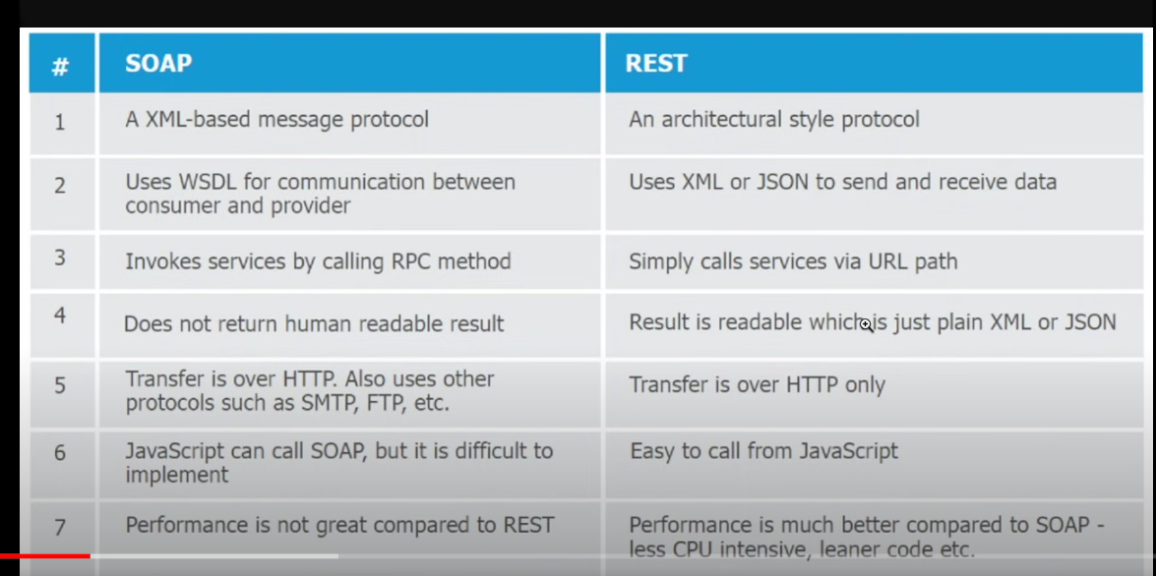

9. How are both transported? Transport Portion

Above

10. String s1 has HashCode (long l), s1==null, After calling GC, what happens to code l1?

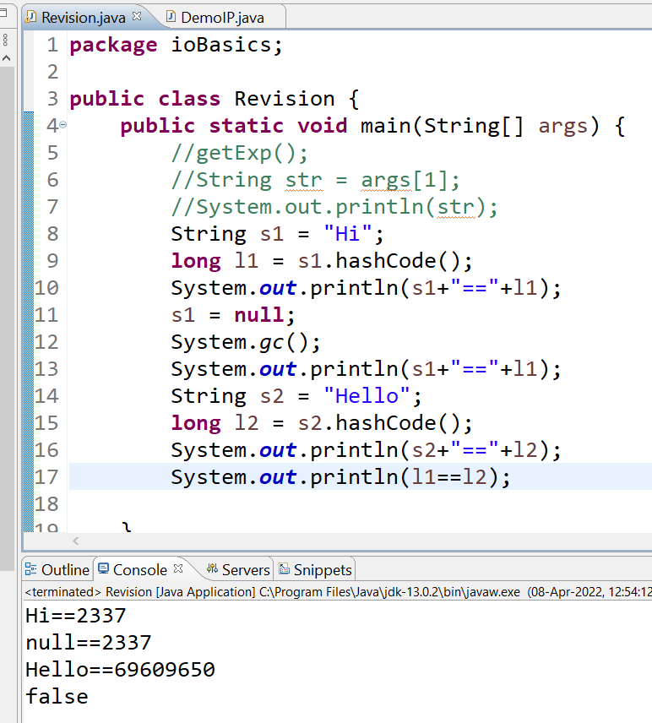

11. Spring @NamedQuery?

<https://www.javatpoint.com/hibernate-named-query>

Hibernate

12. HTTP status 204

The HTTP 204 No Content success status response code indicates that a request has succeeded, but that the client doesn't need to navigate away from its current page.

https://developer.mozilla.org/en-US/docs/Web/HTTP/Status

13. Can final static method overrided?

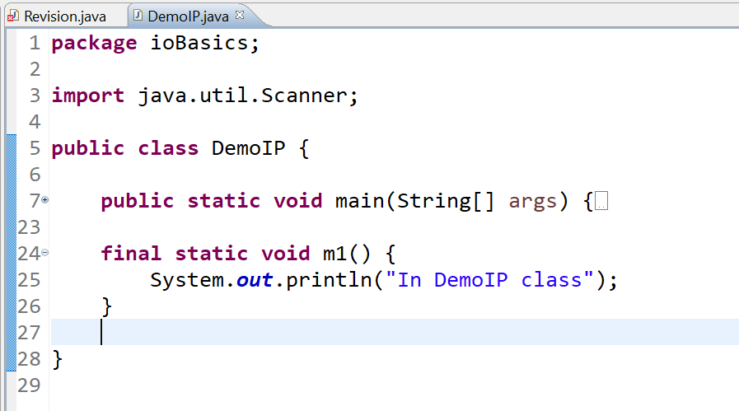

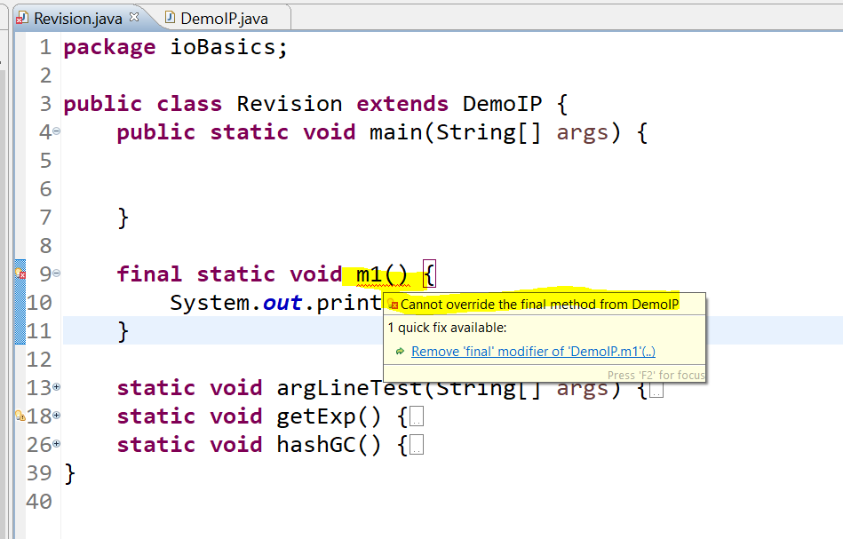

14. POM Project Object Model, start tag?

<https://maven.apache.org/guides/introduction/introduction-to-the-pom.html>

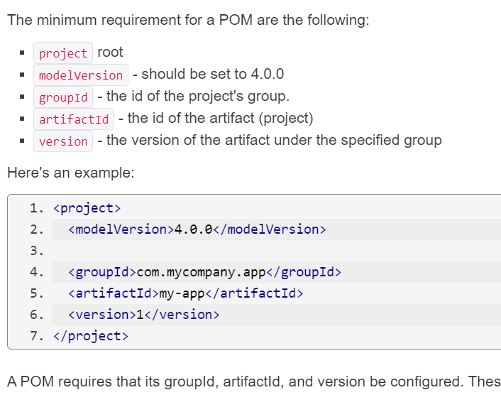

15. Constructor (Private and public static, which is called?)

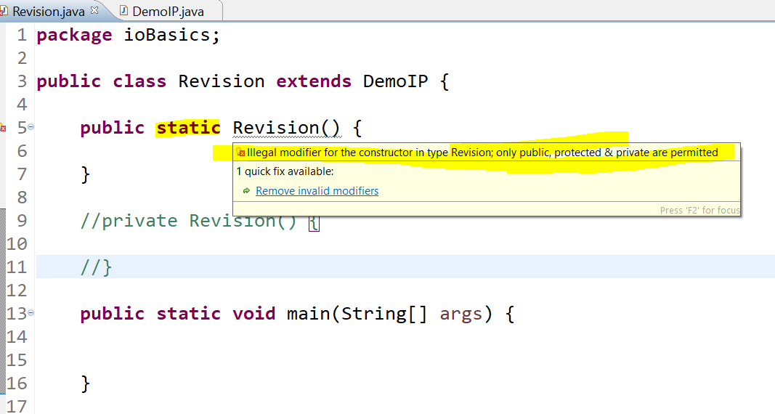

16. SQL - SUM, MAX

17. String, StringBUffer – Immutable

<https://www.javatpoint.com/difference-between-stringbuffer-and-stringbuilder>

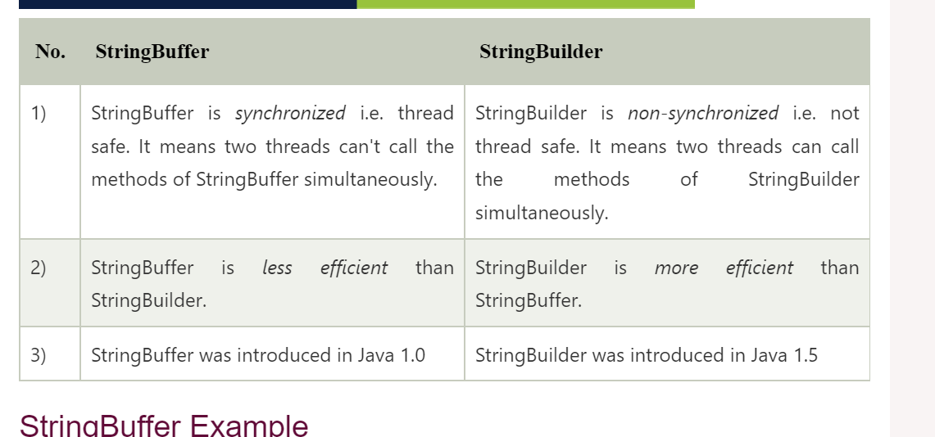

https://www.geeksforgeeks.org/string-vs-stringbuilder-vs-stringbuffer-in-java/

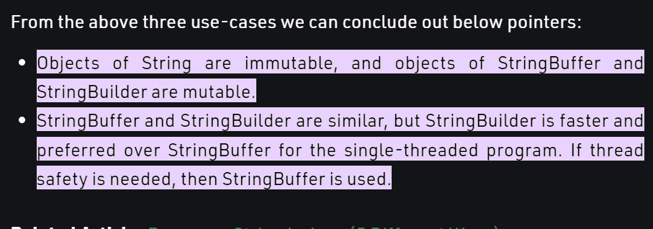

String.replace(), concat() methods return a new string with respective operation, while original is immutable always

18. Mock obj in Junit

<https://springframework.guru/mocking-unit-tests-mockito/>

19. how to read XML file in Java

<https://www.javatpoint.com/how-to-read-xml-file-in-java>

Reading XML file in Java is much different from reading other files like .docx and .txt because XML file contains data between the tags. Java provides many ways to parse an XML file. There are two parsers in Java which parses an XML file:

Java DOM Parser

Java SAX Parser

20. different view, same mapping?

21. Delete vs truncate vs drop

<https://www.geeksforgeeks.org/difference-between-delete-and-truncate/>

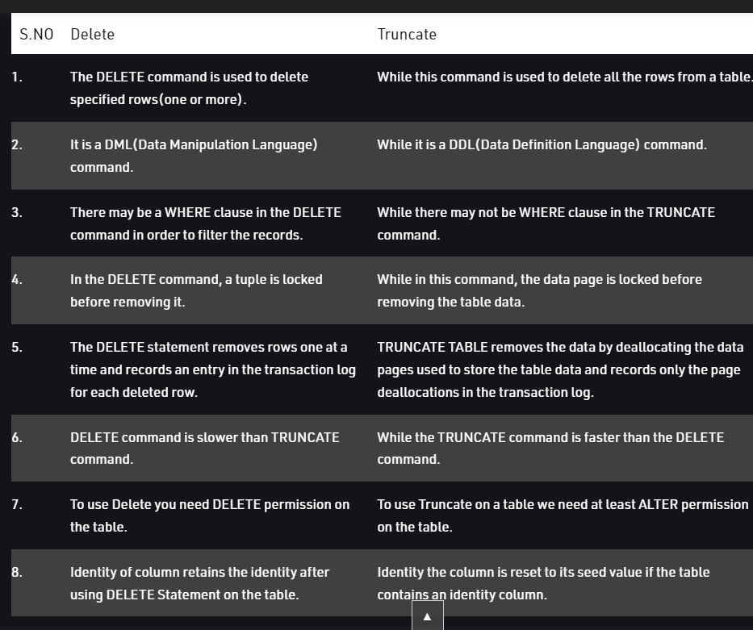

Other

22. Proxy server?

<https://www.fortinet.com/resources/cyberglossary/proxy-server>

Coding: