Lab-1
Question-1:
Create a NumPy array containing the integers from 1 to 20.
Perform the following operations:
1. Display the array.
2. Find the shape of the array.
3. Find the maximum and minimum values.
4. Calculate the mean and standard deviation.
5. Reshape the array into a 4 × 5 matrix.
6. Display the second row of the matrix.
7. Display the third column of the matrix.

Code:
import numpy as np

arr = np.arange(1, 21)
print("Array:")
print(arr)

print("\nShape of the array:", arr.shape)
print("Maximum value:", np.max(arr))
print("Minimum value:", np.min(arr))
print("Mean:", np.mean(arr))
print("Standard Deviation:", np.std(arr))

matrix = arr.reshape(4, 5)
print("\n4 × 5 Matrix:")
print(matrix)
print(matrix[1])
print("\nThird Column:")
print(matrix[:, 2])

Output:
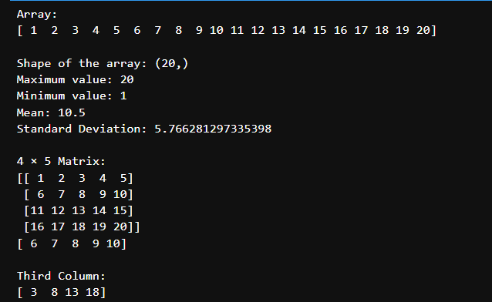

Question-2:
Create two NumPy arrays:
A = [10, 20, 30, 40, 50], B = [5, 10, 15, 20, 25]

Perform:
1. Addition of A and B.
2. Subtraction of B from A.
3. Element-wise multiplication.
4. Element-wise division.
5. Find the sum of all elements in A.
Code:
import numpy as np
A = np.array([10, 20, 30, 40, 50])
B = np.array([5, 10, 15, 20, 25])
print("Addition:", np.add(A, B))
print("Subtraction:", np.subtract(A, B))
print("Element-wise Multiplication:", np.multiply(A, B))
print("Element-wise Division:",np.divide(A, B))
print("Sum of all Elements in A:",np.sum(A))
Output:
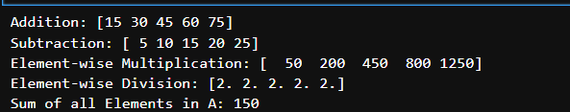

Question-3:
Create a DataFrame using the following student data:

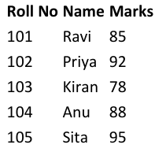
Perform the following operations:
1. Display the DataFrame.
2. Display the first three records.
3. Find the average marks.
4. Find the student with the highest marks.
5. Find the student with the lowest marks.
6. Add a new column called "Grade" using:
- A for Marks ≥ 90
- B for Marks between 80 and 89
- C for Marks < 80

Code:
import pandas as pd

data = {
"Roll No": [101, 102, 103, 104, 105],
"Name": ["ravi", "priya", "kiran", "anu", "sita"],
"Marks": [85, 92, 78, 88, 95] }
df = pd.DataFrame(data)

print("DataFrame:")
print(df)
print("\nFirst Three Records:")
print(df.head(3))
print("\nAverage Marks:", df["Marks"].mean())
print("\nStudent with Highest Marks:", df.loc[df["Marks"].idxmax()])
print("\nStudent with Lowest Marks:", df.loc[df["Marks"].idxmin()])

def grade(mark):
if mark >= 90:
return 'A'
elif mark >= 80:
return 'B'
else:
return 'C'

df["Grade"] = df["Marks"].apply(grade)

print("\nDataFrame with Grades:")
print(df)
Output:
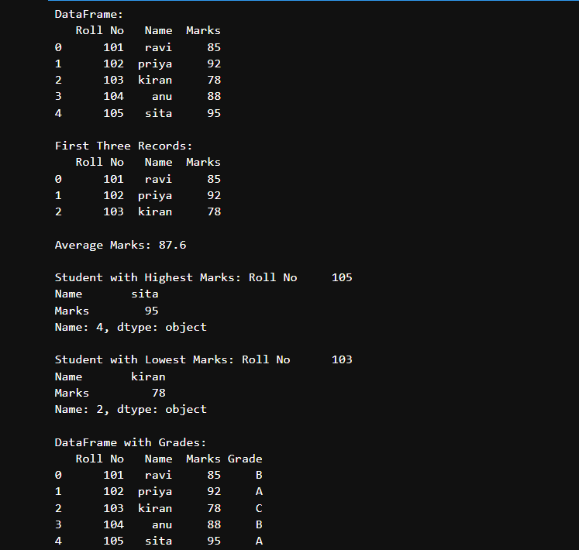
Question-4:
Create a DataFrame containing the following information:
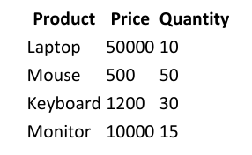
Perform:
1. Calculate the total value of each product using:
Total Value = Price × Quantity
2. Add the Total Value column.
3. Find the product with the highest total value.
4. Calculate the overall inventory value.
Code:
import pandas as pd

data = {
"Product": ["Laptop", "Mouse", "Keyboard", "Monitor"],
"Price": [50000, 500, 1200, 10000],
"Quantity": [10, 50, 30, 15]
}
df = pd.DataFrame(data)
df["Total Value"] = df["Price"] * df["Quantity"]
print("DataFrame with Total Value:")
print(df)
highest = df.loc[df["Total Value"].idxmax()]
print("\nProduct with Highest Total Value:")
print(highest)

overall_value = df["Total Value"].sum()
print("\nOverall Inventory Value:", overall_value)
Output:
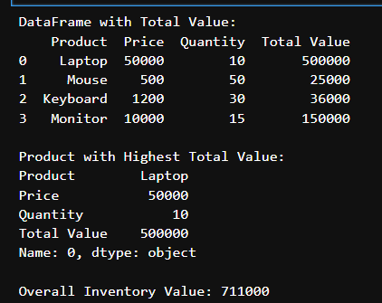

Question-5:
Download the Iris dataset from Scikit-learn and perform the following:
1. Load the dataset into a Pandas DataFrame.
2. Display the first five records.
3. Find the number of rows and columns.
4. Display column names.
5. Check for missing values.
6. Generate summary statistics using describe().
7. Find the number of samples belonging to each class.
Code:
import pandas as pd
from sklearn.datasets import load_iris

iris = load_iris()
df = pd.DataFrame(iris.data, columns=iris.feature_names)
df['species'] = iris.target

print("First Five Records:")
print(df.head())

print("\nNumber of Rows and Columns:")
print(df.shape)

print("\nColumn Names:")
print(df.columns.tolist())
print("\nMissing Values:")

print(df.isnull().sum())
print("\nSummary Statistics:")
print(df.describe())

print("\nNumber of Samples in Each Class:")
print(df['species'].value_counts())

Output:
