Advanced Database Project Report

Haramaya University
College of Computing and Informatics
Department of Software Engineering
Course: Advanced Database
Academic Database Design and Reporting
Student Academic Record Management System
Database-Focused Project Report for the Advanced Database Course
A structured report on relational schema design, SQL reporting logic, access control, testing, and academic data integrity.
Submission Details  University Haramaya University  College College of Computing and Informatics  Department Department of Software Engineering  Course Advanced Database  Date April 16, 2026 | Group Members  Name ID  Chala Gobena 0964/16  Amenti Liben 0686/16  Boka Jiregna 0931/16  Damoze Motuma 0995/16  Jalane Feyisa 1663/16  Dawit Marsha 1026/16
This report documents the database design, SQL implementation, security controls, testing strategy, and reporting logic of the Student Academic Record Management System developed for the Advanced Database course.

Abstract
This project presents a Student Academic Record Management System whose main contribution is the design and implementation of a well-structured academic database. The core problem addressed is the weakness of manual result processing in educational institutions, where marks, totals, ranks, and report sheets are often managed using paper files or disconnected spreadsheets. Such methods are difficult to validate, vulnerable to inconsistency, and unsuitable for secure multi-user access. To solve this problem, the project models academic data using a normalized relational schema implemented in Supabase PostgreSQL.
The database stores the fundamental academic entities of the institution, including students, teachers, subjects, classes, teacher-to-class assignments, marks, and user profiles. The design applies primary keys, foreign keys, composite keys, uniqueness constraints, check constraints, SQL views, stored functions, triggers, and Row-Level Security (RLS). Report values such as total, average, rank, and pass or fail status are derived dynamically from stored marks instead of being duplicated in base tables. This approach improves consistency, reduces update anomalies, and ensures that reports remain synchronized with authoritative source data.
Although a lightweight web interface exists to submit and display data, the academic value of the project lies primarily in the database layer. The web layer acts only as a thin access mechanism; the essential business rules, data integrity rules, reporting logic, and security controls are enforced in the database. For that reason, this report focuses mainly on database understanding, schema design, SQL implementation, normalization, performance, and secure data access.

Table of Contents
- Introduction
- Requirement Analysis
- Database-Oriented System Design
- Entity Relationship Diagram
- Database Design and Normalization
- SQL Implementation and Database Operations
- Security, RLS, and Exception Handling
- Testing and Validation
- Database-Relevant Screenshots and Evidence
- Unique and Innovative Database Features
- Conclusion
- Appendix

1. Introduction
Student result management is one of the most important database problems in academic administration. At the end of every semester, institutions must record marks, maintain correct relationships between students and subjects, calculate totals and averages, assign ranks, determine pass or fail status, and produce readable reports. If these operations are handled manually, errors occur easily and data integrity becomes difficult to maintain.
The Student Academic Record Management System was developed to address this problem through a relational database approach. Instead of storing repeated academic information in multiple files, the system stores each data item once in a structured schema and derives report values from the stored transactions. The project therefore demonstrates how database design principles can be applied to a real institutional problem.

1.1 Problem Statement
Educational institutions need a secure and consistent way to store academic records and generate result reports without relying on manual calculations or unstructured spreadsheets. A database-centered solution is required to maintain correct relationships between students, teachers, classes, subjects, and marks while enforcing integrity and security.

1.2 General Objective
To design and implement a normalized relational database that supports secure storage, processing, and reporting of student academic records.

1.3 Specific Objectives
- Analyze the student result management problem from a database perspective.
- Design an ER model and relational schema with appropriate keys and cardinalities.
- Apply normalization up to Third Normal Form.
- Implement integrity constraints, referential actions, SQL views, stored functions, and triggers.
- Enforce secure access through Row-Level Security and controlled database functions.
- Generate academic reports dynamically using SQL aggregation and ranking logic.
- Use a minimal interface only as a mechanism to access database operations safely.

1.4 Scope of the Project
The project covers:
- student master data,
- teacher master data,
- class and subject definition,
- teacher-to-class assignment,
- mark storage,
- result summary generation,
- role-based record visibility,
- password change support,
- database-backed report generation.
The current project does not cover:
- attendance management,
- finance management,
- timetable management,
- detailed historical transcript archiving across many terms,
- institutional messaging modules.

2. Requirement Analysis
The requirements of the system were identified from the data and control needs of academic result management. The focus of this analysis is not interface design, but the database objects, data relationships, and business rules necessary to support correct academic processing.

2.1 Functional Requirements
Database Function Area | Required Capability | Implemented Design
Student Data Management | Store learner identity and academic placement | Student records are stored in students with class, grade, academic year, and semester attributes
Teacher Data Management | Store teacher identity and teaching scope | Teacher records are stored in teachers, linked to subjects and classes
Subject Management | Store curriculum subjects | Subjects are stored in subjects with unique names and total marks
Class Management | Organize class groups | Classes are stored in classes with optional homeroom teacher reference
Mark Transaction Management | Store each subject mark once | marks stores one mark per (student_id, subject_id) pair
Reporting | Compute totals, averages, rank, and status | SQL views generate summary and subject-level reports dynamically
Authentication Mapping | Connect users to academic identities | profiles links authenticated users to students, teachers, or administrators
Security | Restrict records by role and scope | RLS policies and helper functions enforce row-level visibility and modification rules

2.2 Non-Functional Requirements
- The database must preserve integrity through keys and constraints.
- The design must minimize redundancy.
- The schema must support future growth in students, subjects, and classes.
- Sensitive academic data must not be visible to unauthorized users.
- Derived report values should be computed rather than redundantly stored.
- Queries should remain understandable, maintainable, and extensible.

2.3 Users and Data Responsibilities
Role | Data Responsibility
Administrator | Maintains master data and creates academic accounts
Teacher | Inserts or updates marks only within assigned subject and class scope
Student | Reads only personal report data

2.4 Core Business Rules
- Each student has a unique student_id.
- Each teacher has a unique teacher_id.
- Each subject has a unique subject_name.
- Each class has a unique class_name.
- A mark must be between 0 and 100.
- A subject result is Pass if mark >= 50, otherwise Fail.
- One student can have only one stored mark per subject.
- A teacher may record marks only for assigned classes and assigned subject.
- Report totals, averages, and rank are derived values and must not be stored in base tables.

3. Database-Oriented System Design
The project was designed around the database as the central component. The interface and application logic are secondary layers used only to submit requests and display results. The academic rules themselves are centered in the database schema and SQL logic.

3.1 Design Philosophy
The design follows four principles:
- Store base facts only once
- Model real relationships explicitly
- Compute derived values instead of duplicating them
- Push security and validation as close to the data as possible

3.2 Data-Centered Architecture
Layer | Role
Client Interface | Collects input and displays query results
Application Gateway | Passes validated requests to the database
Database Core | Stores base entities, enforces constraints, executes SQL views, functions, triggers, and RLS policies
In this architecture, the database core is the primary academic asset. The interface is replaceable, but the schema, SQL logic, and access policies define the correctness of the system.

3.3 Current System Architecture
The implemented system follows a three-layer academic data architecture. At the top, the user interface collects academic input and displays reports. In the middle, the application layer forwards validated requests to Supabase/PostgreSQL and returns the resulting output. At the core, PostgreSQL stores the base relations, executes SQL functions and views, applies triggers and indexes, and enforces Row-Level Security policies. Core entities such as students, teachers, subjects, classes, teacher_class_assignments, marks, and profiles are stored in normalized relations, while reporting outputs are generated from database views and controlled query execution.

3.4 Current System Flow
The operational flow of the implemented system is database-driven and can be understood through three main transactions. First, an administrator creates academic records such as classes, subjects, teachers, or students, and the database validates foreign keys, uniqueness rules, and structural constraints before commit. Second, a teacher enters or updates marks, after which authorization is checked, the marks relation is updated, and dependent reporting views immediately reflect the new values. Third, an authorized user requests a report, and the database enforces RLS, calculates totals, averages, ranking positions, and pass or fail status, then returns only the permitted result set.

4. Entity Relationship Diagram
The formal ER model is based on the persistent PostgreSQL schema. Derived views are excluded from the formal ER diagram because they are virtual reporting relations rather than stored entities.
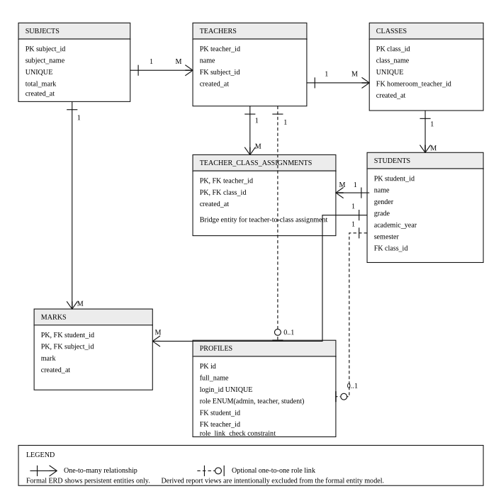 Figure 1. Formal ER diagram of the implemented public PostgreSQL schema.

4.1 Core Entities
Entity | Primary Key | Important Attributes
subjects | subject_id | subject_name, total_mark, created_at
teachers | teacher_id | name, subject_id, created_at
classes | class_id | class_name, homeroom_teacher_id, created_at
teacher_class_assignments | (teacher_id, class_id) | created_at
students | student_id | name, gender, grade, academic_year, semester, class_id
marks | (student_id, subject_id) | mark, created_at
profiles | id | full_name, login_id, role, student_id, teacher_id

4.2 Relationship Specification
The implemented schema has the following cardinalities:
- subjects 1 : M teachers: one subject may be assigned to many teachers, while each teacher references at most one subject.
- teachers M : N classes through teacher_class_assignments: one teacher may teach many classes, and one class may have many assigned teachers.
- teachers 1 : M classes through homeroom_teacher_id: one teacher may be homeroom teacher for many classes, while each class has at most one homeroom teacher.
- classes 1 : M students: one class contains many students, while each student belongs to at most one class in the current schema.
- students 1 : M marks: one student can have many subject marks.
- subjects 1 : M marks: one subject can appear in many mark records.
- students 0..1 : 1 profiles: a profile may reference one student when the role is student.
- teachers 0..1 : 1 profiles: a profile may reference one teacher when the role is teacher.

4.3 ER Diagram Interpretation
The ERD shows a correct relational separation between master entities and transactional entities. Students, teachers, classes, and subjects are master data; marks are transactional data; teacher-to-class assignment is associative data; profiles are identity and authorization data. This separation is important because it avoids storing mixed responsibilities in a single table.

5. Database Design and Normalization
The database was designed to minimize redundancy, preserve integrity, and support dynamic academic reporting. The schema combines natural business identifiers and surrogate keys where appropriate.

5.1 Relational Schema and Key Design
Relation | Key Structure | Database Rationale
subjects | UUID primary key | stable internal identifier for curriculum entities
classes | UUID primary key | avoids dependence on mutable class names
teachers | text primary key | institutional teacher ID is already meaningful business data
students | text primary key | institutional student ID is a business identifier
teacher_class_assignments | composite primary key | prevents duplicate teacher-class pairs
marks | composite primary key | prevents duplicate marks for the same student-subject pair
profiles | UUID primary key | links authenticated identity to academic identity

5.2 Primary Keys, Foreign Keys, and Referential Integrity

Primary Keys
- subjects(subject_id)
- teachers(teacher_id)
- classes(class_id)
- students(student_id)
- profiles(id)
- teacher_class_assignments(teacher_id, class_id)
- marks(student_id, subject_id)

Foreign Keys
- teachers.subject_id -> subjects.subject_id
- classes.homeroom_teacher_id -> teachers.teacher_id
- teacher_class_assignments.teacher_id -> teachers.teacher_id
- teacher_class_assignments.class_id -> classes.class_id
- students.class_id -> classes.class_id
- marks.student_id -> students.student_id
- marks.subject_id -> subjects.subject_id
- profiles.student_id -> students.student_id
- profiles.teacher_id -> teachers.teacher_id
- profiles.id -> auth.users.id

Referential Actions
- ON DELETE CASCADE is used where child rows should not survive independently, such as marks belonging to a deleted student.
- ON DELETE SET NULL is used where the row remains meaningful even after the parent disappears, such as a class whose homeroom teacher has been removed.
This is a sound design choice because referential actions are selected according to business meaning rather than convenience.

5.3 Constraints and Integrity Rules
The schema includes the following important constraints:
- subject_name is unique.
- class_name is unique.
- gender is restricted to male, female, or other.
- total_mark > 0 is enforced for subjects.
- mark between 0 and 100 is enforced in marks.
- login_id is unique in a case-insensitive way through an index on lower(login_id).
- profiles_role_link_check guarantees valid role-to-record mapping. A student profile must reference a student and not a teacher, a teacher profile must reference a teacher and not a student, and an administrator profile must reference neither.
These constraints are academically important because they ensure that invalid states are rejected at the database level.

5.4 Normalization Analysis

First Normal Form (1NF)
The schema satisfies 1NF because:
- all attributes are atomic,
- there are no repeating groups,
- subject performance is not stored as multiple columns in students,
- many-to-many relationships are separated into bridge tables.

Second Normal Form (2NF)
The schema satisfies 2NF because non-key attributes depend on the whole key:
- in marks, the attribute mark depends on the full composite key (student_id, subject_id),
- in teacher_class_assignments, no non-key attribute depends on only part of the key.

Third Normal Form (3NF)
The schema satisfies 3NF because transitive dependencies are removed:
- student data is stored in students,
- teacher data is stored in teachers,
- subject data is stored in subjects,
- class data is stored in classes,
- totals, averages, and rank are not stored in base relations.
This eliminates update anomalies and keeps the schema logically clean.

5.5 SQL Views, Functions, and Ranking Logic
The project demonstrates advanced database understanding through SQL objects beyond ordinary tables.

A. student_subject_report View
Purpose:
- joins students, classes, subjects, and marks,
- shows one row per student-subject pair,
- uses COALESCE to treat missing marks as 0,
- uses CASE to derive subject-level Pass or Fail.
Database significance:
- centralizes subject-level reporting logic,
- prevents repeated pass/fail computation in multiple places,
- provides a reusable base for detailed reports and class matrices.

B. student_report_summary View
Purpose:
- groups marks by student,
- calculates total using SUM(mark),
- calculates average using AVG(mark),
- calculates rank using RANK() OVER (ORDER BY SUM(mark) DESC).
Database significance:
- separates transactional storage from reporting storage,
- demonstrates aggregate functions and window functions,
- guarantees that report summaries always reflect current marks.

C. Stored Functions
Function | Database Role
current_role() | returns the authenticated user's role
current_teacher_subject_id() | returns the teacher's assigned subject
current_teacher_class_ids() | returns the teacher's assigned classes
resolve_login_email() | resolves visible login data to internal auth identity
create_student_with_account() | creates student, auth, and profile data consistently
create_teacher_with_account() | creates teacher, assignment, auth, and profile data consistently
change_own_password() | performs protected password update
build_hidden_login_email() | builds internal email format for authentication compatibility
These functions are important because they move critical business logic into the database instead of leaving it entirely to application code.

D. Trigger
The trigger set_profiles_updated_at updates profiles.updated_at automatically before each update. This is a simple but correct example of using triggers to maintain metadata consistency.

E. Ranking Logic Interpretation
The main ranking logic is implemented in SQL through the student_report_summary view. This is academically stronger than storing rank as a column because rank depends on the current dataset and should be recomputed whenever marks change. If future requirements demand ranking by class, grade, semester, or academic year, the same logic can be extended through partitioned window functions.

5.6 Performance Considerations and Indexing
Performance is important even in a university project because poor schema choices create unnecessary long-term cost.

Existing Performance Strengths
- primary keys automatically create indexes,
- unique constraints on subject and class names create lookup indexes,
- a case-insensitive unique index exists on profiles(login_id),
- composite primary keys prevent duplicates efficiently,
- report summaries are derived from source data rather than stored redundantly.

Recommended Additional Indexes
create index if not exists idx_students_class_id
on public.students (class_id);

create index if not exists idx_teachers_subject_id
on public.teachers (subject_id);

create index if not exists idx_classes_homeroom_teacher_id
on public.classes (homeroom_teacher_id);

create index if not exists idx_teacher_class_assignments_class_id
on public.teacher_class_assignments (class_id);

create index if not exists idx_marks_subject_id
on public.marks (subject_id);

create index if not exists idx_marks_student_id_subject_id
on public.marks (student_id, subject_id);

Optimization Notes
- filtering should occur as close to the database as possible,
- summary values should continue to be computed from views,
- very large deployments may benefit from materialized views for reporting,
- ranking can be optimized further by partitioning over academic cohorts.

5.7 Why Derived Values Are Not Stored
The schema intentionally does not store total, average, rank, or status in transaction tables. This is good database practice because:
- stored derived data becomes inconsistent after updates,
- update operations become more complex,
- duplicated data increases the risk of anomalies,
- SQL views already provide a correct mechanism for deriving such values.

6. SQL Implementation and Database Operations
This section focuses on how the database objects work together to support academic operations.

6.1 Main SQL Objects
Object Type | Name | Purpose
Table | students | stores learner data
Table | teachers | stores teacher data
Table | subjects | stores subject data
Table | classes | stores class data
Table | teacher_class_assignments | models many-to-many teaching assignment
Table | marks | stores academic transactions
Table | profiles | stores role-linked identity metadata
View | student_subject_report | subject-level reporting
View | student_report_summary | total, average, and rank
Function | create_student_with_account() | protected student creation workflow
Function | create_teacher_with_account() | protected teacher creation workflow
Function | change_own_password() | secure password change
Function | resolve_login_email() | authentication mapping
Trigger | set_profiles_updated_at | metadata maintenance

6.2 Table Creation Example
create table if not exists public.marks (
student_id text not null references public.students(student_id) on delete cascade,
subject_id uuid not null references public.subjects(subject_id) on delete cascade,
mark numeric(5,2) not null check (mark between 0 and 100),
created_at timestamptz not null default timezone('utc', now()),
primary key (student_id, subject_id)
);
This design shows three important ideas:
- referential integrity through foreign keys,
- domain validation through a check constraint,
- uniqueness through a composite primary key.

6.3 Report Computation Example
create or replace view public.student_report_summary as
select
s.student_id,
s.name as student_name,
c.class_name,
coalesce(sum(m.mark), 0) as total,
coalesce(avg(m.mark), 0) as average,
rank() over (order by coalesce(sum(m.mark), 0) desc) as rank
from public.students s
left join public.classes c on c.class_id = s.class_id
left join public.marks m on m.student_id = s.student_id
group by s.student_id, s.name, c.class_name;
This view is important because it demonstrates:
- grouping,
- aggregation,
- null handling with COALESCE,
- ranking with a window function.

6.4 Transaction-Oriented Database Workflows

A. Student Creation
create_student_with_account() performs one protected workflow that creates:
- a students row,
- an auth.users row,
- an auth.identities row,
- a profiles row.
From a database perspective, this is valuable because related data is created in a controlled and consistent way.

B. Teacher Creation
create_teacher_with_account() performs a similar multi-table workflow and also inserts teacher-class relationships into the bridge table. This demonstrates coordinated insertion across related relations.

C. Mark Upsert
Mark storage is based on a composite key. When the same student-subject pair is submitted again, the row is updated instead of duplicated. This reflects correct transaction design for academic marks.

6.5 Minimal Role of the Interface Layer
The interface layer is intentionally thin. Its job is only to:
- collect input,
- submit requests,
- display query results.
The important point for this project is that the database, not the interface, owns:
- data structure,
- integrity rules,
- report logic,
- access control,
- identity mapping,
- error enforcement.
For that reason, the academic merit of the project remains database-centered.

7. Security, RLS, and Exception Handling
Security is one of the strongest database aspects of the project because it is enforced close to the data rather than only in the interface.

7.1 Security Model
The system uses:
- role-aware identity in profiles,
- helper functions to determine user scope,
- Row-Level Security policies on key relations,
- protected stored functions for sensitive operations.

7.2 Row-Level Security (RLS) Explanation
RLS is enabled on:
- teachers
- teacher_class_assignments
- classes
- subjects
- students
- marks
- profiles

Why RLS Is Important
RLS makes the database itself responsible for determining which rows a user may read or modify. This is especially important in academic systems because marks and profiles are sensitive.

Helper Functions Used by RLS
- current_role()
- current_teacher_subject_id()
- current_teacher_class_ids()
These functions make the policies clearer, reusable, and easier to maintain.

7.3 Policy Interpretation
- administrators can broadly manage academic master data,
- teachers can read only students in assigned classes,
- teachers can insert or update marks only within assigned subject and class scope,
- students can read only their own records.
This means the database remains secure even if a user tries to bypass the normal interface flow.

7.4 Validation and Exception Handling
Database-level protections include:
- check constraints,
- unique constraints,
- foreign keys,
- RLS policies,
- stored-function exceptions.
Typical rejected cases include:
- duplicate login IDs,
- duplicate academic IDs,
- invalid mark values,
- unauthorized account creation,
- wrong current password,
- mark entry outside teacher scope.
These behaviors demonstrate that the database does not trust external input blindly.

8. Testing and Validation
Testing was evaluated from the perspective of database correctness, not only interface behavior.

8.1 Database-Focused Testing Strategy
The testing strategy should cover:
- key and constraint validation,
- referential integrity,
- view correctness,
- function correctness,
- RLS enforcement,
- boundary values,
- duplicate-prevention behavior.

8.2 Core Integrity Test Cases
Test Scenario | Expected Result
Insert duplicate subject name | rejected by uniqueness constraint
Insert duplicate class name | rejected by uniqueness constraint
Insert mark above 100 | rejected by check constraint
Insert mark below 0 | rejected by check constraint
Insert duplicate student-subject mark pair | existing row is updated rather than duplicated
Delete student with stored marks | dependent marks are removed by cascade
Delete homeroom teacher | class row remains, homeroom field becomes NULL
Query summary view after mark insertion | total, average, and rank reflect the new data

8.3 Advanced Security and Edge Cases
Test Case | Purpose | Expected Result
Teacher inserts mark for unassigned subject | authorization check | rejected
Teacher inserts mark for student outside assigned class | authorization check | rejected
Student attempts to read another student's record | ownership check | blocked by RLS
Create student with login ID differing only by letter case | case-insensitive uniqueness test | rejected
Change password with incorrect current password | protected function validation | rejected
Change password to same password | security rule validation | rejected
Query reports when marks are missing | null-handling validation | values default correctly through COALESCE
Insert teacher without class assignment in protected workflow | business rule validation | rejected by function logic

8.4 Validation Summary
The database satisfies the main objectives of an Advanced Database project because it demonstrates:
- correct relational modeling,
- controlled transaction storage,
- dynamic reporting through SQL,
- authorization through RLS,
- consistent handling of invalid input.

8.5 Testing Gap
The current project does not yet include a full automated database test suite. A stronger future extension would add:
- SQL unit tests for functions,
- policy tests for RLS,
- regression tests for views,
- transactional tests for insert and update workflows.

9. Database-Relevant Screenshots and Evidence
This section keeps only screenshots that directly support database understanding. The purpose is not to show interface beauty, but to show evidence of database-backed operations and derived reporting.

Figure 2. Student Data Entry Backed by Multi-Table Creation
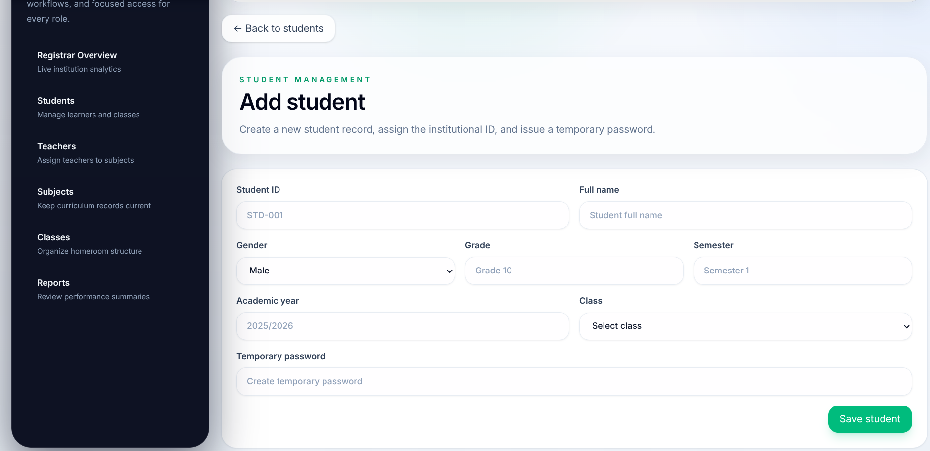 Figure 2. Student data entry backed by multi-table creation.
Database meaning: This page represents insertion into the academic schema. The entered values map to students, while the account creation process also creates linked authentication and profiles records through create_student_with_account().
What it proves: The system does not store student identity in only one isolated table; it coordinates academic and authentication data in a controlled database workflow.

Figure 3. Mark Entry Using Composite-Key Storage
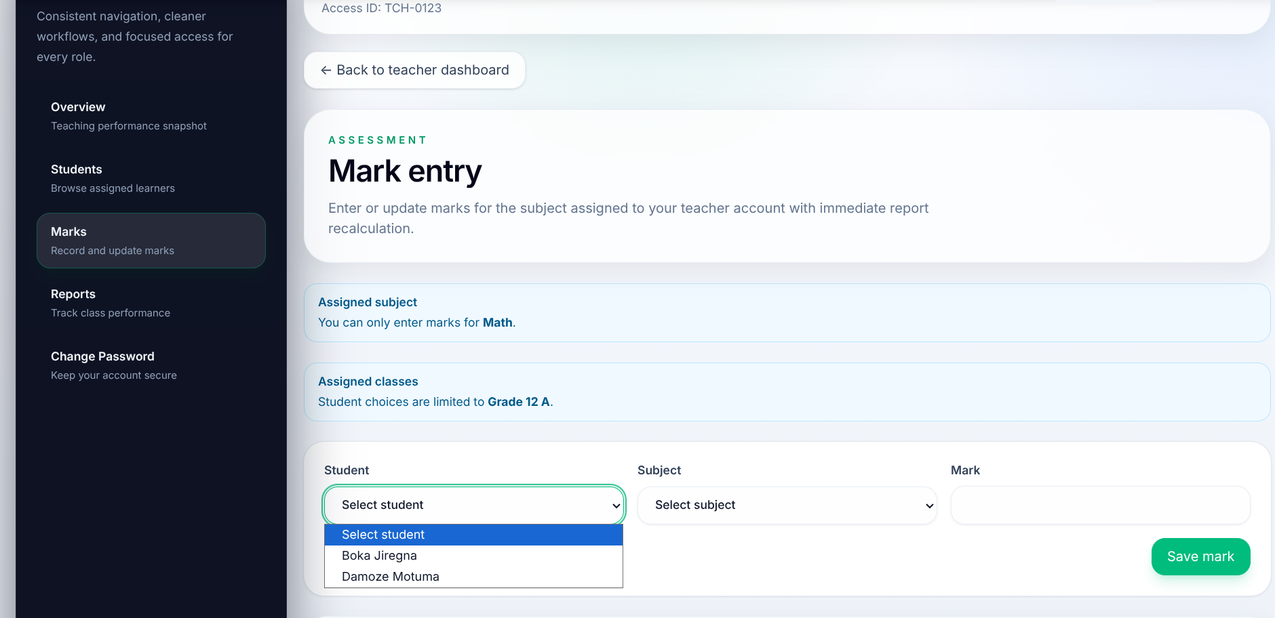 Figure 3. Mark entry using composite-key storage.
Database meaning: This workflow inserts or updates marks(student_id, subject_id, mark). Because the table uses a composite primary key, the same student-subject pair cannot create duplicate rows.
What it proves: The design treats marks as transactions and enforces uniqueness and authorization at the database level.

Figure 4. Class Performance Matrix Generated from SQL Views
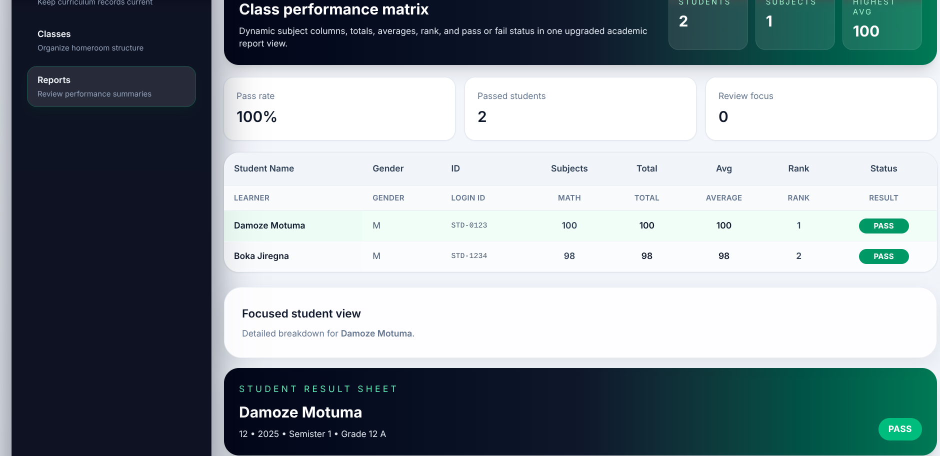 Figure 4. Class performance matrix generated from SQL views.
Database meaning: The displayed totals, averages, rank, and status are not stored directly in master tables. They are derived from student_subject_report and student_report_summary.
What it proves: The screenshot is evidence that reporting is view-based and dynamically computed from normalized data.

Figure 5. Individual Result Sheet Derived from Stored Marks
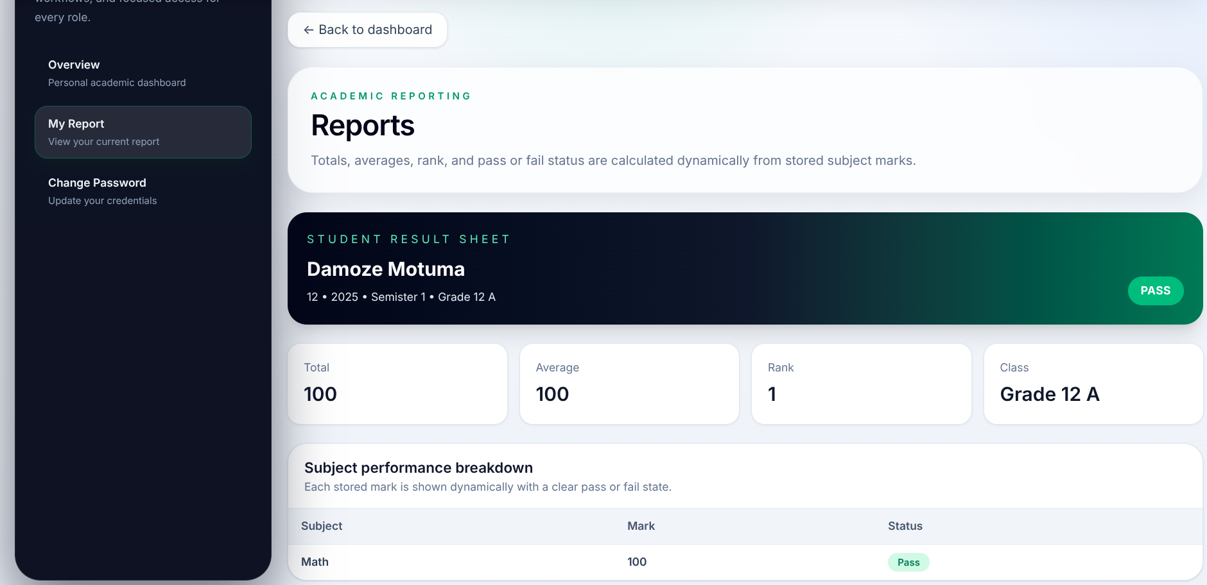 Figure 5. Individual result sheet derived from stored marks.
Database meaning: The detailed result sheet is assembled from summary-level and subject-level SQL outputs rather than from manually maintained report columns.
What it proves: The database can support both aggregate and detailed reporting without duplicating academic data.

9.1 Screenshot Section Interpretation
Taken together, the screenshots demonstrate:
- correct insertion into related tables,
- transactional mark storage,
- dynamic SQL-based reporting,
- separation between base tables and derived report output.

10. Unique and Innovative Database Features
The project contains several database features that make it stronger than a simple CRUD design.

10.1 Separation of Base Tables and Derived Views
The system stores base facts in tables and derives report facts in views. This is a strong relational design decision because it reduces redundancy and inconsistency.

10.2 Bridge-Table Modeling of Teacher-Class Assignment
The use of teacher_class_assignments correctly resolves a many-to-many relationship and demonstrates proper relational modeling.

10.3 Case-Insensitive Login ID Uniqueness
The unique index on lower(login_id) prevents duplicates that differ only by letter case. This is a useful real-world integrity enhancement.

10.4 Role-Link Constraint in profiles
The profiles_role_link_check constraint ensures that role-to-record mapping remains valid. This is more rigorous than relying on application code alone.

10.5 RLS Helper Functions
The use of helper functions inside RLS policies is an advanced design choice because it keeps policies expressive and maintainable.

10.6 Protected Multi-Table Account Creation
The account-creation functions show how complex academic workflows can be encapsulated in stored logic instead of spreading the same rules across multiple interface actions.

11. Conclusion
This project demonstrates a strong understanding of database design for academic record management. Its main achievement is not the existence of a web interface, but the creation of a coherent relational schema supported by keys, constraints, views, functions, triggers, indexes, and Row-Level Security. The project shows how normalized storage and dynamic SQL reporting can solve a real institutional problem while preserving integrity and security.
From an Advanced Database perspective, the most important strengths of the work are:
- correct modeling of academic entities and relationships,
- proper handling of transactional marks,
- dynamic report generation through SQL,
- controlled access through RLS,
- avoidance of redundant stored summaries.
The project therefore stands as a database-centered academic solution rather than a frontend-centered system demonstration. A lightweight interface may change over time, but the database logic, schema quality, and SQL design remain the real foundation of the system.

12. Appendix

Appendix A. Main Database Objects
Object Type | Name | Importance
Table | students | stores learner master data
Table | teachers | stores teacher master data
Table | subjects | stores subject master data
Table | classes | stores class master data
Table | teacher_class_assignments | stores teacher-class relationships
Table | marks | stores academic transaction data
Table | profiles | stores role-linked identity metadata
View | student_subject_report | provides subject-level reporting
View | student_report_summary | provides summary-level reporting
Function | create_student_with_account() | creates linked student and profile records
Function | create_teacher_with_account() | creates linked teacher and assignment records
Function | resolve_login_email() | supports identity resolution
Function | change_own_password() | secures password changes
Function | current_role() | supports RLS
Trigger | set_profiles_updated_at | maintains update timestamps

Appendix A.1 Key Indexes and Constraint Summary
Database Object | Type | Academic Importance
students_pkey | primary key | guarantees that each student record is uniquely identifiable
teachers_pkey | primary key | guarantees that each teacher record is uniquely identifiable
marks_pkey (student_id, subject_id) | composite primary key | prevents duplicate marks for the same student in the same subject
teacher_class_assignments_pkey (teacher_id, class_id) | composite primary key | prevents duplicate teaching assignments
subjects_subject_name_key | unique constraint | avoids duplicate subject definitions
classes_class_name_key | unique constraint | preserves one canonical record per class
profiles_login_id_lower_idx | case-insensitive unique index | prevents logically duplicated login identities
marks_mark_check | check constraint | ensures entered marks remain within the valid academic range
profiles_role_link_check | check constraint | ensures profile roles match the linked academic entity
foreign key constraints | referential integrity | stop orphan records and preserve relational correctness

Appendix A.2 Centrally Enforced Database Rules
- mark values must remain within the permitted numeric range,
- a student-subject mark pair can exist only once,
- a teacher-class assignment pair can exist only once,
- report totals, averages, and ranks are derived rather than stored,
- role-based access is enforced in the database through RLS policies,
- sensitive academic data is exposed only through authorized queries and functions.

Appendix A.3 Role-to-Database Access Summary
Role | Main Database Scope | Access Characteristics
Administrator | students, teachers, classes, subjects, profiles, assignment relations | creates and maintains master data through protected workflows and authorized inserts
Teacher | marks, reporting views, assigned class data | can read only permitted academic rows and update marks within assigned teaching scope
Student | personal reporting views and linked profile data | can read only personal result information under row-level restrictions
This role-to-database mapping is important because it shows that access control is not merely a user-interface feature. Each role operates against a different subset of the schema, and those boundaries are enforced in the database by RLS and helper functions rather than by client-side assumptions alone.

Appendix A.4 Derived Reporting Attributes
Derived Attribute | Source Logic | Reason It Is Not Stored Directly
total | sum(mark) across the student result set | avoids inconsistent totals after mark updates
average | avg(mark) across recorded subjects | prevents duplication of recalculable values
rank | window function over ordered totals | keeps ranking synchronized with current transactions
status | conditional SQL expression from the mark value | avoids storing pass/fail flags that can be recomputed
These derived attributes demonstrate a core advanced-database principle used throughout the project: transactional facts are stored in base tables, while reporting facts are generated by SQL at query time. This keeps the schema normalized and reduces update anomalies.

