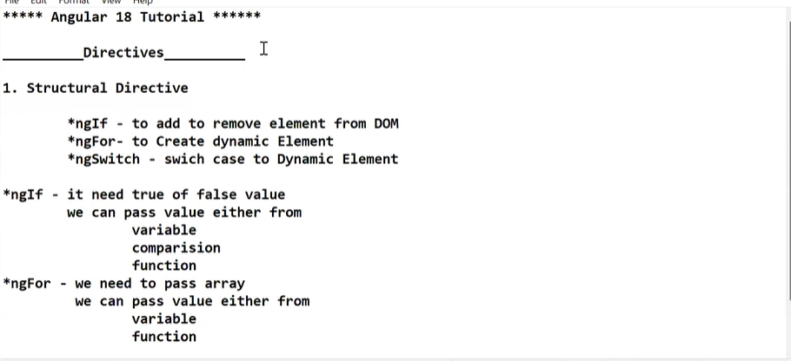

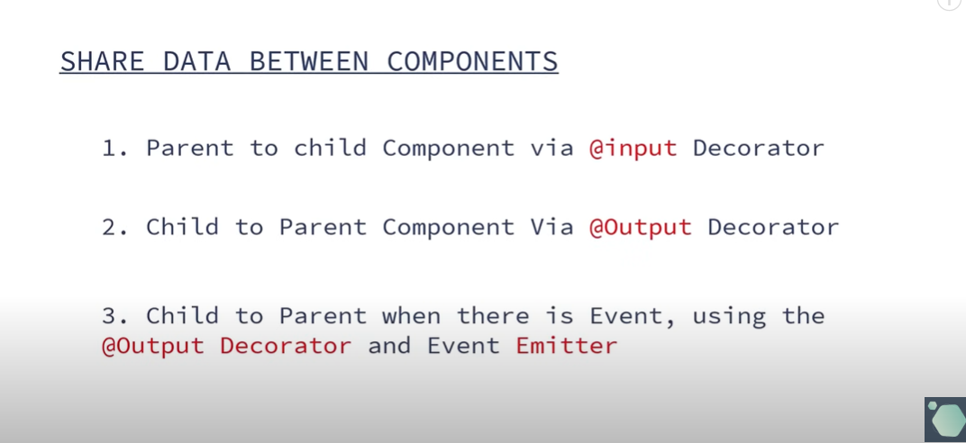

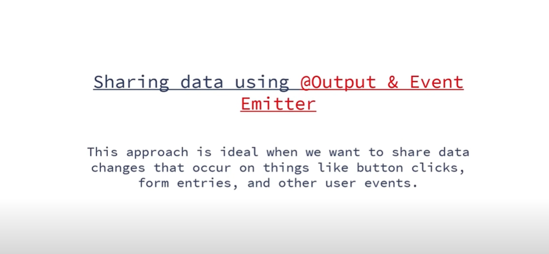

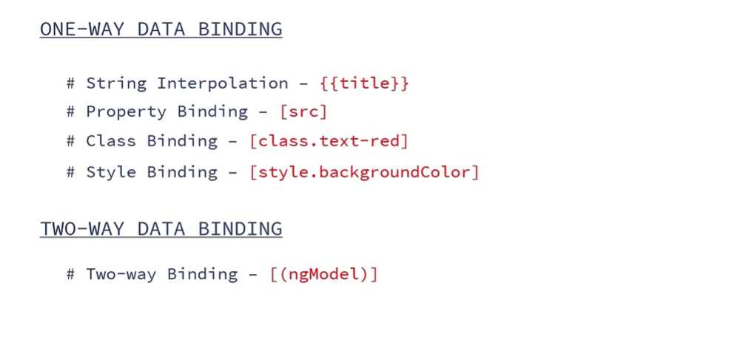

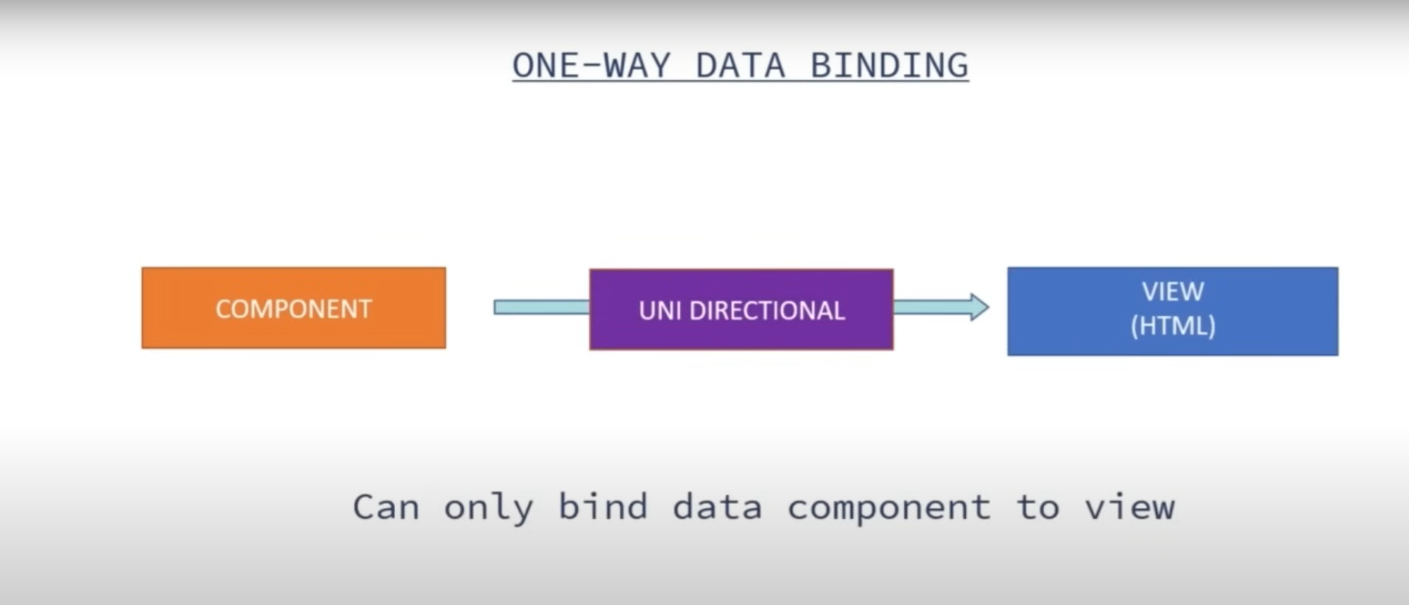

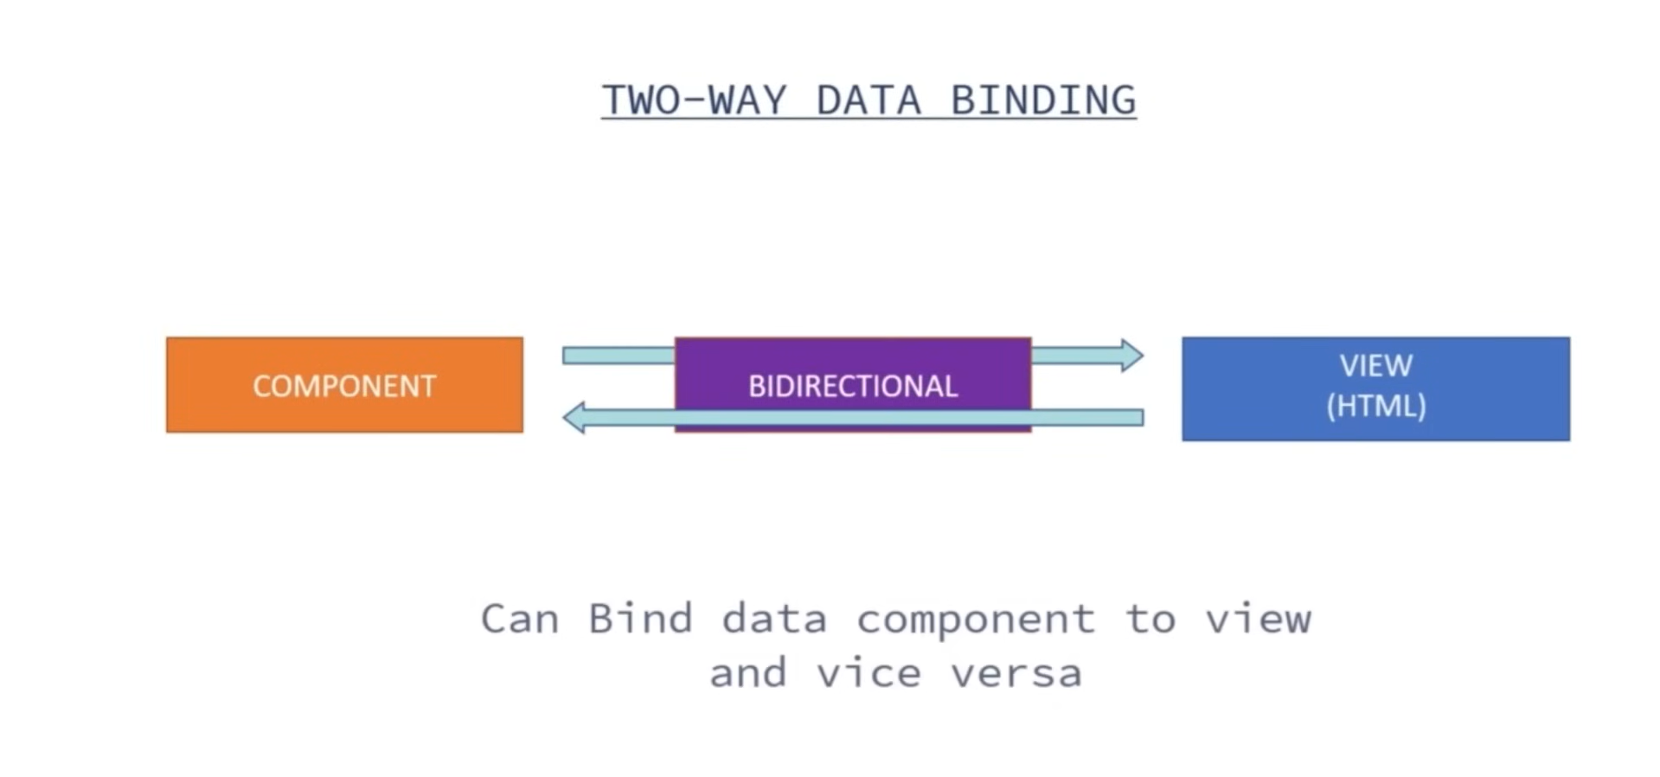

Angular 18:

What is Angular?

-> Angular is a front-end library built using java-script, developed and maintained by the Goole.

->SPA, single page application, an app that doesn’t need to reload the page during its use and works within a browser.

-> Angular CLI -> The angular cli is a command-line interface tool that is used to initialize, develop, scaffold, and maintain angular applications directly from a common shell.

What is Angular Directives?

->static website

-> Add additional behaviour to elements

->Manipulate the DOM

->Make application more dynamic and user-friendly.

