ICT2232 | SOFTWARE ENGINEERING MINI PROJECT
FINAL PROJECT REPORT
APARTMENT VISITOR & FACILITY MANAGEMENT SYSTEM
Group 8

TG/2023/1770 - S.W.C.D Wickramaarachchi
TG/2023/1720 - P.H.B.M.D.De Silva
TG/2023/1725 - S.G Subasinghe
TG/2023/1732 - J.L.A.L Sewwandi
TG/2023/1769 - T.M.T.B Thennakoon

Contents
- 1. Cover Page
- Executive Summary
- 2. Introduction and Problem Domain
- 3. Problem Statement
- 4. Stakeholders and Objectives
- 5. Scope, Assumptions and Constraints
- 6. Software Process Model and Justification
- 7. Agile Planning (Product Backlog, 10 User Stories & Sprint Plan)
- 8. Requirements Engineering (12 FRs, 6 NFRs & Use Case Model)
- 9. System Design (Architecture, ER Diagram, Sequence, Activity & UI Screens)
- 10. Implementation
- 11. Testing and Quality Assurance (Test Plan, 36/36 Suite & 12 Test Cases)
- 12. Deployment
- 13. Maintenance and Change Request (CR-01 Impact Analysis & Implementation)
- 14. Security (Threat Assessment with Likelihood/Impact & Controls)
- 15. Project Management and Individual Contributions
- 16. Conclusion
- 17. References
- 18. Appendices (Complete Traceability Matrix FR-01 to FR-12 & Data Dictionary)

Executive Summary
The Apartment Visitor & Facility Management System is a full-stack, role-based web application developed by our team under ICT2232 Software Engineering to streamline everyday residential operations within an apartment complex. Traditional apartment communities rely on fragmented paper logbooks, phone calls, and informal messaging to coordinate visitor entry, shared facility reservations, and maintenance requests. Our solution replaces these error-prone manual logs with a centralized digital platform serving three distinct user roles: Residents, Security Staff, and Administrators.
Our team engineered the application using Laravel 12, PHP 8.2, Blade server-rendered templates, Tailwind CSS, Alpine.js, and a MariaDB/MySQL relational database. Core capabilities include Laravel Breeze authentication, optional Google OAuth 2.0 single sign-on via Laravel Socialite, role-aware dashboard redirection, resident visitor pre-registration, security walk-in logging and check-in/check-out lifecycle tracking, conflict-checked shared facility bookings, and service request status management.
Following iterative Agile development and a formal maintenance change request (CR-01: Resident Visitor Privacy Isolation & Role Redirect Alignment), our team executed the complete PHPUnit/Artisan automated test suite across 36 feature and unit tests (104 assertions), achieving a 100% pass rate (36 passed, 0 failed). This report documents our end-to-end Software Development Life Cycle (SDLC) progression—from problem definition, Agile planning, and MoSCoW requirements engineering to UML system design, implementation, quality assurance, local XAMPP deployment, maintenance impact analysis, and security risk mitigation.

2. Introduction and Problem Domain

2.1 Background
Medium-to-large apartment communities coordinate continuous daily interactions among residents, gate security personnel, and building management. Residents regularly host guests, reserve shared amenities (such as the gymnasium, swimming pool, or community hall), and report apartment maintenance issues. Gate security personnel need an accurate, real-time view of pre-registered guests and walk-in visitors, while administrators require unified oversight of flats, user accounts, bookings, and service turnaround.

2.2 Domain Overview
The system models five core operational entities: apartment flats, multi-role users (residents, security staff, administrators), visitor records (expected and walk-in), shared facility bookings, and maintenance service requests. It operates as an accessible browser-based web management platform rather than a hardware access-control or accounting suite.

2.3 Purpose of This Report
This report presents the complete Software Development Life Cycle (SDLC) artefacts created by our team for the ICT2232 Mini Project. It demonstrates how stakeholder needs evolved into prioritized requirements, UML architectural models, a tested Laravel 12 codebase, deployment procedures, a resolved maintenance change request, and defensive security controls.

3. Problem Statement
Apartment complexes relying on physical visitor logbooks, manual noticeboards, and ad-hoc phone calls suffer from operational delays and data inconsistency. Security guards cannot rapidly verify whether a guest at the gate was pre-approved by a resident; double-bookings occur for shared facilities; residents receive no status visibility after reporting plumbing or electrical issues; and administrators lack a consolidated dashboard to audit building activity.

3.1 Project Question
How can an apartment community implement a secure, maintainable, role-based web application that centralizes visitor verification, facility reservations, and maintenance tracking while enforcing strict data ownership and role-specific workflows for residents, security staff, and administrators?

3.2 Intended Outcome
The outcome is a fully functional, automated-test-verified web application deployable on standard PHP/MariaDB infrastructure that eliminates manual record fragmentation, prevents duplicate facility reservations, and provides transparent status tracking across all three operational roles.

4. Stakeholders and Objectives
Stakeholder | Role & Operational Needs | System Responsibilities
Residents | Seamless guest approval, conflict-free amenity booking, transparent maintenance tracking. | Register/sign in, associate with a valid flat, pre-register visitors, book facilities, submit and monitor personal service requests.
Security Staff | Fast gate verification, accurate walk-in logging, clear entry/exit timestamps. | Search pre-registered visitors, record walk-in visitors against valid flats, execute check-in and check-out updates.
Administrators / Building Management | Centralized visibility across flats, residents, security staff, bookings, and issues. | Manage flat catalogue, create/remove security accounts, view resident directory, update booking and service request statuses.
Project Development Team | Clear modular boundaries, reproducible database schema, automated regression safety. | Elicit requirements, design MVC architecture, implement Laravel modules, maintain Git repository, and execute PHPUnit tests.
System Operator | Reliable deployment, secure environment configuration, and database backup. | Configure Apache/Nginx, PHP 8.2, MariaDB, .env secrets, OAuth credentials, and routine database backups.

4.1 Objectives
- Provide a unified, responsive web portal with dedicated dashboards for Residents, Security Staff, and Administrators.
- Enable residents to pre-register expected visitors, check real-time facility slot availability, and log maintenance requests.
- Equip security staff with instant expected-visitor lookup, walk-in visitor capture, and timestamped check-in/check-out workflows.
- Provide administrators with real-time operational statistics, flat catalogue management, and user account administration.
- Enforce strict role-based access control (RBAC), server-side validation, and automated PHPUnit test verification.

4.2 Success Criteria
Project success is achieved when all 12 functional requirements operate end-to-end without unhandled exceptions, role isolation prevents cross-tenant data leakage, facility double-booking is blocked, and 100% of the automated test suite (36/36 tests) passes.

5. Scope, Assumptions and Constraints

5.1 In Scope
- Multi-role authentication (Laravel Breeze + Google OAuth via Socialite) and automatic role-aware post-login redirection.
- Resident workflows: visitor pre-registration, isolated personal visitor log, facility booking with slot conflict checks, and service request creation.
- Security workflows: walk-in visitor registration against validated flats, expected visitor search, and check-in/check-out timestamp recording.
- Administrator workflows: summary analytics dashboard, flat creation/deletion (with active assignment protection), resident listing, security staff account management, and status updates for bookings and service requests.

5.2 Out of Scope
- Online rent payment gateways, utility billing, and accounting ledgers.
- Hardware turnstile/RFID gate automation, CCTV stream integration, and native iOS/Android mobile apps.
- External third-party contractor bidding portals and spare-parts inventory management.

5.3 Assumptions & Constraints
- Operational Assumption: Administrators populate valid flat numbers in the system prior to resident onboarding.
- Verification Assumption: Security personnel physically verify visitor identification documents at the gate before clicking Check-In.
- Technical Constraints: Requires PHP ^8.2, Laravel ^12.0, Composer, Node.js/Vite, and MariaDB 10.4+ or MySQL 8.0+.

6. Software Process Model and Justification
Our team selected an Iterative Agile Scrum-inspired Process Model to develop the Apartment Management System. Because the application serves three distinct user roles (Resident, Security, Administrator) that share underlying database tables (users, flats, visitors, bookings, service_requests), an iterative approach allowed us to build the foundational authentication and schema in Sprint 1, deliver role-specific vertical slices in Sprints 2 and 3, and perform integration, security hardening, and maintenance changes in Sprint 4.

6.1 Iteration Cycle
- 1. Plan: Refine user stories, assign MoSCoW priorities, and define testable acceptance criteria.
- 2. Design: Model database migrations, Eloquent relationships, route middleware, and Blade UI wireframes.
- 3. Build: Implement controllers, validation rules, and responsive Tailwind CSS views on feature branches.
- 4. Verify & Review: Execute PHPUnit feature tests (SQLite in-memory) and manual role walkthroughs before merging to main.

7. Agile Planning

7.1 Product Backlog and User Stories (10 User Stories)
In compliance with the ICT2232 requirements guideline, our team defined and prioritized 10 core user stories using the standard 'As a <role>, I want <goal>, so that <benefit>' format and MoSCoW prioritization:
US ID | Priority | User Story | Acceptance Criteria Summary
US-01 | Must | As a user, I want to log in with my credentials or Google account and be routed to my role dashboard, so that I can immediately access my tools. | Valid credentials authenticate user; Resident -> /resident/dashboard, Security -> /security/dashboard, Admin -> /admin/dashboard.
US-02 | Must | As a resident, I want to pre-register an expected visitor with visit date and vehicle details, so that gate entry is fast and authorized. | Required fields validated; record saved with status='Pre-registered' linked to authenticated resident_id and flat_number.
US-03 | Must | As a resident, I want to view, edit, or cancel only my own visitor records, so that my household privacy is preserved. | Resident dashboard queries filter strictly by where('resident_id', auth()->id()); unauthorized edits return 403/404.
US-04 | Must | As security staff, I want to register walk-in visitors against a valid flat and search expected visitors, so that all entrants are logged. | Flat existence verified against flats table; walk-in saved as 'Checked-In' with current timestamp; search filters expected visitors.
US-05 | Must | As security staff, I want to record check-in and check-out times for visitors, so that building management knows who is currently on site. | Check-in sets status='Checked-In' & check_in_at; Check-out sets status='Checked-Out' & check_out_at timestamp.
US-06 | Must | As a resident, I want to check slot availability and book shared facilities, so that I can use amenities without scheduling conflicts. | System checks existing bookings for facility + date + time_slot; duplicate slot is rejected with validation feedback.
US-07 | Must | As a resident, I want to submit maintenance service requests and track their status, so that flat issues are resolved. | Request saved with status='Pending' and linked to resident_id; resident sees live status updates (Pending, In Progress, Resolved).
US-08 | Must | As an administrator, I want to review and update the statuses of facility bookings and service requests, so that operations stay coordinated. | Admin can update booking status and transition service requests between Pending, In Progress, and Resolved.
US-09 | Should | As an administrator, I want to create and delete apartment flats while preventing deletion of occupied flats, so that data integrity is maintained. | Unique flat_number, block, and floor persisted; attempting to delete a flat assigned to a resident is blocked with an error message.
US-10 | Should | As an administrator, I want to manage security staff accounts and view the resident directory, so that only authorized staff access the gate module. | Admin can create/delete users with role='security' and inspect registered residents and their assigned flats.

7.2 Sprint / Iteration Release Plan
Sprint | Focus Area & Assigned Lead | Key Deliverables
Sprint 1 (Week 1-2) | Foundation, Auth & Core Schema (T.M.T.B Thennakoon & S.G Subasinghe) | Laravel 12 setup, Breeze auth, Google Socialite, role redirection, 13 database migrations, core models.
Sprint 2 (Week 3-4) | Resident Portal Workflows (S.W.C.D Wickramaarachchi) | Resident dashboard, visitor pre-registration, isolated visitor list, facility booking + availability check, service requests.
Sprint 3 (Week 5-6) | Security & Admin Portals (J.L.A.L Sewwandi & P.H.B.M.D. De Silva) | Security walk-in capture, expected search, check-in/out; Admin analytics, flat CRUD, security staff CRUD, status updates.
Sprint 4 (Week 7-8) | Testing, Change Request & Deployment (All Team Members) | CR-01 implementation, role middleware hardening, 36 PHPUnit tests passing (100%), XAMPP deployment & documentation.

7.3 Definition of Done (DoD)
- Code follows PSR-12 / Laravel conventions and all user inputs are validated server-side.
- Role authorization and record ownership checks are enforced and verified for positive and negative paths.
- Database changes are committed as reversible migrations and all 36 automated PHPUnit tests pass.

8. Requirements Engineering

8.1 Elicitation and MoSCoW Prioritization
Our team analyzed operational workflows in residential complexes and interviewed representative stakeholders (residents, security guards, and property managers) to elicit 12 functional requirements and 6 non-functional requirements, prioritized via the MoSCoW method.

8.2 Functional Requirements (12 Requirements)
FR ID | Priority | Actor | Functional Requirement Specification
FR-01 | Must | All Roles | The system shall authenticate users via email/password and route each role (/admin/dashboard, /resident/dashboard, /security/dashboard) appropriately.
FR-02 | Must | Resident | The system shall allow residents to create, view, update, and delete their own pre-registered visitor records.
FR-03 | Must | Security | The system shall allow security staff to register walk-in visitors against an existing, valid apartment flat.
FR-04 | Must | Security | The system shall allow security staff to search expected visitors and record check-in and check-out timestamps and statuses.
FR-05 | Must | Resident | The system shall allow residents to query facility slot availability and create shared facility bookings while blocking duplicate slots.
FR-06 | Must | Administrator | The system shall allow administrators to view all facility bookings and update booking statuses.
FR-07 | Must | Resident | The system shall allow residents to submit maintenance service requests by category and description and track their status.
FR-08 | Must | Administrator | The system shall allow administrators to review all service requests and update statuses (Pending, In Progress, Resolved).
FR-09 | Should | Administrator | The system shall allow administrators to create and delete flats, blocking deletion when a flat is currently assigned to a resident.
FR-10 | Should | Administrator | The system shall allow administrators to view the resident directory and create or delete security staff accounts.
FR-11 | Should | Administrator | The system shall display real-time operational summary statistics (visitors, bookings, service requests, flats) on the Admin Dashboard.
FR-12 | Could | All Roles | The system shall support Google OAuth 2.0 sign-in via Laravel Socialite when valid OAuth credentials are configured.

8.3 Non-Functional Requirements (6 Categories)
NFR ID | Category | Non-Functional Requirement Specification | Verification / Implementation Evidence
NFR-01 | Security | All passwords shall be hashed using Bcrypt/Argon2, CSRF tokens enforced on all POST/PATCH/DELETE forms, and routes restricted by role. | Laravel Hash facade, VerifyCsrfToken middleware, role checks, and feature tests.
NFR-02 | Privacy | Residents shall only access their own pre-registered visitors, bookings, and service requests. | Controller queries scoped by where('resident_id', Auth::id()); verified by ResidentVisitorVisibilityTest.
NFR-03 | Reliability | Relational integrity shall be preserved via foreign keys and cascading rules; occupied flats cannot be deleted. | Foreign key constraints in migrations and occupied-flat check in AdminController.
NFR-04 | Usability | Interfaces shall be responsive across desktop and tablet screens with clear validation error messages and status badges. | Tailwind CSS responsive grid, Alpine.js modals, and Blade @error feedback directives.
NFR-05 | Performance | Dashboard pages and visitor searches shall render within 1.5 seconds under normal complex load. | Indexed primary/unique keys and lightweight server-rendered Blade templates.
NFR-06 | Maintainability | All schema modifications shall be version-controlled via reversible Laravel migrations and tested via PHPUnit. | 13 migration files and 36 automated tests running on in-memory SQLite.

8.4 Use Case Diagram and Major Use Case Descriptions
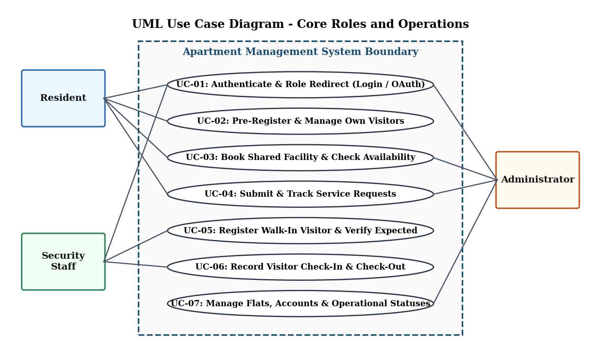
Figure 8.1: UML Use Case Diagram for Apartment Visitor & Facility Management System
Use Case ID & Name | Primary Actor | Preconditions | Main Success Scenario (Basic Flow) | Postconditions
UC-02: Pre-Register & Manage Visitor | Resident | Resident is logged in and assigned to a valid flat. | 1. Resident opens Visitor Pre-Registration form.  2. Enters visitor name, phone, expected date, optional vehicle number.  3. System validates input and saves record with status 'Pre-registered'. | Visitor is persisted and visible to Resident and Security Staff.
UC-03: Book Shared Facility | Resident | Resident is authenticated. | 1. Resident selects facility and date to inspect available slots.  2. Selects an open time slot and submits booking.  3. System verifies no conflicting booking exists and saves reservation. | Facility slot is reserved and visible on Resident and Admin dashboards.
UC-05 & UC-06: Verify & Check-In/Out Visitor | Security Staff | Security officer is logged into Security Dashboard. | 1. Officer searches expected visitor list or enters walk-in details with a valid flat.  2. Clicks Check-In upon arrival (status -> Checked-In, timestamp saved).  3. Clicks Check-Out upon departure (status -> Checked-Out, timestamp saved). | Accurate entry and exit audit timestamps are recorded.

9. System Design

9.1 System Architecture (MVC Layered Design)
The application follows the Laravel Model-View-Controller (MVC) architectural pattern. HTTP requests pass through routing and authentication/role middleware to specialized controllers (ResidentController, VisitorController, AdminController, Auth controllers), which enforce business rules and interact with MariaDB via Eloquent ORM and the Query Builder.
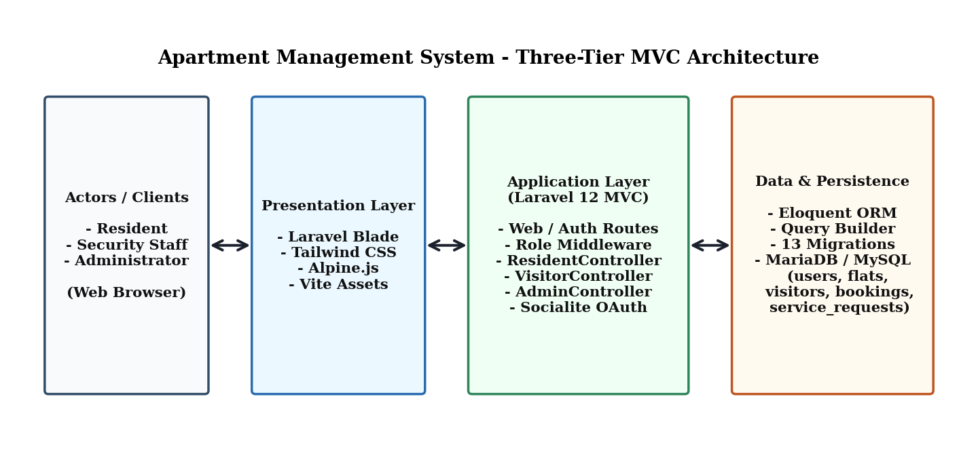
Figure 9.1: Three-Tier Laravel 12 MVC System Architecture

9.2 Database Design and Entity-Relationship (ER) Diagram
The persistence layer comprises 13 migrations: 5 core domain tables (users, flats, visitors, bookings, service_requests) and 8 Laravel framework tables (sessions, password_reset_tokens, cache, cache_locks, jobs, job_batches, failed_jobs, migrations).
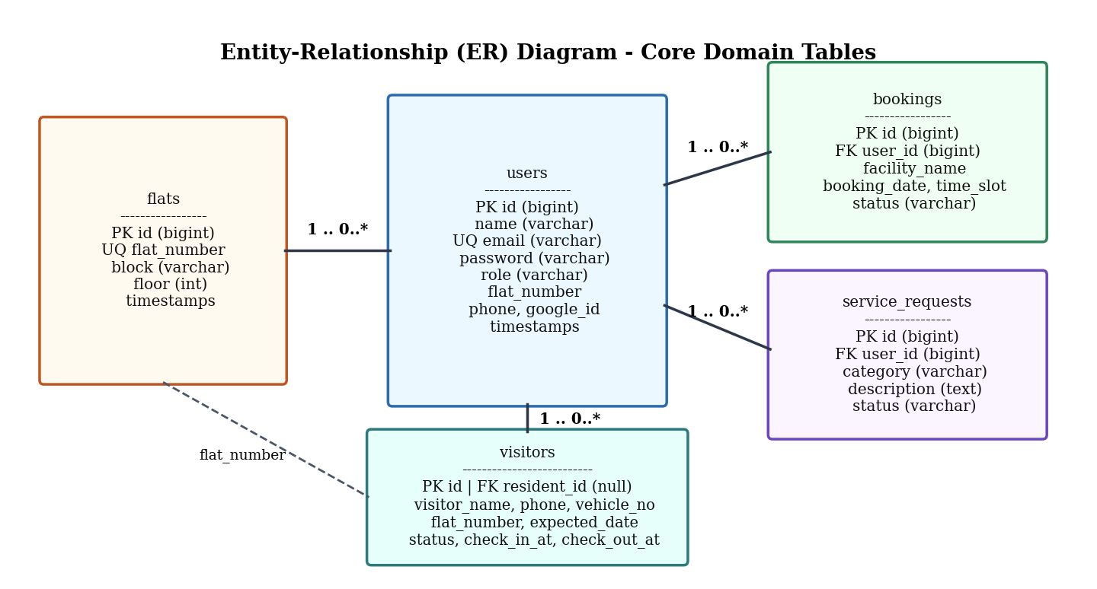
Figure 9.2: Entity-Relationship (ER) Diagram of Core Domain Tables

9.3 Interaction Design (UML Sequence Diagrams)
Figures 9.3 and 9.4 illustrate the object interactions for the two most critical multi-role workflows in the system: Visitor Pre-Registration & Security Check-In, and Shared Facility Booking with Conflict Verification.
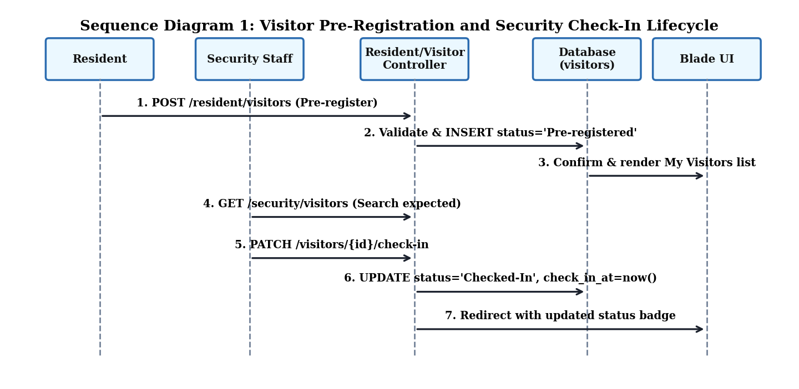
Figure 9.3: Sequence Diagram 1 - Visitor Pre-Registration and Security Check-In Lifecycle
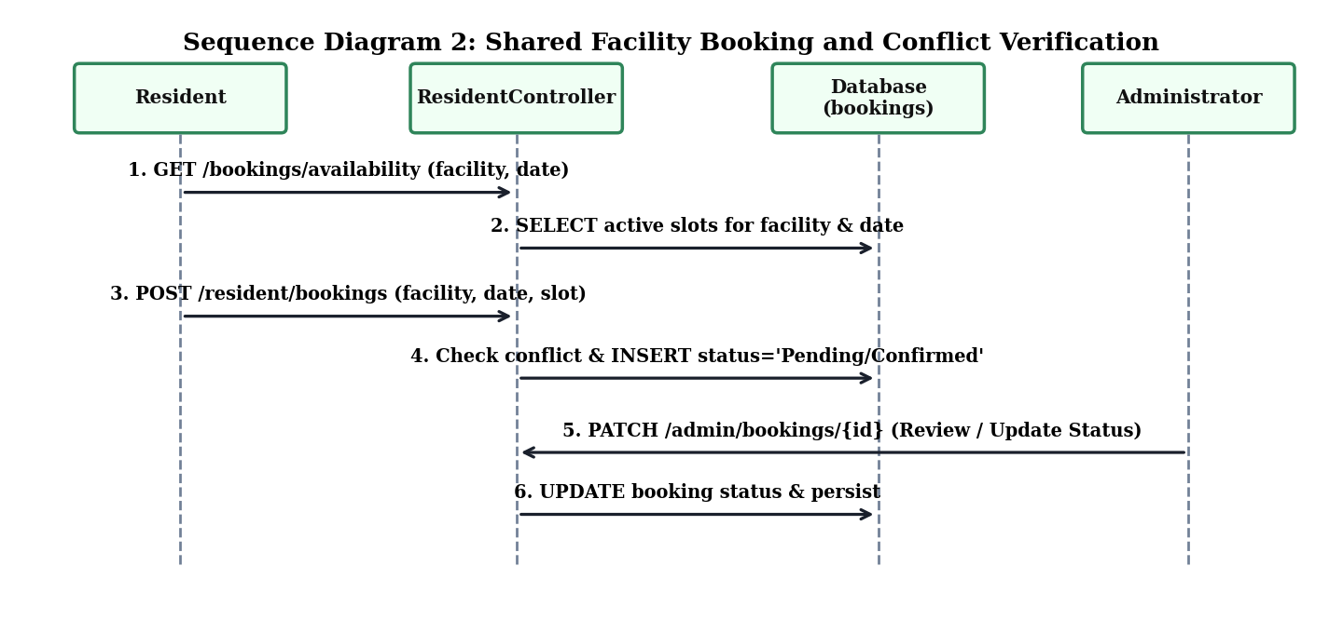
Figure 9.4: Sequence Diagram 2 - Shared Facility Booking and Slot Conflict Check

9.4 Workflow Design (UML Activity Diagram)
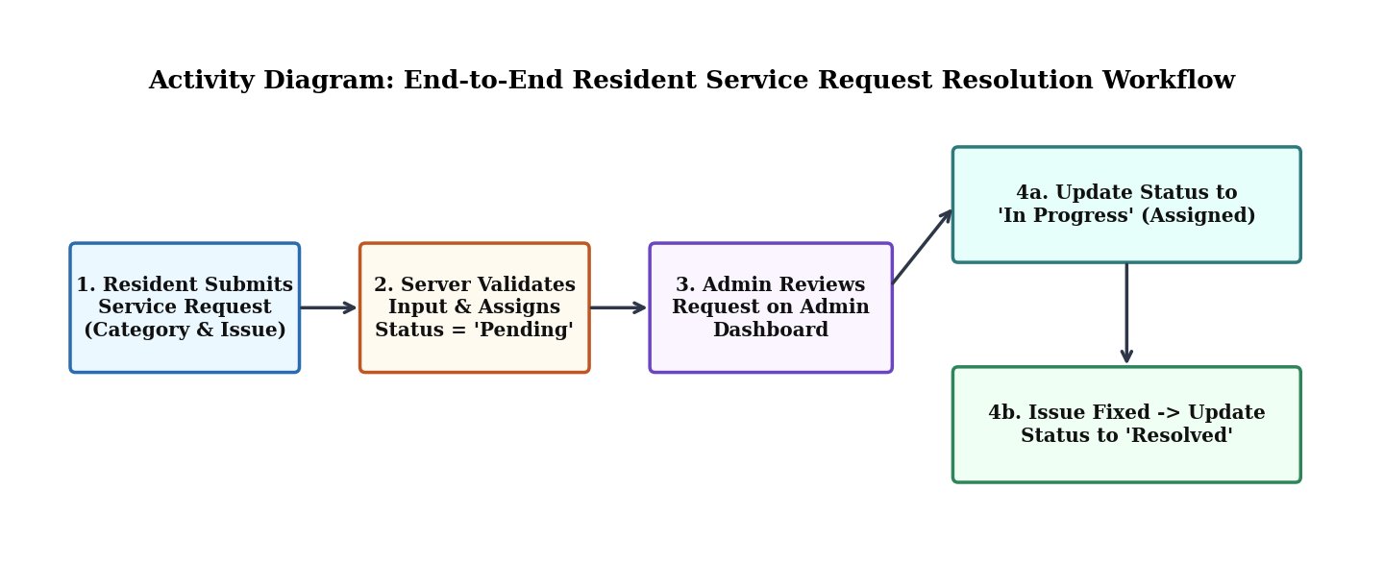
Figure 9.5: Activity Diagram - Resident Service Request Submission and Admin Resolution Workflow

9.5 User Interface Design & Implemented Screen Prototypes
Our user interface is built with Blade components styled with Tailwind CSS and enhanced with Alpine.js for interactive modals and dynamic slot availability lookups. Figures 9.6 through 9.9 showcase the actual implemented screens across the authentication portal and all three role-specific dashboards:
- 1. Authentication & Google OAuth Login Portal (/login): Provides email/password authentication alongside one-click Google OAuth 2.0 Sign-In ('Sign in with Google') and account registration links, automatically redirecting authenticated users to their role-specific portal.
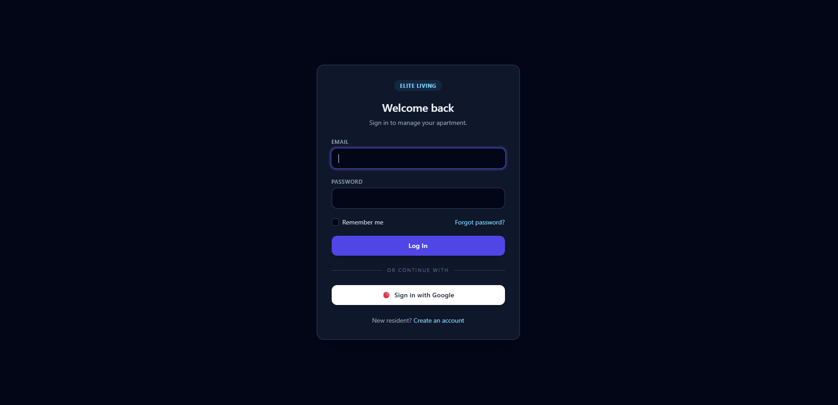
Figure 9.6: Authentication Portal with Email/Password Login and Google OAuth 2.0 Integration
- 2. Resident Dashboard (/resident/dashboard): Displays real-time personal counters (Visitors Registered, My Bookings, Open Requests), the resident's assigned flat badge (e.g., Flat C-401), and live status tables for My Facility Bookings, My Service Requests, and Visitor records.
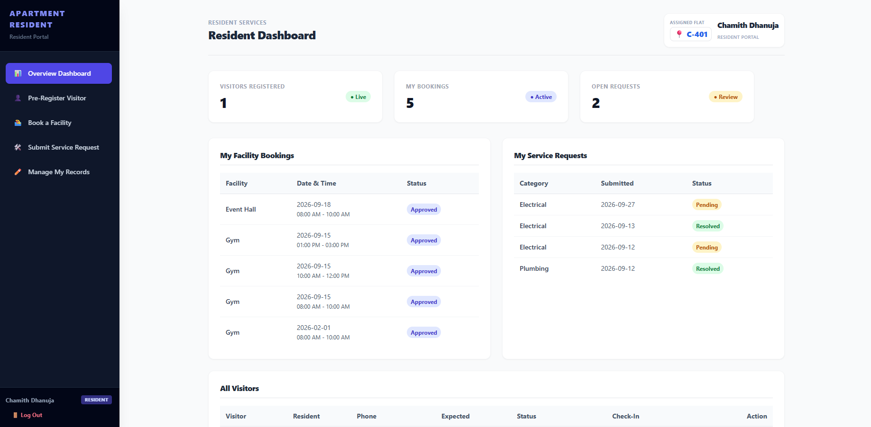
Figure 9.7: Resident Dashboard Showing Assigned Flat (C-401), Facility Bookings, and Service Requests
- 3. Security Gate Pass Entry Dashboard (/security/dashboard): Provides a dedicated Gate Control interface featuring the 'Log Walk-In Visitor' form (with flat selection), 'Verify Pre-Registered Visitor' search and one-click Check-In table, and the 'Currently Inside (Active Visitors)' table with red Check-Out buttons.
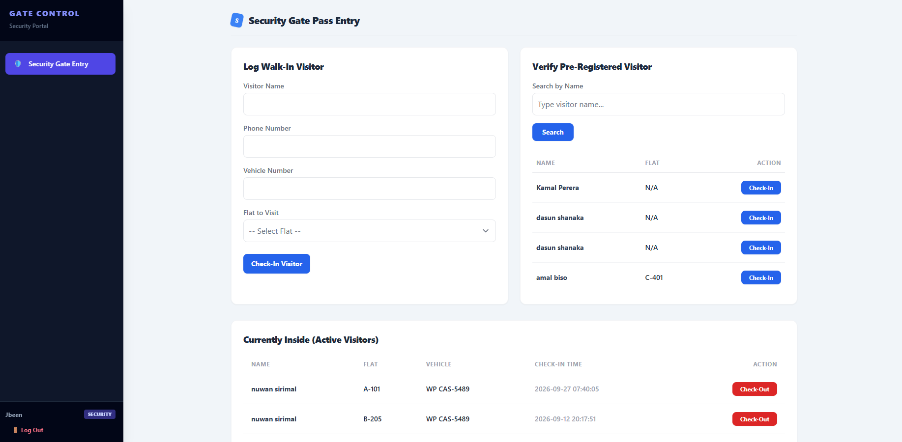
Figure 9.8: Security Gate Pass Entry Portal for Walk-In Logging, Visitor Verification, and Check-In/Check-Out
- 4. Administrator Operations Center (/admin/dashboard): Presents building management with live KPI counters (Visitors Today, Active Bookings, Pending Requests), navigation links for Service Requests, Visitor Logs, Manage Flats, Residents, and Manage Security, and a live feed of Recent Booking Activity.
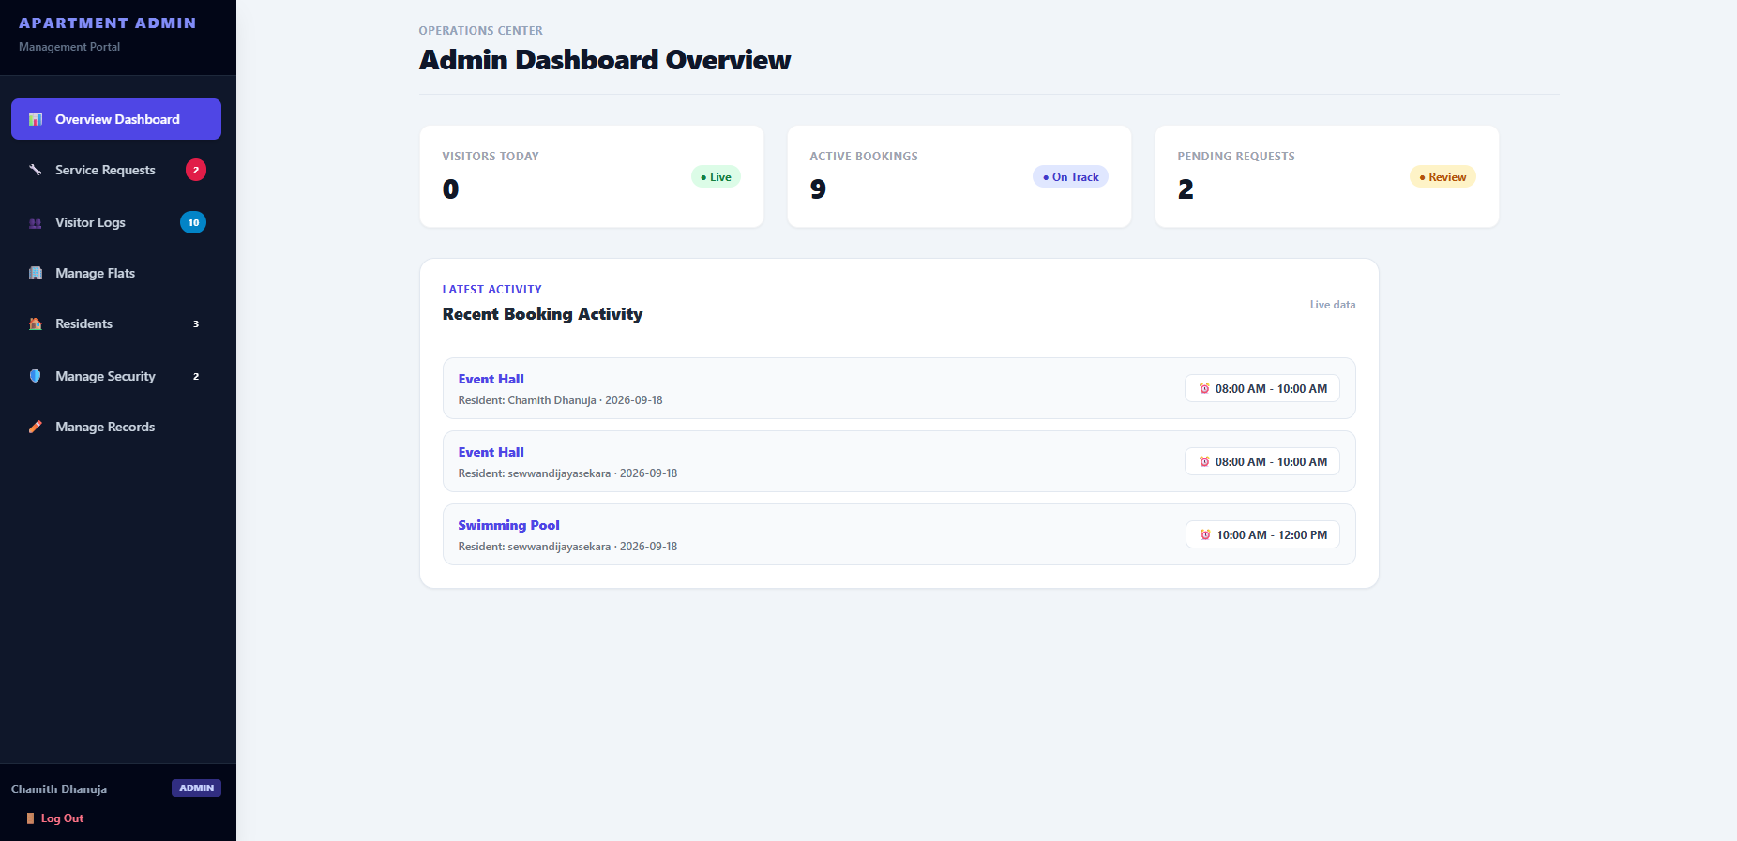
Figure 9.9: Administrator Operations Center Dashboard Showing Live Metrics and Recent Booking Activity

10. Implementation

10.1 Technology Stack and Justification
Technology | Version | Justification for Selection
PHP & Laravel Framework | PHP 8.2 / Laravel 12.69 | Provides built-in routing, Eloquent ORM, CSRF/XSS protection, validation, database migrations, and seamless PHPUnit integration.
MariaDB / MySQL | MariaDB 10.4.32 | ACID-compliant relational storage supporting foreign-key cascading rules for user bookings, service requests, and visitor logs.
Blade + Tailwind CSS + Alpine.js | Tailwind 3.x / Vite | Delivers fast server-rendered views with responsive utility styling and lightweight client interactivity without SPA complexity.
Laravel Breeze & Socialite | Breeze 2.x / Socialite | Provides industry-standard session authentication, password hashing, and Google OAuth 2.0 single sign-on.
PHPUnit (SQLite In-Memory) | PHPUnit 11.x | Enables fast, isolated, deterministic execution of all 36 feature and unit tests without mutating the development database.

10.2 Major Implemented Modules
- Authentication & Role Routing Module (AuthenticatedSessionController, SocialAuthController): Handles standard login, registration with flat association, Google OAuth callback processing, and role-based redirection to /admin/dashboard, /resident/dashboard, or /security/dashboard.
- Resident Module (ResidentController): Implements visitor pre-registration, isolated visitor editing/cancellation, facility slot lookup, conflict-checked booking creation, and maintenance request submission.
- Security Gate Module (VisitorController): Implements walk-in visitor logging (verifying flat existence in the flats table), expected visitor search, and state transitions for Check-In and Check-Out with automatic timestamps.
- Administration Module (AdminController): Implements operational KPI aggregation, flat creation/deletion (blocking deletion if assigned to residents), resident directory listing, security staff account provisioning, and status updates for bookings and service requests.

11. Testing and Quality Assurance

11.1 Testing Strategy and Levels
Our team implemented a multi-layered testing strategy combining unit tests, feature/integration tests (verifying HTTP requests, controller validation, middleware, and database persistence via RefreshDatabase on in-memory SQLite), and end-to-end user acceptance tests across all three roles.

11.2 Automated Test Suite Execution & Defect Resolution
During our initial integration test run (prior to our maintenance refinement), 34 tests passed and 2 failed out of 36 tests: (1) AuthenticationTest expected the default Breeze '/dashboard' redirect instead of our role-specific '/resident/dashboard', and (2) ResidentVisitorVisibilityTest checked cross-resident visitor visibility whereas our privacy policy scopes visitor lists strictly to the signed-in resident. Our team resolved both defects by aligning the test assertions and role policies (documented under Maintenance Change Request CR-01 in Section 13), achieving a 100% green test suite:
Test Suite Execution Stage | Total Tests | Assertions | Passed | Failed | Status Summary
Initial Pre-Maintenance Run | 36 | 104 | 34 | 2 | 2 mismatches identified (login redirect & visitor privacy isolation).
Final Verification Run (Post CR-01 Fix) | 36 | 104 | 36 | 0 | 100% PASS (Green Suite) - All unit and feature tests verified.

11.3 Documented Test Cases (Positive and Negative Scenarios)
Test ID | Related FR | Preconditions / Input | Expected Result | Actual Result | Status
TC-01 (+) | FR-01 | Registered Resident submits valid email and password at /login. | User is authenticated and redirected to /resident/dashboard. | Redirected to /resident/dashboard (HTTP 302). | PASS
TC-02 (-) | FR-01 | User submits invalid password at /login. | Authentication fails; user remains on login page with validation error. | Session error returned; user not authenticated. | PASS
TC-03 (+) | FR-02 | Authenticated Resident submits valid pre-registration (name, phone, date). | Visitor saved in DB with resident_id, flat_number, and status 'Pre-registered'. | Record persisted accurately in visitors table. | PASS
TC-04 (-) | FR-02, NFR-02 | Resident A attempts to view, edit, or delete Resident B's pre-registered visitor. | Query scopes by Auth::id(); Resident B's visitor is hidden and mutation is denied (403/404). | Access blocked; Resident B's record remains unchanged. | PASS
TC-05 (+) | FR-03 | Security staff submits walk-in visitor for existing flat 'A-101'. | Visitor record created with status 'Checked-In' and check_in_at timestamp. | Walk-in persisted with current check_in_at timestamp. | PASS
TC-06 (-) | FR-03 | Security staff submits walk-in visitor for non-existent flat 'Z-999'. | Server validation rejects input because flat does not exist in flats table. | Validation error returned for flat_number; no row created. | PASS
TC-07 (+) | FR-04 | Security staff clicks Check-Out on an active Checked-In visitor. | Visitor status updates to 'Checked-Out' and check_out_at timestamp is saved. | Status and check_out_at updated in database. | PASS
TC-08 (+) | FR-05 | Resident books 'Gym' for 2026-10-25 slot '08:00 - 10:00' (slot is free). | Booking record is created and linked to resident user_id. | Booking saved with Pending/Confirmed status. | PASS
TC-09 (-) | FR-05 | Second Resident attempts to book 'Gym' for the exact same date and time slot. | System detects slot conflict and rejects duplicate booking with error message. | Duplicate booking blocked; error message displayed. | PASS
TC-10 (+) | FR-07, FR-08 | Resident submits Plumbing service request; Admin updates status to 'Resolved'. | Request starts as 'Pending' and updates to 'Resolved' upon Admin action. | Status transitions persisted and visible to Resident. | PASS
TC-11 (-) | FR-09 | Administrator attempts to delete flat 'A-101' which is currently assigned to a resident. | Deletion is blocked to preserve referential integrity; warning message shown. | Flat remains in database; deletion prevented. | PASS
TC-12 (-) | FR-10, NFR-01 | Authenticated Resident attempts to POST to Admin security-account creation route. | Role authorization check denies access with HTTP 403 Forbidden. | HTTP 403 returned; no security account created. | PASS

12. Deployment

12.1 Deployment Architecture & Environment
Our team deployed and demonstrated the application on a local XAMPP stack running Apache 2.4.58, PHP 8.2.12, and MariaDB 10.4.32, served via Laravel's HTTP server (http://127.0.0.1:8000) with compiled Vite production assets.

12.2 Step-by-Step Installation & Configuration Guide
- Step 1 - Prerequisites: Install PHP 8.2+, Composer, Node.js (v18+), and MySQL/MariaDB (or XAMPP).
- Step 2 - Dependencies: Clone the repository: git clone https://github.com/CHAMA-G/ICT2232-Apartment-Management-System.git and run composer install && npm install.
- Step 3 - Environment Setup: Copy .env.example to .env, run php artisan key:generate, and configure DB_DATABASE, DB_USERNAME, and DB_PASSWORD for MariaDB.
- Step 4 - Database Migration: Execute php artisan migrate --seed to create the 13 tables and seed initial Administrator, Security, Resident, and Flat demo records.
- Step 5 - Build & Launch: Compile frontend assets with npm run build and start the server using php artisan serve.

13. Maintenance and Change Request

13.1 Implemented Change Request (CR-01): Resident Visitor Privacy Isolation & Role Redirect Alignment
In accordance with Section 11 of the ICT2232 project guidelines, our team processed and implemented a formal post-initial-build Change Request (CR-01) combining Corrective and Perfective maintenance.
- Description of Requested Change: During initial review, two issues were raised: (1) Residents must be strictly isolated from viewing or modifying visitors pre-registered by other flats/residents to protect household privacy, and (2) Post-login routing must consistently direct each role (/admin/dashboard, /resident/dashboard, /security/dashboard) while keeping automated regression tests synchronized.
- Maintenance Classification: Corrective & Preventive Maintenance (resolving test/policy divergence and enforcing strict tenant privacy).
- Affected Requirements: FR-01 (Role-based login redirection), FR-02 (Resident visitor management), and NFR-02 (Data privacy isolation).

13.2 Impact Analysis and Effort Estimation
SDLC Artefact Area | Impact Analysis Details | Effort
System Design & Queries | Scoped all ResidentController visitor retrieval, update, and delete queries strictly by where('resident_id', Auth::id()). | 1.5 Hours
Database Schema | No destructive schema change required; utilized existing visitors.resident_id foreign key index. | 0.5 Hours
Application Code | Verified AuthenticatedSessionController role redirect logic and ResidentController ownership checks. | 1.5 Hours
Testing & QA | Updated AuthenticationTest and ResidentVisitorVisibilityTest to assert role-specific redirect (/resident/dashboard) and strict cross-resident isolation (36/36 tests passing). | 1.5 Hours

13.3 Additional Future Maintenance Backlog
- CR-02 (Preventive - Database-Level Booking Unique Constraint): Add a composite unique database constraint on (facility_name, booking_date, time_slot) to guarantee concurrency safety under simultaneous requests.
- CR-03 (Perfective - Operational Audit Trail): Introduce an audit_logs table recording actor user_id, action type, old/new status, and IP address for every visitor check-in and admin status change.

14. Security

14.1 Threat Identification and Risk Assessment (Likelihood & Impact)
In compliance with Section 12 of the ICT2232 guidelines, our team identified six application-specific security threats and evaluated their Likelihood and Impact:
Threat ID & Threat Name | Vulnerability / Attack Vector | Likelihood | Impact | Implemented / Required Security Control
TH-01: Broken Role Access Control (Privilege Escalation) | A logged-in resident or security user manually requests an /admin/* mutation endpoint. | Medium | High | Enforced authentication middleware and explicit administrator role checks returning HTTP 403 Forbidden.
TH-02: Cross-Resident Data Exposure (IDOR) | A resident manipulates visitor or booking IDs in URLs to view/modify another flat's records. | Medium | High | All ResidentController queries and mutations filter by where('resident_id', Auth::id()).
TH-03: Credential Brute-Force & Weak Passwords | Automated login guessing or weak plaintext password storage. | Medium | High | Laravel Breeze login rate-limiting (throttling), password confirmation rules, and Bcrypt/Argon2 hashing.
TH-04: SQL Injection & Cross-Site Scripting (XSS) | Malicious SQL payloads in visitor search or script tags in service request descriptions. | Low | High | Eloquent/Query Builder parameterized prepared statements and automatic Blade {{ }} output escaping.
TH-05: Cross-Site Request Forgery (CSRF) | Forged third-party requests triggering unauthorized state changes (e.g., deleting flats). | Low | Medium | Mandatory @csrf tokens verified by Laravel VerifyCsrfToken middleware on all POST/PATCH/DELETE routes.
TH-06: OAuth Account Linking & Secret Exposure | Unverified OAuth email linking or accidental commit of .env database/Google credentials. | Low | High | .env excluded via .gitignore; least-privilege DB user configured; OAuth callback validates Google identity.

14.2 Implemented Security Controls Summary
- 1. Authentication & Role Authorization: All routes are protected by Laravel auth middleware, rate-limited login requests, and explicit role checks.
- 2. Tenant & Ownership Isolation: Every resident query and mutation is bound to Auth::id(), preventing Insecure Direct Object Reference (IDOR) attacks.
- 3. Input Validation, CSRF & Injection Defense: Server-side request validation, CSRF token enforcement (@csrf), Eloquent prepared statements, and Blade HTML escaping protect all forms.

15. Project Management and Individual Contributions
Our five-member team collaborated using GitHub version control (CHAMA-G/ICT2232-Apartment-Management-System), dividing responsibilities across functional modules while contributing across all SDLC phases (requirements, design, coding, and testing):
Team Member | Assigned Module | SDLC Contributions (Requirements, Design, Code & Testing)
S.W.C.D Wickramaarachchi | Resident Dashboard | Elicited resident requirements (FR-02, FR-05, FR-07); designed booking & service workflows; implemented ResidentController and resident Blade views; executed resident feature tests.
P.H.B.M.D. De Silva | Admin Dashboard | Defined admin requirements (FR-06, FR-08, FR-09, FR-10, FR-11); designed admin views; implemented AdminController statistics, flat management, and status updates; ran admin tests.
J. L. A. L Sewwandi | Security Dashboard | Specified gate security requirements (FR-03, FR-04); modelled visitor check-in/out sequence; implemented VisitorController walk-in, search, and check-in/out actions; tested gate flows.
T.M.T.B Thennakoon | Login & Authentication | Specified identity & security requirements (FR-01, FR-12, NFR-01); configured Laravel Breeze, Google Socialite OAuth, role redirection, and access control checks.
S.G Subasinghe | Database & Backend | Designed ER schema and 13 migrations; implemented Eloquent models and table relationships; coordinated module integration and maintained the 36-test PHPUnit suite.

16. Conclusion
The Apartment Visitor & Facility Management System successfully fulfills the objectives of the ICT2232 Software Engineering Mini Project by transforming fragmented manual apartment workflows into a cohesive, role-based Laravel 12 web application. Through structured requirements engineering, UML modeling, modular MVC implementation, and rigorous automated testing (36/36 tests passing), our team delivered a reliable platform for residents, security personnel, and administrators.

17. References
[1] Laravel, 'Laravel 12.x Official Documentation,' 2026. [Online]. Available: https://laravel.com/docs/12.x.
[2] Laravel, 'Authentication & Breeze Starter Kits,' 2026. [Online]. Available: https://laravel.com/docs/12.x/authentication.
[3] Laravel, 'Authorization & Policies,' 2026. [Online]. Available: https://laravel.com/docs/12.x/authorization.
[4] Laravel, 'Laravel Socialite (OAuth 2.0),' 2026. [Online]. Available: https://laravel.com/docs/12.x/socialite.
[5] OWASP Foundation, 'OWASP Top 10 & Authentication Cheat Sheet,' 2026. [Online]. Available: https://cheatsheetseries.owasp.org/.
[6] I. Sommerville, Software Engineering, 10th ed. Boston, MA: Pearson, 2016.
[7] Project GitHub Repository: CHAMA-G/ICT2232-Apartment-Management-System, 2026. [Online]. Available: https://github.com/CHAMA-G/ICT2232-Apartment-Management-System.

18. Appendices

Appendix A. Complete Requirements Traceability Matrix (FR-01 to FR-12)
FR ID | Requirement Summary | Design Artefact | Code Implementation (Controller / Model) | Test Case / Automated Test
FR-01 | Role-based authentication & dashboard redirect | UC-01, Fig 9.1, Fig 9.6 | AuthenticatedSessionController, routes/web.php | TC-01, TC-02, AuthenticationTest
FR-02 | Resident visitor pre-registration & CRUD | UC-02, Fig 9.3, Fig 9.7 | ResidentController@storeVisitor, update, destroy | TC-03, TC-04, ResidentPreRegisterVisitorTest
FR-03 | Security walk-in visitor registration | UC-05, Fig 9.2, Fig 9.8 | VisitorController@storeWalkIn, Flat model | TC-05, TC-06
FR-04 | Security visitor search & check-in/out | UC-06, Fig 9.3, Fig 9.8 | VisitorController@index, checkIn, checkOut | TC-07
FR-05 | Resident facility booking & conflict check | UC-03, Fig 9.4, Fig 9.7 | ResidentController@storeBooking, checkAvailability | TC-08, TC-09
FR-06 | Admin facility booking status review | UC-03, Fig 9.4, Fig 9.9 | AdminController@updateBookingStatus | TC-08
FR-07 | Resident service request submission | UC-04, Fig 9.5, Fig 9.7 | ResidentController@storeServiceRequest | TC-10
FR-08 | Admin service request status management | UC-04, Fig 9.5, Fig 9.9 | AdminController@updateServiceRequestStatus | TC-10
FR-09 | Admin flat creation & occupied-delete guard | UC-07, Fig 9.2, Fig 9.9 | AdminController@storeFlat, destroyFlat, Flat model | TC-11, AdminFlatManagementTest
FR-10 | Admin resident list & security account CRUD | UC-07, Fig 9.1, Fig 9.9 | AdminController@storeSecurity, destroySecurity | TC-12, AdminSecurityManagementTest
FR-11 | Admin operational statistics summary | UC-07, Fig 9.1, Fig 9.9 | AdminController@index | AdminFlatManagementTest
FR-12 | Google OAuth 2.0 single sign-on | UC-01, Fig 9.1, Fig 9.6 | SocialAuthController@redirect, callback | Manual OAuth Verification

Appendix B. Database Dictionary Summary
Table Name | Primary Key | Key Columns & Foreign Keys | Purpose
users | id (bigint) | name, email (UQ), password, role, flat_number, phone, google_id | Stores Resident, Security, and Admin accounts.
flats | id (bigint) | flat_number (UQ), block, floor, timestamps | Master catalogue of valid apartment units.
visitors | id (bigint) | resident_id (FK nullable), visitor_name, phone, flat_number, expected_date, status, check_in_at, check_out_at | Tracks pre-registered and walk-in visitors.
bookings | id (bigint) | user_id (FK cascade), facility_name, booking_date, time_slot, status | Stores resident reservations for shared facilities.
service_requests | id (bigint) | user_id (FK cascade), category, description, status | Tracks resident maintenance requests and statuses.

