A 7T Security Oriented SRAM Bit cell

Usage Instruction

Times New Roman | The normal text in this document should be in Times New Roman
Italics | Used for emphasis
Blue Underline | Hypertext link within the document

Table of Contents
1. Introduction 5
1.1 Purpose 5
1.2 Target Audience 5
1.3 References 5
1.4 Abbreviations 5
2. Introduction to VLSI design: 6
2.1 What is VLSI? 6
2.1.1 Dealing with VLSI Circuits 6
2.1.2 Introduction to VHDL 7
Limitations of traditional programming languages 7
2.1.3 Electronic Design Automation 9
2.1.4 Field-Programmable Gate Array 10
3. Project 13
3.1 Abstract: 13
3.2 Literature survey: 13
3.3 Existing System: 16
3.4 Disadvantages: 20
3.5 Proposed System: 20
3.5.1 SRAM 20
3.5.2 Power Analysis Based Side Channel Attack 20
3.5.3 SPA 20
3.5.4 DPA 21
3.5.5 Countermeasure 21
3.5.6 Power Analysis Resistant 7t Sram 21
3.5.7 Basic Operation 22
3.5.8 Power Analysis 23
3.6 Advantages: 24
4. Comparison 25
5. Software Requirement 27
5.1 Schematic edit tool (s-edit) 27
5.2 T-spice pro circuit analysis 28
5.3 Waveform edit 31
5.4 Layout (l-edit): 32
6. S edit output 35
7. W-edit output 39
8. Area, Power and Results 41
9. Reference 45

List of Figures

Figure 1 : Summary of VHDL design flow 9
Figure 2 : FPGA Architecture 11
Figure 3 : Examples of FPGA Packages 12
Figure 4:Schematic representation of 6T SRAM. 18
Figure 5: Current consumed during write ‘1’ and ‘0’ operations to a 6T SRAM. 19
Figure 6: Write energy distribution of a 6T SRAM during write operations under process variations. 19
Figure 7: Proposed 7T SRAM. 22
Figure 9:Waveform of 7T SRAM during Write operation. 23
Figure 10: Current consumed during write ‘1’ and ‘0’ operations to the 7T cell. 24
Figure 11: Write energy distribution of the proposed 7T SRAM during a write operation under process variations. 24

List of Tables
Table 1 : Comparisons of 7T Security Oriented SRAM Bit Cell 25

Introduction
  - Purpose
The document designed for VLSI reference with Project and software implementation.
  - Target Audience
For client and student verification
  - References
- RTL HARDWARE DESIGN USING VHDL Coding for Efficiency, Portability, and Scalability
- Circuit Design with VHDL Volnei A. Pedroni
- Spartan-6 Family Overview
- Modelsim® User’s Manual Software Version 6.5b
  - Abbreviations
VLSI | Very Large Scale Integrated Circuits
HDL | Hardware Description Language
VHDL | VHSIC Hardware Description Language
VHSIC | Very High Speed Integrated Circuits
IEEE | Institute Of Electrical And Electronic Engineers
VITAL | VHDL Initiative Towards Ask Libraries
RTL | Register Transfer Level
WAVES | Waveform And Vector Exchange to Support Design and Test Verification
PLA | Programmable Logic Array
PAL | Programmable Array Logic
CPLD | Complex Programmable Logic Devices
CLB | Configurable Logic Blocks
ISE | Integrated Software Environment
EDA | Electronic Design Automation
FPGA | Field-Programmable Gate Array

Introduction to VLSI design:
  - What is VLSI?
VLSI stands for "Very Large Scale Integration". This is the field which involves packing more and more logic devices into smaller and smaller areas. VLSI, circuits that would have taken board furls of space can now be put into a small space few millimeters across! VLSI circuits are everywhere ... your computer, your car, your brand new state-of-the-art digital camera, the cell-phones, and what have you. All this involves a lot of expertise on many fronts within the same field, which we will look at in later sections.
    - Dealing with VLSI Circuits

The way normal blocks like latches and gates are implemented is different from what students have seen so far, but the behavior remains the same. All the miniaturization involves new things to consider. A lot of thought has to go into actual implementations as well as design.

Circuit Delays: Large complicated circuits running at very high frequencies have one big problem to tackle - the problem of delays in propagation of signals through gates and wire even for areas a few micrometers across! The operation speed is so large that as the delays add up, they can actually become comparable to the clock speeds.

Power: Another effect of high operation frequencies is increased consumption of power. This has two-fold effect - devices consume batteries faster, and heat dissipation increases. Coupled with the fact that surface areas have decreased, heat poses a major threat to the Stability of the circuit itself.

Layout: Laying out the circuit components is task common to all branches of electronics. What’s so special in our case is that there are many possible ways to do this; there can be multiple layers of different materials on the same silicon, there can be different arrangements of the smaller parts for the same component and soon. The choice between the two is determined by the way we chose the layout the circuit components. Layout can also affect the fabrication of VLSI chips, making it either easy or difficult to implement the components on the silicon.
    - Introduction to VHDL

A digital system can be described at different levels of abstraction and from different points of view. An HDL should faithfully and accurately model and describe a circuit, whether already built or under development, from either the structural or behavioral views, at the desired level of abstraction. Because HDLs are modeled after hardware, their semantics and use are very different from those of traditional programming languages.

Limitations of traditional programming languages

There are wide varieties of computer programming languages, from Frontend to C to Java. Unfortunately, they are not adequate to model digital hardware. To understand their limitations, it is beneficial to examine the development of a language. A programming language is characterized by its syntax and semantics. The syntax comprises the grammatical rules used to write a program, and the semantics is the “meaning” associated with language constructs. When a new computer language is developed, the designers first study the characteristics of the underlying processes and then develop syntactic constructs and their associated semantics to model and express these characteristics.

Most traditional general-purpose programming languages, such as C, are modeled after a sequential process. In this process, operations are performed in sequential order, one operation at a time. Since an operation frequently depends on the result of an earlier operation, the order of execution cannot be altered at will. The sequential process model has two major benefits. At the abstract level, it helps the human thinking process to develop an algorithm step by step. At the implementation level, the sequential process resembles the operation of a basic computer model and thus allows efficient translation from an algorithm to machine instructions.

The characteristics of digital hardware, on the other hand, are very different from those of the sequential model. A typical digital system is normally built by smaller parts, with customized wiring that connects the input and output ports of these parts. When signal changes, the parts connected to the signal are activated and a set of new operations is initiated accordingly. These operations are performed concurrently, and each operation will take a specific amount of time, which represents the propagation delay of a particular part, to complete. After completion, each part updates the value of the corresponding output port. If the value is changed, the output signal will in turn activate all the connected parts and initiate another round of operations. This description shows several unique characteristics of digital systems, including the connections of parts, concurrent operations, and the concept of propagation delay and timing. The sequential model used in traditional programming languages cannot capture the characteristics of digital hardware, and there is a need for special languages (i.e., HDLs) that are designed to model digital hardware.

VHDL includes facilities for describing logical structure and function of digital systems at a number of levels of abstraction, from system level down to the gate level. It is intended, among other things, as a modeling language for specification and simulation. We can also use it for hardware synthesis if we restrict ourselves to a subset that can be automatically translated into hardware.

VHDL arose out of the United States government’s Very High Speed Integrated Circuits (VHSIC) program. In the course of this program, it became clear that there was a need for a standard language for describing the structure and function of integrated circuits (ICs). Hence the VHSIC Hardware Description Language (VHDL) was developed. It was subsequently developed further under the auspices of the Institute of Electrical and Electronic Engineers (IEEE) and adopted in the form of the IEEE Standard 1076, Standard VHDL Language Reference Manual, in 1987. This first standard version of the language is often referred to as VHDL-87.

After the initial release, various extensions were developed to facilitate various design and modeling requirements. These extensions are documented in several IEEE standards:
- IEEE standard 1076.1-1999, VHDL Analog and Mixed Signal Extensions (VHDL-AMS): defines the extension for analog and mixed-signal modeling.
- IEEE standard 1076.2-1996, VHDL Mathematical Packages: defines extra mathematical functions for real and complex numbers.
- IEEE standard 1076.3- 1997, Synthesis Packages: defines arithmetic operations over a collection of bits.
- IEEE standard 1076.4-1995, VHDL Initiative towards ASK Libraries (VITAL): defines a mechanism to add detailed timing information to ASIC cells.
- IEEE standard 1076.6-1999, VHDL Register Transfer Level (RTL) Synthesis: defines a subset that is suitable for synthesis.
- IEEE standard 1 164- 1993 Multivalve Logic System for VHDL Model Interoperability (std-logicJl64): defines new data types to model multivalve logic.
- IEEE standard 1029.1-1998, VHDL Waveform and Vector Exchange to Support Design and Test Verification (WAVES): defines how to use VHDL to exchange information in a simulation environment.

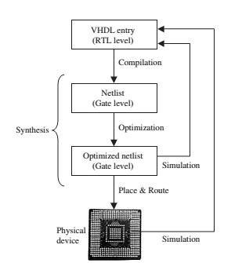
Figure 1 : Summary of VHDL design flow

    - Electronic Design Automation

There are several EDA (Electronic Design Automation) tools available for circuit synthesis, implementation, and simulation using VHDL. Some tools (place and route, for example) are ordered as part of a vendor’s design suite (e.g., Altera’s Quartus II, which allows the synthesis of VHDL code onto Altera’s CPLD/FPGA chips, or Xilinx’s ISE suite, for Xilinx’s CPLD/FPGA chips). Other tools (synthesizers, for example), besides being ordered as part of the design suites, can also be provided by specialized EDA companies (Mentor Graphics, Synopsis, Simplicity, etc.). Examples of the latter group are Leonardo Spectrum (a synthesizer from Mentor Graphics), Simplify (a synthesizer from Simplicity), and Modelsim (a simulator from Model Technology, a Mentor Graphics company). The designs presented in the book were synthesized onto CPLD/FPGA devices (appendix A) either from Altera or Xilinx. The tools used were either ISE combined with ModelSim, MaxPlus II combined with Advanced.

Synthesis Software or Quartus II. Leonardo Spectrum was also used occasionally. Although different EDA tools were used to implement and test the examples presented in the design, we decided to standardize the visual presentation of all simulation graphs. Due to its clean appearance, the waveform editor of MaxPlus II was employed. However, newer simulators like ISE þ ModelSim and Quartus II, over a much broader set of features, which allow, for example, a more refined timing analysis. For that reason, those tools were adopted when examining the fine details of each design.
    - Field-Programmable Gate Array

A field-programmable gate array (FPGA) is a semiconductor device that can be configured by the customer or designer after manufacturing—hence the name "field-programmable". To program an FPGA one must specify how they want the chip to work with a logic circuit diagram or a source code in a hardware description language (HDL). FPGAs can be used to implement any logical function that an application-specific integrated circuit (ASIC) could perform, but the ability to update the functionality after shipping offers advantages for many applications.

FPGAs contain programmable logic components called "logic blocks", and a hierarchy of reconfigurable interconnects that allow the blocks to be "wired together"—somewhat like a one-chip programmable breadboard. Logic blocks can be configured to perform complex combinational functions, or merely simple logic gates like AND and XOR. In most FPGAs, the logic blocks also include memory elements, which may be simple flip-flops or more complete blocks of memory.

For any given semiconductor process, FPGAs are usually slower than their fixed ASIC counterparts. They also draw more power, and generally achieve less functionality using a given amount of circuit complexity. But their advantages include a shorter time to market, ability to re-program in the field to fix bugs, and lower non-recurring engineering costs. Vendors can also take a middle road by developing their hardware on ordinary FPGAs, but manufacture their final version so it can no longer be modified after the design has been committed.

Field Programmable Gate Array (FPGA) devices were introduced by Xilinx in the mid-1980s. They differ from CPLDs in architecture, storage technology, number of built-in features, and cost, and are aimed at the implementation of high performance, large-size circuits.
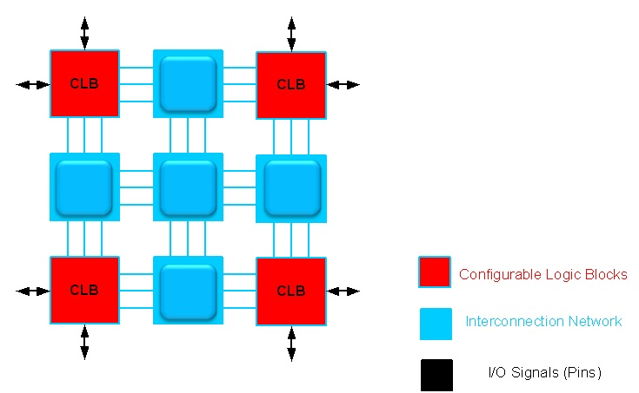
Figure 2 : FPGA Architecture

The basic architecture of an FPGA is illustrated in figure 2. It consists of a matrix of CLBs (Configurable Logic Blocks), interconnected by an array of switch matrices.

The internal architecture of a CLB is different from that of a PLD First, instead of implementing SOP expressions with AND gates followed by OR gates (like in SPLDs), its operation is normally based on a LUT (lookup table). Moreover, in an FPGA the number of flip-flops is much more abundant than in a CPLD, thus allowing the construction of more sophisticated sequential circuits. Besides JTAG support and interface to diverse logic levels, other additional features are also included in FPGA chips, like SRAM memory, clock multiplication (PLL or DLL), PCI interface, etc. Some chips also include dedicated blocks, like multipliers, DSPs, and microprocessors.

Another fundamental difference between an FPGA and a CPLD refers to the storage of the interconnects. While CPLDs are non-volatile (that is, they make use of antifuse, EEPROM, Flash, etc.), most FPGAs use SRAM, and are therefore volatile. This approach saves space and lowers the cost of the chip because FPGAs present a very large number of programmable interconnections, but requires an external ROM. There are, however, non-volatile FPGAs (with antifuse), which might be advantageous when reprogramming is not necessary.
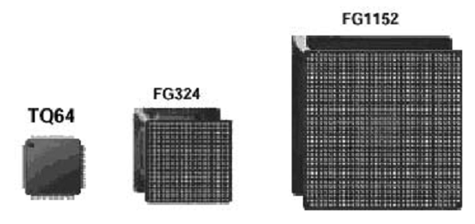
Figure 3 : Examples of FPGA Packages

FPGAs can be very sophisticated. Chips manufactured with state-of-the-art0.09mmCMOS technology, with nine copper layers and over 1,000 I/O pins, are currently available. A few examples of FPGA packages are illustrated in figure A6, which shows one of the smallest FPGA packages on the left (64 pins), a medium-size package in the middle (324 pins), and a large package (1,152 pins) on the right. Several companies manufacture FPGAs, like Xilinx, Actel, Altera, and Quick Logic.

Notice that all Xilinx FPGAs use SRAM to store the interconnects, so are reprogrammable, but volatile (thus requiring external ROM). On the other hand, ActelFPGAs are non-volatile (they use anti fuse), but are non-reprogrammable (except one family, which uses Flash memory). Since each approach has its own advantages and disadvantages, the actual application will dictate which chip architecture is most appropriate.

Project
  - Abstract:
In recent method of Cryptographic application based devices which have more sensitive information with more crucial part of storing and retrieving the data. Thus its affect with power analysis and side channel analysis its exploit correlation between the instantaneous current consumed power supply devices with information leakages. In this work will describe a novel security oriented 7T SRAM cell design, which incorporates a two-phased write operations and significantly reduces the correlation between the written and stored data in the memory and its power dissipation, thus its providing a power analysis resilient memory. This proposed 7T cell includes an additional transistor to the existing 6T SRAM implementation with single power gate transistor per memory. Here, this proposed work will design a 7T SRAM bit cell in 22nm CMOS technology in TANNER EDA Software with single bit and 8-bit level operations with compared to existing 6T SRAM bit cell in terms of area, delay and power leakage.

  - Literature survey:
- A 7T Security Oriented SRAM Bit cell Robert Giterman , Osnat Keren , and Alexander Fish 1549-7747 2018 IEEE. Power analysis (PA) attacks have become a serious threat to security systems by enabling secret data extraction through the analysis of the current consumed by the power supply of the system. Embedded memories, often implemented with six-transistor (6T) static random access memory (SRAM) cells, serve as a key component in many of these systems. However, conventional SRAM cells are prone to side-channel power analysis attacks due to the correlation between their current characteristics and written data. To provide resiliency to these types of attacks, we propose a security-oriented 7T SRAM cell, which incorporates an additional transistor to the original 6T SRAM implementation and a two-phase write operation, which significantly reduces the correlation between the stored data and the power consumption during write operations. The proposed 7T SRAM cell was implemented in a 28 nm technology and demonstrates over 1000× lower write energy standard deviation between write ‘1’ and ‘0’ operations compared to a conventional 6T SRAM. In addition, the proposed cell has a 39%–53% write energy reduction and a 19%–38% reduced write delay compared to other power analysis resistant SRAM cells.
- Leakage Power Analysis Attacks: A Novel Class of Attacks to Nanometer Cryptographic Circuits Massimo Alioto, Senior Member, IEEE, Luca Giancane, Student Member, IEEE, Giuseppe Scotti, and Alessandro Trifiletti,1549-8328 2010 IEEE.In this paper, a novel class of power analysis attacks to cryptographic circuits is presented. These attacks aim at recovering the secret key of a cryptographic core from measurements of its static (leakage) power. These attacks exploit the dependence of the leakage current of CMOS integrated circuits on their inputs (including the secret key of the cryptographic algorithm that they implement), as opposite to traditional power analysis attacks that are focused on the dynamic power. For this reason, this novel class of attacks is named “Leakage Power Analysis” (LPA). Since the leakage power increases much faster than the dynamic power at each new technology generation, LPA attacks that is based on a solid theoretical background is presented. Advantages and measurement issues are also analyzed in comparison with traditional power analysis attacks based on dynamic power measurements. Examples are provided for various circuits, and an experimental attack to a register is performed for the first time. An analytical model of the LPA attack result is also provided to better understand the effectiveness of this technique. The impact of technology scaling is explicitly addressed by means of a simple analytical model and Monte Carlo simulations. Simulations on a 65- and 90-nm technology and experimental results are presented to justify the assumptions and validate the leakage power models that are adopted.
- Effectiveness of Leakage Power Analysis Attacks on DPA-Resistant Logic Styles Under Process Variations Massimo Alioto, Simone Bongiovanni, Milena Djukanovic, Giuseppe Scotti, and Alessandro Trifiletti 1549-8328 2013 IEEE.This paper extends the analysis of the effectiveness of Leakage Power Analysis (LPA) attacks to cryptographic VLSI circuits on which circuit level countermeasures against Differential Power Analysis (DPA) are adopted. Security metrics used for assessing the DPA-resistance of crypto core implementations, such as the minimum number to disclosure (MTD) and the asymptotic correlation coefficient, have been extended to the case of LPA. The LPA-resistance has been evaluated in terms of MTD as a function of the on chip noise. Noise variances up to 10000 times greater than the signal variance have been taken into account and LPA attacks have been successfully executed for all the logic styles under analysis using less than 100000 measurements. Moreover the role of process variations has been investigated through extensive Monte Carlo simulations in order to evaluate their impact on the leakage model for the logic styles under analysis. Results show that LPA attacks can be successfully carried out on the different anti-DPA logic styles even in presence of process variations. To the best of our knowledge, this work proves for the first time the effectiveness of LPA attacks in a real scenario where on chip noise and process variations are taken into account.

- Leakage Power Attack-Resilient Symmetrical 8T SRAM Cell Robert Giterman , Maoz Vicentowski, Itamar Levi , Yoav Weizman, Osnat Keren , and Alexander Fish 1063-8210 2018 IEEE. Power analysis attacks have become a serious threat to security systems by enabling secret data extraction using side-channel leakage information. Embedded memories, often implemented with 6T SRAM cells, serve as a key component in many of these systems. However, conventional SRAM cells are prone to side-channel leakage power attacks. To provide resiliency to these types of attacks, we propose a symmetric 8T SRAM cell which incorporates two more transistors than the conventional 6T cell to significantly reduce the correlation between the stored data and the leakage currents. To demonstrate the improved security of the suggested memory array, both cells were implemented in a 65-nm CMOS technology. Simulation results, including Monte Carlo analysis and signal-to-noise ratio comparison, illustrate the resiliency of the 8T cell to leakage power attacks.

- Design Solutions for Securing SRAM Cell Against Power Analysis Vladimir Roziˇ c´∗, Wim Dehaene† and Ingrid Verbauwhede 978-1-4673-2340-6/12/$31.00 c 2012 IEEE. Side channel attacks exploit physical imperfections of hardware to circumvent security features achieved by mathematically secure protocols and algorithms. This is achieved by monitoring physical quantities, usually power consumption or electromagnetic radiation, which contain information about the secret data. As a countermeasure, several circuit styles have been proposed for designing side-channel resistant logic gates and flip-flops. However, little effort has been made to develop secure memory arrays. An SRAM cell with 8 transistors has been proposed in order to obtain power analysis resistance by using a dual-rail precharge principle, the same technique used in various secure logic styles. In this paper we look into the practical aspects of this cell such as noise margins, layout strategy and read current. In addition, we propose alternative solutions for poweranalysis resistant SRAM. We compare these solutions in terms of data stability, delay and side-channel resistance.
- SRAM Assist Techniques for Operation in a Wide Voltage Range in 28-nm CMOS Brian Zimmer, Student Member, IEEE, Seng Oon Toh, Member, IEEE, Huy Vo, Yunsup Lee, Student Member, IEEE, Olivier Thomas, Krste Asanovic,´ Senior Member, IEEE, and Borivoje Nikolic,´ Senior Member, IEEE 1549-7747 2013 IEEE. Reducing static random-access memory (SRAM) operational voltage (Vmin) can greatly improve energy efficiency, yet SRAM Vmin does not scale with technology due to increased process variability. Assist techniques have been shown to improve the operation of SRAM, but previous investigations of assist techniques at design time have either relied on static metrics that do not account for important transient effects or make specific assumptions about failure distributions. This paper uses importance sampling of dynamic failure metrics to quantify and analyze the effect of different assist techniques, array organization, and timing on Vmin at design time. This approach demonstrates that the most effective technique for reducing SRAM Vmin is the negative bitline write assist, resulting in a Vmin of 600 mV for a 28-nm LP process in the typical corner.

- Design and Iso-Area Vmin Analysis of 9T Subthreshold SRAM With Bit-Interleaving Scheme in 65-nm CMOS Ming-Hung Chang, Student Member, IEEE, Yi-Te Chiu, and Wei Hwang, Fellow, IEEE 1549-7747 2012 IEEE. In this brief, a 9T bit cell is proposed to enhance write ability by cutting off the positive feedback loop of a static random-access memory (SRAM) cross-coupled inverter pair. In read mode, an access buffer is designed to isolate the storage node from the read path for better read robustness and leakage reduction. The bit-interleaving scheme is allowed by incorporating the proposed 9T SRAM bit cell with additional write wordlines (WWL/WWLb) for soft-error tolerance. A 1-kb 9T 4-to-1 bitinterleaved SRAM is implemented in 65-nm bulk CMOS technology. The experimental results demonstrate that the test chip minimum energy point occurs at 0.3-V supply voltage. It can achieve an operation frequency of 909 kHz with 3.51-μW active power consumption.
  - Existing System:
The use of cryptographic devices storing sensitive information has grown considerably during the last few decades and has become a crucial part of many applications, such as smart cards, and mobile devices. Side channel analysis (SCA) is a powerful threat to these devices because it exploits the information related to the physical behavior of these devices to extract sensitive data . PA attacks are considered to be one of the most powerful types of SCA methods since they require relatively simple equipment and setups. PA attacks exploit the correlation between the instantaneous current consumed by the power supply of the device and its processed and stored data, to extract secret data or sensitive information.

Embedded memories dominate the area and power consumption of many VLSI system-on-chips (SoCs) and are key components of many cryptographic systems, such as smart cards and wireless networks employing cryptography algorithms , where they are used to store instruction code and data. Therefore, the analysis and design of secured memories is of utmost importance. Embedded memories are mostly implemented with the 6T SRAM macrocell, which provides high density, robust operation, and high performance. However, 6T SRAM arrays are traditionally designed and optimized for high density and performance, while their security properties are often overlooked, resulting in a high susceptibility to PA attacks.

Previous works have proposed modified SRAM bitcells to reduce the correlation between the dynamic power dissipation and the stored data of a conventional 6T SRAM array. Both of these solutions are based on a two-stage writeoperation. During the first stage, the internal nodes of the SRAM cell (Q and QB) are pre-charged to a constant voltage to eliminate the correlation between the previously stored data, and the write operation that follows. In the authors suggested performing the pre-charge operation by using two additional PMOS transistors beyond the original 6T SRAM in order to power-cut the supply during the additional pre-charge phase. In the authors proposed a feedback-cut SRAM cell, composed of two additional NMOS devices which are used to cut off the feedback of the SRAM cell in order to avoid shortcircuit power dissipation. While these solutions effectively reduce the correlation between the power consumption and stored data of the SRAM array, they result in significant delay and power overheads, as well as reduced static noise margins (SNMs).
In general, we assume that a side-channel attacker has access to the power supply lines of the system, and that he has knowledge of the chip architecture, including the memory organization, array peripherals and internal timing paths. In addition, it is assumed that the attacker can assign input vectors to the system, which can result in memory write operations to selected rows. Finally, it is common to assume that the overall current consumed by the memory macro peripherals and other chip components can be treated as algorithmic noise, which can be filtered out using enough current traces, especially when the memory array is operated under a separate supply voltage.

In this paper, we describe a novel security-oriented 7T SRAM cell design, which incorporates a two-phased write operation, and significantly reduces the correlation between the written and stored data in the memory and its power dissipation, thus providing a PA resilient memory. The proposed 7T cell includes an additional transistor to the original 6T SRAM implementation and a single power gate transistor per memory word, which are used to equalize the Q and QB voltages during the first phase of the write operation. Compared to other PA resistant memory solutions, the proposed cell provides 39%– 53% lower energy dissipation, 19%–38% lower write delay, and the highest read and hold SNMs compared to other PA resilient memory solutions.
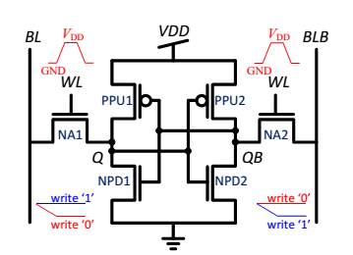
Figure 4:Schematic representation of 6T SRAM.
A conventional 6T SRAM is shown in Fig. 4 with its signal waveforms during a write operation. To enable write access to the cell, the word line (WL) is asserted and the voltages on the bit-line pair (BL and BLB) are transferred to the internal storage nodes, Q and QB, respectively. When the written level differs from the value stored in the cell prior to the write event, the cell dissipates dynamic energy to charge the internal cell capacitances. In addition, the cell dissipates short circuit power since the access transistors (NA1 and NA2) must overcome the internal feedback of the cell (formed by transistors NPD1, PPU1, NPD2, and PPU2) to change its stored value. On the other hand, when the written value is similar to the stored data, no dynamic energy is dissipated by the cell and the total power consumption is dominated by its leakage currents.

Fig.5 depicts the current consumption during write ‘1’ and ‘0’ operations to a cell which previously stored a ‘0’. The current waveforms present a significant difference, with a peak current almost four orders of magnitude lower during the write ‘0’ (0.14 µA) operation than the write ‘1’ operation (100 µA), due to the changed state of the cell which previously stored a ‘0’.
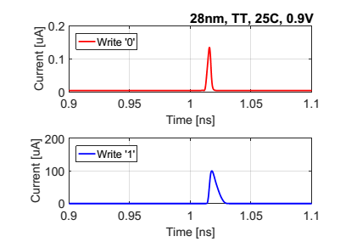
Figure 5: Current consumed during write ‘1’ and ‘0’ operations to a 6T SRAM.
The energy distributions obtained from a full write cycle are shown in Fig. 6, as extracted from 1000 Monte-Carlo (MC) simulations including device mismatch and process variations in 28 nm CMOS technology. As expected, the write energy dissipated during the write ‘0’ operation was over two orders of magnitude lower than the energy dissipated during a write ‘1’ operation. The mean energy dissipations for write ‘1’ and ‘0’ were 1.475 fJ and 0.016 fJ, respectively. The significant difference between the energy dissipations obtained from the different write operations to the cell indicate that the power consumption of the 6T SRAM is highly dependent on the written data to the cell, making it highly susceptible to PA attacks.
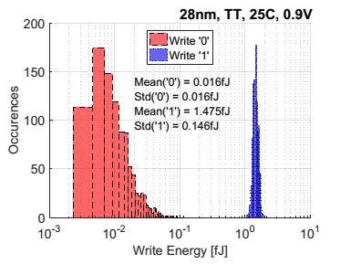
Figure 6: Write energy distribution of a 6T SRAM during write operations under process variations.

  - Disadvantages:
- High area occupied and more delay.
- High energy Consumption.
- Power analysis attack is high.
  - Proposed System:
In recent method of Cryptographic application based devices which have more sensitive information with more crucial part of storing and retrieving the data. Thus its affect with power analysis and side channel analysis its exploit correlation between the instantaneous current consumed power supply devices with information leakages. In this work will describe a novel security oriented 7T SRAM cell design, which incorporates a two-phased write operations and significantly reduces the correlation between the written and stored data in the memory and its power dissipation, thus its providing a power analysis resilient memory. This proposed 7T cell includes an additional transistor to the existing 6T SRAM implementation with single power gate transistor per memory. Here, this proposed work will design a 7T SRAM bit cell in 22nm CMOS technology in TANNER EDA Software with single bit and 8-bit level operations with compared to existing 6T SRAM bit cell in terms of area, delay and power leakage.

    - SRAM
SRAM is semiconductor memory cell. It stores one bit of information. It is faster and consumes very less power as compared to other memory cells. Due to its robustness and stability, researchers are interested in further improvement of SRAM cell. SRAM is vital component in a chip or microprocessor IC. Designing a SRAM cell in nano scale regime has become a challenging task because of reduction in noise margins and increased sensitivity to threshold voltage variation . 10T SRAM cell performs better then 6T SRAM cell in terms of reliability and stability. 6T SRAM cell has less reliability at low supply voltage due to degradation in noise margins.
    - Power Analysis Based Side Channel Attack
Power analysis is a branch of side channel attacks where the side channel used is the power consumption. In electronic devices, the instantaneous power consumption is dependent on the data that is being processed in the device as well as the operation performed by that device . Therefore by analysing the power consumed by a device when it is doing encryption or decryption the key can be deduced. There are two types of power analysis: differential power analysis (DPA) and simple power analysis (SPA).
    - SPA
Simple power analysis is a method of side-channel attack that examines a chip’s current consumption over a period of time. Since different operations will exhibit different power profiles, one can determine what type of function is being performed at a given time. For example, one can distinguish a multiplication function from an addition function, since multiplication consumes more current than addition. Also, when reading data from a memory, the ratio of 1’s vs. 0’s will be reflected in the power profile. SPA is useful when data-dependent features in the power traces are apparent. It may not be practical if there is significant noise in the system. In which case, DPA would be more advantageous.

    - DPA
Differential power analysis is a statistical method for analyzing power consumption to identify data-dependent correlations. This approach takes multiple traces of two sets of data, then computes the difference of the average of these traces. If the difference is close to zero, then the two sets are not correlated. If the sets are correlated, then the difference will be a non-zero number. Given enough traces, even tiny correlations can be seen, regardless of how much noise is in the system, since the noise will effectively cancel out during the averaging.
    - Countermeasure
Side-channel attacks, such as DPA and SPA, are dangerous because they allow hackers to circumvent conventional hardware and software security measures. DPA can accomplish in minutes or days what cryptoanalysis and other brute force methods cannot. Also, since they are non-invasive, they do not leave a trace, allowing for attackers to steal confidential information without being detected. Therefore, measures must be taken to prevent such attacks.
    - Power Analysis Resistant 7t Sram
To overcome the information leakage of the 6T SRAM cell during write operations, we propose a modified 7T SRAM cell employing a two-phase write operation consisting of an equalization and write phases, and resulting in a significantly lower correlation between its current dissipation and the stored data in the cell.
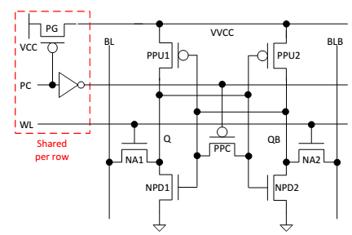
Figure 7: Proposed 7T SRAM.
    - Basic Operation
The schematic representation of the proposed 7T SRAM cell is shown in Fig. 7. A power gate PMOS transistor (PG) is used to disable the voltage supply of an entire memory word (VVDD) to avoid short-circuit power dissipation during the equalization phase of the write operation. Transistor PPC is added to the original 6T SRAM implementation to short Q and QB during the equalization phase. A PC signal is used to disable PG and enable PPC to perform voltage equalization between Q and QB using charge-sharing, hence avoiding additional power consumption from the supply. During the second phase of the write operation, PC is discharged to charge VVDD and cut off PPC, and charged to enable the NMOS access transistors (NA1 and NA2) allowing them to pass the data from BL and BLB to Q and QB, respectively, to complete the write operation.

A waveform demonstration of the two-phased write operation is depicted in Fig. 8, showing how a write ‘1’ operation is made to a cell which previously stored a ‘0’. The internal Q and QB voltages of a conventional 6T SRAM cell are shown for comparison. First, the PC voltage is asserted to cut off the supply voltage of all the cells in a single word.

As a result, VVDD is decreased and the internal Q-7T and QB-7T voltages are equalized using charge-sharing. Then, the PC signal is deasserted to resume the VVDD supply, and the WL is asserted to enable write access to the cell. BL and BLB, already set to VDD and GND, respectively, are then transferred to Q-7T and QB-7T to complete the write ‘1’ operation. For comparison, the internal voltages of a conventional 6T cell (Q-6T and QB-6T) are only changed when the WL has been asserted, resulting in a significant energy difference between write ‘1’ and ‘0’ operations
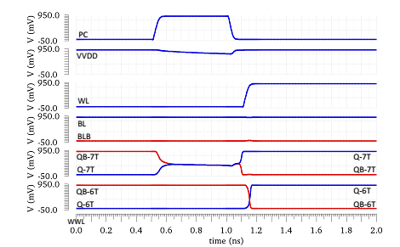
Figure 8:Waveform of 7T SRAM during Write operation.
    - Power Analysis
Due to the symmetric structure of the 7T cell, the current consumed during the equalization phase is independent of the data previously stored in the cell. Moreover, the cell does not consume additional energy during this phase since VVDD is cut off and the voltages on Q and QB are equalized through charge sharing; hence, the power consumption prior to the WL assertion is identical.

The currents dissipated by the 7T SRAM cell during the write ‘1’ and ‘0’ operations to a cell previously storing a ‘0’ are shown in Fig. 9, resulting in almost identical waveforms due to the two-phase write operation, thus demonstrating the lack of current information leakage. The corresponding write energy scatter plot of the 7T SRAM cell is shown in Fig. 10, as extracted from 1000 MC simulations including device mismatch and process variations. As expected, the mean energy dissipations for the write ‘0’ and ‘1’ operations are 2.297 fJ and 2.301 fJ with a standard deviation of 0.0345 fJ and 0.353 fJ, respectively, thus resulting in a much smaller difference than similar distributions obtained for the 6T SRAM cell.

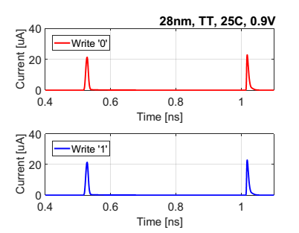
Figure 9: Current consumed during write ‘1’ and ‘0’ operations to the 7T cell.

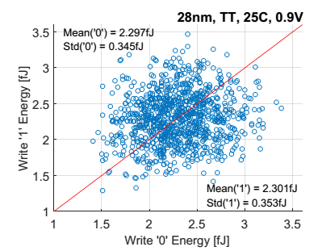
Figure 10: Write energy distribution of the proposed 7T SRAM during a write operation under process variations.

  - Advantages:
- Low Area .
- Low power Consumption.
- Reduction in power analysis attack.

Comparison

Table 1 : Comparisons of 7T Security Oriented SRAM Bit Cell
 | A 7T Security Oriented SRAM Bit cell
 | 6T SRAM (Single Bit)  Conventional | 7T SRAM (Single Bit)  existing | 6T SRAM (Single Bit)  Conventional | 7T SRAM (Single Bit)  Proposed | 6T SRAM (8-Bit)  Conventional | 7T SRAM (8-Bit)  Proposed
MOSFETS | 8 | 12 | 8 | 12 | 64 | 96
Delay (ns) | - | - | 21 | 20.1 | 81 | 81
Power (uW) | - | - | 1.33 | 2.06 | 10.6 | 4.7
Technology (nm) | 28 | 28 | 22 | 22 | 22 | 22
Input Voltage (V) | 0.9 | 0.9 | 0.4 | 0.4 | 0.4 | 0.4
Area(mm) | 0.224 | 0.336 | 0.176 | 0.264 | 1.408 | 2.112

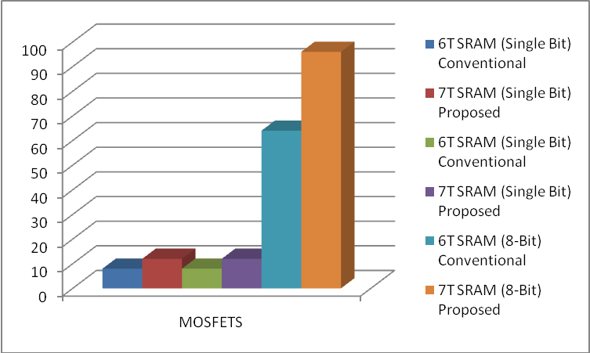

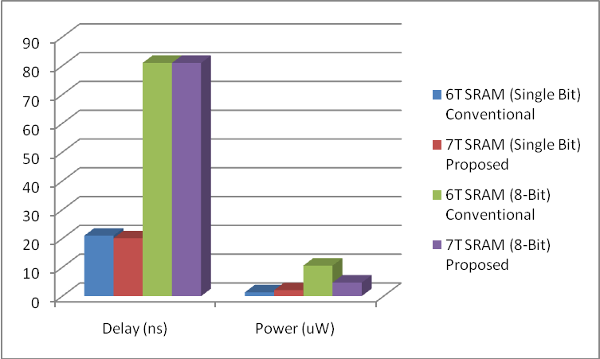

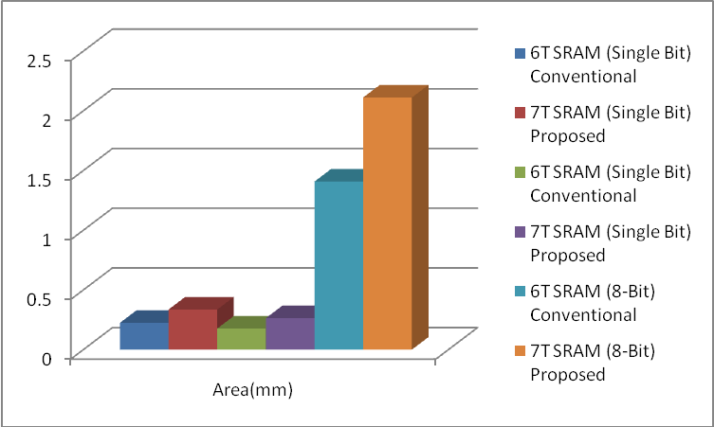

Software Requirement
Tanner tool is a Spice Computer Analysis Programmed for Analogue Integrated Circuits. Tanner tool consists of the following Engine Machines:
- S-EDIT (Schematic Edit)
- T-EDIT (Simulation Edit)
- W-EDIT (Waveforms Edit)
- L-EDIT (Layout Edit)
Using these engine tools, spice program provides facility to the use to design & simulate new ideas in Analogue Integrated Circuits before going to the time consuming & costly process of chip fabrication.
  - Schematic edit tool (s-edit)
S-Edit is hierarchy of files, modules & pages. It introduces symbol & schematic modes. S-Edit provides the facility of:
- Beginning a design.
- Viewing, drawing & editing of objects.
- Design connectivity.
- Properties, net lists & simulation.
Instance & browse schematic & symbol mode.
Beginning a design:
It explains the design process in detail in terms of file module operation and module.
Browser:
Effective schematic design requires a working knowledge of the S-Edit design hierarchy of files & modules. S-Edit design files consist of modules. A module is a functional unit of design such as a transistor, a gate and an amplifier.
Modules contain two components:
- Primitives: Geometrical objects created with drawing tools.
- Instances References to other modules in file. The instanced module is the original.
S-Edit has two viewing modes:
- Schematic Mode: to create or view a schematic, we operate in schematic mode.
- Symbol Mode: it represents symbol of a larger functional unit such as operational amplifier.
  - T-spice pro circuit analysis
An introduction to the integrated components of the T- Spice Pro circuit analysis suite:
Schematic data files (.sdb): describes the circuits to be analyzed in graphical form, for display and editing by S- Edit" Schematic Editor.
Simulation input files (.sp):describes the circuits to be analyzed in textual form, for editing and simulation by T- Spice" Circuit Simulator.
Simulation output files (.out): containing the numerical results of the circuit analyses, form manipulation and display by W- Edit" Waveform Viewer.
Circuit simulator (t-spice)
T-Spice Pro’s waveform probing feature integrates S- Edit, T- Spice, and W- Edit to allow individual points in a circuit to be specified and analyzed. A few analysis is described below: The heart of T-Spice operation is the input file (also known as the circuit description, the net list &the input deck). This is a plain text file that contains the device statement & simulation commands, drawn from the SPICE circuit description language with which T-Spice constructs a model of the circuit to be simulated. Input files can be created and modified with any text editor. T-Spice is a tool used for simulation of the circuit. It provides the facility of
- Design Simulation
- Simulation Commands
- Device Statements
- User-Designed External Models
- Small Signal & Noise Models
T- Spice uses Kirchhoff’s Current Law (KCL) to solve circuit problems. To T-Spice, a circuit is a set of devices attached to nodes. The voltage at all nodes represents the circuit state. T-Spice solves for a set of node voltage that satisfied KCL (implying that sum of currents flowing into each node is zero). In order to evaluate whether a set of node voltages is a solution, T-Spice computers and sums all the current flowing out of each device into nodes connected to it (its terminals). The relationship between the voltages at device terminals and the currents through the terminal is determined by the device model for a resistor of resistance R is
I=∆V/R
Where, ∆V represents the voltage difference across the device. A few analyses are discussed below:
DC Operating Point Analysis
DC operating point analysis finds a circuit’s steady- state condition, obtained (in principle) after the input voltages have been applied for an infinite amount of time. The .include command causes T- Spice to read in the contents of the model file for the evaluation of NMOS and PMOS transistors. The technology file assigns values to MOSFET model parameters for both n - and p -type devices. When read by the input file, these parameters are used to evaluate MOSFET model equations, and the results are used to construct internal tables of current and charge values. Values read or interpolated from these tables are used in the computations called for by the simulation. Following each transistor name are the names of its terminals. The required order of terminal names is: drain-gate -source -bulk. Then the model name (NMOS or PMOS in this example), and physical characteristics such as length and width, are specified. The .op command performs a DC operating point calculation and writes the results to the file specified in the Simulate > Start Simulation dialog. The output file lists the DC operating point information for the circuit described by the input file.
DC Transfer Analysis
DC transfer analysis is used to study the voltage or current at one set of points in a circuit as a function of the voltage or current at another set of points. This is done by sweeping the source variables over specified ranges, and recording the output. A list of sources to be swept, and the voltage ranges across which the sweeps are to take place follow the .dc command, indicating transfer analysis. The transfer analysis will be performed as follows: add will be set at 5 volts and vin will be swept over its specified range; vdd will then be incremented and vin will be swept over its range; and so on, until vdd reaches the upper limit of its range. The .dc command ignores the values assigned to the voltage sources vdd and vin in the voltage source statements, but they must still be declared in those statements. The results for nodes in and out are reported by the. print dc command to the specified destination.
Transient Analysis
Transient analysis provides information on how circuit elements vary with time. The basic T-Spice command for transient analysis has three modes. In the default mode, the DC operating point is computed, and T- Spice uses this as the starting point for the transient simulation. The command specifies the characteristics of the transient analysis to be performed.
AC Analysis
AC analysis characterizes the circuit’s behaviour dependence on small- signal input frequency. It involves three steps:
  - Calculating the DC operating point;
  - Linear zing the circuit; and
  - Solving the liberalized circuit for each frequency.
When ac voltage source is to be applied, then v diff sets the DC voltage difference between nodes the two nodes to -0. 0007 volts; its AC magnitude is 1 volt and its AC phase is 180 degrees. The .ac command performs an AC analysis. Following the .ac keyword is information concerning the frequencies to be swept during the analysis. In case, the frequency is to be swept logarithmically, by decades (DEC); 5 data points are to be included per decade is considered to be the standard The two .print commands write the voltage magnitude (in decibels) and phase (in degrees), respectively, for the node out to the specified file. The .ac model command writes the small- signal model parameters and operating point voltages and currents for all circuit devices.
Noise Analysis
Real circuits, of course, are never immune from small, random fluctuations in voltage and current levels. In T- Spice, the influence of noise in a circuit can be simulated and reported in conjunction with AC analysis. The purpose of noise analysis is to compute the effect of the noise associated with various circuit devices on an output voltage or voltages as a function of frequency. Noise analysis is performed in conjunction with AC analysis; if the .ac command is missing, then the noise command is ignored. With the .ac command present, the .noise command causes noise analysis to be performed at the same frequencies. The .noise command takes two arguments: the output at which the effects of noise are to be computed, and the input at which the .noise can be considered to be concentrated for the purposes of estimating the equivalent noise spectral density. The print command is used to print results.
  - Waveform edit
The ability to visualize the complex numerical data resulting from VLSI circuit simulation is critical to testing, understanding & improving these circuits. W-Edit is a waveform viewer that provides ease of use, power & speed in a flexible environment designed for graphical data representation. The advantages of W-Edit include:
- Tight Integration with T-spice, Tanner EDA_s circuit level simulator. W-Edit can chart data generated by T spice directly, without modification of the output text data files. The data can also be charted dynamically as it is produced during the simulation.
- Charts can automatically configure for the type of data being presented.
- A data is treated by W-Edit as a unit called a trace. Multiple traces from different output file scan be viewed simultaneously in single or several windows; traces can be copied and moved between charts & windows. Trace arithmetic can be performed on existed tracing to create new ones.
- Chart views can be panned back & forth and zoomed in & out, including specifying the exact X-Y co-ordinate range.
- Properties of axes, traces, rides, charts, text & colors can be customized. Numerical data is input to W-Edit in the form of plain or binary text files. Header & Comment information supplied by T-Spice is used for automatic chart configuration. Runtime update of results is made possible by linking W-Edit to a running simulation in T-Spice. W-Edit saves data with chart, trace, axis & environment settings in files with the WDB (W-Edit Database).
  - Layout (l-edit):
It is a tool that represents the masks that are used to fabricate an integrated circuit. It describes a layout design in terms of files, cells & mask primitives. On the layout level, the component parameters are totally different from schematic level. So it provides the facility to the user to analyze the response of the circuit before forwarding it to the time consuming & costly process of fabrication. There are rules for designing layout diagram of a schematic circuit using which user can compare the output response with the expected one.
L- Edit: An Integrated Circuit Layout Tool
In L- Edit, layers are associated with masks used in the fabrication process. Different layers can be conveniently represented by different colours and patterns. L- Edit describes a layout design in terms of files, cells, instances, and mask primitives. You may load as many files as desired into memory. A file may be composed of any number of cells. A file may be composed of any number of cells. These cells may be hierarchically related, as in a typical design, or they may be independent, as in a library file. Cells may contain any number or combination of mask primitive sand instances of other cells.
Cells: The Basic Building Blocks
The basic building block of the integrated circuit design in L- Edit is a cell. Design layout occurs within cells. A cell can:
- Contain part or all of the entire design.
- Be referenced in other cells as a sub- cell, or instance.
- Be made up entirely of instances of other cells.
- Contain original drawn objects, or primitives.
- Be made up entirely of primitives or a combination of primitives and instances of other cells.
Hierarchy
L- Edit supports fully hierarchical mask design. Cells may contain instances of other cells. An instance is a reference to a cell; should you edit the instanced cell, the change is reflected in all the instances of that cell. Instances simplify the process of updating a design, and also reduce data storage requirements, because an instance does not need to store all the data within the instanced cell instead, only a reference to the instanced cell is stored, along with information on the position of the instance and on how the instance may be rotated and mirrored.
L-Edit does not use a “separated” hierarchy: instances and primitives may coexist in the same cell at any level in the hierarchy. Design files are self- contained. The pointer to a cell contained in an instance always points to a cell within the same design file. When cells are copied from one file to another, L- Edit automatically copies across any cells that are instanced by the copied cell, to maintain the self- contained nature of the destination file.
Design Rules
Manufacturing constraints can be defined in L- Edit as design rules. Layouts can be checked against these design rules.
Design Features
L- Edit is a full- custom mask editor. Manual layout can be accomplished more quickly because of L Edit’s intuitive user interface. In addition, one can construct special structures to utilize a technology without, worrying about problems caused by automatic transformations. Phototransistors, guard bars, vertical and horizontal bipolar transistors, static structures, and Schottky diodes, for example, are as easy to design in CMOS- Bulk technology as are conventional MOS transistors.
Floor plans
L- Edit is a manual floor planning tool. You have the choice of displaying instances in outline, identified only by name, or as fully fleshed- out mask geometry. When you display your design in outline, you can manipulate the arrangement of the cells in your design quickly and easily to achieve the desired floor plan. One can manipulate instances at any level in the hierarchy, with insides hidden or displayed, using the same graphical move/ select operations or rotation/ mirror commands that you use on primitive mask geometry.
Memory Limits
In L- Edit, one can make your design files as large as one like, given available RAM and disk space.
Hard Copy
L- Edit provides the capability to print hard copy of the design. A multi age option allows very large plots to be printed to a specific scale on multiple 8 1/ 2 x 11 inch pages. An L- Edit macro is available to support large- format, high- resolution, color plotting on inkjet plotters.
Variable Grid L-Edit’s grid options support lambda- based design as well as micron- based and mil- based design.
Error Recovery L-Edit’s error- trapping mechanism catches system errors and in most cases provides a means to recover without losing or damaging data.
- L- Edit Modules
- L- Edit TM: a layout editor
- L- Edit ¤ Extract TM: a layout extractor
- L- Edit ¤ DRC TM: a design rule checker
L- Edit is a full- featured, high-performance, interactive, graphical mask layout editor. L- Edit generates layouts quickly and easily, supports fully hierarchical designs, and allows an unlimited number of layers, cells, and levels of hierarchy. It includes all major drawing primitives and supports 90°, 45°, and all- angle drawing modes.
L- Edit ¤ Extract creates SPICE - compatible circuit net lists from L- Edit layouts. It can recognize active and passive devices, sub circuits, and the most common device parameters, including resistance, capacitance, device length, width, and area, and device source and drain area.
L- Edit ¤ DRC features user- programmable rules and handles minimum width, exact width, minimum space, minimum surround, non- exist, overlap, and extension rules. It can handle full chip and region- only DRC. DRC offers Error Browser and Object Browser functions for quickly and easily cycling through rule- checking errors.

S edit output
6T- SRAM:

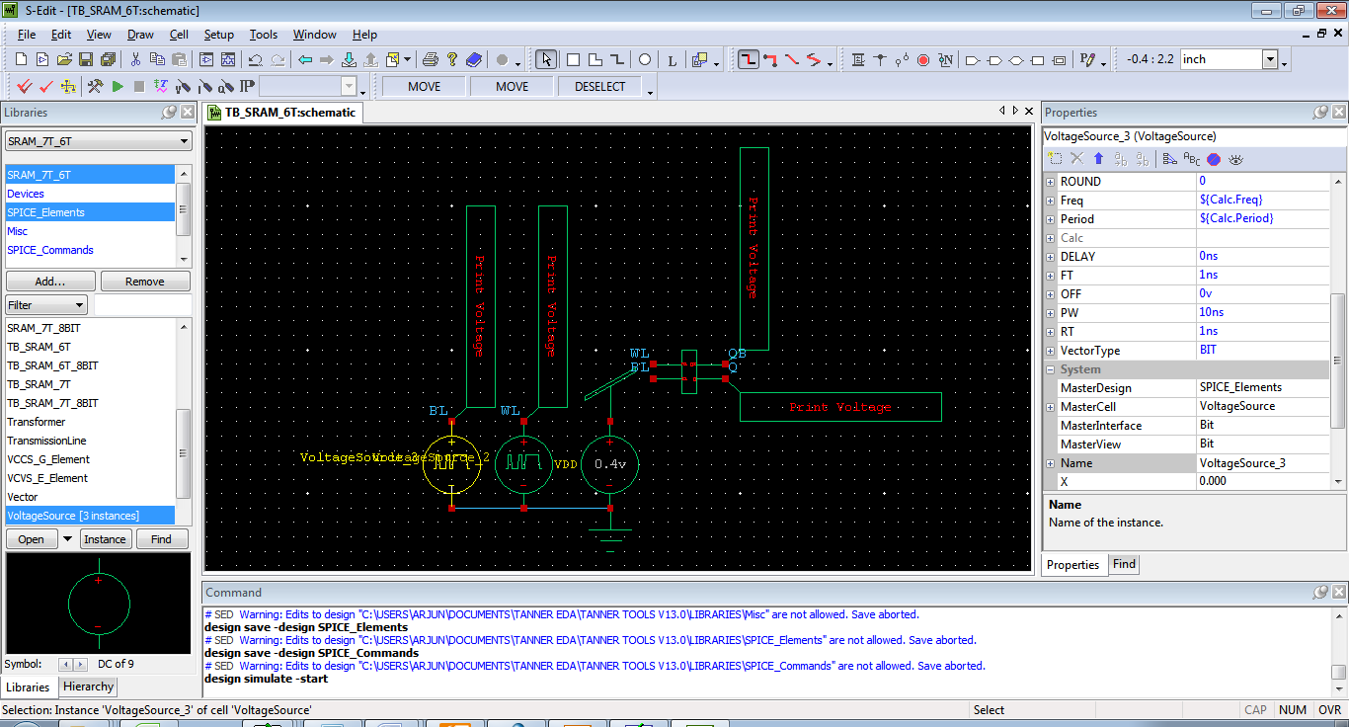

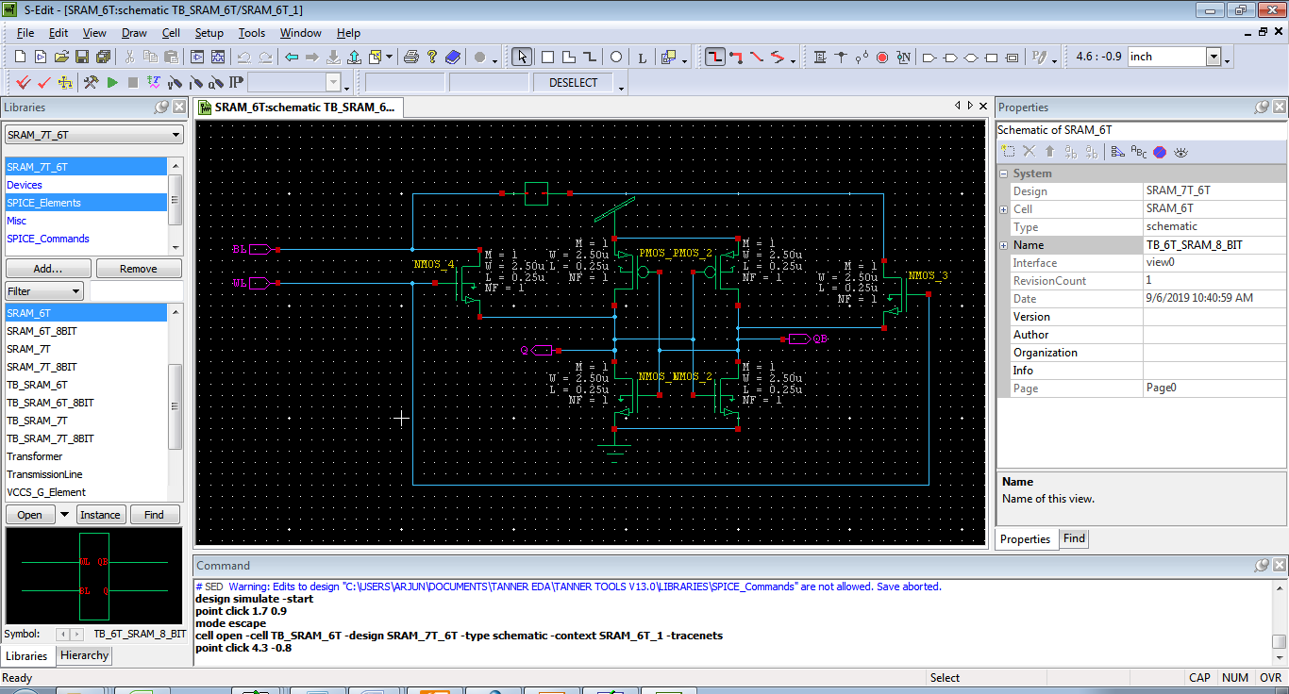

7T- SRAM:

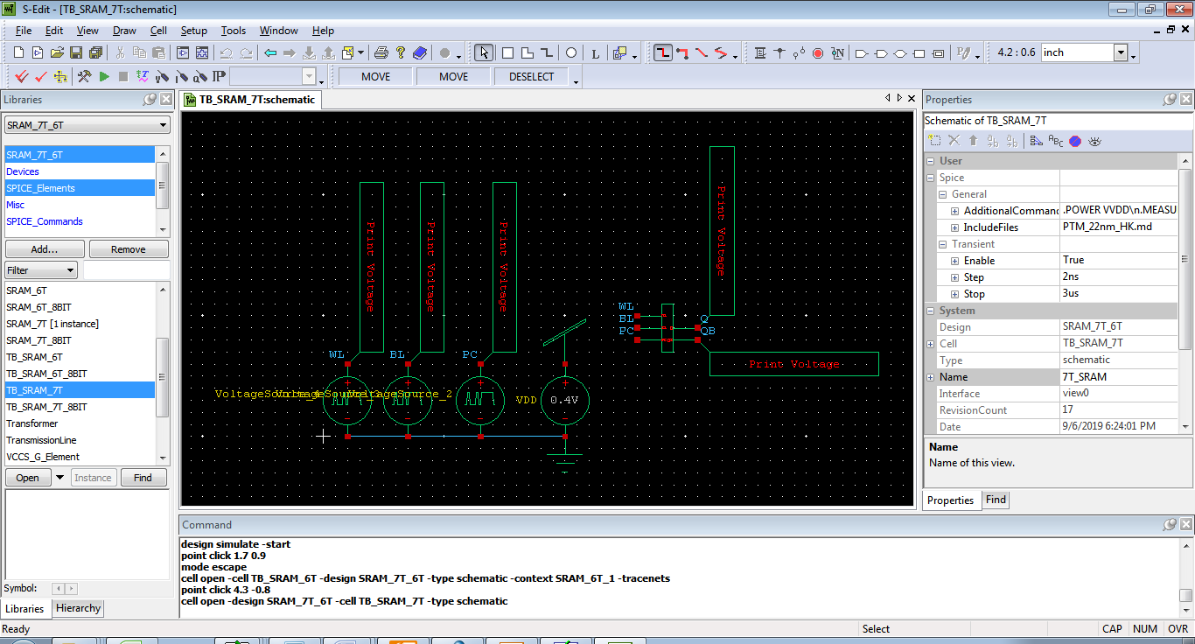

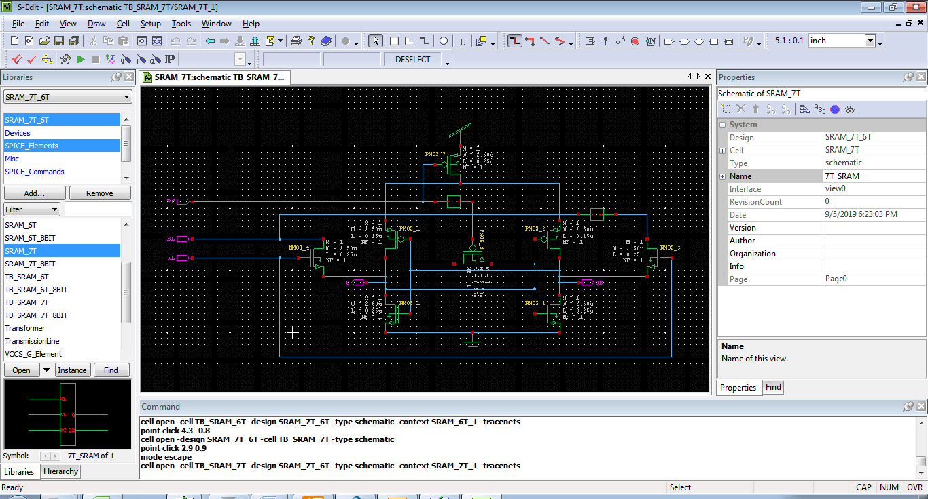

6T- SRAM- 8 BIT:

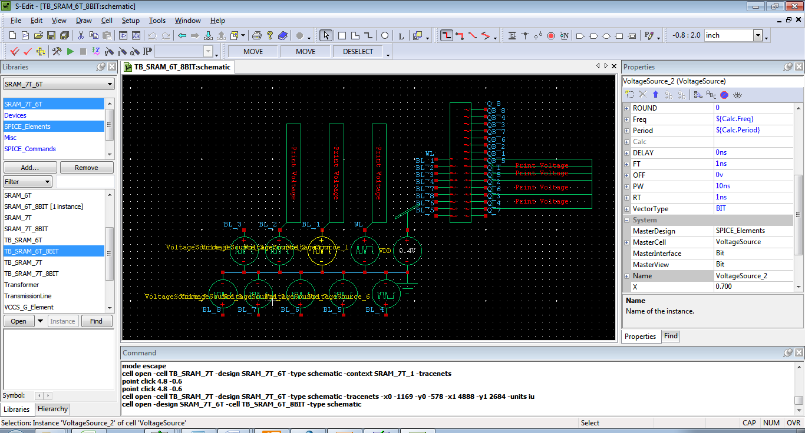

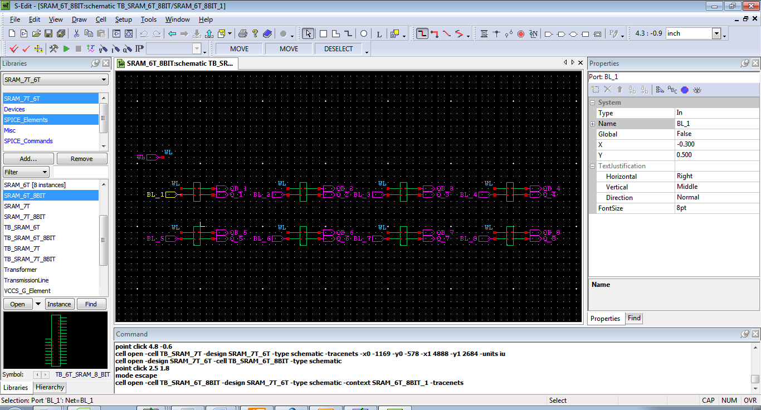

7T- SRAM FOR 8 BIT:

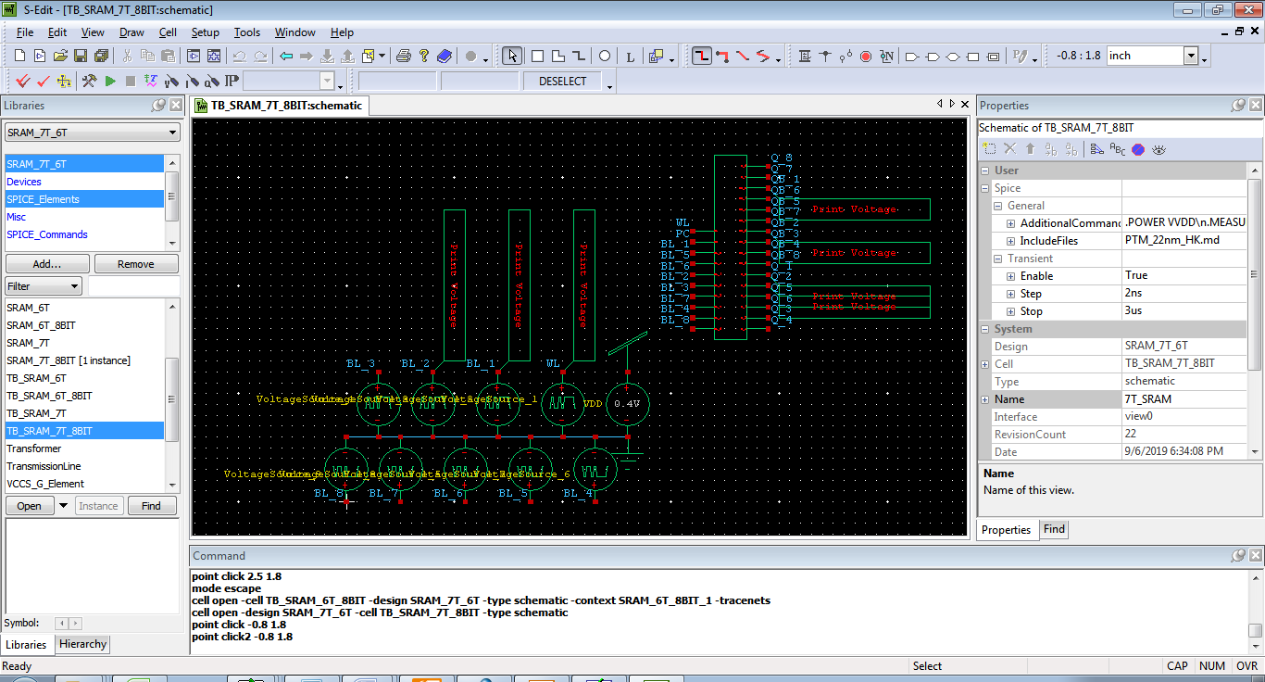

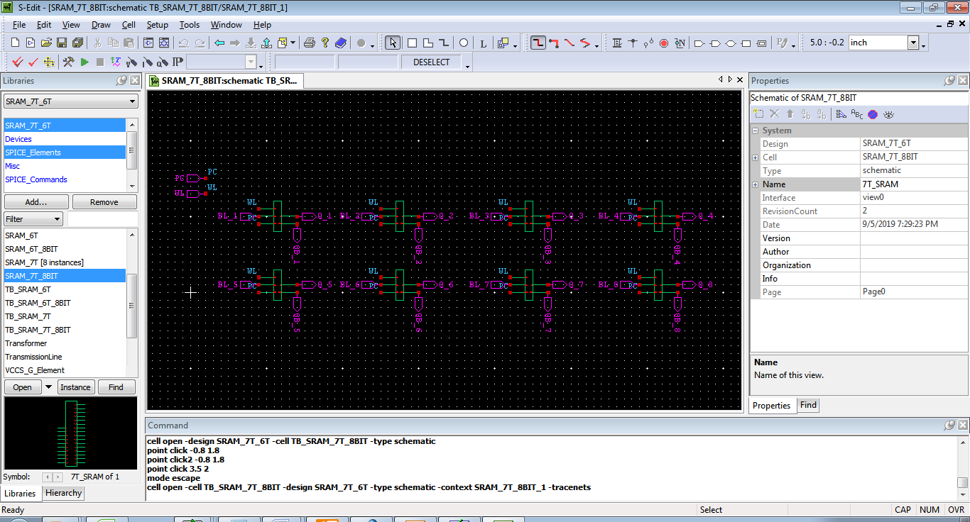

W-edit output
6T- SRAM:

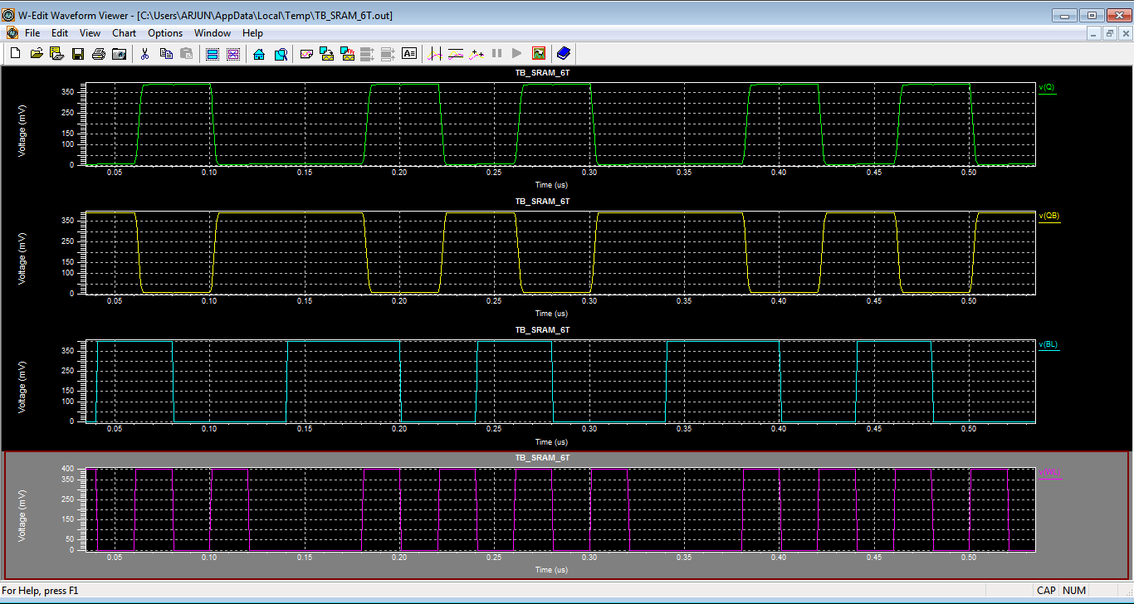

7T- SRAM:

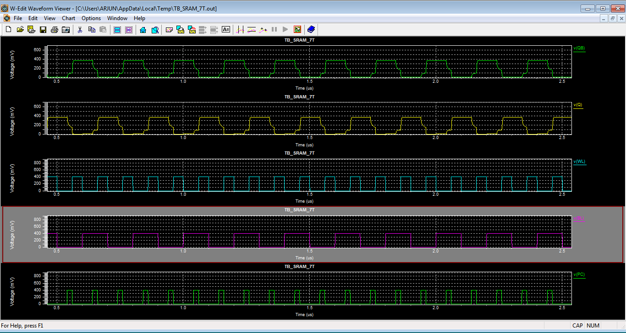

6T- SRAM FOR 8 BIT:
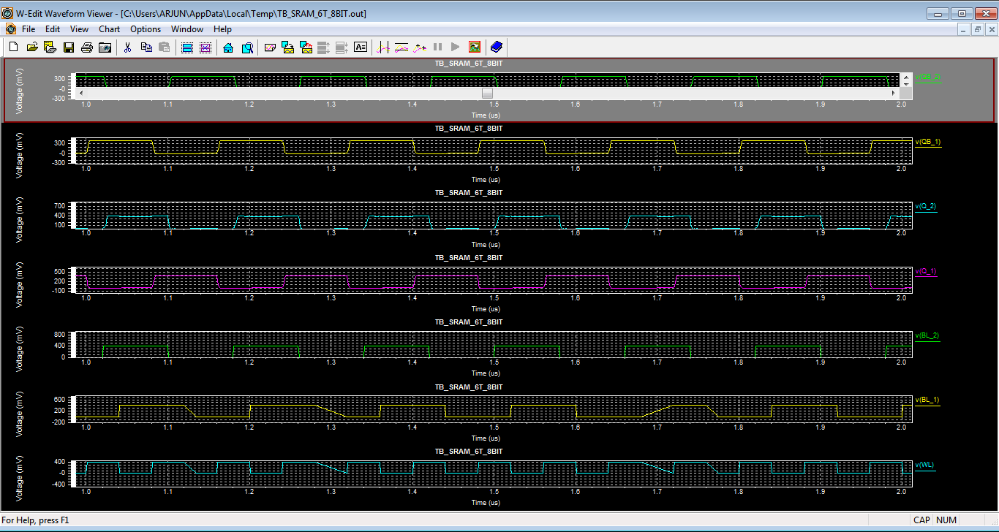

7T- SRAM FOR 8-BIT:
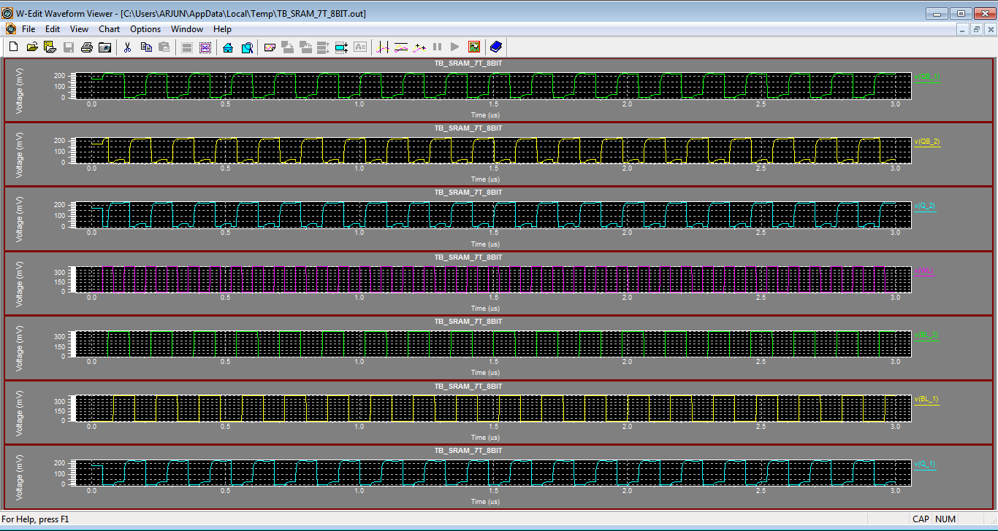

Area, Power and Results
6T- SRAM:

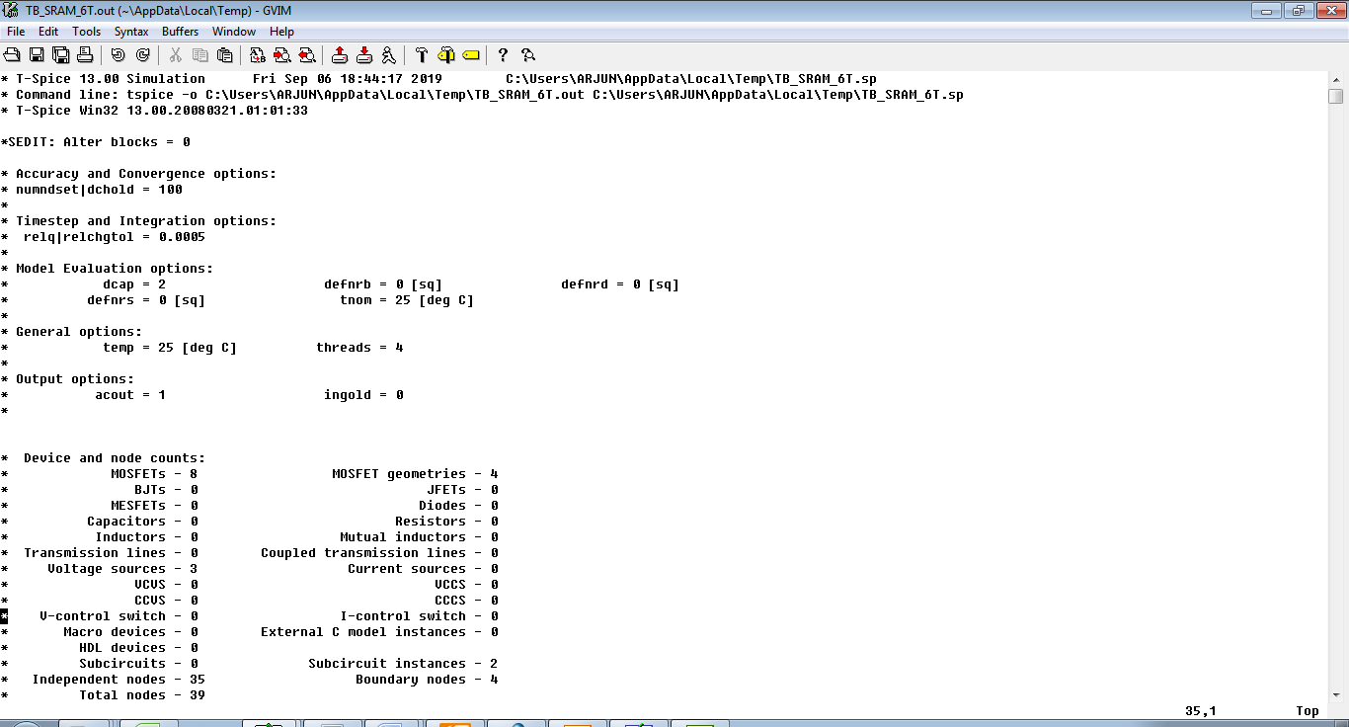

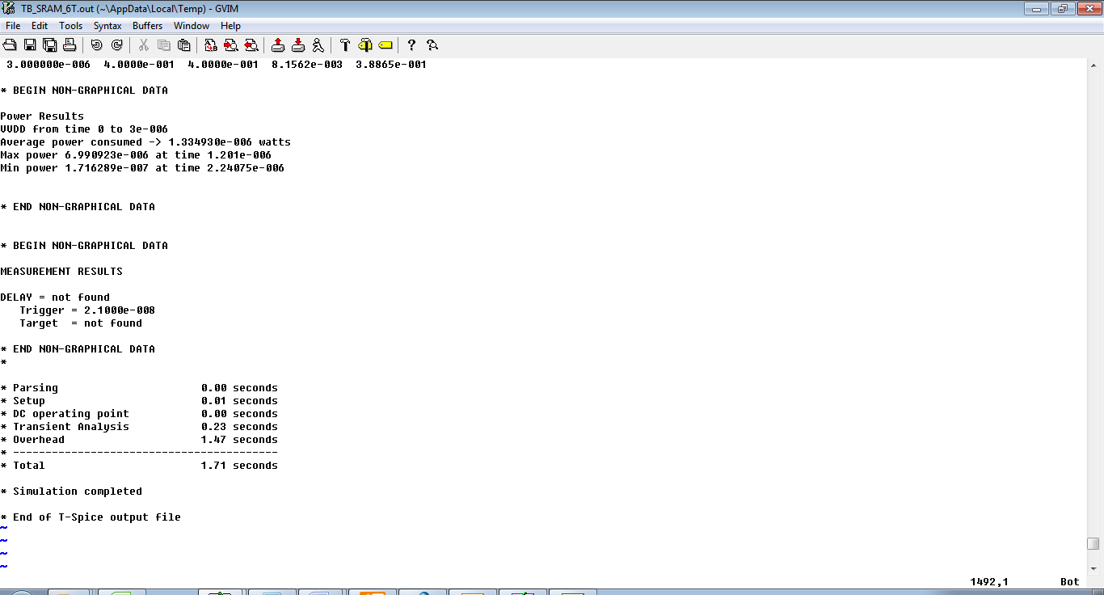

7T- SRAM:

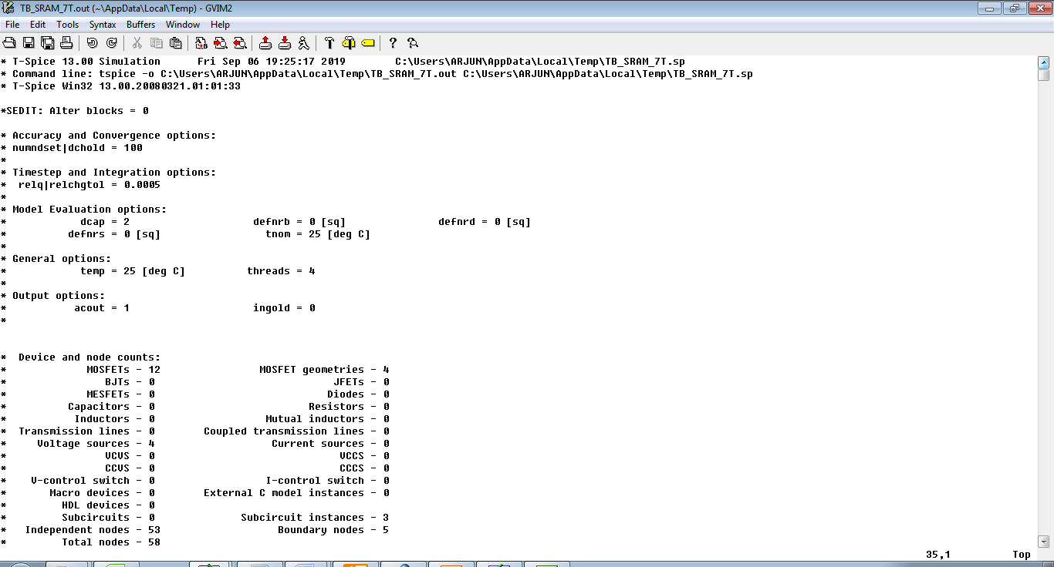

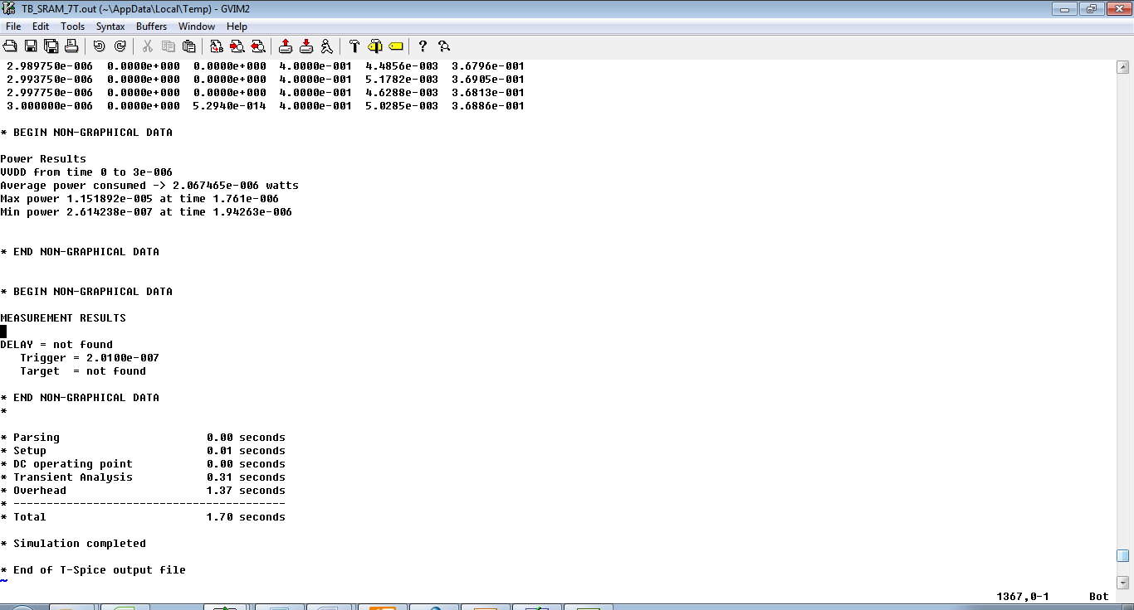

6T- SRAM FOR 8 BIT:

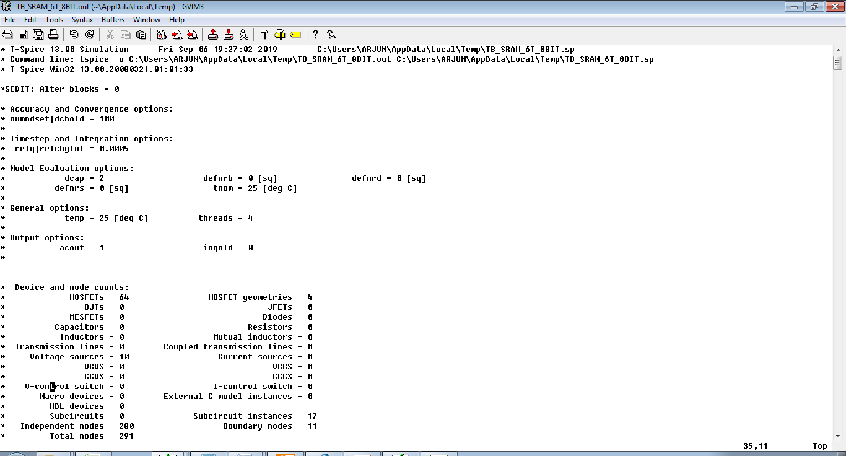

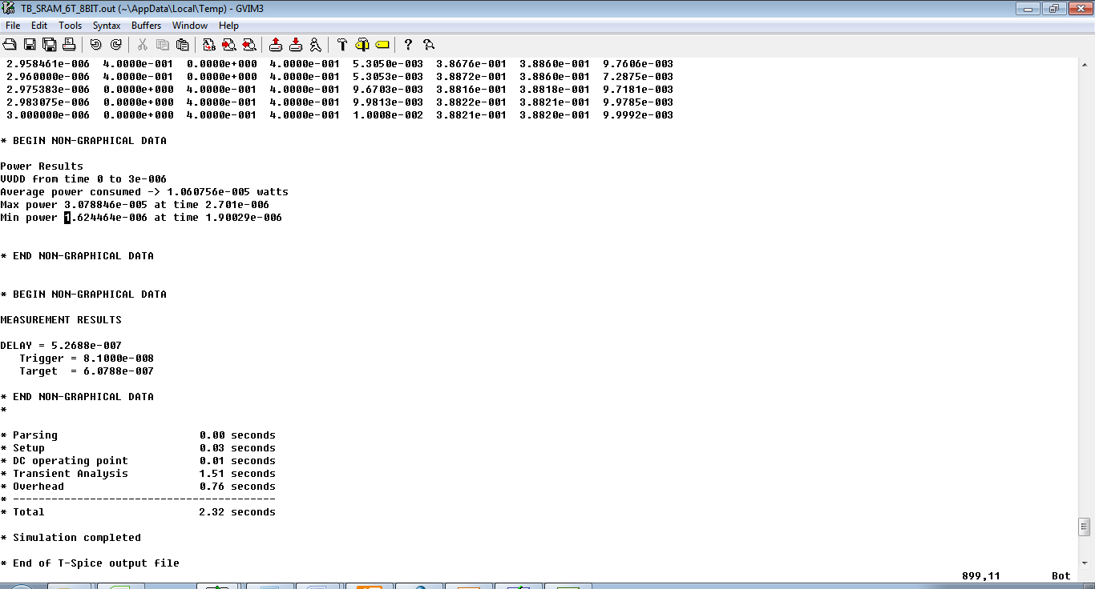

7T- SRAM FOR 8 BIT:
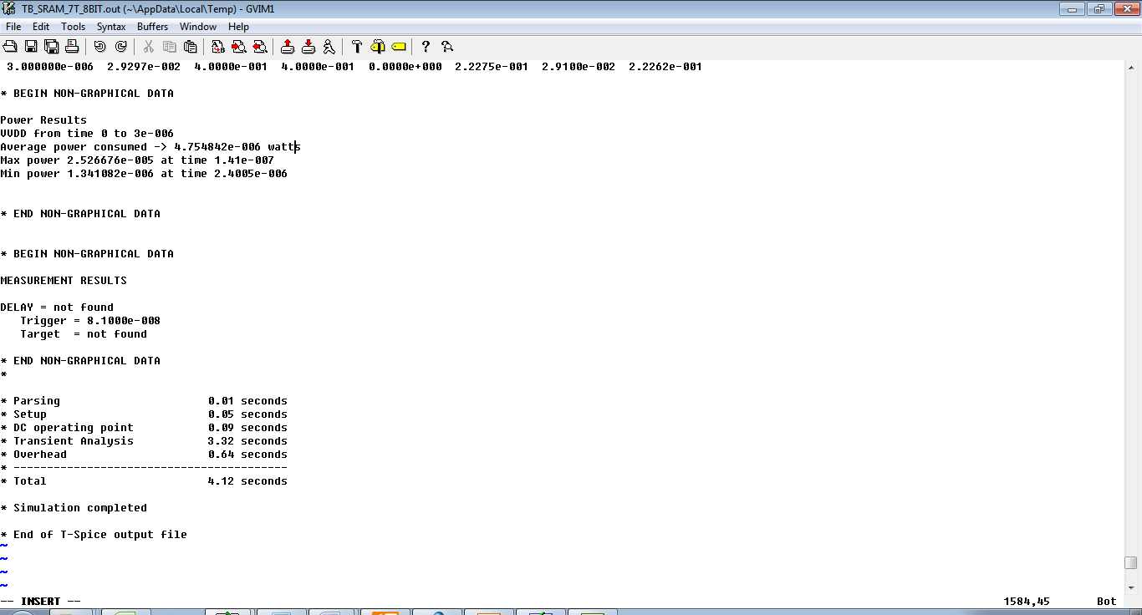

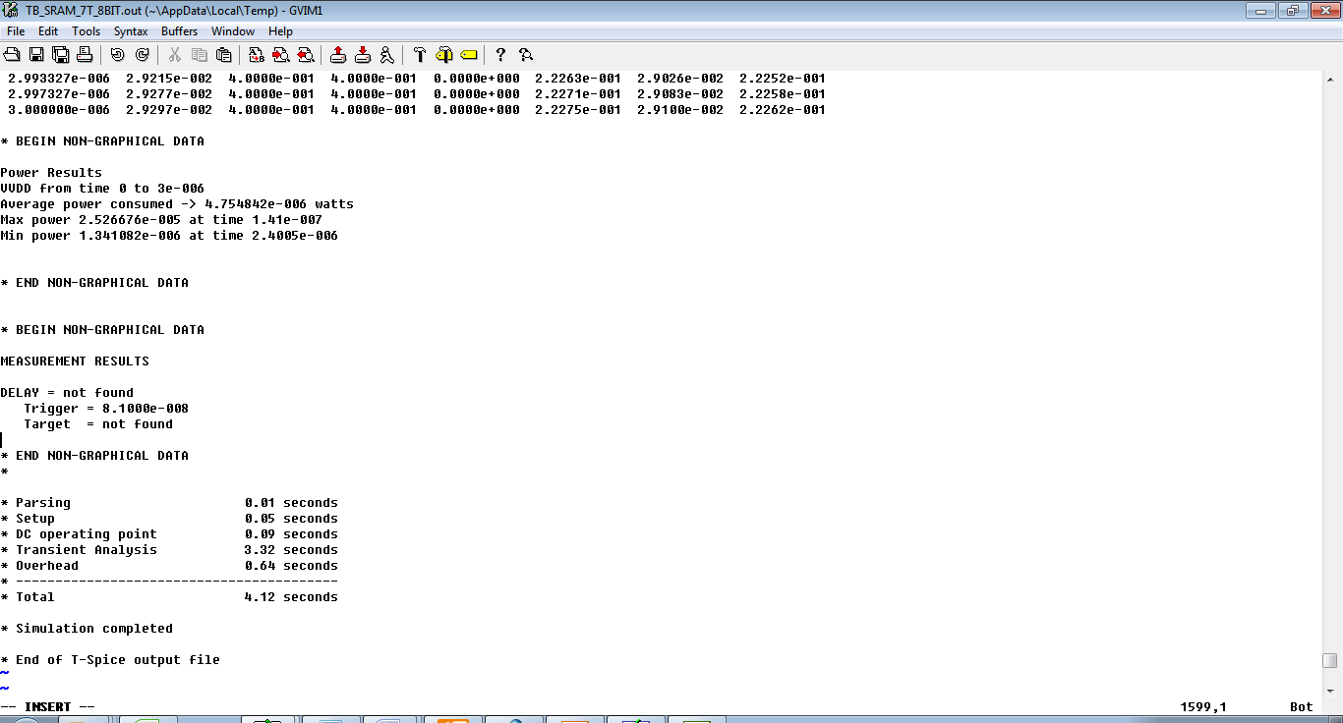

Reference
[1] D. Lim, J. W. Lee, B. Gassend, G. E. Suh, M. Van Dijk, and S. Devadas, “Extracting secret keys from integrated circuits,” IEEE Transactions on Very Large Scale Integration (VLSI) Systems, vol. 13, no. 10, pp. 1200– 1205, 2005.
[2] D. Genkin, L. Pachmanov, I. Pipman, E. Tromer, and Y. Yarom, “Ecdsa key extraction from mobile devices via nonintrusive physical side channels,” in Proceedings of the 2016 ACM SIGSAC Conference on Computer and Communications Security. ACM, 2016, pp. 1626– 1638.
[3] P. Kocher, J. Jaffe, B. Jun, and P. Rohatgi, “Introduction to differential power analysis,” Journal of Cryptographic Engineering, vol. 1, no. 1, pp. 5–27, 2011.
[4] S. Mangard and A. Y. Poschmann, Constructive Side-Channel Analysis and Secure Design. Springer, 2015.
[5] M. Alioto, L. Giancane, G. Scotti, and A. Trifiletti, “Leakage power analysis attacks: A novel class of attacks to nanometer cryptographic circuits,” IEEE Transactions on Circuits and Systems I: Regular Papers, vol. 57, no. 2, pp. 355–367, 2010.
[6] M. Alioto, S. Bongiovanni, M. Djukanovic, G. Scotti, and A. Trifiletti, “Effectiveness of leakage power analysis attacks on dpa-resistant logic styles under process variations,” IEEE Transactions on Circuits and Systems I: Regular Papers, vol. 61, no. 2, pp. 429–442, 2014.
[7] I. Levi, O. Keren, and A. Fish, “Data-dependent delays as a barrier against power attacks,” IEEE Transactions on Circuits and Systems I: Regular Papers, vol. 62, no. 8, pp. 2069–2078, 2015.
[8] M. Avital, I. Levi, O. Keren, and A. Fish, “Cmos based gates for blurring power information,” IEEE Transactions on Circuits and Systems I: Regular Papers, vol. 63, no. 7, pp. 1033–1042, 2016.
[9] M. Avital, H. Dagan, I. Levi, O. Keren, and A. Fish, “Dpa-secured quasi-adiabatic logic (sqal) for low-power passive rfid tags employing s-boxes.” IEEE Trans. on Circuits and Systems, vol. 62, no. 1, pp. 149– 156, 2015.
[10] R. Giterman, M. Vicentowski, I. Levi, Y. Weizman, O. Keren, and A. Fish, “Leakage power attack-resilient symmetrical 8t sram cell,” IEEE Transactions on Very Large Scale Integration (VLSI) Systems, no. 99, pp. 1–5, 2018.
[11] ITRS, “International Technology Roadmap for Semiconductors - 2015 Edition,” 2015. [Online]. Available: http://www.itrs2.net .
[12] M. Neve, E. Peeters, D. Samyde, and J.-J. Quisquater, “Memories: a survey of their secure uses in smart cards,” in Security in Storage Workshop, 2003. SISW’03. Proceedings of the Second IEEE International. IEEE, 2003, pp. 62–62.
[13] W. Liu, R. Luo, and H. Yang, “Cryptography overhead evaluation and analysis for wireless sensor networks,” in Communications and Mobile Computing, 2009. CMC’09. WRI International Conference on, vol. 3. IEEE, 2009, pp. 496–501.
[14] E. Konur et al., “Power analysis resistant sram,” in 2006 World Automation Congress. IEEE, 2006, pp. 1–6.
[15] V. Roziˇ c´ et al., “Design solutions for securing sram cell against power analysis,” in Hardware-Oriented Security and Trust (HOST), 2012 IEEE International Symposium on. IEEE, 2012, pp. 122–127.
[16] B. Zimmer, S. O. Toh, H. Vo, Y. Lee, O. Thomas, K. Asanovic, and B. Nikolic, “Sram assist techniques for operation in a wide voltage range in 28-nm cmos,” IEEE Transactions on Circuits and Systems II: Express Briefs, vol. 59, no. 12, pp. 853–857, 2012.
[17] M.-H. Chang, Y.-T. Chiu, and W. Hwang, “Design and iso-area vmin analysis of 9t subthreshold sram with bit-interleaving scheme in 65-nm cmos,” IEEE Transactions on Circuits and Systems II: Express Briefs, vol. 59, no. 7, pp. 429–433, 2012.
[18] M. Renauld, D. Kamel, F.-X. Standaert, and D. Flandre, “Information theoretic and security analysis of a 65-nanometer ddsll aes s-box,” in International Workshop on Cryptographic Hardware and Embedded Systems. Springer, 2011, pp. 223–239.
[19] E. Seevinck et al., “Static-noise margin analysis of mos sram cells,” Solid-State Circuits, IEEE Journal of, vol. 22, no. 5, pp. 748–754,1987.

