Use case No.13- Use Case: Jenkins Availability Monitoring and Alerting on AWS EC2
Problem statement :
Ensure Jenkins service running on an EC2 instance is continuously monitored for downtime and restarts, generate reports for audit, and trigger automated alerts using AWS services.
Trigger Condition
· Jenkins service goes DOWN or restarts unexpectedly.
Workflow
1. Install Jenkins on EC2
o Deploy Jenkins using package manager and enable systemd service.
2. Monitor Jenkins Status
o Use a bash script scheduled via cron to check systemctl is-active jenkins.
o Log events (UP/DOWN) with timestamps in /var/log/jenkins_monitor.log.
Generate Report
· Parse log file to count downtime and uptime occurrences
Configure AWS Alerts
· Enable CloudWatch Agent to monitor Jenkins process or custom metric.
· Create CloudWatch Alarm for Jenkins DOWN or restart events.
· Attach SNS Topic for email/SMS notifications.
Expected Outcome:
Jenkins downtime and restart events tracked automatically.
Alerts triggered instantly when Jenkins goes down or restarts.

Workflow
1. Provisioning EC2 instance in AWS console
Selected ubuntu AMI
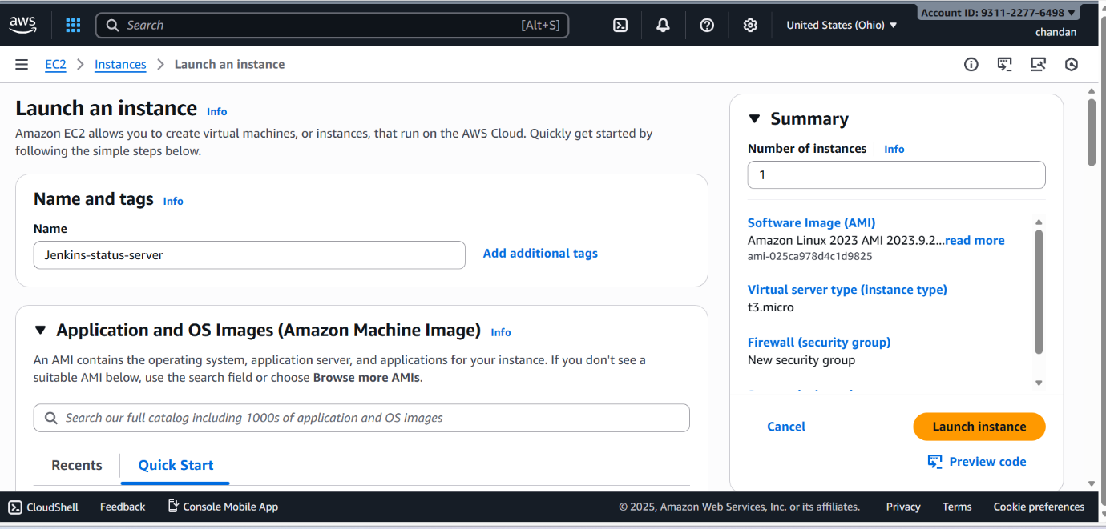

Allow port 8080 to access jenkins server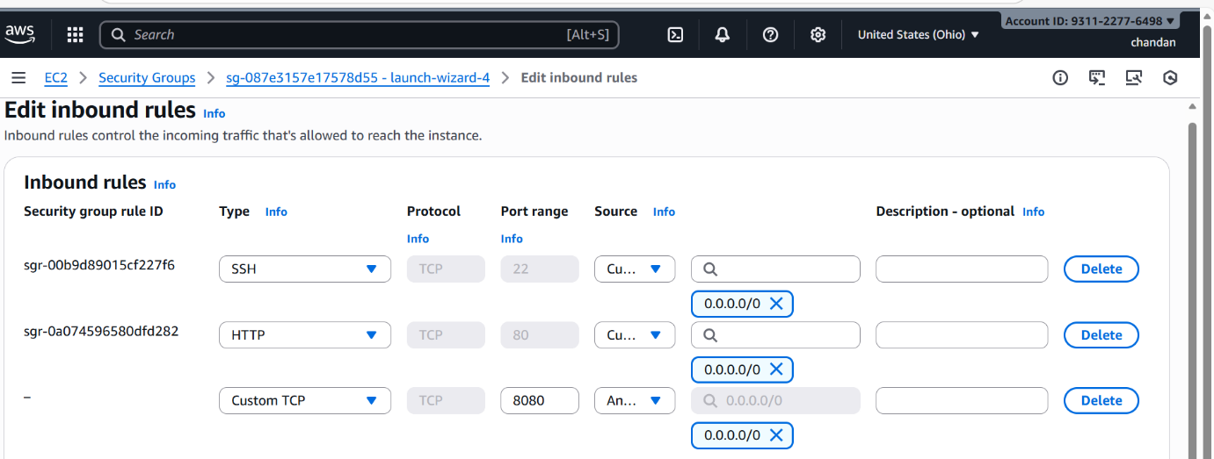

Attach the roles to the created EC2 instance
->Select AmazonSSMManagedInsatnceCore
->Select cloudwatchServerAgentpolicy
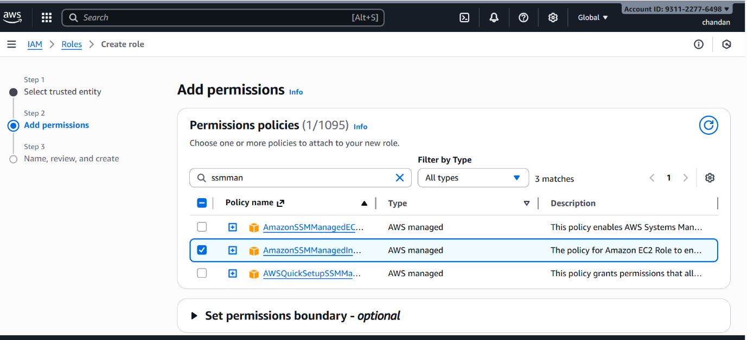

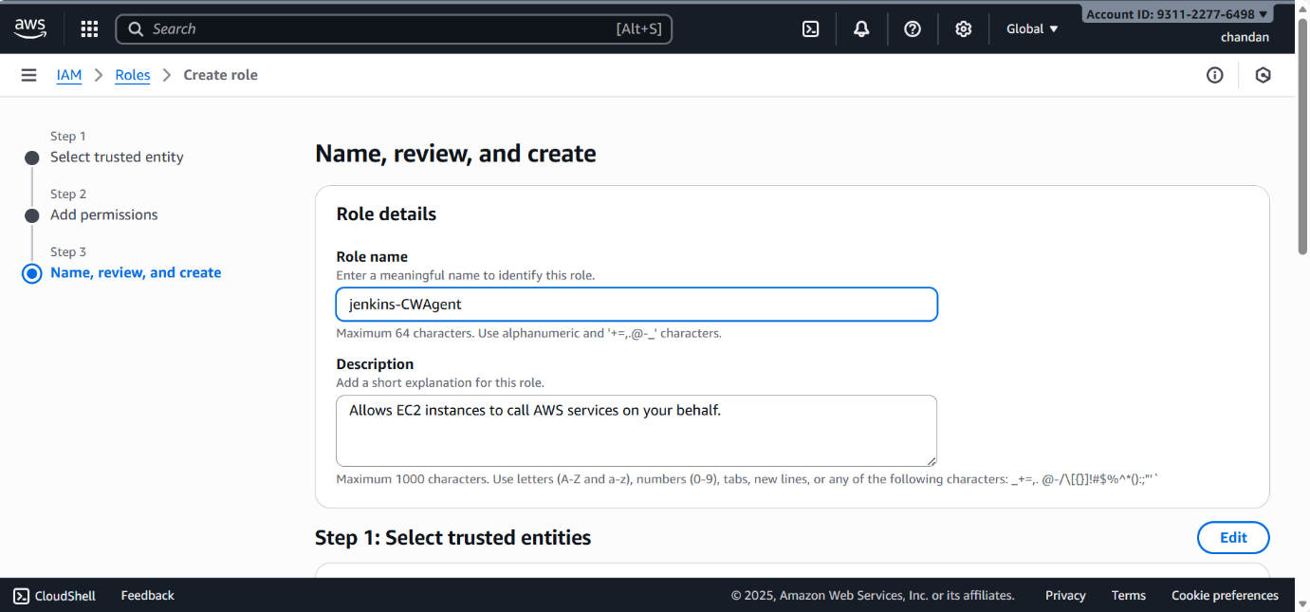

Attach the IAM role to the EC2 instace which you created now
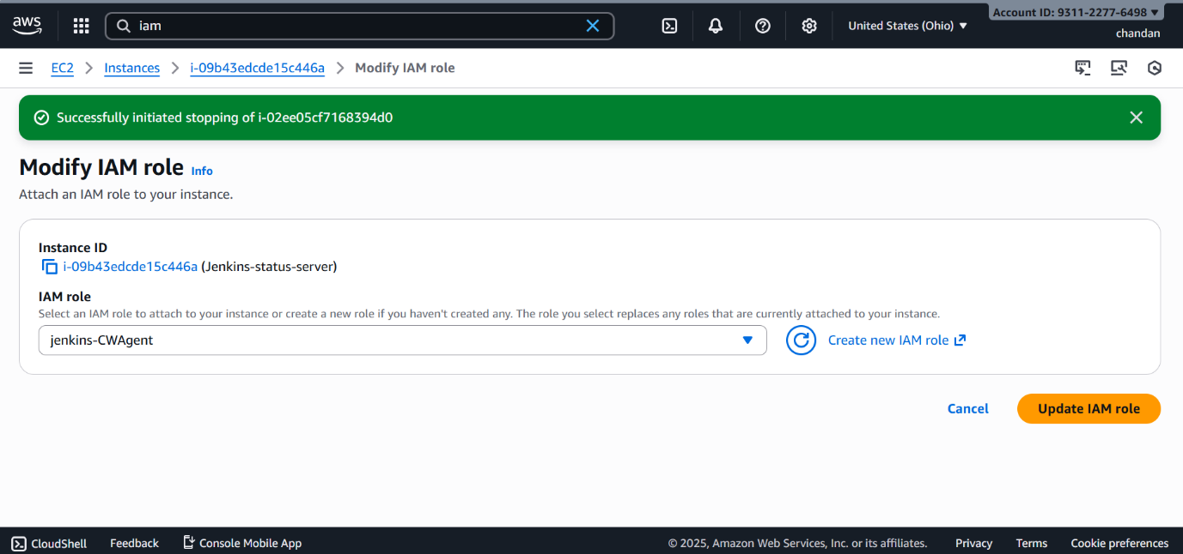

Launched the EC2 instance successfully (ubuntu)
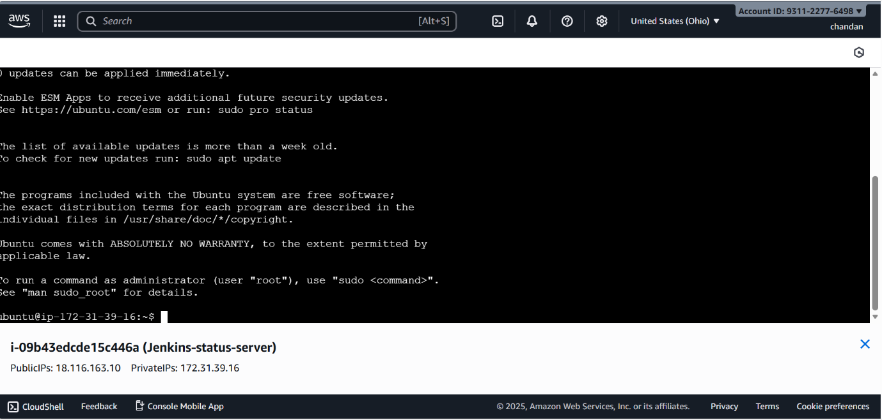

2. Install Jenkins on EC2
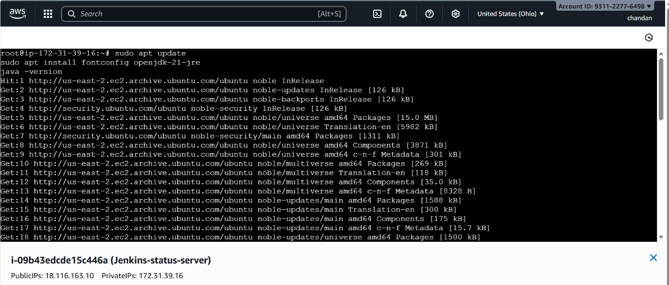
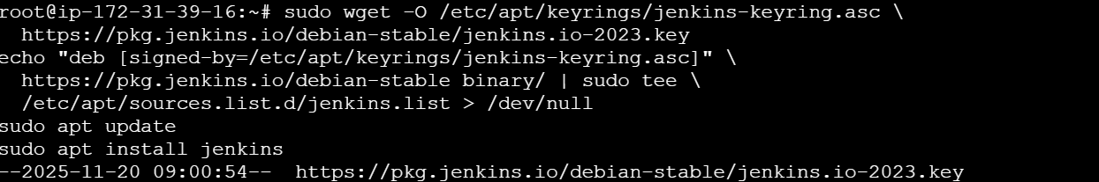

o Deploy Jenkins using package manager and enable systemd service.
->systemctl enable Jenkins
->systemctl start Jenkins
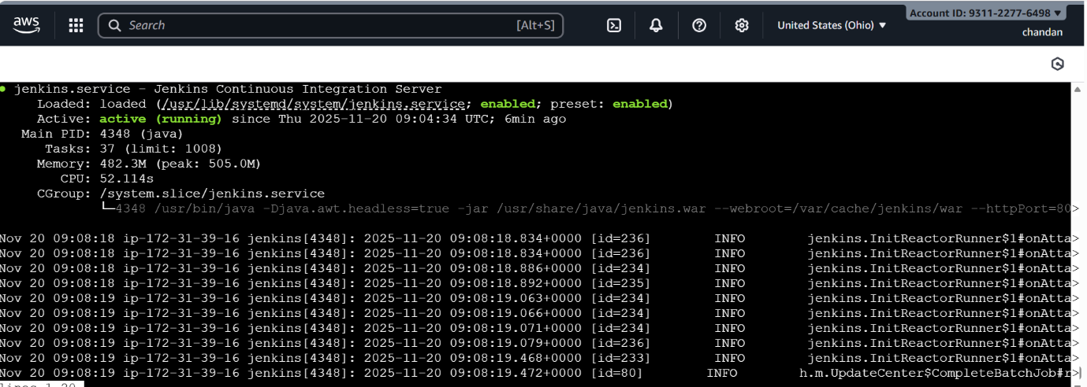

2. Monitor Jenkins Status
o Created a bash script scheduled via cron to check systemctl is-active jenkins.
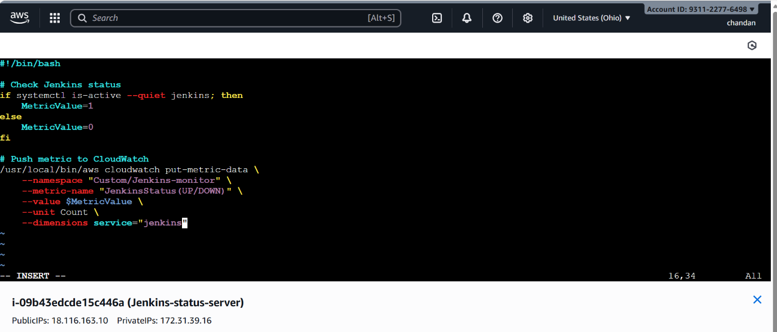
Scheduling the cloudwatch.sh using crontab
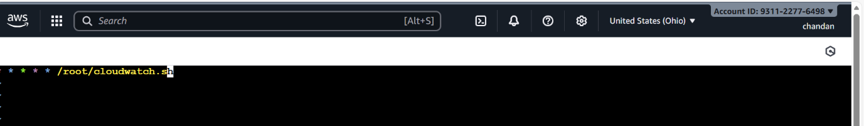
o Log events (UP/DOWN) with timestamps in /var/log/jenkins_monitor.log.
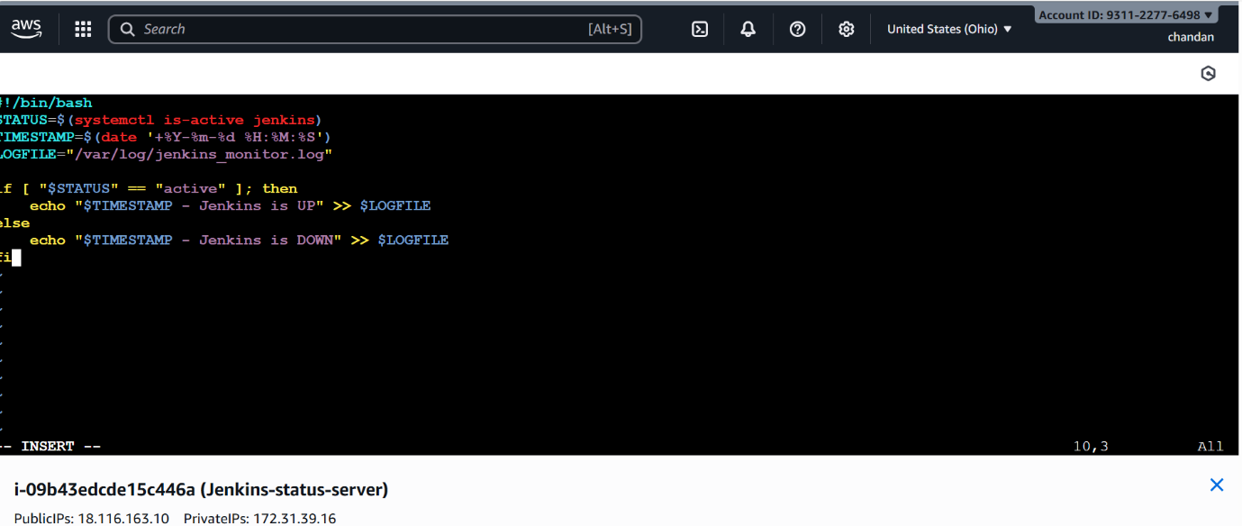

Generate Report

· Created a log file to count downtime and uptime occurrences

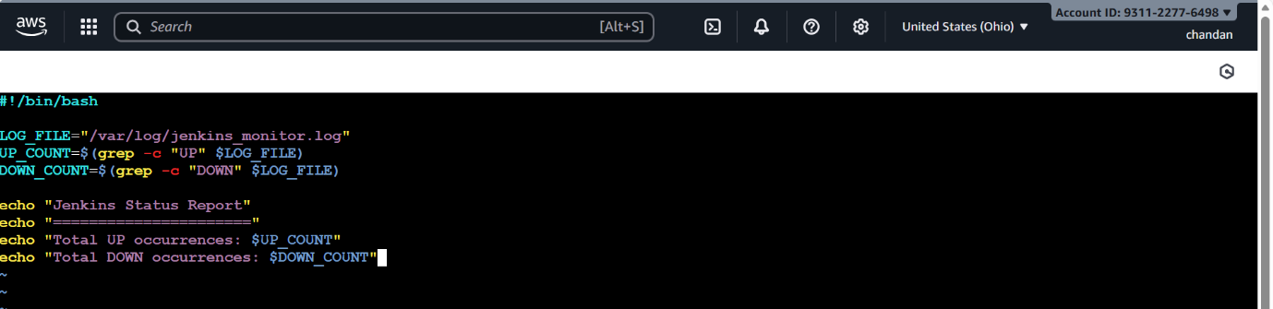

Configure AWS Alerts

· Enable CloudWatch Agent to monitor Jenkins process .

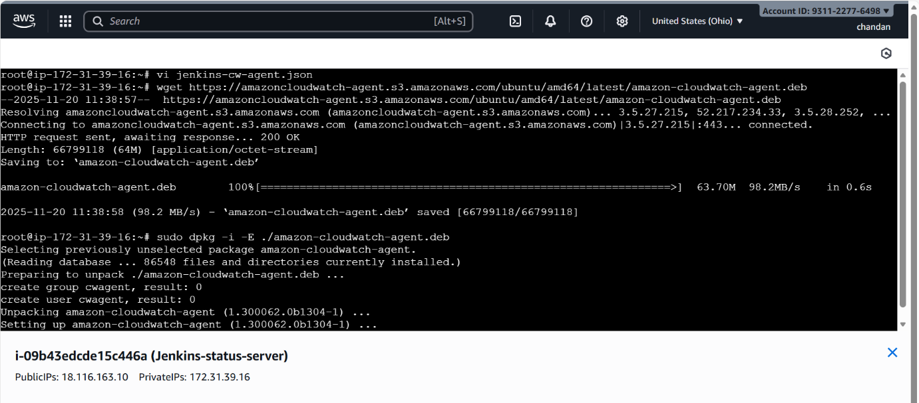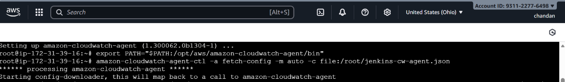

Created a configuration json file for cloud watch agent

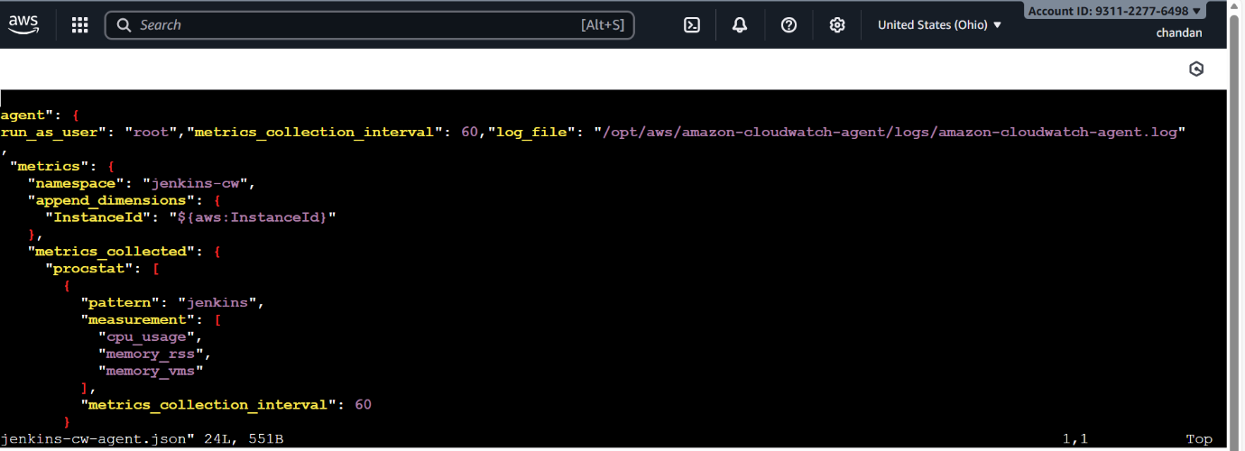

Successfully cloudwatch agent is monitoring the jenkins process
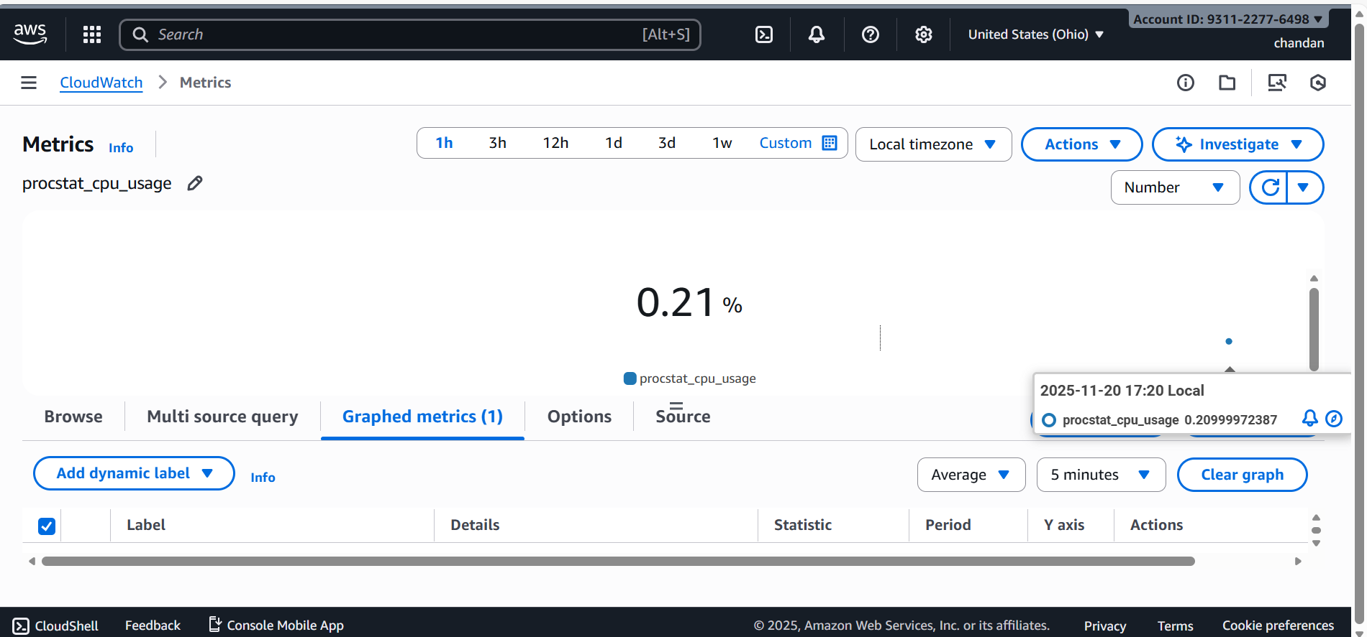

· Created a CloudWatch Alarm for Jenkins DOWN or restart events.

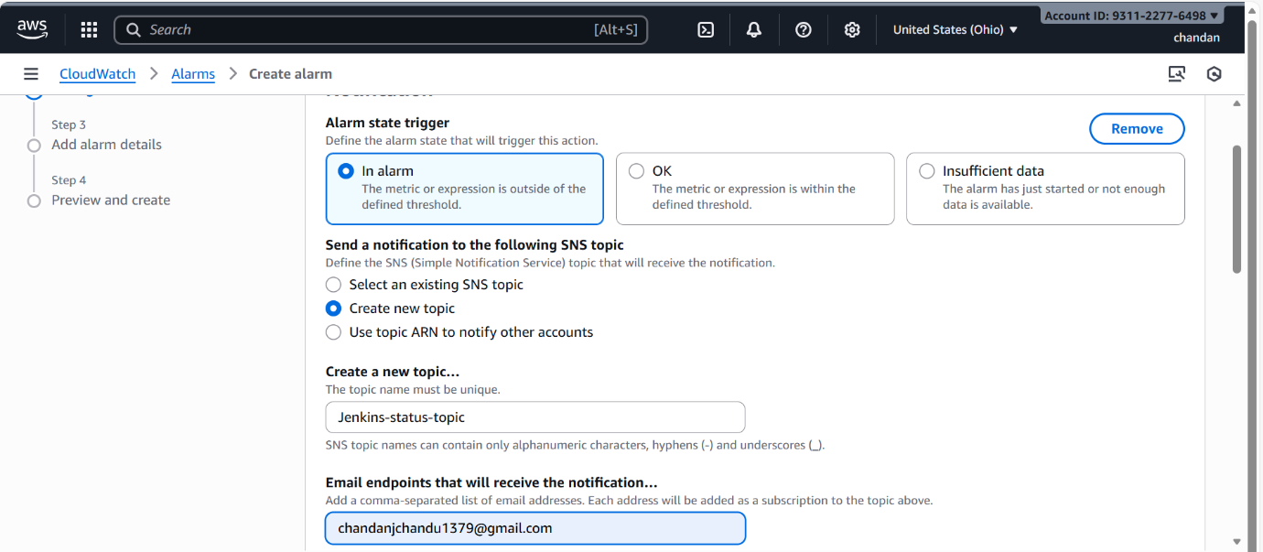

Select the threshold frequency for the UP time alarm
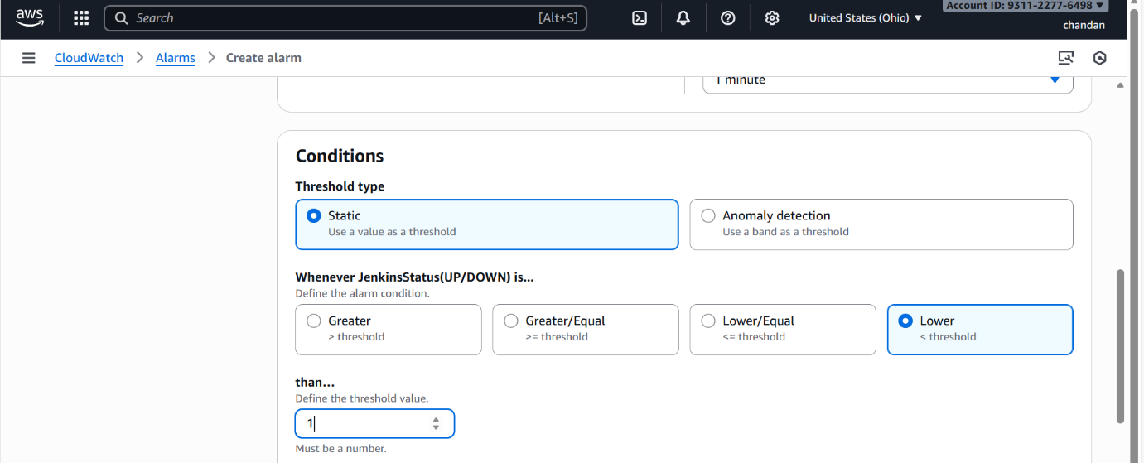

Selecting the metrics for the cloud watch alarm
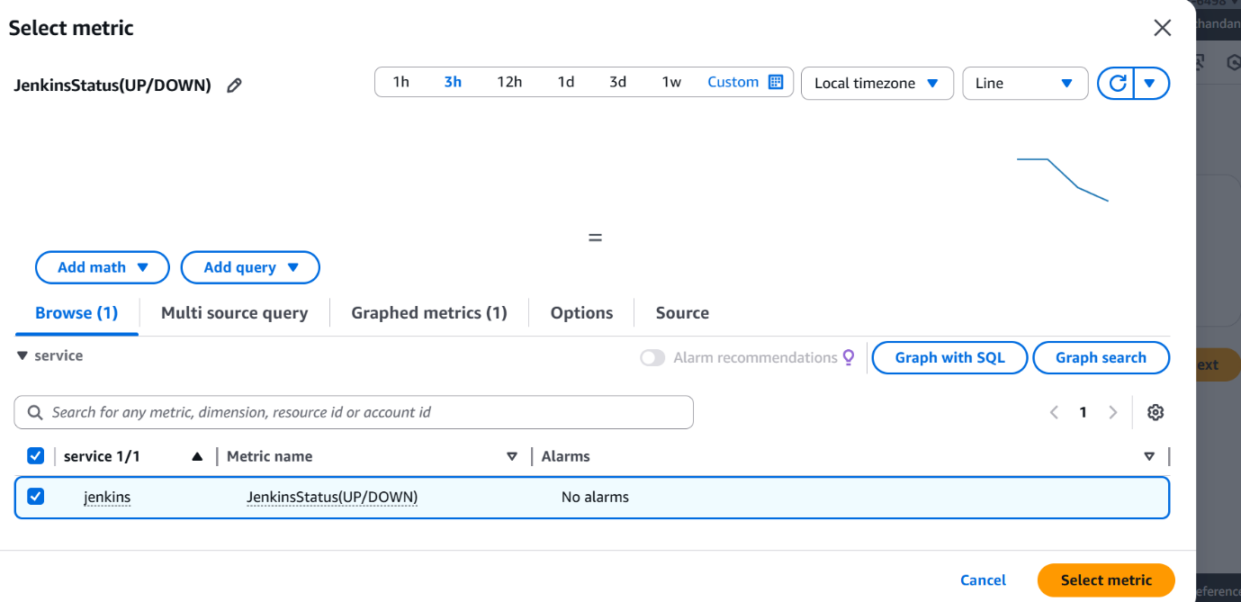
Created the SNS topic for the alarms
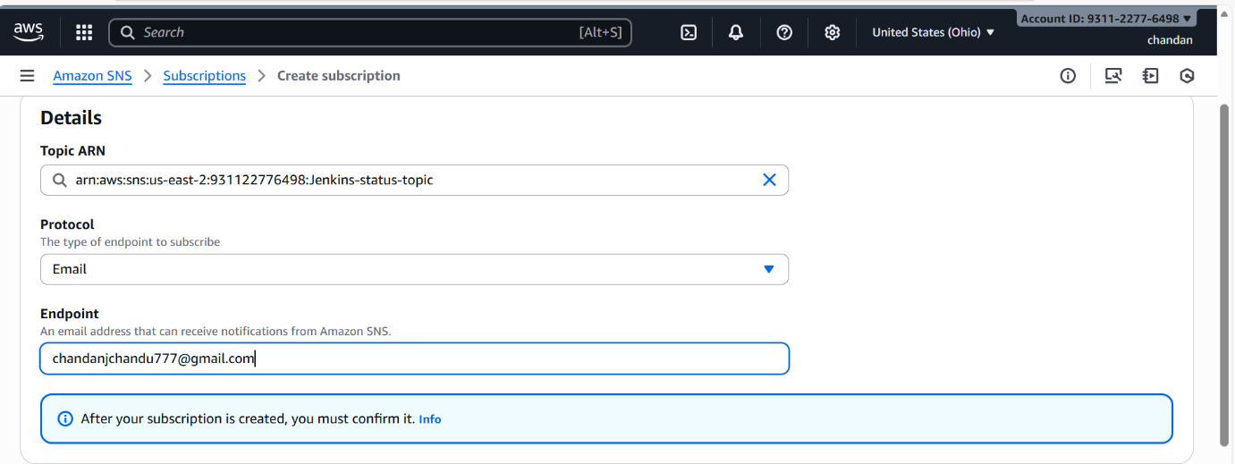

Expected Outcome:
Jenkins downtime and restart events tracked automatically.
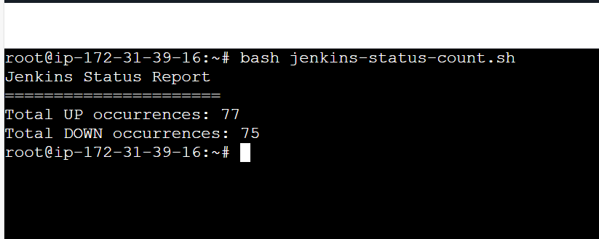

Alerts triggered instantly when Jenkins goes down .
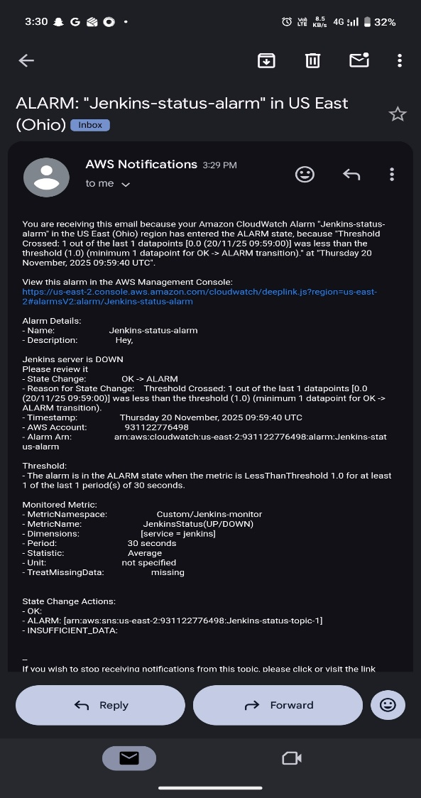

Alerts triggered instantly when Jenkins restarts.
