**DevSecOps – Case Study**

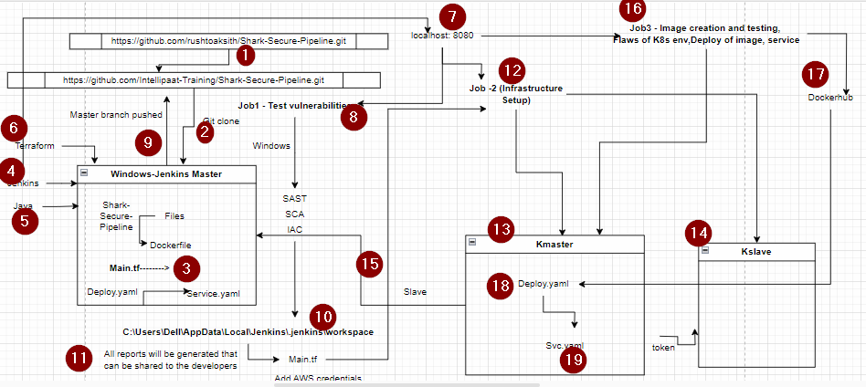

[**https://developer.hashicorp.com/terraform/install#windows**](https://developer.hashicorp.com/terraform/install#windows)

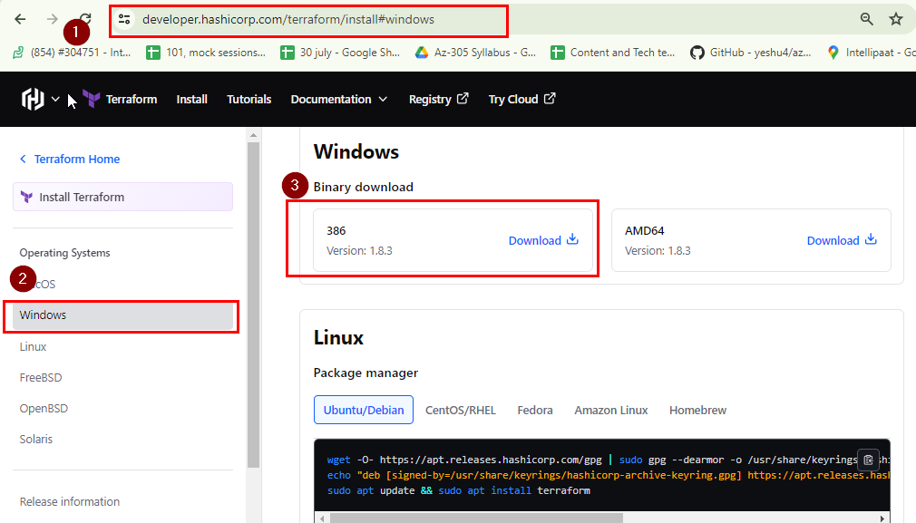

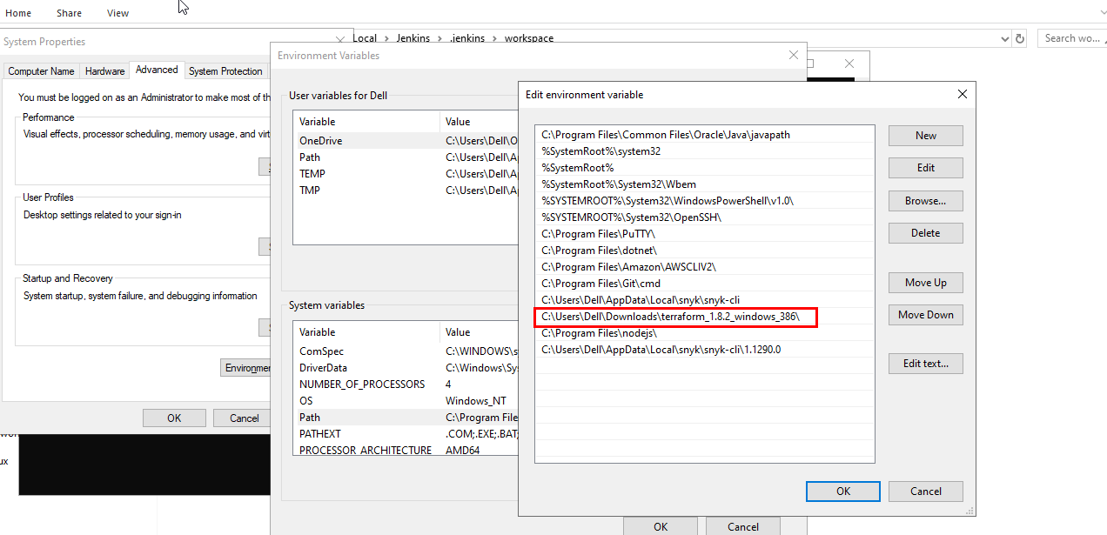

**Before you create and run your job:**

Add git and snyk in Manage Jenkins> tool.

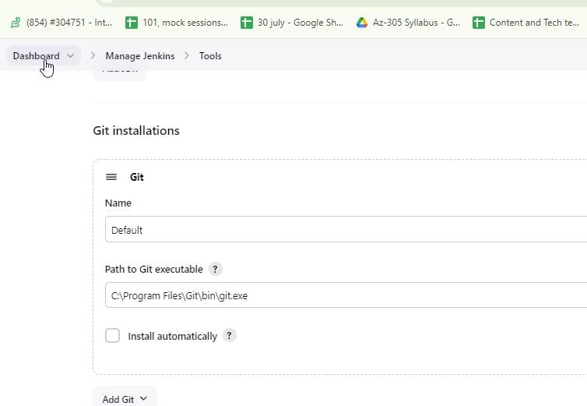

**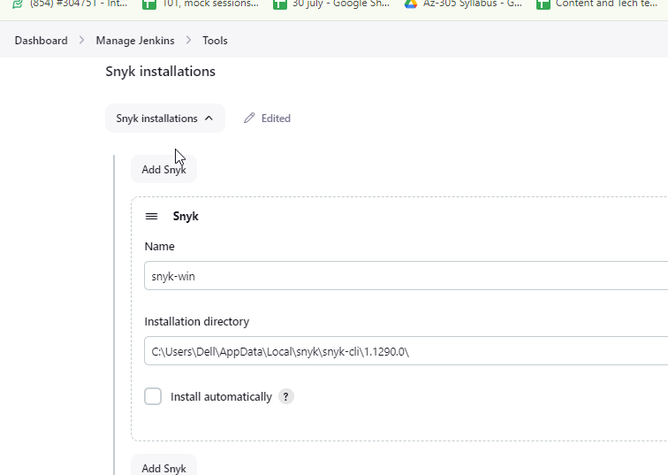  
  
While adding githubwebhook trigger:   
Proxy:** [**https://dashboard.ngrok.com/get-started/setup/windows**](https://dashboard.ngrok.com/get-started/setup/windows)

**Create an account> login  
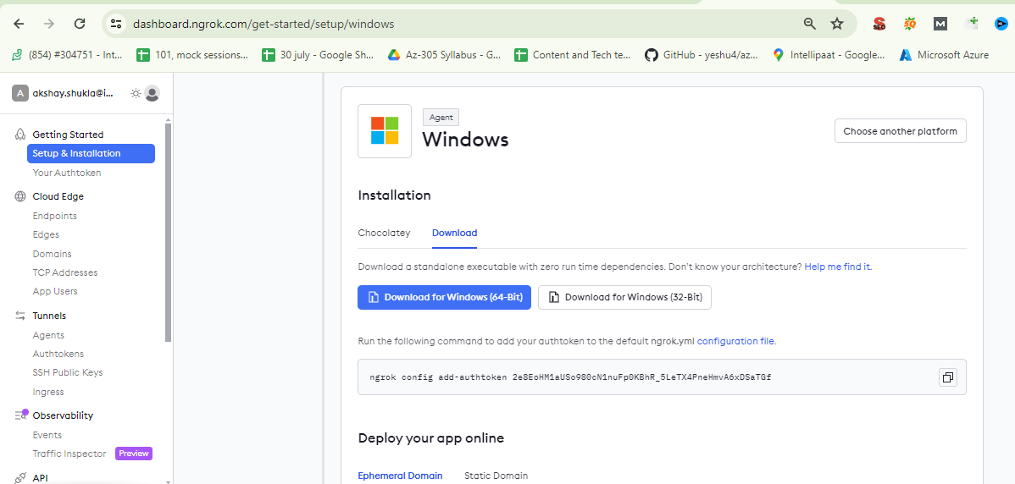  
  
Access after unzipping the download ngrok file:  
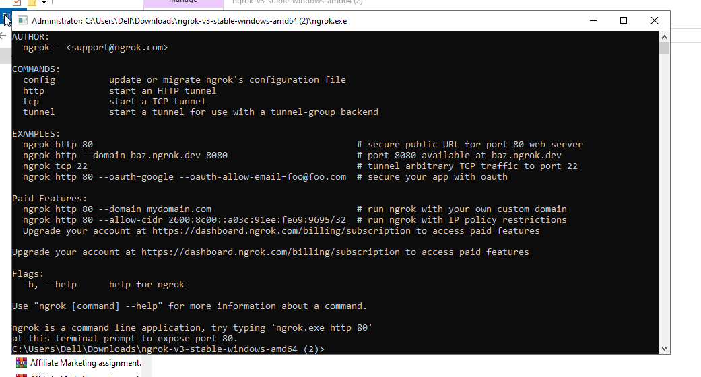**

ngrok config add-authtoken 2e8EoHM1aUSo980cN1nuFp0KBhR_5LeTX4PneHmvA6xDSaTGf  
  
ngrok http <http://localhost:8080>  
  
