**DOMAIN WINTER WINNING CAMP**

**Student Name: PRAVAS UID: 22BCS10464**

**Branch: BE CSE Section/Group: TPP_FL_603-A**

***DAY 1:***

***VERY EASY***

**QUES 1:** Sum of Natural Numbers up to N

Calculate the sum of all natural numbers from 1 to n, where n is a positive integer. Use the formula: Sum=n×(n+1)/2.​

Take n as input and output the sum of natural numbers from 1 to n.

**Solution:**

#include <iostream>

using namespace std;

int main() {

int n;

cout << "Enter a positive integer: ";

cin >> n;

if (n > 0) {

int sum = n * (n + 1) / 2;

cout << "The sum of natural numbers from 1 to " << n << " is: " << sum << endl;

} else {

cout << "Please enter a positive integer." << endl;

}

return 0;

}

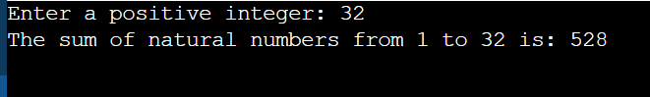

**QUES 2:** Check if a Number is Prime

Objective Check if a given number n is a prime number. A prime number is a natural number greater than 1 that has no positive divisors other than 1 and itself. To determine if a number is prime, iterate from 2 to √n and check if n is divisible by any number in this range. If it is divisible, it is not a prime number; otherwise, it is a prime.

**Solution:**

#include <iostream>

#include <cmath>

using namespace std;

bool isPrime(int n) {

if (n <= 1) return false;

for (int i = 2; i <= sqrt(n); i++) {

if (n % i == 0) {

return false;

}

}

return true;

}

int main() {

int n;

cout << "Enter a number: ";

cin >> n;

if (n >= 2 && n <= 100000) {

if (isPrime(n)) {

cout << "Prime" << endl;

} else {

cout << "Not Prime" << endl;

}

} else {

cout << "Number out of range. Please enter a number between 2 and 100000." << endl;

}

return 0;

}



**QUES 3:** Print Multiplication Table of a Number

Objective: Print the multiplication table of a given number n. A multiplication table for a number n is a list of products of n with integers from 1 to 10. For example, the multiplication table for 3 is:  
3×1=3,3×2=6,…,3×10=30.

**Solution:**

#include <iostream>

using namespace std;

int main() {

int n;

cout << "Enter a number: ";

cin >> n;

for (int i = 1; i <= 10; i++) {

cout << n << " x " << i << " = " << n * i << endl;

}

return 0;}

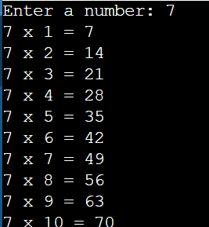

**QUES 4:** Print Odd Numbers up to N

Objective: Print all odd numbers between 1 and n, inclusive. Odd numbers are integers that are not divisible by 2. These numbers should be printed in ascending order, separated by spaces. This problem is a simple introduction to loops and conditional checks. The goal is to use a loop to iterate over the numbers and check if they are odd using the condition i%2≠0.

**Solution:**

#include <iostream>

using namespace std;

int main() {

int n;

cout << "Enter a number: ";

cin >> n;

for (int i = 1; i <= n; i++) {

if (i % 2 != 0) {

cout << i << " ";

}

}

return 0;

}

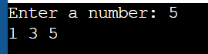

**QUES 5:** Sum of Odd Numbers up to N

Objective: Calculate the sum of all odd numbers from 1 to n. An odd number is an integer that is not divisible by 2.The sum of odd numbers, iterate through all the numbers from 1 to n, check if each number is odd, and accumulate the sum.

**Solution:**

#include <iostream>

using namespace std;

int main() {

int n, sum = 0;

cout << "Enter a number: ";

cin >> n;

for (int i = 1; i <= n; i++) {

if (i % 2 != 0) {

sum += i;

}

}

cout << "Sum of odd numbers up to " << n << " is: " << sum << endl;

return 0;

}

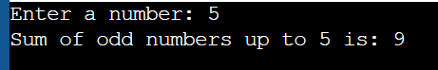

***EASY***

**QUES 6:** Count Digits in a Number

Objective: Count the total number of digits in a given number n. The number can be a positive integer. For example, for the number 12345, the count of digits is 5. For a number like 900000, the count of digits is 6.

Given an integer n, your task is to determine how many digits are present in n. This task will help you practice working with loops, number manipulation, and conditional logic.

**Solution:**

#include <iostream>

using namespace std;

int main() {

int n;

cout << "Enter a positive integer: ";

cin >> n;

if (n > 0) {

int count = 0;

while (n > 0) {

n /= 10;

count++;

}

cout << "The number of digits is: " << count << endl;

} else {

cout << "Please enter a positive integer." << endl;

}

return 0;

}

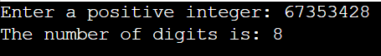

**QUES 7:** Reverse a Number

Objective: Reverse the digits of a given number n. For example, if the input number is 12345, the output should be 54321. The task involves using loops and modulus operators to extract the digits and construct the reversed number.

**Solution:**

#include <iostream>

using namespace std;

int main() {

int n, reversedNumber = 0;

cout << "Enter a number: ";

cin >> n;

while (n > 0) {

int digit = n % 10;

reversedNumber = reversedNumber * 10 + digit; number

n /= 10;

}

cout << "Reversed Number: " << reversedNumber << endl;

return 0;

}

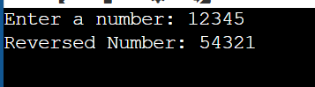

**QUES 8:** Find the Largest Digit in a Number

Objective: Find the largest digit in a given number n. For example, for the number 2734, the largest digit is 7. You need to extract each digit from the number and determine the largest one. The task will involve using loops and modulus operations to isolate the digits.

**Solution:**

#include <iostream>

using namespace std;

int main() {

int n, largestDigit = 0;

cout << "Enter a number: ";

cin >> n;

while (n > 0) {

int digit = n % 10;

if (digit > largestDigit) {

largestDigit = digit;

}

n /= 10;

}

cout << "Largest Digit: " << largestDigit << endl;

return 0;

}

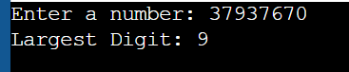

**QUES 9:** Check if a Number is a Palindrome

Objective: Check whether a given number is a palindrome or not. A number is called a palindrome if it reads the same backward as forward. For example, 121 is a palindrome because reading it from left to right is the same as reading it from right to left. Similarly, 12321 is also a palindrome, but 12345 is not.

**Solution:**

#include <iostream>

using namespace std;

int main() {

int n, originalNumber, reversedNumber = 0;

cout << "Enter a number: ";

cin >> n;

originalNumber = n;

while (n > 0) {

int digit = n % 10;

reversedNumber = reversedNumber * 10 + digit;

n /= 10;

}

if (originalNumber == reversedNumber) {

cout << "Palindrome" << endl;

} else {

cout << "Not a Palindrome" << endl; }

return 0;

}

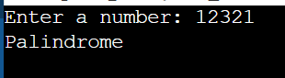

**QUES 10:** Find the Sum of Digits of a Number

Objective: Calculate the sum of the digits of a given number n. For example, for the number 12345, the sum of the digits is 1+2+3+4+5=15. To solve this, you will need to extract each digit from the number and calculate the total sum.

**Solution:**

#include <iostream>

using namespace std;

int main() {

int n, sum = 0;

cout << "Enter a number: ";

cin >> n;

while (n > 0) {

int digit = n % 10;

sum += digit;

n /= 10;

}

cout << "Sum of digits: " << sum << endl;

return 0;

}

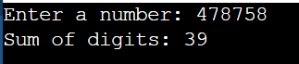

***MEDIUM***

**QUES 11:** Function Overloading for Calculating Area.

Objective: Write a program to calculate the area of different shapes using function overloading. Implement overloaded functions to compute the area of a circle, a rectangle, and a triangle.

**Solution:**

#include <iostream>

using namespace std;

double calculateArea(double radius) {

return 3.14159 * radius * radius;

}

double calculateArea(double length, double breadth) {

return length * breadth;

}

double calculateArea(double base, double height, int isTriangle) {

return 0.5 * base * height;

}

int main() {

double radius, length, breadth, base, height;

cout << "Enter the radius of the circle: ";

cin >> radius;

cout << "Area of the circle: " << calculateArea(radius) << endl;

cout << "Enter the length and breadth of the rectangle: ";

cin >> length >> breadth;

cout << "Area of the rectangle: " << calculateArea(length, breadth) << endl;

cout << "Enter the base and height of the triangle: ";

cin >> base >> height;

cout << "Area of the triangle: " << calculateArea(base, height, 1) << endl;

return 0;

}

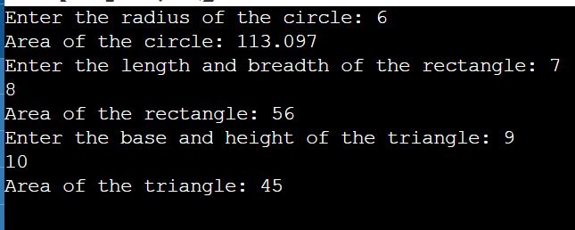

**QUES 12:** Encapsulation with Employee Details

Objective: Write a program that demonstrates encapsulation by creating a class Employee. The class should have private attributes to store:

Employee ID.

Employee Name.

Employee Salary.

Provide public methods to set and get these attributes, and a method to display all details of the employee.

**Solution:**

#include <iostream>

#include <string>

using namespace std;

class Employee {

private:

int employeeID;

string employeeName;

double employeeSalary;

public:

void setEmployeeID(int id) {

employeeID = id;

}

void setEmployeeName(string name) {

employeeName = name;

}

void setEmployeeSalary(double salary) {

employeeSalary = salary;

}

int getEmployeeID() const {

return employeeID;

}

string getEmployeeName() const {

return employeeName;

}

double getEmployeeSalary() const {

return employeeSalary;

}

void displayDetails() const {

cout << "Employee ID: " << employeeID << endl;

cout << "Employee Name: " << employeeName << endl;

cout << "Employee Salary: $" << employeeSalary << endl;

}

};

int main() {

Employee emp;

emp.setEmployeeID(101);

emp.setEmployeeName("John Doe");

emp.setEmployeeSalary(55000.50);

cout << "Employee Details:" << endl;

emp.displayDetails();

return 0;

}

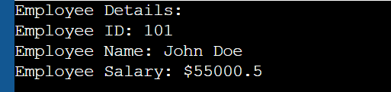

**QUES 13:** Inheritance with Student and Result Classes.

*Objective:* Create a program that demonstrates inheritance by defining:

* A base class Student to store details like Roll Number and Name.
* A derived class Result to store marks for three subjects and calculate the total and percentage.

**Solution:**

#include <iostream>

#include <string>

using namespace std;

class Student {

protected:

int rollNumber;

string name;

public:

void setDetails(int r, string n) {

rollNumber = r;

name = n;

}

void displayDetails() const {

cout << "Roll Number: " << rollNumber << endl;

cout << "Name: " << name << endl;

}

};

class Result : public Student {

private:

float marks[3];

public:

void setMarks(float m1, float m2, float m3) {

marks[0] = m1;

marks[1] = m2;

marks[2] = m3;

}

float calculateTotal() const {

return marks[0] + marks[1] + marks[2];

}

float calculatePercentage() const {

return (calculateTotal() / 300) * 100; // Assuming each subject is out of 100

}

void displayResult() const {

displayDetails(); // Call base class method

cout << "Marks: " << marks[0] << ", " << marks[1] << ", " << marks[2] << endl;

cout << "Total Marks: " << calculateTotal() << endl;

cout << "Percentage: " << calculatePercentage() << "%" << endl;

}

};

int main() {

Result student;

student.setDetails(101, "Alice");

student.setMarks(85, 90, 88);

cout << "Student Result Details:" << endl;

student.displayResult();

return 0;

}

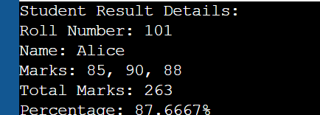

**QUES 14:** Polymorphism with Shape Area Calculation.

Objective: Create a program that demonstrates polymorphism by calculating the area of different shapes using a base class Shape and derived classes for Circle, Rectangle, and Triangle. Each derived class should override a virtual function to compute the area of the respective shape.

**Solution:**

#include <iostream>

#include <cmath>

using namespace std;

class Shape {

public:

virtual double getArea() = 0;

virtual ~Shape() {}

};

class Circle : public Shape {

private:

double radius;

public:

Circle(double r) : radius(r) {}

double getArea() override {

return M_PI * radius * radius; // Area = π * radius²

}

};

class Rectangle : public Shape {

private:

double length, breadth;

public:

Rectangle(double l, double b) : length(l), breadth(b) {}

double getArea() override {

return length * breadth; // Area = length × breadth

}

};

class Triangle : public Shape {

private:

double base, height;

public:

Triangle(double b, double h) : base(b), height(h) {}

double getArea() override {

return 0.5 * base * height; // Area = ½ × base × height

}

};

int main() {

Shape* shapes[3];

shapes[0] = new Circle(5);

shapes[1] = new Rectangle(4, 6);

shapes[2] = new Triangle(3, 7);

for (int i = 0; i < 3; i++) {

cout << "Area of shape " << i + 1 << ": " << shapes[i]->getArea() << endl;

}

for (int i = 0; i < 3; i++) {

delete shapes[i];

}

return 0;

}

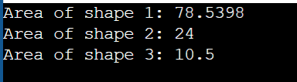

***HARD***

**QUES 15:** Matrix Multiplication Using Function Overloading

Objective: Implement matrix operations in C++ using function overloading. Write a function operate() that can perform:

* Matrix Addition for matrices of the same dimensions.
* Matrix Multiplication where the number of columns of the first matrix equals the number of rows of the second matrix.

**Solution:**

#include <iostream>

#include <vector>

using namespace std;

void printMatrix(const vector<vector<int>>& matrix) {

for (const auto& row : matrix) {

for (int elem : row) {

cout << elem << " ";

}

cout << endl;

}

cout << endl;

}

vector<vector<int>> operate(const vector<vector<int>>& mat1, const vector<vector<int>>& mat2) {

int rows = mat1.size();

int cols = mat1[0].size();

vector<vector<int>> result(rows, vector<int>(cols, 0));

for (int i = 0; i < rows; i++) {

for (int j = 0; j < cols; j++) {

result[i][j] = mat1[i][j] + mat2[i][j];

}

}

return result;

}

vector<vector<int>> operate(const vector<vector<int>>& mat1, const vector<vector<int>>& mat2, bool multiply) {

int rows = mat1.size();

int cols = mat2[0].size();

int common = mat1[0].size();

vector<vector<int>> result(rows, vector<int>(cols, 0));

for (int i = 0; i < rows; i++) {

for (int j = 0; j < cols; j++) {

for (int k = 0; k < common; k++) {

result[i][j] += mat1[i][k] * mat2[k][j];

}

}

}

return result;

}

int main() {

vector<vector<int>> mat1 = {{1, 2}, {3, 4}};

vector<vector<int>> mat2 = {{5, 6}, {7, 8}};

vector<vector<int>> mat3 = {{1, 2, 3}, {4, 5, 6}};

cout << "Matrix 1:" << endl;

printMatrix(mat1);

cout << "Matrix 2:" << endl;

printMatrix(mat2);

cout << "Matrix 3:" << endl;

printMatrix(mat3);

cout << "Matrix Addition (mat1 + mat2):" << endl;

vector<vector<int>> additionResult = operate(mat1, mat2);

printMatrix(additionResult);

cout << "Matrix Multiplication (mat1 x mat3):" << endl;

vector<vector<int>> multiplicationResult = operate(mat1, mat3, true);

printMatrix(multiplicationResult);

return 0;

}

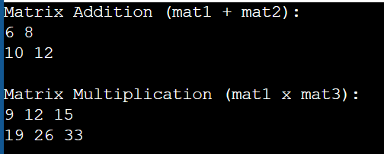

**QUES 17:** Polymorphism in Shape Classes

Objective: Design a C++ program using polymorphism to calculate the area of different shapes:

A Rectangle (Area = Length × Breadth).

A Circle (Area = π × Radius²).

A Triangle (Area = ½ × Base × Height).

Create a base class Shape with a pure virtual function getArea(). Use derived classes Rectangle, Circle, and Triangle to override this function.

**Solution:**

#include <iostream>

#include <cmath>

using namespace std;

class Shape {

public:

virtual double getArea() const = 0;

virtual ~Shape() {}

};

class Rectangle : public Shape {

private:

double length, breadth;

public:

Rectangle(double l, double b) : length(l), breadth(b) {}

double getArea() const override {

return length * breadth;

}

};

class Circle : public Shape {

private:

double radius;

public:

Circle(double r) : radius(r) {}

double getArea() const override {

return M_PI * radius * radius;

}

};

class Triangle : public Shape {

private:

double base, height;

public:

Triangle(double b, double h) : base(b), height(h) {}

double getArea() const override {

return 0.5 * base * height;

}

};

int main() {

Shape* shapes[3];

shapes[0] = new Rectangle(5, 3);

shapes[1] = new Circle(7);

shapes[2] = new Triangle(4, 6);

cout << "Area of Rectangle: " << shapes[0]->getArea() << endl;

cout << "Area of Circle: " << shapes[1]->getArea() << endl;

cout << "Area of Triangle: " << shapes[2]->getArea() << endl;

for (int i = 0; i < 3; ++i) {

delete shapes[i];

}

return 0;

}

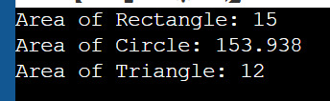

***VERY HARD***

**QUES 18:** Implement Polymorphism for Banking Transactions

Objective: Design a C++ program to simulate a banking system using polymorphism. Create a base class Account with a virtual method calculateInterest(). Use the derived classes SavingsAccount and CurrentAccount to implement specific interest calculation logic:

* SavingsAccount: Interest = Balance × Rate × Time.
* CurrentAccount: No interest, but includes a maintenance fee deduction.

**Solution:**

#include <iostream>

using namespace std;

class Account {

protected:

double balance;

public:

Account(double bal) : balance(bal) {}

virtual void calculateInterest() = 0;

void displayBalance() const {

cout << "Balance: $" << balance << endl;

}

virtual ~Account() {}

};

class SavingsAccount : public Account {

private:

double interestRate;

double time;

public:

SavingsAccount(double bal, double rate, double t) : Account(bal), interestRate(rate), time(t) {}

void calculateInterest() override {

double interest = balance * (interestRate / 100) * time;

balance += interest;

cout << "Interest calculated for Savings Account: $" << interest << endl;

}

};

class CurrentAccount : public Account {

private:

double maintenanceFee;

public:

CurrentAccount(double bal, double fee) : Account(bal), maintenanceFee(fee) {}

void calculateInterest() override {

balance -= maintenanceFee;

cout << "Maintenance fee deducted for Current Account: $" << maintenanceFee << endl;

}

};

int main() {

Account* savingsAcc = new SavingsAccount(10000, 5, 2);

savingsAcc->displayBalance();

savingsAcc->calculateInterest();

savingsAcc->displayBalance();

cout << endl;

Account* currentAcc = new CurrentAccount(5000, 50);

currentAcc->displayBalance();

currentAcc->calculateInterest();

currentAcc->displayBalance();

delete savingsAcc;

delete currentAcc;

return 0;

}

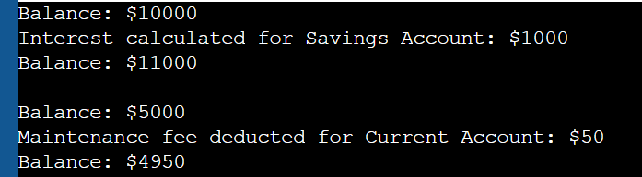

**QUES 19:** Implement Polymorphism for Banking Transactions

Objective: Design a C++ program to simulate a banking system using polymorphism. Create a base class Account with a virtual method calculateInterest(). Use the derived classes SavingsAccount and CurrentAccount to implement specific interest calculation logic:

SavingsAccount: Interest = Balance × Rate × Time.

CurrentAccount: No interest, but includes a maintenance fee deduction.

**Solution:**

#include <iostream>

using namespace std;

class Account {

protected:

double balance;

public:

Account(double bal) : balance(bal) {}

virtual void calculateInterest() = 0;

virtual ~Account() {} // Virtual destructor

};

class SavingsAccount : public Account {

private:

double rate;

int time;

public:

SavingsAccount(double bal, double r, int t) : Account(bal), rate(r), time(t) {}

void calculateInterest() override {

double interest = balance * (rate / 100) * time;

cout << "Savings Account Interest: " << interest << endl;

}

};

class CurrentAccount : public Account {

private:

double maintenanceFee;

public:

CurrentAccount(double bal, double fee) : Account(bal), maintenanceFee(fee) {}

void calculateInterest() override {

balance -= maintenanceFee;

cout << "Current Account Balance after maintenance fee: " << balance << endl;

}

};

int main() {

int accountType;

cout << "Enter Account Type (1 for Savings, 2 for Current): ";

cin >> accountType;

if (accountType == 1) {

double balance, rate;

int time;

cout << "Enter Balance: ";

cin >> balance;

cout << "Enter Interest Rate (%): ";

cin >> rate;

cout << "Enter Time (in years): ";

cin >> time;

if (balance >= 1000 && rate >= 1 && rate <= 15 && time >= 1 && time <= 10) {

SavingsAccount sa(balance, rate, time);

sa.calculateInterest();

} else {

cout << "Invalid input for Savings Account." << endl;

}

} else if (accountType == 2) {

double balance, fee;

cout << "Enter Balance: ";

cin >> balance;

cout << "Enter Monthly Maintenance Fee: ";

cin >> fee;

if (balance >= 1000 && fee >= 50 && fee <= 500) {

CurrentAccount ca(balance, fee);

ca.calculateInterest();

} else {

cout << "Invalid input for Current Account." << endl;

}

} else {

cout << "Invalid Account Type. Please enter 1 or 2." << endl;

}

return 0;

}

