**DOMAIN WINTER WINNING CAMP**

**Student Name:** Garisha Grover **UID:** 22BCS14448

**Branch:** CSE **Section/Group:** 22BCS_FL_IOT-603/B

# Very Easy

**1.Searching a Number**

Given an integer k and array arr. Your task is to return the position of the first occurrence of k in the given array and if element k is not present in the array then return -1.

Note: 1-based indexing is followed here.

**Example1**:

**Input:** k = 16 , arr = [9, 7, 16, 16, 4]

**Output:** 3

**Explanation:** The value 16 is found in the given array at positions 3 and 4, with position 3 being the first occurrence.

**Example2:**

**Input:** k=98 , arr = [1, 22, 57, 47, 34, 18, 66]

**Output:** -1

**Example2:**

**Input:** k=9 , arr = [1, 22, 57, 47, 34, 9, 66]

**Output:** 6

**Explanation:** k = 98 isn't found in the given array.

**Expected Time Complexity:** O(n)

**Expected Auxiliary Space:** O(1) **Constraints:**

* 1 <= arr.size <= 106
* 1 <= arr[i] <= 109
* 1 <= k <= 106 **CODE:**

def find_position(k, arr): try:

return arr.index(k) + 1 except ValueError: return -1

print(find_position(16, [9, 7, 16, 16, 4]))

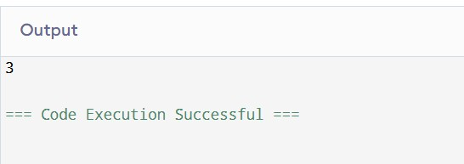

# Easy

**2. Minimum Number of Moves to Seat Everyone**

There are n availabe seats and n students standing in a room. You are given an array seats of length n, where seats[i] is the position of the ith seat. You are also given the array students of length n, where students[j] is the position of the jth student.

You may perform the following move any number of times:

Increase or decrease the position of the ith student by 1 (i.e., moving the ith student from position x to x + 1 or x - 1)

Return the minimum number of moves required to move each student to a seat such that no two students are in the same seat.

Note that there may be multiple seats or students in the same position at the beginning.

**Example 1:**

**Input:** seats = [3,1,5], students = [2,7,4]

**Output:** 4

**Explanation:** The students are moved as follows:

* The first student is moved from position 2 to position 1 using 1 move.
* The second student is moved from position 7 to position 5 using 2 moves.
* The third student is moved from position 4 to position 3 using 1 move. In total, 1 + 2 + 1 = 4 moves were used.

**Example 2:**

**Input:** seats = [4,1,5,9], students = [1,3,2,6]

**Output:** 7

**Explanation:** The students are moved as follows:

* The first student is not moved.
* The second student is moved from position 3 to position 4 using 1 move. - The third student is moved from position 2 to position 5 using 3 moves.
* The fourth student is moved from position 6 to position 9 using 3 moves. In total, 0 + 1 + 3 + 3 = 7 moves were used.

**CODE:**

def min_moves_to_seat(seats, students):

seats.sort() students.sort()

return sum(abs(seat - student) for seat, student in zip(seats, students))

print(min_moves_to_seat([3, 1, 5], [2, 7, 4]))

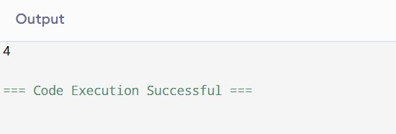

# Medium

**3.Search in 2D Matrix.**

You are given an m x n integer matrix matrix with the following two properties:

Each row is sorted in non-decreasing order.

The first integer of each row is greater than the last integer of the previous row.

Given an integer target, return true if target is in matrix or false otherwise.

You must write a solution in O(log(m * n)) time complexity.

**Example 1:**

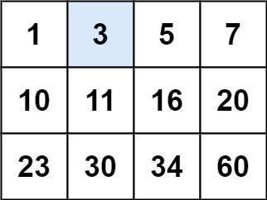

**Input:** matrix = [[1,3,5,7],[10,11,16,20],[23,30,34,60]], target = 3

**Output:** true **Example2:**

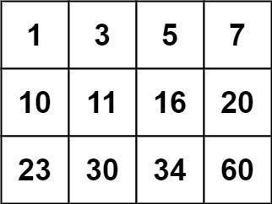

**Input:** matrix = [[1,3,5,7],[10,11,16,20],[23,30,34,60]], target = 13

**Output:** false **Constraints:** m == matrix.length n == matrix[i].length

1 <= m, n <= 100

-104 <= matrix[i][j], target <= 104

**CODE:**

def search_matrix(matrix, target): rows, cols = len(matrix), len(matrix[0])

left, right = 0, rows * cols - 1

while left <= right: mid = (left + right) // 2 mid_val = matrix[mid // cols][mid % cols] if mid_val == target:

return True elif mid_val < target:

left = mid + 1 else:

right = mid - 1

return False

print(search_matrix([[1, 3, 5, 7], [10, 11, 16, 20], [23, 30, 34, 60]], 3))

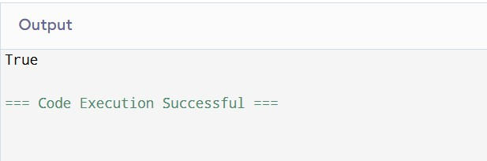

**Hard**

# 4.Sort Items by Groups Respecting Dependencies

There are n items each belonging to zero or one of m groups where group[i] is the group that the i-th item belongs to and it's equal to -1 if the i-th item belongs to no group. The items and the groups are zero indexed. A group can have no item belonging to it.

Return a sorted list of the items such that:

The items that belong to the same group are next to each other in the sorted list.

There are some relations between these items where beforeItems[i] is a list containing all the items that should come before the i-th item in the sorted array (to the left of the i-th item).

Return any solution if there is more than one solution and return an empty list if there is no solution.

**Example 1:**

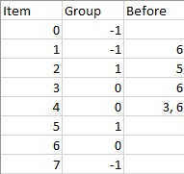

**Input:** n = 8, m = 2, group = [-1,-1,1,0,0,1,0,-1], beforeItems =

[[],[6],[5],[6],[3,6],[],[],[]]

**Output:** [6,3,4,1,5,2,0,7]

**Example 2:**

**Input:** n = 8, m = 2, group = [-1,-1,1,0,0,1,0,-1], beforeItems =

[[],[6],[5],[6],[3],[],[4],[]]

**Output:** []

**Explanation:** This is the same as example 1 except that 4 needs to be before 6 in the sorted list.

**Constraints:**

* 1 <= m <= n <= 3 * 104
* group.length == beforeItems.length == n
* -1 <= group[i] <= m - 1
* 0 <= beforeItems[i].length <= n - 1
* 0 <= beforeItems[i][j] <= n - 1
* i != beforeItems[i][j]
* beforeItems[i] does not contain duplicates elements.

**CODE:**

from collections import default dict, deque

def sort_items(n, m, group, beforeItems):

group_to_items = defaultdict(list) item_graph = defaultdict(list) group_graph = defaultdict(list) item_indegree = [0] * n group_indegree = [0] * m for i, g in enumerate(group): if g == -1: group[i] = m

m += 1 group_to_items[group[i]].append(i) for i, items in enumerate(beforeItems): for item in items: item_graph[item].append(i) item_indegree[i] += 1 if group[i] != group[item]: group_graph[group[item]].append(group[i]) group_indegree[group[i]] += 1

def topological_sort(graph, indegree, nodes): queue = deque([node for node in nodes if indegree[node] == 0]) order = [] while queue: node = queue.popleft() order.append(node) for neighbor in graph[node]: indegree[neighbor] -= 1 if indegree[neighbor] == 0: queue.append(neighbor)

return order if len(order) == len(nodes) else [] group_order = topological_sort(group_graph, group_indegree, list(range(m))) if not group_order:

return [] result = [] for g in group_order:

items = group_to_items[g]

item_order = topological_sort(item_graph, item_indegree, items)

if not item_order:

return []

result.extend(item_order)

return result

print(sort_items(8, 2, [-1, -1, 1, 0, 0, 1, 0, -1], [[], [6], [5], [6], [3, 6], [], [], []]))

## Very Hard

**5.Find Minimum in Rotated Sorted Array II.**

Suppose an array of length n sorted in ascending order is rotated between 1 and n times. For example, the array nums = [0,1,4,4,5,6,7] might become:

[4,5,6,7,0,1,4] if it was rotated 4 times.

[0,1,4,4,5,6,7] if it was rotated 7 times.

Notice that rotating an array [a[0], a[1], a[2], ..., a[n-1]] 1 time results in the array [a[n-1], a[0], a[1], a[2], ..., a[n-2]].

Given the sorted rotated array nums that may contain duplicates, return the minimum element of this array.

You must decrease the overall operation steps as much as possible.

**Example 1:**

**Input:** nums = [1,3,5]

**Output:** 1

**Example 2:**

**Input:** nums = [2,2,2,0,1]

**Output:** 0

**Constraints:**

* n == nums.length
* 1 <= n <= 5000
* -5000 <= nums[i] <= 5000
* nums is sorted and rotated between 1 and n times.

**CODE:** def find_min(nums): left, right = 0, len(nums) - 1 while left < right: mid = (left + right) // 2 if nums[mid] > nums[right]: left = mid + 1 elif nums[mid] < nums[right]:

right = mid else: right -= 1

return nums[left]

print(find_min([1, 3, 5]))

